**Focus keyword**: **Crohn's disease Eyes**

**Meta Title:**– **Crohn's disease Eyes** |vigoursoul

**Meta Description:** Crohn's disease Eyes is a chronic inflammatory condition that affects the gastrointestinal tract. It can also affect other parts including the eyes

**Feature Image:**

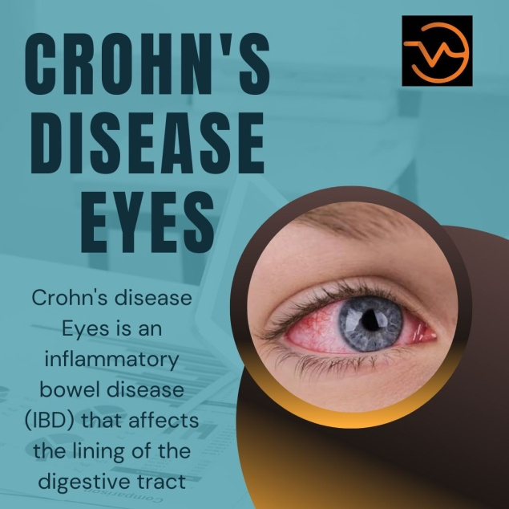

**Crohn's disease Eyes**

**Crohn's disease Eyes** is an inflammatory bowel disease (IBD) that affects the lining of the digestive tract. It causes inflammation of the digestive tract, which can lead to abdominal pain, severe diarrhea, fatigue, weight loss, and malnutrition.

The inflammation caused by **Crohn's disease Eyes** can also affect other parts of the body, such as the skin, joints, and eyes. Treatment usually involves medications to reduce inflammation, and in some cases, surgery to remove the damaged portion of the digestive tract.

**Origin of Crohn's disease:**

IBDs like Crohn's disease, which can affect any part of the digestive system, are inflammatory bowel diseases. Stomach pain, diarrhoea (which could be bloody if the inflammation is severe), fever, abdominal distension, and weight loss are common symptoms. Anemia, skin rashes, arthritis, eye irritation, and weariness are examples of complications outside of the digestive tract.



More than 70 genes have been revealed to play a role in the hereditary component of risk, which accounts for about half of the total risk. Crohn's disease is twice as likely to strike tobacco smokers as nonsmokers. The results of a biopsy, the way the gut wall looks, medical imaging, and a description of the disease all contribute to the diagnosis. Irritable bowel syndrome and Bechtel’s disease are two more illnesses that might exhibit comparable symptoms.

In Europe, North America, and the UK, 3.2 out of every 1,000 people are affected by Crohn's disease. In Asia and Africa, it is less typical. In the past, the developed world has had a higher prevalence of it. However, since the 1970s, rates have been rising, particularly in emerging nations. 47,400 people died from inflammatory bowel illness in 2015, and people with Crohn's disease have a somewhat shorter life expectancy. Although it can happen at any age, it typically begins in young adulthood. Both men and women are equally impacted.

**Crohn's Disease Eyes**

In some cases, **Crohn's disease Eyes** can cause inflammation of the eyes, which can lead to dry eyes, redness, and a gritty sensation. Treatment for inflammation of the eyes includes lubricating eye drops, artificial tears, and anti-inflammatory medications. In more severe cases, surgery may be necessary to reduce the inflammation. Other treatments, such as light therapy, may also be helpful.

Treatment for eye problems related to **Crohn's disease Eyes** will vary depending on the cause of the problem, and lifestyle changes such as getting regular eye exams, wearing sunglasses, and avoiding smoking can help improve vision. In some cases, Crohn's disease can cause permanent vision loss, so it is important to get prompt medical attention to prevent any further damage.

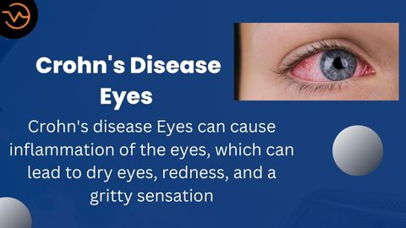

**Early Stage Crohn's Disease Eyes**

At an early stage of **Crohn's disease Eyes** may not show any signs or symptoms of inflammation. However, as the disease progresses, the eyes may become red, dry, itchy, and irritated. In some cases, the eyes may also appear swollen. If you notice any of these symptoms, it is important to seek medical attention as soon as possible.

**Crohn's Disease Symptoms Eyes**

**Crohn's disease Eyes** can cause inflammation of the eyes, which can lead to symptoms such as dryness, redness, and a gritty sensation. Other symptoms may include eye pain, blurred vision, light sensitivity, and swelling. If you experience any of these symptoms, it is important to seek medical attention as soon as possible. Treatment for eye symptoms of **Crohn's disease Eyes** usually includes medications to reduce inflammation and improve circulation.

**Crohn's Disease Dark Eyes**

**Crohn's disease Eyes** can cause dark circles under the eyes due to inflammation and reduced blood circulation in the area. This can give the appearance of dark circles or shadows under the eyes, which can be a sign of Crohn's disease. If you notice dark circles under your eyes, it is important to seek medical attention to determine the cause.

**Crohn's Disease Eye Bags**

**Crohn's disease Eyes** can also cause the appearance of eye bags or puffiness around the eyes due to inflammation. This can be a sign of Crohn's disease, and it is important to seek medical attention if you notice this symptom. Treatment for eye bags usually involves medications to reduce inflammation and improve circulation. In some cases, surgery may be necessary to reduce the swelling.

**Does Crohn's disease cause dark circles under eyes**

Yes, **Crohn's disease Eyes** can cause dark circles under the eyes due to inflammation and reduced blood circulation in the area. This can give the appearance of dark circles or shadows under the eyes, which can be a sign of Crohn's disease. If you notice dark circles under your eyes, it is important to seek medical attention to determine the cause.

**Sore Eyes Crohn's Disease**

Yes, **Crohn's disease Eyes** can cause inflammation of the eyes, which can lead to symptoms such as dryness, redness, and a gritty sensation. Other symptoms may include eye pain, blurred vision, light sensitivity, and swelling.

If you experience any of these symptoms, it is important to seek medical attention as soon as possible. Treatment for eye symptoms of Crohn's disease usually includes medications to reduce inflammation and improve circulation.

**Crohn's Disease Bulging Eyes**

In rare cases, **Crohn's disease Eyes** can cause inflammation of the eyes, which can lead to a bulging of the eyes. This is known as exophthalmos and can be a sign of **Crohn's disease Eyes**. If you notice a bulging of the eyes, it is important to seek medical attention as soon as possible. Treatment for exophthalmos usually involves medications to reduce inflammation and improve circulation. In some cases, surgery may be necessary to reduce the swelling.

**Crohn's Disease Effects on Eye**

* **Crohn's disease Eyes** can cause inflammation of the eyes, which can lead to dryness, redness, and a gritty sensation.
* Other symptoms may include eye pain, blurred vision, light sensitivity, and swelling.
* If you experience any of these symptoms, it is important to seek medical attention as soon as possible.
* Treatment for eye symptoms of **Crohn's disease Eyes** usually includes medications to reduce inflammation and improve circulation.

**Crohn's Disease Eye Complications**

The complications of **Crohn's disease Eyes** in the eyes can include dryness, redness, a gritty sensation, eye pain, blurred vision, light sensitivity, and swelling. In rare cases, **Crohn's disease Eyes** can cause inflammation of the eyes, which can lead to a bulging of the eyes known as exophthalmos. If you experience any of these symptoms, it is important to seek medical attention as soon as possible. Treatment for eye symptoms of Crohn's disease usually includes medications to reduce inflammation and improve circulation.

Here is the information you need to know about specific Crohn's-related eye issues.

**Uveitis**

An inflammation of the uvea, which Roberts describes as "a blood vessel-rich lining of the eye that supplies nutrients to the cornea, retina, iris, and lens," is one of the most typical eye issues in Crohn's disease, according to the Crohn's & Colitis Foundation. The uvea swells, the retina swells, and vision blurs when it is inflamed. According to him, the uveitis-related blurred vision may appear suddenly or develop gradually.

**Episcleritis**

An inflammation of the eye's outer covering, is another frequent eye problem in people with Crohn's disease, according to the Crohn's & Colitis Foundation. There is a definite connection between episcleritis flare-ups and active Crohn's disease, according to Dougherty. According to Johns Hopkins Medicine, episcleritis symptoms include generalized or localized redness of the eyes as well as some pain or discomfort.

**Wet Eyes**

According to the Crohn's & Colitis Foundation, dry eye syndrome, also known as Kerato Conjunctivitis Sicca (KCS), is an eye problem connected to Crohn's that is brought on by decreased tear production or increased tear film evaporation. Dry eyes may cause infection, burning, or irritation.

**Keratopathy**

According to the Crohn's & Colitis Foundation, keratopathy, an irregularity of the cornea where white deposits accumulate, is another eye ailment connected to Crohn's disease. It could be brought on by dry eyes or uveitis. Keratopathy can be identified by an ophthalmologist using a slit lamp examination.

**Crohn's Disease Eye Floaters**

**Crohn's disease Eyes** can cause inflammation of the eyes, which can lead to dryness, redness, and a gritty sensation. It is possible that **Crohn's disease Eyes** can also cause eye floaters, which are small spots or strands that move around in the field of vision.

If you experience any of these symptoms, it is important to seek medical attention as soon as possible. Treatment for eye symptoms of Crohn's disease usually includes medications to reduce inflammation and improve circulation.

**Crohn's Disease Eye Pain and Twitching**

**Crohn's disease Eyes** can cause inflammation of the eyes, which can lead to symptoms such as dryness, redness, and a gritty sensation. Other symptoms may include eye pain, blurred vision, light sensitivity, and swelling.

In some cases, eye pain and twitching may also occur. If you experience any of these symptoms, it is important to seek medical attention as soon as possible. Treatment for eye symptoms of Crohn's disease usually includes medications to reduce inflammation and improve circulation.

**IBD Accelerating Research:**

For many years, little was understood about ulcerative colitis and Crohn's disease. Two English doctors named Wilks and Moxon originally identified ulcerative colitis in 1875 and separated it from infectious diarrheal illnesses. Before the Civil War, there were reports of a condition that shared symptoms with ulcerative colitis, albeit it wasn't labelled as a separate illness until 1875.

Three medical professionals—Burrill Crohn, Leon Ginsberg, and Gordon D. Oppenheimer—described Crohn's disease for the first time in 1932. At the time, intestinal TB was believed to be any condition affecting the small intestine.

To address the shortage of patient education and support services, the Rosenthals, Modells, and Dr. Henry Janowitz created the National Foundation for Ileitis and Colitis on September 12, 1967.

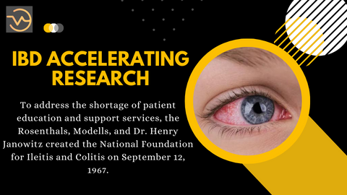

**Pete Davidson Crohn's Disease Eyes**

Pete Davidson has been open about his struggles with Crohn's disease, a type of inflammatory bowel disease. He has also shared that his **Crohn's disease Eyes** has caused inflammation in his eyes, leading to dryness, redness, and a gritty sensation.

Treatment for his eye inflammation includes lubricating eye drops, artificial tears, and anti-inflammatory medications. Davidson has also said that light therapy has been helpful in managing his symptoms.

**Crohn's disease Eyes-FAQS**

**Can Crohn's disease affect the eyes?**

Yes, **Crohn's disease Eyes** can affect the eyes. Common symptoms associated with Crohn's disease that affect the eyes include red, itchy, or watery eyes; blurry vision; halos around lights; floaters; and light sensitivity.

**What causes eye problems in Crohn's disease?**

Eye problems in **Crohn's disease Eyes** can be caused by inflammation of the eye tissue, as well as inflammation of the eye muscles or nerves. It can also be caused by medications used to treat Crohn's disease.

**What should I do if I experience eye problems related to Crohn's disease?**

If you experience any eye problems related to **Crohn's disease Eyes**, you should speak to your doctor as soon as possible. It is important to get prompt medical attention to prevent any further damage to your vision.

**Are there any treatments for eye problems related to Crohn's disease?**

Treatment for eye problems related to Crohn's disease will vary depending on the cause of the problem. Your doctor may recommend medications, such as steroids, to reduce inflammation and help improve vision.

**Are there any lifestyle changes I can make to improve my vision if I have Crohn's disease?**

Yes, there are lifestyle changes you can make to help improve your vision if you have **Crohn's disease Eyes**. You should get regular eye exams, wear sunglasses or hats with wide brims to protect your eyes from the sun, and avoid smoking, as smoking can worsen eye problems.

**Can Crohn's disease cause permanent vision loss?**

In some cases, **Crohn's disease Eyes** can cause permanent vision loss. Prompt medical attention is essential to prevent any permanent damage to the eyes.

**Conclusion**

**Crohn's disease Eyes** can affect the eyes, causing symptoms such as red, itchy, or watery eyes; blurry vision; halos around lights; floaters; and light sensitivity. Treatment for eye problems related to Crohn's disease will vary depending on the cause of the problem, and lifestyle changes such as getting regular eye exams, wearing sunglasses, and avoiding smoking can help improve vision.

In some cases, **Crohn's disease Eyes** can cause permanent vision loss, so it is important to get prompt medical attention to prevent any further damage. Eye problems associated with Crohn's disease include red, itchy, or watery eyes; blurry vision; halos around lights; floaters; and light sensitivity. These symptoms can be caused by inflammation of the eye tissue, as well as inflammation of the eye muscles or nerves.