**Topic:** Buspirone vs Xanax in 2023 – Vigoursoul

**Focus keyword:** Buspirone vs Xanax

**Meta Title**: Buspirone vs Xanax in 2023 – Vigoursoul

**Meta Description:** Both Buspirone vs Xanax ease anxiety; however Buspirone is a safer medication in general. It will not make you as tired.

Anxiety drugs include buspirone vs Xanax (alprazolam). Xanax belongs to the benzodiazepine drug class, however, buspirone is not connected to benzodiazepines and functions differently from other anxiolytics. In the United States, the buspirone brand name BuSpar has been discontinued. It is a generic medication. Both Buspirone vs Xanax are prescription medications used to treat anxiety, although they differ in significant ways. It differs chemically from Xanax and other benzodiazepines in how it affects the brain. It also has a lesser risk of physical dependency or addiction than benzodiazepines and generates less drowsiness.



**Origin of Buspirone vs Xanax:**

**Buspirone:**

Buspirone was first made in 1968 and approved for medical use in the United States in 1986. It is available as a generic medication. In 2020, it was the 55th most commonly prescribed medication in the United States, with more than 12 million prescriptions.

**Xanax:**

Alprazolam was invented by Dr. Jackson Hester at the Upjohn Company and patented in 1971 and approved for medical use in the United States in 1981

**Who Invented Buspirone?**

Buspirone was first synthesized by a team at Mead Johnson in 1968 but was not patented until 1980. It was initially developed as an antipsychotic acting on the D2 receptor but was found to be ineffective in the treatment of psychosis; it was then used as an anxiolytic instead.IN 1986, Bristol-Myers Squibb gained FDA approval for buspirone in the treatment of GAD. The patent expired in 2001, and buspirone is now available as a generic drug.

**Who Invented Xanax?**

Upjohn Laboratories developed this medication in the late 1960s. **Dr. David Sheehan** can primarily be credited with inventing Xanax because he became involved with Upjohn and saw the potential effectiveness of Xanax in the treatment of anxiety and panic.

**What are buspirone vs Xanax?**

* Buspirone is a medication used to treat anxiety. Its method of action is unknown, however it is thought to have effects on the neurotransmitters serotonin and dopamine.
* Buspirone may act on nerves by stimulating serotonin type 1A receptors, changing the chemical information that nerves receive.
* Buspirone, unlike benzodiazepine anxiety medicines, does not cause sedation.
* Xanax (alprazolam) is a benzodiazepine anti-anxiety medicine in the same class as diazepam (Valium), clonazepam (Klonopin), lorazepam (Ativan), and flurazepam (Dalmane).
* Xanax and other benzodiazepines work in the brain by boosting the actions of a neurotransmitter called gamma-aminobutyric acid (GABA). GABA inhibits brain activity. Excessive brain activity is thought to promote anxiety and other psychiatric problems.

**What are the side effects of buspirone and Xanax?**

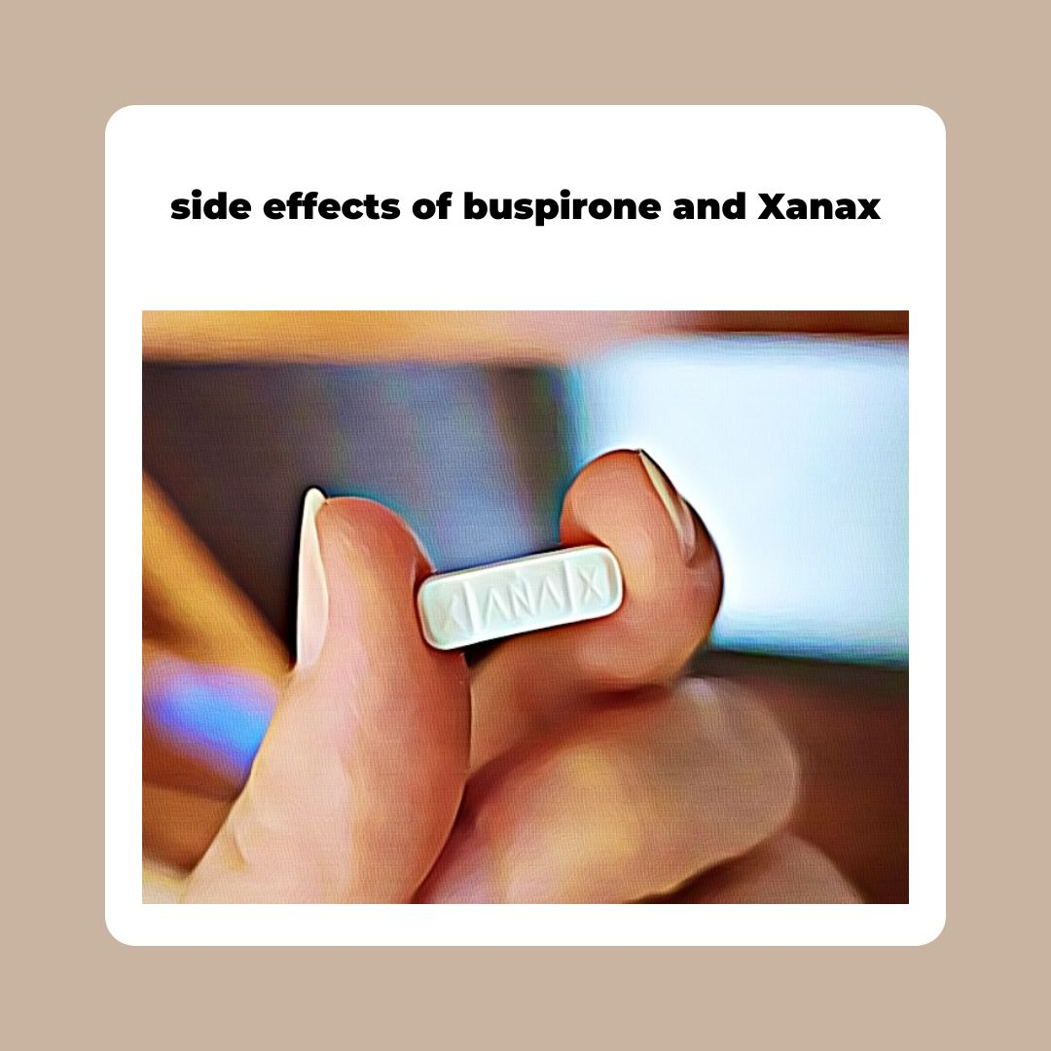

**Buspirone side effects:**

The most common side effects associated with buspirone are:

* [Dizziness](https://www.medicinenet.com/dizziness/symptoms.htm),
* Nausea,
* [Headache](https://www.medicinenet.com/migraine_headaches_pictures_slideshow/article.htm),
* Nervousness,
* Lightheadedness,
* Excitement, and
* [Insomnia](https://www.medicinenet.com/insomnia/symptoms.htm).

**Xanax side effects:**

The most common side effects of Xanax taken at lower doses are:

* Drowsiness
* [Fatigue](https://www.medicinenet.com/fatigue_and_tiredness/symptoms.htm)

Other side effects include:

* Memory problems
* Speech problems
* [Constipation](https://www.medicinenet.com/constipation_myths_facts_pictures_slideshow/article.htm)
* Changes in weight
* [Addiction](https://www.medicinenet.com/drug_abuse/article.htm) (dependency)

**Buspirone vs Xanax: Which is More Effective?**

BuSpar and Xanax are both effective therapy options for GAD. According to research, BuSpar is nearly as effective at treating anxiety symptoms as benzodiazepines like Xanax. If you have an anxiety problem, your doctor will select the medication that is best for you based on your needs and medical history.

If you've already had benzodiazepine side effects, or if you require an anti-anxiety drug that is safe to use long term without establishing physical dependence, your healthcare physician may recommend Buspar.

If you need a fast-acting medicine to treat short-term anxiety symptoms or panic attacks, your doctor would most likely prescribe Xanax or a comparable benzodiazepine medication.

Because anxiety disorders differ so greatly from person to person, there is no single "optimal" drug for everyone suffering with generalized anxiety disorder or a related illness.

**What is the dosage for buspirone vs Xanax?**

* **Dosage of buspirone:**  
  The typical adult starting dose is 10-15 mg daily divided into two or three doses. Increase the dose by 5 mg every 2 to 4 days until an effective dose is discovered.
* Although the maximal adult dose is 60 mg per day, most individuals react to 15-30 mg per day.
* Although meals increases the quantity of buspirone absorbed, the significance of this impact is unknown. Buspirone can be taken with or without food, however it is best taken on a regular basis.

**Dosage of Xanax:**

* The starting dose for treating anxiety is 0.25-0.5 mg three to four times per day in the form of instant release tablets. The dose can be increased every 3-4 days up to a maximum of 4 milligrams per day.
* The recommended starting dose for treating panic attacks is 0.5 mg three times per day. Doses can be raised every 3-4 days, but only by 1 mg per day.
* For some patients, the effective dose for avoiding panic attacks may be as high as 10 mg daily. When utilizing extended release tablets to treat panic disorder, the starting dose is 0.5 mg once daily, and the average dose is 3-6 mg once daily.
* You can take alprazolam with or without food.

**Treating :( Buspirone vs Xanax)**

Both **Buspirone vs Xanax** are anti-anxiety drugs. They differ in a variety of ways, including how they work within your body and the chances of generating adverse effects, drug interactions, and physical dependence. There is no one "best" option among BuSpar and Xanax. Instead, your doctor will choose the best prescription for you based on your anxiety symptoms, medical history, risk of dependence, and other considerations.

**FAQS Buspirone vs Xanax**

**Is Buspar better than Xanax?**

**Buspar vs Xanax** were both equally effective in treating anxiety symptoms in a trial, and Buspar had fewer side effects and withdrawal symptoms than Xanax. Another study looked at the effects of Buspar, Xanax, and Valium (diazepam) on daytime sleepiness. According to the study, Buspar causes the least drowsiness of any medication.

**Is Buspar a safe drug?**

When taking Buspar, it is critical to inform your doctor about all drugs and health conditions. While the medication itself is slow acting and reasonably safe, certain drug interactions can drastically boost its concentration. As a result, Buspar affects sex drive and may cause unpleasant withdrawal symptoms when stopped.

**Does Buspar and Xanax do the same thing?**

**Buspirone vs Xanax** are two medications that may be provided to people who suffer from anxiety or panic attacks. While Buspirone can help with symptoms similar to Xanax, it is a different type of medication. Some folks who are interested in the substance ask if it is as effective as Xanax.

**Does buspirone help you sleep?**

Anxiety medications are typically sedating and tend to be respiratory depressants. Buspirone, a nonbenzodiazepine anxiolytic medication, has been shown to have little sedative impact.

**Is buspirone for anxiety or depression?**

Buspirone is generally used to treat anxiety disorders (GAD). It is an FDA-approved medication for the treatment of anxiety disorders or the temporary reduction of anxiety symptoms. Buspirone that has not been labelled is used to treat unipolar depression.

**Conclusion:**

When transitioning from Xanax to buspirone, exercise caution. After a long time of use, abruptly discontinuing Xanax may result in Xanax withdrawal. Xanax withdrawal symptoms might include agitation, sleeplessness, and other unpleasant symptoms. Seizures or even death may occur in severe situations.

As a result, persons who have been using Xanax or another benzo for more than eight weeks should gradually taper off the medicine rather than discontinuing abruptly. Buspirone does not appear to alleviate the symptoms of benzo withdrawal.