# Department of Computing

# EE353: Computer Networks

# Class: BESE-12AB

**CLO 1,CLO2,CLO4**

**Lab 3: Creating basic Network in CISCO Packet Tracer**

**Date: 27-9-2023**

# Time: 10:00 to 01:00 and 2:00 to 05:00

# Instructor: Dr. Humma Gafoor

# Lab Engineer: Syed Muhammad Ali Musa

**Name:** Aimen Munawar

**Class:** BESE-13-A

**CMS ID:** 415867

**Lab 3: Creating Basic Network in CISCO Packet Tracer**

**Introduction**

This lab introduces Packet Tracer which is a network simulator provided by Cisco.

**Objectives**

This lab exercise is designed to

* To get familiarization with “Packet Tracer ”
* How to make Connections Between more then one Devices
* How to test the Connectivity between the devices

**Tools/Resources Required**

* Computer
* Packet Tracer (version 5 or higher)

**Description**

**Network Simulator**

Network Simulator creates the software portion of the hardware only so you can’t use them with real networks. The process done by it is called **Simulation**. Most widely used network simulators are OPNET, NS (both are general-purpose) and Packet Tracer (for Cisco devices). Using Simulator allows us to (**only**) test networks before deploying in the real world. Also they usually don’t have all the functionalities available in real-life devices.

**The purpose of simulator is to duplicate the software functionality of a device.**

Packet Tracer is a standalone, simulation-based learning  
environment for networking novices to design, configure, and troubleshoot computer networks at a CCNA-level of complexity. Packet Tracer supports student and instructor creation of simulations, visualizations, and animations of networking phenomena. Like any simulation, Packet Tracer 5.0 relies on a simplified model of networking devices and protocols. Real computer networks remain the benchmark for understanding network behavior and developing networking skills. Packet Tracer was created to help address the "digital divide" in networking education, where many students and teachers lack access to equipment, bandwidth, and interactive modes of learning networking. We invite you to use the help files and tutorials to learn about the major features of the program, which include the items in the following table Packet Tracer 5.0 uses two representation schemes for your network: the Logical Workspace and the Physical Workspace. The Logical Workspace allows you to build a logical network topology, without regard to its physical scale and arrangement.

The Physical Workspace allows you to arrange devices physically in cities, buildings, and wiring closets. Distances and other physical measures will affect network performance and other characteristics if wireless connections are used. In Packet Tracer 5.0, you first build your logical network, and then you can arrange it in the Physical Workspace. Most of your time will be spend working in the Logical Workspace.

**The Logical Workspace**

The Logical Workspace is where you will spend the majority of your time building and configuring your network. In conjunction with Real-time Mode, you can use this workspace to complete many of the labs you encounter in your CCNA coursework. First, you will want to create devices. This is done by choosing devices from the  
Network Component box. Then, you can do any of the following:

* Add modules to your devices to install additional interfaces. Note that you must  
  turn off a device (by clicking its power button) before you can add a module.
* Connect your devices by choosing the appropriate cables (also found in thevNetwork Component box).
* Configure device parameters (such as the device name and IP address) through  
  graphical dialogue boxes or the Cisco IOS (in the case of routers and switches).
* Make advanced configurations and view network information from the CLI interface on a router or switch.

**Creating Devices**

To place a device onto the workspace, first choose a device type from the **Device-Type**  
Selection box. Then, click on the desired device model from the **Device-Specific**  
Selection box. Finally, click on a location in the workspace to put your device in that  
location. If you want to cancel your selection, press the **Cancel** icon for that device.  
Alternatively, you can click and drag a device from the **Device-Specific Selection** box  
onto the workspace. You can also click and drag a device directly from the **Device-Type** Selection box and a default device model will be chosen for you.

To quickly create many instances of the same device, press and hold the **Ctrl** button, click on the device in the **Device-Specific Selection** box, and then release the **Ctrl** button. The device is now locked and you can click on the workspace multiple times to add multiple copies of the device. Cancel this operation by pressing the **Cancel** icon for that device. To duplicate devices, you can press and hold the **Ctrl** button and then drag a device on the workspace or select the devices and then use the **Copy** and **Paste** buttons. Most Packet Tracer 5.0 devices have modular bays or slots into which you can insert modules. In the workspace, click on a device to bring up its configuration window. By default, you will be in the **Physical Device View** subpanel of the device. An interactive picture of the device is on the right of the panel, and a list of compatible modules is on  
the left. You can resize the picture with the **Zoom In,** **Original Size,** and **Zoom Out**  
buttons. You can also resize the entire configuration window by dragging its borders with the mouse. Alternatively, you can undock the window so that you can move it around and freely resize it.

**4. Procedure**

1. Open Packet Tracer 5 from Desktop or Start Menu. The following window appears.

2. Click on **Switch** in lower left part, click on **2950T** and then again click in the main window. The switch will appear in the main window.

3. Place four PCs **Generic (in** **End Devices)** in the main window.

4. Find suitable connections in **Connections** to have the following topology.

Basics of Cisco packet tracer

Follow this below tutorial.

<https://www.youtube.com/watch?v=58D8Ua-uc9s&t=26s>

Switch configuration

<https://www.youtube.com/watch?v=iEv_hx7mIOg&t=5s>

**Lab Task:**

1. Create a peer-to-peer network between two end devices. Assign ip address. Test the connection.

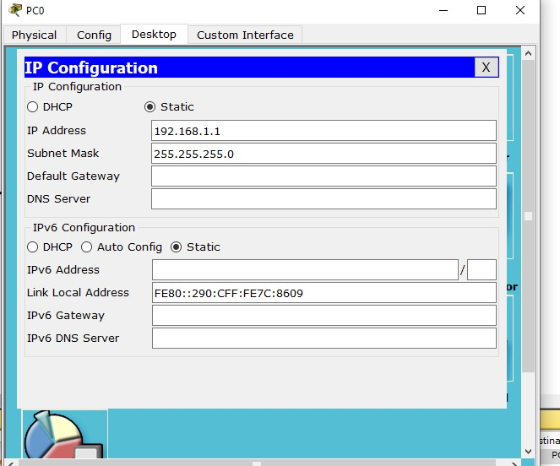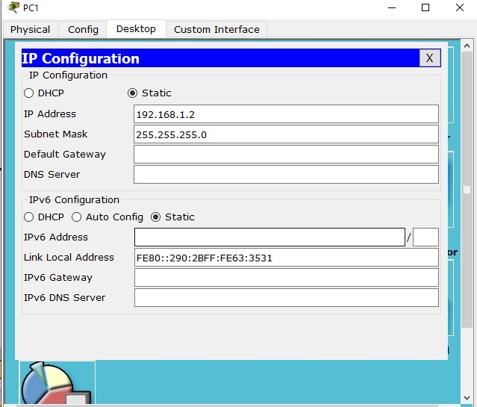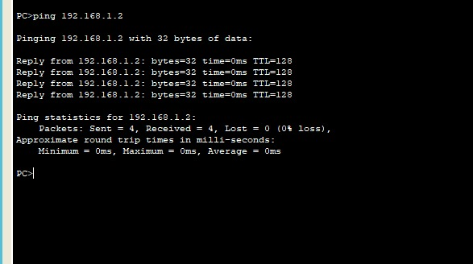

1. Create a basic network topology with seven end devices. Assign ip address to every end devices. Establish connection between switch and end devices. Perform configuration of Switch using command line interface. Test all the connection using ping command.

**Deliverables**

Zip and Upload all .pkt files

**Grade Criteria**

This lab is graded. Min marks: 0. Max marks: 10.

|  |  |  |
| --- | --- | --- |
| **Activity** | **Minimum** | **Maximum** |
| Documentation with clearly defined understanding of the lab task and approach | Fail | Pass |
| Lab Tasks | 0 | 10 |