# Department of Computing

# EE353: Computer Networks

# Class: BESE

**CLO 2: Apply the knowledge of Computer networking to understand contemporary networking issues**

**Lab 8: Router Configuration using CLI**

**Date: 04-10-2023**

# Time: 10:00 to 12:00 and 2:00 to 05:00

# Instructor: Dr. Humma Gafoor

# Lab Engineer: Syed Muhammad Ali Musa

**Name:** Aimen Munawar

**Class:** BESE-13-A

**CMS ID:** 415867

**Lab 8: Router Configuration using CLI**

**Introduction**

Packet Tracer is a cross-platform visual simulation tool designed by Cisco Systems that allows users to create network topologies and imitate modern computer networks.

**Objectives**

Learn basics of CISCO Packet tracer.

**Tools/Software Requirement**

CISCO Packet Tracer

**Description**

## Cisco Router Functions

Cisco router functions - They serve two primary functions that are:

1. They manage traffic between packet-switched networks or subnetworks by forwarding data packets to their intended IP addresses.
2. They allow multiple devices such as PC, tablets, mobile to use the same Internet connection.

## Types of Cisco Router

There are different types of routers to serve these two primary functions, such as a wireless router and a wired router. Also, many specialized types of routers serve specific functions like a core router, edge router, and virtual router.

Here are different types of Cisco routers:

### Wireless Router:

It uses an ethernet cable to connect to a modem. A wireless router converts packets from binary code into radio signals and then wirelessly broadcasts them using antennae. Wireless routers create WLANs that connect multiple devices using wireless communication.

### Wired Router:

Wired routers are similar to wireless routers that use an ethernet cable to connect to a modem. They create LANs using separate cables to connect to one or more devices within the network and then to the Internet.

### Core Router:

Core routers come in handy to large corporations and businesses that transmit a high volume of data packets within their network. They operate at the network's internet backbone or "core" and do not communicate with external networks.

### Edge Router:

An edge router communicates with both core routers and external networks, unlike core routers. They are placed at the "edge" of a network and use the BGP to send and receive data from other LANs and WANs.

### Virtual Router:

A router that performs the same function as a standard hardware router but is a software application is called a Virtual router.

## **How to configure a Cisco Router?**

### **Step 1: Create a Lab in Packet Tracer**

To configure a Cisco router, you need to create a lab in the Packet Tracer first as shown below:

This is just a practice lab, and it will not affect any network configuration on your device.

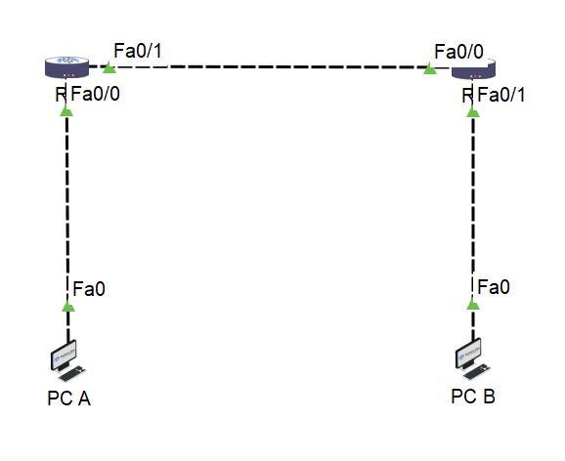

It is not mandatory to use the same topology; you can modify it according to your wish. However, it is recommended to use the same to understand the commands explained more clearly.

**My Screenshot:**

### Step 2: Access Command Line Interface

Access the CLI (Command Line Interface) by clicking on Router 1.

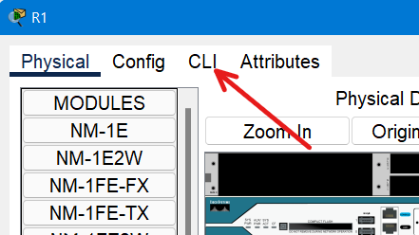

Say no when asked if you would like to enter the initial configuration dialog of the router.

**Good To Remember:**

There are various command modes, and following are the some of the main command modes:

1) User EXEC Mode Router>

2) Privileged EXEC Mode Router#

3) Global Configuration Mode Router(config)#

4) Interface Configuration Mode Router(config-if)#

5) Sub Interface Configuration Mode Router(config-subif)#

**My Screenshot:**

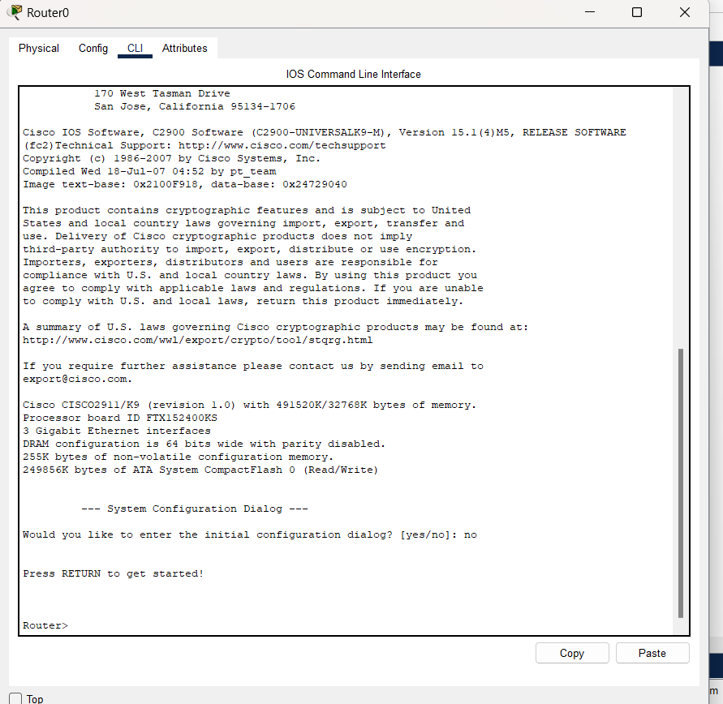

### Step 3: Enter the Privileged EXEC Mode

To enter the Privileged EXEC Mode, you have to use the command 'enable' in the CLI of Router 1.

Router>enable

Router#

**My Screenshot:**

### Step 4: Switch to Global Configuration Mode

Switch to the Global Configuration Mode by using the command 'configure terminal' in the Privileged EXEC Mode.

Router#configure terminal

Enter configuration commands, one per line. End with CNTL/Z.

Router(config)#

**My Screenshot:**

### Step 5: Change the router name

Change the default router name from 'Router' to 'R1'.

You can configure any desired name on the router as per the topology you're creating. This helps you to differentiate the device from other devices in the network. The command to change name is 'hostname name'.

Router(config)#hostname R1

**My Screenshot:**

### Step 6: Assign IP Addresses

Assign IP Addresses to the interfaces of Router 1.

Assigning IP to the router is very important and is required to make your router be able to forward packets from/to networks.

I am configuring 192.168.1.1 and 192.168.2.1 on interface fa 0/1 and fa 0/0, respectively.

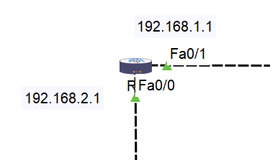

Commands to configure IP Address and make the interface fa 0/1 up:

R1(config)#

R1(config)#interface fa 0/1

R1(config-if)#ip address 192.168.1.1 255.255.255.0

R1(config-if)#no shutdown

R1(config-if)#

%LINK-5-CHANGED: Interface FastEthernet0/1, changed state to up

Commands to configure IP Address and make the interface fa 0/0 up:

R1(config)#

R1(config)#interface fa 0/0

R1(config-if)#ip address 192.168.2.1 255.255.255.0

R1(config-if)#no shutdown

R1(config-if)#

%LINK-5-CHANGED: Interface FastEthernet0/0, changed state to up

**My Screenshot:**

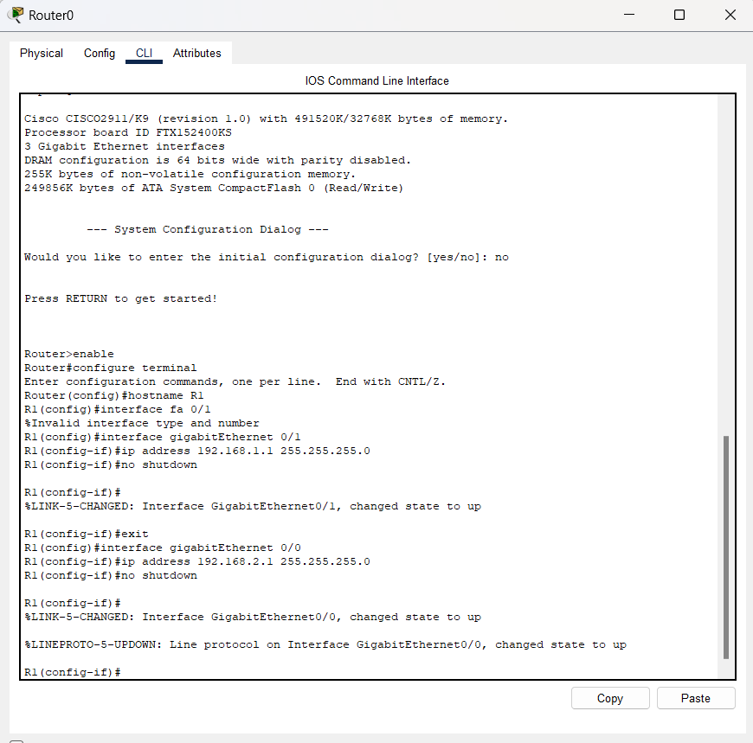

### Step 7: Assign IP Address to R2

Assign the IP Address on the interfaces of Router 2.

I am configuring 192.168.1.2 and 192.168.3.1 on interface fa 0/0 and fa 0/1, respectively.

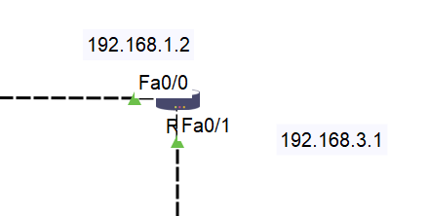

Commands to configure IP Address and make the interface fa 0/0 up:

R2(config)#

R2(config)#interface fa 0/0

R2(config-if)#ip address 192.168.1.2 255.255.255.0

R2(config-if)#no shutdown

R2(config-if)#

%LINK-5-CHANGED: Interface FastEthernet0/1, changed state to up

Commands to configure IP Address and make the interface fa 0/1 up:

R2(config)#

R2(config)#interface fa 0/1

R2(config-if)#ip address 192.168.3.1 255.255.255.0

R2(config-if)#no shutdown

R2(config-if)#

%LINK-5-CHANGED: Interface FastEthernet0/1, changed state to up.

**My Screenshot:**

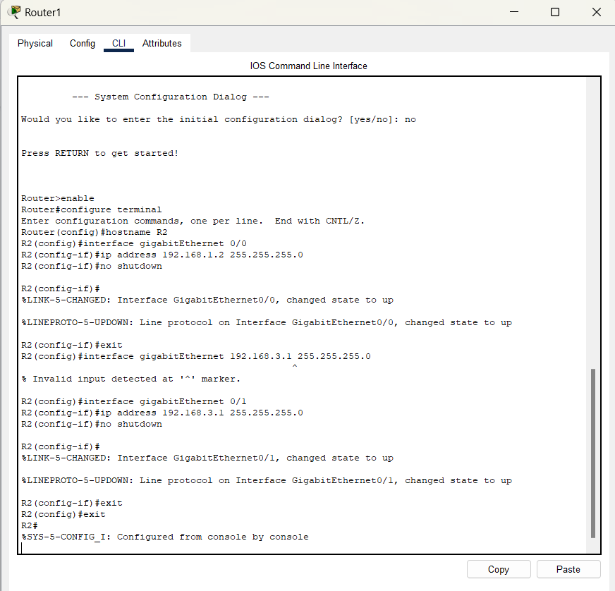

After assigning the IP Addresses and turning on the ports, you'll observe the link lights turning green. This represents that the port is now in forwarding mode and can be used to transmit the data.

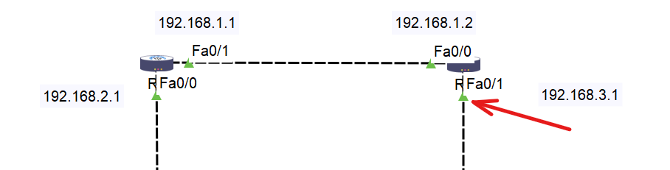

**My Screenshot:**

### Step 8: Assign IP Address to PC

Assigning IP addresses to the PC

Click on PC A and open the Desktop Tab.

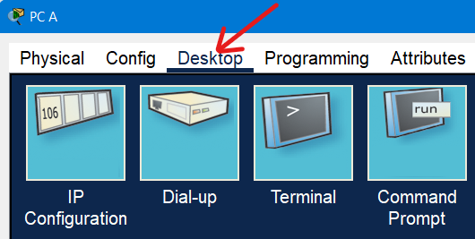

Go to the IP Configuration and assign IP Address 192.168.2.2 with the default subnet mask 255.255.255.0 and gateway 192.168.2.1 on PC A

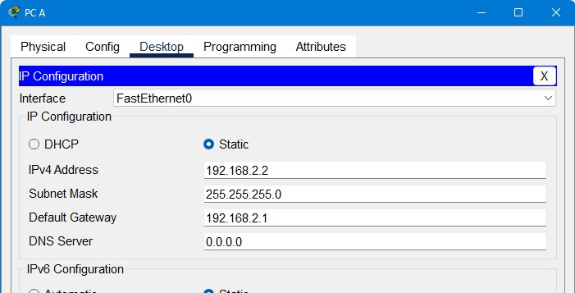

**My Screenshot:**

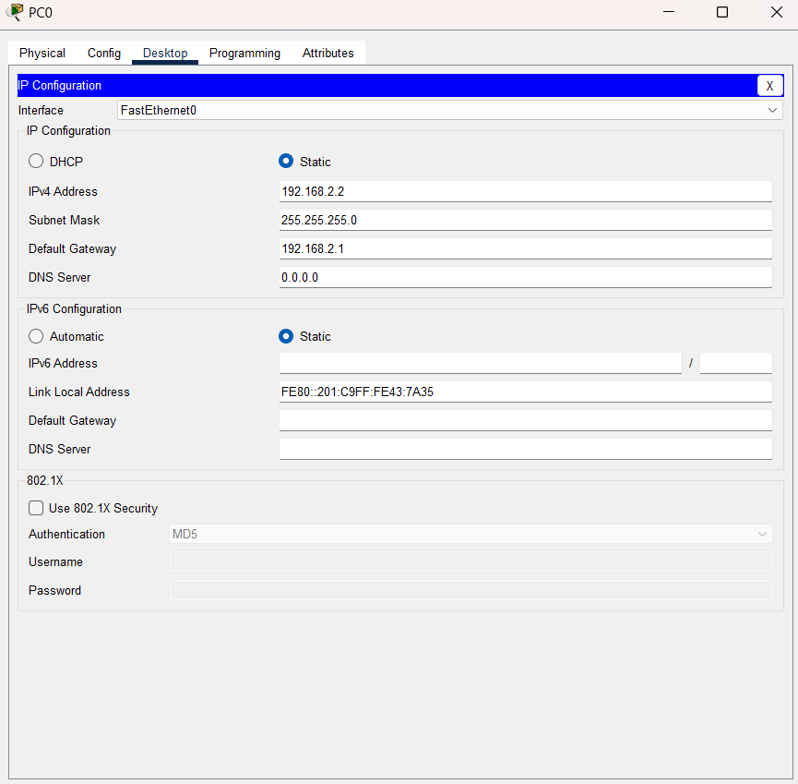

Click on PC B, open the Desktop Tab, and go to the IP Configuration. Assign IP address 192.168.3.2 with the default subnet mask 255.255.255.0 and gateway 192.168.3.1

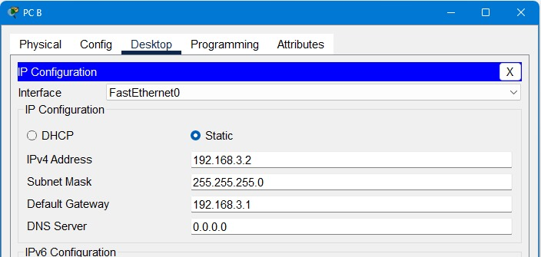

**My Screenshot:**

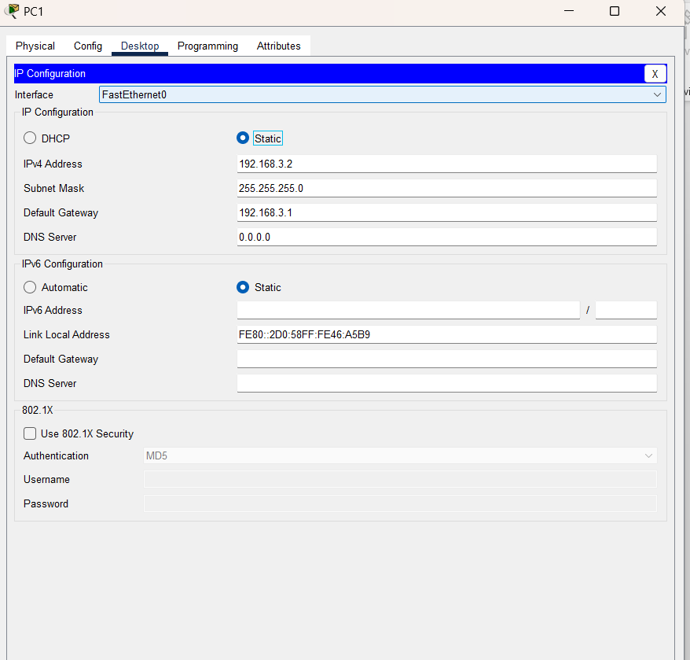

Now, we are moving to probably the most exciting part. Yes, you guessed that right, configuring routing.

### Step 9: Configure Routing

Configure routing on Router 1 and Router 2.

The main purpose or requirement of a router is to forward packets to different networks using the best path, and this purpose can be achieved by configuring routing on the router.

We will configure static routes on both of the routers so that the data can be transmitted from network 192.168.2.0 to 192.168.3.0 and vice versa.

Commands to add a route to 192.168.3.0 in the routing table of Router 1:

R1(config)#

R1(config)#ip route 192.168.3.0 255.255.255.0 192.168.1.2

**My Screenshot:**

Commands to add route to 192.168.2.0 in the routing table of Router 2:

R2(config)#

R2(config)#ip route 192.168.2.0 255.255.255.0 192.168.1.1

**My Screenshot:**

### Step 10: Check connectivity

Checking the connectivity between devices.

We will now ping from PC A to PC B to check if they can communicate.

Click on PC A, go to the Desktop Tab, and click on Command Prompt.

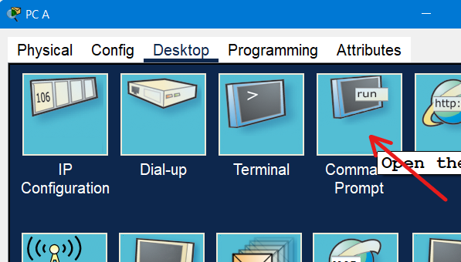

Use the command ‘ping **IP Address of Destination**’

**My Screenshot:**

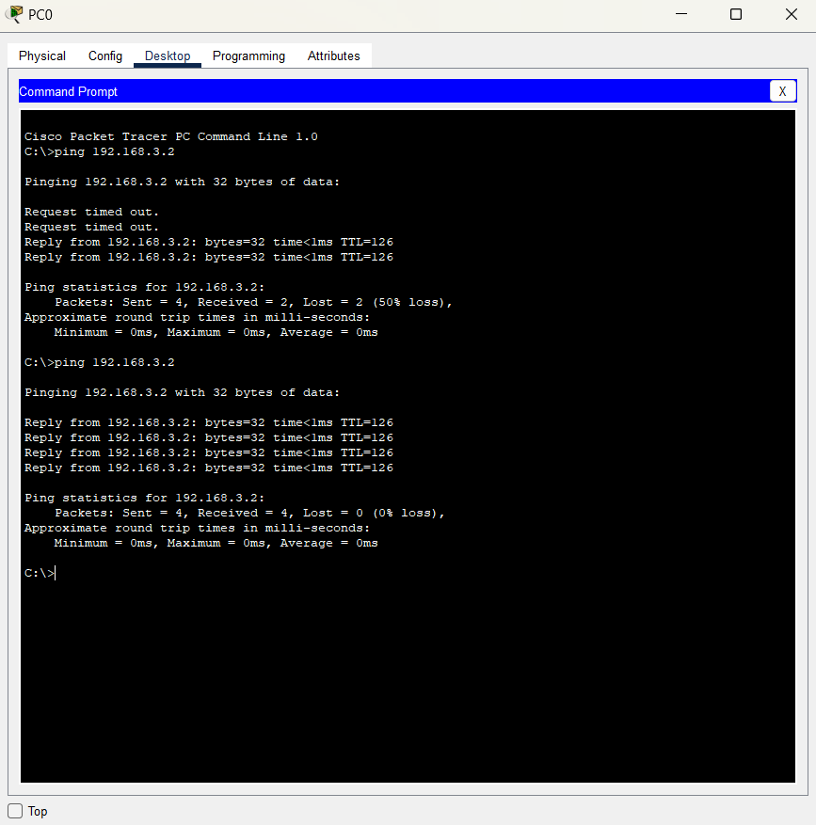

Follow this below tutorial

Router configuration

<https://www.youtube.com/watch?v=vNgwMU4qqAg>

**Lab Task:**

1. Follow the above tutorial. >>Add Snap shots.

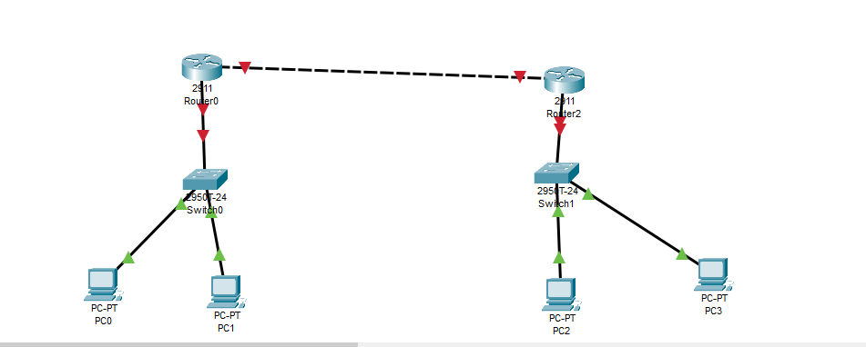

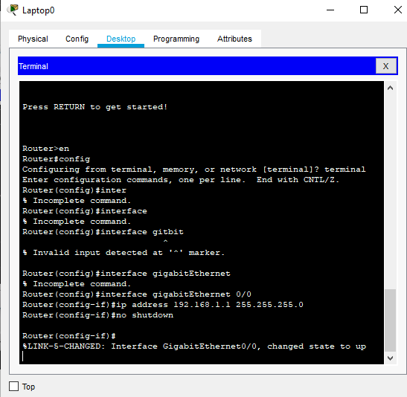

1. Create a network topology as shown in the snap below. Config both routers as described in above tutorials.

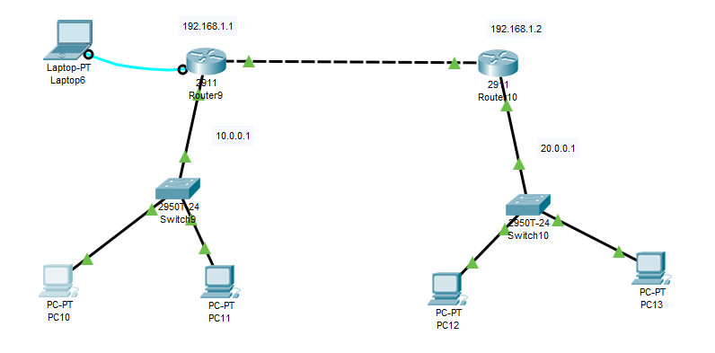

Assign ip-address to every end devices. Establish connection between router, switch and end devices. Perform configuration of routers using command line interface. Hint: Follow video tutorial in case of any confusion.

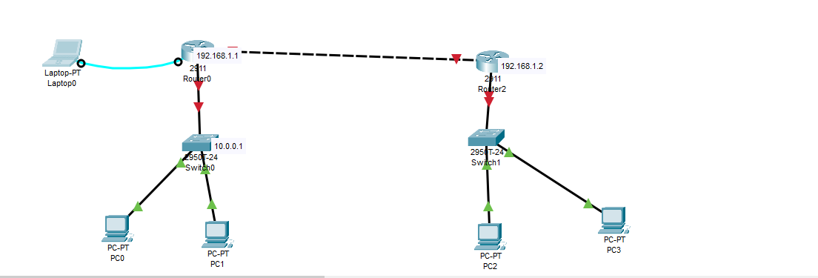

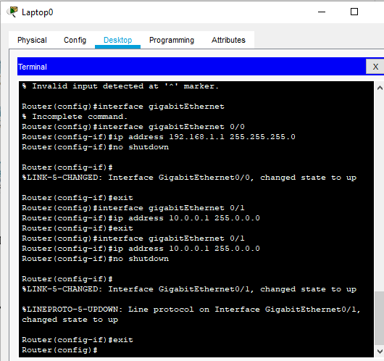

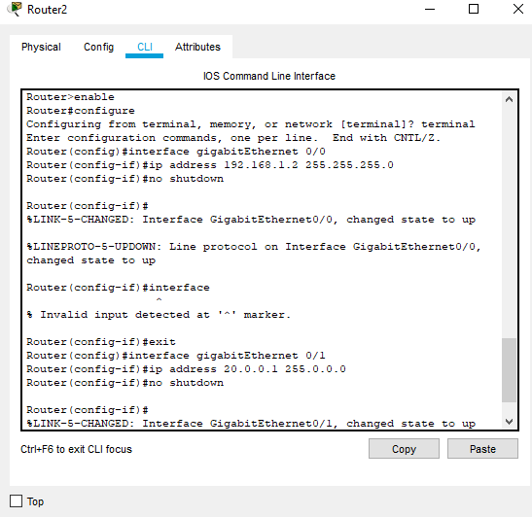

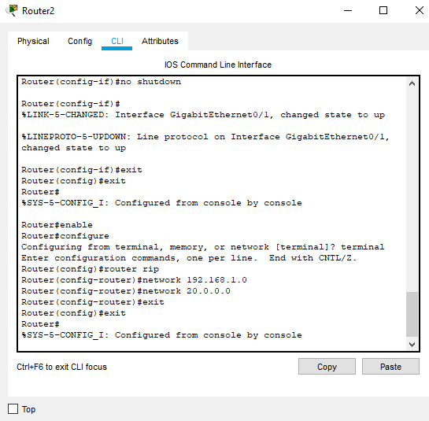

1. Test your connections. >>Attach Screen Shots

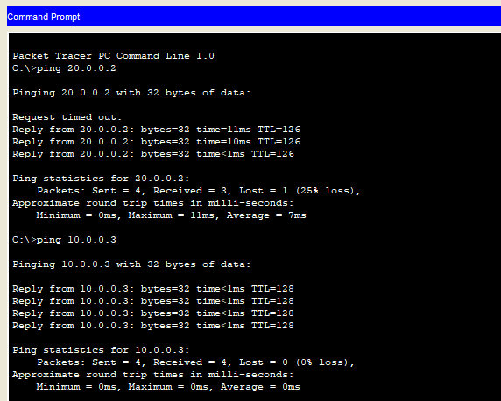

**Deliverables**

Zip and Upload all .pkt files along with the word document with all the ss.

**Grade Criteria**

This lab is graded. Min marks: 0. Max marks: 10.

|  |  |  |
| --- | --- | --- |
| **Activity** | **Minimum** | **Maximum** |
| Documentation with clearly defined understanding of the lab task and approach | Fail | Pass |
| Lab Tasks | 0 | 10 |