Department of Computing

EE353: Computer Networks
Class: BESE-13AB
CLO1: Understand the fundamental Building blocks of Computer Networks i.e., Layered approach and protocols that make networking possible

Lab 1: General Introduction to Wireshark and Networking
Time: 10:00 to 01:00 and 2:00 to 5:00
Date: 13-09-2023
Course Instructor’s: Dr. Humma Gafoor
Lab Engineer: Syed Muhammad Ali Musa
Name: Aimen Munawar
CMD ID: 415867
Class: BESE-13-A
Lab 1: General introduction to Wireshark and Networking
Introduction
The basic purpose of this lab is to introduce you to Wireshark, a popular protocol analyzer. By the end of this lab you will be familiar to its environment and will know how to capture and interactively browse the traffic running on a computer network using it.

Objective
The objective of this lab is to understand basics of Wireshark and Networks.

Tools/Software Requirements
Wireshark

Important Instructions
- Read carefully before starting the lab.
- These exercises are to be done individually.
- You are supposed to provide the answers to the questions listed end of this document and upload this completed document to your course’s LMS site.
Description

Introduction to Networking:
A computer network, often simply referred to as a network, is a collection of hardware components and computers interconnected by communication channels that allow sharing of resources and information. In the world of computers, networking is the practice of linking two or more computing devices together for the purpose of sharing data. In networking, the communication language used by computer devices is called the protocol. Yet another way to classify computer networks is by the set of protocols they support. Networks often implement multiple protocols to support specific applications.


- What is a protocol analyzer?
Protocol analyzers capture conversations between two or more systems or devices. A protocol analyzer not only captures the traffic, it also decodes (interprets) the traffic. Decoding allows you to view the conversation in English, as opposed to binary language. A sophisticated protocol analyzer will also provide statistics and trend information on the captured traffic. Protocol analyzers provide information about the traffic flow on your local area network (LAN), from which you can view device-specific information.
- Introduction to Wireshark

Wireshark is a free and open-source packet analyzer, used for network troubleshooting, analysis, software and communications protocol development, and education.

Getting Wireshark

Download and install the Wireshark software:

- Go to http://www.wireshark.org/download.html and download and install the Wireshark binary for your computer. Wireshark can be installed on both Windows and Linux. See the documentation page of Wireshark for more details.
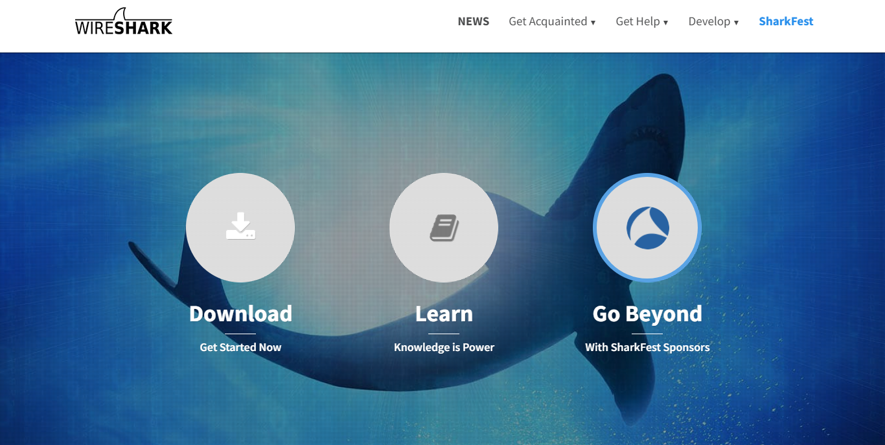
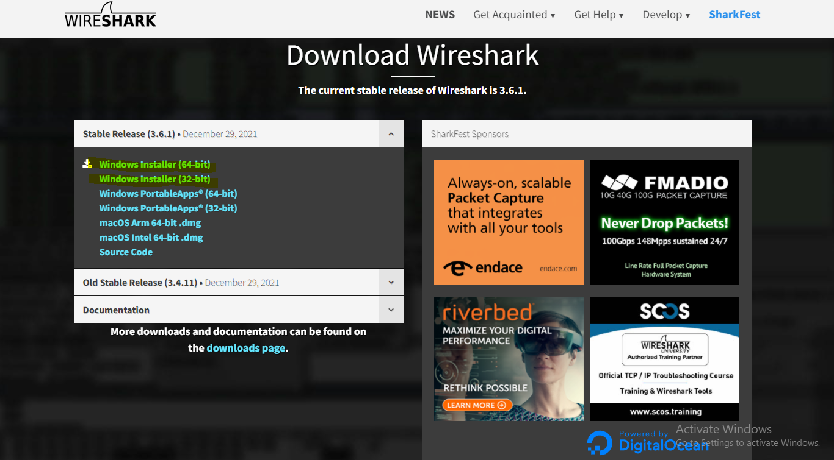

- Download the Wireshark user guide.

The Wireshark FAQ has a number of helpful hints and interesting tidbits of information, particularly if you have trouble installing or running Wireshark.

Running Wireshark

On Windows, you should be able be able to find the link by clicking on the Start option of the Windows taskbar and thereby finding the wireshark program in All Programs.

On Linux machines, wireshark can be run by typing “wireshark” at the command prompt (in case there is a problem with your path, type “which wireshark” that would show path /usr/bin/wireshark where wireshark is typically installed). When you run the Wireshark program, the Wireshark graphical user interface shown in below fig will be displayed. Initially, no data will be displayed in the various windows.

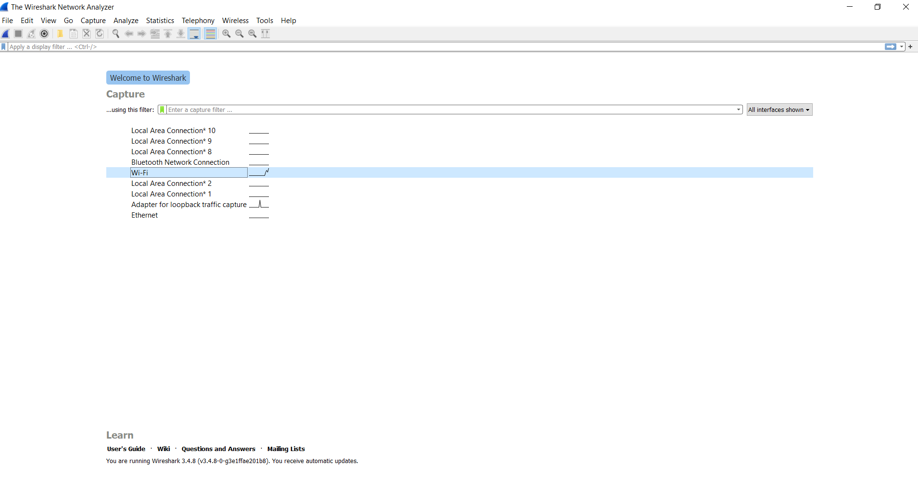
The Wireshark interface has five major components:

- The command menus are standard pull down menus located at the top of the window. Of interest to us is the File and Capture menus. The File menu allows you to save captured packet data or open a file containing previously captured packet data, and exits the Wireshark application. The Capture menu allows you to begin packet capture.

- The packet-listing window displays a one-line summary for each packet captured, including the packet number (assigned by Wireshark; this is not a packet number contained in any protocol’s header), the time at which the packet was captured, the packet’s source and destination addresses, the protocol type, and protocol-specific information contained in the packet. The packet listing can be sorted according to any of these categories by clicking on a column name. The protocol type field lists the highest-level protocol that sent or received this packet, i.e., the protocol that is the source or ultimate sink for this packet.

- The packet-header details window provides details about the packet selected (highlighted) in the packet-listing window. (To select a packet in the packet-listing window, place the cursor over the packet’s one-line summary in the packet-listing window and click with the left mouse button.). These details include information about the Ethernet frame and IP datagram that contains this packet. The amount of Ethernet and IP-layer detail displayed can be expanded or minimized by clicking on the right-pointing or down-pointing arrowhead to the left of the Ethernet frame or IP datagram line in the packet details window. If the packet has been carried over TCP or UDP, TCP or UDP details will also be displayed, which can similarly be expanded or minimized. Finally, details about the highest-level protocol that sent or received this packet are also provided.

- The packet-contents window displays the entire contents of the captured frame, in both ASCII and hexadecimal format.

- Towards the top of the Wireshark graphical user interface, is the packet display filter field, into which a protocol name or other information can be entered in order to filter the information displayed in the packet-listing window (and hence the packet-header and packet-contents windows). In the example below, we’ll use the packet-display filter field to have Wireshark hide (not display) packets except those that correspond to HTTP messages.

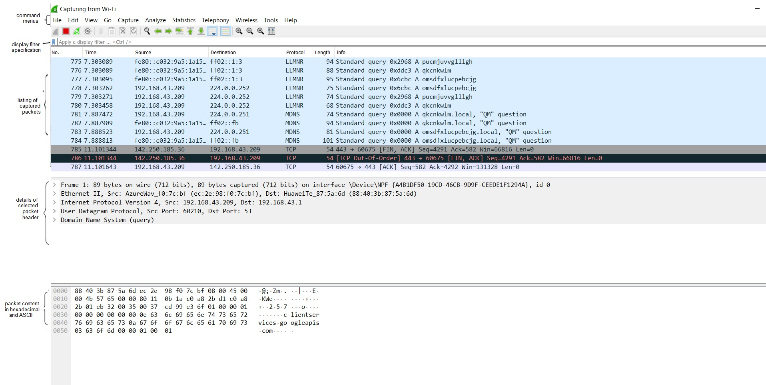Figure 2: Wireshark Graphical User Interface

Steps for performing this lab:

The best way to learn about any new piece of software is to try it out! We’ll assume that your computer is connected to the Internet via a wired Ethernet interface. Do the following:

Start up your favorite web browser, which will display your selected homepage.

- Start up the Wireshark software. You will initially see a window similar to that shown in Figure 2, except that no packet data will be displayed in the packet-listing, packet-header, or packet-contents window, since Wireshark has not yet begun capturing packets.

Questions:
Note: Write your answers here in red font. Paste the screenshot of the relevant output to substantiate your answers.

- Start packet capturing.
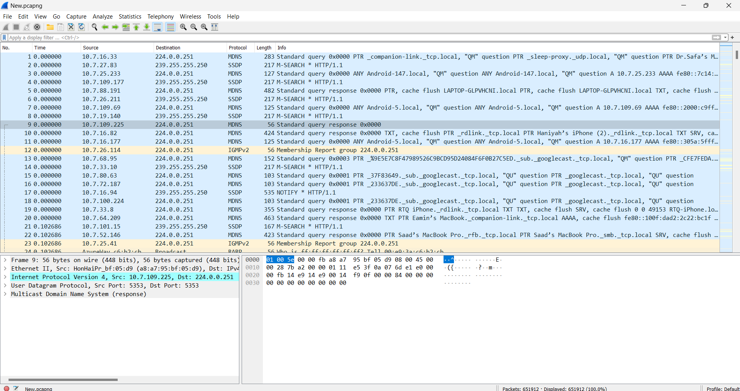
- List up to 10 different protocols that appear in the protocol column in the unfiltered packet-listing window and explain them (only 2 to 3 Lines).

- MDNS(multicast DNS): Protocol that resolves hostnames to IP addresses within small networks that do not have local name server. It is a zero-configuration service.
- TCP(Transmission Control Protocol):A transport protocol used on top of IP to ensure reliable transmission of packets.
- SSDP(Simple Service Discovery Protocol): a protocol developed by the Universal Plug and Play (UPnP) Forum for networked devices to communicate and discover each other.
- QUIC(Quick UDP Internet Connections): It is a transport layer network protocol. It provides secure communication between the endpoints,and make it harder for third parties to intercept and manipulate the internet traffic.
- DNS(Domain Name System): It translates human readable domain to machine readable IP addresses an helps internet users and network devices discover websites using human-readable hostnames, instead of numeric IP addresses.
- UDP(User Datagram Protocol):It is a communications protocol for time-sensitive applications like gaming, playing videos, or Domain Name System (DNS) lookups.
- RARP(Reverse Address Resolution Protocol): It is network specific standard protocol that a physical machine in a local area network (LAN) can use to request its IP address.
- NBNS(NetBIOS Name Service):It is a protocol that exists to resolve names on the network without the requirement for using local hosts files or DNS. It translates human-readable names to IP addresses.
- DTLS (Datagram Transport Layer Security): It is a communications protocol providing security to datagram-based applications by allowing them to communicate in a way designed to prevent eavesdropping, tampering, or message forgery.
- LLMNR(Link-Local Multicast Name Resolution): It is used to resolve host names on local networks to facilitate communication between hosts on local networks.

- Identify source and destination Ip addresses and also try to find the ip address of your machine.
Source IP address: The source IP address is the IP address from which traffic is forwarded.
One source IP address :10.7.17.13
Destination IP address: The destination IP address is the IP address of the server to which traffic is forwarded
One destination IP address :224.0.0.251
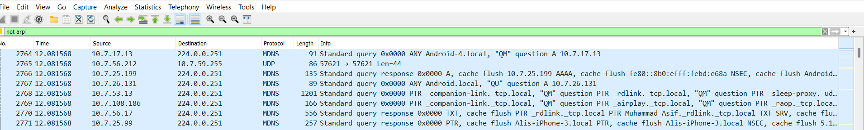
My IP address: 10.7.65.53
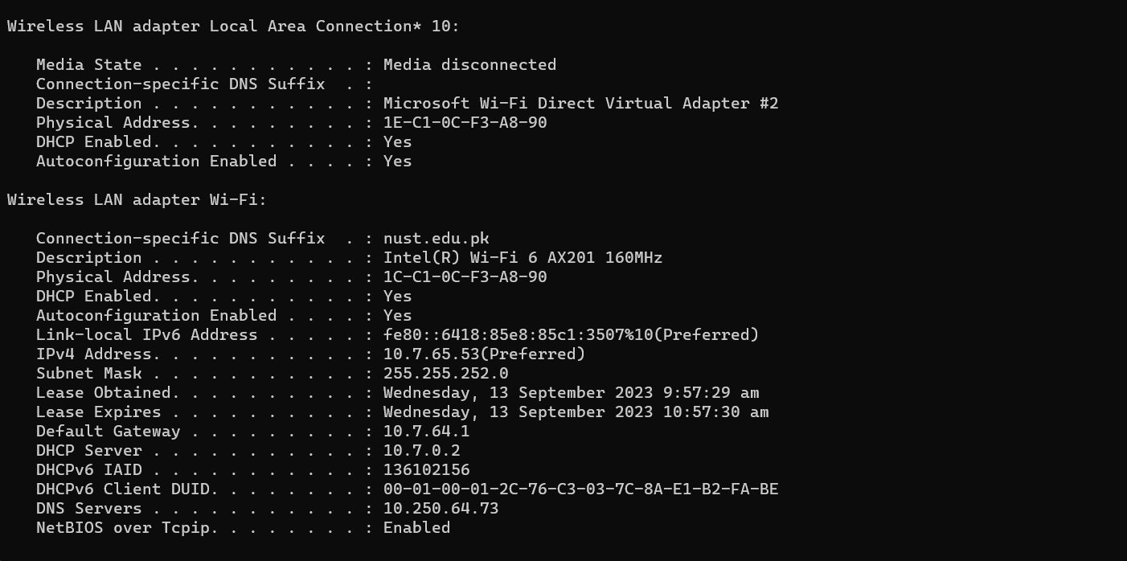

- Open statistics tab and explore the HTTP tab and also explore all its all options attach detailed screen shots.
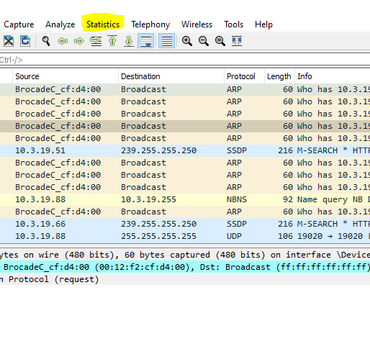
Packet Counter:

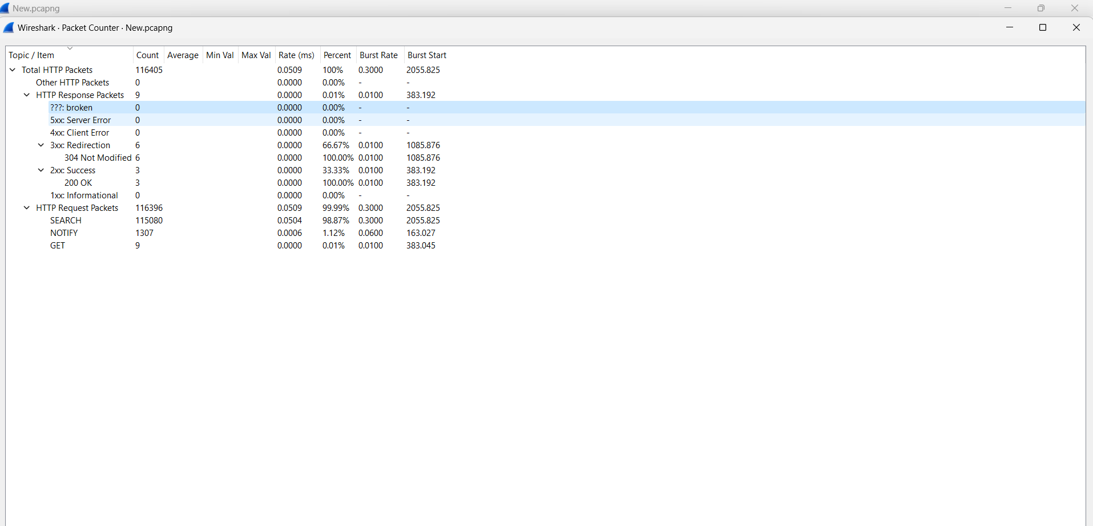

Requests:

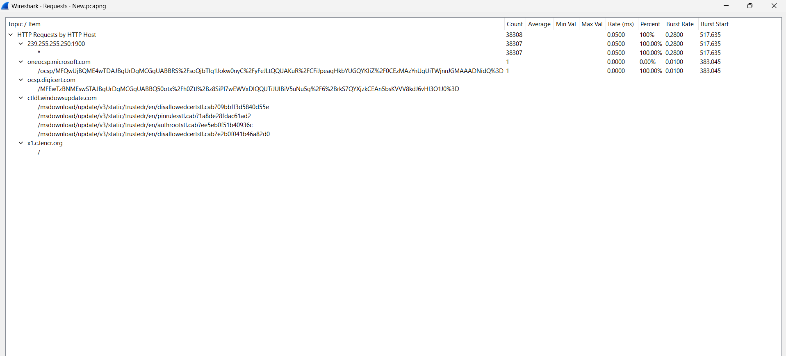

Load Distribution:
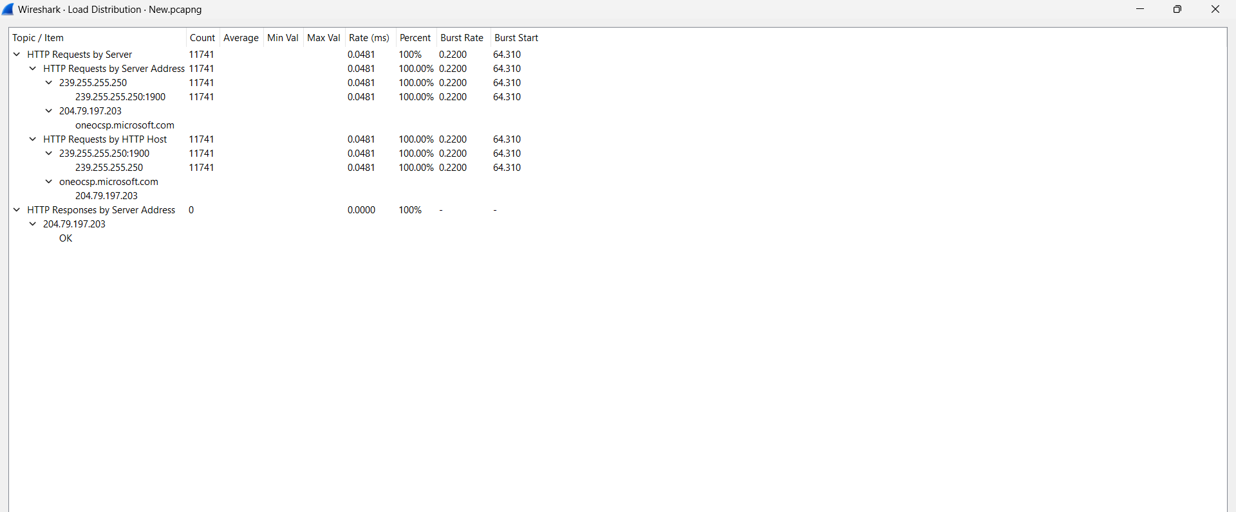

Request Sequences:

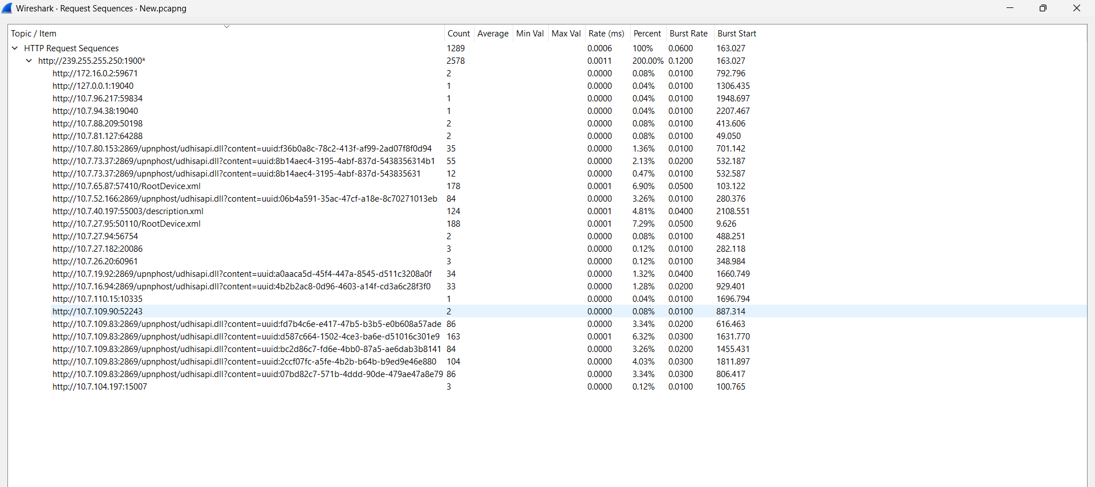

- Display all filters in Wireshark. Run any three filters and explain their working.
TCP only: TCP-only filter in Wireshark allows us to selectively capture and analyze only the traffic using the Transmission Control Protocol (TCP).
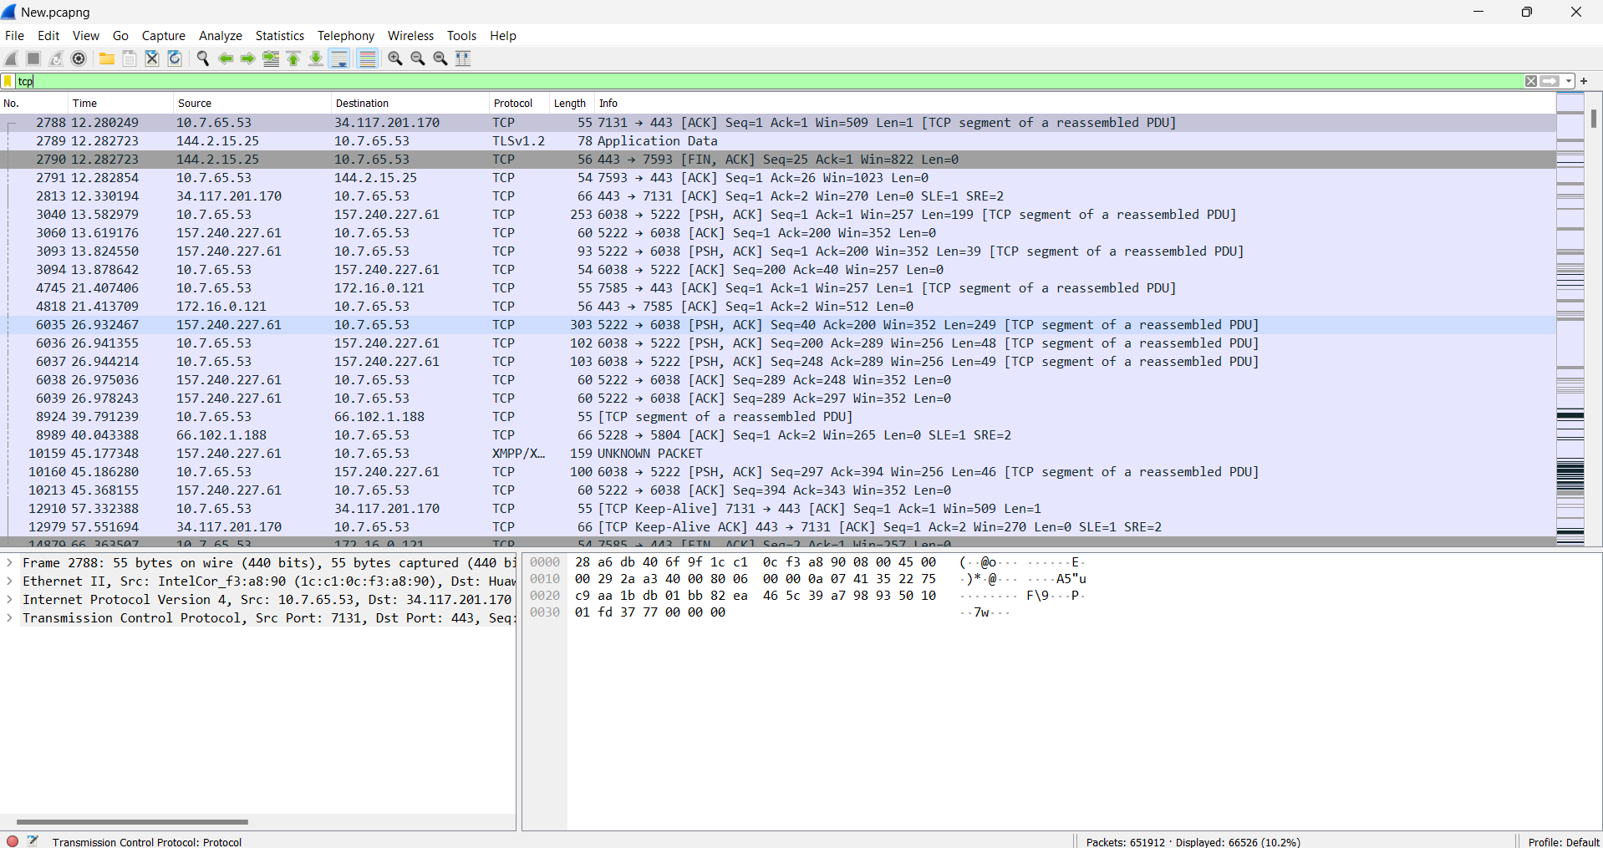
UDP only: UDP-only filter in Wireshark allows us to selectively capture and analyze User Datagram Protocol (UDP) traffic, excluding other protocols from the capture.
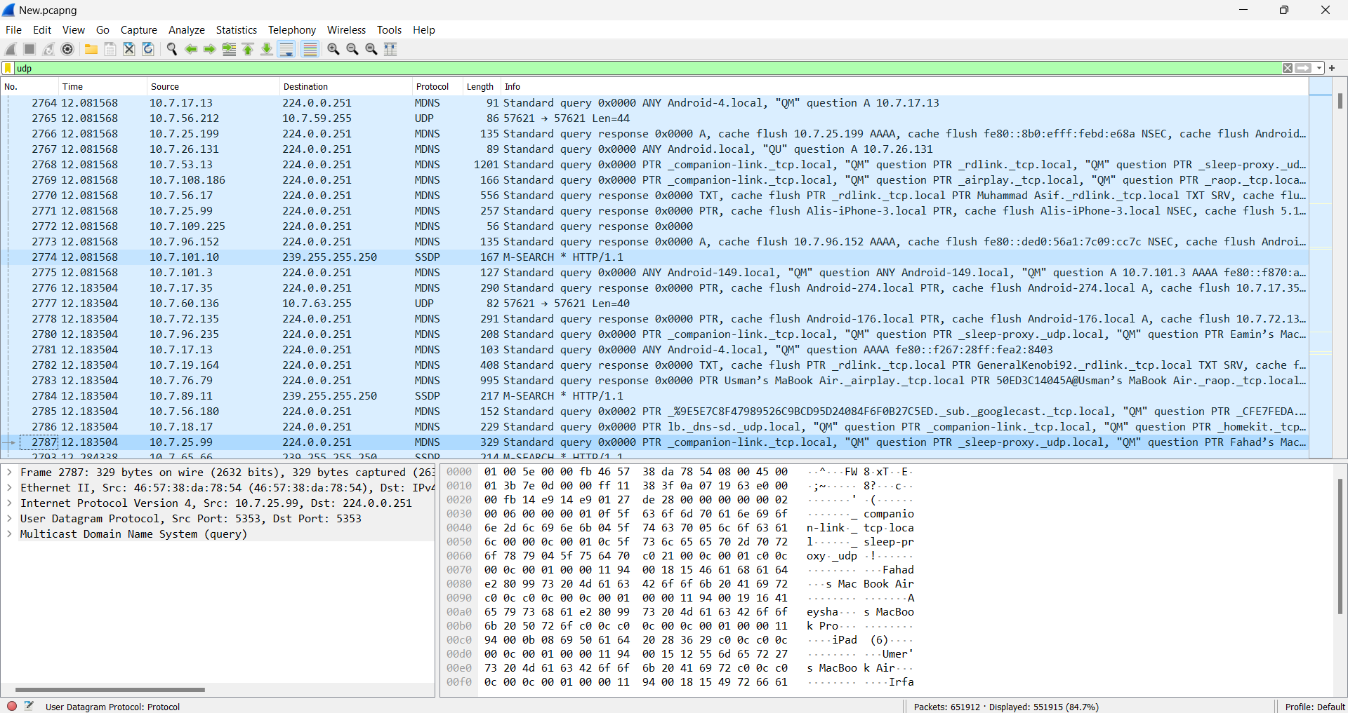
No ARP: The "NO ARP" filter in Wireshark is used to exclude Address Resolution Protocol (ARP) traffic from the captured network packets, allowing for a more focused analysis of higher-level protocols.
