Department of Computing

EE353: Computer Networks

Class: BESE-13 AB

Lab 8: Network Programming

Socket Programming for Linux (Part-1)
Mapped On: CLO3, CLO4

Date: 01-11-2023

Time: 10:00 to 01:00 & 2:00 to 5:00

Instructor: Dr. Huma Ghafoor
Lab Engineer: Syed Muhammad Ali Musa
Name: Aimen Munawar
Class: BESE-13-A
CMS ID: 415867
Group Member Name: Hadia Ali
Group Member CMS ID: 410865

Lab 8: Network Programming Socket Programming for Linux(Part-1)

Introduction/Objectives:

After this lab, the students should be able to

Explain the concepts of client server communication

Setup client/server communication

Use the sockets interface of C programming language

Implement simple Client / Server applications

Tools/Software Requirements
Ubantu ,GCC

Description
Instructions:
- Read carefully before starting the lab.
- These exercises are to be done individually.
- To obtain credit for this lab, you are supposed to complete the lab tasks and provide the source codes and the screen shot of your output in this document (please use red font color) and upload the completed document to your course’s LMS site.
- Avoid plagiarism by copying from the Internet or from your peers. You may refer to source/ text but you must paraphrase the original work.

Back ground

Application programming interface:
An application programming interface (API) is a specification intended to be used as an interface by software components to communicate with each other. An API may include specifications for routines, data structures, object classes, and variables.
Network Application Programming Interface:
The place to start when implementing a network application is the 'interface exported by network'. Generally all operating systems provide an interface to its networking sub system. This interface is called as the 'Network Application Programming Interface' (Network API) or socket interface.
Network Sockets:
A network socket is an endpoint of an inter-process communication flow across a computer network. Today, most communication between computers is based on the Internet Protocol; therefore most network sockets are Internet sockets.

What is a SOCKET?
In layman’s term, a Socket is an end point of communication between two systems on a network. To be a bit precise, a socket is a combination of IP address and port on one system. So on each system a socket exists for a process interacting with the socket on other system over the network. A combination of local socket and the socket at the remote system is also known a ‘Four tuple’ or ‘4-tuple’. Each connection between two processes running at different systems can be uniquely identified through their 4-tuple.
TCP/IP networking model is the most popular and widely used.The communication over the network in TCP/IP model takes place in form of a client server architecture. ie, the client begins the communication and server follows up and a connection is established.

The socket is a special file in UNIX. The socket interface defines various operations for creating a socket, attaching the socket to the network, sending/receiving messages through the socket and so on. Any application uses a socket primitive to establish a connection between client and server.
A socket address is the combination of an IP address and a port number, much like one end of a telephone connection is the combination of a phone number and a particular extension. Based on this address, Internet sockets deliver incoming data packets to the appropriate application process or thread.

Client/Server Communication

At a basic level, network-based systems consist of a server, client, and a media for communication as shown in Figure 1. A computer running a program that makes a request for services is called client machine. A computer running a program that offers requested services from one or more clients is called server machine. The media for communication can be wired or wireless network.

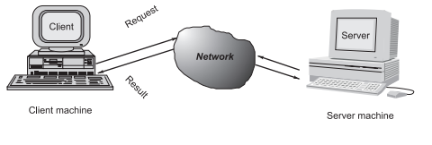

Figure 1. Client server communication

Generally, programs running on client machines make requests to a program (often called as server program) running on a server machine. They involve networking services provided by the transport layer, which is part of the Internet software stack, often called TCP/IP (Transport Control Protocol/Internet Protocol) stack, the transport layer comprises two types of protocols, TCP (Transport Control Protocol) and UDP (User Datagram Protocol)

Port Numbers
At any given time, multiple processes can be using any given transport layer protocol: UDP or TCP. The transport layer uses 16-bit integer port numbers to differentiate between these processes. When a client wants to contact a server, the client must identify the server with which it wants to communicate. The TCP and UDP protocols use ports to map incoming data to a particular process running on a computer. Some ports have been reserved to support common/well known services:
ftp 21/tcp
telnet 23/tcp
smtp 25/tcp
http 80/tcp,udp

User-level process/services generally use port number value >= 1024.

But have you ever given a thought over how two processes communicate across a network?

For example, when you browse a website, on your local system the process running is your web browser, while on the remote system the process running is the web server. So this is also an inter process communication but the technique through which they communicate with each other is SOCKETS, which is the focus of this article.

Socket Server Example
This server continuously runs and sends the date and time to client as soon as a client connects to it.
#include <sys/socket.h>
#include <netinet/in.h>
#include <arpa/inet.h>
#include <stdio.h>
#include <stdlib.h>
#include <unistd.h>
#include <errno.h>
#include <string.h>
#include <sys/types.h>
#include <time.h>

int main(int argc, char *argv[])
{
int listenfd = 0, connfd = 0;
struct sockaddr_in serv_addr;
char sendBuff[1025];
time_t ticks;
listenfd = socket(AF_INET, SOCK_STREAM, 0);
memset(&serv_addr, '0', sizeof(serv_addr));
memset(sendBuff, '0', sizeof(sendBuff));
serv_addr.sin_family = AF_INET;
serv_addr.sin_addr.s_addr = htonl(INADDR_ANY);
serv_addr.sin_port = htons(5000);
bind(listenfd, (struct sockaddr*)&serv_addr, sizeof(serv_addr));
listen(listenfd, 10);
while(1)
{
connfd = accept(listenfd, (struct sockaddr*)NULL, NULL);
ticks = time(NULL);
snprintf(sendBuff, sizeof(sendBuff), "%.24s\r\n", ctime(&ticks));
write(connfd, sendBuff, strlen(sendBuff));
close(connfd);
sleep(1);
}
}
- The call to the function ‘socket()’ creates an UN-named socket inside the kernel and returns an integer known as socket descriptor.

- This function takes domain/family as its first argument. For Internet family of IPv4 addresses we use AF_INET.

- The second argument ‘SOCK_STREAM’ specifies that the transport layer protocol that we want should be reliable ie it should have acknowledgement techniques. For example : TCP

- The third argument is generally left zero to let the kernel decide the default protocol to use for this connection. For connection oriented reliable connections, the default protocol used is TCP.

- The call to the function ‘bind()’ assigns the details specified in the structure ‘serv_addr’ to the socket created in the step above. The details include, the family/domain, the interface to listen on(in case the system has multiple interfaces to network) and the port on which the server will wait for the client requests to come.

- The call to the function ‘listen()’ with second argument as ’10’ specifies maximum number of client connections that server will queue for this listening socket.

- After the call to listen(), this socket becomes a fully functional listening socket.

- In the call to accept(), the server is put to sleep and when for an incoming client request, the three way TCP handshake* is complete, the function accept () wakes up and returns the socket descriptor representing the client socket.
- The call to accept() is run in an infinite loop so that the server is always running and the delay or sleep of 1 sec ensures that this server does not eat up all of your CPU processing.

- As soon as server gets a request from client, it prepares the date and time and writes on the client socket through the descriptor returned by accept().

Three way hand shake is the procedure that is followed to establish a TCP connection between two remote hosts.
Finally, we compile the code and run the server.

Socket Client Example
#include <sys/socket.h>
#include <sys/types.h>
#include <netinet/in.h>
#include <netdb.h>
#include <stdio.h>
#include <string.h>
#include <stdlib.h>
#include <unistd.h>
#include <errno.h>
#include <arpa/inet.h>
int main(int argc, char
*argv[])
{
int sockfd = 0, n = 0;
char recvBuff[1024];
struct sockaddr_in serv_addr;
if(argc != 2)
{
printf("\n Usage: %s <ip of server> \n",argv[0]);
return 1;
}
memset(recvBuff, '0',sizeof(recvBuff));
if((sockfd = socket(AF_INET, SOCK_STREAM, 0)) < 0)
{
printf("\n Error : Could not create socket \n");
return 1;
}
memset(&serv_addr, '0', sizeof(serv_addr));
serv_addr.sin_family = AF_INET;
serv_addr.sin_port = htons(5000);
if(inet_pton(AF_INET, argv[1], &serv_addr.sin_addr)<=0)
{
printf("\n inet_pton error occured\n");
return 1;
}
if( connect(sockfd, (struct sockaddr *)&serv_addr, sizeof(serv_addr)) < 0)
{
printf("\n Error : Connect Failed \n");
return 1;
}
while ( (n = read(sockfd, recvBuff, sizeof(recvBuff)-1)) > 0)
{
recvBuff[n] = 0;
if(fputs(recvBuff, stdout) == EOF)
{
printf("\n Error : Fputs error\n");
}
}
if(n < 0)
{
printf("\n Read error \n");
}
return 0;
}
In the above program, we create a client which will connect to the server and receive date and time from it. In the above piece of code:
- We see that here also, a socket is created through call to socket() function.

- Information like IP address of the remote host and its port is bundled up in a structure and a call to function connect() is made which tries to connect this socket with the socket (IP address and port) of the remote host.

- Note that here we have not bind our client socket on a particular port as client generally use port assigned by kernel as client can have its socket associated with any port but In case of server it has to be a well-known socket, so known servers bind to a specific port like HTTP server runs on port 80 etc. while there is no such restrictions on clients.
- Once the sockets are connected, the server sends the data (date+time) on clients socket through clients socket descriptor and client can read it through normal read call on the its socket descriptor.

We can see that we successfully got the date and time from server. We need to send the IP address of the server as an argument for this example to run. If you are running both server and client example on the same machine for testing purpose, use the loop back ip address as shown above.

Using Virtualbox to run Ubuntu on Windows:

- First copy Cnbuntu VDI file from Computer networks folder preses in Downloads of SSC.

- To open SSC downloads folder type \\10.3.20.65 in Run ,User name and password is “ssc”.

- Once VDI is copied on your computer open Virtualbox installed on your computer. If Virttualbox is not installed please download and install Virtualbox from internet.

- In ordre to create new virtual machine using Virtualbox click new in toolbox .

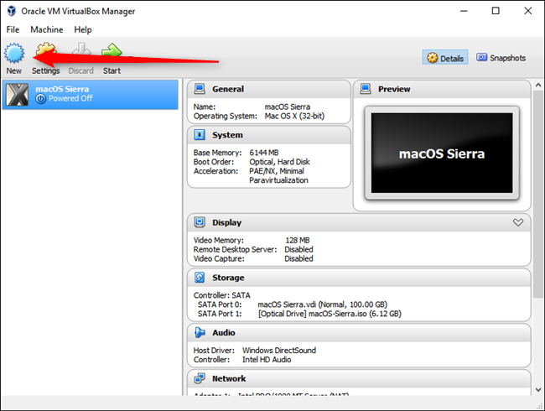
- This opens New Virtual Machine Wizard. Click Next:
.
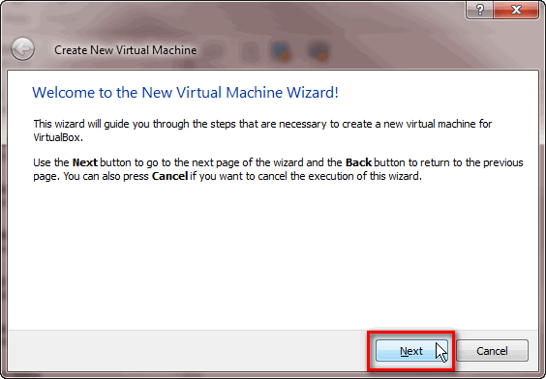
- Enter the Cnbuntu in name field ,Select linux in type field , Ubuntu 64 bit in version feild and click next
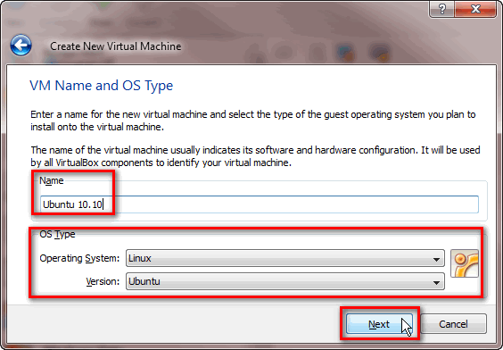
- Assign 4Gb ram to your virtual machine using the slider and click next
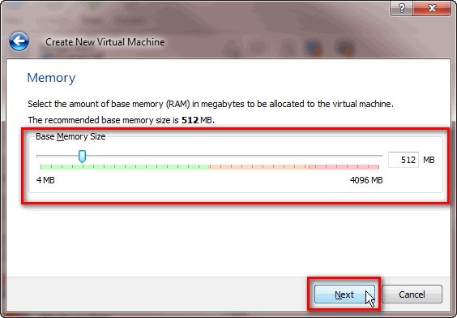

- Select the Use an existing virtual hard disk file option, then click on the folder icon to the right and choose CNbuntu Vdi file you copied from SSC.Click Create
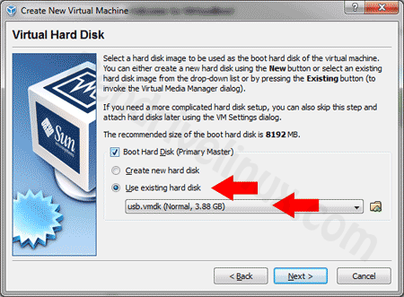

- Select Cnbunt and Click Start to run your virtual machine

.
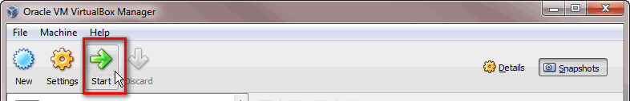

Compiling and running C files on ububtu
- Open text editor in Ubuntu and paste server code and save with c extension
- Create another c file name Client .c and paste client code in it.
- Now open two terminals run server.c code on first terminal and client.c on the other.
- Following are the terminal commands to compile and Run server side C code

- g++ server.c -o serv.out
for executing
- ./serv

- Now one second terminal comple and execute the client as shown below.
- g++ client.c -o cli.out
for executing
- ./cli.out 127.0.0.1

Task:
Individual Part
Perform all the steps above and run both servers and client code.
Pass a Successful Message/communication between client and server.

Running Server Code:

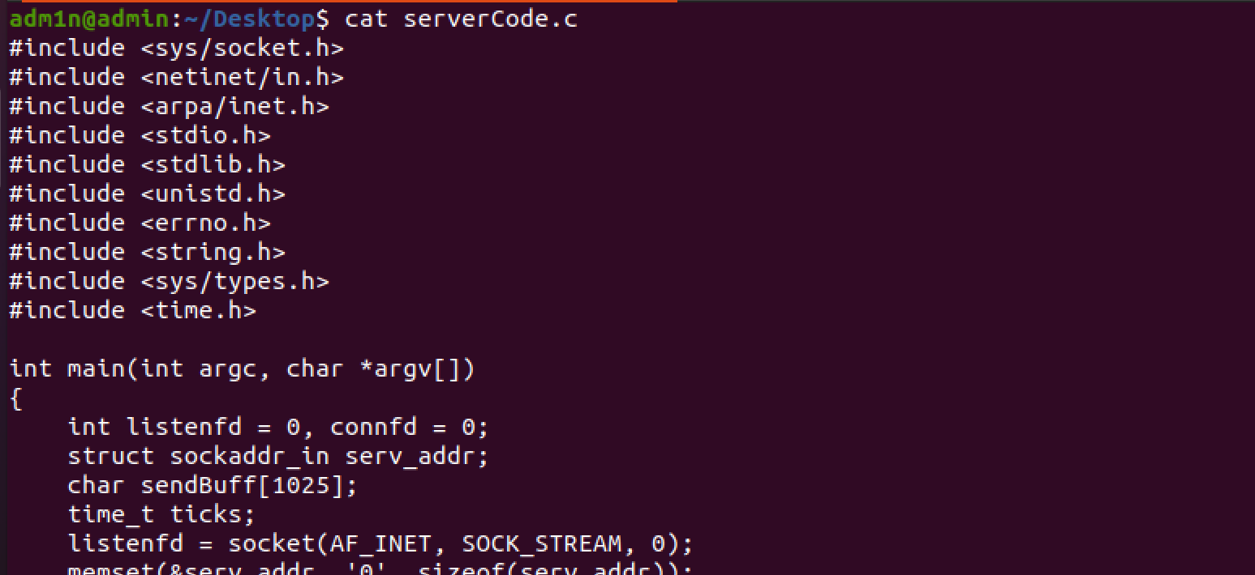
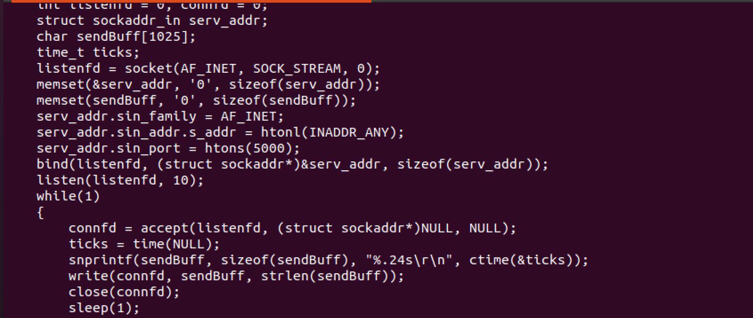
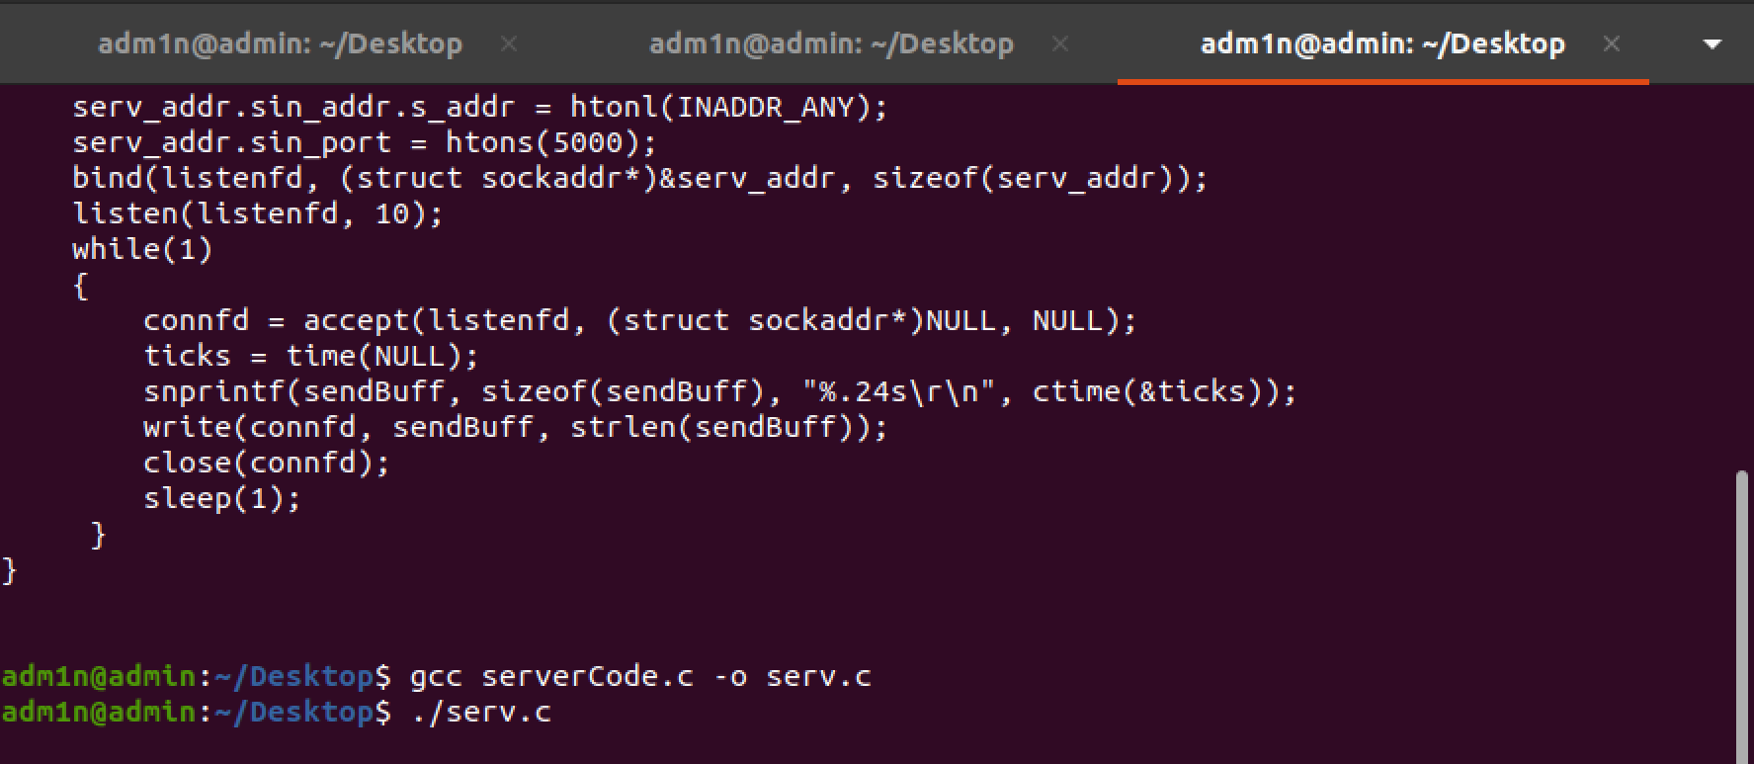

Running Client Code:

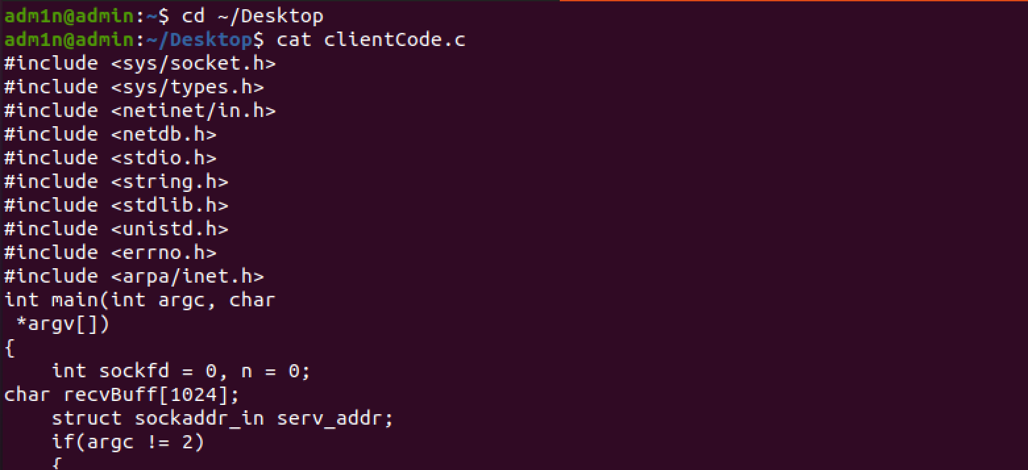
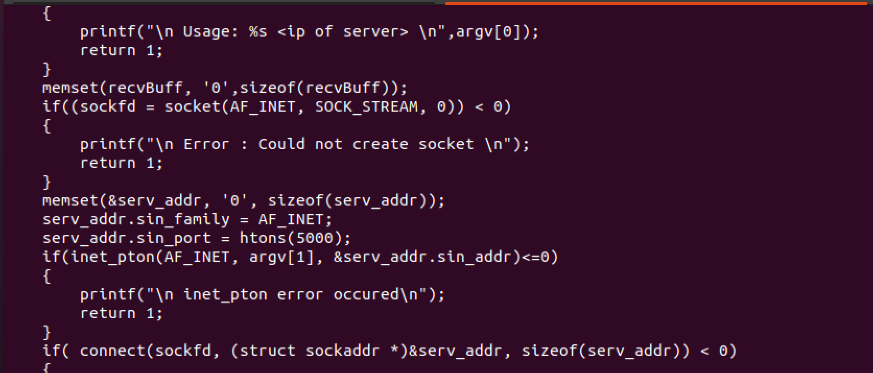
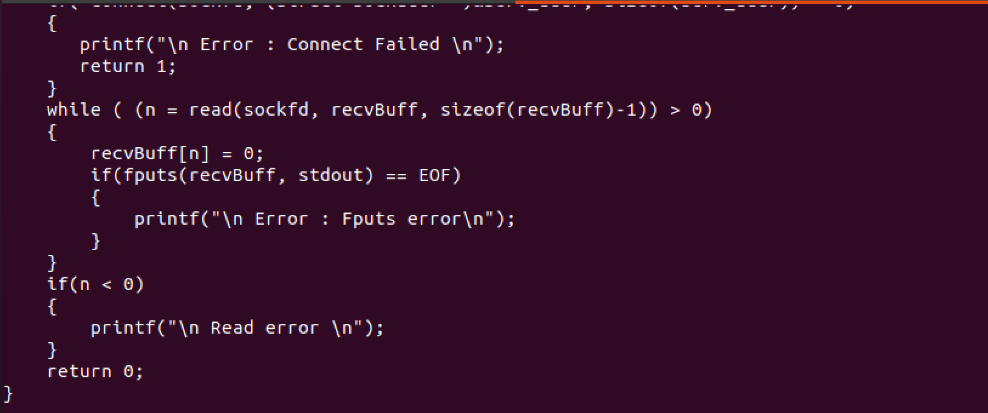
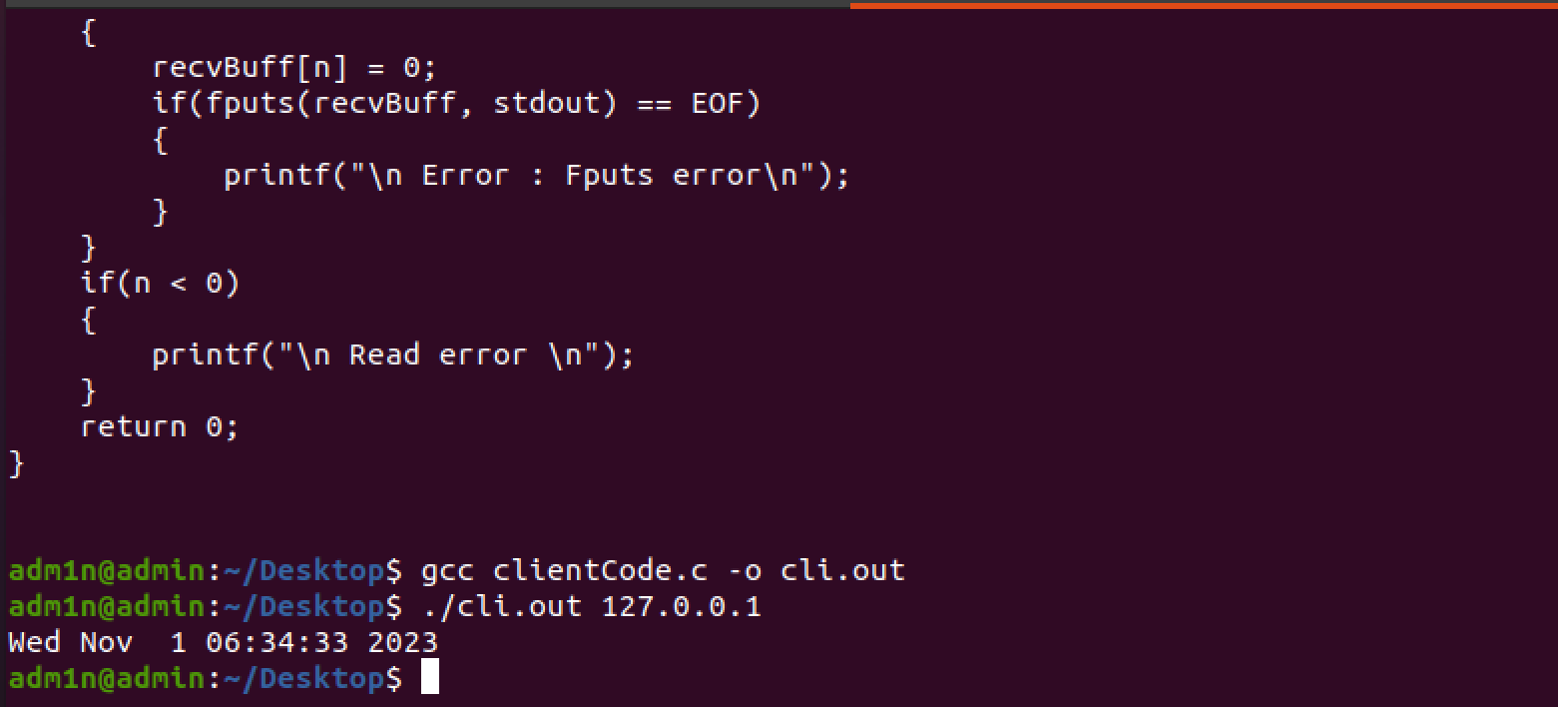

Group Part
Try to Run server and client on different Machine’s.

Methods to Run Server and Client on Different Machines:

- Running Server code on machine with IP 10.7.66.5 and running client code on machine with IP 10.0.2.15:

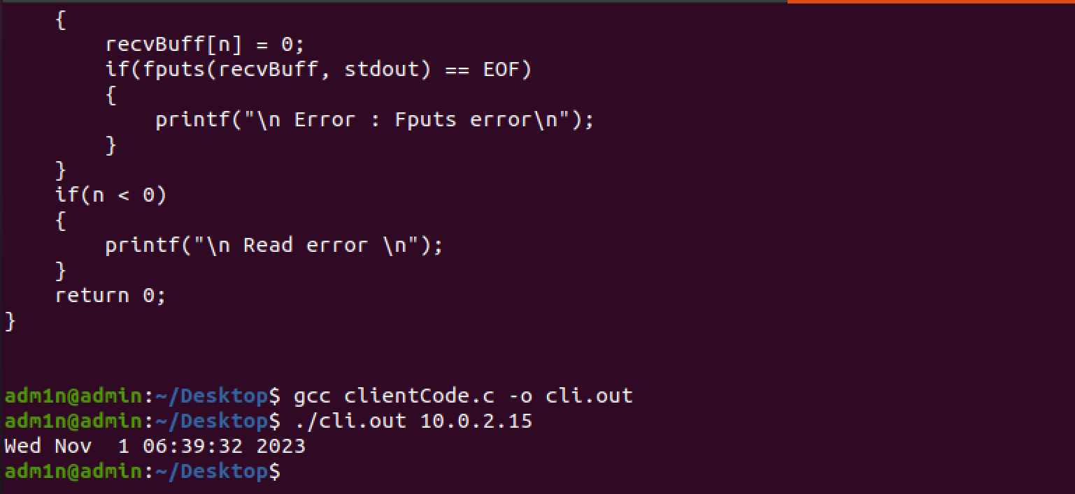

- Running server and client code on different machines using both their IP address and port number.
My machine IP address= IP address for server = 10.7.66.5

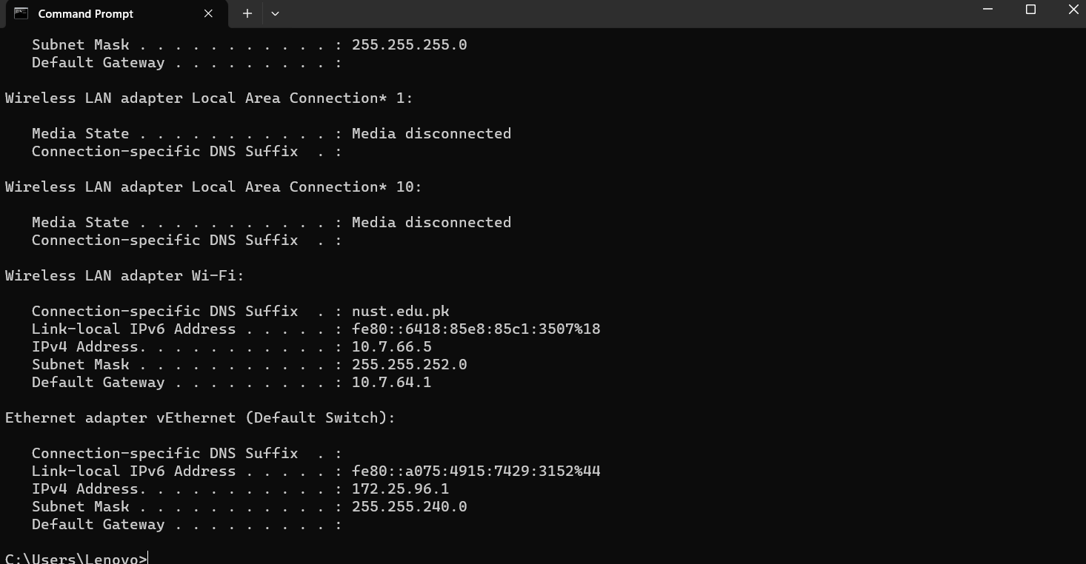
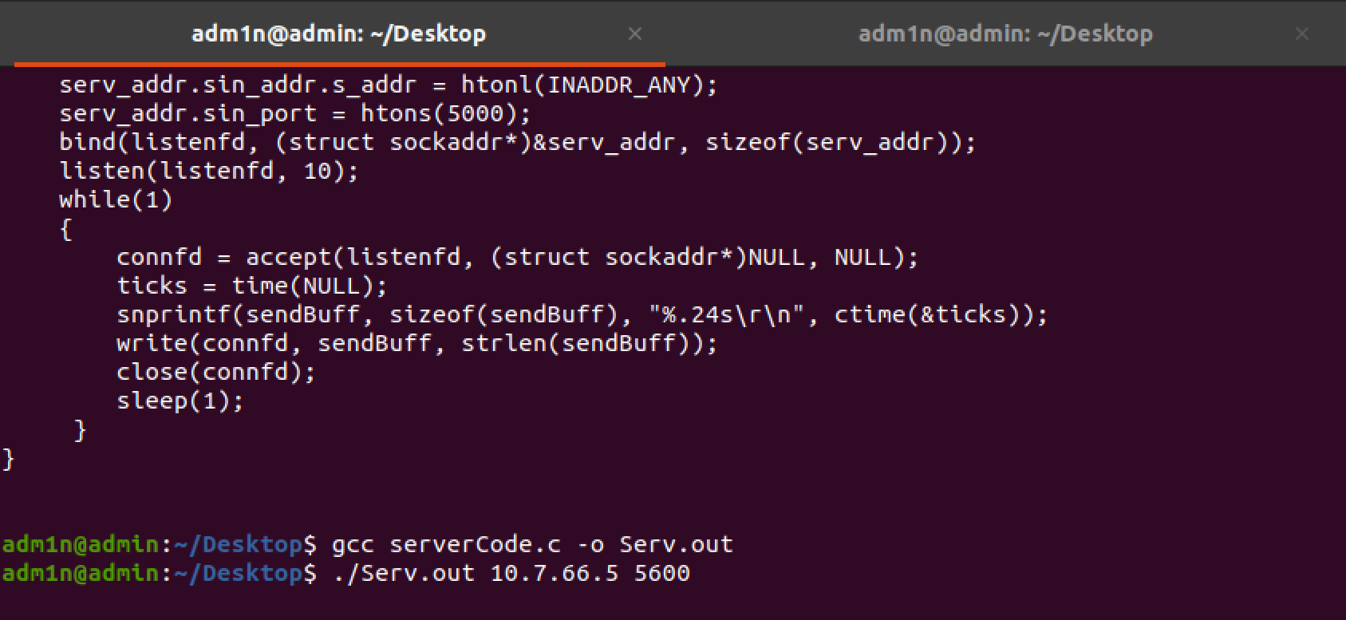
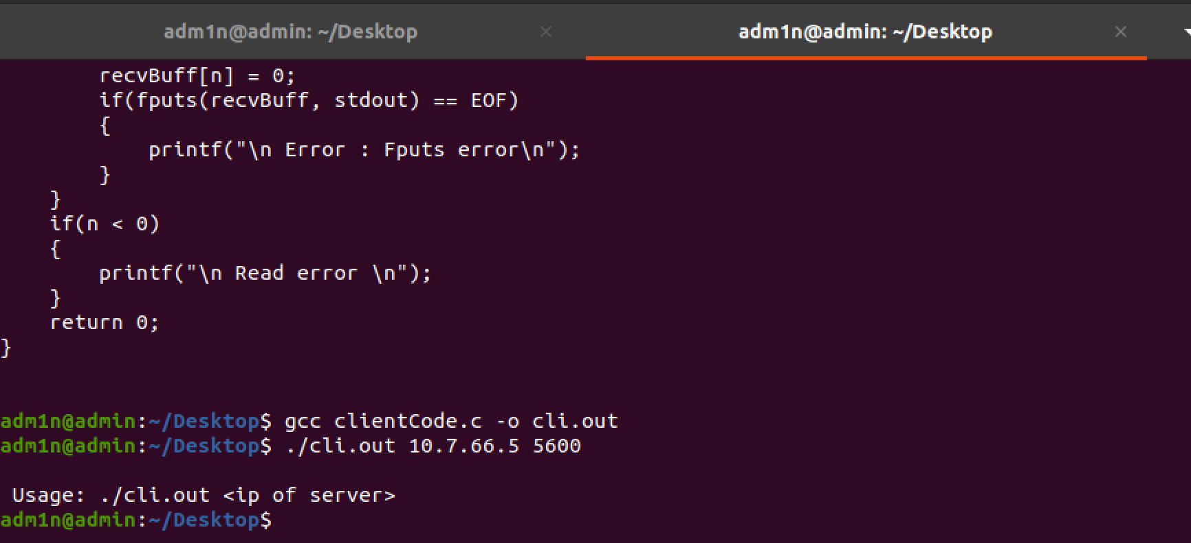
Bonus Task
Try to transfer an image file between client and server.

Modified Server code to transfer image and calculate round trip time:

#include <sys/socket.h>
#include <netinet/in.h>
#include <arpa/inet.h>
#include <stdio.h>
#include <stdlib.h>
#include <unistd.h>
#include <errno.h>
#include <string.h>
#include <sys/types.h>
#include <time.h>

// Function to send image to client
void sendImage(int connfd) {
FILE *image;
char buffer[1024];
size_t bytesRead;

// Open image file in binary mode
image = fopen("sample.jpg", "rb");

if (image == NULL) {
perror("Error opening image file");
return;
}

// Read and send image data in chunks
while ((bytesRead = fread(buffer, 1, sizeof(buffer), image)) > 0) {
send(connfd, buffer, bytesRead, 0);
}

fclose(image);
}

int main(int argc, char *argv[]) {
int listenfd = 0, connfd = 0;
struct sockaddr_in serv_addr;
char sendBuff[1025];
time_t ticks;

// Create a socket
listenfd = socket(AF_INET, SOCK_STREAM, 0);

memset(&serv_addr, '0', sizeof(serv_addr));
memset(sendBuff, '0', sizeof(sendBuff));

serv_addr.sin_family = AF_INET;
serv_addr.sin_addr.s_addr = htonl(INADDR_ANY);
serv_addr.sin_port = htons(5000);

// Bind the socket to the specified address and port
bind(listenfd, (struct sockaddr*)&serv_addr, sizeof(serv_addr));

// Listen for incoming connections, with a backlog queue of 10
listen(listenfd, 10);

while(1) {
// Record start time
clock_t start_time = clock();

// Accept incoming connection
connfd = accept(listenfd, (struct sockaddr*)NULL, NULL);

// Get current time and format it
ticks = time(NULL);
snprintf(sendBuff, sizeof(sendBuff), "%.24s\r\n", ctime(&ticks));

// Send date/time to client
write(connfd, sendBuff, strlen(sendBuff));

// Send image after sending date/time
sendImage(connfd);

// Close connection
close(connfd);

// Wait for a second
sleep(1);

// Record end time
clock_t end_time = clock();

// Calculate and print round trip time
double time_taken = ((double)(end_time - start_time)) / CLOCKS_PER_SEC;
printf("Round trip time: %f seconds\n", time_taken);
}

return 0;
}

Modified Client code to transfer image and calculate round trip time:

#include <sys/socket.h>
#include <sys/types.h>
#include <netinet/in.h>
#include <netdb.h>
#include <stdio.h>
#include <string.h>
#include <stdlib.h>
#include <unistd.h>
#include <errno.h>
#include <arpa/inet.h>
#include <sys/time.h>

// Function to receive and save image from the server
void receiveImage(int sockfd) {
FILE *image;
char buffer[1024];
size_t bytesRead;

image = fopen("received_image.jpg", "wb"); // Save received image as received_image.jpg

if (image == NULL) {
perror("Error opening image file");
return;
}

while (1) {
bytesRead = recv(sockfd, buffer, sizeof(buffer), 0);
if (bytesRead <= 0) break;
fwrite(buffer, 1, bytesRead, image); // Write received data to image file
}

fclose(image);
}

int main(int argc, char *argv[]) {
int sockfd = 0;
struct sockaddr_in serv_addr;

if(argc != 2) {
printf("\n Usage: %s <ip of server> \n",argv[0]);
return 1;
}

if((sockfd = socket(AF_INET, SOCK_STREAM, 0)) < 0) {
printf("\n Error : Could not create socket \n");
return 1;
}

memset(&serv_addr, '0', sizeof(serv_addr));
serv_addr.sin_family = AF_INET;
serv_addr.sin_port = htons(5000);

if(inet_pton(AF_INET, argv[1], &serv_addr.sin_addr) <= 0) {
printf("\n inet_pton error occurred\n");
return 1;
}

if (connect(sockfd, (struct sockaddr *)&serv_addr, sizeof(serv_addr)) < 0) {
printf("\n Error : Connect Failed \n");
return 1;
}

char recvBuff[1024];
ssize_t n;

struct timeval start, end;
gettimeofday(&start, NULL); // Record start time

while ((n = recv(sockfd, recvBuff, sizeof(recvBuff)-1, 0)) > 0) {
recvBuff[n] = 0;
printf("%s", recvBuff); // Print received text data
}

if (n < 0) {
printf("\n Read error \n");
}

receiveImage(sockfd); // Receive and save the image

gettimeofday(&end, NULL); // Record end time
double time_taken = (end.tv_sec - start.tv_sec) + (end.tv_usec - start.tv_usec) / 1e6;
printf("\nRound trip time: %f seconds\n", time_taken);

printf("Image received successfully!\n");

return 0;
}

Running modified Server Code:

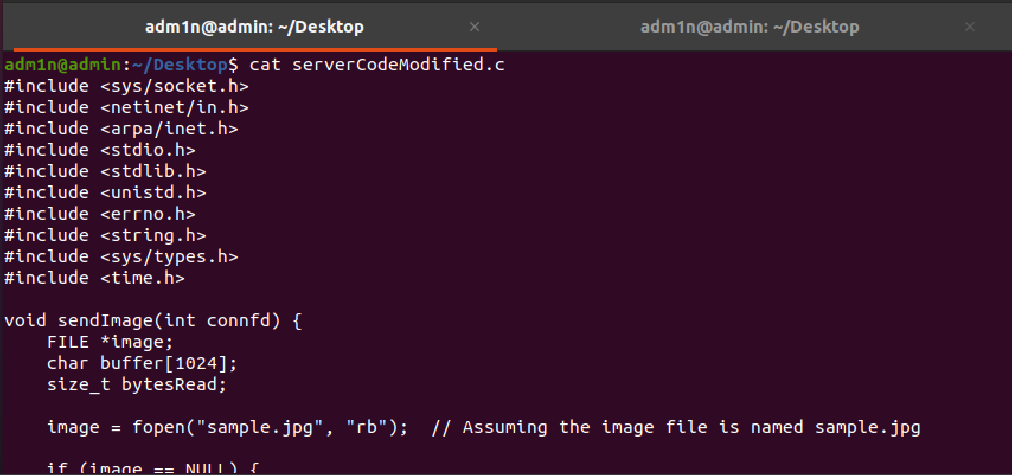

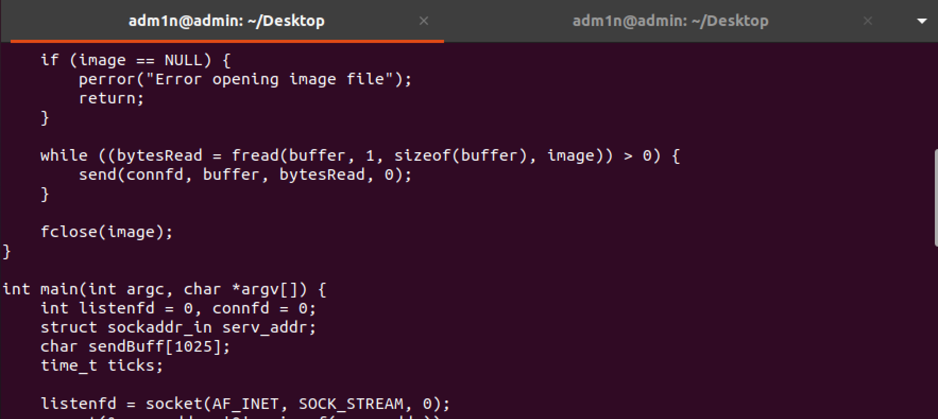
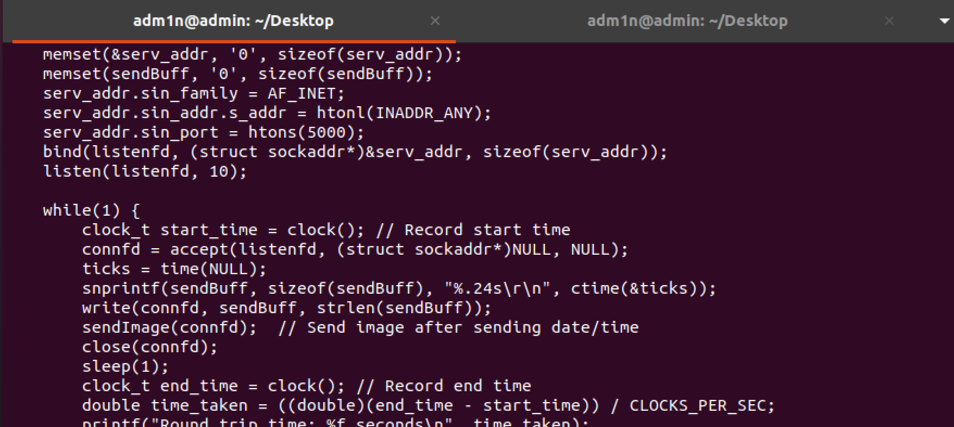
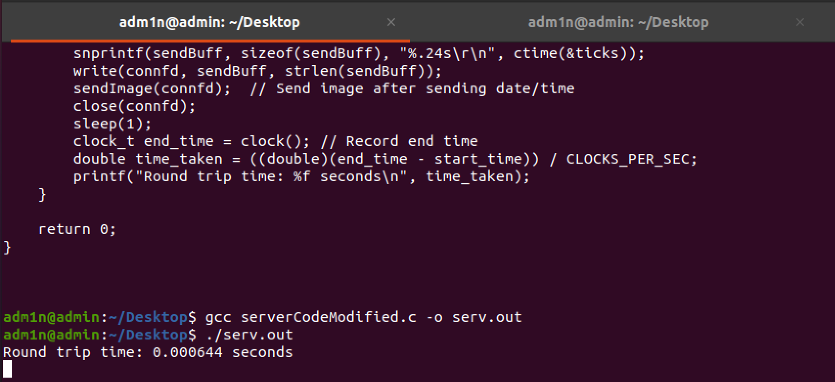

Running modified Client Code:

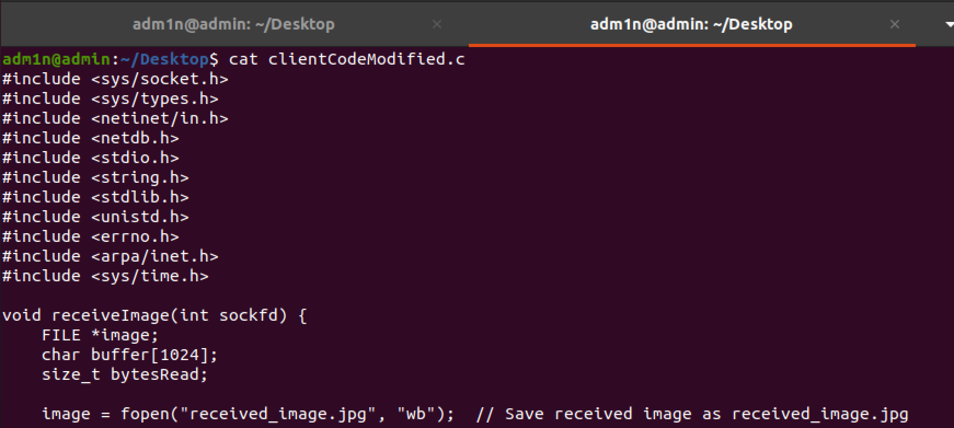
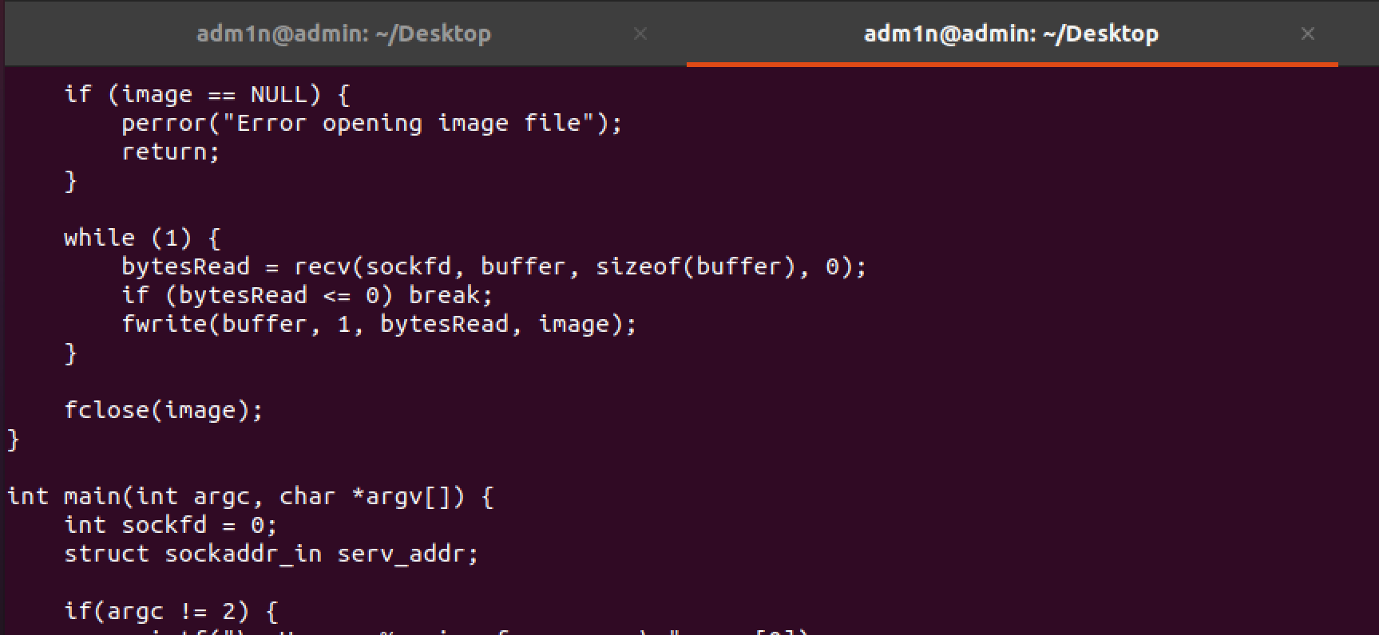
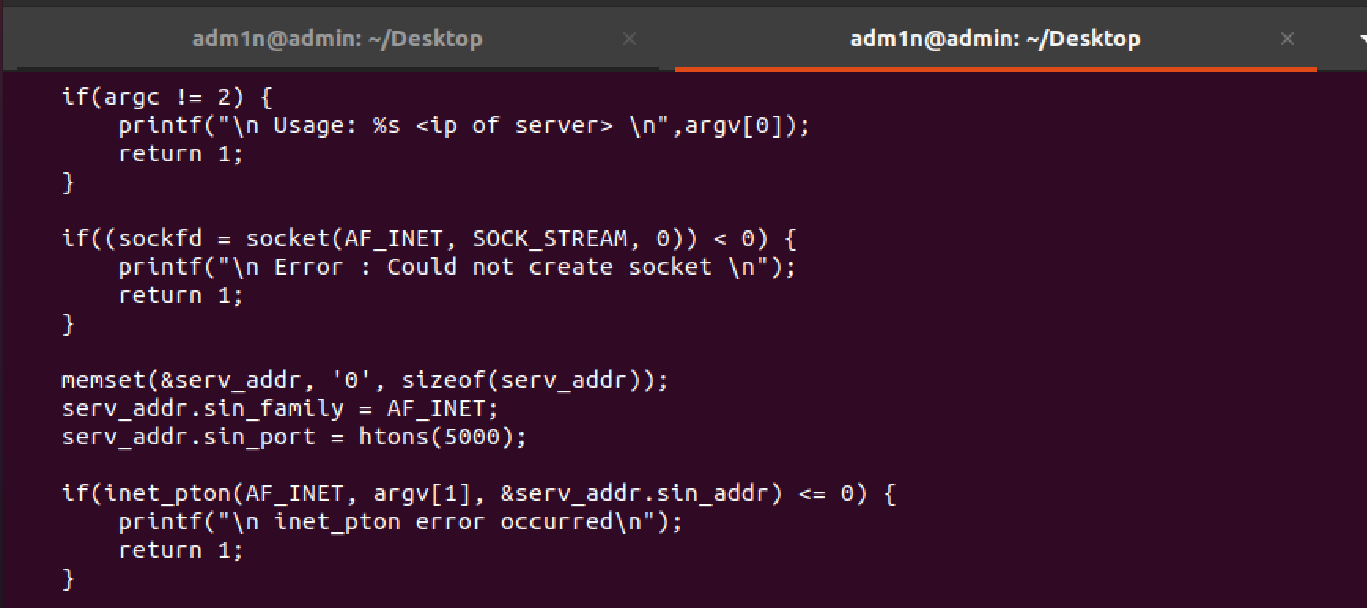

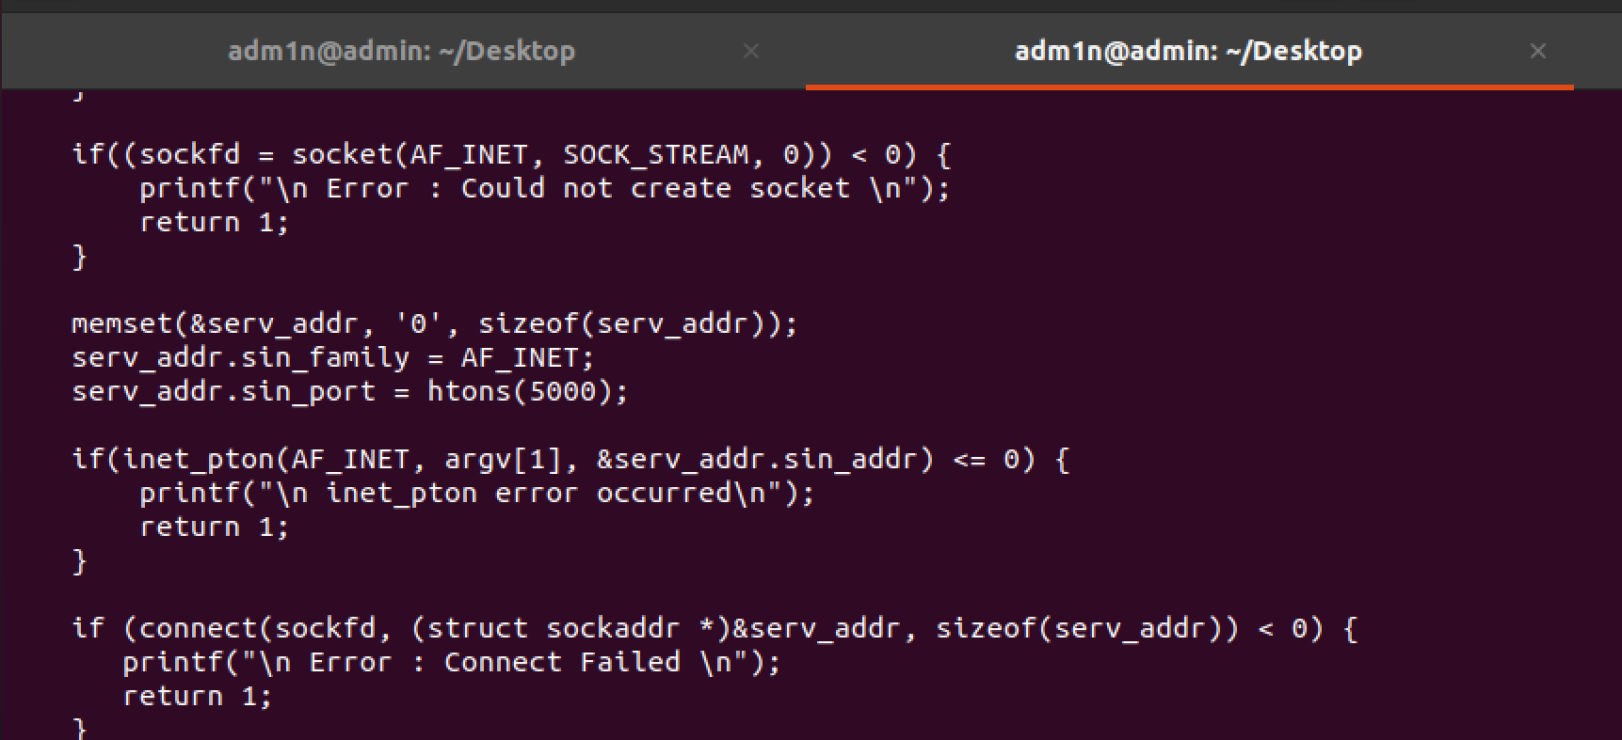
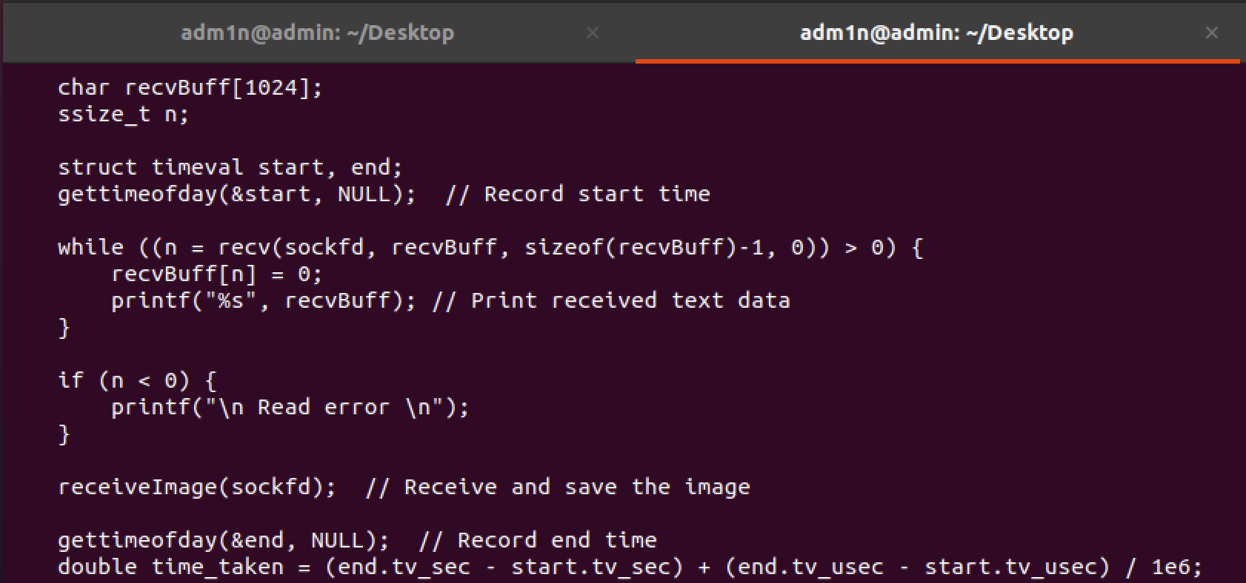
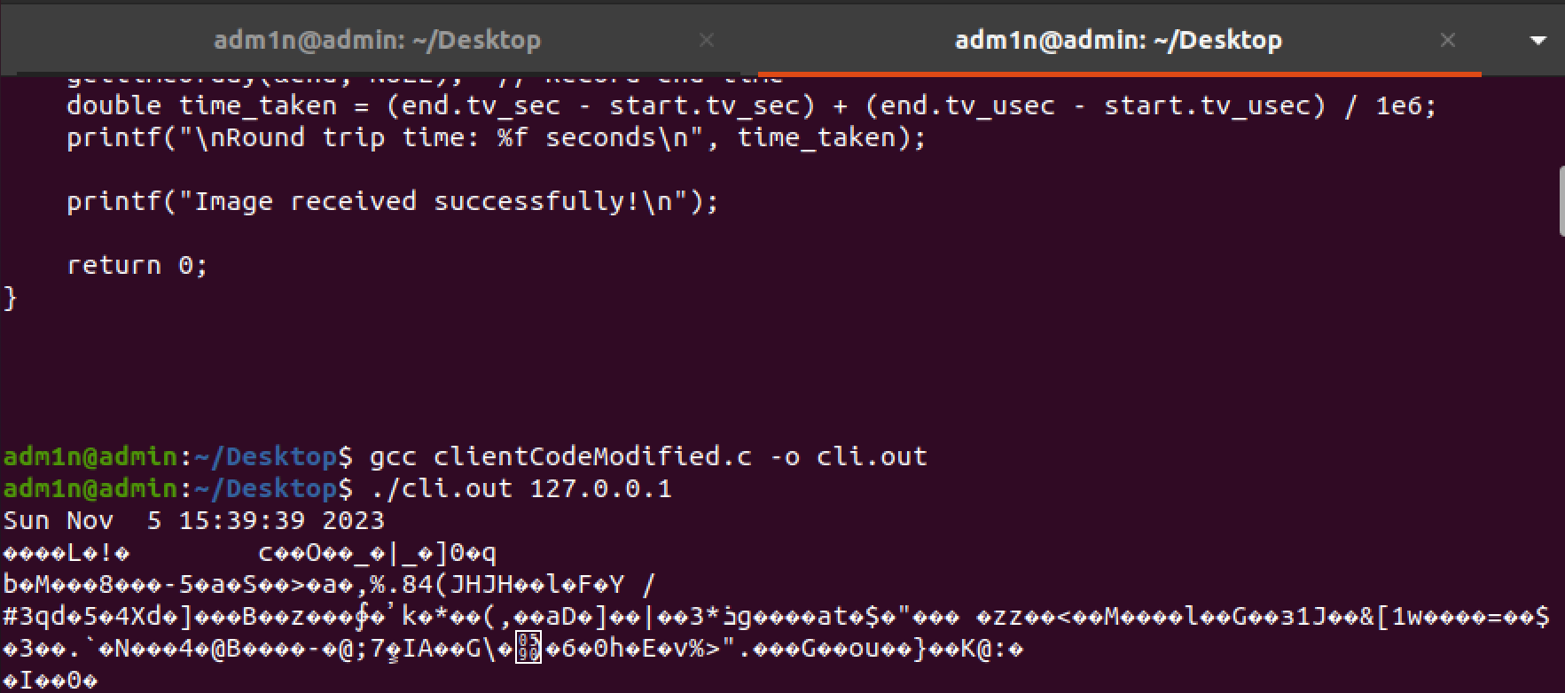
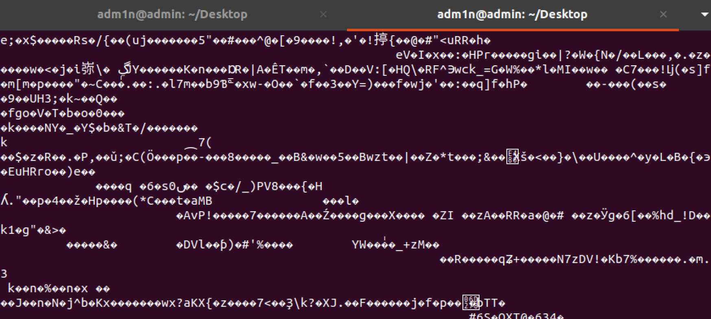

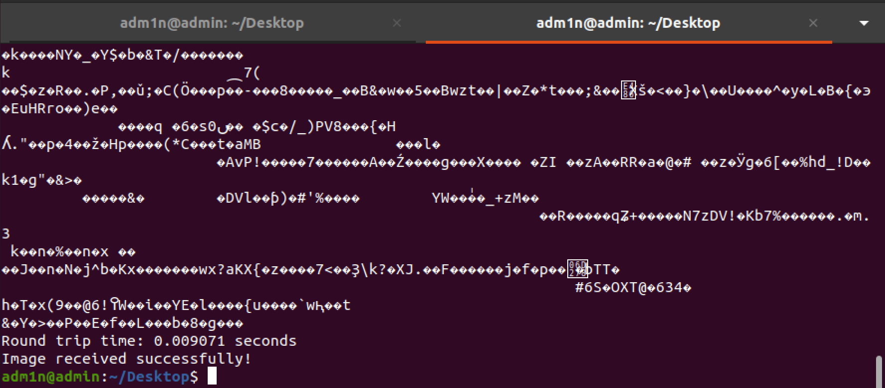

Explanation of function used for networking:

- Socket:

Purpose: Creates a new socket.
Explanation: A socket is like a virtual communication endpoint that allows processes on different devices to send and receive data. It's like a phone line that two programs can use to talk to each other over a network.
- Bind:

Purpose: Associates a socket with a specific network address (IP address and port number).
Explanation: This function tells the operating system which network interface and port the server should use for communication. It's like setting up a specific mailbox for receiving messages.
- Listen:

Purpose: Puts the socket in a passive listening state, allowing it to accept incoming connections.
Explanation: Once a socket is created and bound, listen prepares it to receive incoming connection requests from clients. It's like opening a shop and waiting for customers to come in.
- Accept:

Purpose: Waits for an incoming connection and accepts it when a client tries to connect.
Explanation: When a client wants to communicate with the server, it sends a connection request. accept is like the receptionist who greets the client and assigns a dedicated line for communication.
- Connect:

Purpose: Establishes a connection to a remote server.
Explanation: This is used by the client to connect to the server. It's like dialing a phone number to call someone.
- send and recv:

Purpose: Send and receive data over the network.
Explanation: These functions allow programs to send and receive messages or files. It's like writing a letter and sending it through the mailbox, and then receiving a reply.
- fwrite and fread (added in bonus task):

Purpose: Write and read binary data to and from a file.
Explanation: In the bonus task, these functions are used to handle the image file data. It's like copying a file from one place to another.

Deliverable
A Word Document containing Client and Server codes, Explanation of function used for Networking e.g socket ,listen, bind, accept etc and screen shots of output.

