# Faculty of Computing

**CS220: Database Systems**

**Class: BESE-13AB**

# Lab 9: Data Modelling and Conversion from Conceptual to Logical/Relational Model

# Date: November 20, 2023

# Time: 10:00-01:00 & 02:00-05:00

# Instructor: Dr. Bilal Ali & Dr. Shah Khalid

# Lab Engineer: Sundas Dawood

**Name:** Aimen Munawar

**Class:** BESE-13-A

**CMS ID:** 415867

# 

# 

# 

# Lab 9 : Data Modelling and Conversion from Conceptual to Logical/Relational Model

**Introduction**

This lab will focus on the process of converting a conceptual design in the form of an ERD to a relational design i.e. schema. The process is carried out using an algorithm, which specifies the conversion.

**Objectives**

After completing this lab, you should be able to do the following:

* Learn phases of design process
  + Concepts mapping in the form of ERD and EERD
  + Relational Database Design Using ER-to-Relational Mapping
  + Mapping EER Model Constructs to Relations
* Convert ERD into relational schema

**Tools/Software Requirement**

* MySQL Community Server 5.6
* MySQL Workbench 6.1

**Description**

The 9 step algorithm of mapping conceptual to relational schema includes 7 steps for mapping ER model to relations and the additional two steps are used to map the additional concepts i.e. the EER to relational design. Various steps of the algorithm include:

* Step 1: Mapping of Regular Entity Types
* Step 2: Mapping of Weak Entity Types
* Step 3: Mapping of Binary 1:1 Relationship Types
* Step 4: Mapping of Binary 1:*N* Relationship Types
* Step 5: Mapping of Binary *M*:*N* Relationship Types
* Step 6: Mapping of Multivalued Attributes
* Step 7: Mapping of *N*-ary Relationship Types

**Lab Tasks**

1. For the following ER diagram, convert the conceptual design to relational design using the systematic methodology i.e. 7 step algorithm. Map each part of ERD using the steps given. Write down each step of the mapping separately.

**ERD for Student Record**

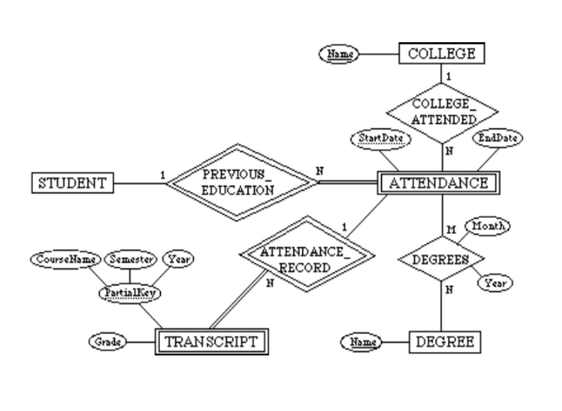

* **Step 1: Mapping of Regular Entity Types**

**Code:**

-- Step 1: Mapping of Regular Entity Types

CREATE DATABASE studentDB;

USE studentDB;

CREATE TABLE student (

studentID INT PRIMARY KEY

);

CREATE TABLE degree (

name VARCHAR(255) PRIMARY KEY

);

CREATE TABLE college (

name VARCHAR(255) PRIMARY KEY

);

**Output:**

* **Step 2: Mapping of Weak Entity Types**

**Code:**

-- Step 2: Mapping of Weak Entity Types

CREATE TABLE Attendance (

start_date DATE,

end_date DATE,

studentID INT,

college_name VARCHAR(255),

degree_name VARCHAR(255),

PRIMARY KEY (start_date, studentID),

FOREIGN KEY (college_name) REFERENCES college(name),

FOREIGN KEY (studentID) REFERENCES student(studentID),

FOREIGN KEY (degree_name) REFERENCES degree(name)

);

CREATE TABLE Transcript (

grade CHAR(1),

semester VARCHAR(50),

year INT,

course_name VARCHAR(255),

start_date DATE,

studentID INT,

PRIMARY KEY (semester, year, course_name, start_date, studentID),

FOREIGN KEY (start_date, studentID) REFERENCES Attendance(start_date, studentID)

);

**Output:**

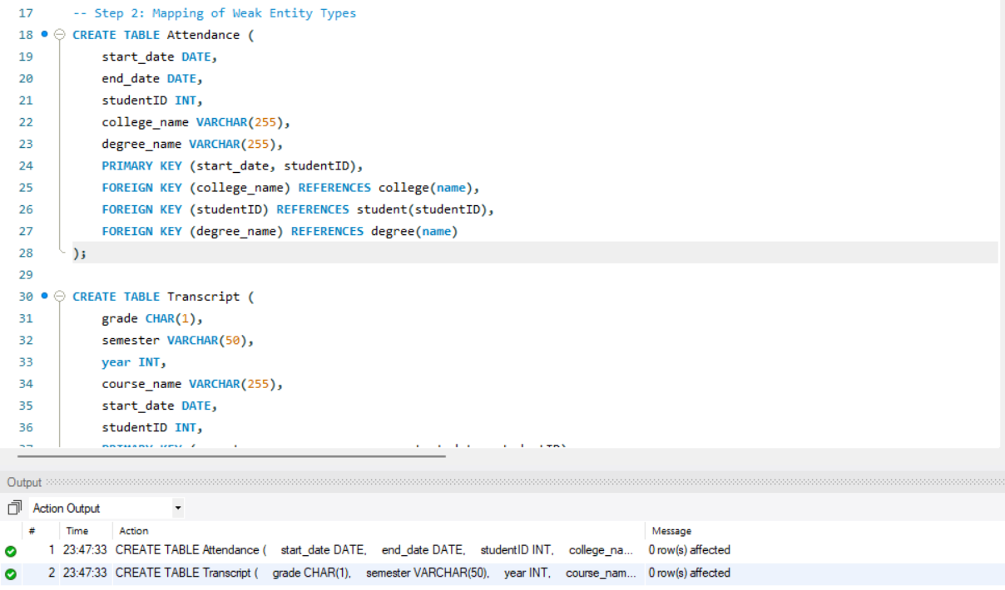

* **Step 3: Mapping of Binary 1:1 Relationship Types**

**There is no Binary 1-1 relationship in this ER diagram.**

* **Step 4: Mapping of Binary 1:*N* Relationship Types**

**Code:**

-- Step 4: Mapping of Binary 1:N Relationship Types

-- Assuming one-to-many relationships with three relations

-- Relationship 1: college_attended

ALTER TABLE Attendance

ADD CONSTRAINT fk_college_attended

FOREIGN KEY (college_name)

REFERENCES college(name);

-- Relationship 2: attendance_record

ALTER TABLE Transcript

ADD CONSTRAINT fk_attendance_record

FOREIGN KEY (start_date, studentID)

REFERENCES Attendance(start_date, studentID);

-- Relationship 3: previous_education

ALTER TABLE Attendance

ADD CONSTRAINT fk_previous_education

FOREIGN KEY (studentID)

REFERENCES student(studentID);

**Output:**

* **Step 5: Mapping of Binary *M*:*N* Relationship Types**

**Code:**

-- Step 5: Mapping of Binary M:N Relationship Types

-- many-to-many relationship

CREATE TABLE Degrees (

start_date DATE,

studentID INT,

degree_name VARCHAR(255),

PRIMARY KEY (start_date, studentID, degree_name),

FOREIGN KEY (start_date, studentID) REFERENCES Attendance(start_date, studentID),

FOREIGN KEY (degree_name) REFERENCES degree(name)

);

**Output:**

* **Step 6: Mapping of Multivalued Attributes**

**There is no Multivalued attributes in this ER diagram.**

* **Step 7: Mapping of *N*-ary Relationship Types**

**There is no N-ary Relationship in this ER diagram.**

**Deliverables**

Submit a document with detailed conversion process of each of the given ERD and upload it on LMS.