# Faculty of Computing

**CS220: Database Systems**

**Class: BESE-13AB**

# Lab 08: SQL Queries (Subqueries)

# Date: 13 November, 2023

# Time: 10:00-01:00 & 02:00-05:00

# Instructor: Dr. Bilal Ali & Dr. Shah Khalid

# Lab Engineer: Sundas Dawood

**Name:** Aimen Munawar

**Class:** BESE-13-A

**CMS ID:** 415867

# Lab 08: SQL Queries (Subqueries)

**Introduction**

The sub query in SQL is a query within query. A sub- query is composed of an outer query and an inner query.

**Objectives**

After completing this lab, you should be able to do the following:

* Understand and practice the single row sub queries
* Understand and practice the multiple row sub queries

**Tools/Software Requirement**

* MySQL Community Server
* MySQL Workbench

**Helping Material**

<https://www.w3resource.com/sql/subqueries/understanding-sql-subqueries.php>

**Description:**

For example, you want to see all the employees whose salary is above average salary. For this you have to first compute the average salary using AVG function and then compare employees’ salaries with this computed salary. This is possible using subquery. Here the sub query will first compute the average salary and then main query will execute.

**Select \***

**from emp**

**where sal >**

**(select avg(sal)**

**from emp);**

Similarly we want to see the name and empno of that employee whose salary is maximum.  
**Select *   
from emp   
where sal = (select max(sal)   
 from emp);**

We want to see how many employees are there whose salary is above average.

**Select count(*)**

**from emp**

**where sal >**

**(select avg(sal)**

**from emp);**

We want to see those employees who are working in 'DALLAS'. Remember emp and dept are joined on deptno and loc column is in the dept table. Assuming that wherever the department is located the employee is working in that city.  
**Select *   
from emp**

**where deptno IN**

**(select deptno**

**from dept**

**where loc='DALLAS');**

**Lab Tasks**

On the basis of the knowledge of the sub-queries, attempt the following questions using the Subqueries concept. The information needs can also be met through join operations; however, you need to practice the subqueries. Try to implement subqueries concept as much as possible. You can use join operation in your queries if required.

Write equivalent join queries for at least two queries.

Write SQL queries for the following information needs using subquery approach.

1. **Number of customers who never rented BREAKING HOME.**

**Code:**

select count(customer_id) as customersWhoNeverRentedBreakingHome

from customer

where customer_id not in (

select customer_id

from rental

where inventory_id in (

select inventory_id

from inventory

where film_id = (

select film_id

from film

where title="Breaking home"

)

)

);

**Output:**

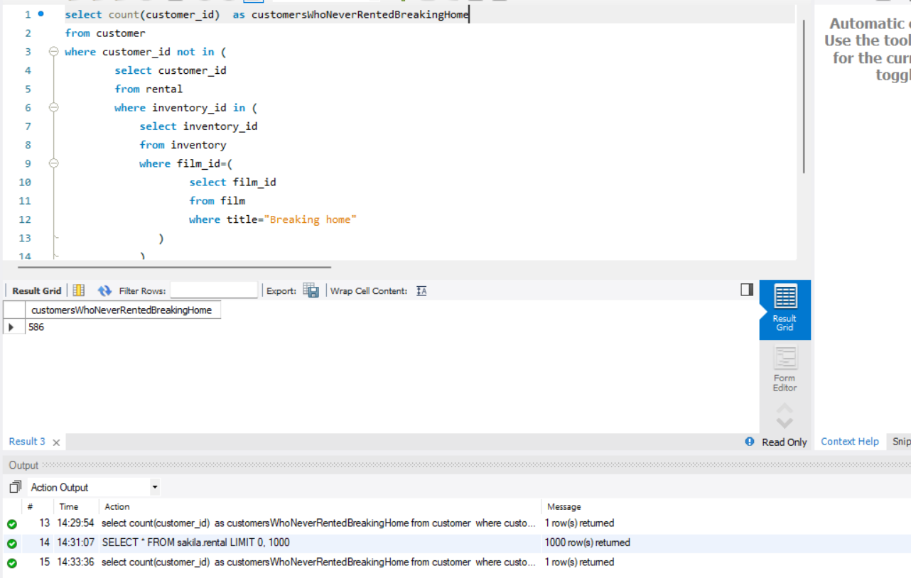

1. List accumulative replacement cost of the movies that were never rented.

**Code:**

select sum(replacement_cost) as accumulativeReplacementCost

from film

where film_id not in(

select film_id

from inventory

where inventory_id in (select inventory_id from rental)

);

**Output:**

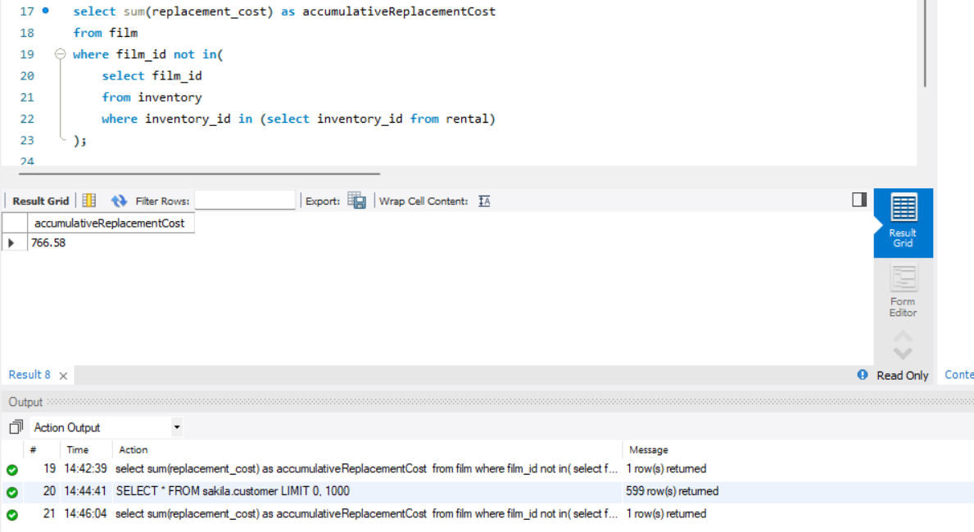

1. Find customers who are associated with the City Abu Dhabi or Aden.

**Code:**

select first_name,last_name

from customer

where address_id in (

select address_id

from address

where city_id in (

select city_id

from city

where (city='Abu Dhabi' )OR (city='Aden')

)

);

**Output:**

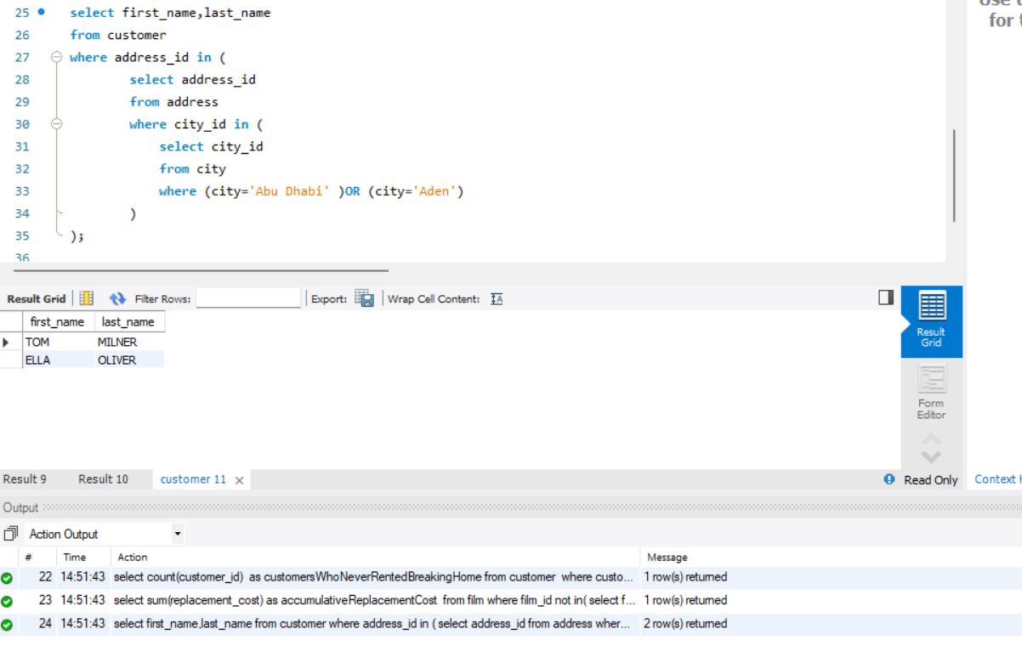

1. What category does the movie COMA HEAD belong to?

**Code:**

select name,category_id

from category

where category_id= (

select category_id

from film_category

where film_id= (

select film_id

from film

where title="Coma Head"

)

);

**Output:**

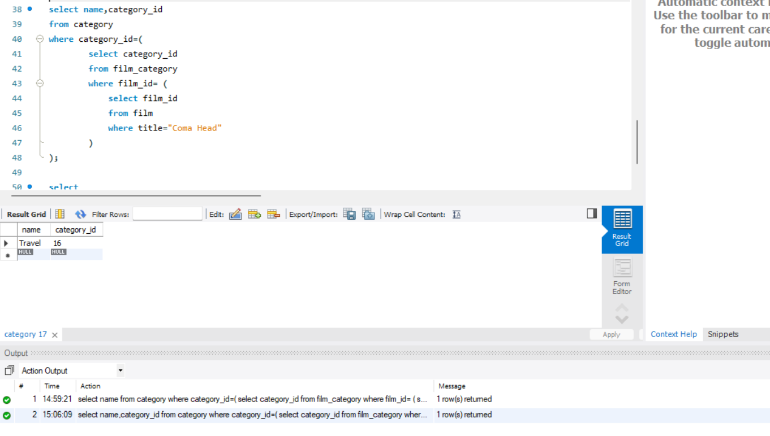

**Using Join:**

**Code:**

select cc.name, cc.category_id

from category cc

join film_category f1 on cc.category_id = f1.category_id

join film f2 on f1.film_id = f2.film_id

where f2.title = 'Coma Head';

**Output:**

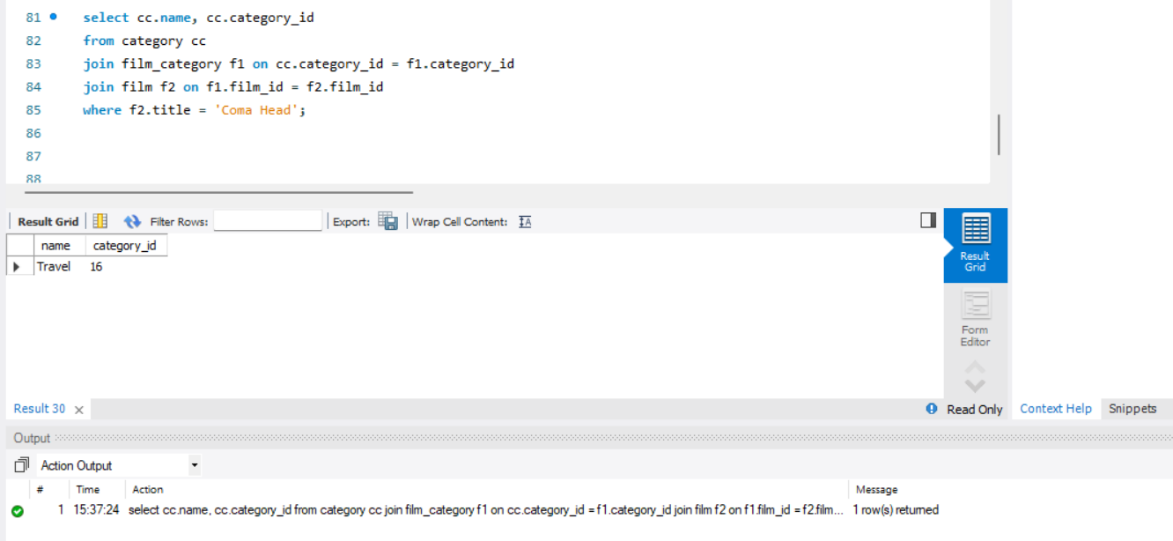

1. Find the movies whose rental duration is less than the rental duration of movie ‘AFRICAN EGG’.

**Code:**

select title,rental_duration

from film

where rental_duration < (

select rental_duration

from film

where title="African Egg"

);

**Output:**

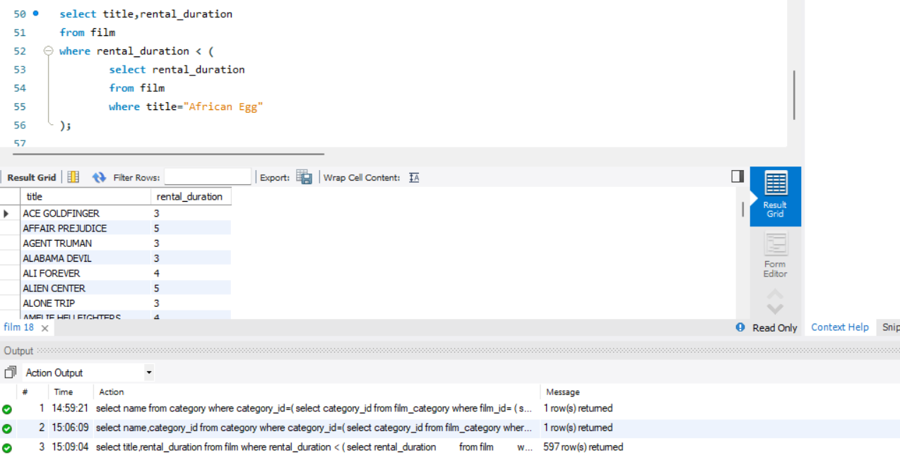

**Using Join:**

**Code:**

select f1.title, f1.rental_duration

from film f1

join film f2 on f1.rental_duration < f2.rental_duration

where f2.title = 'African Egg';

**Output:**

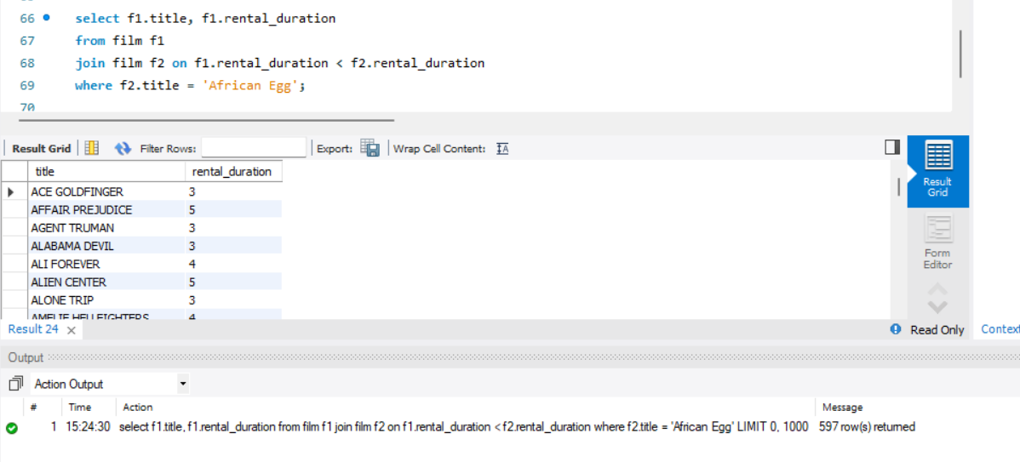

1. Find those films whose category id is greater than every category id of available films.

**Code:**

select title

from film

where film_id in(

select film_id

from film_category

where category_id=(select max(category_id) from category)

);

**Output:**

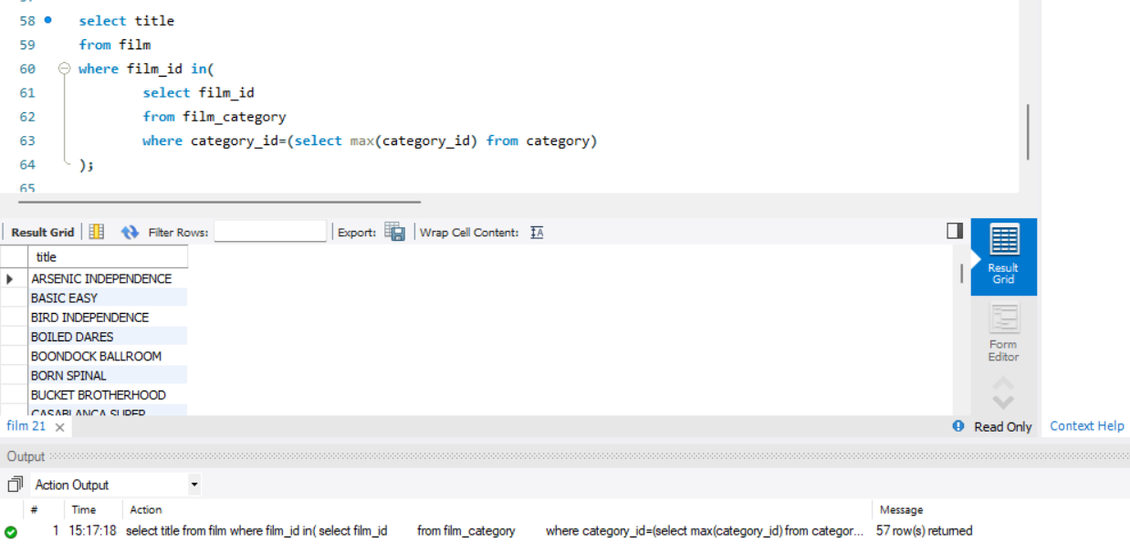

**Using Join:**

**Code:**

select f1.title

from film f1

join film_category f2 on f1.film_id = f2.film_id

join category cc on f2.category_id = cc.category_id

where f2.category_id = (

select MAX(category_id)

from category

);

**Output:**

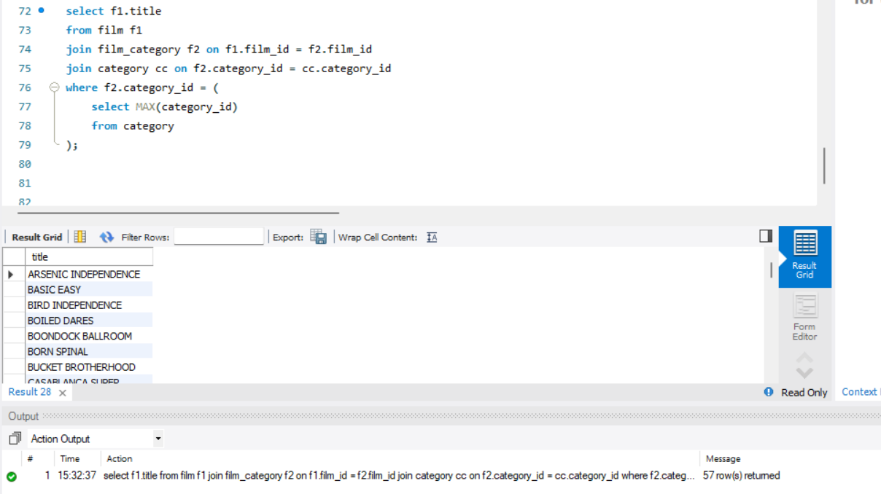

**Deliverables**

Save all queries and their results in the word document that you are executing along with the snapshots of the results. Upload this document to LMS.

# 