# Faculty of Computing

**CS220: Database Systems**

**Class: BESE-13AB**

# Lab 12: Open Ended Lab

# Date: December 18, 2023

# Time: 02:00-05:00

# Instructor: Dr. Shah Khalid

# Lab Engineer: Sundas Dawood

**Name:** Aimen Munawar

**Class:** BESE-13-A

**CMS ID:** 415867

# 

# 

**Lab 12: Open Ended Lab**

**Introduction**

This lab is Open Ended Lab a complete scenario is given and you are required to propose the solutions as per your understandings.

**Objectives**

Objective of this lab is to understand the scenario, make ERD, write DDL , populate data through DML and Execute DRL for reports.

**Animals Well-being Management System**

Akmal, a loyal client of Dist Haywanaat Shifa Khana “DHSK”, arrives with his one of the golden retrievers (Dogs), Tommy, for Tommy's scheduled biannual vaccination. This time, Tommy requires an oral vaccination that involves Treatment of local anesthesia. The veterinarian accesses Tommy's comprehensive medical history and notes the need for the oral vaccination. To ensure Tommy's comfort, the vet administers a local anesthesia treatment before proceeding with the oral vaccination process.

During the visit, various treatments and medications are provided, including the oral vaccine, the local anesthesia, and any additional medications prescribed for Tommy's well-being. Each treatment, medication, its dosage, and price are very well documented.

Post-treatment, the front desk staff compile an itemized bill detailing the treatment and medications. The total cost of the visit, including the oral vaccination, local anesthesia, and any additional services rendered, arriving at a total of 2454/- rupees for the comprehensive treatment.

**Consider the following Business Rules:**

1. A customer can have many pets but must have at least one.

2. A pet must be assigned to one and only one customer.

3. A pet can have one or more treatments per visit but must have at least one.

4. A treatment can have one or more medications.

5. A bill must have details of the treatments including costs.

**Task:**

**1: Analyze the scenario to understand the working of a DHSK.**

* **Overview:**

The scenario revolves around the operation of the Dist Haywanaat Shifa Khana (DHSK), a veterinary clinic, where clients bring their pets for various medical services. The focus is on a specific client, Akmal, who brings his dog, Tommy, for a biannual vaccination.

* **Operational Flow:**

1. **Appointment and Visit:**

Clients, represented by a unique CustomerID, schedule visits for their pets. Each visit is associated with a specific date and may involve multiple services.

1. **Pet Information:**

Pets are identified by PetID and are linked to a specific customer (Owner). A pet may receive one or more treatments during a visit.

1. **Medical History:**

Comprehensive medical records are maintained for each pet. Previous treatments, medications, and vaccinations are recorded for reference.

1. **Treatment and Medications:**

Various treatments are offered, each with a unique TreatmentID. Treatments may involve one or more medications, represented by MedicationID.

1. **Billing:**

Itemized bills are compiled post-treatment, detailing the services provided, including treatments and medications.Total cost is calculated for each visit.

* **Business Rules:**

1. **Customer and Pets:**

A customer can have multiple pets but must have at least one. Each pet is assigned to one and only one customer.

1. **Pet Treatments:**

A pet can undergo one or more treatments during a visit, but at least one treatment is required.

1. **Treatment and Medications:**

A treatment can involve one or more medications.

1. **Billing:**

A bill must include details of the treatments, medications, and their associated costs.

**2: Identify Entities, attributes, and constraints (identify appropriate related attributes)**

**Entities:**

* Customer
* Pet
* Treatment
* Medication
* Bill
* Visit

**Attributes:**

* **Customer:**

1. CustomerID (Primary Key)
2. Name
3. ContactNumber
4. Email
5. Address
6. RegistrationDate
7. PreferredCommunication
8. EmergencyContactNumber
9. Occupation
10. LastVisitDate

* **Pet:**

1. PetID (Primary Key)
2. Name
3. Type (e.g., Dog, Cat)
4. Age
5. Breed
6. CustomerID (Foreign Key)
7. Weight
8. Color
9. MicrochipID
10. LastVaccinationDate

* **Treatment:**

1. TreatmentID (Primary Key)
2. Name
3. Description
4. Cost
5. Duration
6. TreatmentType
7. SeverityLevel
8. FollowUpRequired
9. TreatmentStartDate
10. TreatmentEndDate

* **Medication:**

1. MedicationID (Primary Key)
2. Name
3. Dosage
4. Cost
5. Manufacturer
6. ExpiryDate
7. PrescriptionRequired
8. StorageConditions
9. MedicationType
10. UsageInstructions

* **Bill:**

1. BillID (Primary Key)
2. VisitID (Foreign Key)
3. TotalCost
4. DiscountApplied
5. PaymentStatus
6. PaymentMethod
7. BillingDate
8. DueDate
9. LateFee
10. ReferralSource

* **Visit:**

1. VisitID (Primary Key)
2. PetID (Foreign Key)
3. Date
4. Notes
5. Temperature
6. Weight
7. VetComments
8. NextVisitDate
9. LabResults
10. VisitType

**Constraint:**

* A customer can have many pets but must have at least one.
* A pet must be assigned to one and only one customer.
* A pet can have one or more treatments per visit but must have at least one.
* A treatment can have one or more medications.
* A bill must have details of the treatments, including costs.

**3: Design ERD to meet the requirements**

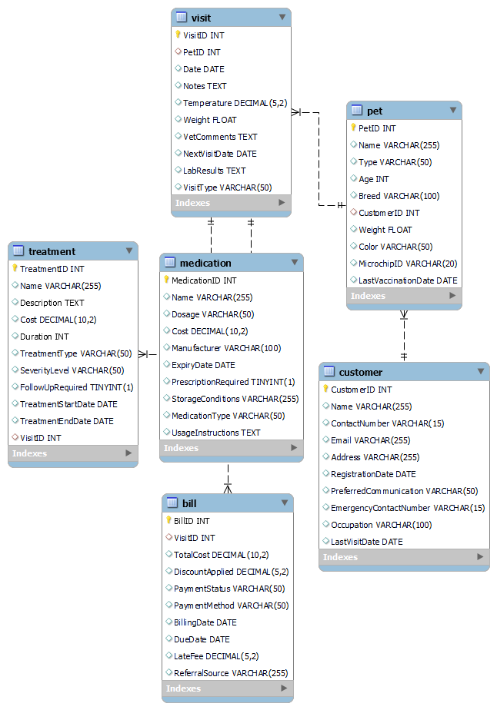

**4: Implement it into an executable relational database**

**Code:**

CREATE DATABASE VeterinaryClinicDatabase;

CREATE TABLE Customer (

CustomerID INT PRIMARY KEY,

Name VARCHAR(255),

ContactNumber VARCHAR(15),

Email VARCHAR(255),

Address VARCHAR(255),

RegistrationDate DATE,

PreferredCommunication VARCHAR(50),

EmergencyContactNumber VARCHAR(15),

Occupation VARCHAR(100),

LastVisitDate DATE

);

CREATE TABLE Pet (

PetID INT PRIMARY KEY,

Name VARCHAR(255),

Type VARCHAR(50),

Age INT,

Breed VARCHAR(100),

CustomerID INT,

Weight FLOAT,

Color VARCHAR(50),

MicrochipID VARCHAR(20),

LastVaccinationDate DATE,

FOREIGN KEY (CustomerID) REFERENCES Customer(CustomerID)

);

CREATE TABLE Visit (

VisitID INT PRIMARY KEY,

PetID INT,

Date DATE,

Notes TEXT,

Temperature DECIMAL(5, 2),

Weight FLOAT,

VetComments TEXT,

NextVisitDate DATE,

LabResults TEXT,

VisitType VARCHAR(50),

FOREIGN KEY (PetID) REFERENCES Pet(PetID)

);

CREATE TABLE Treatment (

TreatmentID INT PRIMARY KEY,

Name VARCHAR(255),

Description TEXT,

Cost DECIMAL(10, 2),

Duration INT,

TreatmentType VARCHAR(50),

SeverityLevel VARCHAR(50),

FollowUpRequired BOOLEAN,

TreatmentStartDate DATE,

TreatmentEndDate DATE,

VisitID INT,

FOREIGN KEY (VisitID) REFERENCES Visit(VisitID)

);

CREATE TABLE Medication (

MedicationID INT PRIMARY KEY,

Name VARCHAR(255),

Dosage VARCHAR(50),

Cost DECIMAL(10, 2),

Manufacturer VARCHAR(100),

ExpiryDate DATE,

PrescriptionRequired BOOLEAN,

StorageConditions VARCHAR(255),

MedicationType VARCHAR(50),

UsageInstructions TEXT

);

CREATE TABLE Bill (

BillID INT PRIMARY KEY,

VisitID INT,

TotalCost DECIMAL(10, 2),

DiscountApplied DECIMAL(5, 2),

PaymentStatus VARCHAR(50),

PaymentMethod VARCHAR(50),

BillingDate DATE,

DueDate DATE,

LateFee DECIMAL(5, 2),

ReferralSource VARCHAR(255),

FOREIGN KEY (VisitID) REFERENCES Visit(VisitID)

);

**Output:**

**Created Tables:**

**5: Populate the database with 3 owners, 5 pets, 3 treatments, 7 medicines, 1 old visit and 1 current visit.**

**Code:**

INSERT INTO Customer VALUES

(1, 'Ali Khan', '+92-300-1234567', 'ali@example.com', '123 Lahore St', '2022-01-01', 'SMS', '+92-301-7654321', 'Engineer', '2023-11-15'),

(2, 'Fatima Ahmed', '+92-321-9876543', 'fatima@example.com', '456 Islamabad St', '2022-03-15', 'Email', '+92-333-8765432', 'Doctor', '2023-10-20'),

(3, 'Usman Malik', '+92-345-6789012', 'usman@example.com', '789 Karachi St', '2022-05-20', 'Phone', '+92-321-2345678', 'Teacher', '2023-12-01');

INSERT INTO Pet VALUES

(1, 'Buddy', 'Dog', 3, 'Labrador', 1, 25.5, 'Brown', 'MIC123', '2023-01-15'),

(2, 'Misty', 'Cat', 2, 'Siamese', 1, 5.0, 'Gray', 'MIC456', '2023-02-20'),

(3, 'Rocky', 'Dog', 4, 'German Shepherd', 2, 30.0, 'Black', 'MIC789', '2023-03-10'),

(4, 'Whiskers', 'Cat', 1, 'Persian', 2, 4.5, 'White', 'MIC012', '2023-04-05'),

(5, 'Rusty', 'Dog', 5, 'Golden Retriever', 3, 22.0, 'Golden', 'MIC345', '2023-05-01');

INSERT INTO Treatment VALUES

(1, 'Vaccination', 'Routine vaccination for pets', 50.00, 30, 'Preventive', 'Low', 0, '2023-01-15', '2023-02-14', NULL),

(2, 'Deworming', 'Deworming treatment for pets', 30.00, 15, 'Preventive', 'Low', 0, '2023-03-10', '2023-03-25', NULL),

(3, 'Surgery', 'Spaying/neutering surgery', 200.00, 120, 'Therapeutic', 'High', 1, '2023-04-05', '2023-06-15', NULL);

INSERT INTO Medication VALUES

(1, 'Heartguard', '1 tablet/day', 20.00, 'XYZ Pharma', '2024-01-01', 1, 'Store in a cool place', 'Oral', 'Follow vet instructions'),

(2, 'FleaAway', '1 spray/week', 15.00, 'ABC Pharma', '2023-12-01', 0, 'Avoid direct sunlight', 'Topical', 'Apply as directed'),

(3, 'PainX', '1 tablet/day', 25.00, 'PQR Pharma', '2023-12-15', 1, 'Store at room temperature', 'Oral', 'Take with food'),

(4, 'EarCleaner', '2 drops/ear', 10.00, 'LMN Pharma', '2023-12-10', 0, 'Shake well before use', 'Topical', 'Apply with cotton ball'),

(5, 'AntibioticX', '1 tablet/twice a day', 35.00, 'JKL Pharma', '2023-11-25', 1, 'Keep away from children', 'Oral', 'Complete the course'),

(6, 'EyeDrops', '2 drops/eye', 18.00, 'RST Pharma', '2023-11-20', 0, 'Do not touch dropper tip', 'Topical', 'Apply as directed'),

(7, 'JointCare', '1 tablet/day', 30.00, 'UVW Pharma', '2023-11-05', 1, 'Store in a dry place', 'Oral', 'Administer with food');

INSERT INTO Visit VALUES

(1, 1, '2023-01-15', 'Routine checkup', 38.5, 25.5, 'Healthy dog', '2023-07-15', 'Blood test results pending', 'Routine'),

(2, 2, '2023-03-10', 'Weight loss concerns', 39.0, 5.0, 'Mild cough observed', '2023-09-10', 'Lab results normal', 'Routine'),

(3, 3, '2023-04-05', 'Spaying surgery follow-up', 38.8, 30.0, 'Incision healing well', '2023-06-15', 'Lab results pending', 'Therapeutic'),

(4, 4, '2022-12-20', 'Old Visit Example', 38.0, 10.0, 'Previous issue resolved', '2023-01-20', 'Lab results not applicable', 'Follow-up');

INSERT INTO Bill VALUES

(1, 1, 100.00, 10.00, 'Paid', 'Credit Card', '2023-01-20', '2023-02-20', NULL, 'Word of Mouth'),

(2, 2, 75.00, 5.00, 'Pending', 'Cash', '2023-03-15', '2023-04-15', NULL, 'Online Review'),

(3, 3, 250.00, 20.00, 'Paid', 'Cheque', '2023-04-30', '2023-05-30', NULL, 'Veterinarian Recommendation');

**Output:**

**Data_ in_ Tables:**

**6: Provide the reports through SQL queries for the followings:**

**a: bill with details of the old visit**

**Code:**

select bill.*, visit.date as visitdate, pet.name as petname, customer.name as customername

from bill

join visit on bill.visitid = visit.visitid

join pet on visit.petid = pet.petid

join customer on pet.customerid = customer.customerid

where visit.date < curdate()

order by bill.totalcost desc

limit 1;

**Output:**

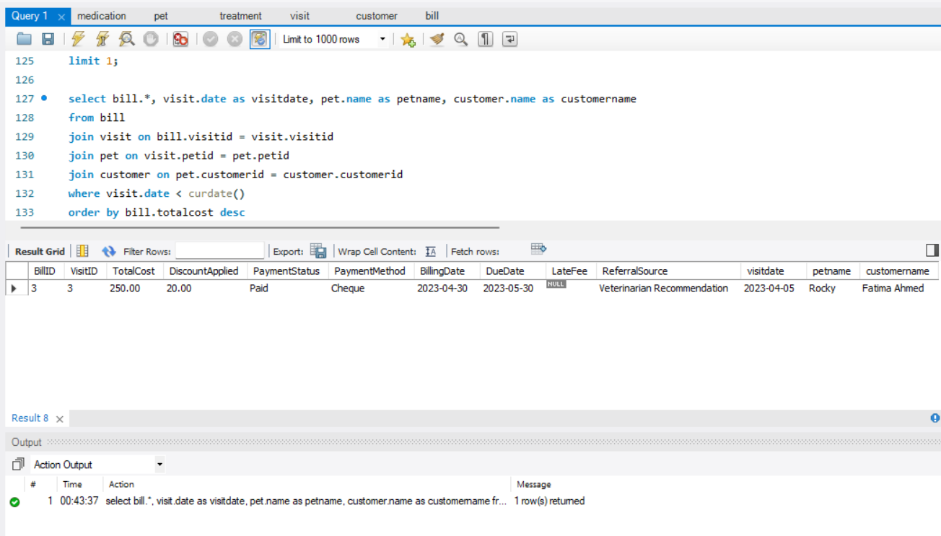

**b: bill with details of the current visit**

**Code:**

select bill.*, visit.date as visitdate, pet.name as petname, customer.name as customername

from bill

join visit on bill.visitid = visit.visitid

join pet on visit.petid = pet.petid

join customer on pet.customerid = customer.customerid

where visit.date >= curdate()

order by bill.totalcost desc

limit 1;

**Output:**

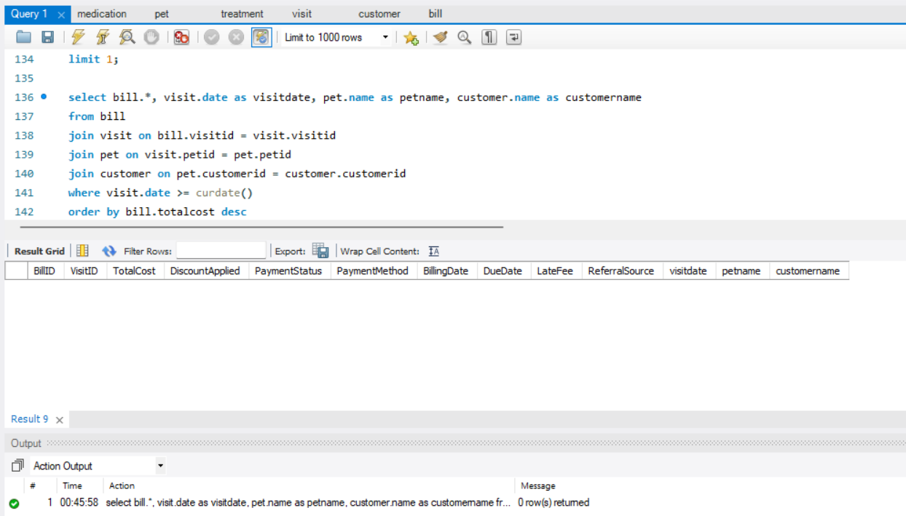

**c: bill having maximum cost with details of the visit**

**Code:**

select bill.*, visit.date as visitdate, pet.name as petname, customer.name as customername

from bill

join visit on bill.visitid = visit.visitid

join pet on visit.petid = pet.petid

join customer on pet.customerid = customer.customerid

order by bill.totalcost desc

limit 1;

**Output:**

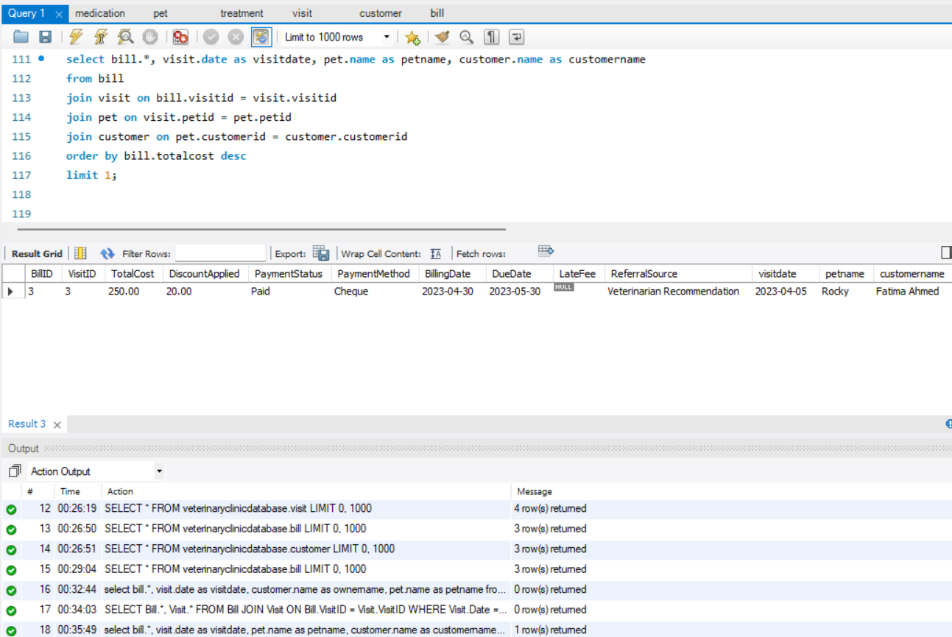

**d: Identify the Pet having maximum distinct treatments along with treatment name.**

**Code:**

select pet.petid, pet.name as petname, count(distinct treatment.treatmentid) as numdistincttreatments, group_concat(distinct treatment.name) as treatmentnames

from pet

left join visit on pet.petid = visit.petid

left join treatment on visit.visitid = treatment.visitid

group by pet.petid, pet.name

order by numdistincttreatments desc

limit 1;

**Output:**

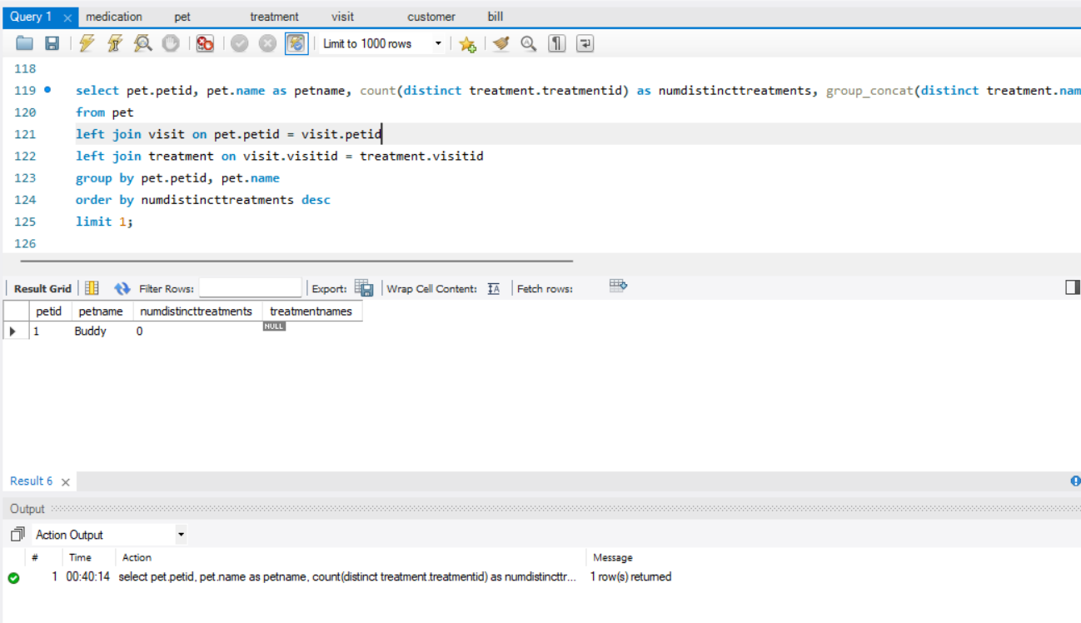

**Deliverables:**

Provide a complete report having ERD, DDL, DML, DRL and snapshot of results.