# Department of Computing

**CS220: Database Systems**

**Class: BESE 13 A & B**

# Lab05: Single Row Functions

# Date: 09th October 2023

# Time: 10:00-01:00

# Instructor: Muhammad Bilal Ali

# Lab Engineer: Sundas Dawood

**Name:** Aimen Munawar

**Class:** BESE-13-A

**CMS ID:** 415867

**Lab 5: Single Row Functions**

# Introduction

Structured Query Language (SQL) is a high level query language which has inbuilt operators and functions for different presentation/manipulation of the data that is retrieved.

# Objectives

After performing this lab students should be able to:

1. Design SQL queries to retrieve data using SELECT clause and using logical operators, SQL operator precedence.
2. Explore and learn various inbuilt single row functions of SQL.

# Tools/Software Requirement

* MySQL Community Server
* MySQL Workbench
* Sakila Database

# Description

## The SQL SELECT DISTINCT Statement

In a table, a column may contain many duplicate values; and sometimes you only want to list the different (distinct) values.

The DISTINCT keyword can be used to return only distinct (different) values.

### SQL SELECT DISTINCT Syntax

SELECT DISTINCT column_name,column_name  
FROM table_name;

## The SQL WHERE Clause

The WHERE clause is used to extract only those records that fulfill a specified criterion.

### SQL WHERE Syntax

SELECT column_name,column_name  
FROM table_name  
WHERE column_name operator value;

**Example**

The following SQL statement selects all the customers from the country "Mexico", in the "Customers" table

SELECT * FROM Customers  
WHERE Country='Mexico';

## Text Fields vs. Numeric Fields

## SQL requires single quotes around text values (most database systems will also allow double quotes). However, numeric fields should not be enclosed in quotes

**Example**

SELECT * FROM Customers  
WHERE CustomerID=1;

# Single Row Functions

**What is a function?**

A function is similar to an operator in operation. A function is a name that performs a specific task. A function may or may not take values (arguments) but it always returns a value as the result. If function takes values then these values are to be given within parentheses after the function name. The following is the general format of a function.

function [(argument-1, argument-2,...) ]

If the function doesn’t take any value then function name can be used alone and even parentheses are not required.

Single-row functions return a single result row for every row of a queried table or view. These functions can appear in select lists, WHERE clauses, START WITH and CONNECT BY clauses, and HAVING clauses.

Arithmetic functions perform take numeric data; date functions take date type data and string functions take strings. Conversion functions are used to convert the given value from one type to another. Miscellaneous functions perform operations on any type of data. Group functions are used to perform operations on the groups created by GROUP BY clause.

# Character Functions

Character functions operate on values of dataype  CHAR or VARCHAR.

|  |  |
| --- | --- |
| Function | Description |
| [CHARACTER_LENGTH](https://www.w3schools.com/mysql/func_mysql_character_length.asp) | Returns the length of a string (in characters) |
| [CONCAT](https://www.w3schools.com/mysql/func_mysql_concat.asp) | Adds two or more expressions together |
| [CONCAT_WS](https://www.w3schools.com/mysql/func_mysql_concat_ws.asp) | Adds two or more expressions together with a separator |
| [INSERT](https://www.w3schools.com/mysql/func_mysql_insert.asp) | Inserts a string within a string at the specified position and for a certain number of characters |
| [LCASE](https://www.w3schools.com/mysql/func_mysql_lcase.asp) | Converts a string to lower-case |
| [LEFT](https://www.w3schools.com/mysql/func_mysql_left.asp) | Extracts a number of characters from a string (starting from left) |
| [LOWER](https://www.w3schools.com/mysql/func_mysql_lower.asp) | Converts a string to lower-case |
| [LPAD](https://www.w3schools.com/mysql/func_mysql_lpad.asp) | Left-pads a string with another string, to a certain length |
| [LTRIM](https://www.w3schools.com/mysql/func_mysql_ltrim.asp) | Removes leading spaces from a string |
| [MID](https://www.w3schools.com/mysql/func_mysql_mid.asp) | Extracts a substring from a string (starting at any position) |
| [POSITION](https://www.w3schools.com/mysql/func_mysql_position.asp) | Returns the position of the first occurrence of a substring in a string |
| [REPEAT](https://www.w3schools.com/mysql/func_mysql_repeat.asp) | Repeats a string as many times as specified |
| [REPLACE](https://www.w3schools.com/mysql/func_mysql_replace.asp) | Replaces all occurrences of a substring within a string, with a new substring |
| [REVERSE](https://www.w3schools.com/mysql/func_mysql_reverse.asp) | Reverses a string and returns the result |
| [RIGHT](https://www.w3schools.com/mysql/func_mysql_right.asp) | Extracts a number of characters from a string (starting from right) |
| [RPAD](https://www.w3schools.com/mysql/func_mysql_rpad.asp) | Right-pads a string with another string, to a certain length |
| [RTRIM](https://www.w3schools.com/mysql/func_mysql_rtrim.asp) | Removes trailing spaces from a string |
| [SPACE](https://www.w3schools.com/mysql/func_mysql_space.asp) | Returns a string of the specified number of space characters |
| [STRCMP](https://www.w3schools.com/mysql/func_mysql_strcmp.asp) | Compares two strings |
| [SUBSTR](https://www.w3schools.com/mysql/func_mysql_substr.asp) | Extracts a substring from a string (starting at any position) |
| [SUBSTRING](https://www.w3schools.com/mysql/func_mysql_substring.asp) | Extracts a substring from a string (starting at any position) |
| [SUBSTRING_INDEX](https://www.w3schools.com/mysql/func_mysql_substring_index.asp) | Returns a substring of a string before a specified number of delimiter occurs |
| [TRIM](https://www.w3schools.com/mysql/func_mysql_trim.asp) | Removes leading and trailing spaces from a string |
| [UCASE](https://www.w3schools.com/mysql/func_mysql_ucase.asp) | Converts a string to upper-case |
| [UPPER](https://www.w3schools.com/mysql/func_mysql_upper.asp) | Converts a string to upper-case |

## LOWER

Returns a given string in lower case.

select LOWER(first_name)

from actor;

## UPPER Returns a given string in UPPER case.

select UPPER(first_name)

from actor;

**LENGTH**

Returns the length of a given string.

select length(first_name)

from actor;

**CONCAT(str1,str2,...)**

Returns the string that results from concatenating the arguments. May have one or more arguments.

SELECT CONCAT('My', 'S', 'QL');

+---------------------------------------------------------+

| CONCAT('My', 'S', 'QL') |

+---------------------------------------------------------+

MySQL

**CONCAT_WS(separator,str1,str2,...)**

CONCAT_WS() stands for Concatenate With Separator and is a special form of CONCAT(). The first argument is the separator for the rest of the arguments. The separator is added between the strings to be concatenated. The separator can be a string, as can the rest of the arguments. If the separator is NULL, the result is NULL.

SELECT CONCAT_WS(',','First name','Last Name' );

+---------------------------------------------------------+

| CONCAT_WS(',','First name','Last Name' ) |

+---------------------------------------------------------+

| First name, Last Name |

**LPAD(str,len,padstr)**

Returns the string str, left-padded with the string padstr to a length of len characters. If str is longer than len, the return value is shortened to len characters.

SELECT LPAD('hi',4,'??');

+---------------------------------------------------------+

| LPAD('hi',4,'??') |

+---------------------------------------------------------+

| ??hi |

+---------------------------------------------------------+

**RPAD(str,len,padstr)**

Returns the string str, right-padded with the string padstr to a length of len characters. If str is longer than len, the return value is shortened to len characters.

SELECT RPAD('hi',5,'?');

+---------------------------------------------------------+

| RPAD('hi',5,'?') |

+---------------------------------------------------------+

| hi??? |

+---------------------------------------------------------+

**LTRIM(str)**

Returns the string str with leading space characters removed.

SELECT LTRIM(' lecture');

+---------------------------------------------------------+

| LTRIM(' lecture') |

+---------------------------------------------------------+

| lecture |

+---------------------------------------------------------+

**REPEAT(str,count)**

Returns a string consisting of the string str repeated count times. If count is less than 1, returns an empty string. Returns NULL if str or count are NULL.

SELECT REPEAT('MySQL', 3);

+---------------------------------------------------------+

| REPEAT('MySQL', 3) |

+---------------------------------------------------------+

| MySQLMySQLMySQL |

+---------------------------------------------------------+

**RTRIM(str)**

Returns the string str with trailing space characters removed.

SELECT RTRIM('barbar ');

+---------------------------------------------------------+

| RTRIM('barbar ') |

+---------------------------------------------------------+

| barbar |

+---------------------------------------------------------+

**SUBSTRING(str,pos)**

**SUBSTRING(str FROM pos)**

**SUBSTRING(str,pos,len)**

**SUBSTRING(str FROM pos FOR len)**

The forms without a len argument return a substring from string str starting at position pos. The forms with a len argument return a substring len characters long from string str, starting at position pos. The forms that use FROM are standard SQL syntax. It is also possible to use a negative value for pos. In this case, the beginning of the substring is pos characters from the end of the string, rather than the beginning. A negative value may be used for pos in any of the forms of this function.

SELECT SUBSTRING('Quadratically',5);

+---------------------------------------------------------+

| SSUBSTRING('Quadratically',5) |

+---------------------------------------------------------+

| ratically |

+---------------------------------------------------------+

> SELECT SUBSTRING('foobarbar' FROM 4);

+---------------------------------------------------------+

| SUBSTRING('foobarbar' FROM 4) |

+---------------------------------------------------------+

| barbar |

+---------------------------------------------------------+

> SELECT SUBSTRING('Quadratically',5,6);

+---------------------------------------------------------+

| SUBSTRING('Quadratically',5,6) |

+---------------------------------------------------------+

| ratica |

+---------------------------------------------------------+

## MySQL Numeric Functions

|  |  |
| --- | --- |
| Function | Description |
| [ABS](https://www.w3schools.com/sql/func_mysql_abs.asp) | Returns the absolute value of a number |
| [ACOS](https://www.w3schools.com/sql/func_mysql_acos.asp) | Returns the arc cosine of a number |
| [ASIN](https://www.w3schools.com/sql/func_mysql_asin.asp) | Returns the arc sine of a number |
| [ATAN](https://www.w3schools.com/sql/func_mysql_atan.asp) | Returns the arc tangent of one or two numbers |
| [ATAN2](https://www.w3schools.com/sql/func_mysql_atan2.asp) | Returns the arc tangent of two numbers |
| [AVG](https://www.w3schools.com/sql/func_mysql_avg.asp) | Returns the average value of an expression |
| [CEIL](https://www.w3schools.com/sql/func_mysql_ceil.asp) | Returns the smallest integer value that is >= to a number |
| [CEILING](https://www.w3schools.com/sql/func_mysql_ceiling.asp) | Returns the smallest integer value that is >= to a number |
| [COS](https://www.w3schools.com/sql/func_mysql_cos.asp) | Returns the cosine of a number |
| [COT](https://www.w3schools.com/sql/func_mysql_cot.asp) | Returns the cotangent of a number |
| [COUNT](https://www.w3schools.com/sql/func_mysql_count.asp) | Returns the number of records returned by a select query |
| [DEGREES](https://www.w3schools.com/sql/func_mysql_degrees.asp) | Converts a value in radians to degrees |
| [DIV](https://www.w3schools.com/sql/func_mysql_div.asp) | Used for integer division |
| [EXP](https://www.w3schools.com/sql/func_mysql_exp.asp) | Returns e raised to the power of a specified number |
| [FLOOR](https://www.w3schools.com/sql/func_mysql_floor.asp) | Returns the largest integer value that is <= to a number |
| [GREATEST](https://www.w3schools.com/sql/func_mysql_greatest.asp) | Returns the greatest value of the list of arguments |
| [LEAST](https://www.w3schools.com/sql/func_mysql_least.asp) | Returns the smallest value of the list of arguments |
| [LN](https://www.w3schools.com/sql/func_mysql_ln.asp) | Returns the natural logarithm of a number |
| [LOG](https://www.w3schools.com/sql/func_mysql_log.asp) | Returns the natural logarithm of a number, or the logarithm of a number to a specified base |
| [LOG10](https://www.w3schools.com/sql/func_mysql_log10.asp) | Returns the natural logarithm of a number to base 10 |
| [LOG2](https://www.w3schools.com/sql/func_mysql_log2.asp) | Returns the natural logarithm of a number to base 2 |
| [MAX](https://www.w3schools.com/sql/func_mysql_max.asp) | Returns the maximum value in a set of values |
| [MIN](https://www.w3schools.com/sql/func_mysql_min.asp) | Returns the minimum value in a set of values |
| [MOD](https://www.w3schools.com/sql/func_mysql_mod.asp) | Returns the remainder of a number divided by another number |
| [PI](https://www.w3schools.com/sql/func_mysql_pi.asp) | Returns the value of PI |
| [POW](https://www.w3schools.com/sql/func_mysql_pow.asp) | Returns the value of a number raised to the power of another number |
| [POWER](https://www.w3schools.com/sql/func_mysql_power.asp) | Returns the value of a number raised to the power of another number |
| [RADIANS](https://www.w3schools.com/sql/func_mysql_radians.asp) | Converts a degree value into radians |
| [RAND](https://www.w3schools.com/sql/func_mysql_rand.asp) | Returns a random number |
| [ROUND](https://www.w3schools.com/sql/func_mysql_round.asp) | Rounds a number to a specified number of decimal places |
| [SIGN](https://www.w3schools.com/sql/func_mysql_sign.asp) | Returns the sign of a number |
| [SIN](https://www.w3schools.com/sql/func_mysql_sin.asp) | Returns the sine of a number |
| [SQRT](https://www.w3schools.com/sql/func_mysql_sqrt.asp) | Returns the square root of a number |
| [SUM](https://www.w3schools.com/sql/func_mysql_sum.asp) | Calculates the sum of a set of values |
| [TAN](https://www.w3schools.com/sql/func_mysql_tan.asp) | Returns the tangent of a number |
| [TRUNCATE](https://www.w3schools.com/sql/func_mysql_truncate.asp) | Truncates a number to the specified number of decimal places |

## MySQL Date Functions

|  |  |
| --- | --- |
| **Function** | **Description** |
| [ADDDATE](https://www.w3schools.com/sql/func_mysql_adddate.asp) | Adds a time/date interval to a date and then returns the date |
| [ADDTIME](https://www.w3schools.com/sql/func_mysql_addtime.asp) | Adds a time interval to a time/datetime and then returns the time/datetime |
| [CURDATE](https://www.w3schools.com/sql/func_mysql_curdate.asp) | Returns the current date |
| [CURRENT_DATE](https://www.w3schools.com/sql/func_mysql_current_date.asp) | Returns the current date |
| [CURRENT_TIME](https://www.w3schools.com/sql/func_mysql_current_time.asp) | Returns the current time |
| [CURRENT_TIMESTAMP](https://www.w3schools.com/sql/func_mysql_current_timestamp.asp) | Returns the current date and time |
| [CURTIME](https://www.w3schools.com/sql/func_mysql_curtime.asp) | Returns the current time |
| [DATE](https://www.w3schools.com/sql/func_mysql_date.asp) | Extracts the date part from a datetime expression |
| [DATEDIFF](https://www.w3schools.com/sql/func_mysql_datediff.asp) | Returns the number of days between two date values |
| [DATE_ADD](https://www.w3schools.com/sql/func_mysql_date_add.asp) | Adds a time/date interval to a date and then returns the date |
| [DATE_FORMAT](https://www.w3schools.com/sql/func_mysql_date_format.asp) | Formats a date |
| [DATE_SUB](https://www.w3schools.com/sql/func_mysql_date_sub.asp) | Subtracts a time/date interval from a date and then returns the date |
| [DAY](https://www.w3schools.com/sql/func_mysql_day.asp) | Returns the day of the month for a given date |
| [DAYNAME](https://www.w3schools.com/sql/func_mysql_dayname.asp) | Returns the weekday name for a given date |
| [DAYOFMONTH](https://www.w3schools.com/sql/func_mysql_dayofmonth.asp) | Returns the day of the month for a given date |
| [DAYOFWEEK](https://www.w3schools.com/sql/func_mysql_dayofweek.asp) | Returns the weekday index for a given date |
| [DAYOFYEAR](https://www.w3schools.com/sql/func_mysql_dayofyear.asp) | Returns the day of the year for a given date |
| [EXTRACT](https://www.w3schools.com/sql/func_mysql_extract.asp) | Extracts a part from a given date |
| [FROM_DAYS](https://www.w3schools.com/sql/func_mysql_from_days.asp) | Returns a date from a numeric datevalue |
| [HOUR](https://www.w3schools.com/sql/func_mysql_hour.asp) | Returns the hour part for a given date |
| [LAST_DAY](https://www.w3schools.com/sql/func_mysql_last_day.asp) | Extracts the last day of the month for a given date |
| [LOCALTIME](https://www.w3schools.com/sql/func_mysql_localtime.asp) | Returns the current date and time |
| [LOCALTIMESTAMP](https://www.w3schools.com/sql/func_mysql_localtimestamp.asp) | Returns the current date and time |
| [MAKEDATE](https://www.w3schools.com/sql/func_mysql_makedate.asp) | Creates and returns a date based on a year and a number of days value |
| [MAKETIME](https://www.w3schools.com/sql/func_mysql_maketime.asp) | Creates and returns a time based on an hour, minute, and second value |
| [MICROSECOND](https://www.w3schools.com/sql/func_mysql_microsecond.asp) | Returns the microsecond part of a time/datetime |
| [MINUTE](https://www.w3schools.com/sql/func_mysql_minute.asp) | Returns the minute part of a time/datetime |
| [MONTH](https://www.w3schools.com/sql/func_mysql_month.asp) | Returns the month part for a given date |
| [MONTHNAME](https://www.w3schools.com/sql/func_mysql_monthname.asp) | Returns the name of the month for a given date |
| [NOW](https://www.w3schools.com/sql/func_mysql_now.asp) | Returns the current date and time |
| [PERIOD_ADD](https://www.w3schools.com/sql/func_mysql_period_add.asp) | Adds a specified number of months to a period |
| [PERIOD_DIFF](https://www.w3schools.com/sql/func_mysql_period_diff.asp) | Returns the difference between two periods |
| [QUARTER](https://www.w3schools.com/sql/func_mysql_quarter.asp) | Returns the quarter of the year for a given date value |
| [SECOND](https://www.w3schools.com/sql/func_mysql_second.asp) | Returns the seconds part of a time/datetime |
| [SEC_TO_TIME](https://www.w3schools.com/sql/func_mysql_sec_to_time.asp) | Returns a time value based on the specified seconds |
| [STR_TO_DATE](https://www.w3schools.com/sql/func_mysql_str_to_date.asp) | Returns a date based on a string and a format |
| [SUBDATE](https://www.w3schools.com/sql/func_mysql_subdate.asp) | Subtracts a time/date interval from a date and then returns the date |
| [SUBTIME](https://www.w3schools.com/sql/func_mysql_subtime.asp) | Subtracts a time interval from a datetime and then returns the time/datetime |
| [SYSDATE](https://www.w3schools.com/sql/func_mysql_sysdate.asp) | Returns the current date and time |
| [TIME](https://www.w3schools.com/sql/func_mysql_time.asp) | Extracts the time part from a given time/datetime |
| [TIME_FORMAT](https://www.w3schools.com/sql/func_mysql_time_format.asp) | Formats a time by a specified format |
| [TIME_TO_SEC](https://www.w3schools.com/sql/func_mysql_time_to_sec.asp) | Converts a time value into seconds |
| [TIMEDIFF](https://www.w3schools.com/sql/func_mysql_timediff.asp) | Returns the difference between two time/datetime expressions |
| [TIMESTAMP](https://www.w3schools.com/sql/func_mysql_timestamp.asp) | Returns a datetime value based on a date or datetime value |
| [TO_DAYS](https://www.w3schools.com/sql/func_mysql_to_days.asp) | Returns the number of days between a date and date "0000-00-00" |
| [WEEK](https://www.w3schools.com/sql/func_mysql_week.asp) | Returns the week number for a given date |
| [WEEKDAY](https://www.w3schools.com/sql/func_mysql_weekday.asp) | Returns the weekday number for a given date |
| [WEEKOFYEAR](https://www.w3schools.com/sql/func_mysql_weekofyear.asp) | Returns the week number for a given date |
| [YEAR](https://www.w3schools.com/sql/func_mysql_year.asp) | Returns the year part for a given date |
| [YEARWEEK](https://www.w3schools.com/sql/func_mysql_yearweek.asp) | Returns the year and week number for a given date |

**LAB TASKS**

**Revision Task**

1. Write SQL queries for the following information needs. You should execute your attempt

and make necessary corrections if needed.

Information needs:

1. Retrieve unique first and last names of actors.

**Code:**

SELECT Distinct first_name,last_name

from actor;

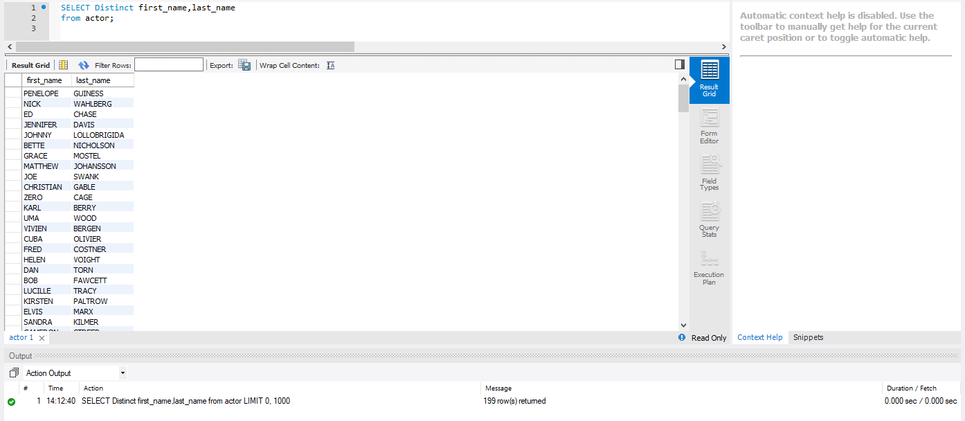

1. Retrieve all payments over and above $10 made during 14-22 August 2005.

**Code:**

SELECT amount

from payment

where amount>10 AND payment_date between '2005-08-14' AND '2005-08-22';

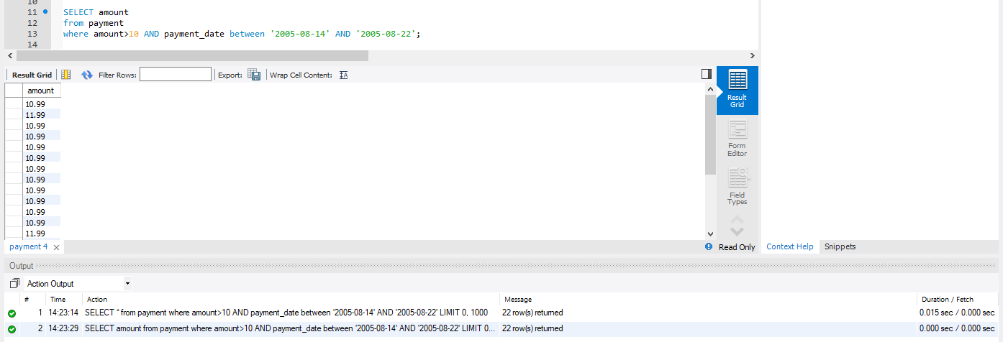

1. Find all films of more than two and half hour length and not rated PG-13.

**Code:**

SELECT title

from film

where length>150 AND rating<>13;

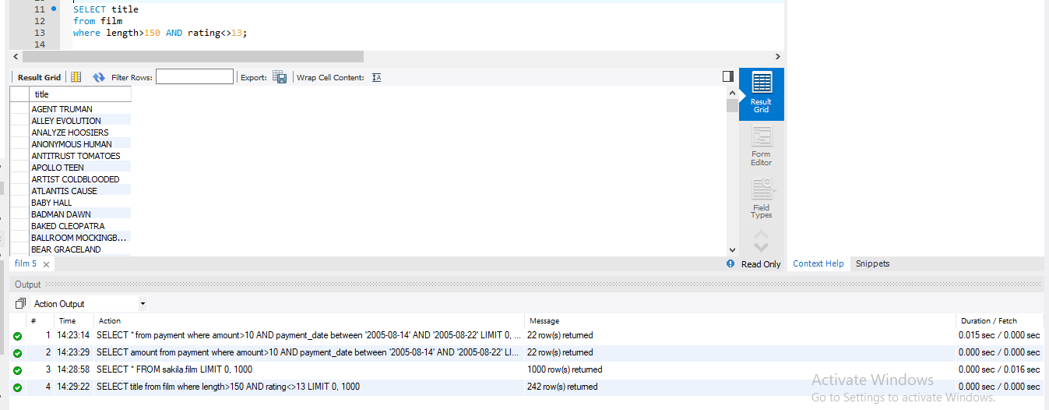

1. Find ten lengthiest films featuring “Behind the Scenes”.

**Code:**

SELECT title

from film

where special_features like '%Behind the Scenes%'

order by length desc

limit 10

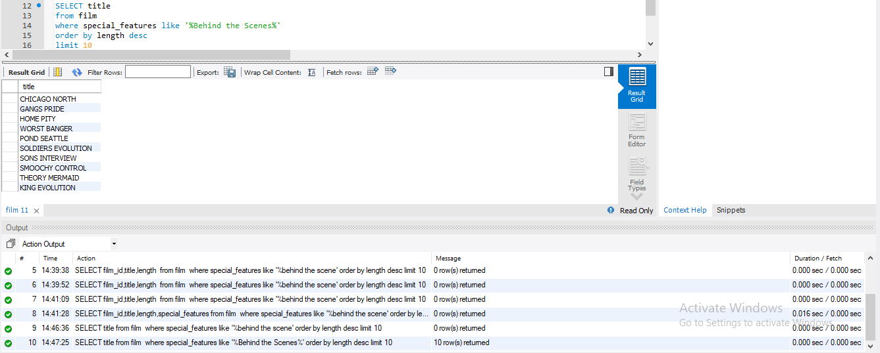

e) List id, title, rental rate, and replacement cost of all films below $1 rental value.

Sort the list on descending order of replacement cost.

**Code:**

SELECT film_id, title, rental_rate, replacement_cost

from film

where rental_rate <1

order by replacement_cost desc;

