**Mobile Application**

**Lesson Planner**



**B.S. (SE) 2013**

**BS (SE) - 2015**

**Name: Syeda Aimen Naeem Enrolment : 2015/COMP/BS-SE/18690**

**Name: Maria Abubakar Enrolment: 2015/COMP/BS-SE/18656**

**Date: 18-05-2018**

**Department of Computer Science and Information Technology**

##### Jinnah University for Women

5-C Nazimabad, Karachi 74600

**Project Description:**

Its is a Lesson Planner application, whose aim is to reduce the teacher efforts and time that teacher use in managing and scheduling their work manually. This application provides a digital way to do their work which reduce their time and efforts. In this application Teacher can manage their activities such as creating lessons scheduling lessons, Creating Co-Curricular Activities and so on.

The main user of our application are the teacher of any type who want to manage and summarize their work.

**Platform Justification:**

This application is completely based on the smart devices such as mobiles and tablet etc. This Application is built for the Android OS. The purpose of choosing this platform is to make the user accessibility much easier. By sticking to the smart devices the teacher can use our application any where they want to use. And choosing android is that it is the most common OS for the mobiles that were using in our Country.

**Major Features/Screens:**

1. **Splash screen**- This is a splash screen which is a very first screen of our app.

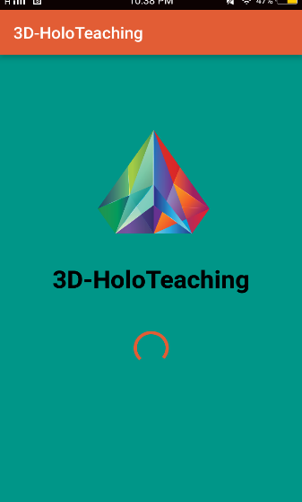

1. **Sign In for admin, teacher , and parent**- this screen gives an option for which user want to sign in.

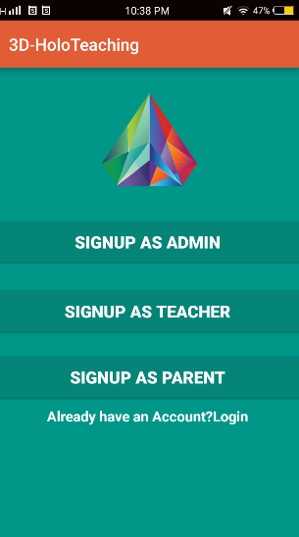

1. **Login for teacher**- this login page is only for teacher.

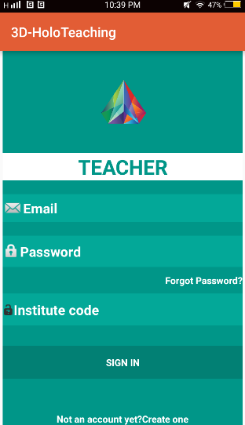

1. **Assigned Classes**- This page is contain all the classes that were assigned by the admin.

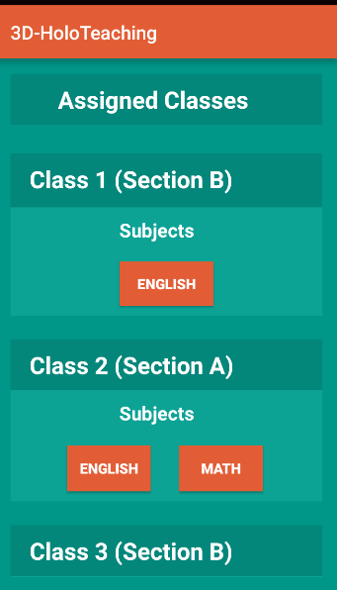

1. **Scheduled Activities**- This page contain a list of all the activities that were created.

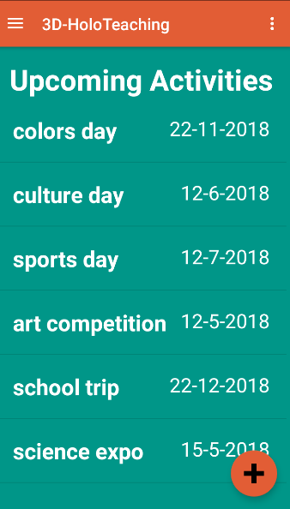

1. **Create Activities**- This page allow the user to create an activities.

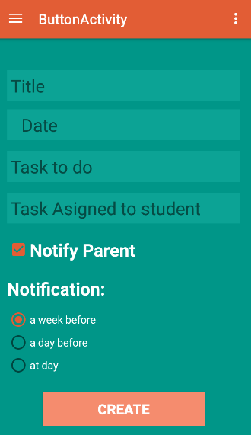

1. **Create Lesson**- This page allow the user to create lesson .

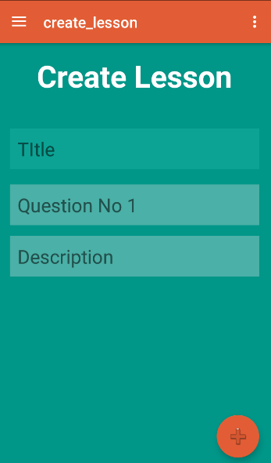

1. **Scheduled lessons**- This is a tab activity which contain 3 tabs that are monthly, weekly and daily. Which show the scheduled lesson according their tab.

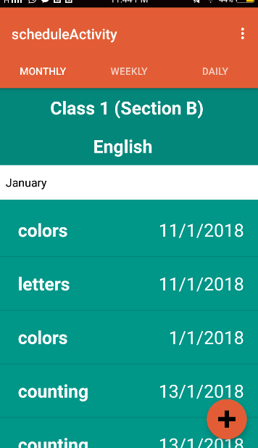

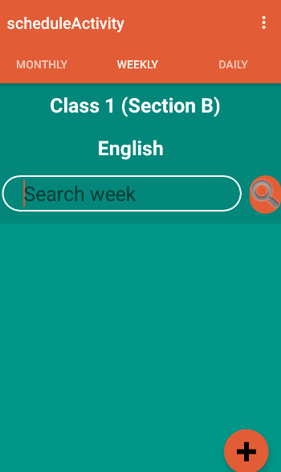

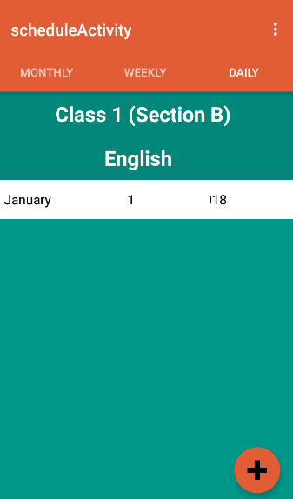

1. **List of lesson**- This screen contain a list of created lesson, By clicking on one lesson an new page will open to schedule lesson.

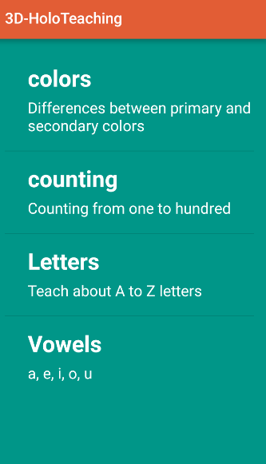

1. **Schedule Lesson**- This screen is use to schedule lesson.

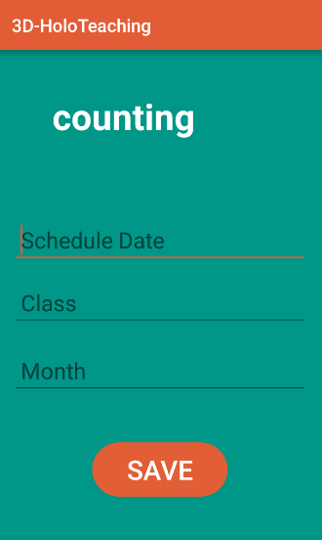

**Optional Features:**

**Activities planning-** For this feature first select the subject then activity will be open in which teacher can view its schedules activities. For creating an activity click the button at bottom right of the screen. Then an screen will open which allow teacher to create their co-curricular.

**Create Lesson**-For this feature click the top left button on the screen navigation bar will be open then select the create lesson which will direct you on a screen which aloe teacher to create their lesson.

**Schedule Lesson**- for this feature click the top left button on the screen navigation bar will be shown then select the schedule lesson which will direct you on the schedule screen which contain 3 tab of monthly schedule, weekly schedule and daily schedule. In monthly schedule there is a dropdown through that you can select the month and view lessons for that month. In weekly schedule there is a search option. In daily schedule there is a dropdown for selecting a specific date.

At the bottom right of the screen click the button which will direct you on the screens on which all the the created lessons are shown in which you have to select one which you want to schedule after clicking a new screen will be open which allow you to enter date and class for the selected lesson and save.

**Testing Methodologies:**

For Testing this application we will check the following things:

* All the data feeding is done properly through the form screens such as activities creation, lesson creation, scheduling lessons.
* All the data fetching from the firebase database should be done properly at their tragetd screens.
* Application should only allow the authenticate users to access the application
* After logging off user should not be able to access the screens.

**Usage:**

To use this application you should have the following things:

* Internet Connection.
* Should have Email id and password.
* Should have Classes assigned by the admin.

**Lesson Learned:**

While Creating this project we have learned about how to create firebase project and use it in android studio, Authenticate email id through firebase authentication, data feeding and fetching from the firebase database, firebase queries, tab screens , navigation bar and a lot more about android studio.

**Coding:**

1. **ActivityAdapter:**

package com.example.lenovo.a3d_holoteaching;

import android.app.Activity;

import android.support.annotation.NonNull;

import android.view.LayoutInflater;

import android.view.View;

import android.view.ViewGroup;

import android.widget.ArrayAdapter;

import android.widget.TextView;

import java.util.List;

public class ActivitiesAdapter extends ArrayAdapter<CreateActivites> {

private Activity context;

private List<CreateActivites> activitieslist;

public ActivitiesAdapter(Activity context, List<CreateActivites> activitieslist){

super(context,R.layout.list_layout,activitieslist);

this.context = context;

this.activitieslist = activitieslist;

}

@NonNull

@Override

public View getView(int position, View convertView, ViewGroup parent) {

LayoutInflater inflater = context.getLayoutInflater();

View ListViewItem = inflater.inflate(R.layout.list_layout,null,true);

TextView title = (TextView) ListViewItem.findViewById((R.id.title));

TextView date = (TextView) ListViewItem.findViewById((R.id.date));

CreateActivites act = activitieslist.get(position);

title.setText(act.getActivitytitle());

date.setText(act.getScheduleddate());

return ListViewItem;}}

1. **Create Activities:**

package com.example.lenovo.a3d_holoteaching;

import android.content.Context;

import android.content.Intent;

import android.os.Bundle;

import android.support.design.widget.NavigationView;

import android.support.v4.view.GravityCompat;

import android.support.v4.widget.DrawerLayout;

import android.support.v7.app.ActionBarDrawerToggle;

import android.support.v7.app.AppCompatActivity;

import android.support.v7.widget.Toolbar;

import android.text.TextUtils;

import android.view.Menu;

import android.view.MenuItem;

import android.view.View;

import android.widget.Button;

import android.widget.EditText;

import android.widget.Toast;

import com.google.firebase.auth.FirebaseAuth;

import com.google.firebase.database.DatabaseReference;

import com.google.firebase.database.FirebaseDatabase;

public class ButtonActivity extends AppCompatActivity

implements NavigationView.OnNavigationItemSelectedListener {

Context ctx=ButtonActivity.this;

Button btn_create;

EditText ettitle, etdate, ettask, editText;

DatabaseReference databaseActivities;

@Override

protected void onCreate(Bundle savedInstanceState) {

super.onCreate(savedInstanceState);

setContentView(R.layout.activity_button);

Toolbar toolbar = (Toolbar) findViewById(R.id.toolbar);

setSupportActionBar(toolbar);

databaseActivities = FirebaseDatabase.getInstance().getReference("Activities");

btn_create= (Button) findViewById(R.id.btn_create);

ettitle = (EditText) findViewById(R.id.ettitle);

etdate = (EditText) findViewById(R.id.etdate);

ettask = (EditText) findViewById(R.id.ettask);

editText = (EditText) findViewById(R.id.editText);

btn_create.setOnClickListener(new View.OnClickListener() {

@Override

public void onClick(View v) {

createActivity();

}

});

DrawerLayout drawer = (DrawerLayout) findViewById(R.id.drawer_layout);

ActionBarDrawerToggle toggle = new ActionBarDrawerToggle(

this, drawer, toolbar, R.string.navigation_drawer_open, R.string.navigation_drawer_close);

drawer.setDrawerListener(toggle);

toggle.syncState();

NavigationView navigationView = (NavigationView) findViewById(R.id.nav_view);

navigationView.setNavigationItemSelectedListener(this);

}

@Override

public void onBackPressed() {

DrawerLayout drawer = (DrawerLayout) findViewById(R.id.drawer_layout);

if (drawer.isDrawerOpen(GravityCompat.START)) {

drawer.closeDrawer(GravityCompat.START);

} else {

super.onBackPressed();

}

}

@Override

public boolean onCreateOptionsMenu(Menu menu) {

// Inflate the menu; this adds items to the action bar if it is present.

getMenuInflater().inflate(R.menu.button, menu);

return true;

}

@Override

public boolean onOptionsItemSelected(MenuItem item) {

// Handle action bar item clicks here. The action bar will

// automatically handle clicks on the Home/Up button, so long

// as you specify a parent activity in AndroidManifest.xml.

int id = item.getItemId();

//noinspection SimplifiableIfStatement

if (id == R.id.action_settings) {

return true;

}

return super.onOptionsItemSelected(item);

}

@SuppressWarnings("StatementWithEmptyBody")

@Override

public boolean onNavigationItemSelected(MenuItem item) {

// Handle navigation view item clicks here.

int id = item.getItemId();

if (id == R.id.nav_model) {

Intent intent = new Intent(ctx,ModelLibrary.class);

startActivity(intent);

} else if (id == R.id.nav_weeklyreport) {

} else if (id == R.id.nav_activity) {

Intent intent=new Intent(ctx,TeacherHome.class);

startActivity(intent);

} else if (id == R.id.lesson) {

Intent intent = new Intent(ctx,create_lesson.class);

startActivity(intent);

}else if(id == R.id.lessonschedule){

Intent intent = new Intent(ctx,scheduleActivity.class);

startActivity(intent);

}else if(id == R.id.nav_feedback){

Intent intent =new Intent(ctx,boardcast_teacher.class);

startActivity(intent);

}else if(id == R.id.nav_log){

FirebaseAuth.getInstance().signOut();

Intent intent = new Intent(ctx,login_as_teacher.class);

finish();

}

DrawerLayout drawer = (DrawerLayout) findViewById(R.id.drawer_layout);

drawer.closeDrawer(GravityCompat.START);

return true;

}

private void createActivity(){

String title = ettitle.getText().toString().trim();

String date = etdate.getText().toString().trim();

String message = ettask.getText().toString().trim();

String taskstd = editText.getText().toString().trim();

if(!TextUtils.isEmpty(title)){

String id =databaseActivities.push().getKey();

CreateActivites activities = new CreateActivites(id, title,date,message,taskstd);

databaseActivities.child(id).setValue(activities);

Toast.makeText(ButtonActivity.this, "activities created", Toast.LENGTH_SHORT).show();

}else{

Toast.makeText(ButtonActivity.this, "Title is required.", Toast.LENGTH_SHORT).show();

}

}

}

1. **Main Create lesson Class:**

package com.example.lenovo.a3d_holoteaching;

import android.content.Context;

import android.content.Intent;

import android.os.Bundle;

import android.support.design.widget.FloatingActionButton;

import android.support.design.widget.NavigationView;

import android.support.v4.view.GravityCompat;

import android.support.v4.widget.DrawerLayout;

import android.support.v7.app.ActionBarDrawerToggle;

import android.support.v7.app.AppCompatActivity;

import android.support.v7.widget.Toolbar;

import android.text.TextUtils;

import android.view.Menu;

import android.view.MenuItem;

import android.view.View;

import android.widget.EditText;

import android.widget.Toast;

import com.google.firebase.auth.FirebaseAuth;

import com.google.firebase.database.DatabaseReference;

import com.google.firebase.database.FirebaseDatabase;

public class create_lesson extends AppCompatActivity

implements NavigationView.OnNavigationItemSelectedListener {

Context ctx =create_lesson.this;

EditText title, ques, description;

DatabaseReference databaselesson;

@Override

protected void onCreate(Bundle savedInstanceState) {

super.onCreate(savedInstanceState);

setContentView(R.layout.activity_create_lesson);

Toolbar toolbar = (Toolbar) findViewById(R.id.toolbar);

setSupportActionBar(toolbar);

title= (EditText) findViewById(R.id.title);

ques = (EditText) findViewById(R.id.ques);

description = (EditText) findViewById(R.id.description);

databaselesson = FirebaseDatabase.getInstance().getReference("Lessons");

FloatingActionButton fab = (FloatingActionButton) findViewById(R.id.fab);

fab.setOnClickListener(new View.OnClickListener() {

@Override

public void onClick(View view) {

createLesson();

}

});

DrawerLayout drawer = (DrawerLayout) findViewById(R.id.drawer_layout);

ActionBarDrawerToggle toggle = new ActionBarDrawerToggle(

this, drawer, toolbar, R.string.navigation_drawer_open, R.string.navigation_drawer_close);

drawer.setDrawerListener(toggle);

toggle.syncState();

NavigationView navigationView = (NavigationView) findViewById(R.id.nav_view);

navigationView.setNavigationItemSelectedListener(this);

}

@Override

public void onBackPressed() {

DrawerLayout drawer = (DrawerLayout) findViewById(R.id.drawer_layout);

if (drawer.isDrawerOpen(GravityCompat.START)) {

drawer.closeDrawer(GravityCompat.START);

} else {

super.onBackPressed();

}

}

@Override

public boolean onCreateOptionsMenu(Menu menu) {

// Inflate the menu; this adds items to the action bar if it is present.

getMenuInflater().inflate(R.menu.create_lesson, menu);

return true;

}

@Override

public boolean onOptionsItemSelected(MenuItem item) {

// Handle action bar item clicks here. The action bar will

// automatically handle clicks on the Home/Up button, so long

// as you specify a parent activity in AndroidManifest.xml.

int id = item.getItemId();

//noinspection SimplifiableIfStatement

if (id == R.id.action_settings) {

return true;

}

return super.onOptionsItemSelected(item);

}

@SuppressWarnings("StatementWithEmptyBody")

@Override

public boolean onNavigationItemSelected(MenuItem item) {

// Handle navigation view item clicks here.

int id = item.getItemId();

if (id == R.id.nav_model) {

Intent intent = new Intent(ctx,ModelLibrary.class);

startActivity(intent);

} else if (id == R.id.nav_weeklyreport) {

} else if (id == R.id.nav_activity) {

Intent intent=new Intent(ctx,TeacherHome.class);

startActivity(intent);

} else if (id == R.id.lesson) {

Intent intent = new Intent(ctx,create_lesson.class);

startActivity(intent);

}else if(id == R.id.lessonschedule){

Intent intent = new Intent(ctx,scheduleActivity.class);

startActivity(intent);

}else if(id == R.id.nav_feedback){

Intent intent =new Intent(ctx,boardcast_teacher.class);

startActivity(intent);

}else if(id == R.id.nav_log){

FirebaseAuth.getInstance().signOut();

Intent intent = new Intent(ctx,login_as_teacher.class);

finish();

}

DrawerLayout drawer = (DrawerLayout) findViewById(R.id.drawer_layout);

drawer.closeDrawer(GravityCompat.START);

return true; }

public void createLesson(){

String titlee = title.getText().toString().trim();

String quess = ques.getText().toString().trim();

String des = description.getText().toString().trim();

if(!TextUtils.isEmpty(titlee)) {

String id = databaselesson.push().getKey();

CreateLesson activities = new CreateLesson(id, titlee, quess, des);

databaselesson.child(id).setValue(activities);

Toast.makeText(create_lesson.this, "Lesson is created", Toast.LENGTH_SHORT).show();

}else{

Toast.makeText(create_lesson.this, "Title is required.", Toast.LENGTH_SHORT).show();

}}}

1. **Createn Lesson (DataSet) class:**

package com.example.lenovo.a3d_holoteaching;

/**

* Created by Lenovo on 5/3/2018.

*/

public class CreateLesson {

String id;

String title;

String ques;

String description;

public CreateLesson() {

}

public CreateLesson(String id, String title, String ques, String description) {

this.id = id;

this.title = title;

this.ques = ques;

this.description = description;

}

public String getTitle() {

return title;

}

public String getQues() {

return ques;

}

public String getDescription() {

return description;

}

public String getId() {

return id;

}

}

1. **Lesson Adapter class:**

package com.example.lenovo.a3d_holoteaching;

import android.app.Activity;

import android.support.annotation.NonNull;

import android.view.LayoutInflater;

import android.view.View;

import android.view.ViewGroup;

import android.widget.ArrayAdapter;

import android.widget.TextView;

import java.util.List;

/**

* Created by Lenovo on 5/5/2018.

*/

public class lessonAdapter extends ArrayAdapter<CreateLesson> {

private Activity context;

private List<CreateLesson> lessonlist;

public lessonAdapter(Activity context, List<CreateLesson> lessonlist){

super(context,R.layout.list_layout,lessonlist);

this.context = context;

this.lessonlist = lessonlist;

}

@NonNull

@Override

public View getView(int position, View convertView, ViewGroup parent) {

LayoutInflater inflater = context.getLayoutInflater();

View ListViewItem = inflater.inflate(R.layout.mlist_layout,null,true);

TextView title = (TextView) ListViewItem.findViewById((R.id.title));

TextView date = (TextView) ListViewItem.findViewById((R.id.ques));

CreateLesson act = lessonlist.get(position);

title.setText(act.getTitle());

date.setText(act.getQues());

return ListViewItem;}}

1. **Monthly Schedule:**

package com.example.lenovo.a3d_holoteaching;

import android.content.Context;

import android.os.Bundle;

import android.support.v4.app.Fragment;

import android.view.LayoutInflater;

import android.view.View;

import android.view.ViewGroup;

import android.widget.AdapterView;

import android.widget.ArrayAdapter;

import android.widget.ListView;

import android.widget.Spinner;

import android.widget.Toast;

import com.google.firebase.database.DataSnapshot;

import com.google.firebase.database.DatabaseError;

import com.google.firebase.database.DatabaseReference;

import com.google.firebase.database.FirebaseDatabase;

import com.google.firebase.database.Query;

import com.google.firebase.database.ValueEventListener;

import java.util.ArrayList;

import java.util.List;

public class Month extends Fragment {

Spinner month;

Month ctx= Month.this;

ListView mschedule;

List<slesson> msch;

DatabaseReference db;

@Override

public View onCreateView(LayoutInflater inflater, ViewGroup container,

Bundle savedInstanceState) {

final View rootView = inflater.inflate(R.layout.activity_month, container, false);

mschedule= (ListView) rootView.findViewById(R.id.mschedule);

db = FirebaseDatabase.getInstance().getReference("ScheduleLessons");

Context ctx = rootView.getContext();

msch = new ArrayList<>();

month = (Spinner) rootView.findViewById(R.id.month);

ArrayAdapter<CharSequence> aa= ArrayAdapter.createFromResource(rootView.getContext(),R.array.months,android.R.layout.simple_spinner_dropdown_item);

aa.setDropDownViewResource(android.R.layout.simple_spinner_dropdown_item);

month.setAdapter(aa);

month.setOnItemSelectedListener(new AdapterView.OnItemSelectedListener() {

@Override

public void onItemSelected(AdapterView<?> parent, View view, int position, long id) {

String text = month.getSelectedItem().toString();

Query query = FirebaseDatabase.getInstance().getReference("ScheduleLessons").orderByChild("month").equalTo(text);

Toast.makeText(rootView.getContext(),text+ " is selected", Toast.LENGTH_SHORT).show();

query.addValueEventListener(new ValueEventListener() {

@Override

public void onDataChange(DataSnapshot dataSnapshot) {

msch.clear();

for(DataSnapshot activitiesSnapshot : dataSnapshot.getChildren() ){

slesson act = activitiesSnapshot.getValue(slesson.class);

msch.add(act);

//Toast.makeText(scheduling.this, act.getTitle(), Toast.LENGTH_SHORT).show();

}

monthAdapter adapter = new monthAdapter(getActivity(),msch);

mschedule.setAdapter(adapter);

}

@Override

public void onCancelled(DatabaseError databaseError) {

} });}

@Override

public void onNothingSelected(AdapterView<?> parent) {

}}); return rootView;}

@Override

public void onStart() {

super.onStart();

}}

1. **MonthAdapter:**

package com.example.lenovo.a3d_holoteaching;

import android.app.Activity;

import android.support.annotation.NonNull;

import android.view.LayoutInflater;

import android.view.View;

import android.view.ViewGroup;

import android.widget.ArrayAdapter;

import android.widget.TextView;

import java.util.List;

/**

* Created by Lenovo on 5/6/2018.

*/

public class monthAdapter extends ArrayAdapter<slesson> {

private Activity context;

private List<slesson> slessonList;

public monthAdapter(Activity context, List<slesson> slessonList){

super(context,R.layout.month_layout_list,slessonList);

this.context = context;

this.slessonList = slessonList;

}

@NonNull

@Override

public View getView(int position, View convertView, ViewGroup parent) {

LayoutInflater inflater = context.getLayoutInflater();

View ListViewItem = inflater.inflate(R.layout.month_layout_list,null,true);

TextView title = (TextView) ListViewItem.findViewById((R.id.LessonName));

TextView date = (TextView) ListViewItem.findViewById((R.id.date));

slesson act = slessonList.get(position);

title.setText(act.getName());

date.setText(act.getDate());

return ListViewItem; }}

1. **Login page:**

package com.example.lenovo.a3d_holoteaching;

import android.content.Intent;

import android.os.Bundle;

import android.support.annotation.NonNull;

import android.support.v7.app.AppCompatActivity;

import android.text.Editable;

import android.text.TextWatcher;

import android.view.View;

import android.widget.Button;

import android.widget.EditText;

import android.widget.TextView;

import android.widget.Toast;

import com.google.android.gms.tasks.OnCompleteListener;

import com.google.android.gms.tasks.Task;

import com.google.firebase.auth.AuthResult;

import com.google.firebase.auth.FirebaseAuth;

import java.util.regex.Pattern;

public class login_as_teacher extends AppCompatActivity {

EditText email, password, institute_code;

Button email_sign_in_button;

TextView SignUpTextView;

private FirebaseAuth mAuth;

public FirebaseAuth.AuthStateListener mAuthListener;

final static String Email = "^[_A-Za-z0-9-\\+]+(\\.[_A-Za-z0-9-]+)*@[A-Za-z0-9-]+(\\.[A-Za-z0-9]+)*(\\.[A-Za-z]{2,})$";

@Override

protected void onCreate(Bundle savedInstanceState) {

super.onCreate(savedInstanceState);

setContentView(R.layout.activity_login_as_teacher);

mAuth= FirebaseAuth.getInstance();

email = (EditText) findViewById(R.id.email);

password = (EditText) findViewById(R.id.password);

institute_code = (EditText) findViewById(R.id.institute_code);

SignUpTextView = (TextView) findViewById(R.id.signUpTextView);

email_sign_in_button = (Button) findViewById(R.id.email_sign_in_button);

mAuthListener = new FirebaseAuth.AuthStateListener(){

@Override

public void onAuthStateChanged(@NonNull FirebaseAuth firebaseAuth){

if(firebaseAuth.getCurrentUser() != null){

startActivity(new Intent(login_as_teacher.this,teacher_main.class));

}

}

};

email.addTextChangedListener(new TextWatcher() {

@Override

public void beforeTextChanged(CharSequence s, int start, int count, int after) {

}

@Override

public void onTextChanged(CharSequence s, int start, int before, int count) {

}

@Override

public void afterTextChanged(Editable s) {

if (Pattern.matches(Email, email.getText().toString().trim())) {

} else {

email.setError("invalid email address");

}

}

});

password.addTextChangedListener(new TextWatcher() {

@Override

public void beforeTextChanged(CharSequence s, int start, int count, int after) {

}

@Override

public void onTextChanged(CharSequence s, int start, int before, int count) {

}

@Override

public void afterTextChanged(Editable s) {

if (!(password.getText().toString().length() >= 6)) {

password.setError("should contain 6 to 8 letter ");

}}});

email_sign_in_button.setOnClickListener(new View.OnClickListener() {

@Override

public void onClick(View v) {

if (email.getText().toString().length() == 0) {

email.setError("Email is required");

} else if (password.getText().toString().length() == 0) {

password.setError("Name is required");

} else {

startsignin();}}});

SignUpTextView.setOnClickListener(new View.OnClickListener() {

@Override

public void onClick(View v) {

Intent intent = new Intent(login_as_teacher.this,signup_teacher.class);

startActivity(intent);}});}

@Override

public void onStart() {

super.onStart();

mAuthListener.onAuthStateChanged(mAuth);

}

private void startsignin() {

String emaill = email.getText().toString();

String pass = password.getText().toString();

mAuth.signInWithEmailAndPassword(emaill,pass).addOnCompleteListener(new OnCompleteListener<AuthResult>() {

@Override

public void onComplete(@NonNull Task<AuthResult> task) {

if(!task.isSuccessful()){

Toast.makeText(login_as_teacher.this, "sign in problem", Toast.LENGTH_SHORT).show();

}else {

Intent intent = new Intent(login_as_teacher.this, teacher_main.class);

startActivity(intent);

finish();

}} });}}