SS4850 Final Project

Rui Zhu

4/6/2021

# Explanatory analysis

HCVdata <- read.csv(file = 'hcvdat0.csv')  
suppressMessages(library(dplyr))  
drop <- c("X")  
HCVdata = HCVdata[,!(names(HCVdata) %in% drop)]  
colnames(HCVdata) = c("Category","Age","Sex","ALB","ALP","ALT","AST",  
 "BIL","CHE","CHOL","CREA","GGT","PROT")  
  
# 1 and 2 for blood donor and suspect blood donor, 2,3,4 for hepatitis, fibrosis,cirrhosis respectively  
HCVdata$Category <- factor(HCVdata$Category,labels=c(1,2,3,4,5),  
 levels=c('0=Blood Donor',  
 '0s=suspect Blood Donor',  
 '1=Hepatitis',  
 '2=Fibrosis',   
 '3=Cirrhosis'))  
  
  
# 0 for male, 1 for female  
HCVdata$Sex <- factor(HCVdata$Sex,levels=c("m","f"),labels=c("0","1"))  
HCVdata=na.omit(HCVdata[c("Category","Age","Sex","ALB","ALP","ALT","AST",  
 "BIL","CHE","CHOL","CREA","GGT","PROT")])  
for(var in 1:13)  
{  
 HCVdata[,var]=as.numeric(HCVdata[,var])  
}  
  
tail(HCVdata)

## Category Age Sex ALB ALP ALT AST BIL CHE CHOL CREA GGT PROT  
## 608 5 52 2 39 37.0 1.3 30.4 21 6.33 3.78 158.2 142.5 82.7  
## 609 5 58 2 34 46.4 15.0 150.0 8 6.26 3.98 56.0 49.7 80.6  
## 610 5 59 2 39 51.3 19.6 285.8 40 5.77 4.51 136.1 101.1 70.5  
## 611 5 62 2 32 416.6 5.9 110.3 50 5.57 6.30 55.7 650.9 68.5  
## 612 5 64 2 24 102.8 2.9 44.4 20 1.54 3.02 63.0 35.9 71.3  
## 613 5 64 2 29 87.3 3.5 99.0 48 1.66 3.63 66.7 64.2 82.0

# EDA!!!

#class information, distribution of "category"  
library(dplyr)  
HCVdata %>%   
 group_by(Category) %>%  
 summarise(no_rows = length(Category))

## # A tibble: 5 x 2  
## Category no_rows  
## <dbl> <int>  
## 1 1 526  
## 2 2 7  
## 3 3 20  
## 4 4 12  
## 5 5 24

#mean of each variable  
colMeans(HCVdata)

## Category Age Sex ALB ALP ALT AST BIL   
## 1.303905 47.417657 1.383701 41.624278 68.123090 26.575382 33.772835 11.018166   
## CHE CHOL CREA GGT PROT   
## 8.203633 5.391341 81.669100 38.198472 71.890153

#median of each variable  
apply(HCVdata,2,median)

## Category Age Sex ALB ALP ALT AST BIL   
## 1.00 47.00 1.00 41.90 66.20 22.70 25.70 7.10   
## CHE CHOL CREA GGT PROT   
## 8.26 5.31 77.00 22.80 72.10

## train and test split 7:3

## train and test set 7:3  
HCVdata<-HCVdata[complete.cases(HCVdata),]  
set.seed(4850)  
sample <- sample.int(n = nrow(HCVdata), size = floor(.70*nrow(HCVdata)), replace = F)  
train <- HCVdata[sample, ]  
test <- HCVdata[-sample, ]

## roc with random forest

#binary category  
#1 for HCV, 0 for donor(regular/suspect)  
set.seed(4850)  
train$binary <- ifelse(as.numeric(train$Category)>2,1,0)  
test$binary <- ifelse(as.numeric(test$Category)>2,1,0)  
#barplot on binary  
counts <- table(train$binary)  
barplot(counts, main="HCV distribution",  
 xlab="Binary")

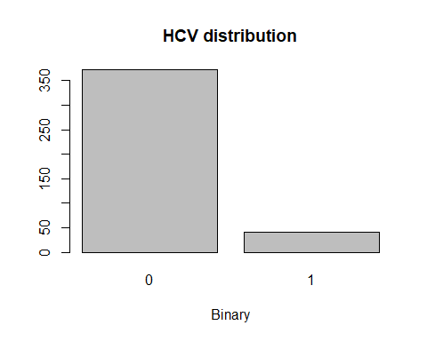

#load libraries  
library(randomForest)

## randomForest 4.6-14

## Type rfNews() to see new features/changes/bug fixes.

##   
## Attaching package: 'randomForest'

## The following object is masked from 'package:dplyr':  
##   
## combine

rfmod <- randomForest(formula = binary ~ .-Category, data = train, ntree = 10, maxnodes= 100, norm.votes = F)

## Warning in randomForest.default(m, y, ...): The response has five or fewer  
## unique values. Are you sure you want to do regression?

suppressMessages(library(dplyr))  
testm <- mutate(test,  
 rf_pred = predict(rfmod,newdata = test,  
 type="response"))  
  
suppressMessages(library(pROC))  
  
rocrf <- roc(testm$binary,testm$rf_pred)

## Setting levels: control = 0, case = 1

## Setting direction: controls < cases

AUCrf <- auc(rocrf)  
rs <- rocrf[['rocs']]

## Mixed model GLMM

### binary random: AST

suppressMessages(library(ggpubr))  
library(ggplot2)  
agePlot=ggplot(train, aes(x=Age,y=binary))+geom_point()  
ALPPlot=ggplot(train, aes(x=ALP,y=binary))+geom_point()  
ALBPlot=ggplot(train, aes(x=ALB,y=binary))+geom_point()  
  
# regular logistic model  
bmod <- glm(binary ~.-Category,binomial,data=,train)

## Warning: glm.fit: fitted probabilities numerically 0 or 1 occurred

#GLMM model random effect:Age  
library(MASS)

##   
## Attaching package: 'MASS'

## The following object is masked from 'package:dplyr':  
##   
## select

set.seed(4850)  
suppressMessages(modpql1 <- glmmPQL(binary ~Sex+ALB+Age+ALT+ALT+BIL+CHE+CHOL+CREA+GGT+PROT,  
 data=train, random= ~ 1|AST, family=binomial))

## Warning: glm.fit: fitted probabilities numerically 0 or 1 occurred

suppressMessages(drop1(modpql1, test="Chi"))

## Warning: glm.fit: fitted probabilities numerically 0 or 1 occurred  
  
## Warning: glm.fit: fitted probabilities numerically 0 or 1 occurred  
  
## Warning: glm.fit: fitted probabilities numerically 0 or 1 occurred  
  
## Warning: glm.fit: fitted probabilities numerically 0 or 1 occurred  
  
## Warning: glm.fit: fitted probabilities numerically 0 or 1 occurred  
  
## Warning: glm.fit: fitted probabilities numerically 0 or 1 occurred  
  
## Warning: glm.fit: fitted probabilities numerically 0 or 1 occurred  
  
## Warning: glm.fit: fitted probabilities numerically 0 or 1 occurred

## Single term deletions  
##   
## Model:  
## binary ~ Sex + ALB + Age + ALT + ALT + BIL + CHE + CHOL + CREA +   
## GGT + PROT  
## Df AIC LRT Pr(>Chi)  
## <none>   
## Sex 1   
## ALB 1   
## Age 1   
## ALT 1   
## BIL 1   
## CHE 1   
## CHOL 1   
## CREA 1   
## GGT 1   
## PROT 1

testm1 <- mutate(test,  
 glmm_pred = predict(modpql1,newdata = test,  
 type="response"))  
  
suppressMessages(library(pROC))  
  
roc1 <- roc(testm1$binary,testm1$glmm_pred)

## Setting levels: control = 0, case = 1

## Setting direction: controls < cases

AUC <- auc(roc1)  
rs <- roc1[['rocs']]  
coords(roc1,"best",ret=c("threshold",  
"specificity", "sensitivity", "accuracy","precision"))

## threshold specificity sensitivity accuracy precision  
## threshold 8.117251e-06 0.952381 0.6666667 0.9444444 0.2857143

# Random effect:CHE

#GLMM model random effect:CHE  
library(MASS)  
set.seed(4850)  
suppressMessages(modpql2 <- glmmPQL(binary ~Sex+ALB+Age+ALT+ALT+BIL+AST+CHOL+CREA+GGT+PROT,  
 data=train, random= ~ 1|CHE, family=binomial))

## Warning: glm.fit: fitted probabilities numerically 0 or 1 occurred

suppressMessages(drop1(modpql2, test="Chi"))

## Warning: glm.fit: fitted probabilities numerically 0 or 1 occurred  
  
## Warning: glm.fit: fitted probabilities numerically 0 or 1 occurred  
  
## Warning: glm.fit: fitted probabilities numerically 0 or 1 occurred  
  
## Warning: glm.fit: fitted probabilities numerically 0 or 1 occurred  
  
## Warning: glm.fit: fitted probabilities numerically 0 or 1 occurred  
  
## Warning: glm.fit: fitted probabilities numerically 0 or 1 occurred  
  
## Warning: glm.fit: fitted probabilities numerically 0 or 1 occurred  
  
## Warning: glm.fit: fitted probabilities numerically 0 or 1 occurred  
  
## Warning: glm.fit: fitted probabilities numerically 0 or 1 occurred

## Single term deletions  
##   
## Model:  
## binary ~ Sex + ALB + Age + ALT + ALT + BIL + AST + CHOL + CREA +   
## GGT + PROT  
## Df AIC LRT Pr(>Chi)  
## <none>   
## Sex 1   
## ALB 1   
## Age 1   
## ALT 1   
## BIL 1   
## AST 1   
## CHOL 1   
## CREA 1   
## GGT 1   
## PROT 1

testm2 <- mutate(test,  
 glmm_pred = predict(modpql2,newdata = test,  
 type="response"))  
  
suppressMessages(library(pROC))  
  
roc2 <- roc(testm2$binary,testm2$glmm_pred)

## Setting levels: control = 0, case = 1

## Setting direction: controls < cases

coords(roc2,"best",ret=c("threshold",  
"specificity", "sensitivity", "accuracy","precision"))

## threshold specificity sensitivity accuracy precision  
## threshold 0.3358878 1 0.8571429 0.9863014 1

# Random effect:Sex

#GLMM model random effect:Sex  
library(MASS)  
set.seed(4850)  
suppressMessages(modpql3 <- glmmPQL(binary ~CHE+ALB+Age+ALT+ALT+BIL+AST+CHOL+CREA+GGT+PROT,  
 data=train, random= ~ 1|Sex, family=binomial))

## Warning: glm.fit: fitted probabilities numerically 0 or 1 occurred

suppressMessages(drop1(modpql3, test="Chi"))

## Warning: glm.fit: fitted probabilities numerically 0 or 1 occurred  
  
## Warning: glm.fit: fitted probabilities numerically 0 or 1 occurred  
  
## Warning: glm.fit: fitted probabilities numerically 0 or 1 occurred  
  
## Warning: glm.fit: fitted probabilities numerically 0 or 1 occurred  
  
## Warning: glm.fit: fitted probabilities numerically 0 or 1 occurred  
  
## Warning: glm.fit: fitted probabilities numerically 0 or 1 occurred  
  
## Warning: glm.fit: fitted probabilities numerically 0 or 1 occurred  
  
## Warning: glm.fit: fitted probabilities numerically 0 or 1 occurred  
  
## Warning: glm.fit: fitted probabilities numerically 0 or 1 occurred

## Single term deletions  
##   
## Model:  
## binary ~ CHE + ALB + Age + ALT + ALT + BIL + AST + CHOL + CREA +   
## GGT + PROT  
## Df AIC LRT Pr(>Chi)  
## <none>   
## CHE 1   
## ALB 1   
## Age 1   
## ALT 1   
## BIL 1   
## AST 1   
## CHOL 1   
## CREA 1   
## GGT 1   
## PROT 1

testm3 <- mutate(test,  
 glmm_pred = predict(modpql3,newdata = test,  
 type="response"))  
  
suppressMessages(library(pROC))  
  
roc3 <- roc(testm3$binary,testm3$glmm_pred)

## Setting levels: control = 0, case = 1

## Setting direction: controls < cases

coords(roc3,"best",ret=c("threshold",  
"specificity", "sensitivity", "accuracy","precision"))

## threshold specificity sensitivity accuracy precision  
## threshold 0.4924259 0.9937888 0.9375 0.9887006 0.9375

## Deep learning

### binary

library(dplyr)  
library(keras)  
library(tensorflow)  
library(tfdatasets)  
  
  
  
set.seed(4850)  
# Store the overall correlation in `M`  
M <- cor(train[,1:10])  
  
# Plot the correlation plot with `M`  
library(corrplot)

## corrplot 0.84 loaded

predictorsCorr=corrplot(M, method="circle")

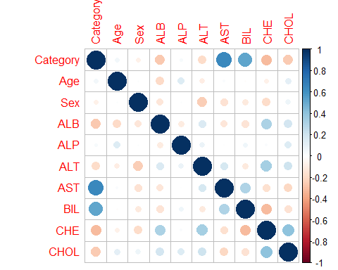

figure <- ggarrange(agePlot, ALPPlot, ALBPlot,predictorsCorr,  
 labels = c("A", "B", "C","D"),  
 ncol = 2, nrow = 2)

## Warning in as_grob.default(plot): Cannot convert object of class matrixarray  
## into a grob.

figure

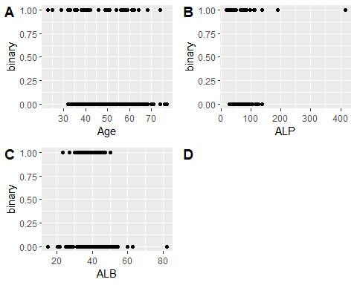

#normalize   
spec <- feature_spec(train, binary ~ .-Category ) %>%   
 step_numeric_column(all_numeric(), normalizer_fn = scaler_standard()) %>%   
 fit()

## Warning in normalizePath(path.expand(path), winslash, mustWork): path[1]="C:  
## \Users\Admin\.conda\envs\test-env/python.exe": The system cannot find the file  
## specified

## Warning in normalizePath(path.expand(path), winslash, mustWork): path[1]="C:  
## \Users\Admin\.conda\envs\test-env/python.exe": The system cannot find the file  
## specified

spec

## -- Feature Spec ----------------------------------------------------------------   
## A feature_spec with 12 steps.  
## Fitted: TRUE   
## -- Steps -----------------------------------------------------------------------   
## The feature_spec has 1 dense features.  
## StepNumericColumn: Age, Sex, ALB, ALP, ALT, AST, BIL, CHE, CHOL, CREA, GGT, PROT   
## -- Dense features --------------------------------------------------------------

layer <- layer_dense_features(  
 feature_columns = dense_features(spec),   
 dtype = tf$float32  
)  
suppressMessages(layer(train))

## tf.Tensor(  
## [[ 0.653347 -0.6670947 -0.568868 ... -0.4312038 0.7929118  
## -0.76765865]  
## [-0.44780117 -0.22397378 -0.13247223 ... -0.32766175 -0.35917082  
## -0.76765865]  
## [-0.05207561 2.561358 0.41447717 ... 1.2864846 0.079717  
## 1.2995006 ]  
## ...  
## [-0.9811694 -0.68571323 -1.2147336 ... 0.36570016 0.55518115  
## -0.76765865]  
## [-1.1188128 0.05530416 -0.1441094 ... -0.14276527 -2.059866  
## 1.2995006 ]  
## [ 0.08556774 -0.71922666 0.8683287 ... 0.6338001 -0.03000497  
## -0.76765865]], shape=(412, 12), dtype=float32)

input <- layer_input_from_dataset(train[,2:13])  
  
  
output <- input %>%   
 layer_dense_features(dense_features(spec)) %>%   
 layer_dense(units = 64, activation = "relu") %>%  
 layer_dense(units = 64, activation = "relu") %>%  
 layer_dense(units = 1)   
  
dpmod <- keras_model(input, output)  
  
  
  
  
  
dpmod %>%   
 compile(  
 loss = "mse",  
 optimizer = optimizer_rmsprop(),  
 metrics = list("mean_absolute_error")  
 )  
  
build_model <- function() {  
 input <- layer_input_from_dataset(train[,2:13])  
   
 output <- input %>%   
 layer_dense_features(dense_features(spec)) %>%   
 layer_dense(units = 64, activation = "relu") %>%  
 layer_dense(units = 64, activation = "relu") %>%  
 layer_dense(units = 1)   
   
 dpmod <- keras_model(input, output)  
   
 dpmod %>%   
 compile(  
 loss = "mse",  
 optimizer = optimizer_rmsprop(),  
 metrics = list("mean_absolute_error")  
 )  
   
 dpmod  
}  
  
  
# Display training progress by printing a single dot for each completed epoch.  
print_dot_callback <- callback_lambda(  
 on_epoch_end = function(epoch, logs) {  
 if (epoch %% 80 == 0) cat("\n")  
 cat(".")  
 }  
)   
  
dpmod <- build_model()  
  
history <- dpmod %>% fit(  
 x = train[2:13],  
 y = train$binary,  
 epochs = 500,  
 validation_split = 0.2,  
 verbose = 0,  
 callbacks = list(print_dot_callback)  
)

##   
## ................................................................................  
## ................................................................................  
## ................................................................................  
## ................................................................................  
## ................................................................................  
## ................................................................................  
## ....................

library(ggplot2)  
  
plot(history)

## `geom_smooth()` using formula 'y ~ x'

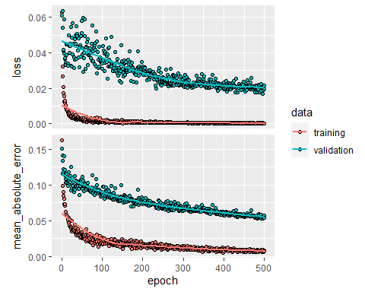

# it will stop when no more improvement  
early_stop <- callback_early_stopping(monitor = "val_loss", patience = 20)  
  
dpmod <- build_model()  
  
history <- dpmod %>% fit(  
 x = train[2:13],  
 y = train$binary,  
 epochs = 500,  
 validation_split = 0.2,  
 verbose = 0,  
 callbacks = list(early_stop)  
)  
  
plot(history)

## `geom_smooth()` using formula 'y ~ x'

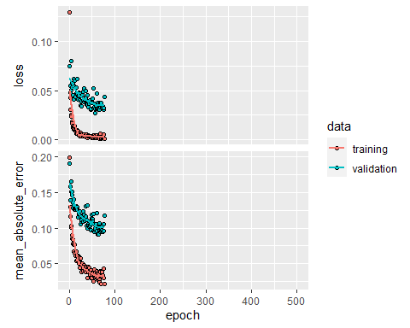

suppressMessages(library(dplyr))  
testm <- mutate(test,  
 dp_pred = dpmod %>% predict(test[,2:13]), type="response")  
  
  
  
rocnn <- roc(testm$binary,testm$dp_pred)

## Setting levels: control = 0, case = 1

## Warning in roc.default(testm$binary, testm$dp_pred): Deprecated use a matrix as  
## predictor. Unexpected results may be produced, please pass a numeric vector.

## Setting direction: controls < cases

AUCnn <- auc(rocnn)  
rs <- rocnn[['rocs']]  
suppressMessages(summary(dpmod))

## Model: "model_2"  
## ________________________________________________________________________________  
## Layer (type) Output Shape Param # Connected to   
## ================================================================================  
## ALB (InputLayer) [(None,)] 0   
## ________________________________________________________________________________  
## ALP (InputLayer) [(None,)] 0   
## ________________________________________________________________________________  
## ALT (InputLayer) [(None,)] 0   
## ________________________________________________________________________________  
## AST (InputLayer) [(None,)] 0   
## ________________________________________________________________________________  
## Age (InputLayer) [(None,)] 0   
## ________________________________________________________________________________  
## BIL (InputLayer) [(None,)] 0   
## ________________________________________________________________________________  
## CHE (InputLayer) [(None,)] 0   
## ________________________________________________________________________________  
## CHOL (InputLayer) [(None,)] 0   
## ________________________________________________________________________________  
## CREA (InputLayer) [(None,)] 0   
## ________________________________________________________________________________  
## GGT (InputLayer) [(None,)] 0   
## ________________________________________________________________________________  
## PROT (InputLayer) [(None,)] 0   
## ________________________________________________________________________________  
## Sex (InputLayer) [(None,)] 0   
## ________________________________________________________________________________  
## dense_features_3 (DenseFe (None, 12) 0 ALB[0][0]   
## ALP[0][0]   
## ALT[0][0]   
## AST[0][0]   
## Age[0][0]   
## BIL[0][0]   
## CHE[0][0]   
## CHOL[0][0]   
## CREA[0][0]   
## GGT[0][0]   
## PROT[0][0]   
## Sex[0][0]   
## ________________________________________________________________________________  
## dense_8 (Dense) (None, 64) 832 dense_features_3[0][0]   
## ________________________________________________________________________________  
## dense_7 (Dense) (None, 64) 4160 dense_8[0][0]   
## ________________________________________________________________________________  
## dense_6 (Dense) (None, 1) 65 dense_7[0][0]   
## ================================================================================  
## Total params: 5,057  
## Trainable params: 5,057  
## Non-trainable params: 0  
## ________________________________________________________________________________

#RM,(AST ALT ALP) glmm, nn  
coords(rocrf,"best",ret=c("threshold",  
"specificity", "sensitivity", "accuracy","precision"))##the random forest model

## threshold specificity sensitivity accuracy precision  
## threshold 0.2833333 0.9689441 1 0.9717514 0.7619048

coords(roc1,"best",ret=c("threshold",  
"specificity", "sensitivity", "accuracy","precision"))# the AST GLMM model

## threshold specificity sensitivity accuracy precision  
## threshold 8.117251e-06 0.952381 0.6666667 0.9444444 0.2857143

coords(roc2,"best",ret=c("threshold",  
"specificity", "sensitivity", "accuracy","precision"))#the CHE GLMM model

## threshold specificity sensitivity accuracy precision  
## threshold 0.3358878 1 0.8571429 0.9863014 1

coords(roc3,"best",ret=c("threshold",  
"specificity", "sensitivity", "accuracy","precision"))# the Sex GLMM model

## threshold specificity sensitivity accuracy precision  
## threshold 0.4924259 0.9937888 0.9375 0.9887006 0.9375

coords(rocnn,"best",ret=c("threshold",  
"specificity", "sensitivity", "accuracy","precision"))# the nn GLMM model

## threshold specificity sensitivity accuracy precision  
## threshold 0.2867029 0.9937888 0.9375 0.9887006 0.9375

#importance: impurity gini importance  
c(log(importance(rfmod)),importance(rfmod))

## [1] -1.018644e+00 -4.042568e+01 -8.560265e-01 1.207540e+00 2.027953e+00  
## [6] 2.982227e+00 5.400411e-01 2.264169e-01 -1.000342e+00 -7.677341e-01  
## [11] 9.831243e-01 -3.262736e+01 3.610843e-01 2.775558e-18 4.248468e-01  
## [16] 3.345247e+00 7.598513e+00 1.973172e+01 1.716077e+00 1.254098e+00  
## [21] 3.677537e-01 4.640634e-01 2.672794e+00 6.762646e-15

#neural network and random forest  
plot(rocrf)  
plot(rocnn, add=TRUE, col='blue')  
legend(1.45, 0.5, legend=c("RF", "NN"),  
 col=c( "black","blue"), lty=1, cex=0.8)

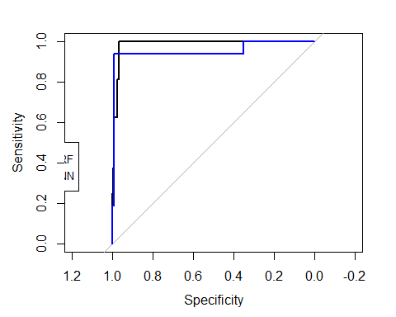

#three glmm roc curve  
plot(roc1)  
plot(roc2, add=TRUE, col='red')  
plot(roc3, add=TRUE, col='blue')  
legend(1.45, 0.5, legend=c("AST", "CHE", "Sex"),  
 col=c( "black","red", "blue"), lty=1, cex=0.8)

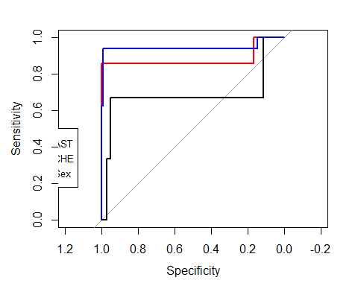

#randomforest best glmm and nn roc curve  
plot(rocrf)  
plot(roc3, add=TRUE, col='red')  
plot(rocnn, add=TRUE, col='blue')  
legend(1.45, 0.5, legend=c("RF", "Sex-GLMM", "NN"),  
 col=c( "black","red", "blue"), lty=1, cex=0.8)

