Lab1 – Introduction to Machine Learning in R
Dr. Reza Arabi Belaghi
Table of Contents

1. Overview
In this lab, you will:
- Review the basic workflow of supervised learning using logistic regression.
- Compare classical logistic regression with penalized methods: LASSO, Ridge, and Elastic Net.
- Explore a high-dimensional setting where the number of predictors is larger than the number of observations (p > n).
- Use PCA (Principal Component Analysis) as an unsupervised tool for dimensionality reduction.
- Fit penalized models on high-dimensional data.
- Work through one real-data example using a publicly available dataset.
We will use the R packages glmnet (for penalized regression) and ISLR (for a real dataset).
If needed, install them before running the lab:
# install.packages("glmnet")
# install.packages("ISLR")

2. Example 1 – Logistic Regression & Penalized Methods (Supervised ML)
In this example, we simulate a binary outcome and a few predictors. We then:
- Fit a standard logistic regression model.
- Fit LASSO, Ridge, and Elastic Net models.
- Compare their performance.

2.1 Simulate a binary classification dataset
We simulate 3 predictors where $X_{1}$ and $X_{2}$ are truly associated with the outcome, and $X_{3}$ is mostly noise.
n <- 500
x1 <- rnorm(n, mean = 0, sd = 1)
x2 <- rnorm(n, mean = 1, sd = 1.5)
x3 <- rnorm(n, mean = 0, sd = 1) # mostly noise
# True linear predictor
eta <- -0.5 + 1.2 * x1 - 1.0 * x2 + 0.1 * x3
prob <- 1 / (1 + exp(-eta))
y <- rbinom(n, size = 1, prob = prob)
data1 <- data.frame(y = factor(y), x1, x2, x3)
head(data1)
## y x1 x2 x3
## 1 0 -0.56047565 0.09716073 -0.99579872
## 2 1 -0.23017749 -0.49054789 -1.03995504
## 3 0 1.55870831 2.54017758 -0.01798024
## 4 0 0.07050839 2.12659195 -0.13217513
## 5 1 0.12928774 -1.26374981 -2.54934277
## 6 1 1.71506499 0.85727882 1.04057346

2.2 Train–test split
We split the data into training (70%) and test (30%) sets.
set.seed(123)
train_index <- sample(seq_len(nrow(data1)), size = 0.7 * nrow(data1))
train1 <- data1[train_index, ]
test1 <- data1[-train_index, ]
nrow(train1); nrow(test1)
## [1] 350
## [1] 150

2.3 Standard logistic regression (GLM)
fit_glm <- glm(y ~ x1 + x2 + x3,
data = train1,
family = binomial)
summary(fit_glm)
##
## Call:
## glm(formula = y ~ x1 + x2 + x3, family = binomial, data = train1)
##
## Coefficients:
## Estimate Std. Error z value Pr(>|z|)
## (Intercept) -0.78188 0.17272 -4.527 5.98e-06 ***
## x1 1.26506 0.20259 6.245 4.25e-10 ***
## x2 -1.00611 0.13918 -7.229 4.87e-13 ***
## x3 0.08461 0.15904 0.532 0.595
## ---
## Signif. codes: 0 '***' 0.001 '**' 0.01 '*' 0.05 '.' 0.1 ' ' 1
##
## (Dispersion parameter for binomial family taken to be 1)
##
## Null deviance: 388.05 on 349 degrees of freedom
## Residual deviance: 255.08 on 346 degrees of freedom
## AIC: 263.08
##
## Number of Fisher Scoring iterations: 6
Make predictions and evaluate accuracy on the test set:
# Predict probabilities
pred_prob_glm <- predict(fit_glm, newdata = test1, type = "response")
# Classify using 0.5 cutoff
pred_class_glm <- ifelse(pred_prob_glm > 0.5, 1, 0)
# Confusion matrix
table(Predicted = pred_class_glm, Observed = test1$y)
## Observed
## Predicted 0 1
## 0 90 24
## 1 5 31
# Accuracy
accuracy_glm <- mean(pred_class_glm == as.numeric(as.character(test1$y)))
accuracy_glm
## [1] 0.8066667
Question 1 (for students):
- Which predictors appear statistically significant in the logistic regression output?
The interaction (Intercept)
- How does this relate to how we simulated the data?

2.4 Penalized logistic regression: LASSO, Ridge, Elastic Net
We now fit penalized models using the glmnet package.
library(glmnet)
# glmnet expects matrix of predictors and numeric outcome (0/1)
x_train <- as.matrix(train1[, c("x1", "x2", "x3")])
y_train <- as.numeric(as.character(train1$y))
x_test <- as.matrix(test1[, c("x1", "x2", "x3")])
y_test <- as.numeric(as.character(test1$y))

2.4.1 LASSO (L1 penalty)
# alpha = 1 => LASSO
cv_lasso <- cv.glmnet(x_train, y_train,
family = "binomial",
alpha = 1,
nfolds = 10)
plot(cv_lasso)
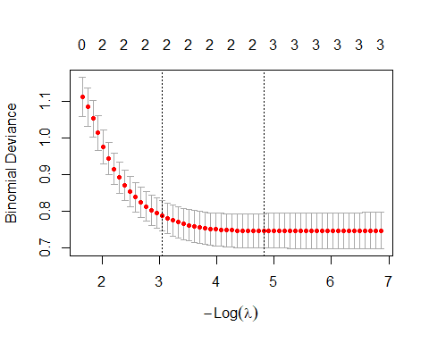
cv_lasso$lambda.min # best lambda
## [1] 0.008090269
coef(cv_lasso, s = "lambda.min")
## 4 x 1 sparse Matrix of class "dgCMatrix"
## lambda.min
## (Intercept) -0.78335303
## x1 1.13610971
## x2 -0.90987420
## x3 0.01196709
Evaluate LASSO on the test set:
pred_prob_lasso <- predict(cv_lasso, newx = x_test, s = "lambda.min", type = "response")
pred_class_lasso <- ifelse(pred_prob_lasso > 0.5, 1, 0)
table(Predicted = pred_class_lasso, Observed = y_test)
## Observed
## Predicted 0 1
## 0 90 25
## 1 5 30
accuracy_lasso <- mean(pred_class_lasso == y_test)
accuracy_lasso
## [1] 0.8

2.4.2 Ridge (L2 penalty)
# alpha = 0 => Ridge
cv_ridge <- cv.glmnet(x_train, y_train,
family = "binomial",
alpha = 0,
nfolds = 10)
plot(cv_ridge)
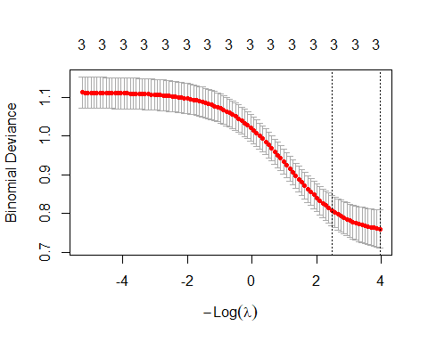
cv_ridge$lambda.min
## [1] 0.01912936
coef(cv_ridge, s = "lambda.min")
## 4 x 1 sparse Matrix of class "dgCMatrix"
## lambda.min
## (Intercept) -0.7935993
## x1 0.9972352
## x2 -0.7825003
## x3 0.0607223
Evaluate Ridge:
pred_prob_ridge <- predict(cv_ridge, newx = x_test, s = "lambda.min", type = "response")
pred_class_ridge <- ifelse(pred_prob_ridge > 0.5, 1, 0)
table(Predicted = pred_class_ridge, Observed = y_test)
## Observed
## Predicted 0 1
## 0 90 27
## 1 5 28
accuracy_ridge <- mean(pred_class_ridge == y_test)
accuracy_ridge
## [1] 0.7866667

2.4.3 Elastic Net (mix of L1 and L2)
We choose $α=0.5$ for a 50/50 mixture, but this can be tuned.
alpha_enet <- 0.5
cv_enet <- cv.glmnet(x_train, y_train,
family = "binomial",
alpha = alpha_enet,
nfolds = 10)
plot(cv_enet)
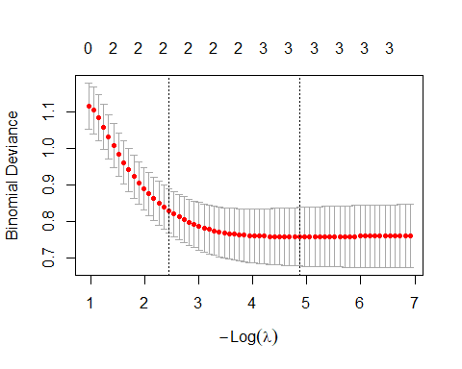
cv_enet$lambda.min
## [1] 0.007687067
coef(cv_enet, s = "lambda.min")
## 4 x 1 sparse Matrix of class "dgCMatrix"
## lambda.min
## (Intercept) -0.78426035
## x1 1.13555311
## x2 -0.90311469
## x3 0.04489156
Evaluate Elastic Net:
pred_prob_enet <- predict(cv_enet, newx = x_test, s = "lambda.min", type = "response")
pred_class_enet <- ifelse(pred_prob_enet > 0.5, 1, 0)
table(Predicted = pred_class_enet, Observed = y_test)
## Observed
## Predicted 0 1
## 0 90 25
## 1 5 30
accuracy_enet <- mean(pred_class_enet == y_test)
accuracy_enet
## [1] 0.8

2.5 Compare model performances
data.frame(
Model = c("Logistic (GLM)", "LASSO", "Ridge", "Elastic Net"),
Accuracy = c(accuracy_glm, accuracy_lasso, accuracy_ridge, accuracy_enet)
)
## Model Accuracy
## 1 Logistic (GLM) 0.8066667
## 2 LASSO 0.8000000
## 3 Ridge 0.7866667
## 4 Elastic Net 0.8000000
Question 2 (for students): - Which model has the highest accuracy?
Lasso > Ridge
We don’t need to penalize , the sample size is quite big, penalties just make things worst
- Look at the LASSO coefficients: did it shrink any variable close to zero?
Is not close to 0, it’s closer to the actual value X3
- How does penalization help when we have many predictors or multicollinearity?
It would help with many predictors.
PCA works when there is correlation

3. Example 2 – High-Dimensional Data (p > n), PCA & Penalization
In this example, we:
- Simulate a high-dimensional dataset with $n=80$ observations and $p=200$ predictors.
- Use PCA (unsupervised) for dimensionality reduction.
- Fit a logistic regression model using the leading principal components.
- Fit a LASSO logistic regression directly on the high-dimensional predictors.
This illustrates why ML (and penalized methods) are useful when p > n.

3.1 Simulate p > n data
We let only a few predictors drive the true signal, and the rest act as noise.
n_hd <- 80
p_hd <- 200
# Design matrix: standard normal
X_hd <- matrix(rnorm(n_hd * p_hd), nrow = n_hd, ncol = p_hd)
# True coefficients: only first 5 are nonzero
true_beta <- c(1.5, -1.0, 0.8, -0.7, 1.2, rep(0, p_hd - 5))
eta_hd <- X_hd %*% true_beta
prob_hd <- 1 / (1 + exp(-eta_hd))
y_hd <- rbinom(n_hd, size = 1, prob = prob_hd)
y_hd <- as.numeric(y_hd)
dim(X_hd)
## [1] 80 200
head(y_hd)
## [1] 0 0 1 0 1 0
Train–test split:
set.seed(123)
train_index_hd <- sample(seq_len(n_hd), size = 0.7 * n_hd)
X_train_hd <- X_hd[train_index_hd, ]
X_test_hd <- X_hd[-train_index_hd, ]
y_train_hd <- y_hd[train_index_hd]
y_test_hd <- y_hd[-train_index_hd]
length(y_train_hd); length(y_test_hd)
## [1] 56
## [1] 24

3.2 PCA (unsupervised step)
PCA is an unsupervised method: it ignores the outcome and tries to summarize the variance in the predictors.
pca_hd <- prcomp(X_train_hd, center = TRUE, scale. = TRUE)
# Proportion of variance explained
pve <- pca_hd$sdev^2 / sum(pca_hd$sdev^2)
plot(pve[1:20], type = "b",
xlab = "Principal Component",
ylab = "Proportion of Variance Explained",
main = "Scree Plot (first 20 PCs)")
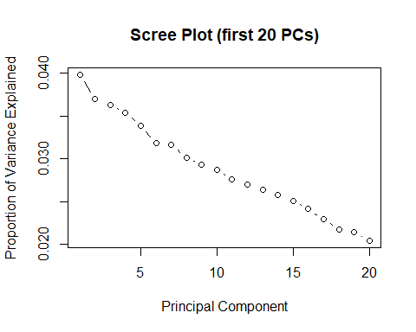
Select enough PCs to explain, say, ~80–90% of the variance:
cum_pve <- cumsum(pve)
which(cum_pve >= 0.80)[1] # first PC index reaching 80%
## [1] 34
which(cum_pve >= 0.90)[1] # first PC index reaching 90%
## [1] 42
Let’s take the first 20 PCs (for illustration).
k <- 20
Z_train <- pca_hd$x[, 1:k]
# Get PC scores for the test data
Z_test <- predict(pca_hd, newdata = X_test_hd)[, 1:k]
dim(Z_train); dim(Z_test)
## [1] 56 20
## [1] 24 20

3.3 Logistic regression on PCs (supervised model after PCA)
pca_data_train <- data.frame(y = factor(y_train_hd), Z_train)
pca_data_test <- data.frame(y = factor(y_test_hd), Z_test)
fit_glm_pca <- glm(y ~ ., data = pca_data_train, family = binomial)
summary(fit_glm_pca)
##
## Call:
## glm(formula = y ~ ., family = binomial, data = pca_data_train)
##
## Coefficients:
## Estimate Std. Error z value Pr(>|z|)
## (Intercept) -10.8844 27009.7618 0.000 1.000
## PC1 5.8119 15824.3057 0.000 1.000
## PC2 -10.0645 17002.8461 -0.001 1.000
## PC3 13.1867 12218.0701 0.001 0.999
## PC4 -5.4960 14016.2794 0.000 1.000
## PC5 -45.5201 27559.0170 -0.002 0.999
## PC6 0.8602 11391.7216 0.000 1.000
## PC7 -4.6658 24407.5686 0.000 1.000
## PC8 -4.7221 21628.3999 0.000 1.000
## PC9 -2.6138 21126.2167 0.000 1.000
## PC10 -18.6379 29075.4857 -0.001 0.999
## PC11 -1.3395 18733.9570 0.000 1.000
## PC12 -4.8297 9574.3762 -0.001 1.000
## PC13 -10.3975 25919.7505 0.000 1.000
## PC14 -17.2574 11831.7473 -0.001 0.999
## PC15 14.8863 21376.8244 0.001 0.999
## PC16 1.2611 10227.2751 0.000 1.000
## PC17 0.4723 17167.6794 0.000 1.000
## PC18 -14.8187 15601.4427 -0.001 0.999
## PC19 -6.2675 15404.5960 0.000 1.000
## PC20 -15.8044 24149.7427 -0.001 0.999
##
## (Dispersion parameter for binomial family taken to be 1)
##
## Null deviance: 7.6486e+01 on 55 degrees of freedom
## Residual deviance: 5.4891e-09 on 35 degrees of freedom
## AIC: 42
##
## Number of Fisher Scoring iterations: 25
Evaluate performance:
pred_prob_pca_glm <- predict(fit_glm_pca, newdata = pca_data_test, type = "response")
pred_class_pca_glm <- ifelse(pred_prob_pca_glm > 0.5, 1, 0)
table(Predicted = pred_class_pca_glm, Observed = y_test_hd)
## Observed
## Predicted 0 1
## 0 6 7
## 1 6 5
accuracy_pca_glm <- mean(pred_class_pca_glm == y_test_hd)
accuracy_pca_glm
## [1] 0.4583333
Question 3 (for students): - Why was it helpful (or necessary) to reduce dimensionality with PCA before fitting a logistic regression in this p > n setting?
- Is PCA supervised or unsupervised? Explain.

3.4 LASSO directly on high-dimensional predictors
Now we skip PCA and fit a LASSO model directly on $X$. This is a typical ML approach in high-dimensional data.
cv_lasso_hd <- cv.glmnet(X_train_hd, y_train_hd,
family = "binomial",
alpha = 1,
nfolds = 10)
plot(cv_lasso_hd)
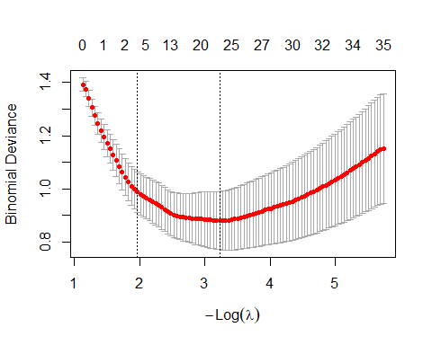
cv_lasso_hd$lambda.min
## [1] 0.03984284
Look at selected coefficients:
coef_lasso_hd <- coef(cv_lasso_hd, s = "lambda.min")
coef_lasso_hd[1:15, ] # first 15 coefficients (including intercept)
## (Intercept) V1 V2 V3 V4 V5
## -0.3555945 0.7260110 -1.1286058 0.0000000 -0.5101633 0.4454439
## V6 V7 V8 V9 V10 V11
## 0.0000000 0.0000000 0.0000000 0.0000000 0.0000000 0.0000000
## V12 V13 V14
## 0.0855619 0.0000000 0.0000000
Evaluate performance:
pred_prob_lasso_hd <- predict(cv_lasso_hd, newx = X_test_hd, s = "lambda.min", type = "response")
pred_class_lasso_hd <- ifelse(pred_prob_lasso_hd > 0.5, 1, 0)
table(Predicted = pred_class_lasso_hd, Observed = y_test_hd)
## Observed
## Predicted 0 1
## 0 10 2
## 1 2 10
accuracy_lasso_hd <- mean(pred_class_lasso_hd == y_test_hd)
accuracy_lasso_hd
## [1] 0.8333333

3.5 Compare PCA+GLM vs LASSO in high-dimensional setting
data.frame(
Model = c("GLM on first 20 PCs", "LASSO on all 200 predictors"),
Accuracy = c(accuracy_pca_glm, accuracy_lasso_hd)
)
## Model Accuracy
## 1 GLM on first 20 PCs 0.4583333
## 2 LASSO on all 200 predictors 0.8333333
Question 4 (for students): - Which approach performs better in this simulation: PCA + logistic regression or LASSO on all predictors?
- How might your choice depend on interpretability vs predictive performance in a real biomedical dataset?

4. Example 3 – Real Data: Credit Default (ISLR::Default)
In this final example, we use a real dataset from the ISLR package: Default, which contains information on individuals and whether they defaulted on their credit card debt.
We will:
- Explore the data.
- Fit a standard logistic regression model.
- Fit a LASSO logistic regression model.
- Compare predictions and discuss when ML adds value.

4.1 Load and explore the data
library(ISLR) # may need: install.packages("ISLR")
data("Default")
str(Default)
## 'data.frame': 10000 obs. of 4 variables:
## $ default: Factor w/ 2 levels "No","Yes": 1 1 1 1 1 1 1 1 1 1 ...
## $ student: Factor w/ 2 levels "No","Yes": 1 2 1 1 1 2 1 2 1 1 ...
## $ balance: num 730 817 1074 529 786 ...
## $ income : num 44362 12106 31767 35704 38463 ...
head(Default)
## default student balance income
## 1 No No 729.5265 44361.625
## 2 No Yes 817.1804 12106.135
## 3 No No 1073.5492 31767.139
## 4 No No 529.2506 35704.494
## 5 No No 785.6559 38463.496
## 6 No Yes 919.5885 7491.559
summary(Default)
## default student balance income
## No :9667 No :7056 Min. : 0.0 Min. : 772
## Yes: 333 Yes:2944 1st Qu.: 481.7 1st Qu.:21340
## Median : 823.6 Median :34553
## Mean : 835.4 Mean :33517
## 3rd Qu.:1166.3 3rd Qu.:43808
## Max. :2654.3 Max. :73554
The main variables are:
- default: Yes/No (outcome)
- student: Yes/No
- balance: average credit card balance
- income: income
We create a binary outcome (y = 1 if default == “Yes”).
Default$y <- ifelse(Default$default == "Yes", 1, 0)
# Simple exploratory plots
plot(Default$balance, Default$y,
xlab = "Balance", ylab = "Default (0/1)",
main = "Credit Card Balance vs Default")
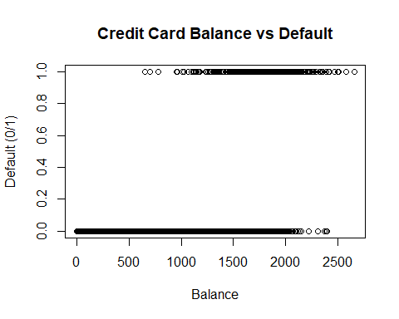
table(Default$default, Default$student)
##
## No Yes
## No 6850 2817
## Yes 206 127

4.2 Train–test split
set.seed(123)
n_def <- nrow(Default)
train_index_def <- sample(seq_len(n_def), size = 0.7 * n_def)
train_def <- Default[train_index_def, ]
test_def <- Default[-train_index_def, ]
nrow(train_def); nrow(test_def)
## [1] 7000
## [1] 3000

4.3 Standard logistic regression
fit_glm_def <- glm(y ~ student + balance + income,
data = train_def,
family = binomial)
summary(fit_glm_def)
##
## Call:
## glm(formula = y ~ student + balance + income, family = binomial,
## data = train_def)
##
## Coefficients:
## Estimate Std. Error z value Pr(>|z|)
## (Intercept) -1.109e+01 5.923e-01 -18.723 <2e-16 ***
## studentYes -5.222e-01 2.828e-01 -1.847 0.0648 .
## balance 5.760e-03 2.772e-04 20.777 <2e-16 ***
## income 7.592e-06 9.799e-06 0.775 0.4385
## ---
## Signif. codes: 0 '***' 0.001 '**' 0.01 '*' 0.05 '.' 0.1 ' ' 1
##
## (Dispersion parameter for binomial family taken to be 1)
##
## Null deviance: 2043.8 on 6999 degrees of freedom
## Residual deviance: 1094.9 on 6996 degrees of freedom
## AIC: 1102.9
##
## Number of Fisher Scoring iterations: 8
Predict and evaluate:
pred_prob_glm_def <- predict(fit_glm_def, newdata = test_def, type = "response")
pred_class_glm_def <- ifelse(pred_prob_glm_def > 0.5, 1, 0)
table(Predicted = pred_class_glm_def, Observed = test_def$y)
## Observed
## Predicted 0 1
## 0 2889 70
## 1 11 30
accuracy_glm_def <- mean(pred_class_glm_def == test_def$y)
accuracy_glm_def
## [1] 0.973
Because default is rare, accuracy alone can be misleading. Compute sensitivity and specificity:
glm_cm <- table(Predicted = pred_class_glm_def, Observed = test_def$y)
tn <- glm_cm["0","0"]
tp <- glm_cm["1","1"]
fn <- glm_cm["0","1"]
fp <- glm_cm["1","0"]
sensitivity_glm <- tp / (tp + fn)
specificity_glm <- tn / (tn + fp)
c(Accuracy = accuracy_glm_def,
Sensitivity = sensitivity_glm,
Specificity = specificity_glm)
## Accuracy Sensitivity Specificity
## 0.9730000 0.3000000 0.9962069

4.4 LASSO logistic regression on real data
We now treat this as a simple ML problem with penalization. For illustration, we include interaction terms and let LASSO decide which to keep.
# Create model matrix with main effects and interaction
x_def <- model.matrix(y ~ student * (balance + income), data = Default)[, -1] # remove intercept
y_def <- Default$y
# Train–test split aligned with previous split
x_train_def <- x_def[train_index_def, ]
x_test_def <- x_def[-train_index_def, ]
y_train_def <- y_def[train_index_def]
y_test_def <- y_def[-train_index_def]
Fit LASSO:
cv_lasso_def <- cv.glmnet(x_train_def, y_train_def,
family = "binomial",
alpha = 1,
nfolds = 10)
plot(cv_lasso_def)
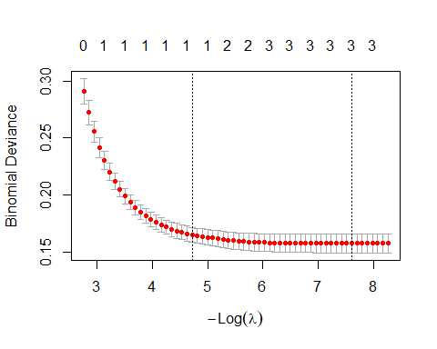
cv_lasso_def$lambda.min
## [1] 0.0004985238
coef(cv_lasso_def, s = "lambda.min")
## 6 x 1 sparse Matrix of class "dgCMatrix"
## lambda.min
## (Intercept) -1.096051e+01
## studentYes .
## balance 5.740254e-03
## income 4.964011e-06
## studentYes:balance -3.260835e-04
## studentYes:income .

Predict and evaluate:
pred_prob_lasso_def <- predict(cv_lasso_def, newx = x_test_def, s = "lambda.min", type = "response")
pred_class_lasso_def <- ifelse(pred_prob_lasso_def > 0.5, 1, 0)
lasso_cm <- table(Predicted = pred_class_lasso_def, Observed = y_test_def)
lasso_cm
## Observed
## Predicted 0 1
## 0 2889 71
## 1 11 29
accuracy_lasso_def <- mean(pred_class_lasso_def == y_test_def)
tn_l <- lasso_cm["0","0"]
tp_l <- lasso_cm["1","1"]
fn_l <- lasso_cm["0","1"]
fp_l <- lasso_cm["1","0"]
sensitivity_lasso <- tp_l / (tp_l + fn_l)
specificity_lasso <- tn_l / (tn_l + fp_l)
c(Accuracy = accuracy_lasso_def,
Sensitivity = sensitivity_lasso,
Specificity = specificity_lasso)
## Accuracy Sensitivity Specificity
## 0.9726667 0.2900000 0.9962069

4.5 Compare logistic regression vs LASSO on real data
data.frame(
Model = c("GLM", "LASSO"),
Accuracy = c(accuracy_glm_def, accuracy_lasso_def),
Sensitivity = c(sensitivity_glm, sensitivity_lasso),
Specificity = c(specificity_glm, specificity_lasso)
)
## Model Accuracy Sensitivity Specificity
## 1 GLM 0.9730000 0.30 0.9962069
## 2 LASSO 0.9726667 0.29 0.9962069
Questions for students (Real Data): 1. Which model (GLM vs LASSO) performs better in terms of sensitivity and specificity?
2. Look at the LASSO coefficients: which variables or interactions are shrunk toward zero?
studentYes .
studentYes:income .
3. How would you explain the added value of penalized ML methods to a clinician or non-statistical collaborator?

5. Reflection
- In Example 1, how did penalized methods compare to the standard logistic regression in terms of:
  - Accuracy?
  - Coefficient shrinkage and variable selection?
- In Example 2, why are ML methods like LASSO (and dimensionality reduction via PCA) especially useful when we have more variables than observations?
- In the real-data example (Example 3):
  - Does penalization improve sensitivity or specificity compared to the standard GLM?
  - How might class imbalance affect your model evaluation?

- Think about your own research data:
  - Where might supervised learning (e.g., penalized logistic regression) be appropriate?
  - Where might unsupervised learning (e.g., PCA or clustering) be more useful?

End of Lab
You can modify the simulation settings (sample size, number of predictors, signal strength) to explore how model performance changes, and you can replace the real dataset with one from your own research domain.

