#### Plant Growth and Development, 15p

#### Swedish University of Agricultural Sciences

Department of Plant Biology, SLU, Uppsala

**Teacher**: Derek Lundberg (derek.lundberg@slu.se)

**TAs:**  Aimer G. Diaz ([aimer.gutierrez.diaz@slu.se](mailto:aimer.gutierrez.diaz@slu.se))

Ezgi Mehmetoglu ([ezgi.mehmetoglu@slu.se](mailto:ezgi.mehmetoglu@slu.se))

Samuel Van Es ([sam.van.es@slu.se](mailto:sam.van.es@slu.se)).

Tsung-Ta Yu ([tsung.ta.yu@slu.se](mailto:tsung.ta.yu@slu.se)).

#### LAB2: Growth & Defense trade-off in *Nicotiana benthamiana* and Turnip Mosaic Virus interaction

Schedule:

2024-11-25 Day 1 9:15-12:00 Infection of seedlings

2024-12-10 Day 15 09:15-12:00 Symptom scoring and Harvest of samples

2024-12-11 Day16 09:15-16:45 RNA extraction and quality assessment

2024-12-12 Day17 09:15-16:45 cDNA synthesis and qPCR

2024-12-13 Day18 09:15-12:00 Discussion of qPCR results

**Introduction**

Plant viruses occur globally and have a profound impact on plant evolution, population structure, and agricultural practices. As obligate biotrophs, these intracellular nanorganisms depend entirely on their host's survival to complete their replication cycle, propagate, and disperse. In response, plants have evolved an array of defenses to counteract viral infection, often leading to a trade-off between growth and defense. This trade-off is central to plant-virus interactions, as mounting a defense response frequently comes at the cost of reduced growth and reproduction (Karasov *et al.* 2017). Understanding how plants prioritize growth or defense in viral infection context is essential to developing effective crop protection methods, making it a pressing issue in agricultural research.

In this laboratory practice, we will investigate how variations in viral genetics lead to a differential impact on plant growth and defense trade-off using the compatible *Nicotiana benthamiana* / Turnip Mosaic Virus pathosystem.

*Nicotiana benthamiana*, a species susceptible to a wide range of viruses, serves as an important model organism for research in molecular plant sciences and genetics. The single-stranded RNA virus Turnip Mosaic Virus (TuMV) is a widespread plant pathogen known to infect a broad range of host species, causing significant agricultural losses.

Today We will infect *N.* *benthamiana* plants with two TuMV constructs: TuMV-6K2-GFP (6K2G) and TuMV-ΔHCPro expressing free GFP (ΔHCG) to evaluate the growth-defense trade-off. These constructs allow us to assess how specific viral proteins influence the growth and defense balance. By infecting individual plants with each construct and with a mix of both constructs, we aim to determine which virus and growth effects prevail under mixed infections. As a negative control, plants will be infiltrated with Agrobacterium expressing free GFP to account for agroinfiltration effects.

The two viral constructs of our growth impact contest are:

* TuMV “6K2-GFP” (6K2G) construct developed by Thivierge *et al.* (2008)
* TuMV “ΔHCPro” expressing free GFP (ΔHCG) construct developed by Hafren *et al.* (2018).

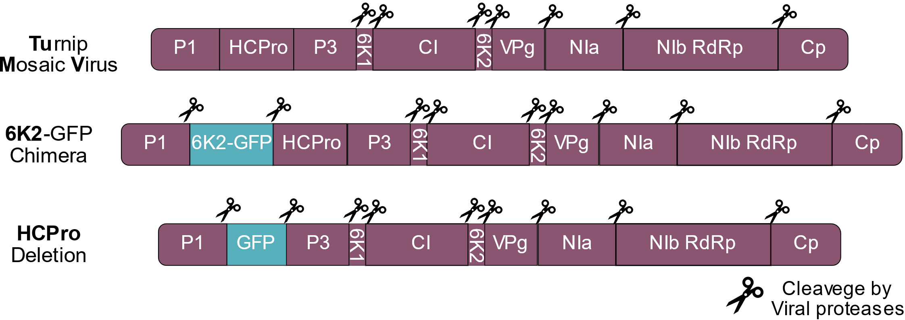

**Figure 1.** Polyprotein structure of three viral constructs of TuMV. On top, Wild type configuration of TuMV genome. 6K2G construct expresses an additional copy of the membrane-associated 6K2 protein with a GFP attached to its C-terminal region. HCPro deletion or ΔHCPro construct expresses a cleavable free GFP instead of the viral protease HC.

We will then determine disease symptoms by evaluating at 15 days post-infection the degree of GFP expression using a UV torch in plant leaves and quantifying viral accumulation to compare these traits between the two viral strains as well with the combinatory treatment exploring the relationships between TuMV genetics and their growth impact on *N. benthamiana*

**Day1: Infection of Nicotiana seedlings**

To study the growth impact of plant virus in *Nicotiana benthamiana* we will infect the plants at an early stage (14 days post germination). This means that the plant grows with the virus and needs to compromise its resource allocation between growth and defense. Turnip Mosaic Virus (TuMV) is a single-stranded RNA virus of 9,835 nucleotides that encode a single polyprotein of 3,164 amino acids, which is ulteriorly cleavage into 10 proteins. The TuMV genome is packed on filamentous virion structures, which contrary to the icosahedral “globular” virion structures, makes it amenability to biotechnological modification, such as introducing exogenous genes, modifying or deleting endogenous genes as shown in Figure 1. Additionally, the short length of TuMV genome makes it suitable to be cloned into an Agrobacterium-compatible plasmid, allowing for an efficient and reproducible agrobacterium-mediated transfection of the viral genome in a DNA into plant tissue.

For our viral competition contest, today we will infect 14-day-old seedlings of *Nicotiana benthamiana* with four different agrobacterium preparations carrying three different genetic constructs, as negative control we will use a free GFP construct without viral genes. To evaluate single construct effect, we will inoculate two symmetrical leaves of independent plants using *Agrobacterium* carrying 6K2-GFP and the *Agrobacterium* with ΔHCPro free GFP. For the contest test we will use an extra falcon tube where both agros 6K2G and ΔHCG have been mixed in equal proportion.

We will determine the progression of viral disease 15 days post-infection (DPI). As a control, we will infect Arabidopsis plants with Agrobacteria carrying a plasmid for the green fluorescent protein (GFP) to account for agroinfiltration-mediated effects.

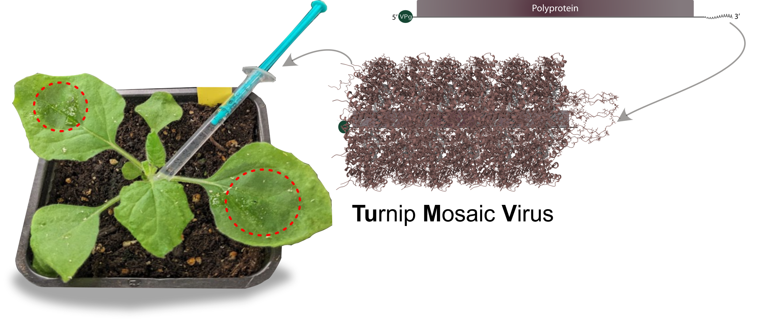

**Material**

Agrobacterium suspension (OD 0.10)

Suspension Buffer:

10 mM MES pH 5.6

10 mM MgCl2

150 µM Acetosyringone

1 ml plastic syringes without needles

15 ml falcon tubes

50 ml Falcon tubes

Gloves and plastic security glasses

Nicotiana plants are grown for 15 days in long-day conditions, well-watered before infection

1. Make a tiny hole in the abaxial (lower) side of two symmetrical opposite leaves using the plant label tip or a pencil
2. Draw up 0.5-1 ml bacterial suspension with your syringe, make sure to eliminate all air bubbles
3. Press the syringe (gently) on the abaxial (lower) side of the leaf in the holes generated at step 1 and gently press. The leaf will become dark translucent when infiltrated.
4. Continue with the corresponding leaf on the opposite side and then all plants in the pot.

Plants will be placed back into the greenhouse to grow in long-day conditions.

**Task until the next meeting:**

* Why are filamentous plant viruses (such as potyviruses) easier to manipulate biotechnologically than icosahedral viruses (like *Cucumovirus*)?  
  *(Hint: Consider structural and genomic differences.)*
* Why does GFP fluoresce under UV light, and how is this fluorescence used as a marker in plant-virus studies?
* What are the specific functions of the TuMV viral proteins 6K2 and HCPro? How do these proteins influence viral replication, movement, or host interactions?
* Based on the role of HCPro, what are your expectations regarding plant growth and symptom development in a TuMV strain lacking HCPro?
* Is out-competition the only possible outcome in viral coinfections? Could there be a scenario where two viral strains coexist and benefit from each other?  
  *(Hint: Besides the deletion, both viral constructs have the same genetic identity.)*
* Does the location of GFP in the viral genome (e.g., as a fusion to 6K2 or as free GFP) affect its utility as a marker for viral infection? Why might one configuration be more effective or reliable than the other?
* Do you expect the negative control, (free GFP expression) to propagate systemically beyond the initial inoculation site? Why or why not?

**References**

Grangeon, R., Jiang, J., Wan, J., Agbeci, M., Zheng, H. & Laliberté, J.-F. (2013). Frontiers | 6K2-induced vesicles can move cell to cell during Turnip Mosaic Virus infection. Frontiers in Microbiology, 4. https://doi.org/10.3389/fmicb.2013.00351

Hafren, A., Ustun, S., Hochmuth, A., Svenning, S., Johansen, T. & Hofius, D. (2018). Turnip Mosaic Virus Counteracts Selective Autophagy of the Viral Silencing Suppressor HCpro. Plant Physiol, 176(1), 649-662. https://doi.org/10.1104/pp.17.01198

Karasov, T.L., Chae, E., Herman, J.J. & Bergelson, J. (2017). Mechanisms to Mitigate the Trade-Off between Growth and Defense. The Plant cell, 29(4). https://doi.org/10.1105/tpc.16.00931