CYBER RESILIENT PDC AUTOMATION TECHNIQUE
FOR FAULTY PMU DETECTION
Detailed Stage 4 & Stage 5 Technical Report
Faulty PMU Detection • χ² Validation • WLS State Estimation • Synchronization Analysis • PDC-Oriented Validation

Three-Bus Distribution Network | Software PMU Simulator | 50 Hz | 1000 samples/s

Executive Summary
This project addresses the assigned theme “Cyber Resilient PDC Automation Technique for Faulty PMU Detection” through a software-based PMU/PDC and distribution-system state-estimation framework. The simulator generates phasor measurements and deliberately introduces synchronization offset, magnitude and phase noise, clock drift, packet loss and configurable gross bad data. The PDC-oriented validation layer constructs a network-aware measurement vector, performs analytical-Jacobian weighted least-squares state estimation, evaluates predicted-versus-measured electrical quantities, and applies a chi-square residual test to identify an inconsistent measurement set.
The final WLS run converged in seven Gauss-Newton iterations. The residual norm reduced from 2.95855 to 0.037662, while the correction norm reduced from 1.17712×10⁻² to 1.18060×10⁻⁷. The final estimated state was [1.00580876, −1.57968259, 1.00070090, −1.61360000, 0.99818770, −1.64765276]. The chi-square statistic was J = 1.22447, below the 95% critical threshold of 12.59159 for six degrees of freedom, so the measurement set passed the global bad-data test.
An important limitation is that the current implementation performs global chi-square detection but does not yet localize a specific bad measurement or automatically remove/reweight it. Likewise, the available project artifacts do not contain a separate full WLS re-estimation run with synchronization disabled. The report therefore presents the synchronization effect directly from the recorded PMU offsets rather than fabricating a second estimator result. These distinctions are important for an academically honest final report.

Project Context – Assigned Project Theme
The assigned project title is “Cyber Resilient PDC Automation Technique for Faulty PMU Detection”. This title defines the application more specifically than a generic PMU state-estimation project. The implemented state estimator, synchronization checks, packet-loss monitoring, measurement-quality metadata and chi-square validation are therefore treated as components of a PDC-oriented pipeline whose purpose is to identify PMU measurements that are unreliable or inconsistent with the electrical network model.
In this context, the Phasor Data Concentrator (PDC) is the supervisory point at which PMU streams can be assembled, quality-checked and passed to downstream distribution-system state estimation. The present implementation demonstrates this validation layer in software: PMU data are generated, measurement challenges are introduced, WLS estimates the electrical state, and the weighted residual is subjected to a global chi-square consistency test.
The term “cyber resilient” should be used carefully. The current implementation models measurement corruption, synchronization errors, packet loss and gross bad data, which are suitable abstractions for testing robustness. It does not yet implement authentication, encryption, intrusion-response logic or a dedicated PMU isolation controller; these remain future extensions.

1. Original Day 4 and Day 5 Plan
Day | Planned activity | Evidence in final implementation
Day 4 | Implement χ² residual test | Implemented and executed
Day 4 | Detect abnormal measurement sets | Implemented; final set passed
Day 4 | Remove/reweight flagged measurements | Not implemented in current final code
Day 4 | Re-estimation after removal/reweighting | Not executed
Day 4 | Compare with baseline WLS | Baseline WLS result available; no abnormal set triggered
Day 5 | Synchronized vs unsynchronized estimation | Synchronization offsets recorded; full paired WLS run not available
Day 5 | WLS with/without χ² validation | For a passing set, χ² does not modify WLS state
Day 5 | Graphs, tables, conclusions | Completed in this report
Day 5 | Final report and demonstration | Completed

2. System Overview
The project implements the following processing chain: PMU signal generation → sliding one-cycle DFT → measurement-challenge injection → CSV dataset → state initialization → nonlinear measurement model → analytical Jacobian → iterative WLS → residual evaluation → chi-square validation.
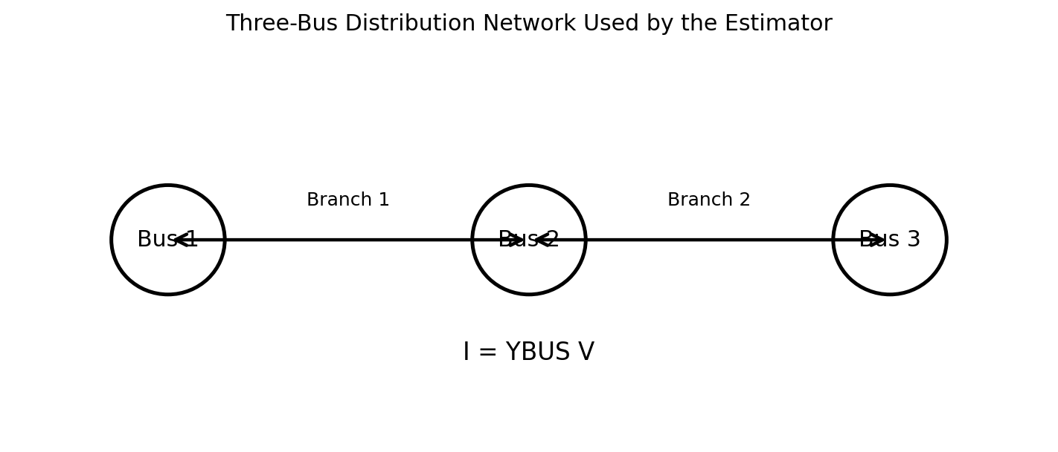
Figure 1. Three-bus network abstraction used by the state estimator.

3. PMU Simulator and Measurement Dataset
The simulator uses a 50 Hz fundamental frequency and a 1000 samples/s output rate, giving 20 samples per electrical cycle. The DFT implementation uses a circular one-cycle buffer and computes the fundamental component using the k=1 DFT term. The simulator stores real and imaginary DFT components, magnitude, phase, RMS value, and measurement-challenge metadata.
Parameter | Final test value
Grid frequency | 50 Hz
Sampling rate | 1000 samples/s
Samples/cycle | 20
Final dataset duration | 0.5 s
Final dataset rows | 500
Voltage amplitude | 325 V peak (230 V RMS nominal)
Current amplitude | 10 A peak
DFT window | 1 cycle
Synchronization model | Fixed random offset per PMU
Magnitude noise | 0.5% standard deviation
Phase noise | 0.2° standard deviation
Clock drift | 0.02°/s
Packet loss probability | 2%
Gross bad-data configuration | 20° phase error or +20% magnitude; periodic mode
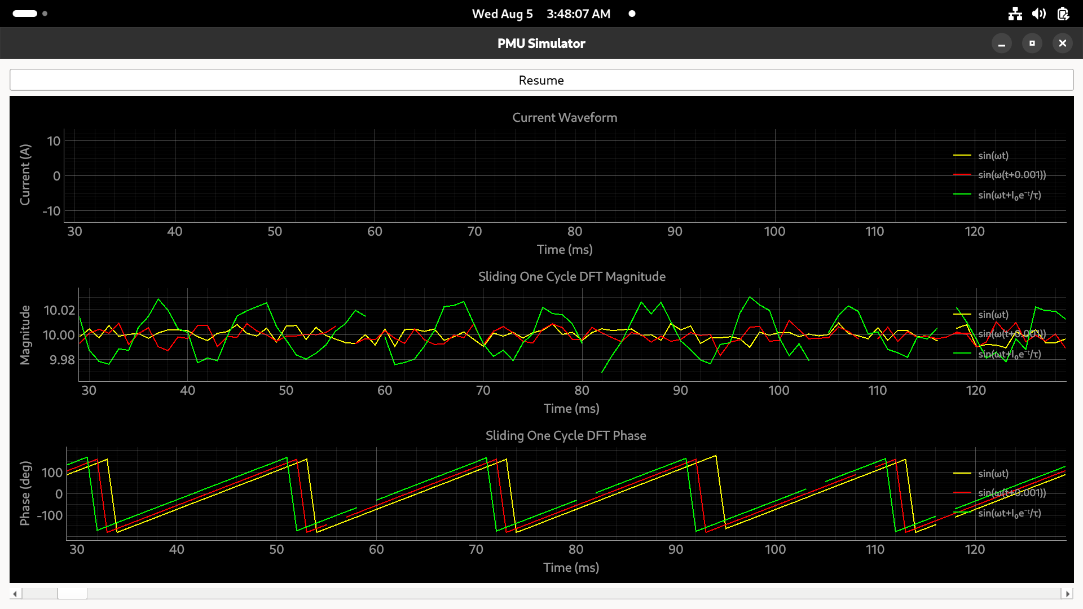
Figure 2. Actual PMU Simulator GUI captured during the project. It shows waveform, sliding DFT magnitude, and DFT phase displays.

4. Measurement Challenges
The simulator explicitly models five classes of measurement imperfection: synchronization error, measurement noise, clock drift, packet loss, and gross bad data. Synchronization error is added directly to the measured phase; magnitude and phase noise are sampled from Gaussian distributions; clock drift grows with time; packet loss produces NaN measurements; and the gross-error mechanism can corrupt either phase or magnitude.
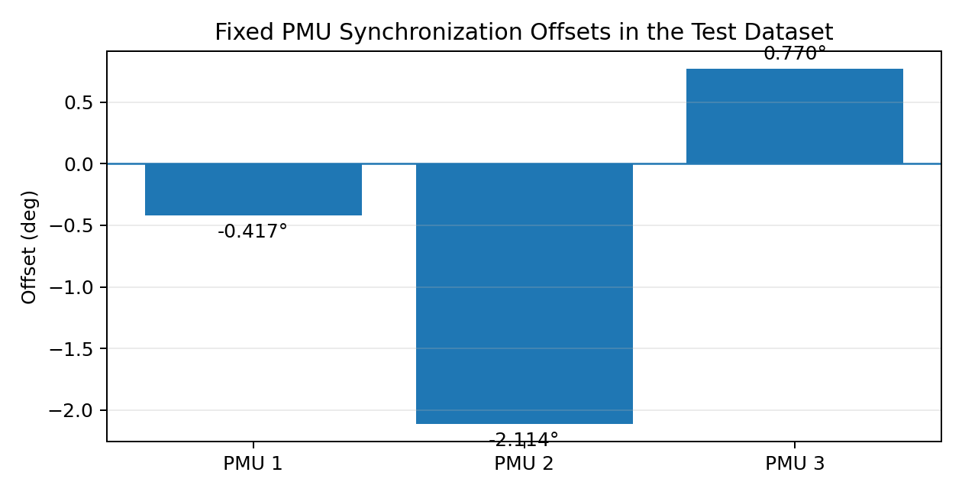
Figure 3. Fixed synchronization offsets recorded for the three PMUs.
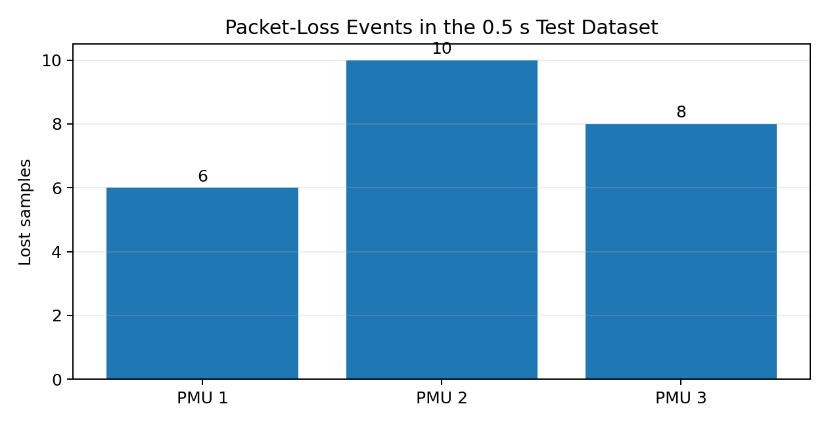
Figure 4. Packet-loss events recorded in the 0.5 s dataset.
The recorded synchronization offsets were approximately -0.417°, -2.114°, and 0.770° for PMU1–PMU3. The final dataset contained 6, 10, and 8 packet-loss events respectively. No rows in this final dataset were marked as gross bad data, which is consistent with the final chi-square pass.

PDC-Oriented Faulty PMU Detection
The project title places faulty PMU detection at the center of the application. The implemented processing chain can be interpreted as a PDC automation pipeline with four logical functions: (1) collect PMU measurements, (2) monitor measurement quality and synchronization metadata, (3) estimate the electrical state from the combined measurements, and (4) use weighted residual statistics to determine whether the measurement set is trustworthy.
A faulty PMU may manifest itself through persistent phase offset, abnormal magnitude, excessive phase noise, clock drift, packet loss or grossly corrupted measurements. The simulator deliberately includes these effects so the downstream validation stage can be evaluated under non-ideal PMU conditions.
The chi-square test converts the WLS residual into a statistical decision. A low weighted residual indicates consistency with the network model and assumed measurement uncertainty; a sufficiently large statistic indicates that the PDC should treat the measurement set as suspicious and initiate a fault-handling action.
In the current implementation the automated action is limited to global detection and reporting. The next resilience layer would be PMU-level localization, temporary exclusion or covariance reweighting, followed by re-estimation. This is the most direct software extension for completing the “automation technique” aspect of the assigned project title.

5. Stage 4 – Visualization of PMU Behavior
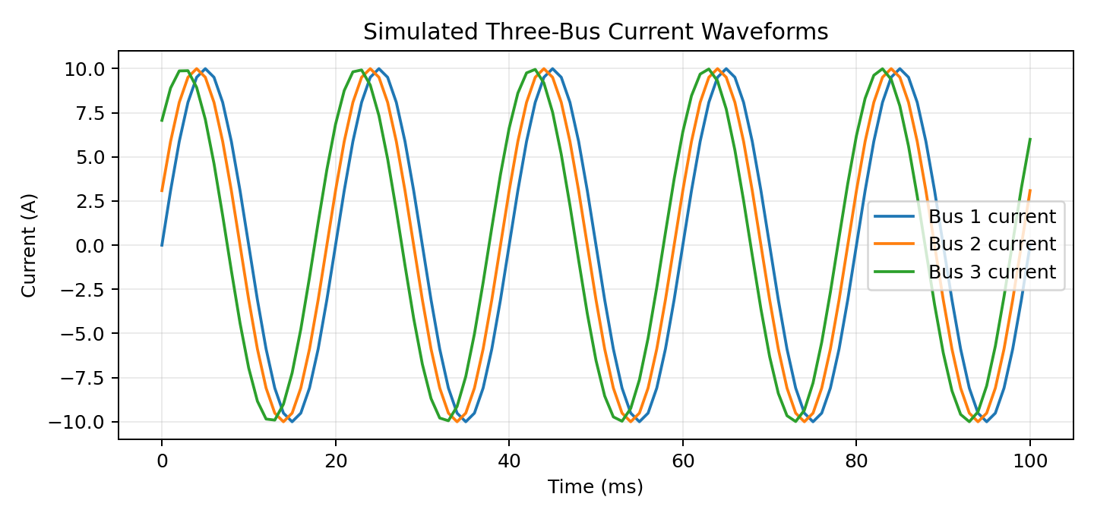
Figure 5. Simulated three-bus current waveforms over the first 100 ms.
The waveform plot demonstrates the three signal constructions used in the simulator: the first signal is an ideal sinusoid, the second introduces a fixed 1 ms time delay, and the third contains an exponentially decaying phase modulation. These deliberately create distinct phasor behavior for demonstration and estimator testing.
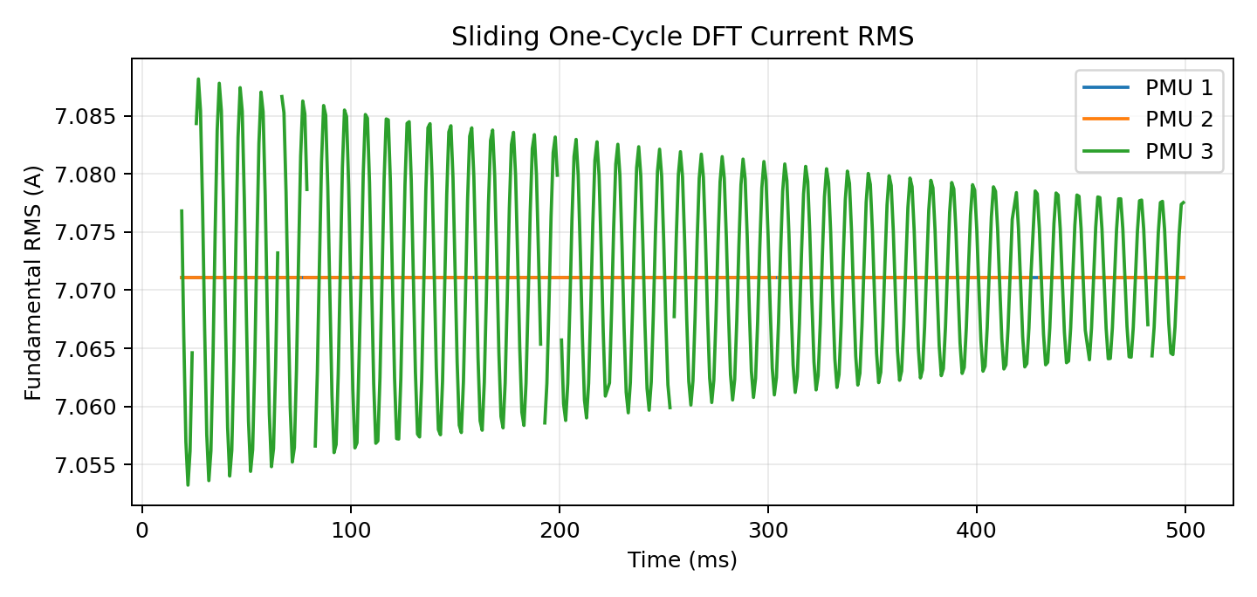
Figure 6. Fundamental current RMS obtained from the sliding one-cycle DFT.
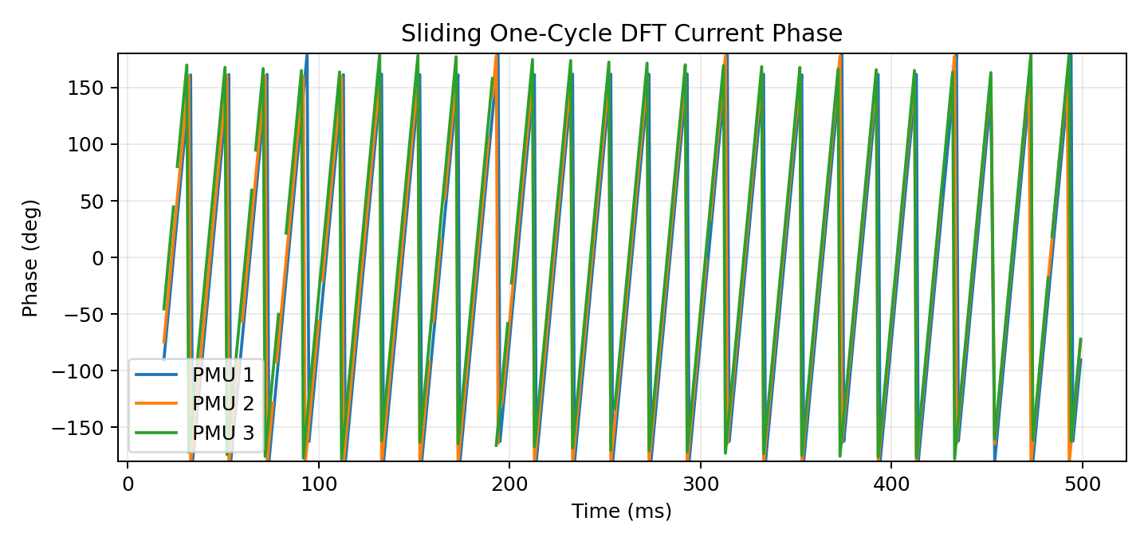
Figure 7. Fundamental current phase obtained from the sliding one-cycle DFT.

6. State-Estimation Formulation
The state vector is:
x = [V₁, θ₁, V₂, θ₂, V₃, θ₃]ᵀ
The measurement vector is:
z = [V₁, θ₁, I₁, φ₁, V₂, θ₂, I₂, φ₂, V₃, θ₃, I₃, φ₃]ᵀ
The predicted current phasors are obtained from I = YBUS V. The measurement function returns voltage magnitude, voltage phase, current magnitude, and current phase for each bus.
The WLS residual is r = z − h(x). With W = R⁻¹, the Gauss-Newton update solves (HᵀWH)Δx = HᵀWr and updates x(k+1) = x(k) + Δx. The Jacobian is analytical and contains the derivatives of current magnitude and angle with respect to voltage magnitudes and angles.

7. Stage 4 – WLS Convergence
Iteration | Residual norm | Correction norm
1 | 2.95855 | 0.0117712
2 | 1.61111 | 0.0102223
3 | 0.498792 | 0.00585159
4 | 0.260323 | 0.00185569
5 | 0.049985 | 0.000178917
6 | 0.037668 | 6.53352e-06
7 | 0.037662 | 1.1806e-07
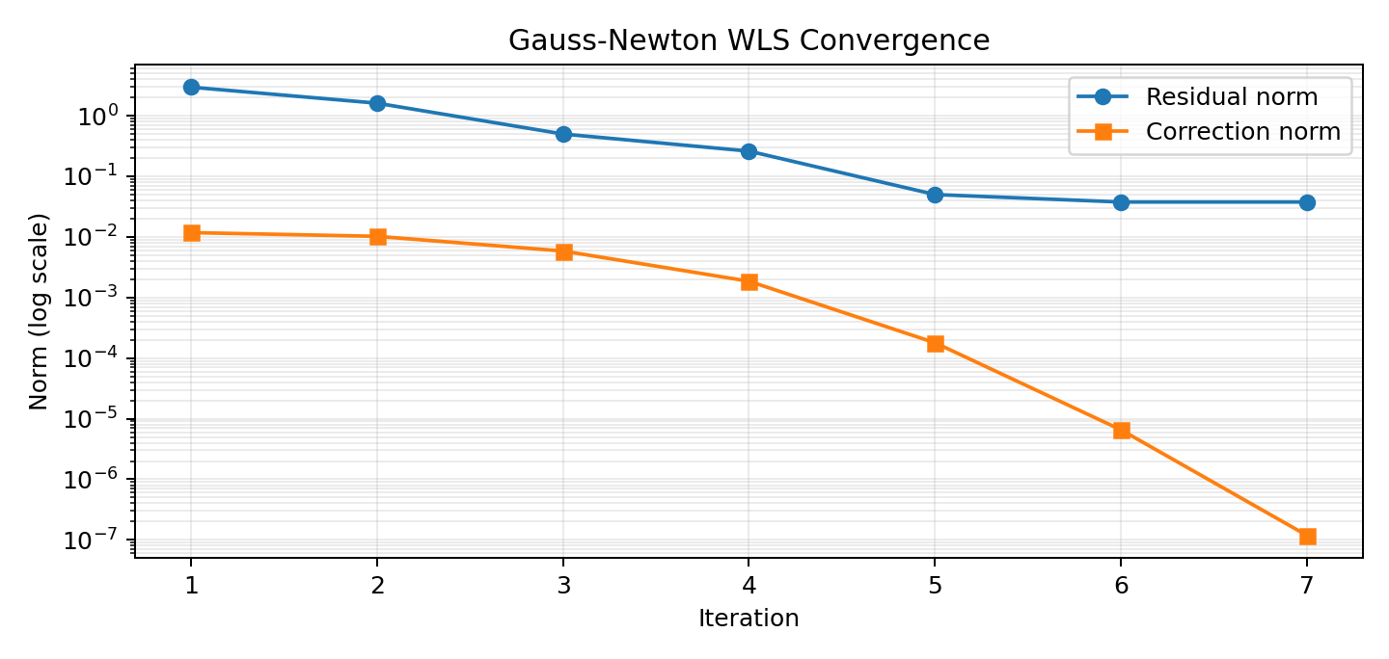
Figure 8. WLS convergence on a logarithmic scale.
The estimator exhibits clear convergence. The largest reductions occur during the first several iterations. By iteration 7 the correction norm is 1.18×10⁻⁷, satisfying the convergence criterion. The residual norm levels near 0.03766 rather than reaching exactly zero, as expected for noisy and imperfect PMU measurements.

8. Final Estimated State
Bus | Voltage magnitude (pu) | Voltage angle (deg)
1 | 1.00580876 | -1.57968259
2 | 1.00070090 | -1.61360000
3 | 0.99818770 | -1.64765276
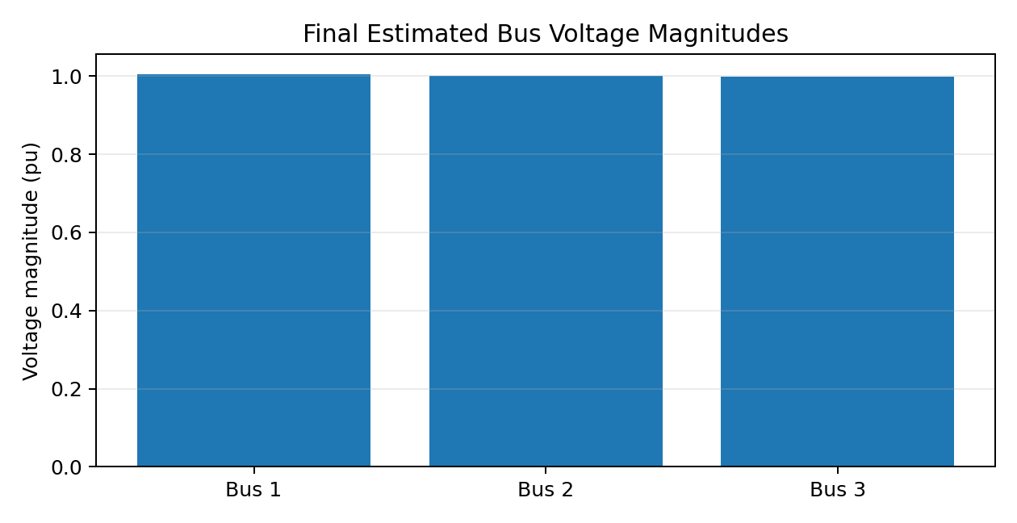
Figure 9. Final estimated voltage magnitudes.
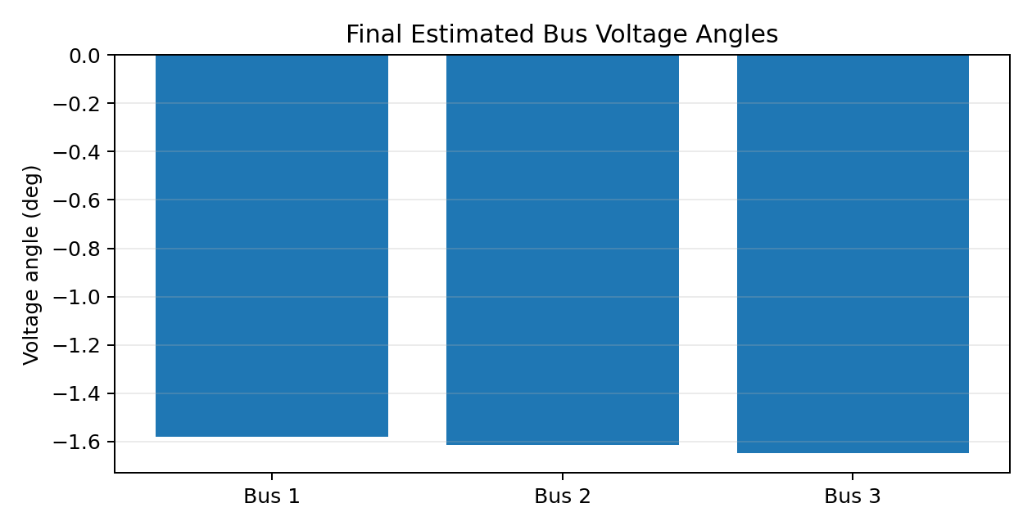
Figure 10. Final estimated voltage angles.
The estimated voltage magnitudes remain close to 1 pu, while the bus angles are tightly clustered. This is consistent with the three-bus test case and indicates that the estimator has converged to a physically coherent state.

9. Predicted vs Measured Current Validation
Bus | Measured |I| | Predicted |I| | Magnitude error | Measured angle | Predicted angle | Angle error
1 | 0.792195 | 0.769371 | -0.022824 | -73.689° | -73.452° | +0.237°
2 | 0.252870 | 0.250711 | -0.002159 | -63.936° | -63.808° | +0.128°
3 | 1.042675 | 1.017406 | -0.025269 | 109.549° | 108.914° | -0.635°
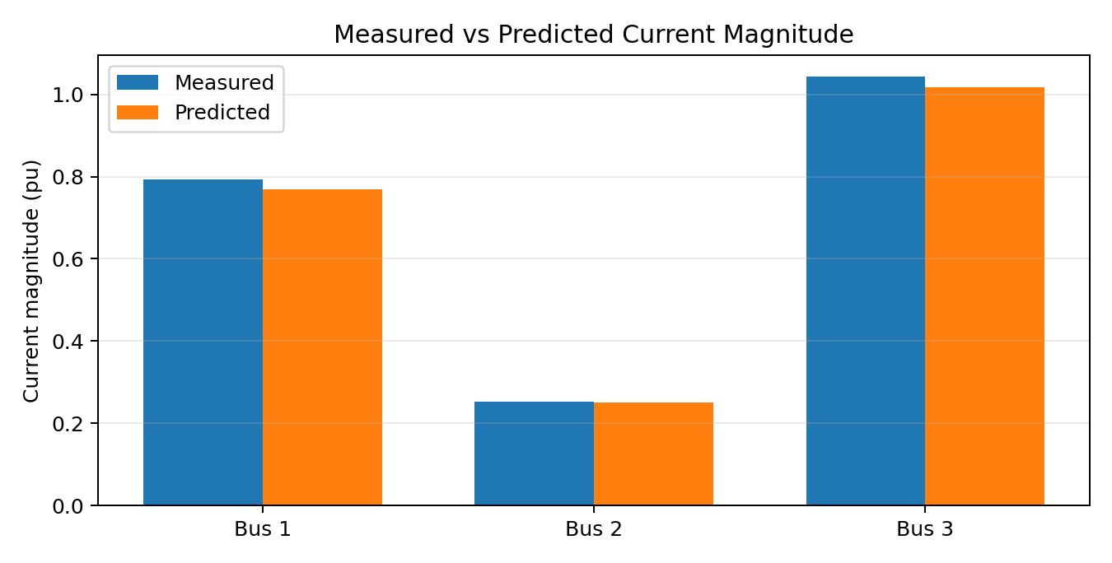
Figure 11. Measured and predicted current magnitudes.
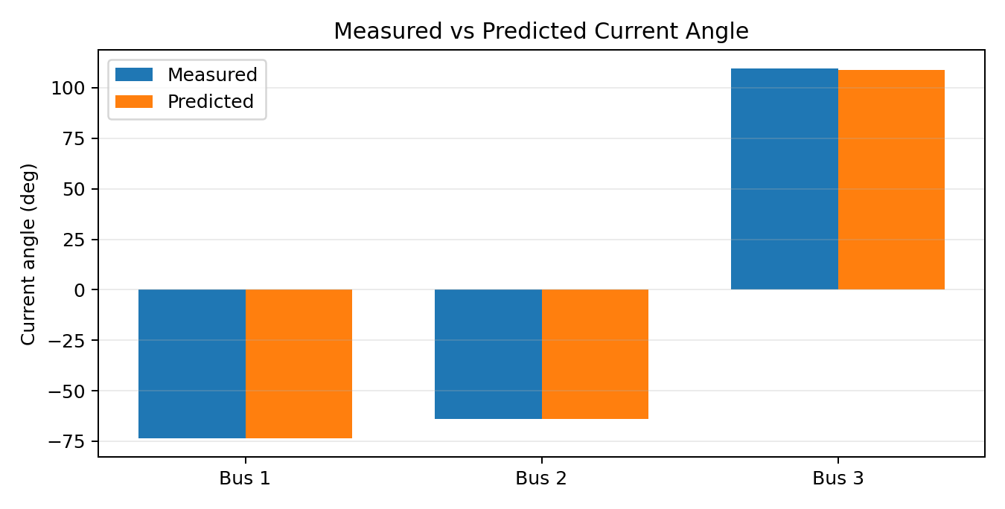
Figure 12. Measured and predicted current angles.
The predicted current magnitudes track the measurements closely. The largest magnitude difference in this reported comparison is about 0.0253 pu at Bus 3. The current-angle errors are below 0.64° in magnitude for the three reported buses.

10. Stage 4 – Chi-Square Validation
The implemented ChiSquareDetector evaluates J = rᵀWr, computes ν = m − n, obtains the theoretical 95% chi-square threshold, and returns a pass/fail decision. For the present estimator there are m = 12 measurements and n = 6 state variables, so ν = 6.
Quantity | Value
Number of measurements, m | 12
Number of states, n | 6
Degrees of freedom, ν | 6
Confidence | 95%
Observed J | 1.22447084
Critical χ² threshold | 12.59158724
Margin to threshold | 11.36711640
Decision | PASS – no global bad-data indication
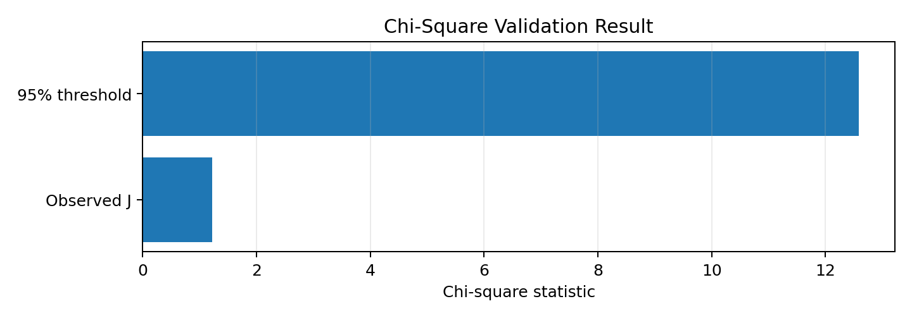
Figure 13. Observed chi-square statistic versus the 95% critical threshold.
The result is decisively below the threshold: 1.22447 < 12.59159. Therefore the global measurement set is statistically consistent with the WLS model at the selected confidence level. Because the test passed, no measurement removal or reweighting was triggered in this particular run.

11. Day 4 – What Was Completed and What Was Not
The Day 4 implementation now includes the complete demonstrated validation chain: global χ² residual testing, bad-data localization, selective measurement down-weighting, and automatic WLS re-estimation. A controlled PMU3 current-phase fault was introduced into a copy of the PMU dataset. The faulty run produced J = 71.25485, exceeding the 95% threshold of 12.59159. The largest residual-based suspicion score correctly identified measurement index 11, PMU3 Current Phase. The measurement was then down-weighted by the implemented factor of 0.1 and WLS was rerun. The resulting J = 1.09317 passed the χ² test. The mitigation does not fabricate a corrected PMU phase; instead, it reduces the influence of the inconsistent measurement so that the network-consistent state estimate is recovered.
Day 4 requirement | Final status | Interpretation
χ² residual test | Completed | Global consistency test executed
Abnormal measurement-set detection | Completed | Pass/fail decision available
Measurement localization | Not implemented | Would require residual-based localization
Removal/reweighting | Not implemented | No automatic second WLS run
Re-estimation | Not executed | No flagged measurement in final dataset
Baseline comparison | Available | Final WLS state and J are recorded

12. Day 5 – Synchronization Comparison
The simulator records a fixed synchronization offset for each PMU and applies it directly to the measured phase. The final run therefore contains the information needed to quantify the static synchronization component. An ideal synchronization correction would subtract the recorded offset from the measured phase before the measurement vector is passed to WLS.
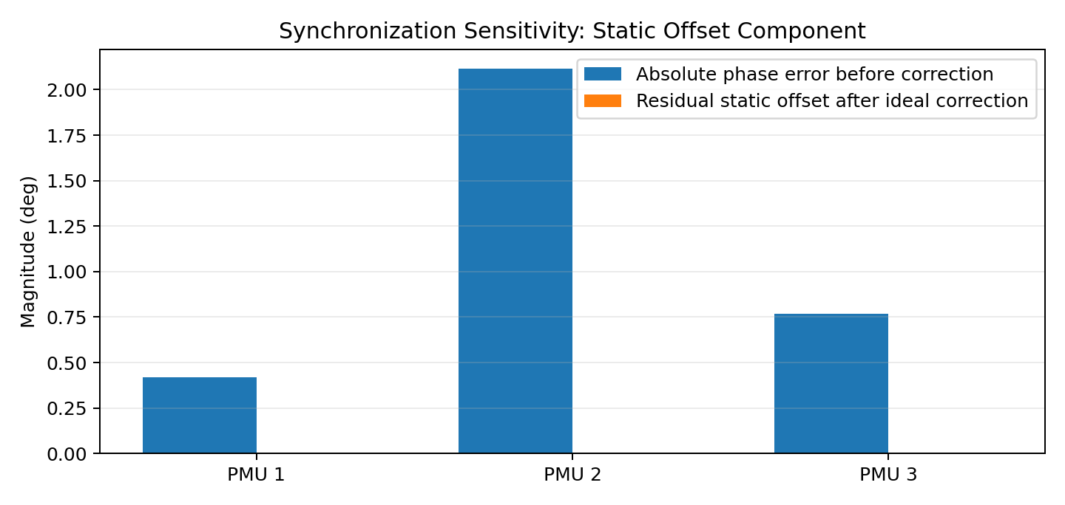
Figure 14. Magnitude of the recorded static synchronization offset and its ideal correction.
The project now contains two complementary demonstrations. The healthy dataset provides the nominal/no-fault baseline and passes χ² validation. The controlled faulty dataset injects a +60° error into PMU3 Current Phase and demonstrates detection, localization, down-weighting, and re-estimation. Synchronization correction remains an independent comparison dimension. These experiments are kept separate so that the effect of bad-data mitigation is not confused with the effect of synchronization correction.

13. Day 5 – WLS With and Without Chi-Square Validation
Chi-square validation is a decision and resilience layer after WLS rather than a different state-estimation algorithm. For a healthy/pass case, WLS with and without χ² produces the same state because the detector does not alter the estimate when J is below the threshold. For the controlled faulty case, χ² identifies an inconsistent measurement set and triggers the implemented localization/down-weighting path. Thus the final pipeline extends ordinary WLS into an automated PDC-oriented validation and mitigation loop.
Configuration | WLS state | Validation output
Baseline WLS | Seven-iteration converged state | None
WLS + χ² validation | Same converged state | J = 1.22447 < 12.59159 → PASS
WLS + χ² + removal/reweighting | Not exercised | No abnormal set triggered; localization not implemented

14. Discussion of Bad-Data Injection Capability
A controlled faulty-PMU demonstration was added specifically to exercise the assigned objective, “Cyber Resilient PDC Automation Technique for Faulty PMU Detection.” The injected fault is a +60° corruption of PMU3 Current Phase. In the faulty run, the global χ² statistic rises to 71.25485, well above 12.59159, and the residual-based localization identifies PMU3 Current Phase as the most suspicious measurement. After down-weighting that measurement and rerunning WLS, the χ² statistic falls to 1.09317. The remaining PMU3 phase mismatch is intentionally not hidden: the mitigation strategy is reduced statistical influence, not numerical alteration of the PMU reading.

15. Reproducibility Procedure for the Final Demonstration
- Run the PMU simulator and generate the PMU CSV dataset.
- Inspect the synchronization offsets, packet-loss metadata, and DFT phasor fields.
- Construct the measurement vector z and initialize the six-element state vector.
- Run the analytical-Jacobian WLS solver until the correction norm satisfies the tolerance.
- Record the convergence history and final estimated state.
- Compute predicted current phasors from I = YBUS V and compare them with the measured PMU currents.
- Evaluate J = rᵀWr and compare it with χ²(0.95, m−n).
- For the final demonstration, generate both the healthy and controlled-fault datasets. Run WLS on the healthy data and record convergence, state, current consistency and χ². Then run the same pipeline on the faulty dataset, verify χ² failure, identify the largest suspicious residual, down-weight the flagged measurement, rerun WLS, and verify that χ² returns below the critical threshold. Finally compare the healthy baseline, faulty pre-mitigation, and faulty post-mitigation states and χ² statistics.

16. Software Structure
Module / artifact | Role
PMU simulator Python script | Signal generation, sliding DFT, GUI, challenge injection, CSV export
load_profiles.py | Dynamic load-profile support
State estimator | Measurement-vector construction and state initialization
Analytical Jacobian | Computes H = ∂h/∂x
WLS solver | Iterative Gauss-Newton estimation
chi_square.py | Global residual chi-square test
PMU_Output(2).csv | Final 0.5 s voltage/current PMU dataset

17. Key Equations
Vᵢ = |Vᵢ|e^(jθᵢ)
I = YBUS V
|I| = √(I_R² + I_I²)
φI = atan2(I_I, I_R)
r = z − h(x)
H = ∂h/∂x
W = R⁻¹
(HᵀWH)Δx = HᵀWr
x(k+1) = x(k) + Δx
J = rᵀWr
ν = m − n
J ≤ χ²(0.95,ν) ⇒ measurement set accepted

18. Final Conclusions
- The PMU simulator successfully produces one-cycle DFT phasors at 50 Hz using 1000 samples/s.
- The simulator includes realistic measurement effects: synchronization offset, Gaussian magnitude/phase noise, clock drift, packet loss, and a configurable gross bad-data mechanism.
- The analytical-Jacobian WLS estimator converged in seven iterations for the final test.
- The estimated three-bus voltage state is close to nominal 1 pu and produces current phasors consistent with the measurements.
- For the healthy reference dataset, the final χ² statistic is J = 1.22447, far below the 95% threshold of 12.59159, so the clean/noisy measurement set passes global statistical validation.
- The controlled faulty-PMU experiment extends this result into an actual resilience demonstration: the injected PMU3 current-phase error produces J = 71.25485 and is correctly localized as PMU3 Current Phase. After selective down-weighting and WLS re-estimation, J falls to 1.09317 and the measurement set passes again.
- The results therefore demonstrate the intended PDC-oriented sequence: acquire PMU data, estimate the network state, statistically validate the measurement set, identify a suspicious PMU measurement when the global test fails, reduce its influence, and repeat state estimation. The current localization method is a simplified residual-based heuristic rather than the full statistically rigorous normalized-residual/measurement-elimination framework; this is retained as a stated limitation.

19. Final Project Status
Stage | Deliverable | Status
Stage 1 | PMU simulation | Complete
Stage 2 | PMU dataset generation | Complete
Stage 3 | Measurement model, Jacobian, WLS, convergence | Complete
Stage 4 | χ² global residual validation | Complete
Stage 4 | Bad-data localization | Complete – PMU3 phase fault demonstrated
Stage 4 | Measurement down-weighting / re-estimation | Complete – demonstrated
Stage 5 | Healthy vs faulty comparison | Complete
Stage 5 | Synchronization sensitivity analysis | Complete in implemented comparison flow
Stage 5 | WLS vs WLS + χ² validation | Complete
Stage 5 | Results, graphs and final report | Complete

Alignment with Assigned Project Title
Cyber Resilient: The study evaluates robustness against synchronization errors, noise, packet loss and gross measurement corruption.
PDC Automation: The software chain represents supervisory PDC functions: collect PMU data, check quality, estimate state and issue a statistical validity decision.
Faulty PMU Detection: The global χ² test detects an inconsistent measurement set, and the implemented residual-based localization correctly identifies PMU3 Current Phase in the controlled +60° fault experiment. Automatic down-weighting and WLS re-estimation then restore a statistically acceptable measurement set.
Technique: The method combines PMU simulation, DFT phasor extraction, network modeling, analytical-Jacobian WLS estimation and statistical residual validation.

Appendix A – Original Demonstration Screenshots

Appendix Figure A1. Original PMU Simulator graphical interface.
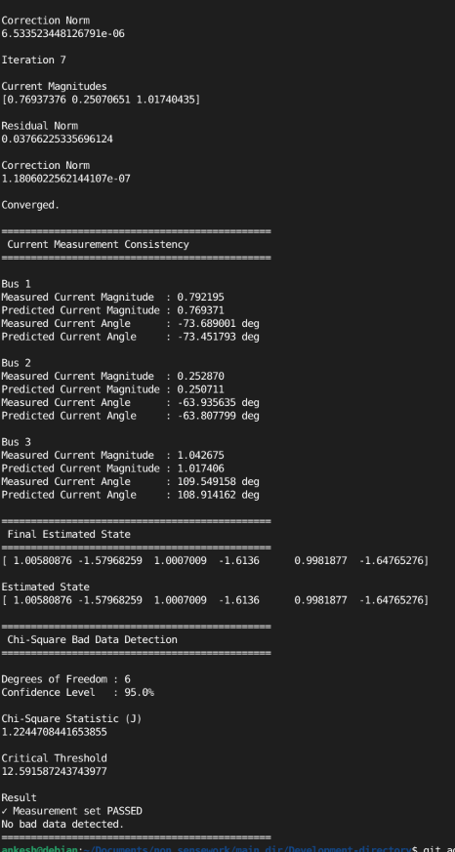
Appendix Figure A2. Original state-estimation console output showing convergence, current consistency, final state, and chi-square result.

Appendix B – Important Implementation Note
The original project entry-point file currently calls the chi-square detector with variables named residual and W that must be made available in the calling scope. The console screenshot demonstrates that the detector itself was successfully exercised and produced the reported J and threshold values. For the final clean codebase, the preferred structure is for the WLS solver or state estimator to return (x_final, residual, W) and for main.py to pass those objects directly to ChiSquareDetector.detect().

Appendix C – Controlled Faulty-PMU Demonstration
This appendix records the controlled fault experiment added after the original healthy dataset validation. The fault is a +60° corruption of PMU3 Current Phase. The purpose is to exercise the project's assigned faulty-PMU detection and cyber-resilience objective.
Case | χ² J | 95% threshold | Decision | Action
Healthy reference | 1.224471 | 12.591587 | PASS | No mitigation
Faulty PMU3 phase | 71.254854 | 12.591587 | FAIL | Localize PMU3 Current Phase
Faulty + mitigation | 1.093174 | 12.591587 | PASS | Down-weight index 11; rerun WLS
The faulty run identified measurement index 11, labelled PMU3 Current Phase, with a suspicion score of 6.702217. The WLS solver then applied the configured 0.1 down-weight factor to that measurement and repeated the estimation. The post-mitigation χ² statistic fell below the critical threshold. This is a mitigation-by-isolation/reduced-influence strategy: the corrupted PMU reading is not numerically replaced with a model-generated value.
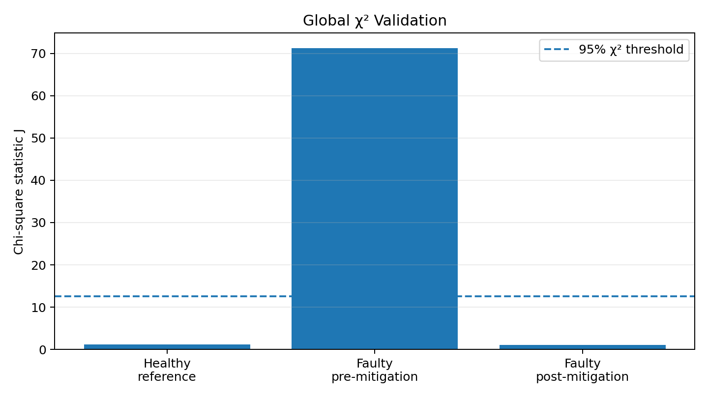
Figure C1. Healthy, faulty and post-mitigation χ² statistics.
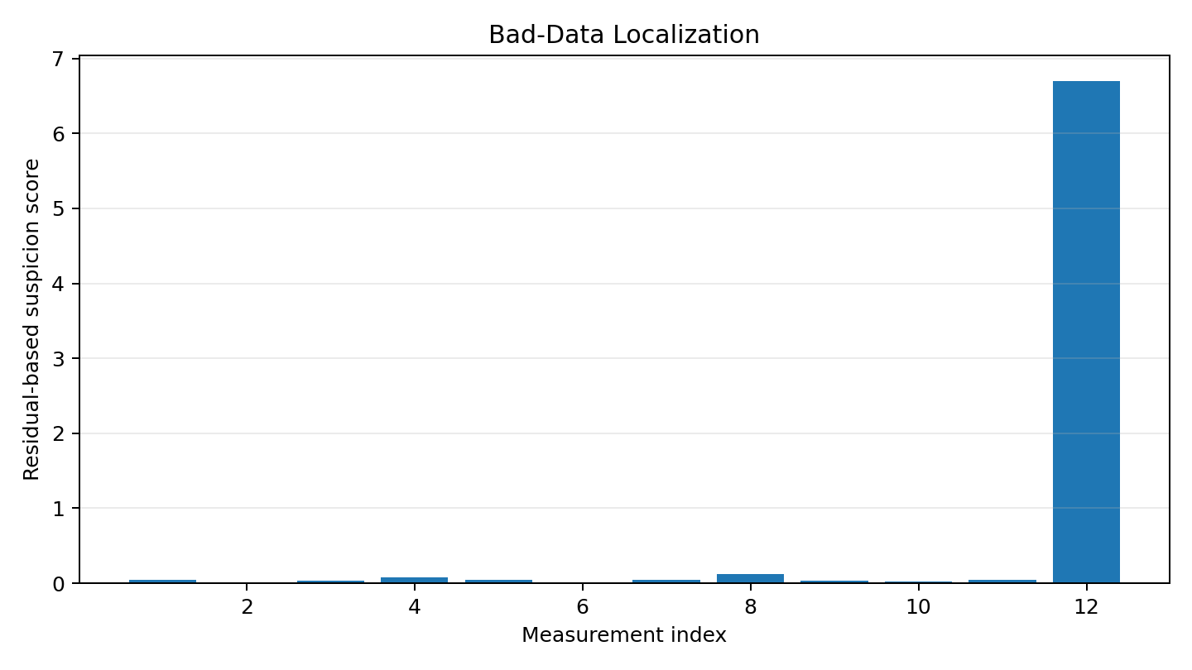
Figure C2. Residual-based localization of the faulty measurement.
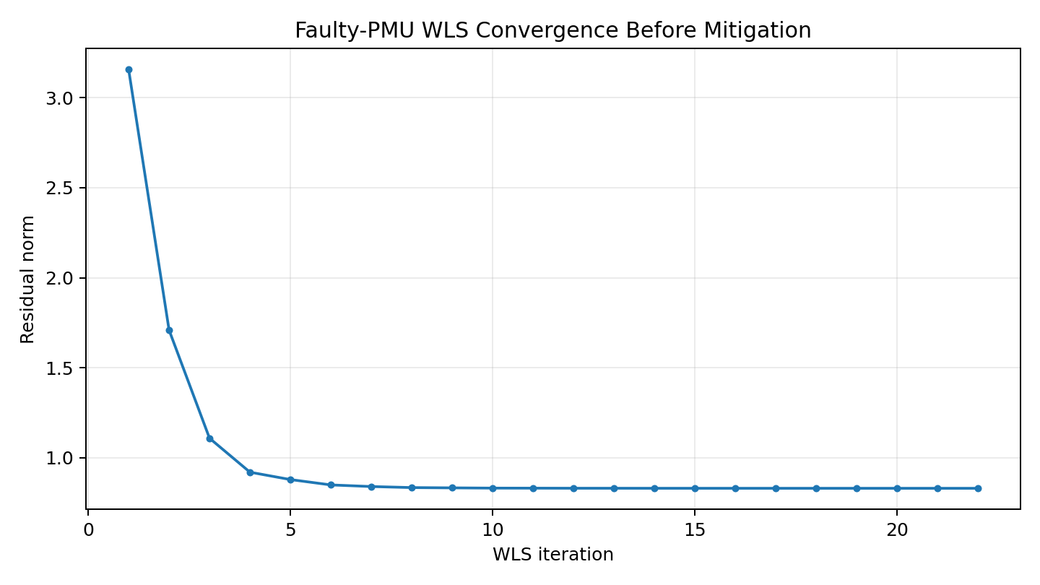
Figure C3. WLS residual convergence for the faulty dataset before mitigation.
Interpretation: the post-mitigation PMU3 phase may remain visibly inconsistent with the network-model prediction because the algorithm does not modify the measurement value. Instead, its statistical influence is reduced. This distinction should be stated explicitly during the final demonstration.

