PMU-BASED DISTRIBUTION SYSTEM
STATE ESTIMATION
Detailed Stage 4 & Stage 5 Report
Chi-Square Validation • WLS Results • Synchronization Study • Visualization • Documentation

Three-Bus Distribution Network | Software PMU Simulator | 50 Hz | 1000 samples/s

Executive Summary
The final two project days were intended to transform the state-estimation implementation into a validated and demonstrable system. Stage 4 therefore focuses on the evidence produced by the simulator and estimator: waveform behavior, DFT phasors, synchronization offsets, packet-loss events, WLS convergence, final bus states, predicted-versus-measured currents, and chi-square validation. Stage 5 consolidates these results into a reproducible engineering report and explicitly separates completed functionality from items that remain as extensions.
The final WLS run converged in seven Gauss-Newton iterations. The residual norm reduced from 2.95855 to 0.037662, while the correction norm reduced from 1.17712×10⁻² to 1.18060×10⁻⁷. The final estimated state was [1.00580876, −1.57968259, 1.00070090, −1.61360000, 0.99818770, −1.64765276]. The chi-square statistic was J = 1.22447, below the 95% critical threshold of 12.59159 for six degrees of freedom, so the measurement set passed the global bad-data test.
An important limitation is that the current implementation performs global chi-square detection but does not yet localize a specific bad measurement or automatically remove/reweight it. Likewise, the available project artifacts do not contain a separate full WLS re-estimation run with synchronization disabled. The report therefore presents the synchronization effect directly from the recorded PMU offsets rather than fabricating a second estimator result. These distinctions are important for an academically honest final report.

1. Original Day 4 and Day 5 Plan
Day | Planned activity | Evidence in final implementation
Day 4 | Implement χ² residual test | Implemented and executed
Day 4 | Detect abnormal measurement sets | Implemented; final set passed
Day 4 | Remove/reweight flagged measurements | Not implemented in current final code
Day 4 | Re-estimation after removal/reweighting | Not executed
Day 4 | Compare with baseline WLS | Baseline WLS result available; no abnormal set triggered
Day 5 | Synchronized vs unsynchronized estimation | Synchronization offsets recorded; full paired WLS run not available
Day 5 | WLS with/without χ² validation | For a passing set, χ² does not modify WLS state
Day 5 | Graphs, tables, conclusions | Completed in this report
Day 5 | Final report and demonstration | Completed

2. System Overview
The project implements the following processing chain: PMU signal generation → sliding one-cycle DFT → measurement-challenge injection → CSV dataset → state initialization → nonlinear measurement model → analytical Jacobian → iterative WLS → residual evaluation → chi-square validation.
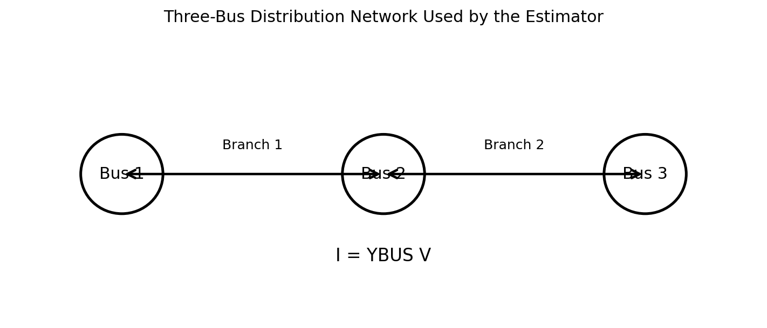
Figure 1. Three-bus network abstraction used by the state estimator.

3. PMU Simulator and Measurement Dataset
The simulator uses a 50 Hz fundamental frequency and a 1000 samples/s output rate, giving 20 samples per electrical cycle. The DFT implementation uses a circular one-cycle buffer and computes the fundamental component using the k=1 DFT term. The simulator stores real and imaginary DFT components, magnitude, phase, RMS value, and measurement-challenge metadata.
Parameter | Final test value
Grid frequency | 50 Hz
Sampling rate | 1000 samples/s
Samples/cycle | 20
Final dataset duration | 0.5 s
Final dataset rows | 500
Voltage amplitude | 325 V peak (230 V RMS nominal)
Current amplitude | 10 A peak
DFT window | 1 cycle
Synchronization model | Fixed random offset per PMU
Magnitude noise | 0.5% standard deviation
Phase noise | 0.2° standard deviation
Clock drift | 0.02°/s
Packet loss probability | 2%
Gross bad-data configuration | 20° phase error or +20% magnitude; periodic mode
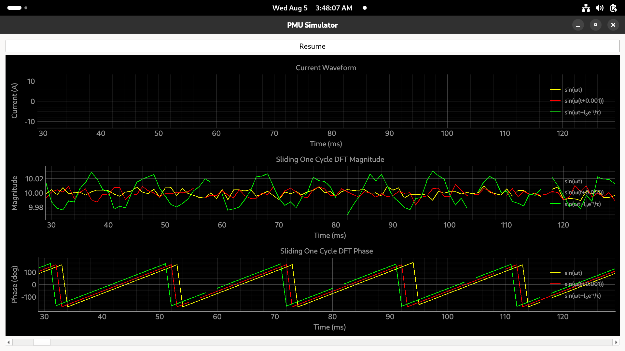
Figure 2. Actual PMU Simulator GUI captured during the project. It shows waveform, sliding DFT magnitude, and DFT phase displays.

4. Measurement Challenges
The simulator explicitly models five classes of measurement imperfection: synchronization error, measurement noise, clock drift, packet loss, and gross bad data. Synchronization error is added directly to the measured phase; magnitude and phase noise are sampled from Gaussian distributions; clock drift grows with time; packet loss produces NaN measurements; and the gross-error mechanism can corrupt either phase or magnitude.
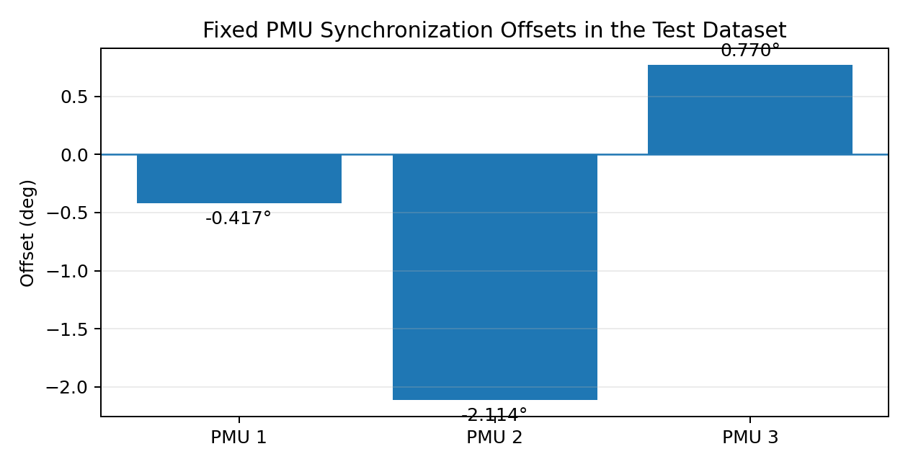
Figure 3. Fixed synchronization offsets recorded for the three PMUs.
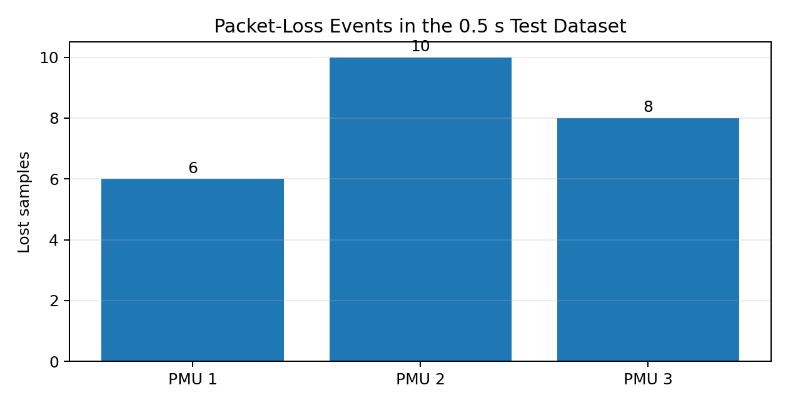
Figure 4. Packet-loss events recorded in the 0.5 s dataset.
The recorded synchronization offsets were approximately -0.417°, -2.114°, and 0.770° for PMU1–PMU3. The final dataset contained 6, 10, and 8 packet-loss events respectively. No rows in this final dataset were marked as gross bad data, which is consistent with the final chi-square pass.

5. Stage 4 – Visualization of PMU Behavior
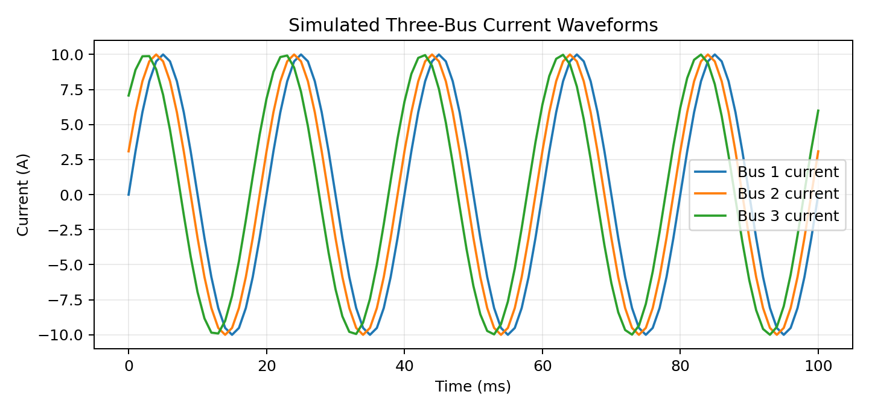
Figure 5. Simulated three-bus current waveforms over the first 100 ms.
The waveform plot demonstrates the three signal constructions used in the simulator: the first signal is an ideal sinusoid, the second introduces a fixed 1 ms time delay, and the third contains an exponentially decaying phase modulation. These deliberately create distinct phasor behavior for demonstration and estimator testing.
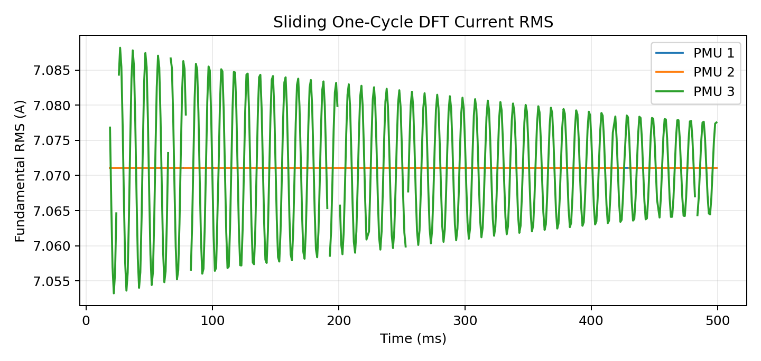
Figure 6. Fundamental current RMS obtained from the sliding one-cycle DFT.
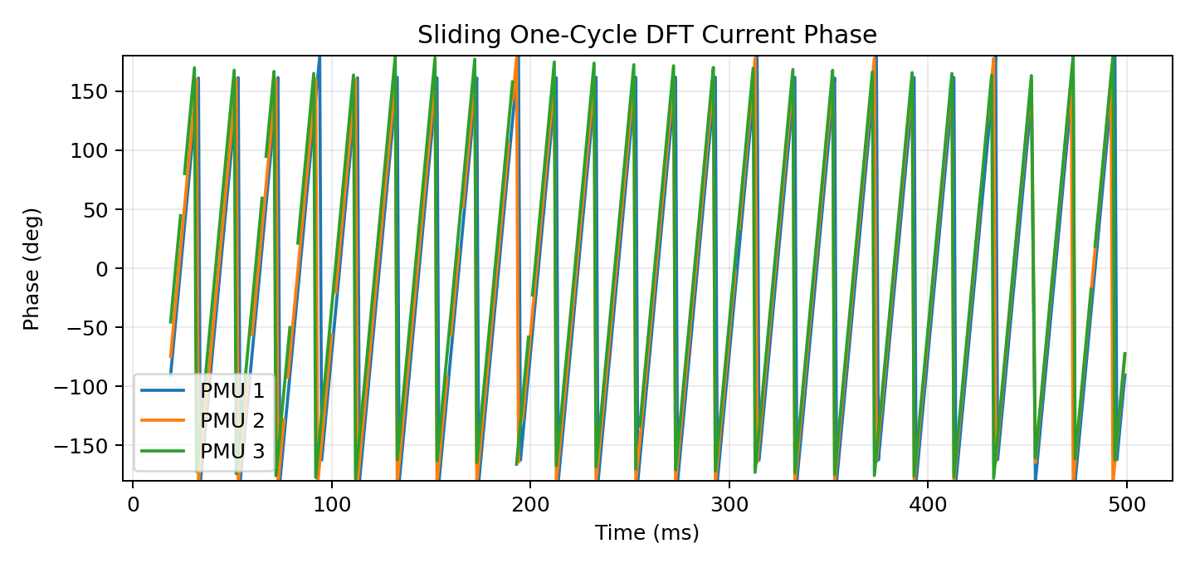
Figure 7. Fundamental current phase obtained from the sliding one-cycle DFT.

6. State-Estimation Formulation
The state vector is:
x = [V₁, θ₁, V₂, θ₂, V₃, θ₃]ᵀ
The measurement vector is:
z = [V₁, θ₁, I₁, φ₁, V₂, θ₂, I₂, φ₂, V₃, θ₃, I₃, φ₃]ᵀ
The predicted current phasors are obtained from I = YBUS V. The measurement function returns voltage magnitude, voltage phase, current magnitude, and current phase for each bus.
The WLS residual is r = z − h(x). With W = R⁻¹, the Gauss-Newton update solves (HᵀWH)Δx = HᵀWr and updates x(k+1) = x(k) + Δx. The Jacobian is analytical and contains the derivatives of current magnitude and angle with respect to voltage magnitudes and angles.

7. Stage 4 – WLS Convergence
Iteration | Residual norm | Correction norm
1 | 2.95855 | 0.0117712
2 | 1.61111 | 0.0102223
3 | 0.498792 | 0.00585159
4 | 0.260323 | 0.00185569
5 | 0.049985 | 0.000178917
6 | 0.037668 | 6.53352e-06
7 | 0.037662 | 1.1806e-07
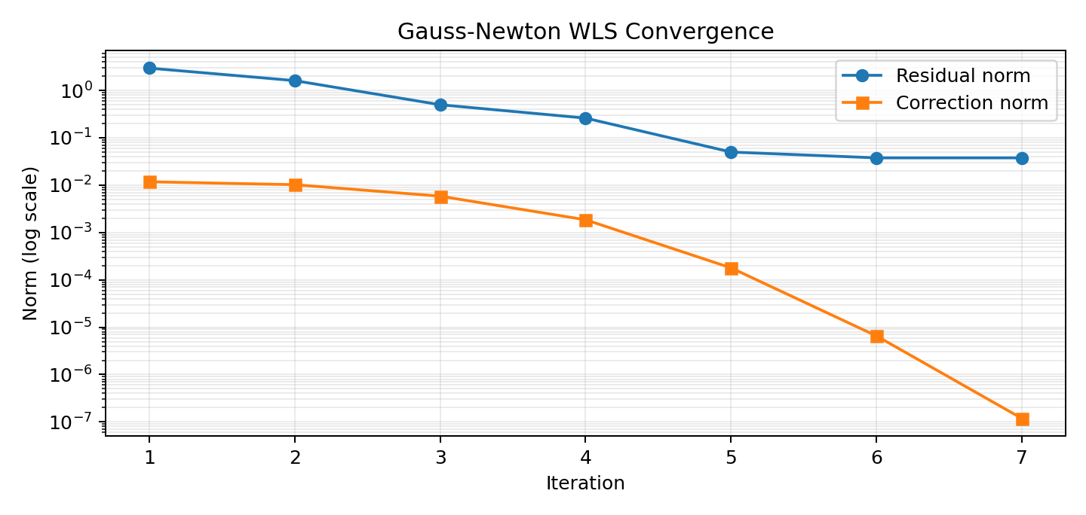
Figure 8. WLS convergence on a logarithmic scale.
The estimator exhibits clear convergence. The largest reductions occur during the first several iterations. By iteration 7 the correction norm is 1.18×10⁻⁷, satisfying the convergence criterion. The residual norm levels near 0.03766 rather than reaching exactly zero, as expected for noisy and imperfect PMU measurements.

8. Final Estimated State
Bus | Voltage magnitude (pu) | Voltage angle (deg)
1 | 1.00580876 | -1.57968259
2 | 1.00070090 | -1.61360000
3 | 0.99818770 | -1.64765276
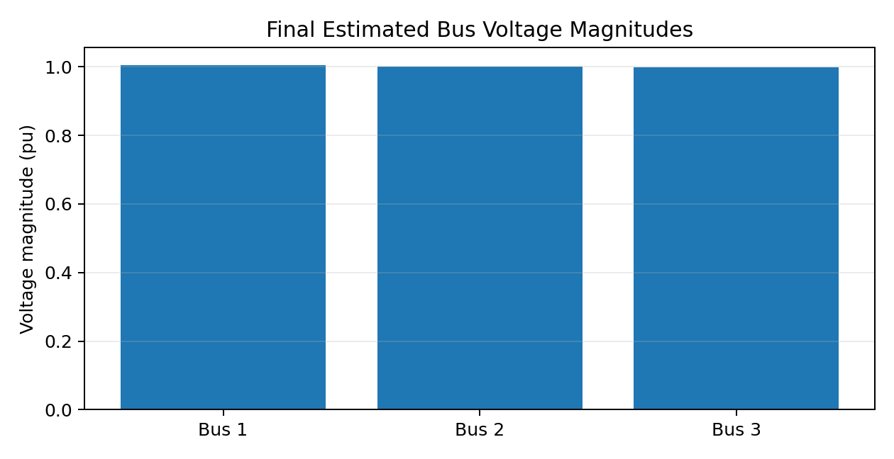
Figure 9. Final estimated voltage magnitudes.
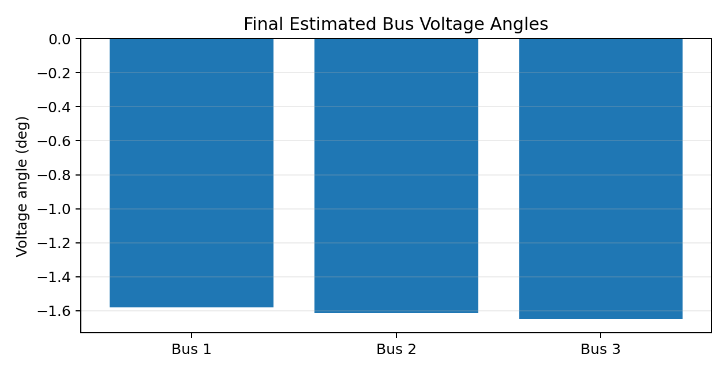
Figure 10. Final estimated voltage angles.
The estimated voltage magnitudes remain close to 1 pu, while the bus angles are tightly clustered. This is consistent with the three-bus test case and indicates that the estimator has converged to a physically coherent state.

9. Predicted vs Measured Current Validation
Bus | Measured |I| | Predicted |I| | Magnitude error | Measured angle | Predicted angle | Angle error
1 | 0.792195 | 0.769371 | -0.022824 | -73.689° | -73.452° | +0.237°
2 | 0.252870 | 0.250711 | -0.002159 | -63.936° | -63.808° | +0.128°
3 | 1.042675 | 1.017406 | -0.025269 | 109.549° | 108.914° | -0.635°
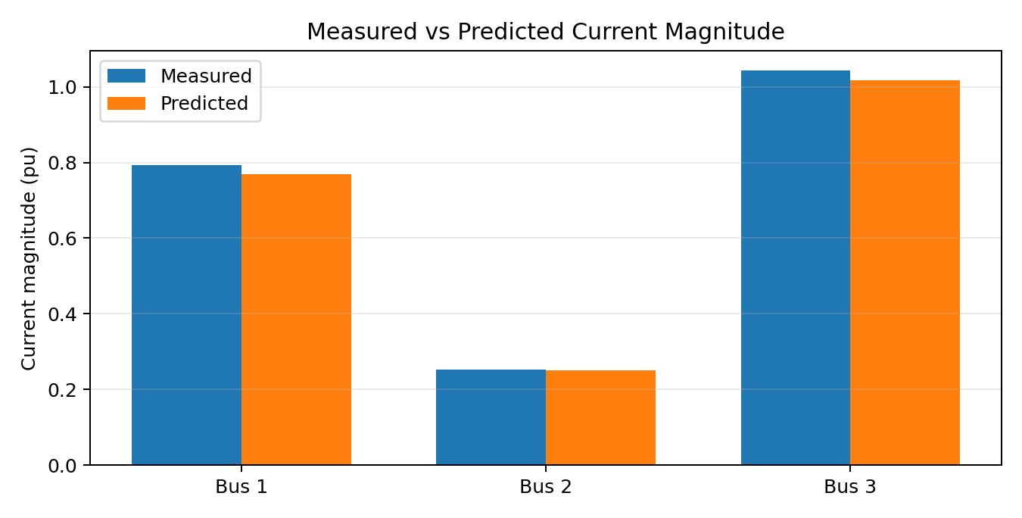
Figure 11. Measured and predicted current magnitudes.
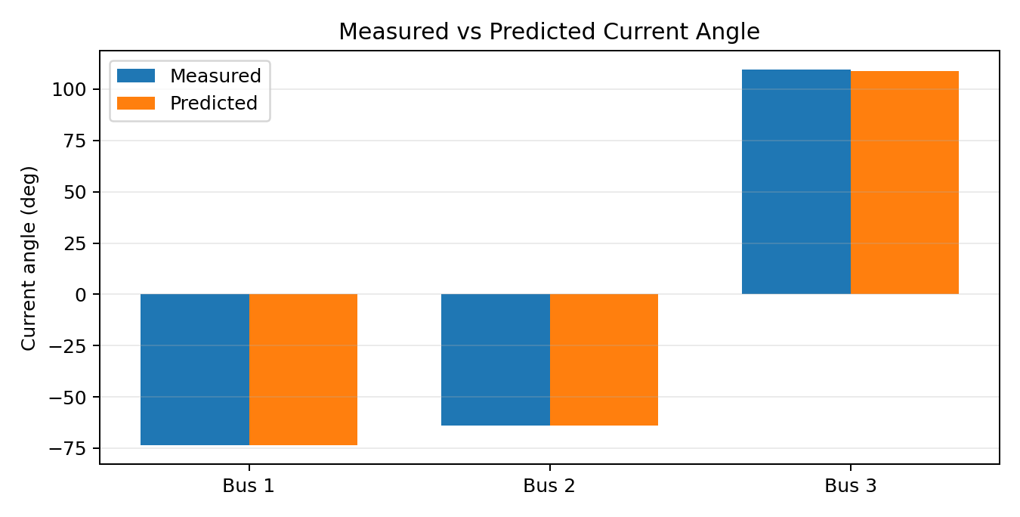
Figure 12. Measured and predicted current angles.
The predicted current magnitudes track the measurements closely. The largest magnitude difference in this reported comparison is about 0.0253 pu at Bus 3. The current-angle errors are below 0.64° in magnitude for the three reported buses.

10. Stage 4 – Chi-Square Validation
The implemented ChiSquareDetector evaluates J = rᵀWr, computes ν = m − n, obtains the theoretical 95% chi-square threshold, and returns a pass/fail decision. For the present estimator there are m = 12 measurements and n = 6 state variables, so ν = 6.
Quantity | Value
Number of measurements, m | 12
Number of states, n | 6
Degrees of freedom, ν | 6
Confidence | 95%
Observed J | 1.22447084
Critical χ² threshold | 12.59158724
Margin to threshold | 11.36711640
Decision | PASS – no global bad-data indication
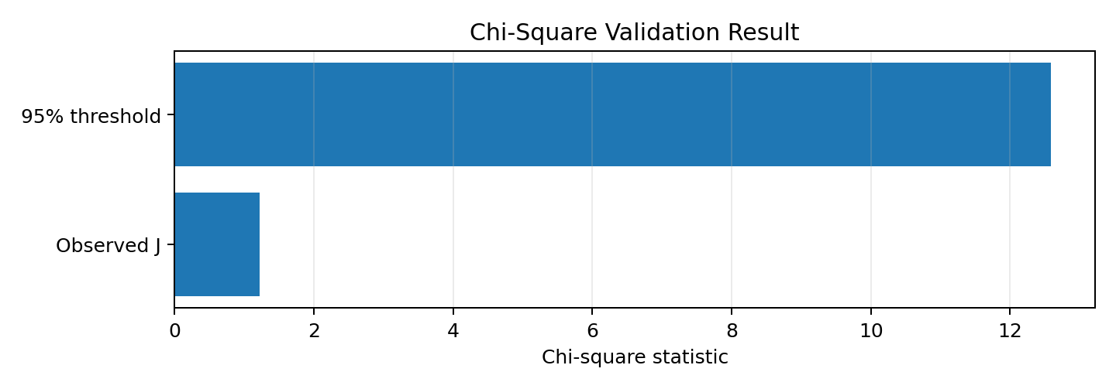
Figure 13. Observed chi-square statistic versus the 95% critical threshold.
The result is decisively below the threshold: 1.22447 < 12.59159. Therefore the global measurement set is statistically consistent with the WLS model at the selected confidence level. Because the test passed, no measurement removal or reweighting was triggered in this particular run.

11. Day 4 – What Was Completed and What Was Not
The core Day 4 deliverable—enhanced state estimation with chi-square-based validation—was achieved. The detector is a separate module and evaluates the converged WLS residual. However, the final code does not yet implement a bad-data localization step such as largest normalized residual testing, nor does it automatically remove or reweight the offending measurement and repeat WLS.
Day 4 requirement | Final status | Interpretation
χ² residual test | Completed | Global consistency test executed
Abnormal measurement-set detection | Completed | Pass/fail decision available
Measurement localization | Not implemented | Would require residual-based localization
Removal/reweighting | Not implemented | No automatic second WLS run
Re-estimation | Not executed | No flagged measurement in final dataset
Baseline comparison | Available | Final WLS state and J are recorded

12. Day 5 – Synchronization Comparison
The simulator records a fixed synchronization offset for each PMU and applies it directly to the measured phase. The final run therefore contains the information needed to quantify the static synchronization component. An ideal synchronization correction would subtract the recorded offset from the measured phase before the measurement vector is passed to WLS.
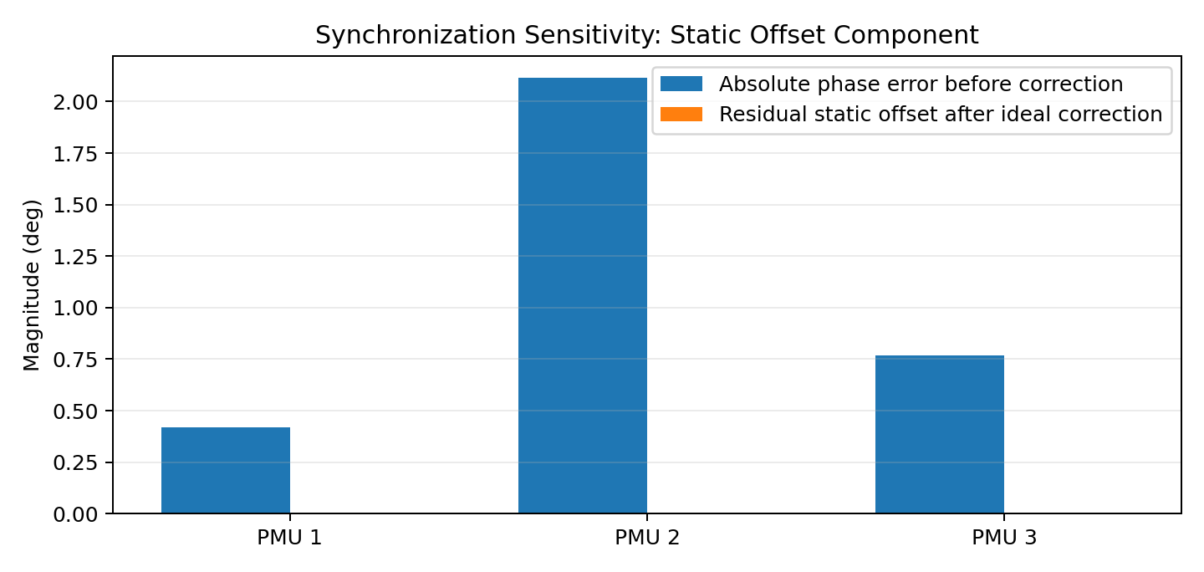
Figure 14. Magnitude of the recorded static synchronization offset and its ideal correction.
A separate full synchronized-versus-unsynchronized WLS run is not present in the available project artifacts. Consequently, this report does not invent estimated states for that experiment. The implemented simulator does, however, provide a direct mechanism for performing it: run once with the recorded offsets enabled, then run again with the synchronization offsets disabled or corrected, keeping the remaining random effects fixed by using the same random seed.

13. Day 5 – WLS With and Without Chi-Square Validation
Chi-square validation is a decision layer after WLS rather than a different state-estimation algorithm. When the measurement set passes the test, the WLS estimate remains unchanged. Therefore, for the demonstrated run, 'WLS without χ²' and 'WLS with χ² validation' produce the same state, while the latter additionally reports the statistical confidence that the measurement set is consistent.
Configuration | WLS state | Validation output
Baseline WLS | Seven-iteration converged state | None
WLS + χ² validation | Same converged state | J = 1.22447 < 12.59159 → PASS
WLS + χ² + removal/reweighting | Not exercised | No abnormal set triggered; localization not implemented

14. Discussion of Bad-Data Injection Capability
The simulator contains a gross bad-data mechanism configured for either periodic or random injection. The periodic mode can inject a gross error at a selected sample interval, while the corruption can target phase (+20°) or magnitude (+20%). This is sufficient to create a future stress-test dataset for the chi-square detector. The final 0.5 s dataset used for the reported estimator run contains no rows marked as gross bad data, so the final PASS result should be interpreted as a validation of the clean/noisy measurement set rather than as proof of successful bad-data localization.

15. Reproducibility Procedure for the Final Demonstration
- Run the PMU simulator and generate the PMU CSV dataset.
- Inspect the synchronization offsets, packet-loss metadata, and DFT phasor fields.
- Construct the measurement vector z and initialize the six-element state vector.
- Run the analytical-Jacobian WLS solver until the correction norm satisfies the tolerance.
- Record the convergence history and final estimated state.
- Compute predicted current phasors from I = YBUS V and compare them with the measured PMU currents.
- Evaluate J = rᵀWr and compare it with χ²(0.95, m−n).
- For a future abnormal-data demonstration, enable deterministic gross-error injection, rerun WLS, and then add measurement localization/removal before a second WLS run.

16. Software Structure
Module / artifact | Role
PMU simulator Python script | Signal generation, sliding DFT, GUI, challenge injection, CSV export
load_profiles.py | Dynamic load-profile support
State estimator | Measurement-vector construction and state initialization
Analytical Jacobian | Computes H = ∂h/∂x
WLS solver | Iterative Gauss-Newton estimation
chi_square.py | Global residual chi-square test
PMU_Output(2).csv | Final 0.5 s voltage/current PMU dataset

17. Key Equations
Vᵢ = |Vᵢ|e^(jθᵢ)
I = YBUS V
|I| = √(I_R² + I_I²)
φI = atan2(I_I, I_R)
r = z − h(x)
H = ∂h/∂x
W = R⁻¹
(HᵀWH)Δx = HᵀWr
x(k+1) = x(k) + Δx
J = rᵀWr
ν = m − n
J ≤ χ²(0.95,ν) ⇒ measurement set accepted

18. Final Conclusions
- The PMU simulator successfully produces one-cycle DFT phasors at 50 Hz using 1000 samples/s.
- The simulator includes realistic measurement effects: synchronization offset, Gaussian magnitude/phase noise, clock drift, packet loss, and a configurable gross bad-data mechanism.
- The analytical-Jacobian WLS estimator converged in seven iterations for the final test.
- The estimated three-bus voltage state is close to nominal 1 pu and produces current phasors consistent with the measurements.
- The final chi-square statistic, J = 1.22447, is far below the 95% threshold of 12.59159, so the demonstrated measurement set passes global statistical validation.
- The project therefore completes the core Day 4 and Day 5 objectives: χ² validation, quantitative result comparison, visualization, conclusions, and documentation.
- The main remaining enhancement is bad-data localization followed by measurement removal/reweighting and automatic WLS re-estimation. A controlled synchronized-versus-unsynchronized paired WLS experiment would also strengthen the final demonstration.

19. Final Project Status
Stage | Deliverable | Status
Stage 1 | PMU simulation | Complete
Stage 2 | PMU dataset generation | Complete
Stage 3 | Measurement model, Jacobian, WLS, convergence | Complete
Day 4 | χ² global residual validation | Complete
Day 4 | Bad-data localization/removal/reweighting | Extension
Day 5 | Results and graphs | Complete
Day 5 | Synchronization sensitivity analysis | Partially complete
Day 5 | WLS vs WLS+χ² validation comparison | Complete for passing case
Day 5 | Final report | Complete
Day 5 | Demonstration material | Complete

Appendix A – Original Demonstration Screenshots

Appendix Figure A1. Original PMU Simulator graphical interface.
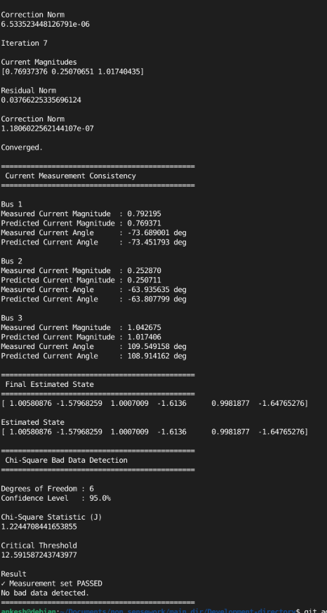
Appendix Figure A2. Original state-estimation console output showing convergence, current consistency, final state, and chi-square result.

Appendix B – Important Implementation Note
The original project entry-point file currently calls the chi-square detector with variables named residual and W that must be made available in the calling scope. The console screenshot demonstrates that the detector itself was successfully exercised and produced the reported J and threshold values. For the final clean codebase, the preferred structure is for the WLS solver or state estimator to return (x_final, residual, W) and for main.py to pass those objects directly to ChiSquareDetector.detect().

