（1）查询出所有欠费用户。

select distinct client.name

from client,receivables,device

where client.id = device.clientid and device.deviceid = receivables.deviceid

and receivables.flag=0

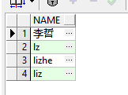

（2）查询出拥有超过2个设备的用户（1201-1208为新增数据）

select id

from device,client

where clientid=id

GROUP BY name

having count(*)>2

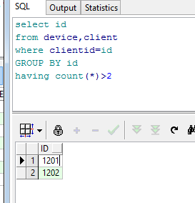

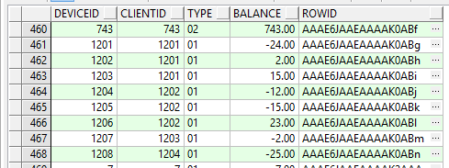

1. 统计电力企业某每天的总应收费用，实收费用

应收费用：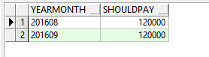

select receivables.yearmonth,sum(receivables.basicfee) as shouldPay

from receivables

group by receivables.yearmonth

实收费用：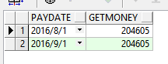

select paydate,sum(paymoney) as getmoney

from payfee

group by paydate

1. 查询出所有欠费超过半年的用户

select name

from client,device,receivables

where flag=0 and client.id = device.clientid and device.deviceid = receivables.deviceid

and months_between(to_date(receivables.yearmonth,'yyyymm'),to_date('201612','yyyymm'))<-6

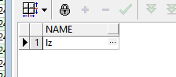



1. 查询任意用户的欠费总额

select clientid,sum(basicfee) as sumFee

from device,receivables

where device.deviceid = receivables.deviceid and flag = 0

group by device.clientid

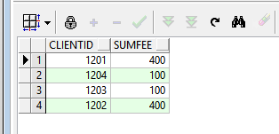

1. 查询出某个月用电量最高的3名用户（8月）

select client.name,cost

from (

select sum(receivables.basicfee) as cost,device.clientid as cid,

row_number()over(order by sum(receivables.basicfee) desc)rn

from client,device,receivables

where client.id = device.clientid

and receivables.yearmonth='201608'

and device.deviceid = receivables.deviceid

group by device.clientid

)T,client

where rn<4 and client.id = T.cid

**注：**

设备1201-1203为用户1201的设备（lz）

设备1204-1206为用户1202的设备（lizhe）

设备1207为用户1203的设备（李哲）

设备1208为用户1204的设备（liz）

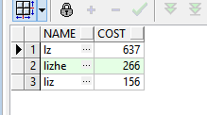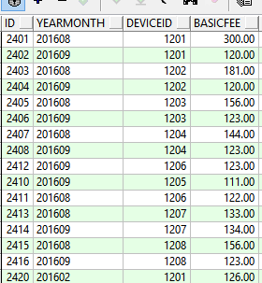

（7）查询出电力企业某每个月哪天的缴费人数最多

这是后面添加的数据：

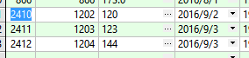

结果为：

with T as(select payfee.paydate as pdate,count(*)as num

from client,device,payfee

where client.id = device.clientid

and device.deviceid = payfee.deviceid

and to_char(payfee.paydate,'yyyy/mm')='2016/09'

group by payfee.paydate)

第一句with执行的结果为：

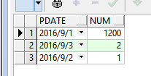

select pdate

from (select max(T.num)as num from T)S,T

where T.num = S.num



1. 按设备类型使用人数从高到低排序查询列出设备类型，使用人数。

select type,count(deviceid)

from device

group by device.type

order by count(deviceid) desc

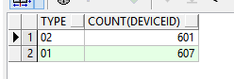

1. 统计每个月各银行缴费人次，从高到低排序。

select to_char(payfee.paydate,'yyyymm') as mon,count(*) as paynum

from bankrecord,payfee

where bankrecord.bankserial = payfee.bankserial

group by to_char(payfee.paydate,'yyyymm')

order by to_char(payfee.paydate,'yyyymm') desc

加入的数据如下：

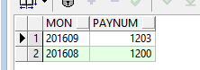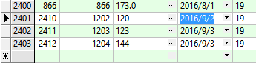

（10）查询出电力企业所有新增用户（使用设备不足半年）。

select name

from client,device,electricity

where client.id = device.clientid and device.deviceid = electricity.deviceid

and months_between(to_date(electricity.yearmonth,'yyyymm'),to_date('201612','yyyymm'))>-6

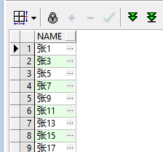（没有全部展示）