Assignment - 7

Name :- Aindrail Santra Roll No. :- 2029044

Q1.

import java.util.**\***;

class Complex

{

double real, imaginary;

Complex(double *r*, double *i*)

{

**this**.real = *r*;

**this**.imaginary = *i*;

}

public void disp ()

{

System.out.println(**this**.real + " + " + **this**.imaginary + " i");

}

public static Complex add (Complex *n1*, Complex *n2*)

{

Complex res = new Complex (0, 0);

res.real = *n1*.real + *n2*.real;

res.imaginary = *n1*.imaginary + *n2*.imaginary;

return res;

}

public static Complex subtract (Complex *n1*, Complex *n2*)

{

Complex r = new Complex (0, 0);

r.real = *n1*.real - *n2*.real;

r.imaginary = *n1*.imaginary - *n2*.imaginary;

return r;

}

public static void main(String[] *args*)

{

Scanner sc = new Scanner(System.in);

double r1,c1,r2,c2;

System.out.println("Enter the first complex number : ");

r1 = sc.nextDouble();

c1 = sc.nextDouble();

System.out.println("Enter the second complex number : ");

r2 = sc.nextDouble();

c2 = sc.nextDouble();

Complex num1 = new Complex (r1, c1);

Complex num2 = new Complex (r2, c2);

Complex sum = add(num1, num2);

Complex difference = subtract(num1, num2);

System.out.println("Addition of two complex numbers : " );

sum.disp();

System.out.println("Subtraction of two complex numbers : " );

difference.disp();

sc.close();

}

}

OUTPUT

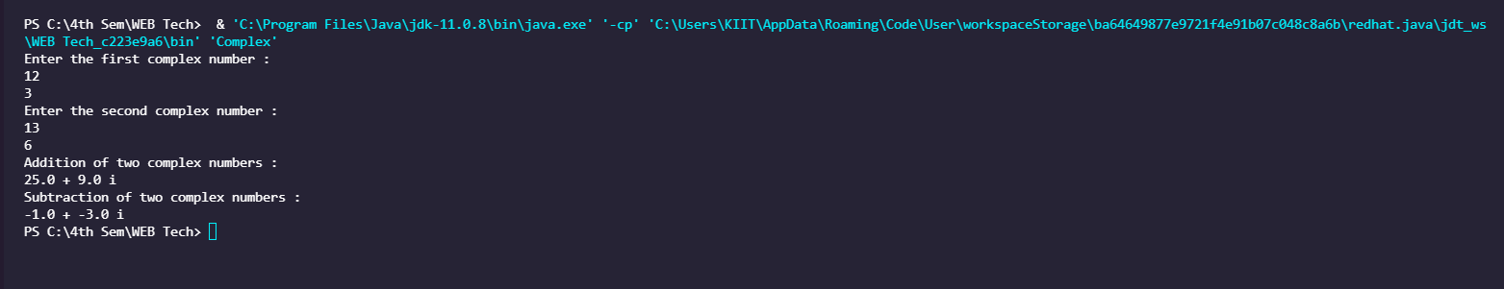

Q2.

import java.util.**\***;

public class Volume

{

static double vol (double *r*)

{

return (4 * 3.14 * *r* * *r* * *r*)/3;

}

static double vol (int *b*, int *h*)

{

return *b* * *h*;

}

static double vol (double *r*, int *h*)

{

return (22.7 * *r* * *r* * *h*);

}

static double vol (double *r*, double *h*)

{

return (22.7 * *r* * *r* * (*h*/3));

}

static double vol (double *l*, double *w*, double *h*)

{

return *l* * *w* * *h*;

}

public static void main (String[] *args*)

{

Scanner sc = new Scanner(System.in);

System.out.println(" Volume calculator ");

System.out.println(" 1 - Sphere, 2 - Prism, 3 - Cylinder, 4 - Cone, 5- Cuboid");

int c;

System.out.println("Enter your choice : ");

c = sc.nextInt();

double res;

switch (c)

{

case 1 :

{

double r;

System.out.println("Enter the radius of the circle");

r = sc.nextDouble();

res = vol(r);

System.out.println("Volume of the circle : " + res);

break;

}

case 2 :

{

int b, h;

System.out.println("Enter the base and height of the prism");

b = sc.nextInt();

h = sc.nextInt();

res = vol(b,h);

System.out.println("Volume of the prism: " + res);

break;

}

case 3 :

{

double r; int h;

System.out.println("Enter the base and height of the cylinder");

r = sc.nextDouble();

h = sc.nextInt();

res = vol(r,h);

System.out.println("Volume of the cylinder : " + res);

break;

}

case 4 :

{

double r, h;

System.out.println("Enter the base and height of the cone");

r = sc.nextDouble();

h = sc.nextDouble();

res = vol(r,h);

System.out.println("Volume of the cone : " + res);

break;

}

case 5 :

{

double l,b,h;

System.out.println("Enter the length, breadth and height of the cuboid");

l = sc.nextDouble();

b = sc.nextDouble();

h = sc.nextDouble();

res = vol(l,b,h);

System.out.println("Volume of the cuboid : " + res);

break;

}

default : System.out.println("Wrong choice.");

}

sc.close();

}

}

OUTPUT

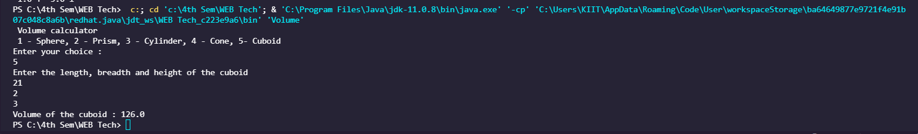

Q3.

import java.util.**\***;

public class Distance

{

double feet, inches;

Distance(double *f*, double *i*)

{

**this**.feet = *f*;

**this**.inches = *i*;

}

public void disp ()

{

System.out.println(**this**.feet + " and " + **this**.inches + ".");

}

public static Distance add (Distance *d1*, Distance *d2*)

{

Distance res = new Distance (0, 0);

res.feet = *d1*.feet + *d2*.feet;

res.inches = *d1*.inches + *d2*.inches;

if (res.inches >= 12)

{

res.inches = res.inches - 12;

res.feet = res.feet + 1;

}

return res;

}

public static Distance subtract (Distance *d1*, Distance *d2*)

{

Distance res = new Distance (0, 0);

res.feet = *d1*.feet - *d2*.feet;

res.inches = *d1*.inches - *d2*.inches;

if (res.inches < 0)

{

res.inches = res.inches + 12;

res.feet = res.feet - 1;

}

return res;

}

public static void main(String[] *args*)

{

Scanner sc = new Scanner(System.in);

double f1,i1,f2,i2;

System.out.println("Enter the first distance : ");

f1 = sc.nextDouble();

i1 = sc.nextDouble();

System.out.println("Enter the second distance : ");

f2 = sc.nextDouble();

i2 = sc.nextDouble();

Distance dis1 = new Distance (f1, i1);

Distance dis2 = new Distance (f2, i2);

Distance sum = add(dis1, dis2);

Distance difference = subtract(dis1, dis2);

System.out.println("Addition of two distances : " );

sum.disp();

System.out.println("Subtraction of two distances : " );

difference.disp();

sc.close();

}

}

OUTPUT

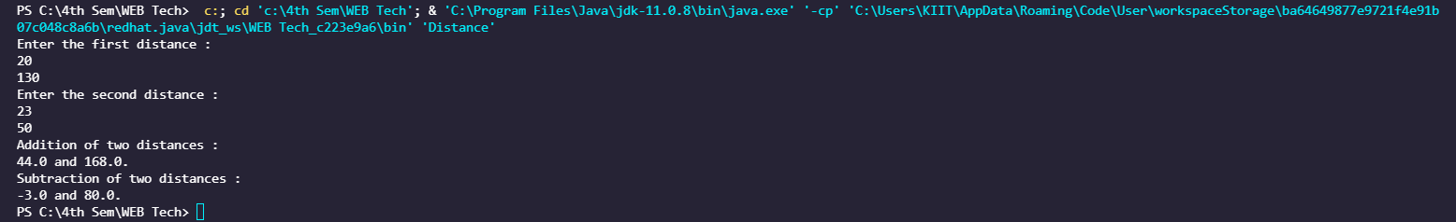

Q4.

import java.util.**\***;

public class Account

{

int Accno;

String AccHolderName;

char Account_type;

double balance;

Account(int *a*, String *b*, char *c*, double *d*)

{

**this**.Accno = *a*;

**this**.AccHolderName = *b*;

**this**.Account_type = *c*;

**this**.balance = *d*;

}

public void disp ()

{

System.out.println("Details");

System.out.println("Account number : " + Accno);

System.out.println("Account holder name : " + AccHolderName);

System.out.println("Account type : " + Account_type);

System.out.println("Account balance : " + balance);

}

public void deposit (double *price*)

{

System.out.println("Account in balance : (initial) " + balance);

double amount = balance + *price*;

System.out.println("Account deposited : " + *price*);

System.out.println("Account in balance : (final) " + amount);

}

public void withdraw (double *price*)

{

System.out.println("Account in balance : (initial) " + balance);

double amount = balance - *price*;

System.out.println("Account withdrawn : " + *price*);

System.out.println("Account in balance : (final) " + amount);

}

public void search (int *num*)

{

if (*num* == Accno)

{

System.out.println("Details");

System.out.println("Account number : " + Accno);

System.out.println("Account holder name : " + AccHolderName);

System.out.println("Account type : " + Account_type);

System.out.println("Account balance : " + balance);

}

else

{

System.out.println("Wrong account number.");

}

}

public static void main(String[] *args*)

{

Scanner sc = new Scanner(System.in);

System.out.println("Implementation of banking system.");

System.out.println("Enter the details.");

int id; String name; char type; double total;

System.out.println("Enter the account id: ");

id = sc.nextInt();

System.out.println("Enter the account holder name: ");

name = sc.next();

System.out.println("Enter the account type: (S for savings, Cforcurrent) ");

type = sc.next().charAt(0);

System.out.println("Enter the account balance: ");

total = sc.nextDouble();

Account obj = new Account(id, name, type, total);

System.out.println("1- Display details 2- Deposit amount 3- Withdraw amount 4- Search account");

int ch;

System.out.println("Enter the choice: ");

ch = sc.nextInt();

switch(ch)

{

case 1:

{

obj.disp();

break;

}

case 2:

{

double a;

System.out.println("Enter the amount to be deposited");

a = sc.nextDouble();

obj.deposit(a);

break;

}

case 3:

{

double a;

System.out.println("Enter the amount to be withdrawn");

a = sc.nextDouble();

obj.withdraw(a);

break;

}

case 4:

{

int a;

System.out.println("Enter the account id to be searched");

a = sc.nextInt();

obj.search(a);

break;

}

default : System.out.println("Wrong choice.");

}

sc.close();

}

}

OUTPUT

