./



Version Number:

Team Members :

Team No:

Module: Model Based System Engineering

|  |  |  |  |  |  |
| --- | --- | --- | --- | --- | --- |
| **Ver.Rel. No.** | **Release Date** | **Prepared. By** | **Reviewed By** | **Approved By** | **Remarks/Revision Details** |
|  |  |  |  |  |  |
|  |  |  |  |  |  |
|  |  |  |  |  |  |
|  |  |  |  |  |  |
|  |  |  |  |  |  |

**Document History**

# 

**CASE STUDY 1:**

**Fingerprint based Attendance System:**

* **Purpose**: Aims to automate the attendance taking procedure of an organization/educational institute using biometric technology(fingerprint). This procedure is extremely efficient as compared to the traditional name call out procedures.
* **Block Diagram**:

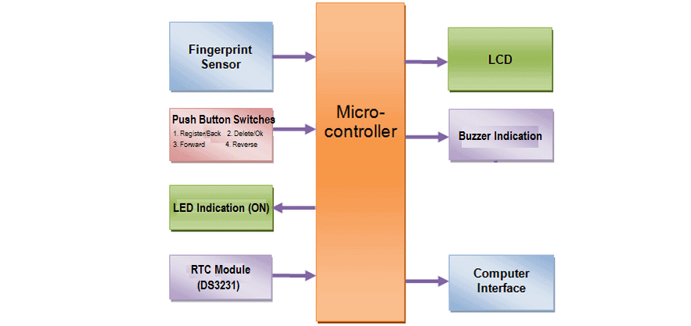

1. Fingerprint sensor module: To authenticate a true person or employee by taking their finger input in the system.
2. The Push button switches: To register new fingerprint or delete stored fingerprint or match stored fingerprint.
3. LED: Power indication.
4. RTC Module: For registering scanning/entering/exiting time of the user.
5. LCD: Displays the time record and every function happening via push buttons.
6. Buzzer: Indicates different functions happening whenever any interrupt is detected.

* **Components used:**

|  |  |
| --- | --- |
| **NAME** | **DESCRIPTION** |
| Arduino | Arduino UNO |
| Fingerprint Sensor | R305/R307 |
| RTC Module | DS3231/DS1307 Real Time Clock Module |
| LCD Display | 16*2 LCD display |
| Push Buttons | Push to ON reset tact switch |
| Buzzer | 5V active buzzer |
| LED | 5mm |

* **High level requirements:**

1.Vein Pattern recognition: Scanning the pattern of veins under the skin of the fingers and recording the bifurcations & patterns as digitized images in a favored technique

2.Fingerprint can conduct secondary development & embedded into a variety of end products

3.Fingerprint Recognition: Images of the ridge endings & bifurcations that makes up a fingerprint pattern are stored as images.

4.It will have the capability of storing, enrolling, deleting, verifying fingerprints.

5.Tracks time and prevents unauthorized people from entering secure areas.

* **Low level requirements:**

We have 4 push buttons as input from the user:

**1.Register/Back Button:** Used for enrolling new fingerprint as well as reversing the back process or going back

**2.Delete/OK Button**: This Button is used for deleting the earlier stored fingerprint system as well as granting access as an OK selection.

**3.Forward Button:** Used for moving forward while selecting the memory location for storing or deleting fingerprints.

**4.Reverse Button:** Used for moving backward while selecting memory location for storing or deleting fingerprints.

**In addition to these buttons, we will get the various outputs from 16*2 LCD displays when the finger is to be placed/removed.**

**RTC module for date & time display**

**Buzzer for different function indication**

**Working of the buttons:**

* **Enrolling New Fingerprint:**

To enroll New Fingerprint, click on the Enroll button. Then select the memory location where you want to store your fingerprint using the UP/DOWN button. Then click on OK. Put your finger and remove your finger as the LCD instructs. Put your finger again. So finally, your fingerprint gets stored.

* **Deleting Stored Fingerprint:**

To delete the fingerprint which is already clicked on DEL Button. Then select the memory location where your fingerprint was stored earlier using the UP/DOWN button. Then click on OK. So finally, your fingerprint is deleted.

* **Downloading Data:**

Simply click on Register/Back Button and reset the button together. At this movement, the serial monitor should be opened.

* **References:**

<https://www.ijeast.com/papers/195-199,Tesma106,IJEAST.pdf>

[**https://how2electronics.com/fingerprint-biometric-attendance-system-arduino/**](https://how2electronics.com/fingerprint-biometric-attendance-system-arduino/)