15CSE381 Computer Organization and Architecture Lab
Lab Sheet 5

- https://www.youtube.com/watch?v=9mpRF6bAY1g
Watch the above video (Outside Lab)
- Verilog Basic Examples
Note: Here different input values are given in the program itself .Modify the Task 2 in Labsheet 2 and Execute the program.

  - AND GATE
- Truth Table
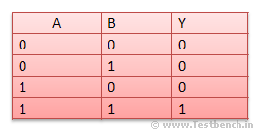
Verilog design
//in data flow model
module and_gate(
input a,b,
output y);
//Above style of declaring ports is ANSI style.Verilog2001 Feature
assign y = a & b;
endmodule
//TestBench which gives possible inputs
module tb_and_gate;
reg A,B;//inputs
wire Y;// connection to output
and_gate a1 (.a(A) ,.b(B),.y(Y));// Unit Under Test
//Above style is connecting by names
initial begin
A =1'b0; //Meaning is , input is single bit and value is zero
B= 1'b0;
#45 $finish;
end
always #6 A =~A; // Delay to change the input values
always #3 B =~B;
endmodule
b. XOR GATE
Truth Table
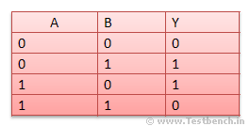
Verilog design
//in Structural model
module xor_gate (
input a,b,
output y);
xor x1(y,a, b); //xor is a built in primitive. While using these primitives //you should follow the connection rules. First signal should be output and //then inputs.
endmodule
//TestBench
module tb_xor_gate;
reg A,B;
wire Y;
xor_gate a1 (.a(A) ,.b(B),.y(Y)); //Unit under Test
initial begin
A =1'b0;
B= 1'b0;
#45 $finish;
end
always #6 A =~A;
always #3 B =~B;
endmodule
c. OR GATE
Truth Table
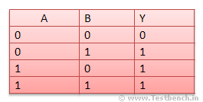
Verilog design
//in Behaviour model
module or_gate(
input a,b,
output reg y);
always @(a,b)
y = a |b;
endmodule
//TestBench
module tb_or_gate;
reg A,B;
wire Y;
or_gate a1 (.a(A) ,.b(B),.y(Y));
initial begin
A =1'b0;
B= 1'b0;
#45 $finish;//Check in ModelSim Reference
end
always #6 A =~A;
always #3 B =~B;
endmodule
d. Half Adder
Truth Table
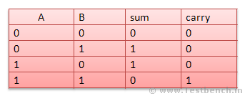
Verilog design
module half_adder(
input a,b,
output sum,carry);
assign sum = a^b;
assign carry = a & b;
endmodule
//TestBench
module tb_half_adder;
reg A,B;
wire SUM,CARRY;
half_adder HA (.a(A) ,.b(B),.sum(SUM),.carry(CARRY))
initial begin
A =1'b0;
B= 1'b0;
#45 $finish;
end
always #6 A =~A;
always #3 B =~B;
endmodule
3. Design a full adder circuit and check it’s correctness.

