
;l
Foundations of Programming
Assignment No. : 01

1. PROBLEM STATEMENT:
Write a program in C to check whether a given year is a Leap Year

OBJECTIVE:

- To understand the use of conditional statements in C programming.
- To implement logical conditions for solving real-world problems.
- To develop problem-solving skills using decision control structures.

THEORY:
- Theory for conditional statements with syntax (if , if-else, if-else ladder) are used in C programming.
The if statement is used to execute a block of code only when a given
condition is true. If the condition is false, the block is skipped.
Syntax:
if (condition)
{
// statements to be executed if condition is true
}

Eg:
#include <stdio.h>
int main() {
int number = 10;
if (number %2 == 0)
printf("The number is Even");
else
printf("The number is Odd");
}
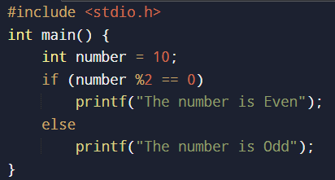
Output:

The if-else statement provides two alternative paths of execution. If the
condition is true, the if block runs; otherwise, the else block runs.

if (condition)
{
// statements executed if condition is true
}
else
{
// statements executed if condition is false
}

Eg: if-else:
#include <stdio.h>
void main() {
int age;
printf("Enter your age: ");
scanf("%d",&age);
if(age>=18)
printf("You are eligible to vote");
else
printf("You are not eligible to vote");
}
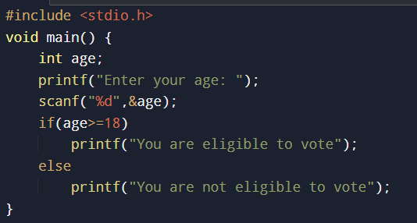

Output:
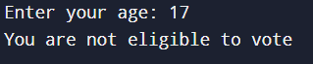

An if-else ladder is used when multiple conditions need to be checked in
sequence. As soon as one condition becomes true, its corresponding block is
executed, and the rest are skipped.

Syntax:
if (condition1)
{
// statements if condition1 is true
}
else if (condition2)
{
// statements if condition2 is true
}
else if (condition3)
{
// statements if condition3 is true
}
else
{
// statements if none of the above conditions are true
}
eg:
#include <stdio.h>
void main()
{
int marks;
printf("Enter your marks: ");
scanf("%d", &marks);
if (marks >= 90)
printf("Your grade is A");
else if (marks >= 80)
printf("Your grade is B");
else if (marks >= 70)
printf("Your grade is C");
else if (marks >= 50)
printf("Your grade is D");
else if (marks >= 35)
printf("Your grade is E");
else
printf("You are grade is F");
}
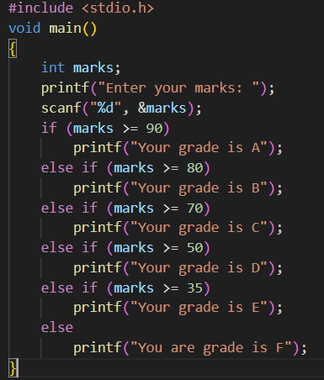
Output:
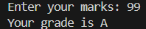
- Theory for a Leap Year - year that contains 366 days instead of the usual 365 days.
Rules:
  - A year is a leap year if it is divisible by 400, OR
- A year is a leap year if it is divisible by 4 but not divisible by 100.

Algorithm:
- Start
- Accept Year
- Check if Year is Divisible by 4 not by 100 or by 400.
- If yes then Leap Year else it is not a Leap Year.
- End
PLATFORM: Linux
C PROGRAM:
#include <stdio.h>
void main()
{
int year;
printf("Enter a year: ");
scanf("%d", &year);
if ((year % 4 == 0 && year % 100 != 0) || year % 400 == 0)
printf("%d is a leap year.", year);
else
printf("%d is not a leap year.", year);
}

INPUT: 2100
OUTPUT:
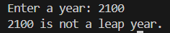

Sample Input
2024

Sample Output
2024 is a Leap Year
CONCLUSION: Thus, the program successfully checks whether a given year is a Leap Year using conditional statements in C.
FAQs:
- What is a leap year?
- Why is the year 1900 not a leap year but 2000 is?
- Which operators are used in this program?
- Difference between if and if–else statements.

