

Foundations of Programming
Assignment No. : 10

PROBLEM STATEMENT:
Write a program in C to simulate a simple calculator that performs basic arithmetic operations such as addition, subtraction, multiplication, and division. The calculator should also perform special operations like computing xʸ (power) and x! (factorial).

OBJECTIVE:
• To understand the use of switch-case statements in C.
• To perform basic arithmetic and special mathematical operations.
• To enhance problem-solving skills using menu-driven programs.

THEORY:
A calculator is a basic computing device used to perform arithmetic operations. In C programming, a simple calculator can be implemented using conditional or switch-case statements. Arithmetic operations like addition, subtraction, multiplication, and division are fundamental operations. Special operations such as power (xʸ) and factorial (x!) require loops for repeated calculations.

PLATFORM:
Linux

ALGORITHM:
- Start
- Accept 2 Numbers and choice from user
- Perform respective operation
- Display result
- End

C PROGRAM:
#include <stdio.h>
#include <math.h>
int fact(int n)
{
if (n == 1)
return n;
else
return n * fact(n - 1);
}
void main()
{
float a, b;
char ch;
printf("Enter Two Numbers: \n");
scanf("%f", &a);
scanf("%f", &b);
printf("What Operation You want to Perform: \n");
printf("+\n");
printf("-\n");
printf("*\n");
printf("/\n");
printf("%%\n");
printf("!\n");
printf("^\n");
printf("Enter Your Choice: ");
scanf(" %c", &ch);
switch (ch)
{
case '+':
printf("Addition: %f", a + b);
break;
case '-':
printf("Subtraction: %f", a - b);
break;
case '*':
printf("Multiplication: %f", a * b);
break;
case '/':
printf("Division: %f", a / b);
break;
case '%':
printf("Modulus: %d", (int)a % (int)b);
break;
case '!':
printf("Factorial of First Number: %d", fact(a));
printf("\nFactorial of Second Number: %d", fact(b));
break;
case '^':
printf("Power: %f", pow(a, b));
break;
default:
printf("Wrong Choice!!");
}
}

INPUT:
User selects an operation from the menu and enters required values.
Example Input:
Choice: !
Numbers: 5 7

OUTPUT:
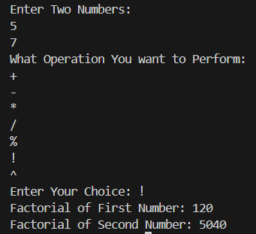

CONCLUSION:
Thus, a simple calculator program was successfully implemented using C programming. The program demonstrates the use of switch-case statements, loops, and arithmetic operations.

FAQs:
- What is a simple calculator program?
- Why is switch–case preferred in calculator programs?
- How does the program handle division by zero?
- How is the power operation (xʸ) implemented without using math library functions?
- What is factorial and how is it calculated using loops in C?

