Internet Programming

TP8: **VueJS, NodeJS**

(Authentication frontend and APIs)

**Name: Aing Hongsin**

**Id: e20190004**

**Group: I4 GIC A**

**Github:** [**AingHongSin**](https://github.com/AingHongSin/TP-Internet_Programming-I4/tree/TP8)

Table of Contents

Exercise1: Auth screens in VueJS 2

Login 2

Register 3

Exercise2: NodeJS with ExpressJS 3

Register 3

Login 4

Exercise 3: UI and APIs Integration 5

# Exercise1: Auth screens in VueJS

## Login

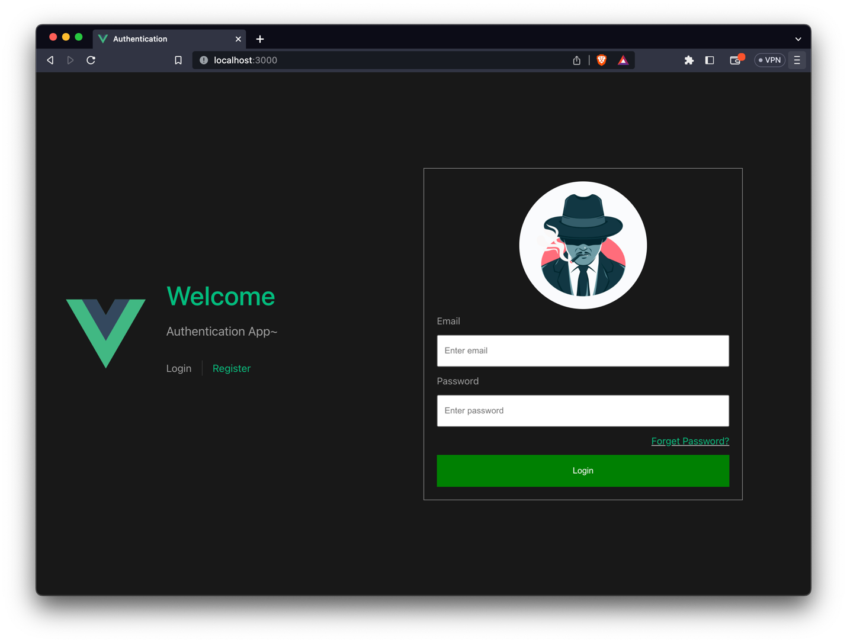

## Register

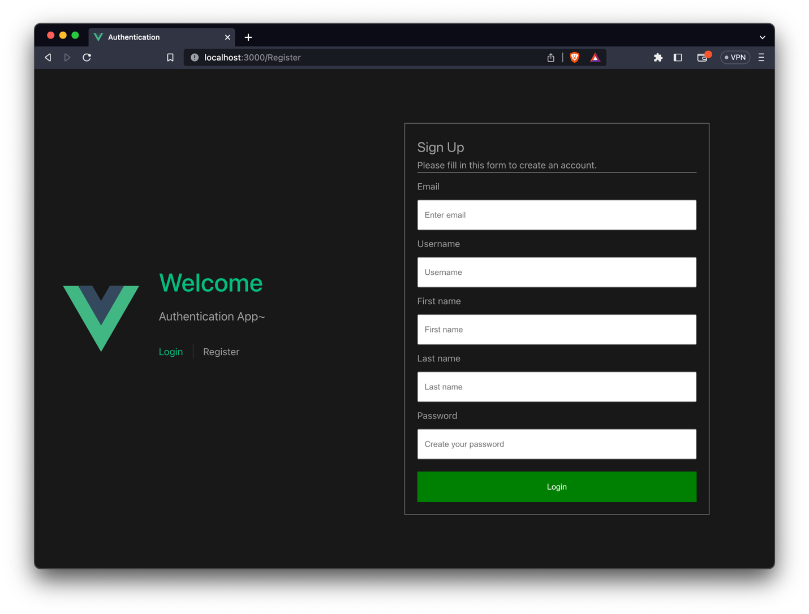

# Exercise2: NodeJS with ExpressJS

## Register

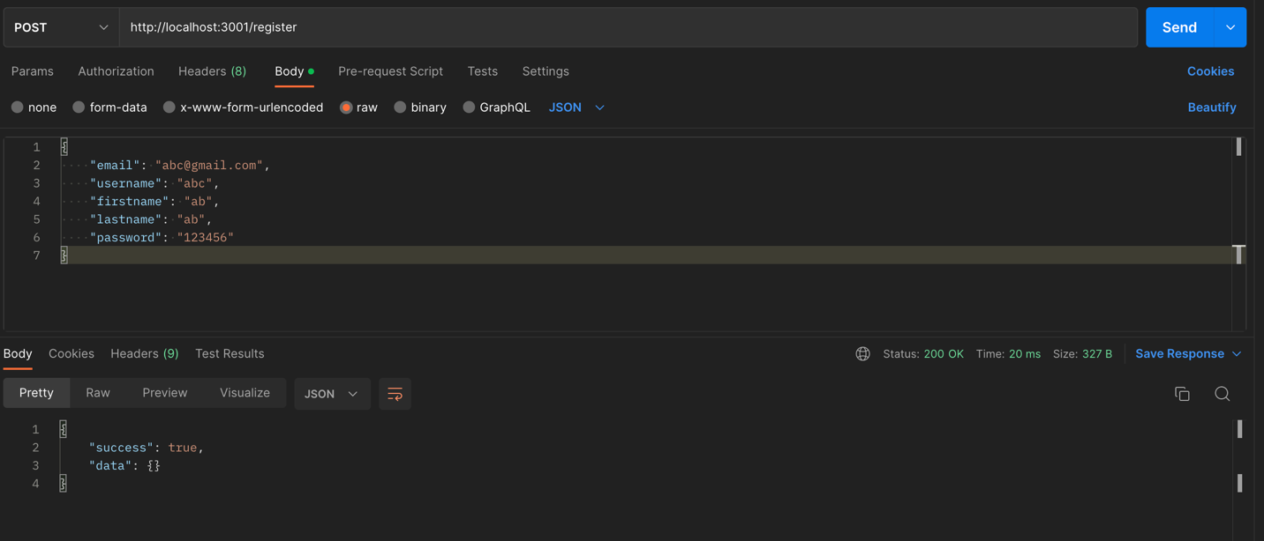

## Login

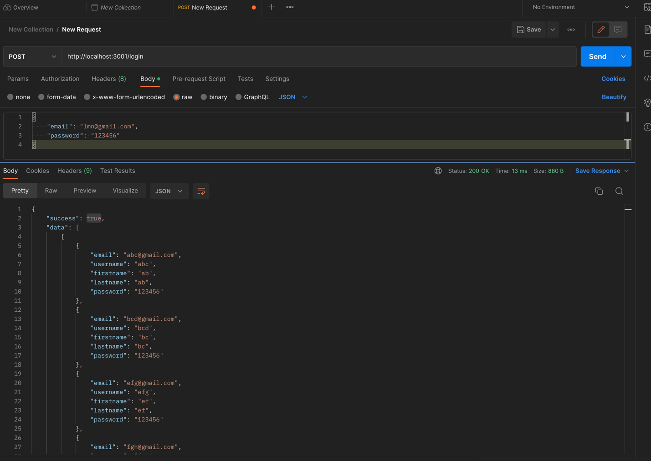

# Exercise 3: UI and APIs Integration

