# RESULTS

## MICROCLIMATIC CONDITIONS IN SCOTT BASE

The climate is Scott Base is governed by a marked **cyclical pattern** constant over the years (Fig. 1).

Cryptograms in Scott Base start receiving sunlight between the end of November and the beginning of December, when snow starts to melt (Fig. 1). Light is available until late February or early March in the following year (Fig. 1). During those three months, PAR follows a daily pattern in which at some points during the summer there is photosynthetic light available all the time throughout the day, but its intensity decreases around noon (Fig. 2). The amount of PAR received varied across samples, but in average all the samples received a mean radiation of ~200 μmol m-2 s-1, as summarised in Table 1, with maximum values of around 1500 μmol m-2 s-1 (Table 1).

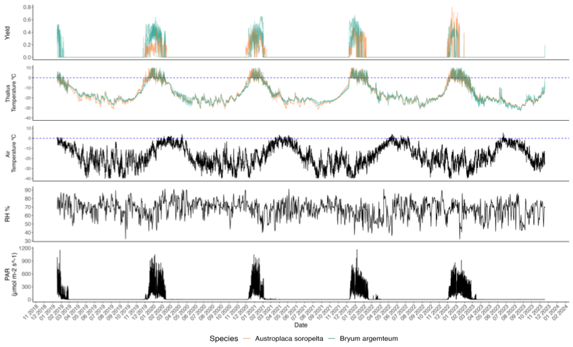

*Figure 1.*

*Figure 2*.

The average air temperature over the whole measuring period was -17.4 °C (Table 1) and values over 0 °C where only recorded in the summer months – defining as summer the period from the beginning of November until the end of February (Fig. 1). This generated a contrast of almost 11 degrees between the overall mean and the summer mean that was -6.73 °C in average across all years (Table 1). The minimum air temperature recorded was reached in August 2021, and was -53.4 °C, and the maximum, documented in December of 2022, 6.45 °C (Table 1). The minimum temperature during a summer season was – 28.9 °C and it was recorded in November 2022 (Table 2). December was the warmest month every year (Fig.1, Appendix E)

*Table 1.*



RH had an average value of 67.5% over the whole measuring period (Table 1), nearly identical to the 67.2% average over the summer months (Table 2). It did not show any seasonal variation (Figure 1).

All of these variables remained constant over time, and there was no clear increasing or decreasing trend over time in any of them (Figure 1, Table 2).

There were no anomalies in any of our variables recorded during the heatwave from the 15th to the 19th of March 2023 (Figure 1 and closeup in Appendix D).



*Table 2.*

## CHARACTERIZATION OF AUSTROPLACA AND BRYUM ACTIVIVTY AND ACTIVATION PATTERNS AND CHANGE OF THOSE OVER TIME

* 1. Active time

Both species showed **nearly identical annual activity cycles** highly coupled with available radiation. All the **activity was concentrated in the summer** months (Figure 1). The activity for both species is **continuous throughout the summer** except for occasional short inactivity events with an average length of 48 hours (Figure 3, see Appendix C). These were followed by uninterrupted dormancy until the following summer. There was a significant difference in the amount of active hours each year for both species (Kruskal-Wallis, X2 = 13.336, df = 3, p = 0.003) and both species showed a decline over time (Fig. X, Table 2).

Both the lichen and the moss stayed inactive during the heatwave of March 2023 (Figure 1).

*Figure X.*

* + 1. Austroplaca Soropelta

*Austroplaca* was active 11.77% of the measuring period (Table 1). A total of 4991 hours of activity were distributed in a **decreasing trend** between the four measured summers, as seen in Table 2. There is a steep decline from the summer 21-22, when there were 1176 active hours, to the summer 22-23, when there were only 483 (Table 2). Activity during the last summer was more sporadic with longer interruptions than in previous years (Check Appendix C).

Every summer, *Austroplaca* had the less active time during the month of November, with 31, 24, 0 and 8 hours each respective year (Check Appendix B for monthly values). This is because activation did not occur until late in the month (Table 3, Appendix C). In 2019 *Austroplaca* activated on the 29th of November, in 2020 on the 30th of the same month, in 2021 on the 8th of December (meaning there was no active time during the month of November), and in 2023 again on the 29th of November.

Then activity increases dramatically during the months of December and January, December being the month with the most active hours every year (741, 715, 533, 301 active hours respectively).

Lastly, active time decreased in February with 240, 147, 125 and 0 hours each year. The decrease on the number of hours of activity over February through the years indicates that the **lichen dries earlier in the month every year** as summarised in Table 3**.** In 2023 it dried the 11th of January, so there was no activity in February.

* + 1. Bryum argenteum

*Bryum* was active 10.33% of the measured time (Table 1). The total 4380 hours, as with *Austroplaca*, were unevenly distributed over the summers showcasing a **decreasing trend over time** (Table 2). The decline was especially abrupt from summer 2021-2022 to summer 2022-2023 when the active hours reduced, in average, from 910 to 541, as shown in Table 2. This last summer activity was more sporadic, with longer periods of interruption (Appendix C).

Every year, November was the month of the summer when Bryum was the less active. Two of the samples did not have any active time during this month any of the years, and Sample X2 only had 15 hours of activity in 2019 –it was active from the 24th to the 26th of November before drying until 2nd of December– and 21 in 2023 –activated the 30th of November. The dates of activation each year of the rest of samples are summarised in Table 3.

Bryum had the most active time during December and January. During the summers of 2019-2020 and 2021-2022 it had more active hours during the December whereas

In 2020-2021 and 2022-2023 it had more active hours during the month of January. This variation was constant across the three samples (check Appendix B).

Lastly, as with the lichen, active time in February decreased over the years. Specifically, there was a dramatic reduction in the number of active hours between the first two summers – of 84.67 and 47.33 hours of activity on average respectively – and the second two, in which the moss was active 4.33 and 0 hours respectively. This indicates that **the samples dried, on average, earlier in the month each year**, as evidenced in Table 3.

*Table 3.*



*Table 3.*

2.2 Yield and ETR

*Austroplaca*’s average yield when active was 0.25, which was lower than *Bryum*’s, that had an average of 0.35 as showed in the summarized data of Table 1. On the contrary, *Austroplaca* reached higher maximum yield, that got up to 0.8 in December 2023. The maximum yield for *Bryum* was, in average, 0.61 (Table 1).

*Austroplaca*’s mean and maximum yield when active increased over the years, as shown in Table 2 and Figure 1. This trend was not present in Bryum.

When was max yield reached?

ETR followed a similar pattern. Whereas *Austroplaca* showcased a higher maximum ETR, *Bryum* has a higher mean ETR during active time (Table 1). None of the species showed a trend of change over time in ETR values (Table 2).

2.3 Thallus Temperature

Thallus temperature (TT) followed a nearly **identical cycle** in both species (Fig. 1). Both species had similar mean, maximum and minimum TT values over the measuring and active time (Table 1). The mean TT over the active time is around 0°C in both cryptograms, and the minimum TT is around -32 °C for both species, 20 degrees over the minimum air temperature (Table 1).

Values remained below 0 °C for most of the year, only reaching above freeze values during the summer (Fig. 1). TT did not show a changing trend over time of any of the species (Table 2).

## CORRELATION BETWEEN ACTIVITY AND MICROENVIRONMENTAL VARIABLES- DRIVERS OF ACTIVITY

The three main microenvironmental variables affecting the cryptograms are incidental PAR, TT, and RH. There is a clear relationship between Yield, PAR and TT (Fig. 1). From the graphs under snow, TT seemed to be more closely related to activity than PAR, since activity started once TT was closer to 0 °C, even if PAR was still not available (Fig. 3). This relationship was more obvious in *Bryum*.

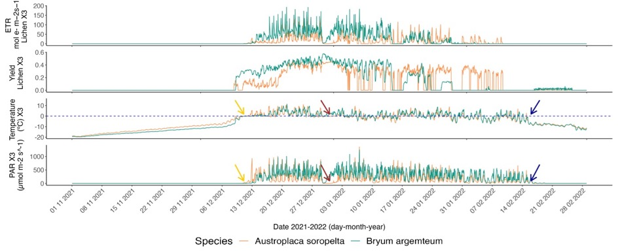

*Fig. 3*.

From plotting the relationship between yield and RH and yield- TT showed a higher connection in the latter (Fig. 4). However, there was no correlation between Yield and TT of samples during active time (Spearman’s Rank Correlation analysis, ρ = 0.37, n = 16, p = 0.15), (Kendall Tau Test, t = 0.37, n =16, p = 0.15). No correlation was found either between TT during active time and number of active hours, neither with Spearman’s Rank Correlation analysis ( ρ = -0.18, n = 16, p = 0.48) nor Kendall Tau Test (t = -0.12, n =16, p = 0.53).

*Figure 4.*

The number of reactivation events for each species every summer are summarized in Table 3. *Austroplaca* had more reactivation events, which are not always related to snowfall. We found no correlation between the number of reactivation events and the number of active hours nor in the high metric (Spearman’s rank correlation, ρ = -0.07, n = 16, p = 0.78) (Kendall Tau Test, t = -0.05,n =16, p = 0.78) nor in the low one (Spearman’s rank correlation, ρ = -0.00, n=16, p = 0.99) (Kendall Tau Test, t = -0.02, n=16, p = 0.88)

## BEHAVIOUR UNDER SNOW

We classified three different types of under-snow activity events: the snowmelt at the beginning of the season (Fig. 5), snowfalls in the middle of the season (Fig. 6), and the last snowfall of the season (Fig. 7). In all three types of events, and in both species, TT had to reach values near 0 °C for activation to occur (Fig. 3, 5 & 6). ETR for all under-snow activity was 0 in both species (Fig. 3)

In the snowmelt at the beginning of the season, the lichen had, on average across the years, 5.5 days of activity under snow. *Bryum* had an average of 8.5. The lichen also had less days in which TT reached freeze point but there was still snow cover (Fig. 5). Both species could activate without PAR if the TT was close to melting point (Fig. 5). The relationship between TT and activation was more evident in the moss (Fig. 5). Yield was lower under snow that it was over snow for the lichen (Fig. 3, Appendix C). This difference was less notable for the moss.

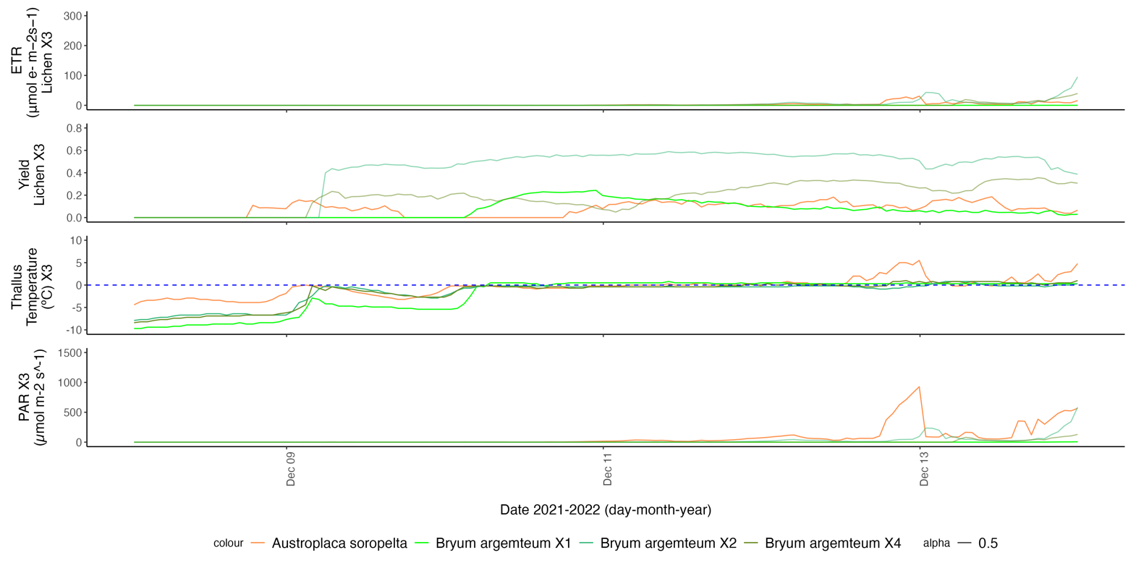

*Fig. 5*

Snowfall events in the middle of the season lasted between 24 and 48 hours and generated a very similar response in the lichen and the moss. Yield did not variate significantly in any of the two species during a snowfall event unless the sample was dry before, in which case, it reactivated. Both species were exposed to the same snowfall events.

*Fig. 6*

Lastly, *Bryum* did not have any activity under snow at the end of the season. *Austroplaca* was active under snowcover for 5 and 7 days in 2020 and 2021 respectively. It did not show any activity under snow in the last two summers.

*Fig. 7*