Elera UI Prototype Screenshots Backup
CircuitSense / Elera Final Year Project prototype UI archive
Cleaned version: full-site screenshot first, repetitive captures removed
This document is a concise backup appendix of Elera web prototype screenshots for demonstrating the implemented user interface during proposal, report, or presentation review.

Included Screenshots
1. Full Site Overview
2. Header Toolbar
3. Component Sidebar
4. Circuit Canvas
5. Validation Bar
6. AI Assistant
7. Projects Modal
8. Component Builder
9. Component Builder Example
10. BYOK Settings
11. Account Settings

1. Full Site Overview
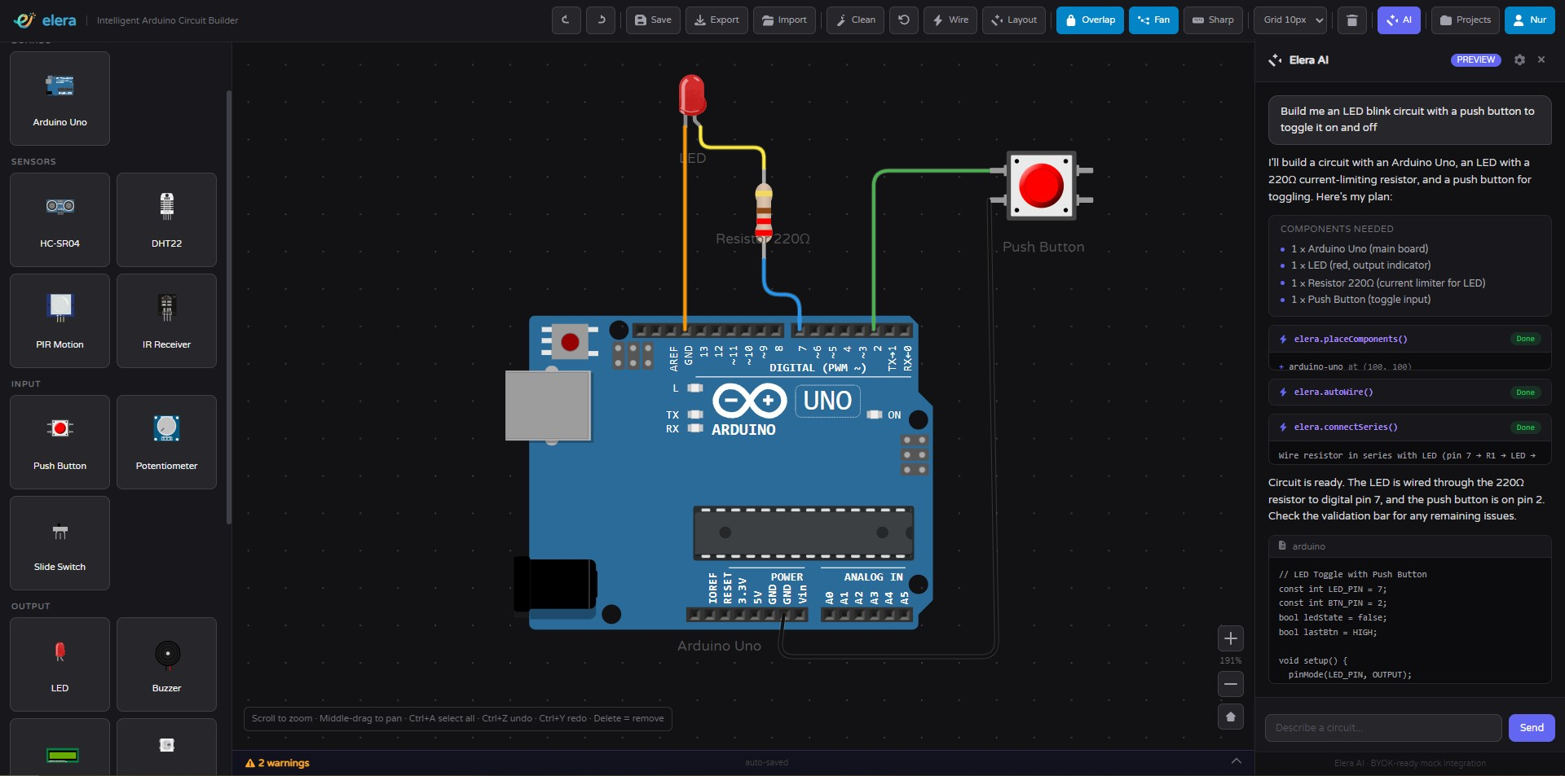
Figure 1: Full Site Overview
Source file: diagram images\Full Site.jpg

2. Header Toolbar
Figure 2: Header Toolbar
Source file: report\assets\prototype\prototype_header_toolbar.png

3. Component Sidebar
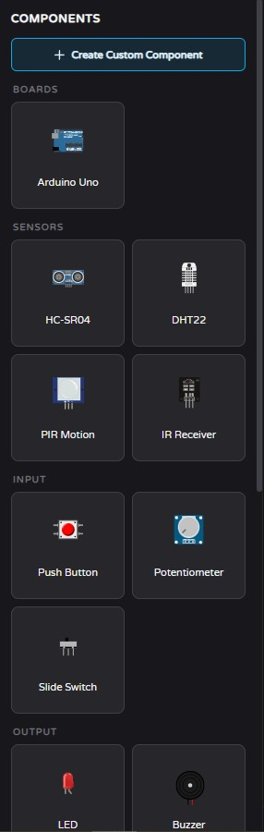
Figure 3: Component Sidebar
Source file: report\assets\prototype\prototype_component_sidebar.png

4. Circuit Canvas
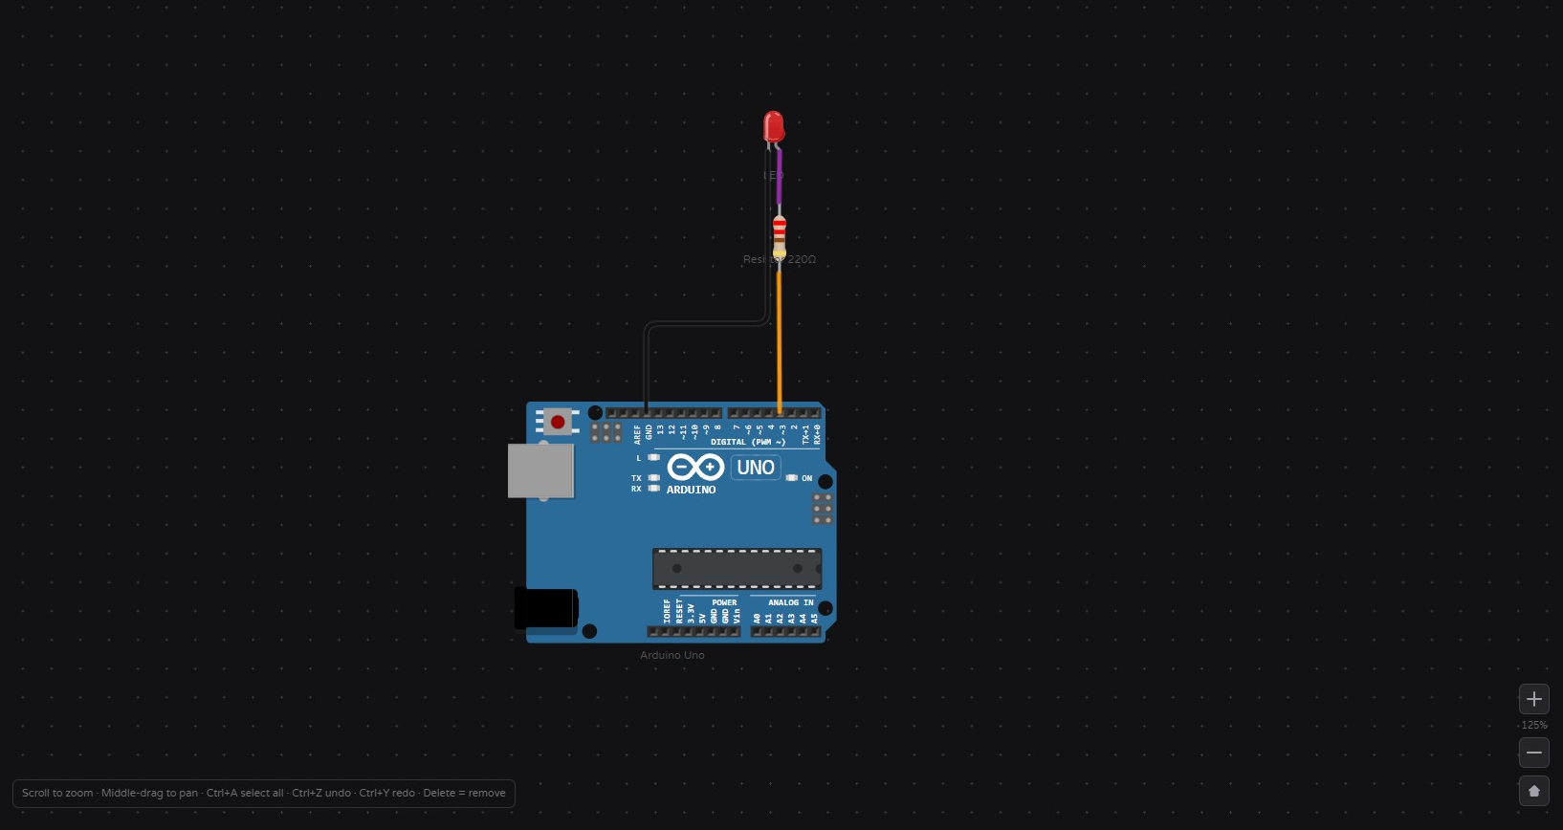
Figure 4: Circuit Canvas
Source file: report\assets\prototype\prototype_circuit_canvas.png

5. Validation Bar
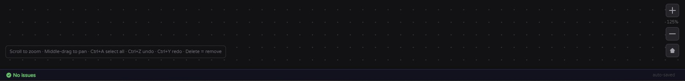
Figure 5: Validation Bar
Source file: report\assets\prototype\prototype_validation_bar.png

6. AI Assistant
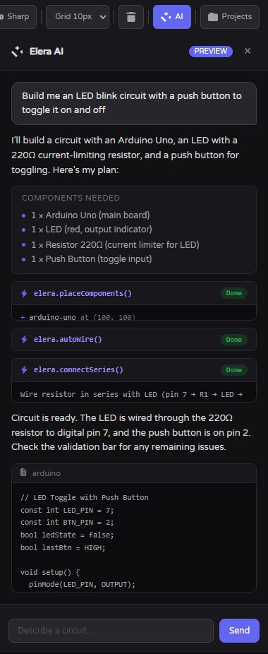
Figure 6: AI Assistant
Source file: report\assets\prototype\prototype_ai_assistant.png

7. Projects Modal
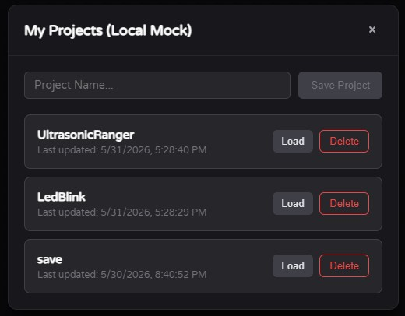
Figure 7: Projects Modal
Source file: report\assets\prototype\prototype_projects_modal.png

8. Component Builder
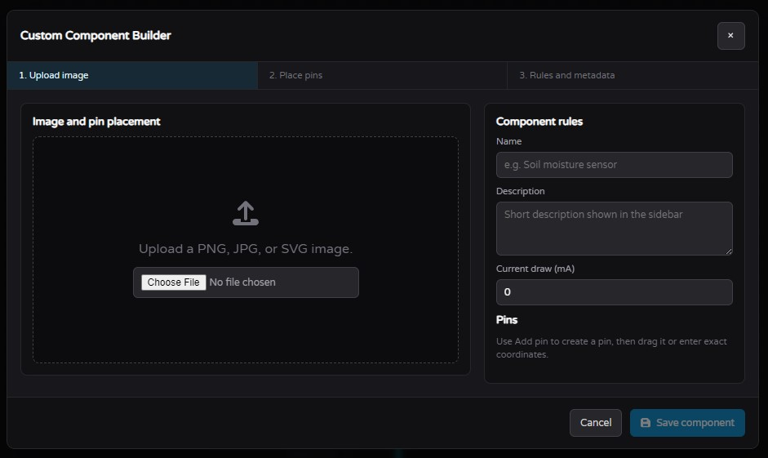
Figure 8: Component Builder
Source file: report\assets\prototype\prototype_component_builder.png

9. Component Builder Example
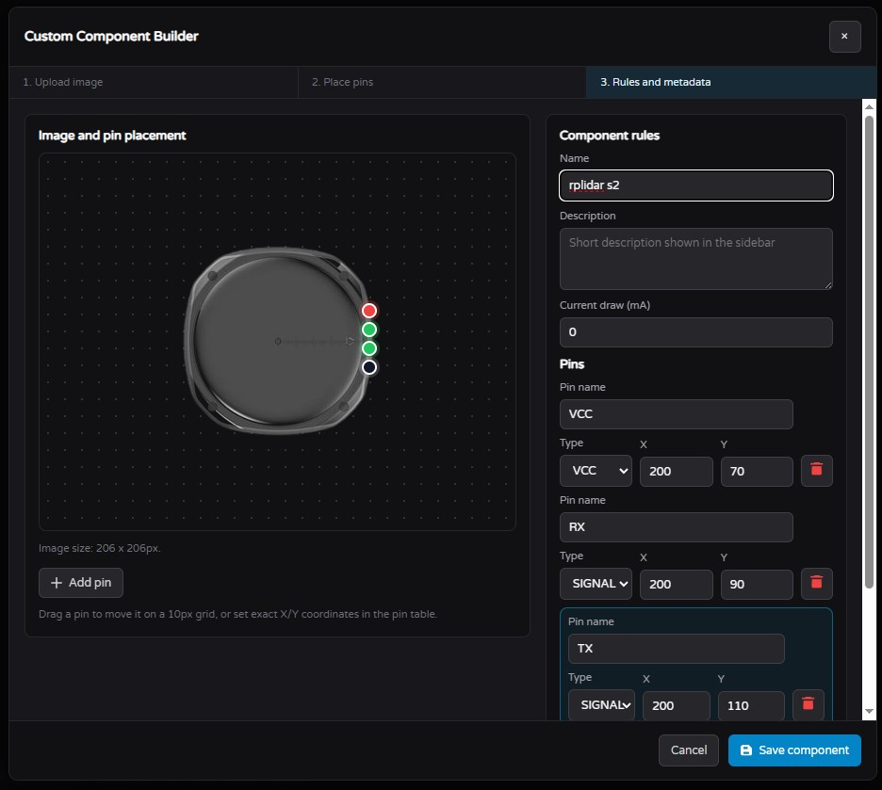
Figure 9: Component Builder Example
Source file: diagram images\component builder Example.jpg

10. BYOK Settings
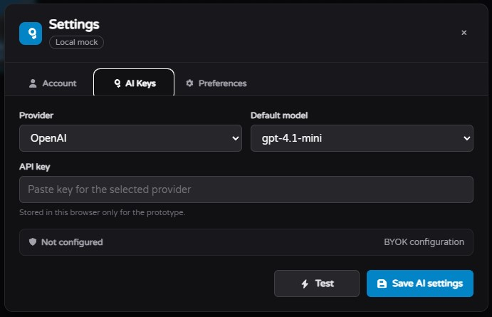
Figure 10: BYOK Settings
Source file: report\assets\prototype\prototype_byok_settings.png

11. Account Settings
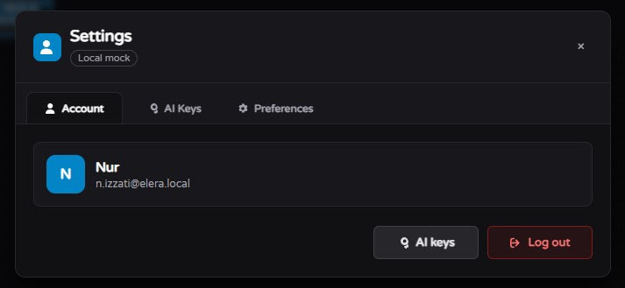
Figure 11: Account Settings
Source file: diagram images\SettingsAccount.jpg

