Elera: An Intelligent Web-Based Circuit Design Assistant

Mohamad Imad Addin bin Ja'far
Department of Information Systems
Kulliyyah of Information and Communication Technology
International Islamic University Malaysia (IIUM)
Kuala Lumpur, Malaysia
ainmimdal@gmail.com
Ahmad Fatzilah bin Misman
Department of Information Systems
Kulliyyah of Information and Communication Technology
International Islamic University Malaysia (IIUM)
Kuala Lumpur, Malaysia
afatizlah@live.iium.edu.my

Abstract— Arduino has become a standard platform for teaching electronics and embedded systems in universities. However, beginner students continue to make common circuit wiring errors that existing tools do not catch during the design phase. Errors such as connecting LEDs without current-limiting resistors, exceeding the Arduino Uno’s 500 mA USB current limit, assigning multiple components to the same I/O pin, and wiring I2C devices to incorrect analogue pins are frequent among novice learners. Popular web-based tools like Tinkercad Circuits, Wokwi, and Fritzing allow students to build circuits virtually, but they only reveal errors after simulation or not at all. None of them validate wiring during design or explain why a mistake occurred. This paper presents Elera, an intelligent web-based Arduino circuit design assistant that provides real-time, rule-based validation and beginner-friendly feedback within the design environment. Elera includes a drag-and-drop circuit canvas, a metadata-driven component library covering 14 common Arduino parts, a validation engine that checks nine categories of electrical errors, an auto-wiring engine that assigns correct Arduino pins based on each component’s electrical requirements, an AI assistant that accepts natural language circuit descriptions, and a component builder that allows users to import custom component images with AI-assisted pin detection. The application runs entirely in the browser with no installation required.
Keywords—arduino, circuit design, real-time validation, auto-wiring, web-based learning, electronics education, beginner feedback, rule-based engine
I. Introduction
A. Background
Arduino has become one of the most widely used platforms for introducing students to electronics and embedded systems. At the International Islamic University Malaysia (IIUM), mechatronics students learn Arduino circuit wiring through hands-on laboratory courses such as the Mechatronic Workshop Lab and the System Integration Lab. Both courses require students to assemble circuits on breadboards using components like LEDs, sensors, and servo motors. In practice, students spend a large portion of their lab time troubleshooting wiring problems rather than focusing on programming logic or system design [1], [2].
Web-based simulation tools such as Tinkercad Circuits [3] and Wokwi [4] can help by letting students prototype circuits before using physical hardware. Fritzing [5] provides a desktop-based breadboard layout tool for documentation and PCB design. More recently, Cirkit Designer [6] introduced AI-assisted circuit prototyping using large language models. These tools are useful, but they share one critical limitation: they are passive. The user builds the circuit manually, and errors only become visible when the simulation runs or when the physical circuit fails. None of them actively check for wiring problems during the design process, and none of them explain to the user why something is wrong or how to fix it.
B. Problem Statement
There is a clear gap between tools that simulate circuits and tools that teach students how to wire them correctly. Five specific problems have been identified:
First, beginners regularly make electrical wiring errors such as missing ground connections, overcurrent, wrong pin types, and floating pins. These errors only surface during simulation or physical testing. Second, when errors appear, current tools do not explain them in educational terms. Third, every existing web-based circuit builder requires fully manual wiring, which is tedious for students who do not yet know the correct pin assignments. Fourth, the circuit-building experience in current tools is frustrating. Wires overlap and cross over components as the circuit grows, snapping behaviour is inconsistent, and there is no automatic way to clean up wire routing. Students end up spending time managing the visual layout instead of focusing on the circuit logic. Fifth, no single accessible web application combines visual circuit building, real-time rule-based validation, automated pin assignment, and wire management tools in one environment.
C. Objectives
The main goal of this project is to design and develop Elera, a web-based Arduino circuit design assistant that gives beginners proactive guidance while they build circuits. The specific objectives are:
1. To design and develop a web-based Arduino circuit builder with drag-and-drop component placement and manual pin-to-pin wiring on an interactive canvas.
2. To design a rule-based validation engine (the Elera Validation Engine, or EVE) that detects nine categories of common electrical errors, including missing power and ground connections, current overload, duplicate pin assignments, wrong I2C wiring, floating pins, and missing current-limiting resistors.
3. To design an auto-wiring engine that assigns the correct Arduino pins to component pins based on their electrical requirements (digital, analogue, PWM, I2C) and generates the wire connections automatically.
4. To create a metadata-driven component library where each component's pin roles, current draw, and auto-wiring rules are stored as structured data, so the system can be extended with new components without modifying the core logic.
5. To integrate a generative AI assistant using a Bring Your Own Key (BYOK) model, enabling autonomous circuit-building guidance and canvas manipulation through natural language prompts.
6. To design a component builder that allows users to import custom component images and use AI-assisted pin detection to define pin placements, signal types, and names, enabling the creation of user-defined components that integrate with the validation and auto-wiring engines.
D. Project Scope
The system is designed to include: a component library with 14 beginner-level parts, a visual canvas with drag-and-drop placement and pin-to-pin wiring, a validation engine covering nine rule categories, and an auto-wiring engine that assigns pins based on type. Crucially, the system features an integrated AI assistant capable of autonomously building and modifying circuits using the same canvas tools available to the human user. This AI operates on a Bring Your Own Key (BYOK) model, allowing users to plug in their own API keys, such as Google Gemini, to access the assistant. Although Elera applies BYOK to AI-provider credentials rather than cloud-storage encryption keys, the same principle of user-controlled key ownership is relevant because BYOK research emphasises reducing third-party control over the key lifecycle [14]. User authentication and cloud-based project storage are handled via Supabase. Full circuit simulation, running Arduino code, and PCB design are outside the current scope.
Target Audience: The primary audience is undergraduate students taking electronics, embedded systems, or mechatronics courses, particularly Mechatronic and Electrical students at IIUM. These students typically have basic programming skills but limited experience with physical circuit wiring. The secondary audience is hobbyists and self-learners who are starting out with Arduino.
Specific Platform and Technology Stack: Elera runs in the browser and uses Supabase as its backend for project persistence and user authentication. The development environment consists of Windows 10/11, Node.js 18+, Vite 6.0, Lit 3.2 (Web Components), @wokwi/elements 1.9.2, JavaScript (ES Modules), and Supabase (hosted PostgreSQL, authentication, REST API). Web Components support modular, reusable custom elements, while Shadow DOM-style encapsulation helps separate component logic and styling from the wider application interface [15], [16]. The user-facing environment requires any modern browser (Chrome, Firefox, Edge), no installation or plugins, and a minimum screen resolution of 1280 x 720.
II. Related Work
A. Pedagogical Challenges in Electronics Education
Learning electronics through hands-on prototyping places a heavy cognitive demand on students. When working with Arduino circuits, learners must simultaneously manage programming syntax, the pin layout of the microcontroller, component datasheets, and the physical routing of wires on a breadboard or virtual canvas. Cognitive load theory suggests that when the total demand on a learner's working memory exceeds its capacity, learning becomes less effective and errors increase [7]. In a circuit design context, this overload often manifests as wiring mistakes that students do not notice until the circuit fails, at which point tracing the root cause is difficult.
Physical breadboarding adds spatial complexity. Students must understand which rows and columns on the breadboard are electrically connected, how power rails function, and how to route wires without creating short circuits. Research on novice electronics learners has found that a significant portion of lab time is spent on low-level troubleshooting rather than on the conceptual learning objectives of the exercise [1], [2]. Virtual circuit simulators reduce the risk of hardware damage and allow rapid experimentation, but studies on virtual labs in electronics education have noted that simulators do not inherently reduce cognitive load [8]. Students still face the same wiring decisions, and most simulators offer no guidance during the design process.
Beyond electrical errors, the circuit-building experience itself presents usability friction. During hands-on evaluation of the four reviewed platforms for this project, it was observed that as students add more components and wires, the canvas becomes cluttered. Wires overlap, cross over components, and obscure pin labels, making the circuit harder to read and debug. None of the evaluated tools provide any automatic way to clean up or re-route wires after they are placed. Students must either delete and redraw each wire manually or accept a messy layout. Snapping behaviour also varies across tools, where components do not always align to a consistent grid and wires do not always attach cleanly to pin targets. These usability issues compound the cognitive load described above, because students must spend additional effort managing the visual layout of their circuit on top of the electrical logic.
B. Review of Existing Platforms
Four platforms were reviewed as they represent the most commonly used options in electronics education: Tinkercad Circuits, Fritzing, Wokwi, and Cirkit Designer.
Tinkercad Circuits is a browser-based circuit editor built by Autodesk, aimed at beginners in primary, secondary, and introductory university-level programmes [3]. It provides a drag-and-drop interface with a large selection of simulated components, including the Arduino Uno and Micro:bit. It supports dual programming through visual block-based coding and direct C++ editing [9]. Research has shown that Tinkercad's visual environment helps with student motivation in secondary school settings [10]. However, the platform has usability issues. There is no quick reset function, and the code blocks panel covers the circuit view when open [11]. More critically, there is no proactive error checking during the design phase.
Fritzing started in 2007 at the University of Applied Sciences Potsdam as an open-source tool for documenting electronic prototypes [5]. It offers three views: a photorealistic Breadboard View, a Schematics View, and a PCB View that generates Gerber manufacturing files. Fritzing is widely used in academic settings, but it cannot simulate circuits at all. It does not run code, does not show voltage or current, and has no validation of any kind [12]. Users must build and test their circuits elsewhere.
Wokwi was introduced around 2019 and provides advanced simulation capabilities [4]. Its engine, AVR8js, compiles and runs Arduino code directly in the browser. Board support extends to ESP32, STM32, and Raspberry Pi Pico. The platform provides tools such as a virtual logic analyser and GDB debugging, and it integrates with VS Code and CI/CD pipelines. A study at Jambi University tested Wokwi in basic physics and electronics courses and found a positive correlation between simulator use and skill improvement [13]. However, Wokwi is code-centric, assumes prior programming knowledge, and places several advanced features behind a paid subscription [9].
Cirkit Designer was created by Austin Small, a former Google engineer, to address the gap between manual wiring and code generation [6]. The platform combines a massive component library with a generative AI assistant that can automatically route wires and write C++ code from plain-English prompts. However, relying on probabilistic large language models for circuit logic presents a pedagogical risk, as the AI bypasses the manual learning process and can hallucinate incorrect connections [6]. Furthermore, placing these advanced routing features behind a premium paywall creates strict accessibility barriers for university adoption.
C. Comparison, Identified Gaps, and System Adaptation
A feature comparison across the four reviewed platforms and Elera is summarised in Table 1.
The comparison reveals five critical gaps when evaluating these tools for undergraduate education. First, real-time, deterministic validation is absent; existing tools either show errors only after simulation, rely on probabilistic AI guessing, or do not validate at all. Second, while commercial tools like Cirkit Designer offer generative auto-wiring and dynamic wire cleanup, they utilize AI to bypass the student's manual design process rather than assisting it with strict electrical rules. Third, educational feedback is either missing entirely, limited to generic compiler errors, or hidden behind premium paywalls. Fourth, most tools treat components as static graphics without structured metadata about their electrical properties, making deterministic rule-checking impossible. Fifth, there is a lack of accessible, completely free platforms that combine visual circuit building, automated routing, and deterministic error explanations in one cohesive environment tailored for academia.
Elera adapts the strengths of each reviewed platform while addressing their shared weaknesses in a pedagogical context. From Tinkercad, Elera adopts the browser-based, drag-and-drop approach that makes circuit building accessible to beginners. From Fritzing, the concept of realistic visual component rendering is retained through the @wokwi/elements library. From Wokwi, the idea of a web-first platform with no installation requirement is carried forward. From Cirkit Designer, the concepts of AI-assisted guidance and dynamic layout cleanup are adapted. However, Elera separates language-model interpretation from electrical decision-making. Instead of allowing a probabilistic language model to guess the electrical physics, Elera uses model-agnostic function calling, an LLM interaction pattern where a model selects documented external tools and passes structured arguments for execution [17], [18]. The actual execution of auto-wiring and orthogonal routing is strictly governed by Elera?s internal rule-based validation engine (EVE). The key differentiation is that Elera delivers real-time deterministic validation, metadata-driven automated wiring, and plain-language educational feedback within a completely free, client-side environment.
TABLE 1: COMPARISON OF CIRCUIT DESIGN PLATFORMS
Feature / Capability | Tinkercad | Fritzing | Wokwi | Cirkit Designer | Elera (Proposed)
Primary Phase | Simulation | Doc / PCB | Simulation | Prototyping | Active Design & Learning
Auto-Wiring | No | No | No | AI-driven (LLM logic) | AI & Metadata-driven
Routing & Layout | No | No | No | Dynamic Wire Routing | Orthogonal Routing & Auto-Layout
Error Validation | Post-sim | No | Post-sim | On-demand (AI review) | Real-time (Rule-based EVE)
Feedback Logic | None | None | Compiler | Probabilistic | Deterministic
AI Integration | No | No | No | Proprietary Generative | Model-Agnostic (Function Calling)
Simulation | Basic | No | Advanced | Advanced | N/A (Project Scope)
Cost Model | Free | Paid | Freemium | Freemium | Free

III. Methodology
A. Development Approach
The Agile Iterative model was selected as the development approach for this project. The Agile model was chosen for three reasons. First, the requirements for the validation rules, pin assignment logic, and metadata schema were expected to evolve as each feature was designed and prototyped. An iterative model accommodates that kind of gradual refinement. Second, each sprint produces a working deliverable, so even during the pre-production phase there is always a demonstrable output. Third, the iterative structure allows feedback from each sprint to be incorporated into the next cycle, which is well suited to a single-developer Final Year Project.
The project is organised into seven sprints: (1) interactive canvas with component placement, grid snapping, and pan/zoom, (2) component library with metadata and the sidebar interface, (3) manual pin-to-pin wiring with orthogonal routing, (4) validation engine covering nine rules and the validation bar UI, (5) auto-wire engine with smart pin assignment, (6) state management upgrades including undo/redo, localStorage persistence, and anti-overlap collision detection, and (7) integration testing, UI polish, and wire cleanup features.
B. Requirements Specifications
Requirements were gathered through three methods. First, a literature review of existing circuit design tools identified which features are standard and which are absent. Second, a needs analysis questionnaire was distributed to 35 undergraduate students from Kulliyyah of Information & Communication Technology and the Kulliyyah of Engineering at IIUM. Third, iterative prototyping of the UI and validation logic provided practical feedback on which design decisions worked and which needed adjustment.
Requirements were formally gathered through a needs analysis questionnaire distributed to 35 undergraduate students from KICT and the Kulliyyah of Engineering at IIUM. This primary data collection method was utilized to identify common pain points in existing tools and scientifically justify the proposed system features.
The survey findings confirmed a high prevalence of time wasted on manual debugging and frequent component damage due to undetected wiring errors. Crucially, respondents indicated low satisfaction with the passive error feedback mechanisms found in current virtual simulators. The data revealed that the highest user demand was for real-time validation with explanatory educational feedback, followed closely by automated pin-to-pin wiring. These specific insights provided the foundational justification for prioritizing the rule-based validation engine (EVE) and the auto-wiring engine in the system's logical design, ensuring the development directly addresses the target audience's core needs.
These findings directly informed the prioritisation of the Validation Engine as the primary system contribution and the inclusion of automatic wire cleanup as a planned feature.
C. Logical Design
The logical design of Elera describes the system's structure and behaviour through standard UML diagrams. This subsection presents the narrative that accompanies each diagram.
System Architecture. Elera uses a modular architecture built with Lit 3 Web Components. The system comprises twelve modules that communicate through an event-driven pattern. When a user performs an action on the canvas, such as placing a wire, the Circuit Store updates its internal state and fires a "structural-change" event. The Validation Engine listens for that event, re-checks the circuit, and sends the results to the Validation Bar, which re-renders automatically. The user sees updated feedback without any manual refresh. The modules are grouped into three layers. The UI layer consists of Circuit App, Component Sidebar, Circuit Canvas, Placed Component, Validation Bar, AI Assistant, and Component Builder. The Service layer consists of the Validation Engine and Auto-Wire Engine. The Data layer consists of the Circuit Store and Component Library.
FIGURE 1: SYSTEM ARCHITECTURE DIAGRAM
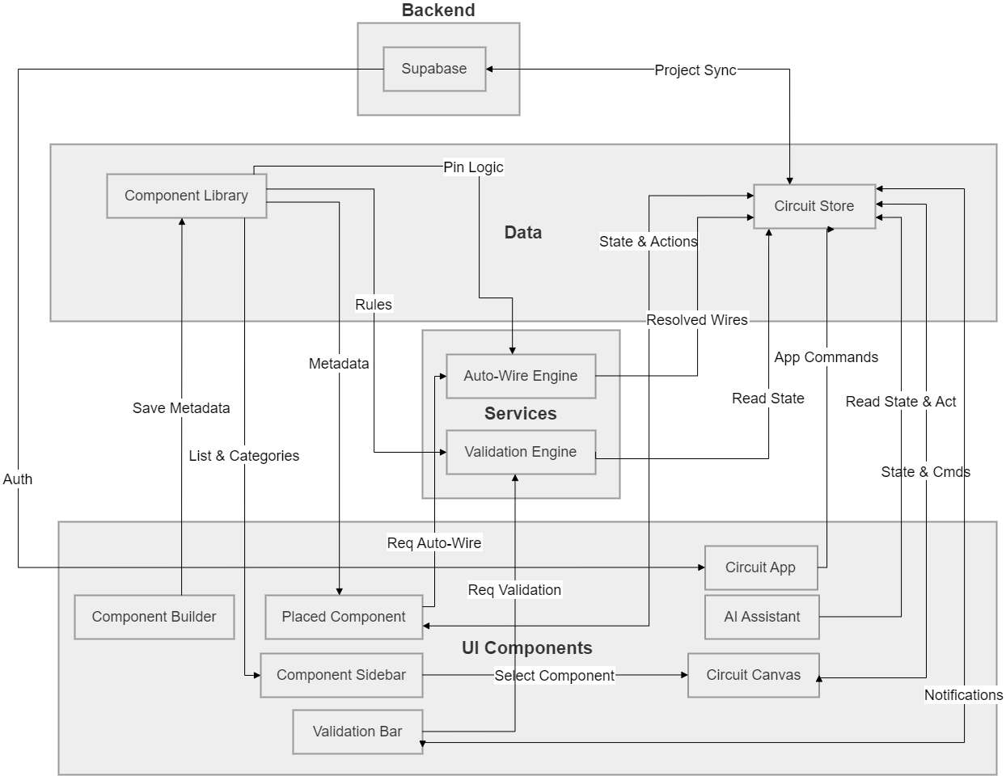
Use Case Diagram. The primary actor is the Student. The use cases are grouped into four packages: Component Management, Wiring, Validation, and Project. The Wiring package captures both paths available to the student. In the manual path, the student clicks a source pin and a destination
pin to create a wire. In the auto-wire path, the student triggers the engine and the system assigns pins and generates wires automatically. After either path, the Validation Engine runs and the student views the results in the Validation Bar. If errors are present, the student adjusts the circuit and the cycle repeats. This feedback loop is the core interaction pattern of the system.
FIGURE 2: USE CASE DIAGRAM
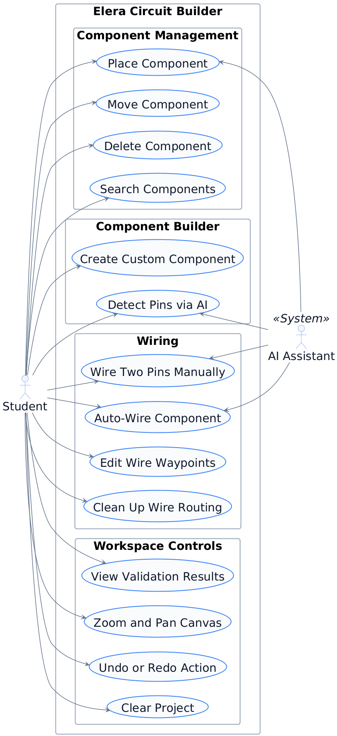
Sequence Diagram. The Sequence diagram illustrates the validation flow. The interaction begins when the user completes a wire on the Canvas. notifies the Store that a wire has been completed. The Store records the wire, saves a history snapshot, and fires a "structural-change" event. The Validation Bar listens for that event, requests validation from the Validation Engine. The Validation Engine reads the current component instances and wires from the Store, runs the nine rules, and returns the results to the Validation Bar. The Validation Bar re-renders the updated issue list, and the user sees the new error and warning counts.
FIGURE 3: SEQUENCE DIAGRAM
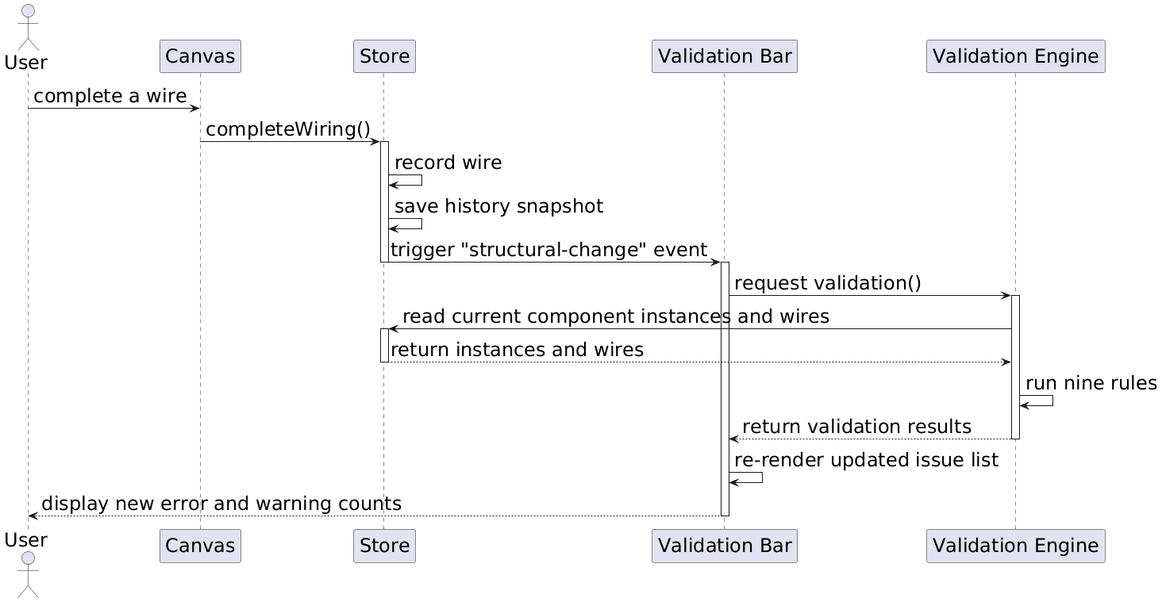
D. Database Design
The data model is designed around a PostgreSQL database hosted on Supabase, organised into four tables: Users, Projects, ComponentInstances, and Wires. The Entity-Relationship Diagram (Fig. 4) illustrates the logical relationships between the core entities. A single Component from the metadata library maps to many Instances placed on the canvas, and one Instance connects to many Wires from both source and destination pins. The Users and Projects tables handle account authentication and session management. Within the Wires table, routing waypoints are stored dynamically as a JSONB column to accommodate variable-length path arrays without requiring a separate table. The component library definitions are maintained as static metadata in the application layer rather than the database, as they do not change between sessions and are not specific to any user or project.

FIGURE 4: ERD DIAGRAM
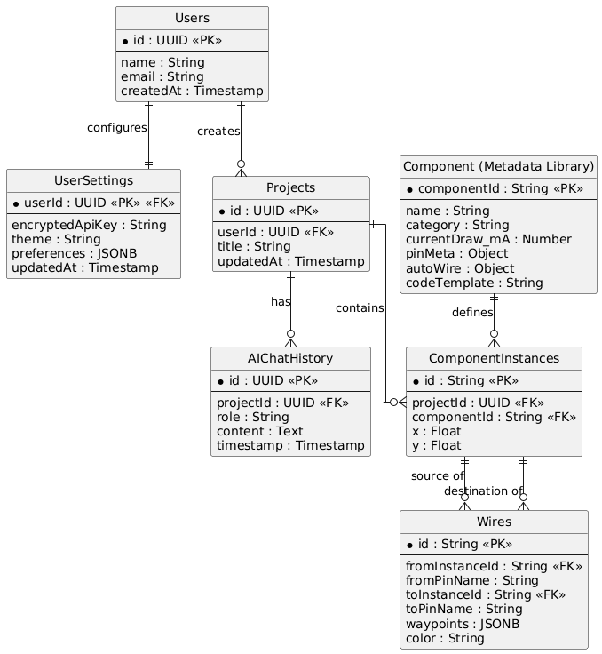
The Users table stores account information for each registered student, including a UUID primary key, name, email address, and account creation timestamp. The Projects table represents a saved circuit design. Each project belongs to one user through a foreign key relationship and stores a title and the timestamp of the last modification. The ComponentInstances table records each component placed on the canvas for a given project. It stores the component type identifier, which maps to the static component library definition, and the canvas position coordinates. The Wires table stores each wire connection between two component pins. The source and destination are recorded as foreign keys to ComponentInstances along with the specific pin names. Wire routing waypoints are stored as a JSONB column to accommodate variable-length path arrays without requiring a separate table. The wire colour is stored as a string and is assigned automatically based on signal type during rendering.
The component library definitions are maintained as static metadata in the application layer rather than the database, as they do not change between sessions and are not specific to any user or project.
E. Prototype Design
The user interface prototype follows a three-panel layout: a header toolbar, a component sidebar, and a large central circuit canvas (Fig. 5). The canvas serves as the primary workspace, supporting drag-and-drop placement, grid-snapped movement, and interactive pin-to-pin wiring. Components are rendered using the @wokwi/elements library, which provides realistic SVG visuals of actual Arduino parts. A validation bar sits as an overlay inside the canvas area. It updates automatically whenever the circuit changes, displaying a scrollable list of colour-coded validation messages (red for errors, amber for warnings, blue for informational notes) so the user always sees the current state of the circuit. To address the usability pain points identified in existing tools , the interface includes automation tools accessible via the header toolbar. When a user triggers auto-wire on a component, the engine automatically creates and routes wires to the appropriate Arduino pins. Furthermore, a wire cleanup feature utilises an orthogonal pathfinding algorithm to re-route all existing wires, cleaning up crossed or overlapping paths with a single action. [INSERT FIG. 5: ELERA USER INTERFACE PROTOTYPE (a) Canvas and Toolbar, (b) Component Sidebar, (c) Validation Bar HERE]
References
[1] D. Nair, "Online Laboratory Course using Low Tech Supplies to Introduce Digital Logic Design Concepts," in 2021 International e-Engineering Education Services Conference (e-Engineering), 2021, pp. 121-126.
[2] D. J. Merrill and S. Swanson, "Reducing Instructor Workload in an Introductory Robotics Course via Computational Design," in Proceedings of the 50th ACM Technical Symposium on Computer Science Education, 2019.
[3] Autodesk, "Tinkercad Circuits," Tinkercad. [Online]. Available: https://www.tinkercad.com. [Accessed: May 2025].
[4] Wokwi Ltd., "Wokwi - World's Most Advanced ESP32 Simulator," Wokwi. [Online]. Available: https://wokwi.com/. [Accessed: May 2025].
[5] Friends-of-Fritzing, "Fritzing," Fritzing. [Online]. Available: https://fritzing.org. [Accessed: May 2025].
[6] Cirkit Designer, "Introducing Cirkit Designer: An AI-Powered IDE for Building Arduino and Circuit Projects," Medium, 2024. [Online]. Available: https://medium.com/@cirkit-designer/introducing-cirkit-designer-an-ai-powered-ide-for-building-arduino-and-circuit-projects-3fafb519b9bd. [Accessed: May 2025].
[7] G. Cooper, "Cognitive load theory as an aid for instructional design," Australasian Journal of Educational Technology, vol. 6, 1990.
[8] K. Altmeyer, R. Brunken, J. Kuhn, and S. Malone, "The Role of Cognitive Learner Prerequisites for Cognitive Load and Learning Outcomes in AR-Supported Lab Work," Education Sciences, vol. 14, p. 1161, 2024.
[9] IoTDunia, "Top 5 Best IoT Simulation Tools Online (No Hardware Needed)," IoTDunia, 2024. [Online]. Available: https://iotdunia.com/best-iot-simulation-tools-online/rbsnp/. [Accessed: May 2025].
[10] ERIC, "Effect of Tinkercad on Students' Computational Thinking Skills and Perceptions," 2024. [Online]. Available: https://files.eric.ed.gov/fulltext/EJ1290797.pdf. [Accessed: May 2025].
[11] PMC, "Examination of the Usability of Tinkercad Application in Educational Environments," PLOS ONE, 2023. [Online]. Available: https://pmc.ncbi.nlm.nih.gov/articles/PMC10034876/. [Accessed: May 2025].
[12] KSPU, "Specialized Applied Software Fritzing and Its Use for Education," Information Technologies in Education. [Online]. Available: https://www.ite.kspu.edu/index.php/ite/article/view/767. [Accessed: May 2025].
[13] Cahaya-IC, "Utilization of Wokwi Technology as a Modern Electronics Learning Media," Journal of Education Technology and Literacy Culture, 2024. [Online]. Available: https://cahaya-ic.com/index.php/JETLC/article/view/1392. [Accessed: May 2025].
[14] V. Kumar and I. Sharma, "Bring-your-own-encryption: How far are we?," in 2016 11th International Conference on Industrial and Information Systems (ICIIS), 2016, pp. 672-677, doi: 10.1109/ICIINFS.2016.8263023.
[15] G. A. Salazar et al., "Nightingale: web components for protein feature visualization," Bioinformatics Advances, vol. 3, no. 1, 2023, doi: 10.1093/bioadv/vbad064.
[16] Y.-H. Long, Y.-C. Chen, X.-P. Chen, X.-H. Shi, and F. Zhou, "Test-Driven Feature Extraction of Web Components," Journal of Computer Science and Technology, vol. 37, no. 2, pp. 389-404, 2022, doi: 10.1007/s11390-022-0673-4.
[17] Y.-C. Chen, P.-C. Hsu, C.-J. Hsu, and D. Shiu, "Enhancing Function-Calling Capabilities in LLMs: Strategies for Prompt Formats, Data Integration, and Multilingual Translation," arXiv preprint arXiv:2412.01130, 2024, doi: 10.48550/arXiv.2412.01130.
[18] T. Hsieh et al., "Tool Documentation Enables Zero-Shot Tool-Usage with Large Language Models," arXiv preprint arXiv:2308.00675, 2023.

