Nama : Asjad Iman Nazeb Zebua
NIM : 5243151011
Kelas : PTIK-B 2024

Soal : buatlah contoh kode program array ;

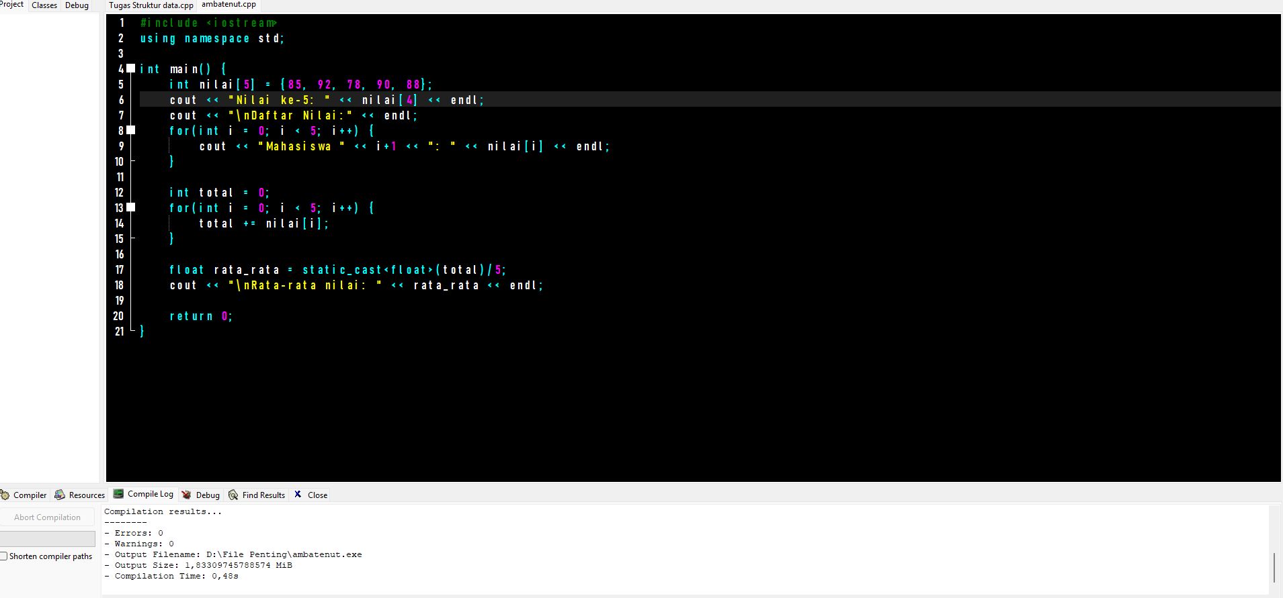
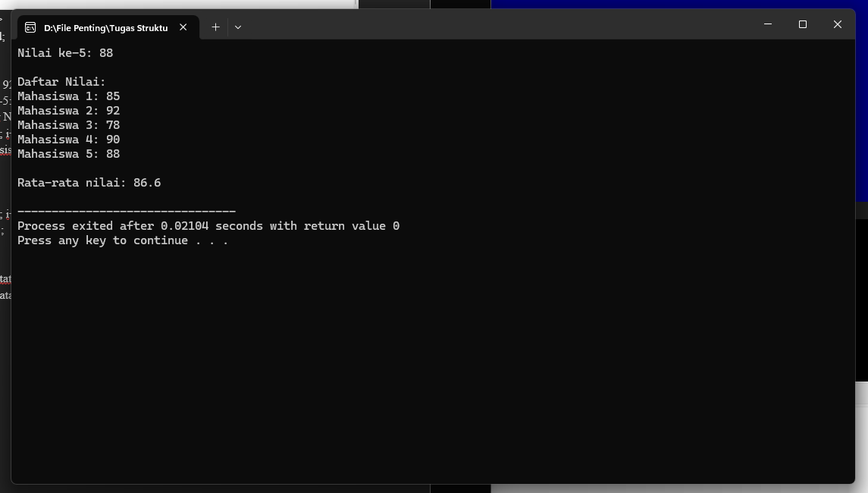

#include <iostream>
using namespace std;

int main() {
int nilai[5] = {85, 92, 78, 90, 88};
cout << "Nilai ke-5: " << nilai[4] << endl;
cout << "\nDaftar Nilai:" << endl;
for(int i = 0; i < 5; i++) {
cout << "Mahasiswa " << i+1 << ": " << nilai[i] << endl;
}

int total = 0;
for(int i = 0; i < 5; i++) {
total += nilai[i];
}

float rata_rata = static_cast<float>(total)/5;
cout << "\nRata-rata nilai: " << rata_rata << endl;

return 0;
}

