**Alignment Tool Help**

Called align_ref.m in Matlab, the alignment tool is meant to assist the wavelet explorer (WaveEx) by providing the facility to adjust the temporal alignment of reflectivity with the seismic trace. Usually, align_ref is invoked through one of the three wavelet explorers (waveex_simple, waveex_match, waveex_rw) by right clicking in the white background of the “traces” axes. Once launched, the tool looks much like Figure 1.

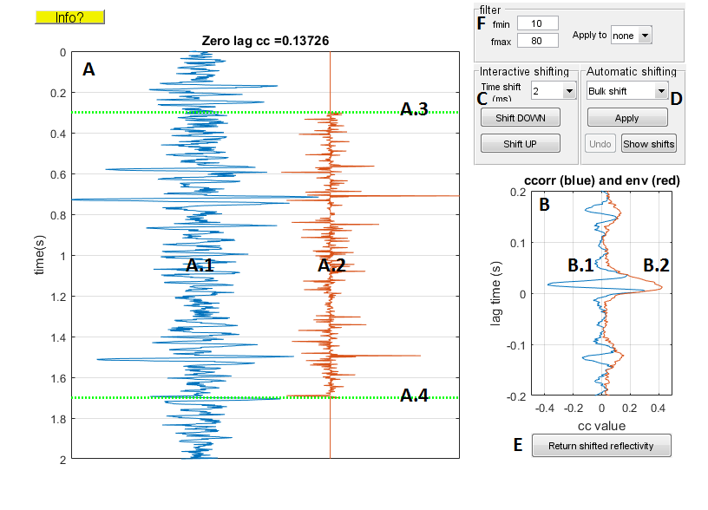

Figure 1: The alignment tool’s main window is shown. Denoted are: A: the trace panel, A.1: The seismic trace $s(t)$, A.2: the reflectivity trace $r(t)$, A.3: top of the correlation gate, A.4: bottom of the correlation gate, B: the correlation panel, B.1 the cross correlation $s⊗r$, B.2: the envelope of $s⊗r$, C: the interactive shifting controls, D: automatic shifting controls, E: the return reflectivity button, and F: the filter specification panel.

This tool provides basic facilities to study the alignment of $r$ with $s$ and to apply shifts to $r$ that will hopefully improve the subsequent wavelet estimation. Since most logs lack an overburden, the time coordinates of the reflectivity are likely suspect and hence any shifts are applied to $r$ not $s$.

**The Trace Panel**: Shown here are the seismic trace (A.1) then the reflectivity trace (A.2) as they are presently aligned in time. As the reflectivity is shifted or stretched and squeezed, the reflectivity will change but the seismic trace will not. Also shown are the top and bottom of the cross correlation gate (A.3 and A.4). The value of the cross correlation at zero lag is shown in the title of this panel and the central lags of the cross correlation function are displayed in the correlation panel (B). This correlation information is directly dependent upon the chosen correlation gate and the gate can be easily adjusted by clicking and dragging the green markers (A.3 and A.4).

**The Correlation Panel**: This panel (B) shows the central portion of the normalized cross correlation between $s$ and $r$. At present it is hard-wired to show lag times within the range $±0.2$ sec so it is important that the preliminary alignment of $s$ and $r$ be accurate to within this tolerance. Also shown is the Hilbert envelope of the cross correlation which is useful to judge the most significant point. In simple theory, suppose $s\left(t\right)=w\left(t\right)∙r(t)$ (the bullet denotes convolution and $w\left(t\right)$ is the wavelet, then the cross correlation $(s⊗r)(τ)$ can be shown to be equal to $w\left(-τ\right)∙A_{r}\left(τ\right)$ where $A_{r}\left(τ\right)$ is the autocorrelation of the reflectivity and $w\left(-τ\right)$ is the time-reverse wavelet. From this comes the expectation that the centermost lags of cross correlation should look like the time-reverse wavelet and this is the case in Figure 1 because it was built using a perfect stationary synthetic. In a real data case, the reflectivity is likely to have time-variant (i.e. nonstationary) misalignments. It follows that a shift that improves the alignment should result in a more concentrated cross-correlation function. That is, it should look more localized and hopefully more wavelet like.

**Interactive shifting**: Interactive shifting is accomplished using the controls in panel C and also using right-clicking on the reflectivity in panel A. Interactive shifts can be either bulk shifts to the entire reflectivity or they can be confined to specific time zones. The magnitude of the shift is specified by choosing one of the predefined values in the time-shift popup in panel C. Available shift sizes range from ¼ of the sample rate up to 40 ms. Shifts for values not found in this list can be synthesized from multiple shifts. Once the shift size is chosen, then clicking either “Shift DOWN” or “Shift UP” shifts the reflectivity in the corresponding direction. After the shift the cross correlation will be recomputed and the display refreshed. If no additional action is taken, then the shift will be a bulk (constant) shift applied to the entire reflectivity. To confine the shift to a specific time interval, anchors must be defined at the boundaries of the interval. To define an anchor, right-click on the reflectivity in panel A at the desired anchor time and choose “Drop anchor”. This point is now immovable until the anchor is cleared and is marked with a black circle. Then repeat this action to define a second anchor at the other interval boundary. Defining two anchors in this way segments the reflectivity into three parts. You must now define which of the three parts will be shifted (above the first anchor, below the second anchor, or between anchors). You do this by left-clicking at a target point which gets marked with a black square. This target point will get the full magnitude of the specified shift and then this shift is tapered linearly to zero at the bounding anchors. You can define as many anchors as you want. You may wish to adjust the correlation gate (A.3 and A.4) to coincide with the boundaries of the zone

**Automatic shifting**: Three options are available in panel D: (1) Bulk shift, (2) TV ccorr, and (3) DTW. Bulk shift uses cross-correlation to deduce a single bulk time shift for the reflectivity. TV ccorr uses time-variant cross-correlation to deduce a time-variant stretch (it may also compress which is a negative stretch). DTW stands for *dynamic time warping* which is an alternative to TV ccorr developed by Dave Hale at Colorado School of Mines. Selecting any of these causes a window to appear with relevant parameters. Choose the defaults at first. Clicking OK causes the automatic shifting. The “Show shifts” button causes a window to appear showing the details of the automatically derived shifts. Finally, the “Undo” button will undo any just-completed automatic shift. There is only one level of undo so it might be best to avoid multiple automatic shifts. Comparing TV corr with DTW can be done by launching two alignment tools from the same source window.

**Filtering**: Panel F provides a basic bandpass filter ability. It may be easier to judge the correct alignment after application of a bandpass filter. The minimum and maximum frequencies of the passband can be specified and the filter is a zero-phase Butterworth implementation. The filter can be applied to either the reflectivity (‘rcs’), the seismic, both the reflectivity and the seismic, or to none. Changing the filter passband will not cause a re-application of the filter, this only happens with the selection of “Apply to”. Regardless of the filter specifications, the unfiltered reflectivity is always returned to the calling window.

**Return shifted reflectivity**: Pressing this button causes the current reflectivity trace to be returned to the calling window. The returned reflectivity is never filtered even if a filter was applied in the shifting process.