**WaveEx Help**

*WaveEx* is an interactive tool that facilitates the exploration of seismic wavelet estimation from well logs. Currently there are three wavelet estimation mechanisms available: (1) smoothness constrained match filtering, (3) the Roy White method (either frequency domain or time domain), and (3) a simple method that constrains the wavelet to have the same amplitude spectrum as the seismic data (but smoothed), a constant phase spectrum (i.e. a phase rotation), and a constant time delay. These three methods will be called *match, roywhite*, and *simple* respectively for convenience. A separate tool exists for each method but all three tools are built on top of the WaveEx engine. These tools are *waveex_match*, *waveex_rw*, and *waveex_simple*.

Figure 1 shows main *WaveEx* window as configured by *waveex_match*, red bold letters denote key parts that will now be described. The tool title (A) identifies this as the match filter WaveEx tool. Only the algorithm parameters panel (I) changes with each tool. The traces axes (B) shows four traces identified in the legend as trace, model trace, reflectivity, and estimated r. Trace refers to the seismic traces that is to be matched to the reflectivity. Initially only two traces will be seen in this panel because the model trace and the estimated reflectivity (estimated r) can only be calculated once a wavelet has been estimated. Also indicated in this panel is the wavelet extraction gate denoted by the dotted green lines. In this case the gate is at its maximum size (the length of the reflectivity). This gate can be adjusted either by clicking and dragging the green lines or by typing in time values in panel (I).

Panels (C) and (D) show time variant estimates of phase and delay. Initially these panels will have only 1 curve each which represents the estimates before any wavelet processing. Once a wavelet has been estimated, there will be both before and after curves. The before curves will never change as new wavelet estimates are made but there will be unique after curves for each wavelet. These time variant estimates are controlled by the two parameters in panel (H). These are the “Time window size” and the “window increment”. The former is the half-width of a Gaussian window used to localize the signals being compared while the latter is the increment between adjacent windows. Window positions are taken at this increment from the start of the reflectivity to the end. In each window the best (least squares) phase rotation and the best time delay (corresponding to the maximum of the crosscorrelation) are estimated. Values are interpolated and extrapolated to cover the entire time range.

Panel (E) shows a measure (PEP) comparing the model trace to the trace, and another measure (PRR) the estimated reflectivity to the reflectivity. Let $s(t)$ be the trace, $r(t)$ the well reflectivity, and $w(t)$ the estimated wavelet. Generally $r(t)$ will be a shorter time series than $s(t)$ as shown in Figure 1. The model trace is calculated as $s_{m}\left(t\right)=(w⋆r)(t)$ where $⋆$ denotes convolution. WaveEx always truncates the convolution to the length of $r\left(t\right)$. The reflectivity estimate is calculated from $r_{e}\left(t\right)=(d⋆s)(t)$ where $d(t)$ is a bandlimited inverse to $w(t)$. (The band limits come from the filter parameters prescribed in panel (I).) The comparisons of $s_{m}(t)$ to $s(t)$ and $r_{e}\left(t\right)$ to $r(t)$ offers two different means of assessing the quality of the estimated wavelet. Both comparisons are done in the same way with the comparison of $s_{m}(t)$ to $s(t)$ being called PEP (Portion of Energy Predicted) and the comparison of $r_{e}\left(t\right)$ to $r(t)$ being called PRR (Portion of Reflectivity Resolved). The wavelet inverse, $d(t)$, used to create $r_{e}\left(t\right)$ was bandlimited so the actual calculation of PRR compares $r_{e}\left(t\right)$ to $r_{B}\left(t\right)$ where the latter is a bandlimited version of the true reflectivity $r\left(t\right)$. PEP is calculated from

$PEP=1-\frac{\sum_{k}{{\left(s\left(t_{k}\right)-s_{m}\left(t_{k}\right)\right)}^{2}}}{\sum_{k}{s{\left(t_{k}\right)}^{2}}}$. (1)

The term being subtracted from 1 in this expression is the ratio of the energy (sum of squares of samples) of the residual trace to the energy of the trace. PEP is 1 if the model trace matches the residual trace exactly and less than 1 in any real case[1]. PRR is calculated in a similar fashion as

$PRR=1-\frac{\sum_{k}{{\left(r_{B}\left(t_{k}\right)-r_{e}\left(t_{k}\right)\right)}^{2}}}{\sum_{k}{r_{B}{\left(t_{k}\right)}^{2}}}$. (2)

Equations (1) and (2) are made time-variant by applying them to Gaussian-windowed traces just as was described for time-variant phase and delay previously. However, since amplitude balancing is routinely done in well tying, and since seismic amplitudes are difficult to control and are often erroneous in a time-variant way, the time-variant estimation finds a best constant scalar in each time window to match $s_{m}(t)$ to $s(t)$ and $r_{e}\left(t\right)$ to $r_{B}(t)$. In a sense, this is line running an optimal AGC in the estimates before making the comparison.

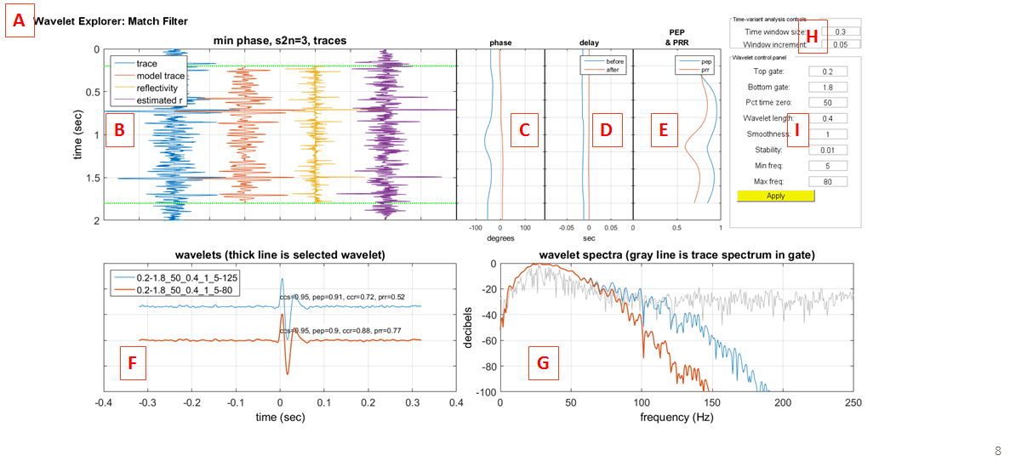

Figure 1: The main figure window for the match filter wavelet explorer (WaveEx). Designated by large red letters are: (A) The window title. (B) The trace display panel showing the seismic trace (trace), the model trace (reflectivity convolved with estimated wavelet), the well-derived reflectivity (reflectivity), and the estimated reflectivity (trace convolved with bandlimited wavelet inverse). (C) Time-variant phase estimates before and after wavelet deconvolution. (D) Time-variant delay estimates before and after wavelet deconvolution. (E) Time-variant PEP and PRR after wavelet deconvolution. (F) The estimated-wavelets panel showing two wavelet estimates. (G) The Spectra panel showing the spectra of the estimated wavelets and the trace spectrum. (H) Control panel with time-variant analysis controls. (I) Control panel with wavelet estimation controls.

Shown in panel (F) in Figure 1 is the estimated-wavelets panel which shows in this case two estimates have been made. The legend shows these wavelets with auto-generated names created by stringing together the parameters in the wavelet-estimation panel (I) for each wavelet. These parameters are in the same order as they appear in the panel (top to bottom) and will be discussed shortly. The “current wavelet” is shown with a thicker line than the other(s) and in this case is the red curve. The results in panels (C), (D), and (E) are for the current wavelet only. By right clicking on any wavelet in this panel, you can either make it current or delete it. Making the wavelet current will cause a re-draw in panels (C), (D), and (E) to show results for that wavelet. Annotated in text with each wavelet are four additional quality control parameters. These are not time variant but are calculated for the entire length of the reflectivity. Denoted ccs is the maximum of the crosscorrelation between the seismic trace and the model trace and denoted pep is the Portion of Energy Predicted for these two traces. This PEP is a sort of bulk average for the time-variant measure shown in panel (E); however, because the time-variant measure uses local trace scaling, the bulk measure can be very small for very nonstationary traces. Also annotated on each wavelet are ccr, the maximum of the crosscorrelation between the bandlimited reflectivity and the estimated reflectivity, and prr the Portion of Reflectivity Resolved. In the case shown in Figure 1, the two wavelets differ only in $f_{max}$ the maximum frequency of the passband. This is indicated by the last number in their auto-generated names and is 125 Hz for the blue wavelet and 80 Hz for the red wavelet. The ccs and pep values are identical for the two wavelets but the red wavelet has higher values for both ccr and prr. This is entirely due to the reflectivity estimate being less noisy when bandlimited to 80 Hz as opposed to 125 Hz. This illustrates the fundamental difference between ccs-pep and ccr-prr. The former measure the quality of the trace model and are both dominated by the strong signal near the dominant frequency of the wavelet. The latter measure the quality of the reflectivity estimate and are much more strongly affected by frequencies throughout the specified band limits.

Panel (F) in Figure 1 shows the spectra of the wavelets in panel (E) together with the spectrum of the seismic trace in the extraction gate. In this case the wavelet spectra differ only on the high frequency end due to their different band limits.

Panel (H) allows the time-variant analysis parameters to be specified. These are $t_{win}$, the half-width of the Gaussian window, and $t_{inc}$, the time increment between windows. Both values are specified in seconds and it is important to keep $t_{inc}≪t_{win}$. A good rule of thumb is to make $t_{win}$ are least four times larger than $t_{inc}.$ The curves shown in panels (C), (D), and (E) are determined by these parameters and are computed at the time of wavelet estimation. However, you can change these values and cause the curve to be recomputed by right-clicking on the wavelet and selecting it after entering new values.

**Match filter wavelet estimation parameters**

Figure 2 shows the wavelet estimation parameters for the match filter algorithm. This method deiv3ed directly from the convolutional model which can be expressed as $s\left(t\right)=r\left(t\right)⋆w\left(t\right)$ with $⋆$ being convolution. Forming a convolution matrix from $r(t)$ allows this to be written as a matrix equation $R\underline{w}=\underline{s}$, where $R$ is that convolution matrix and $\underline{w}$ and $\underline{s}$ are column vectors containing the wavelet and the trace. Choosing length($\underline{w}$)< length($\underline{s}$) allows a least-squares solution ${\underline{w}}_{LS}={\left(R^{T}R\right)}^{-1}R^{T}\underline{s}$ where the superscript $T$ denotes a transpose. When modified to include a slowness constraint this becomes ${\underline{w}}_{LS}={\left(R^{T}R+μD_{2}^{T}D_{2}\right)}^{-1}R^{T}\underline{s}$ where $D_{2}$ is a second derivative finite difference matrix and $μ≥0$ is the *smoothness parameter* which controls the relative weight of misfit minimization versus imposed smoothness. Setting $μ=0$ gives a standard least squares solution with no imposed smoothness bias.

The first two parameters prescribe the top and bottom of the wavelet extraction gate. The wavelet will represent an average or effective wavelet over this gate. Making the gate smaller to focus on a zone of interest may give better resolution in that zone but will generally be less effective elsewhere. Extremely small gates will not generally have sufficient statistics to achieve a good estimate. This can be judged by paying close attention to the wavelet quality measures in panels (C), (D), and (E) and as annotated in panel (F). The gate times are specified in seconds and may either be typed into the boxes or determined by clicking and dragging the green lines in the traces panel (panel (B) of figure 1).

The third parameter in Figure 2 is “percent time zero” and controls the causal nature of the estimate. A fully causal wavelet will have $t=0$ (hereafter called time zero) as the first wavelet sample while placing time zero as the center sample is very non-causal. Intuitively, the point here is to decide if the reflectivity estimate at a given sample is entirely determined by samples at later times (the fully causal case) or if samples at earlier times are also important. This parameter specifies the location of time zero and the value shown of 50% means that it is in the middle or symmetric position. This is often the best choice even if the wavelet is expected to be fully causal. A value of 0 means fully causal but generally gives worse performance than a small number like 5 or 10.

The next parameter, wavelet length, is specified as a fraction of the extraction gate. The value of 0.4 here means that the wavelet length will be 0.4 times the gate which in this case means $0.4\left(1.8-0.2\right)=0.64$ sec. This value is constrained to be positive and less than 1 to ensure that the wavelet is overdetermined by the gate and thus a least-squares solution is possible.

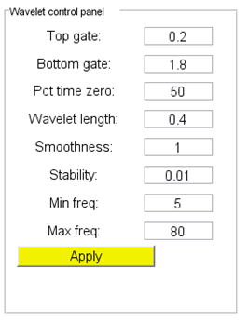

Figure 2: A close-up of the wavelet estimation control panel (panel (I) of Figure 1) for the match filter wavelet estimation method.

The smoothness parameter controls the time-domain smoothness of the wavelet estimate. The smoothness constraint is introduced into the least-squares estimation by modifying the normal objective function from a simple misfit between trace and model trace to misfit plus a smoothness measure. The smoothness measure is the L2 norm of the second derivative and the smoothness parameter controls the relative weights of smoothness and misfit in the overall objective function. The value of 1 (shown) is the default and means that smoothness and misfit are given equal weight. A value of 0 means that only misfit is considered. There is no upper limit to this parameter but extremely large value tend to give unrealistic estimates.

The stability parameter is used only in the wavelet inversion that is needed to calculate the reflectivity estimate. Essentially identical to the white noise parameter in spiking decon, this value tends to stabilize the inversion. It should be a non-negative number less than 1. The wavelet inverse is calculated by least squares matching of the wavelet to an impulse and then has the filter band limits applied. The degree of causality of the inverse is controlled to be the same as that as the wavelet estimate as determined by “Pct time zero”.

The final two parameters are the filter band limits. These control the zero-phase, Butterworth, bandpass filter that is applied to both the wavelet and the wavelet inverse. They are specified in Hz.

Pushing the “Apply” button causes a new wavelet estimate with the specified parameters. Wavelet estimates accumulate in panels (F) and (G) as they are created. The most recent wavelet is set to be current by default and its time variant analyses are displayed in panels (C), (D), and (E). Any wavelet can be deleted or selected (made current) by right clicking on it in panel (F). Note that you must directly on the curve and this can be difficult in a noisy part of the wavelet. Choosing a smooth part addresses this.

**Roy White wavelet estimation parameters**

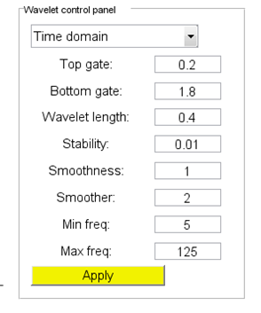

Figure 3: A close-up of the wavelet estimation control panel (panel (I) of Figure 1) for the Roy White wavelet estimation method.

The Roy White wavelet estimation method (White, 1980; Walden and White, 1998) is also based on the convolutional trace model but proceeds slightly differently from the match filter approach. Starting again from the convolutional model $s\left(t\right)=r\left(t\right)⋆w\left(t\right)$, we first cross correlate both sides with the reflectivity to get $r\left(t\right)⊗s\left(t\right)=r\left(t\right)⊗r\left(t\right)⋆w\left(t\right)$ where $⊗$ denotes cross correlation. Let $r\left(t\right)⊗r\left(t\right)=C_{rr}(t)$ which is the autocorrelation of the reflectivity and let $r\left(t\right)⊗s\left(t\right)=C_{rs}(t)$ which is the cross correlation of the reflectivity with the seismic trace. Then we have $C_{rs}\left(t\right)=C_{rr}\left(t\right)⋆w(t)$ which says that $C_{rs}(t)$ can be used to estimate the wavelet but we must deconvolve $C_{rr}(t)$ from it. Let $C_{rr}^{-1}(t)$ denote the convolutional inverse to $C_{rr}(t)$ and we have

$w\left(t\right)={C_{rr}^{-1}\left(t\right)⋆C}_{rs}(t)$ (3).

In the frequency domain this is easily accomplished by a simple division. However White goes further and incorporates a frequency-dependent weighting factor, $γ^{-2}\left(f\right),$ that down weights noisy frequencies. The final formula for the Roy White frequency domain method is

$\hat{w}\left(f\right)=γ^{-2}(f)\frac{{\hat{C}}_{rs}(f)}{\left({\hat{C}}_{rr}\left(f\right)+λC_{max}\right)}$ where $γ^{-2}\left(f\right)=\frac{{\hat{C}}_{rr}\left(f\right){\hat{C}}_{ss}\left(f\right)}{{\left|{\hat{C}}_{rx}\left(f\right)\right|}^{2}+λD_{max}}$ (4)

Where $C_{max}$ is the maximum of ${\hat{C}}_{rr}\left(f\right)$, $D_{max}$ is the maximum of ${\left|{\hat{C}}_{rx}\left(f\right)\right|}^{2}$ and $0<λ<1$ is a small constant. Also, all of the spectra in formula (4) must be smoothed.

Figure 3 shows the wavelet estimation control panel for the Roy White method. The first prameter is actually a binary choice of either time domain or frequency domain solutions. The time-domain solution proceeds from equation (3) but uses a smoothness constraint much like the match filter method. It produces similar results to the match filter method but is conceptually distinct in that the latter deconvolves the reflectivity from the trace while the former deconvolves the autocorrelation of the reflectivity from the cross correlation of the reflectivity with the trace.

1. It is technically possible for PEP to be negative if the model trace is very poor.