My first word document written in RStudio

Firstname Surname

04 July, 2019

# Famous people in public health

## John Snow

John Snow is famous for, among other things, working out that *cholera was waterborne* (Snow, 1856). He was an English physician and a leader in the development of anaesthesia and medical hygiene. He is considered one of the fathers of modern epidemiology, in part because of his work in tracing the source of a cholera outbreak in Soho, London, in 1854.

## Florence Nightingale

Florence Nightingale was an English social reformer and statistician, and the founder of modern nursing (Nightingale, 1992). Nightingale came to prominence while serving as a manager and trainer of nurses during the Crimean War, in which she organised care for wounded soldiers. She gave nursing a favourable reputation and became an icon of Victorian culture, especially in the persona of “The Lady with the Lamp” making rounds of wounded soldiers at night.

## Michael Marmot

Michael Marmot led the Whitehall studies, which showed that socioeconomic *class inequalities can be bad for your health* (when you’re at the **bottom**, not the top!) (Marmot *et al.*, 1991). He is Professor of Epidemiology and Public Health at University College London.

## Doll and Bradford-Hill

Along with others, these two lead studies that supported the idea, controversial at the time, that smoking is bad for you (Doll & Hill, 1950), causing:

* Lung disease
* Heart disease
* Yellow teeth
* Bad breath

# Tables

## Table 1: characteristics of famous people

|  |  |  |  |
| --- | --- | --- | --- |
| Name | Gender | Year of birth | University / institution |
| John Snow | Male | 1813 | Royal College of Physicians |
| Florence Nightingale | Female | 1820 | St Thomas’ Hospital |
| Michael Marmot | Male | 1945 | UCL |
| Richard Doll | Male | 1912 | Oxford University |
| Austin Bradford-Hill | Male | 1897 | LSHTM |

Note that this table is a ‘Markdown’ table and is not generated using R in a chunk.

We could generate a table with R, as was done for the table below.

## Table 2: cycling deaths in London

|  |  |  |  |  |  |
| --- | --- | --- | --- | --- | --- |
| Year | Fatal | Serious | KSI | Slight | Total |
| 1989 | 33 | 752 | 785 | 4,379 | 5,164 |
| 1990 | 19 | 625 | 644 | 3,895 | 4,539 |
| 1991 | 17 | 633 | 650 | 3,693 | 4,343 |
| 1992 | 18 | 546 | 564 | 3,722 | 4,286 |
| 1993 | 18 | 493 | 511 | 3,695 | 4,206 |
| 1994 | 15 | 488 | 503 | 3,924 | 4,427 |
| 1995 | 15 | 527 | 542 | 3,997 | 4,539 |
| 1996 | 20 | 577 | 597 | 3,753 | 4,350 |
| 1997 | 12 | 566 | 578 | 3,852 | 4,430 |
| 1998 | 12 | 602 | 614 | 3,702 | 4,316 |
| 1999 | 10 | 482 | 492 | 3,682 | 4,174 |
| 2000 | 14 | 408 | 422 | 3,084 | 3,506 |
| 2001 | 21 | 444 | 465 | 2,857 | 3,322 |
| 2002 | 20 | 394 | 414 | 2,648 | 3,062 |
| 2003 | 19 | 421 | 440 | 2,616 | 3,056 |
| 2004 | 8 | 332 | 340 | 2,620 | 2,960 |
| 2005 | 21 | 351 | 372 | 2,523 | 2,895 |
| 2006 | 19 | 373 | 392 | 2,566 | 2,958 |
| 2007 | 15 | 446 | 461 | 2,509 | 2,970 |
| 2008 | 15 | 430 | 445 | 2,757 | 3,202 |
| 2009 | 13 | 420 | 433 | 3,236 | 3,669 |
| 2010 | 10 | 457 | 467 | 3,540 | 4,007 |
| 2011 | 16 | 555 | 571 | 3,926 | 4,497 |
| 2012 | 14 | 657 | 671 | 3,942 | 4,613 |
| 2013 | 14 | 475 | 489 | 4,134 | 4,623 |
| 2014 | 13 | 419 | 432 | 4,714 | 5,146 |

# Figures

## Figure 1: John Snow’s map

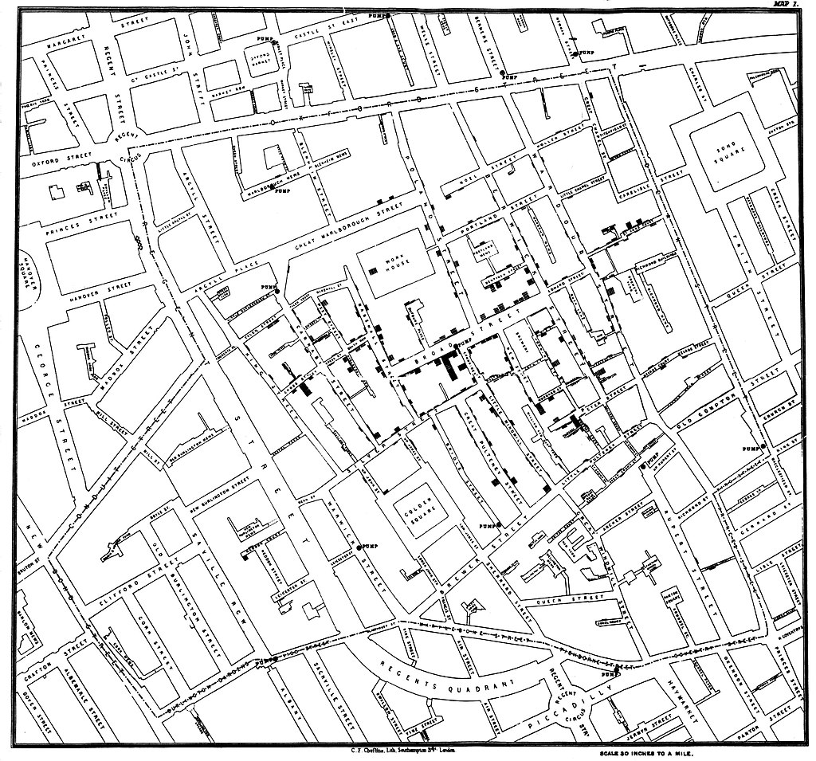

John Snow’s map

## Figure 2: plot of deaths

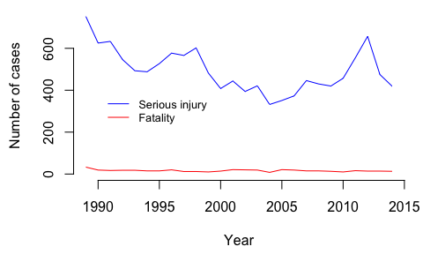

# References

Doll, R. & Hill, A.B. (1950) Smoking and carcinoma of the lung. *British medical journal*. 2 (4682), 739.

Marmot, M.G., Stansfeld, S., Patel, C., North, F., et al. (1991) Health inequalities among british civil servants: The whitehall ii study. *The Lancet*. 337 (8754), 1387–1393.

Nightingale, F. (1992) *Notes on nursing: What it is, and what it is not*. Lippincott Williams & Wilkins.

Snow, J. (1856) On the mode of communication of cholera. *Edinburgh medical journal*. 1 (7), 668.