IE University
School of Science & Technology



The Demographic Tide:
Retirement Flows and Price Impact in an Inelastic Equity Market

Antonio de Ipiña Sanchez
Bachelor of Data and Business Analytics

Supervised by:
Prof. Manuele Leonelli

Executive Summary
The academic consensus that retiring baby boomers would not depress equity markets was established before passive index investing captured a third of U.S. equities and before automatic enrolment channelled retirement savings mechanically through target-date funds (TDFs). In an inelastic market where one dollar of flow moves prices by roughly five dollars, these mechanical flows could have serious price effects, yet the demographic, inelastic markets, and retirement behaviour literatures have never been integrated into a single projection framework. This study asks when and whether aggregate retirement account outflows will structurally exceed passive equity inflows between 2025 and 2050. A five-module accounting model, calibrated from Census projections, participant-level plan data, and industry flow statistics, propagates uncertainty across a Monte Carlo simulation, decomposing output variance through Sobol sensitivity analysis. The median net flow trajectory crosses zero between 2040 and 2041, but the annual price drag reaches only −0.11% of market capitalisation by 2050, less than one-hundredth of the long-run equity return. Corporate buybacks prevent sustained negative flows in most simulations, though this offset weakens in downturns. Return volatility dominates long-horizon uncertainty, but the conditional Sobol decomposition shows that once market noise is removed, retirement withdrawal behaviour becomes the decisive structural parameter. The conservative base case understates near-term pressure. The total defined-contribution (DC) system is already in net outflow, and when the model applies observed retiree equity allocations of roughly 50% rather than the TDF glide-path assumption of 18 to 21%, the crossover is already happening. The findings suggest that the transition from inflow-dominated to outflow-dominated retirement flows could change the background conditions of U.S. equity markets, even if the annual effect remains too small to detect against return volatility.
Table of Contents
Executive Summary 1
1. Introduction 4
2. Literature Review 7
2.1 The Demographic Asset Meltdown Debate 7
2.2 The Inelastic Markets Revolution 9
2.3 Retirement Savings and Withdrawal Behaviour 10
2.4 The Institutional Channel 12
2.5 The Gap 13
3. Data 13
3.1 Data Sources and Calibration 15
3.2 Data Limitations 17
4. Methodology 18
4.1 Model Architecture 18
4.2 The Five-Module Pipeline 19
4.3 Monte Carlo Simulation Design 22
4.4 Passive Share Forecasting: ARIMA 24
4.5 Regression Evidence 25
4.6 Global Sensitivity Analysis: Sobol Indices 25
4.7 Methodological Limitations 26
5. Results 27
5.1 Flow Trajectories and Crossover Timing 27
5.2 Buyback Offset 30
5.3 Price Impact 31
5.4 Scenario and Stress Analysis 32
5.5 Variance Decomposition 34
5.6 Regression Evidence 36
6. Discussion 39
6.1 The Central Finding 39
6.2 Robustness and Sensitivity 40
6.3 Implications 41
6.4 Limitations 42
6.5 Future Work 44
7. Conclusion 45
References 47
Appendices 51
Appendix A: Data Sources and Parameter Tables 51
Appendix B: Primer on Financial Concepts 54
Appendix Figures 57

Introduction
The first generation of Americans to build part of their retirement savings through employer-sponsored DC plans are the baby boomers (born 1946 to 1964) and early Generation X (born 1965 to 1970). As these generations continue retiring, the population aged 65 and older will grow from 63 million to 82 million between 2025 and 2050, a 30% increase, while the working-age population will grow from 173 million to 184 million, roughly 7% (U.S. Census Bureau, 2023) (Figure 1).
Demographic shifts have previously been studied and have not been shown to be a risk to equity markets. In the early 2000s, economists debated the question and the consensus was no (Poterba, 2001; Abel, 2001). That consensus, though, was formed before two developments changed the picture. Passive index investing has risen from close to zero in 1990 to roughly a third of all U.S. equity holdings (Chinco & Sammon, 2024), driven by lower fees, the Pension Protection Act of 2006, and the growing evidence that most active managers underperform benchmarks. These DC retirement funds accumulate assets in vehicles that do not respond to price signals. And automatic enrolment and TDFs have built a mechanical pipeline between demographics and equity markets that did not exist when the original debate took place. In an inelastic market where one dollar of flow moves prices by roughly five dollars (Gabaix & Koijen, 2023), these mechanical flows could matter far more than earlier models assumed.

Figure 1
Population aged 65+ grows from 63 million to 82 million (2025–2050), while the working-age population grows roughly 7%. Source: U.S. Census Bureau (2023).
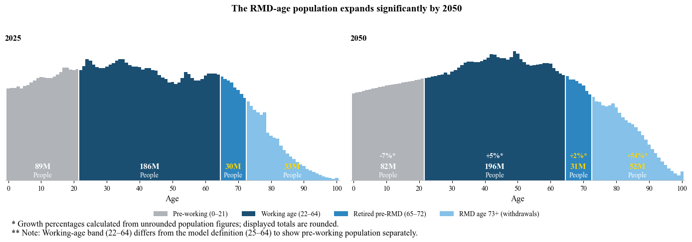
Three bodies of research bear on this question, but no study has connected them into a single forward-looking projection model: the demographic meltdown literature (Abel, 2001; Geanakoplos et al., 2004; Poterba, 2001), the inelastic markets literature (Chinco & Sammon, 2024; Gabaix & Koijen, 2023; Haddad et al., 2025), and the retirement behaviour literature (Madrian & Shea, 2001; Parker et al., 2023; Poterba et al., 2011). The tools needed to connect these areas have only recently been developed. The Gabaix-Koijen flow multiplier, which quantifies how much one dollar of passive flow moves aggregate market capitalisation, was circulated in 2021. Demand elasticity measurements that track how responsive the remaining active investors are to price changes followed in 2025 (Haddad et al., 2025). And the SECURE 2.0 mandates, which extended automatic enrolment to virtually all new retirement plans, were legislated only in 2022.
This study asks whether and when aggregate retirement account outflows will overtake inflows into passive equity index funds, and what the net flow trajectory looks like from 2025 to 2050. That crossover, the point at which retirement withdrawals from passive equity vehicles exceed working-age contributions into them, would mark a structural shift in how the market’s flow regime operates. A five-module accounting model traces DC plan flows from working-age contributions through TDF allocations to retirement withdrawals, translating net flows into price impact. Most parameters in the model are calibrated using actual observed data, rather than assumptions. The model propagates uncertainty across 25,000 Monte Carlo paths and decomposes output variance through Sobol sensitivity analysis.
The total DC system already disburses more than it receives, with net contributions negative every year since 2020 (ICI, 2025). Simulating observed retiree equity allocations of roughly 50%, the equity channel crossover is already happening, aligning the model with reality. The base case models the institutional pipeline as it is actually constructed, following the TDF glide-path allocations that auto-enrolment and regulation channel participants through. Current retirees, who built their portfolios before TDFs became the default, hold substantially more equity than the glide path prescribes. The sensitivity test in Section 5.4 quantifies this gap. The base case is where the system is heading. Current conditions are already beyond it.
The paper is structured as follows. Section 2 will review the demographic, inelastic markets, and retirement behaviour literatures, tracing how each contributes to the mechanism modelled here. Section 3 will describe the six data sources and their limitations. Section 4 will develop the five-module methodology along with the Monte Carlo, ARIMA, regression, and Sobol analyses that propagate and decompose uncertainty. Section 5 will report results. Section 6 will discuss implications, robustness, and limitations. Section 7 will conclude.

Literature Review
Three literatures converge on whether demographic flows can move equity prices: the demographic asset meltdown debate of the early 2000s, the inelastic markets revolution of the 2020s, and the retirement savings and withdrawal behaviour literature that documents how mechanical these flows are. Each addresses a piece of the question this study asks, but no existing work has connected them into a single forward-looking projection framework. This review traces what each literature establishes and where it falls short, leading to the gap this study addresses.

The Demographic Asset Meltdown Debate
The life-cycle hypothesis (Modigliani & Brumberg, 1954) predicts that individuals accumulate wealth during their working years and draw it down in retirement. The asset meltdown hypothesis extends this logic to the aggregate level, that when a large cohort retires simultaneously, their collective dissaving could depress equity prices. The idea prompted two distinct questions in the early 2000s, whether the mechanism is theoretically sound and whether it can be detected empirically.
On the theoretical side, the most common dismissal was shown to be incomplete. The objection was simple: retirees do not actually sell all their holdings, and many pass assets to heirs, so no net selling pressure emerges. Abel (2001) shows this reasoning is flawed. In an overlapping-generations model, when a retiree sells shares, the sale depresses prices, but a younger buyer provides offsetting demand. When a retiree bequeaths shares instead, the heir receives what they would otherwise have bought. Both the selling pressure and the buying demand disappear together. The two paths lead to the same equilibrium price. Bequests do not prevent demographic effects on valuations; they rearrange who holds the shares. Abel frames this result as a rhetorical device to illustrate that one cannot predict the price of capital by focusing on demand while ignoring supply and describes the broader question as "an open question worthy of further study." Geanakoplos et al. (2004) provide the most comprehensive theoretical framework, introducing the MY ratio as a predictor of equity valuations. Their "favoured cohort effect" shows that large cohorts face unfavourable terms of trade at every stage, that when they enter the labour market, their collective demand bids prices up, and when they retire and sell, the supply surge depresses them.
On the empirical side, the evidence was inconclusive. Poterba (2001) combines age-specific wealth holdings from the SCF with Census population projections to construct a projected asset demand variable. Their core finding is a null result. Population age structure does not significantly predict asset returns, though they find a more substantial relationship for price levels. Brooks (2004) raises a further concern, that the MY ratio's correlation with prices could reflect coincident structural changes rather than demographics. That is a valid criticism, but it does not affect the present analysis, which models specific institutional channels rather than relying on the MY ratio.
These two sets of findings are not contradictory. The theoretical objections to the meltdown hypothesis were weakened, but the empirical tools of the early 2000s were too blunt to detect the mechanism. Poterba's population ratios are too broad to capture the specific institutional channels through which retirement generates equity selling, and their sample predates the passive revolution entirely. Poterba's own conclusion is that future work is needed to isolate and empirically measure the channels through which demographic changes may affect asset prices. Those measurement tools arrived with the inelastic markets literature.

The Inelastic Markets Revolution
The central finding of this literature is that equity markets are far less elastic than standard models assume, meaning that uninformed flows move prices by much more than previously believed. This challenges the efficient markets view that prices primarily reflect fundamentals and that uninformed flows should be absorbed without significant price impact.
Gabaix and Koijen (2023) estimate that one dollar of net flow increases aggregate market capitalisation by approximately three to seven dollars, with a central estimate of five. They identify this multiplier using Granular Instrumental Variables (GIV) across 13 sectors. The multiplier arises because a large share of equity is held by investors who rarely adjust in response to price changes, including passive index funds, pension funds following policy portfolios, foreign central banks, and inattentive households. Their general equilibrium model matches the observed equity premium, return predictability, and excess volatility, lending theoretical credibility to the empirical estimate.
The effective passive share driving this inelasticity is larger than commonly measured. Chinco and Sammon (2024) show that it is approximately 33.5%, roughly double the commonly reported figure, because standard measures miss closet indexers and institutional separate accounts. Haddad et al. (2025) confirm low demand elasticity at the individual stock level and document that it declined by approximately 11% between 2001 and 2020 as passive investing grew. Their strategic response parameter χ ≈ 3 means that active investors partially offset the elasticity lost to passive growth, but about one-third passes through to equilibrium prices. Empirical validation through Russell index reconstitution events yields a pass-through estimate of 0.35, close to the theoretical prediction. Mitchell et al. (2007) document that flow-driven price displacements persist for weeks to months, as arbitrage capital responds slowly.
Independent confirmation at the plan level points in the same direction. Sabbatucci et al. (2025) use BrightScope data on individual employer retirement plans, estimating a baseline flow multiplier of approximately 8, already above the Gabaix and Koijen central estimate. When they incorporate a feedback channel specific to 401(k) ownership patterns, where stocks held by retirement plans attract additional demand from funds that value that characteristic, the multiplier reaches 12 to 13. These estimates are not directly comparable to the aggregate time-series approach of Gabaix and Koijen, as Sabbatucci et al. operate at the stock level using cross-sectional variation in plan-level passive allocation, but they support the conclusion that M = 5 is, if anything, conservative.
Two independent empirical strategies, aggregate time-series identification (Gabaix & Koijen, 2023) and cross-sectional stock-level variation (Haddad et al., 2025), converge on the conclusion that low elasticity is a robust feature of modern equity markets. The GIV identification strategy is not without criticism. It relies on sector-level flow variation that may not perfectly separate mechanical flows from those carrying fundamental information, and the resulting multiplier spans a wide confidence interval. The multiplier was also estimated from an inflow-dominated period, so its applicability to sustained outflows remains untested.

Retirement Savings and Withdrawal Behaviour
If markets are inelastic, the magnitude of the price impact depends on how mechanical the flows are. The retirement savings literature establishes that DC plan flows are highly mechanical on both sides of the lifecycle.
On the inflow side, behavioural inertia dominates. Madrian and Shea (2001) show that automatic enrolment raises 401(k) participation from approximately 37% to 86% at a single large employer, with the majority of new participants retaining the default contribution rate and fund allocation. They attribute this to procrastination, status quo bias, and complexity-driven reliance on defaults. Subsequent aggregate data have broadly confirmed this pattern across the industry. Giglio et al. (2021), using Vanguard data on a large panel of retail investors, confirm that beliefs about expected returns vary substantially across investors but portfolio allocations respond weakly. Participants rarely engage with their accounts regardless of market conditions, which is precisely the behavioural pattern that connects retirement savings to the inelastic markets framework.
These inflows now route predominantly through TDFs, which allocate based on age, not prices. TDFs have grown from $70 billion in 2005 to approximately $2.0 trillion in mutual fund assets alone by year-end 2024 (ICI, 2025), with additional holdings in collective investment trusts bringing the total to roughly $3.5 to $4.0 trillion. Parker et al. (2023) show that this growth creates a mechanical channel between demographics and equity markets. Because TDFs maintain target equity allocations by age band, they systematically rebalance against market moves, buying when equity weight drops below target and selling when it exceeds target. Roughly 45% of this rebalancing occurs within the same month.
On the outflow side, retirement withdrawals are also predictable. Poterba et al. (2011) document actual withdrawal behaviour using Health and Retirement Study microdata, showing that retirees decumulate more slowly than life-cycle models predict. These findings calibrate the voluntary withdrawal rates in the outflow module. Where voluntary withdrawals fall short, required minimum distributions (RMDs) compensate. RMDs force annual withdrawals from tax-deferred accounts that increase with age, mechanically transmitting demographic pressure into equity selling regardless of participant decisions.
Both the inflow evidence (Madrian & Shea, 2001) and the outflow evidence (Poterba et al., 2011) draw on single-employer or survey samples, which raises questions about generalisability. Aggregate ICI flow data can partially address this limitation.

The Institutional Channel
The institutional machinery connecting these literatures has been constructed over the past decades through regulatory and structural change, and the literature and industry data collectively document that this channel is now large enough and mechanical enough to matter.
The shift from defined benefit (DB) to DC pension plans transferred investment decisions from professional managers to millions of individual participants. DC plans now total $12.4 trillion compared with $3.3 trillion in private-sector DB plans at year-end 2024 (ICI, 2025), covering around 70 million active 401(k) participants. Auto-enrolment, mandated for new plans under the SECURE 2.0 Act of 2022, pushes participation to 94% compared with 64% under voluntary enrolment (Vanguard, 2025b).
These contributions flow overwhelmingly into TDFs, which adjust their equity allocation from approximately 90% for young workers to 30% in the final retirement stage (total equity, including international allocations) (Vanguard, 2025b). TDFs do not yet dominate total accumulated DC assets; the remaining balance sits in self-directed portfolios established before auto-enrolment. They do, however, overwhelmingly capture new contributions, which is the flow channel the model tracks. On the outflow side, when an RMD is taken from an account invested in an index fund, the custodian sells shares pro rata, transmitting demographic pressure directly into equity order flow.
Together, these features ensure that the entire savings-to-withdrawal lifecycle operates without active participant decisions. The result is precisely the kind of price-insensitive flow that the inelastic markets hypothesis identifies as a mover of price levels.

The Gap
These three literatures, and the institutional channel that connects them, have developed largely in isolation. This study assembles them into a single projection framework using a partial-equilibrium accounting model. Rather than solving for an equilibrium in which all agents optimise simultaneously, the model projects prices forward from observed flows, tracking dollars from working-age contributions through TDF allocations to retirement withdrawals and translating net flows into price impact.

Data
Turning this pipeline into a quantitative projection requires data on each stage. The target output is the annual net passive equity flow by age cohort from 2025 to 2050, denominated in nominal dollars. All primary sources except Bloomberg and FactSet are publicly available (Table 1). Full parameter tables, descriptive statistics, and all processing code are available in Appendix A and the project’s GitHub repository (github.com/Aipinas/capstone-demographic-flows).

Table 1
Data Sources and Calibration
Source | Module | Variables / Parameters
U.S. Census Bureau (2023) | 1 | Population by single-year age, 2025–2060; main, high, low, zero immigration scenarios
Vanguard, How America Saves (2025b) | 2 | Age-specific participation rates, total contribution rates (9.3–14.6%), TDF glide paths (12 vintages), auto-enrolment adoption
BLS National Compensation Survey (2024) | 2 | DC plan access rate (72%); age-specific employment-to-population ratios
BLS Employment Cost Index (2025) | 2 | Nominal wage growth rate (2.84%/yr CAGR, 2001–2025); 65+ employment trend (+0.18 pp/yr)
Morningstar TDF Landscape (2025) | 2 | Cross-provider validation of Vanguard glide-path representativeness
IRS Publication 590-B, Table III (2024) | 3 | RMD divisors by age (deterministic withdrawal floor)
Federal Reserve SCF (2022) | 3 | Retirement account balances and ownership rates by age bracket
Vanguard, How America Retires (2025a) | 3 | Voluntary withdrawal rates by age group; retiree equity allocations (52% at ages 65–69)
Federal Reserve Z.1, Table F.103 (2025) | 4 | Quarterly net equity issuance, 1996:Q4–2025:Q3 (buyback yield: 0.98% ± 0.72%)
S&P Dow Jones Buyback Reports (2024) | 4 | Gross repurchase data (cross-validation); recession cut calibration (30%/50%)
Bloomberg Business Intelligence (2025) | 5 | Semi-annual passive equity AUM, 56 asset-class series, 2012–2025
FactSet, FT Wilshire 5000 (2025) | 5 | Historical U.S. equity market capitalisation (passive share denominator)
Chinco & Sammon (2024) | 5 | Corrected passive ownership share (33.5%); scaling factor 1.583
Damodaran (2025) | MC | Annual U.S. equity returns 1928–2024 (arithmetic mean 11.8%, std dev 19.5%)
ICI Fact Book, Table 20 (2025) | Regression | Quarterly net new cash flow into U.S. equity mutual funds, 2007:Q3–2024:Q3
EBRI/ICI 401(k) Database (2022) | Validation | Actual equity allocations by age (57% at ages 60–69); balance cross-checks
Note. Module column indicates the primary model component calibrated from each source. MC = Monte Carlo simulation parameters. All primary sources except Bloomberg and FactSet are publicly available. Full parameter tables are reported in Appendix A.

Data Sources and Calibration
The demographic backbone of the simulation is the U.S. Census Bureau’s 2023 National Population Projections, which provide population counts by single-year age for 2025 through 2060 in four scenarios. These are a main projection and three immigration variants (high, low, zero). The simulation uses the main projection as the central case. Demographic projections over a 25-year horizon are among the most reliable inputs in the model. The majority of the relevant population (those who will be of working or retirement age between 2025 and 2050) has already been born. Immigration is the primary source of demographic uncertainty. The three variant scenarios bracket this uncertainty (Module 1).
Inflow parameters come primarily from Vanguard’s “How America Saves” (2025b), which covers approximately 1,400 plans and nearly 5 million participants. The simulation extracts age-specific participation rates, total contribution rates including employer matching (approximately 9% to 15% of salary depending on age), auto-enrolment adoption rates, and TDF usage patterns. The equity allocation of inflows follows Vanguard’s published TDF glide paths across 12 target-date vintages (2020 through 2070 plus Income). The U.S. equity share ranges from 53.6% for the youngest workers (Target Retirement 2070) to 18.5% for the Income fund (Figure 2) (Appendix Table A9). Morningstar’s TDF Landscape report provides cross-provider validation, confirming that Vanguard’s glide path is representative of the industry. Plan access rates come from the National Compensation Survey (Bureau of Labor Statistics, 2024), which reports that 72% of private-sector workers have access to employer-sponsored retirement benefits, the vast majority through DC plans.

Figure 2
TDF U.S. equity glide path by vintage, from 53.6% for the 2070 fund to 18.5% for the Income fund. Younger workers hold substantially more domestic equity exposure. Source: Vanguard (2025b).
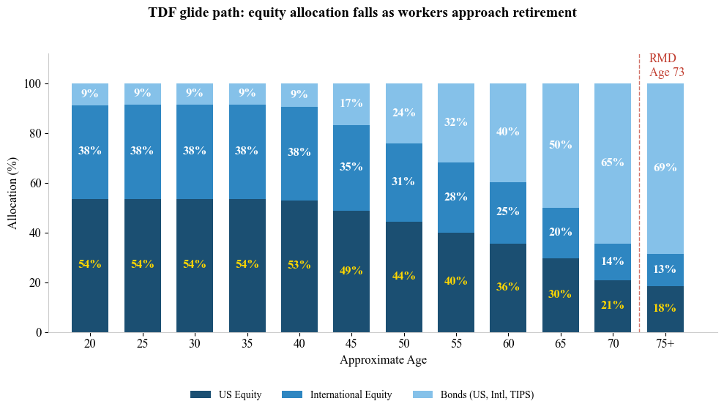
Outflow parameters combine three sources. The IRS Publication 590-B Uniform Lifetime Table (Table III) provides deterministic RMD divisors by age. The Federal Reserve’s 2022 SCF provides retirement account balances by age bracket, used to calibrate the initial balance distribution for outflow calculations. Vanguard’s “How America Retires” (2025a) provides empirical data on actual withdrawal behaviour beyond RMDs. These data calibrate the base voluntary withdrawal rates by age group.
The buyback offset in Module 4 is calibrated from the Federal Reserve’s Enhanced Financial Accounts (Z.1 release, Table F.103), which reports quarterly net equity issuance and retirement from 1996Q4 to 2025Q3. The resulting net buyback yield is approximately 0.98% with a standard deviation of 0.72%. S&P Dow Jones Quarterly Buyback Reports provide gross repurchase data for cross-validation. FactSet provides historical U.S. equity market capitalisation data (FT Wilshire 5000) used as the denominator for the passive share calculation.
The time-varying multiplier in Module 5 depends on the trajectory of passive equity ownership. Bloomberg’s Business Intelligence database provides semi-annual passive equity assets under management (AUM) across 56 asset-class series from 2012 to 2025. This series feeds the ARIMA passive share forecast. Chinco and Sammon’s (2024) corrected passive share estimate of 33.5% as of 2021 anchors the calibration; the simulation’s 2025 starting point of approximately 35% reflects continued growth in the Bloomberg series, with a scaling factor of 1.583 (the ratio of corrected to raw industry figures) applied to convert standard measures to the true passive share (Module 5).

Data Limitations
The Vanguard data represents a single plan administrator. This skews the participant base towards larger employers and higher balances compared with the full universe of DC plans. ICI industry-wide data confirm that 68% of 401(k) participants hold TDFs (ICI, 2025), supporting the model's assumption that TDFs are the dominant allocation vehicle. The model applies TDF glide path equity shares to all cohorts. This correctly describes the allocation for participants auto-enrolled after the Pension Protection Act of 2006, but it understates the equity exposure of current retirees who established their portfolios before TDFs became the default. Employee Benefit Research Institute (EBRI)/ICI data show that actual total equity allocations exceed the TDF assumption at every age, with the gap widest for retirees: 57% actual versus 21% in the model for participants in their sixties (Vanguard, 2025b). As TDF-era cohorts age into retirement, this gap will close. The TDF sensitivity test in Section 5.4 quantifies the near-term effect by applying observed retiree equity allocations to the 2025 to 2045 window. ICI does not report industry-wide contribution rates by age, so the Vanguard-calibrated rates (9.3% to 14.6%) cannot be directly validated against an independent source.
The Federal Reserve’s SCF reports retirement account balances at the household level, not the individual level. This may overstate per-person holdings in dual-earner households.
ICI Table 20 (used in the regression analysis) reports mutual fund equity outflows only, excluding exchange-traded fund (ETF) redemptions. The regression coefficient on population aged 65+ should be read as a lower bound on the demographic sensitivity of total equity outflows.

Methodology
The model translates the data described in Section 3 into a forward-looking projection through a sequential pipeline, one module for each stage of the retirement flow chain.

Model Architecture
An accounting model was chosen because the research question requires tracking cohort-level flows year by year through the institutional pipeline. Every assumption must be visible.
The five modules form a sequential pipeline. Demographic projections (Module 1) feed inflow estimation (Module 2) and outflow estimation (Module 3), which aggregate into net flows with a buyback offset and translate into price impact through the Gabaix-Koijen multiplier with the Haddad et al. time-varying elasticity framework (Module 5). The simulation tracks 76 individual age cohorts (ages 25 through 100), ageing one year per step.
The analysis runs across four Jupyter notebooks and three Python modules (simulation_engine.py, model_runner.py, sobol_runner.py). A shared simulation engine ensures parameter consistency across the Monte Carlo and Sobol analyses.

The Five-Module Pipeline
    - Module 1: Demographic Projections. Module 1 draws on the Census projections described in Section 3.1, aggregating single-year ages into six working-age brackets (under 25, 25-34, 35-44, 45-54, 55-64, 65+) for Module 2 and seven retirement-age brackets (55-59, 60-64, 65-72, 73-74, 75-84, 85-94, 95+) for Module 3. The simulation uses the mid scenario as the central projection and treats low and high scenarios as bounds in the 3x3 scenario matrix (Appendix Table A7).
    - Module 2: Inflow Estimation. For each simulation year and age group, the inflow into U.S. equities through the retirement system is computed as a contribution funnel. The funnel is expressed as:
$Inflow(g,t)=Population(g,t)*Employment(g)*PlanAcces*Participation(g)*DeferralRate(g)*Salary(g)*TDF_{EquityShare}(g)$
Population is the cohort size from Module 1, Employment is the age-specific employment ratio, PlanAccess is the fraction of workers with access to a DC plan, Participation is the enrolment rate, DeferralRate is the total contribution rate including employer matching, Salary is median earnings by age, and TDF_{EquityShare} is the U.S. equity allocation corresponding to the cohort’s expected retirement year. All parameters vary by age and are calibrated as described in Section 3 (Appendix Table A1). Employment ratios are derived as BLS full-time wage and salary workers (USDL-25-1529, Q3 2025) divided by Census 2025 population and are held constant for working-age groups. Salary is the BLS median weekly earnings by age group from the same report, annualised. The resulting 2025 baseline is $265 billion, consistent with the approximately 37% equity share of the $716 billion in total DC plan contributions reported for 2023 (ICI, 2025). The simulation tracks U.S. equity flows only. International equity allocations within TDFs are excluded because the study focuses on U.S. market impact.
Inflows grow through nominal wage growth of 2.84% per year, the mean annual increase in the Employment Cost Index from 2001 to 2025 (Bureau of Labor Statistics, 2025). The employment ratio for workers aged 65 and older increases by 0.18 percentage points per year (capped at 25%), reflecting the trend in BLS employment-to-population data from 2008 to 2024, excluding the COVID period.
    - Module 3: Outflow Estimation. Retirement outflows arise from three channels. RMDs, voluntary withdrawals in excess of RMDs, and the systematic de-risking of TDF allocations as participants age through the glide path. The outflow is expressed as:
$Outflow\left(g,t\right)=Population\left(g,t\right)*Ownership\left(g,t\right)*Balance\left(g,t\right)*\max\left(RMD_{Rate}\left(g\right),VoluntaryRate\left(g\right)\right)*TDF_{EquityShare}(g)$
Population is the cohort size from Module 1 and Ownership is the fraction of each age group that holds a retirement account. Balance is the mean account balance, which grows or shrinks with market returns. RMD_{Rate} and VoluntaryRate are the mandatory and voluntary withdrawal rates, and TDF_{EquityShare} is the U.S. equity allocation at the appropriate point on the glide path. The max() operator means whichever rate is higher applies. All parameters are age-specific and calibrated as described in Section 3 (Appendix Table A2). Voluntary withdrawal rates are set at 1% of balance for ages 55-59, 2% for 60-64, and 3% for 65-72, derived from the population-weighted withdrawal patterns documented in Vanguard (2025a) and EBRI data. Above age 73 the RMD rate exceeds any voluntary rate and becomes the binding constraint (Appendix Table A8). The SECURE 2.0 Act raised the RMD starting age from 73 to 75 for individuals born in 1960 or later. This creates a two-year window of reduced mandatory outflows for the tail end of the boomer cohort incorporated in the simulation.
Ownership rates among retirees rise over time as pension-era cohorts give way to the 401(k) generation. Older cohorts converge toward younger cohorts’ ownership levels at 2.7% per year, derived from SCF ownership trends (2013 to 2022) and adjusted downward to account for a potential slowing of the convergence trend.
Account balances are updated each simulation year by applying the stochastic market return. In strong years, account balances grow and subsequent RMDs are mechanically larger. In crash years, balances shrink and RMDs decline, partially self-correcting the outflow. The 2025 baseline aggregate outflow is $188 billion.
    - Module 4: Net Flow Aggregation and Buyback Offset. The demographic net flow in each simulation year is the difference between aggregate inflows and outflows, summed across all age cohorts. The model then incorporates corporate stock repurchases as an offsetting force. Buybacks are treated as a yield on market capitalisation so that buyback volume scales with market size. The net buyback yield of approximately 0.98% is calibrated directly from Federal Reserve Z.1 net equity issuance data (2020-2024) (Appendix Table A3), which already accounts for dilution from new share issuance and stock-based compensation. The total net equity flow is the sum of the demographic net flow and the buyback contribution. The buyback offset is modelled as procyclical. When annual returns fall below −10%, the effective buyback yield is reduced by 30%, and below −20% by 50%, calibrated to observed corporate behaviour during the 2008-2009 and 2020 downturns (S&P Dow Jones Indices, 2024).
    - Module 5: Price Impact Estimation. The flows modelled in Modules 2 and 3 are mechanical and do not respond to price signals. The inelastic markets hypothesis holds that such flows move aggregate market capitalisation by a multiplier M = 1/ζ, where ζ is the price elasticity of demand. The model draws the base multiplier uniformly from [3, 7], spanning the approximate 95% confidence interval around the central estimate of M = 5 (Gabaix & Koijen, 2023) (Appendix Table A4). A stress test at M = 2 provides the lower bound.
As passive ownership grows, more of the lost elasticity passes through to prices. The effective elasticity in each simulation year is:
$$ζ_{eff}= ζ_{base}*(1-PassThrough*Δ_{passive})$$
Where $PassThrough=1/(1+χ*Active share)$, ActiveShare is one minus the passive share, χ = 3 is the strategic response parameter from Haddad et al. (2025), and Δ_{passive} is the change in passive share relative to the 2025 baseline of 35%. The effective multiplier $M_{eff}=1/ζ_{eff}$ is floored at ζ = 0.05 to prevent numerical instability.

Monte Carlo Simulation Design
The research question is not what the expected net flow is in a given year, but when and whether outflows permanently exceed inflows. That question demands a probability distribution, not a point estimate. The Monte Carlo simulation generates 25,000 independent paths over the 2025 to 2050 horizon (Appendix Figure A-1).
Three structural parameters are drawn once per path and held constant. These are a demographic scenario (mid, high, or low immigration, weighted 40/30/30), a base multiplier M from U(3, 7), and a passive share growth term from N(0, 1) applied to the ARIMA confidence band. Four parameters vary independently each simulation year. Equity returns are drawn from N(11.8%, 19.5%), calibrated from annual U.S. equity returns over 1928 to 2024 (Damodaran, 2025), buyback yields from a truncated normal centred on 0.98%, voluntary withdrawal multipliers from U(0.5, 1.5), and inflow shocks from N(1.0, 0.07), where the 7% standard deviation is set wide enough to cover cross-provider variation beyond the Vanguard sample (Table 2). The return distribution uses the arithmetic mean (11.8%) because compounding with volatility erodes median growth. A portfolio earning 11.8% per year on average with 19.5% volatility compounds to the same median terminal wealth as a riskless 9.9% return. Deterministic scenarios therefore apply 9.9% directly.
When projected net passive equity flows are negative, a regime absent from the model’s base case, the model applies the Gabaix-Koijen multiplier as a return drag. The adjustment is $r_{adj}=r_{t}+M*min⁡(netflow,0)/mktcap$. Positive flows produce no adjustment. Their price effect is already embedded in the historical return distribution. The feedback is self-dampening. Negative flows reduce returns, which reduce balance growth, which in turn reduce future outflows.
Table 2
Monte Carlo Parameter Distributions
Parameter | Distribution | Calibration
Demographic scenario | Categorical | Mid (40%), High (30%), Low (30%) immigration
Equity return | N(0.118, 0.195) | Arithmetic mean and std dev, Damodaran (2025), 1928–2024
Buyback yield | N(0.0098, 0.0072) | Fed Z.1 Table F.103, 2020–2024; truncated [0.1%, 3.5%]
Inflow shock | N(1.0, 0.07) | Multiplicative; ±2σ covers 0.86–1.14
Voluntary withdrawal multiplier | U(0.5, 1.5) | Scales base voluntary rates from Vanguard (2025a)
Base multiplier M | U(3, 7) | 95% CI of Gabaix & Koijen (2023) central estimate
Passive share z-score | N(0, 1) | Applied to ARIMA forecast confidence band
Seed = 42 for reproducibility. Returns are drawn from a normal distribution; observed equity returns exhibit fatter tails, which would widen confidence intervals without changing the central estimate.

Passive Share Forecasting: ARIMA
The model forecasts the passive ownership share of U.S. equities using an autoregressive integrated moving average (ARIMA) model fitted to 27 semi-annual observations of passive fund AUM as a percentage of total U.S. equity market capitalisation. The data come from Bloomberg. The entire series is scaled by a factor of 1.583 to align with Chinco and Sammon’s (2024) corrected estimate of 33.5%, accounting for closet indexing and quasi-passive strategies. This yields an adjusted passive share of approximately 35% in 2025 (Figure 3).
Figure 3
Historical passive equity share (solid) with ARIMA (0,1,0) forecast (dashed), 95% confidence interval (shaded), and 67% upper cap (horizontal line). The forecast reaches the cap before 2050. Source: Bloomberg; Chinco and Sammon (2024).
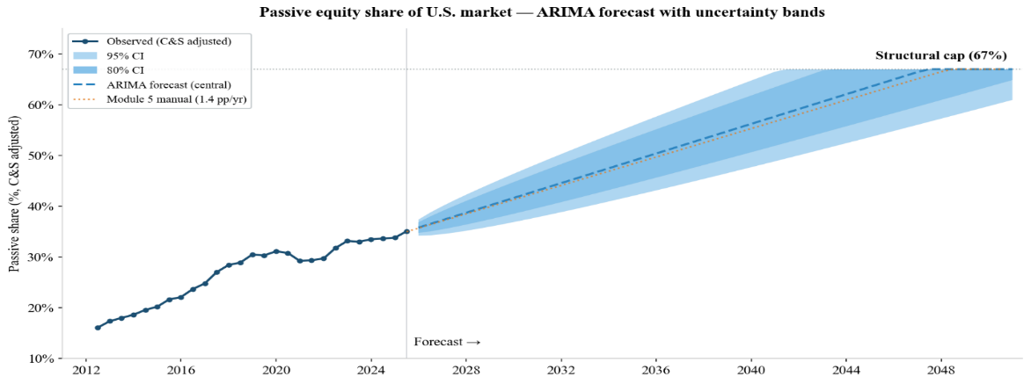
Augmented Dickey-Fuller tests confirm non-stationarity in levels (t = −1.65, p = 0.46) and stationarity in first differences (t = −3.71, p = 0.004), motivating first-differencing. The Akaike information criterion (AIC) selects ARIMA(0,1,0) with drift, the simplest specification. Passive share grows at approximately 0.46 percentage points per half-year plus noise, with no additional memory structure improving the forecast. Ljung-Box tests on the residuals show no autocorrelation at lags 4, 8, and 12 (all p > 0.18), and the one-step-ahead root mean square error is 1.93 percentage points. Appendix Table A5 reports the full model comparison. A 67% upper cap is imposed because without it the ARIMA trend projects passive shares beyond any plausible limit. The cap represents approximately double the current U.S. passive share (Chinco & Sammon, 2024) and is imposed as a modelling assumption. No empirical evidence pins the ceiling precisely, but double the current level is a generous upper bound. Beyond that point, the remaining active base is assumed thin enough that profit opportunities would slow further adoption. Appendix Figure A-2 compares the 67% cap with an 80% alternative.

Regression Evidence
The simulation projects forward. To validate the mechanism it models, a reduced-form ordinary least squares (OLS) regression tests whether the ageing population has historically been associated with equity mutual fund outflows. The dependent variable is quarterly net new cash flow into U.S. equity mutual funds (ICI Table 20, 2007:Q3 to 2024:Q3, 69 observations). The control variable is the contemporaneous S&P 500 quarterly return. Newey-West standard errors with four lags address serial correlation. Full results are reported in Section 5.6.

Global Sensitivity Analysis: Sobol Indices
The Monte Carlo simulation addresses the timing and probability of the crossover. Sobol variance decomposition isolates each parameter’s contribution to output variance, disentangling the competing mechanisms. The analysis uses Saltelli sampling (Saltelli et al., 2010) (N = 2,048) in four configurations. An overall analysis varies all seven parameters simultaneously, with equity returns represented as a single draw applied to all 26 years. A 32-parameter analysis disaggregates returns into 26 individual annual draws, testing whether aggregating the return sequence into a single parameter understates its contribution through path interactions. A 57-parameter analysis further disaggregates voluntary withdrawal multipliers into 26 annual draws alongside the 26 annual returns, testing whether the dominance of returns is an artefact of returns being the only parameter that varies per year. A conditional analysis fixes the annual return at 9.9% (the geometric equivalent used in deterministic scenarios) and varies only the six structural parameters, isolating the drivers of crossover timing once market noise is removed. All four analyses are evaluated at three horizons (2030, 2040, 2050).

Methodological Limitations
Several equilibrium channels remain outside the model. The DC return feedback adjusts returns when net flows turn negative, but does not apply to positive flows even when they fall below historical norms. This modestly overstates balance growth in the transition years before crossover. The historical return distribution reflects a period when DC equity inflows consistently exceeded outflows, and decomposing the DC channel’s contribution to those returns remains a causal identification problem addressed in Section 6.4. Returns are drawn independently each year. This omits the volatility clustering that would concentrate extreme returns and widen the crossover year distribution. Buyback yields, withdrawal multipliers, inflow shocks, and returns likely move together, particularly during recessions when all four deteriorate simultaneously. But the model draws them independently, likely understating tail risk. The Haddad χ = 3 parameter captures active investor response in the cross-section, but whether it remains stable under sustained aggregate outflows is untested.
On the outflow side, the model applies TDF glide-path equity allocations to all retirees. This understates near-term outflows from self-directed participants, as discussed in Section 3.2. The model also excludes the SECURE Act's 10-year rule for inherited accounts, IRA rollovers, and household debt-driven early withdrawals, all of which would add to outflow pressure.
On the inflow side, contributions are modelled as acyclical, likely understating the procyclicality of net flows during downturns. Nominal wage growth is held constant at 2.84% per year, and the 2.7% annual ownership convergence rate for older cohorts is derived from a short observation window from 2013 to 2022 (SCF).

Results
The simulation answers the research question in three stages. When does the demographic crossover occur? Does it survive corporate buybacks? And what is the resulting price impact? Sections 5.1 through 5.3 address these in sequence, while 5.4 through 5.6 test robustness, decompose variance, and validate the mechanism against historical data.

Flow Trajectories and Crossover Timing
Table 3 reports the 2025 baseline of the model.
Table 3
2025 Baseline Calibration
Metric | Value ($B)
Median inflow (Module 2) | 265.2
Median outflow (Module 3) | 188.3
Median demographic net flow | 77.2
Median buyback offset (Module 4) | 591.2
Note. Each column reports the independent median across 25,000 Monte Carlo paths. Net flow does not equal inflow minus outflow because the median of a difference is not the difference of medians. Buyback offset = net buyback yield × market capitalisation.
Both inflows and outflows grow over the projection horizon, but at different rates. Median inflows more than double from $265 billion to $579 billion by 2050, driven by nominal wage growth applied to salary-linked contributions. Median outflows nearly quadruple from $188 billion to $746 billion as the retirement-age population expands and account balances compound under positive returns (Figure 4).
Figure 4
Median inflow and outflow trajectories, 2025–2050. Inflows rise from $265 billion driven by wage growth while outflows accelerate from $188 billion as the retirement-age population expands, converging around 2040.
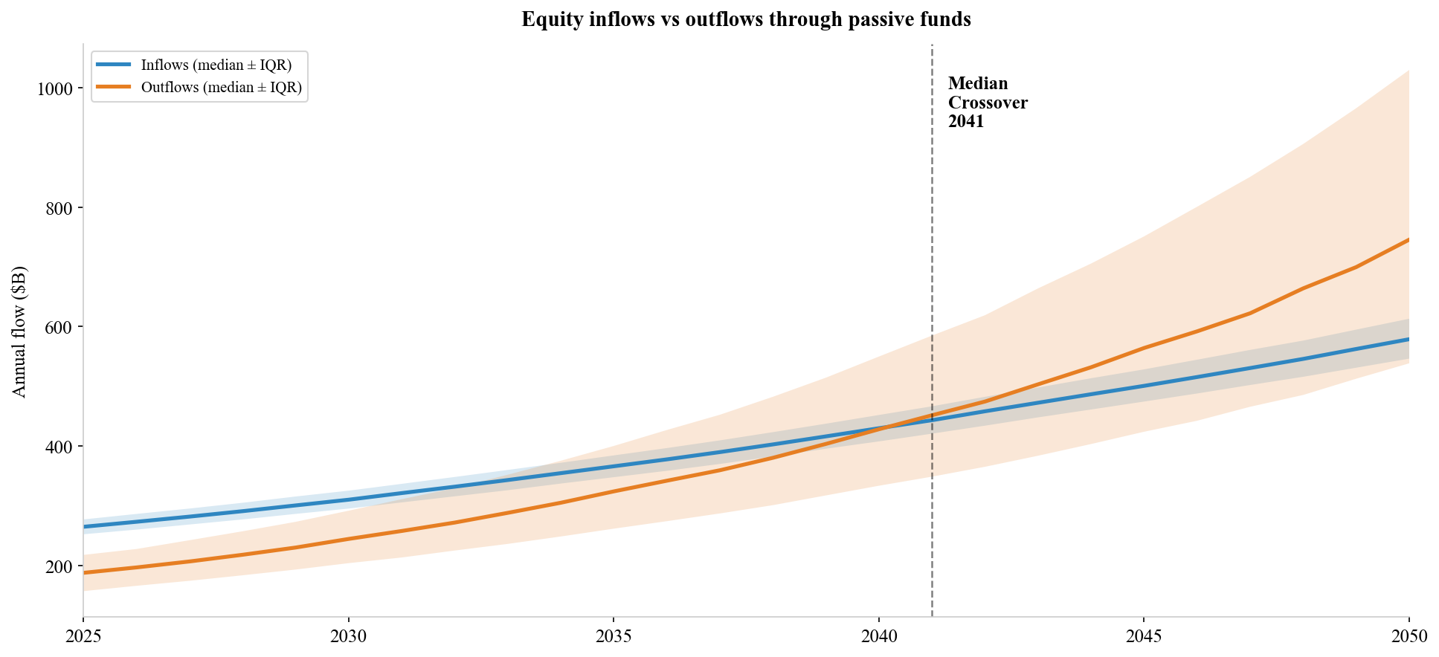
The model’s 2025 baseline positions the equity channel at a turning point, but the broader DC system has already crossed it. ICI data confirm this transition is underway at the aggregate level. Net cash flow from DC plans into equity mutual funds has been negative every year since 2019, running −$93 billion in 2019, −$241 billion in 2020, and −$228 billion in 2024, with no sign of reversal (ICI, 2025). The modelled TDF equity channel remains positive at +$77 billion in 2025, reflecting the conservative glide-path assumption. Under observed retiree equity allocations of approximately 50%, the sensitivity test in Section 5.4 produces immediate crossover. The base case projects the structural regime the system is converging toward as auto-enrolled cohorts replace self-directed retirees. It is not a description of current conditions.
The median net flow narrows from +$65 billion at 2030 to +$41 billion at 2035, to +$0.4 billion by 2040, and reaches −$167 billion by 2050. The median trajectory crosses zero between 2040 and 2041, consistent with the deterministic baseline (9.9% geometric mean, no volatility), which crosses between 2042 and 2043. The transition spans roughly a decade from the first signs of narrowing in the mid-2030s to sustained negative flows in the mid-2040s (Figure 5).
Return volatility can cause negative years to appear well before the structural crossover. Of 25,000 simulations, 22,804 (91.2%) experience at least one year of negative demographic net flows before 2050, with a median first occurrence in 2031 (interquartile range [IQR]: 2029 to 2036) (Figure 6). These early crossovers are largely temporary. Below-average return years that inflate outflows relative to inflows before the structural trend reasserts itself. By 2050 the worst 5% of paths show over $1 trillion in annual net selling, while the best 5% still show positive net flows.
Appendix Table A7 disaggregates by immigration scenario. The probability of at least one negative year ranges from 89.1% (high immigration) to 91.5% (low immigration), a 2.4 percentage point spread driven by the working-age population that determines inflow growth.
Figure 5
Fan chart of net demographic flows, 2025–2050. Shaded bands show 25th–75th and 5th–95th percentile ranges across 25,000 simulations. The widening range reflects compounding return uncertainty.
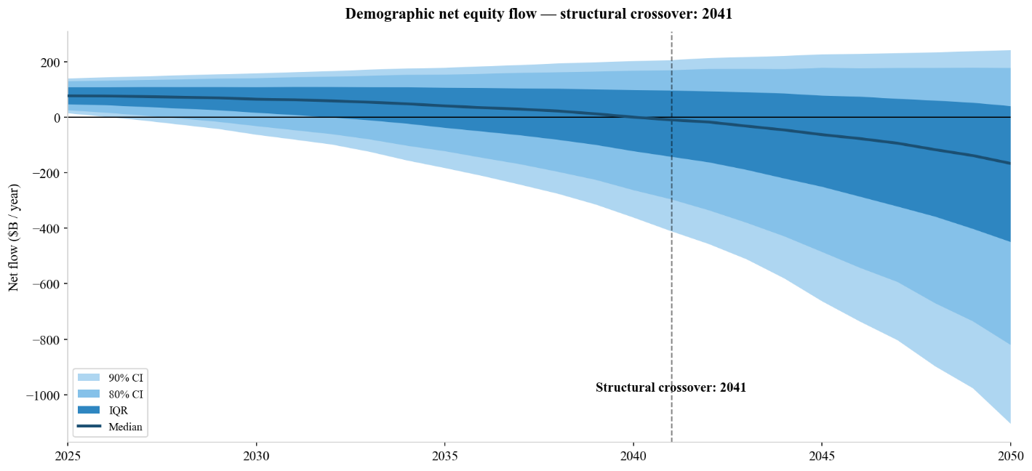
Figure 6
Distribution of first negative year across 25,000 simulations. Left panel: demographic flows only (91.2% of paths cross, median 2031). Right panel: with buyback offset (4.5% of paths cross, median 2041).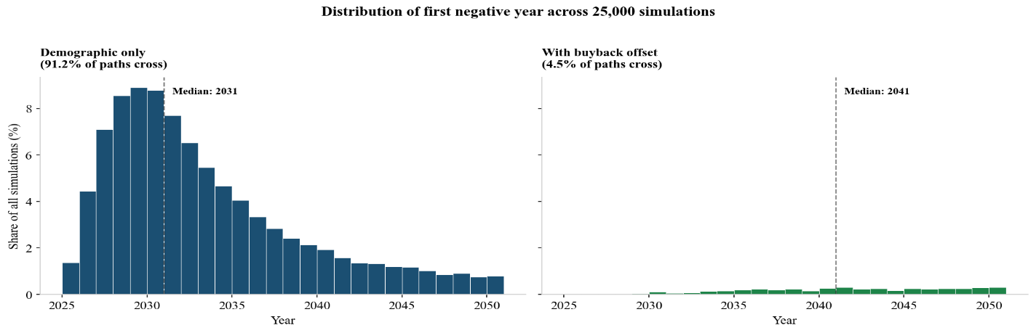

Buyback Offset
When corporate buybacks are included as an offsetting flow, the demographic crossover largely disappears. Only 1,115 of 25,000 paths (4.5%) experience at least one year of negative total net flows by 2050, with a conditional median first occurrence of 2041. The buyback-adjusted probability is 0.2% at 2030, 1.9% at 2040, and 4.5% at 2050 (Figure 7). Of the 1,115 paths that cross, 1,036 (93%) are positive again by 2050. The crossover is temporary in the vast majority of cases. Only 79 paths (0.3% of all simulations) are in sustained deficit at the end of the horizon.
Figure 7
Cumulative probability of demographic crossover by year. Dashed lines show the probability of at least one transient negative year; solid lines show permanently negative paths. Buybacks reduce the transient crossover probability from 91.2% to 4.5% and the permanent probability from 70% to 0.3% by 2050.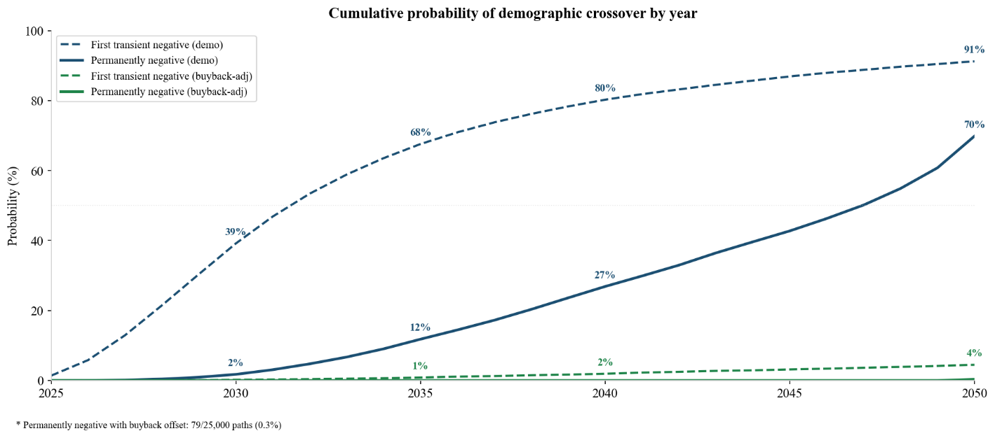

Price Impact
Demographic flows currently support equity prices. The median annual price impact is +0.57% of market capitalisation in 2025, declining to +0.29% at 2030 and +0.12% at 2035 as outflows grow. The median reaches essentially zero at 2040 (+0.001%) and turns negative by 2045 (−0.07%), reaching −0.11% by 2050. Under the central scenario, the effective multiplier grows from 5.0 in 2025 to approximately 6.0 by 2050 as the passive share rises from 35% to 67%. The IQR at 2050 spans −0.22% to +0.05% (Figure 8). Cumulatively, the demographic channel adds a median +$3.5 trillion in market capitalisation by 2040 before reversing to −$1.3 trillion by 2050 (IQR: −$15.1 trillion to +$9.1 trillion).
Figure 8
Annual price impact of demographic net flows on market capitalisation, 2025-2050. Positive values (pre-2040) indicate demographic support; negative values indicate drag. The median reaches -0.11% by 2050.
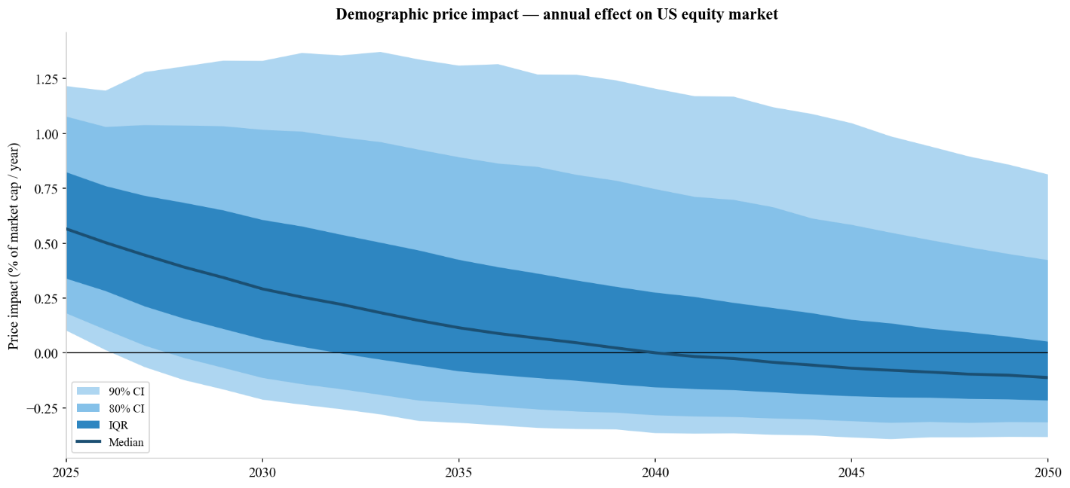

Scenario and Stress Analysis
A 3×3 scenario matrix combines three base multiplier assumptions (M = 3, 5, 7) with three passive share growth rates (1.0, 1.4, 1.8 pp/yr), using mid-scenario demographics and the 9.9% geometric mean return. All nine scenarios produce a demographic crossover between 2042 and 2043, with net flows at 2035 uniformly positive at +$51 billion. The 2050 price impact ranges from −0.050% (M = 3, 1.0 pp/yr) to −0.122% (M = 7, 1.8 pp/yr). The 67% passive cap compresses the high-growth scenarios toward the base case (Table 4).
A 30% market crash in 2030, 2035, or 2040 temporarily lifts net flows by reducing account balances and therefore RMD-driven outflows. The swing grows with the horizon, from +$40 billion for a 2030 crash to +$51 billion for 2035 and +$65 billion for 2040. This reflects the growing stock of retirement balances exposed to the crash (Figure 9).
Table 4
3×3 Scenario Matrix: 2050 Price Impact (% of Market Capitalisation)
Scenario | Crossover | Net 2035 | Net 2050 | Impact 2050
M = 3, 1.0 pp/yr | 2043 | $51.0B | −$100.2B | −0.050%
M = 3, 1.4 pp/yr | 2043 | $51.0B | −$100.2B | −0.052%
M = 3, 1.8 pp/yr | 2043 | $51.0B | −$100.2B | −0.052%
M = 5, 1.0 pp/yr | 2043 | $51.0B | −$99.9B | −0.083%
M = 5, 1.4 pp/yr | 2043 | $51.0B | −$99.9B | −0.087%
M = 5, 1.8 pp/yr | 2043 | $51.0B | −$99.8B | −0.087%
M = 7, 1.0 pp/yr | 2043 | $51.0B | −$99.5B | −0.115%
M = 7, 1.4 pp/yr | 2043 | $51.0B | −$99.5B | −0.122%
M = 7, 1.8 pp/yr | 2043 | $51.0B | −$99.4B | −0.122%
Note. Deterministic scenarios using 9.9% geometric mean return, mid-scenario demographics. M = base multiplier (Gabaix & Koijen, 2023). Passive share growth in percentage points per year. The 67% passive cap compresses high-growth scenarios toward the base case.

Figure 9
Crash stress test. Net demographic flow following a 30% crash in 2030, 2035, and 2040.
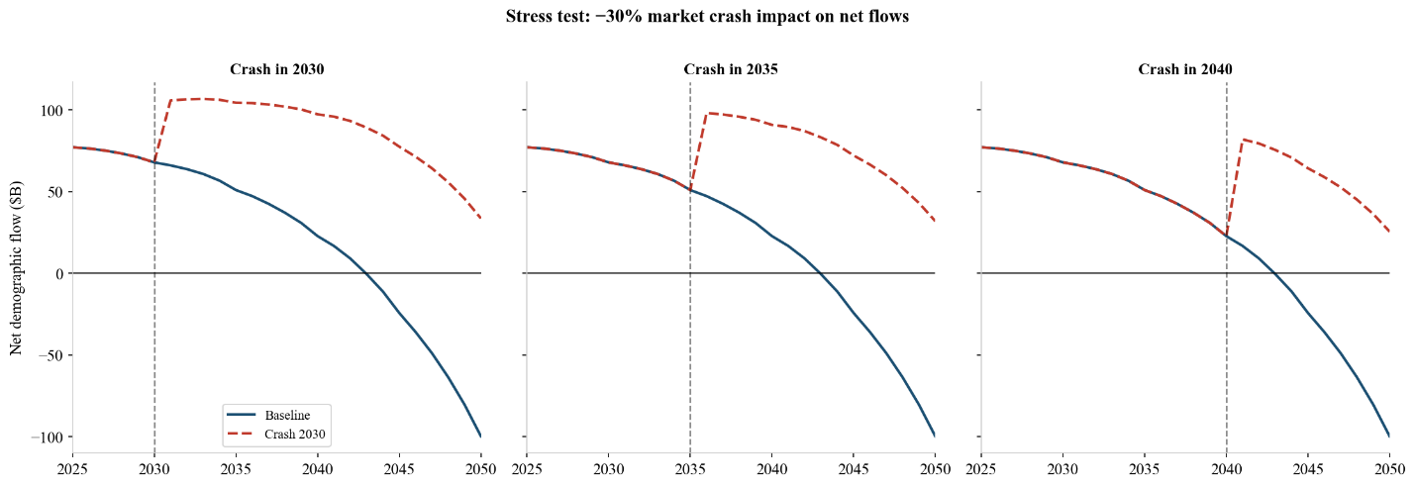
Recomputing price impact with a static M = 2 across all 25,000 paths tests whether the direction of the finding holds under a lower multiplier. Both M = 5 and M = 2 median trajectories are essentially zero at 2040 and permanently negative thereafter, reaching −0.112% and −0.047% respectively by 2050. The ratio is approximately 2.4× across the full horizon. The multiplier governs the scale of the drag, not its direction (Figure 10).
Two sensitivity tests apply observed retiree equity allocations with exponential decay over 2025 to 2045 to capture the gradual replacement of self-directed retirees by TDF-era cohorts. Under a 52% allocation, approximating observed Vanguard participant holdings of 52% at ages 65 to 69 and 45% at 70+ (Vanguard, 2025b), the crossover probability rises from 91.1% to 100% and the median first negative year advances from 2031 to 2025. A conservative 36% alternative (double the TDF allocation) produces a crossover probability of 99.7%. The decay assumes TDF-era cohorts gradually replace self-directed retirees over a 20-year window. If self-directed allocations persist longer, the elevated outflows would extend further (Figure 11).

Figure 10
Multiplier symmetry stress test comparing median price impact under M = 5 (base) and M = 2 (conservative). Both trajectories turn permanently negative after 2040, and the direction holds under both assumptions.
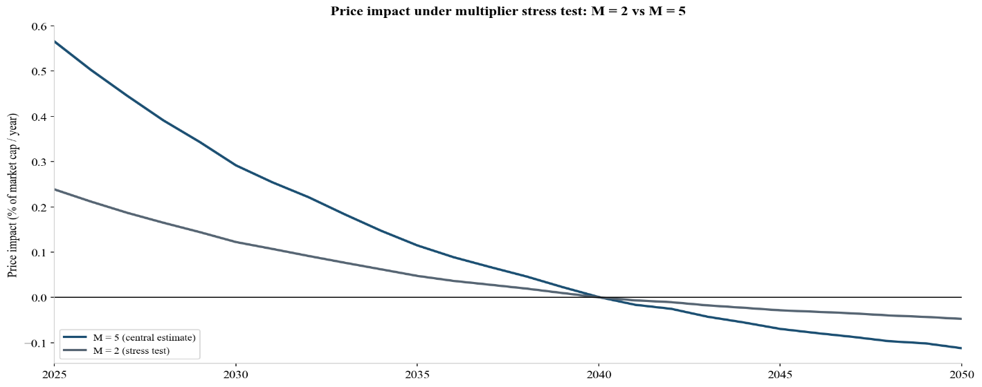
Figure 11
Outflow trajectories under three equity allocation assumptions: TDF baseline (18-21%), double TDF (36%), and observed allocation (52%), each decaying toward the TDF baseline over 2025-2045 as TDF-era cohorts replace self-directed retirees.
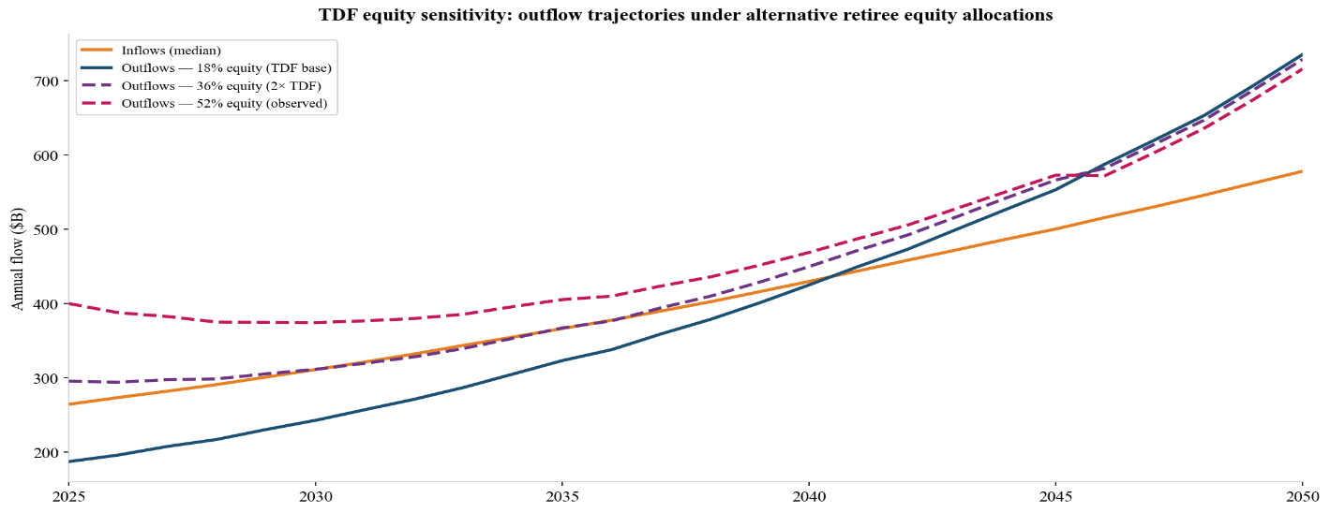

Variance Decomposition
Return uncertainty dominates net flow variance at all horizons. The 57-parameter Sobol analysis, which varies both returns and voluntary withdrawal multipliers at annual resolution, shows aggregate return ST rising from 0.541 at 2030 to 1.064 by 2050, while the voluntary withdrawal multiplier declines from ST = 0.375 to 0.099 (Figure 12).
Figure 12
57-parameter Sobol total-order indices for net flow at 2030, 2040, and 2050. Return dominates at all horizons, with voluntary withdrawal declining from comparable to negligible.
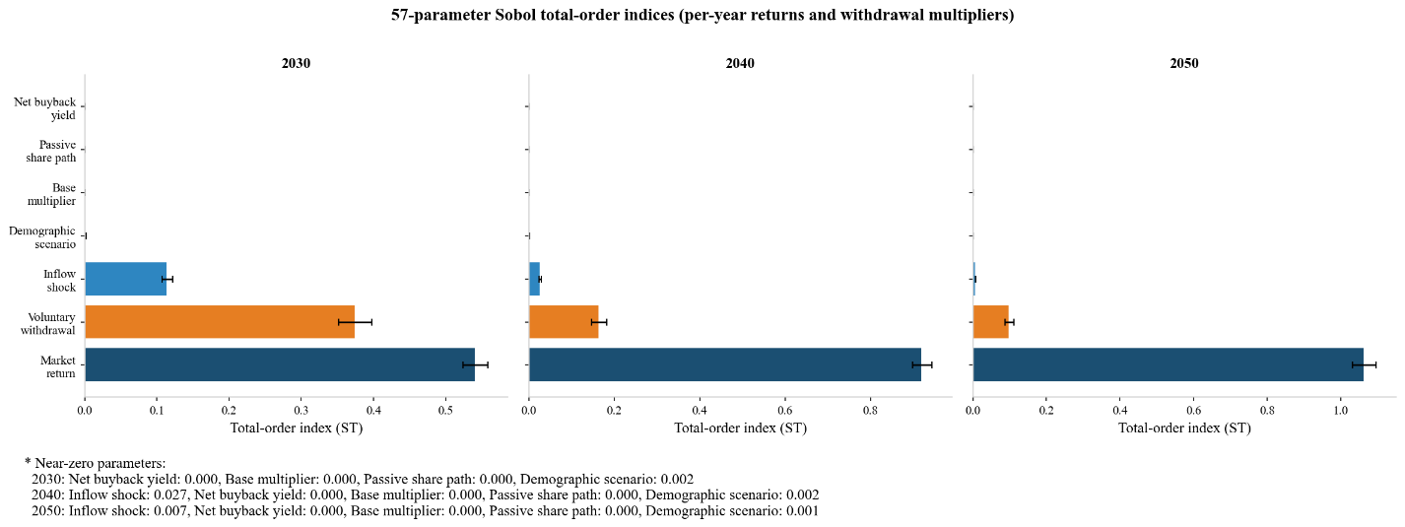
Disaggregating the return sequence into 26 independent annual draws produces virtually identical results (aggregate return ST = 1.064 versus 0.971 in the 7-parameter analysis), indicating that return dominance is structural rather than an artefact of parameter grouping.
With returns fixed at the 9.9% geometric mean, the conditional analysis isolates the structural drivers. The withdrawal multiplier dominates at every horizon (S1 = 0.680 at 2030, 0.590 at 2040, 0.624 at 2050), with inflow shock accounting for most of the remainder (Figure 13).
Figure 13
Conditional Sobol indices with return fixed at 9.9%. The voluntary withdrawal multiplier dominates crossover timing at every horizon once return noise is removed.
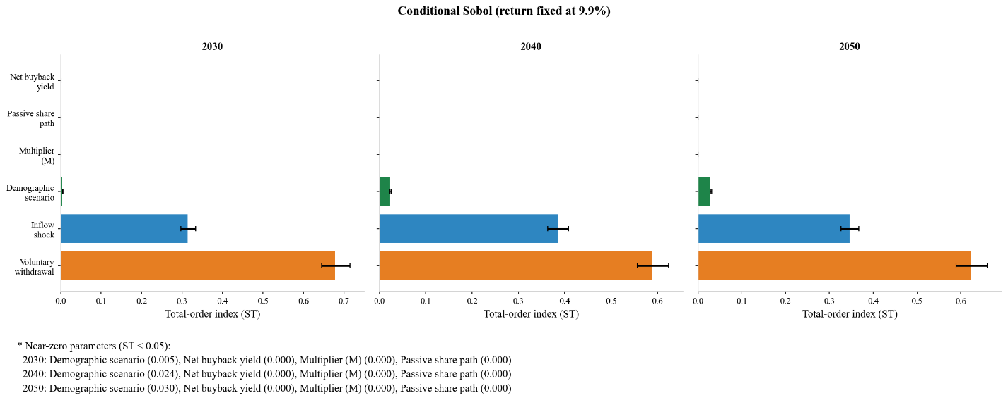
Figure 14
Sobol total-order indices for price impact at 2030, 2040, and 2050. The base multiplier M contributes 6-11% of variance despite near-zero influence on net flows.
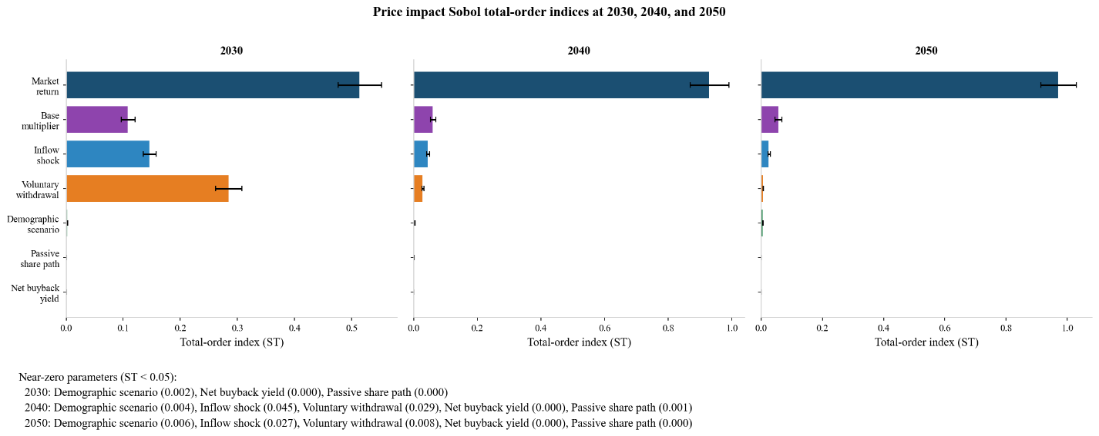
For price impact, the base multiplier M contributes 6% to 11% of variance despite near-zero influence on net flows. Return dominates at all horizons (Figure 14).

Regression Evidence
Independent of the simulation, the demographic channel should leave a trace in historical equity fund flows if the mechanism is real. An OLS regression of quarterly ICI Table 20 mutual fund equity net flows on population aged 65+ and S&P 500 returns (2007:Q3 to 2024:Q3, 69 observations) provides independent empirical support (Table 5; Figure 15). Newey-West standard errors with four lags address serial correlation identified by Breusch-Godfrey tests (p = 0.004). The coefficient on the 65+ population is β = −2.84 (p < 0.001): each additional million people aged 65+ is associated with a $2.84 billion quarterly reduction in equity mutual fund net flows. The S&P 500 return coefficient is positive but not statistically significant (β = 0.475, p = 0.331). Quarterly equity fund flows from retirement accounts do not track contemporaneous market performance, consistent with the behavioural inertia documented in the retirement savings literature.
Table 5
Regression Results: Quarterly Equity Mutual Fund Net Flows on Demographic Structure
Variable | β | SE (NW) | p | R² | N
Population 65+ (millions) | −2.839 | 0.481 | < .001
S&P 500 quarterly return | 0.475 | 0.487 | .331
Model fit |  |  |  | .374 | 69
Note. Dependent variable: quarterly net new cash flow into U.S. equity mutual funds ($B), ICI Table 20, 2007:Q3 to 2024: Q3. Newey-West standard errors with four lags. The coefficient on population 65+ indicates that each additional million people aged 65 and older is associated with a $2.84 billion quarterly reduction in equity mutual fund net flows.
Figure 15
Regression diagnostics for the preferred specification. Panels show actual versus fitted scatter, residuals over time, actual versus fitted time series, and residual distribution.
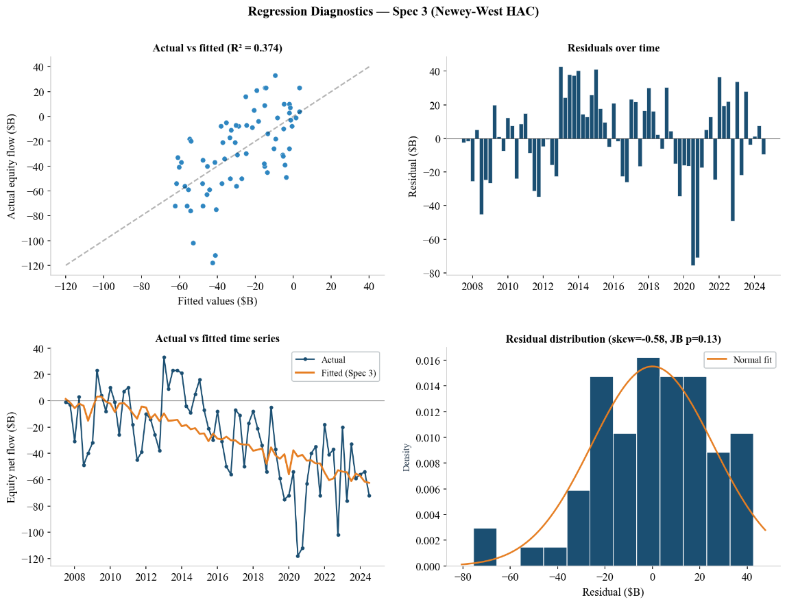
Appendix Table A6 reports alternative specifications. The coefficient is robust to lag structure (one-quarter lag, β = −2.89, p < 0.001) and the inclusion of a federal funds rate (FFR) control (β = −2.79, p < 0.001; FFR coefficient p = 0.857). To assess parameter stability, the regression was re-estimated on the pre-pandemic subsample (2007:Q3 to 2019:Q4, N = 50). The demographic coefficient remains significant at the 1% level (β = −2.10), though attenuated relative to the full-sample estimate of −2.84. This is consistent with the intensification of boomer-cohort outflows after 2020 as larger cohorts crossed the age-65 threshold (Figure 15).

Discussion
The structural crossover, the buyback dependency, and the price trajectory each raise questions that the numbers alone cannot answer. This section interprets the findings, tests them against counterarguments, and draws out what they imply.

The Central Finding
The asset meltdown predicted by the early demographic literature does not find support in the model’s projections. The annual price impact in 2050 is −0.11% of market capitalisation, less than one-hundredth of the long-run nominal equity return. Cumulatively from 2025, the demographic channel adds a median +$3.5 trillion to market capitalisation through 2040 before the cumulative effect reverses to −$1.3 trillion by 2050. The outcome aligns more closely with the temperate view of Geanakoplos et al. (2004) than with the meltdown hypothesis. Poterba (2001) concluded that any relationship between demographic structure and equity returns is at most modest. That is consistent with this result, and a drag of this magnitude within a return distribution with 19.5% annual standard deviation would be difficult to detect in the time-series regressions he employed.
Corporate buybacks, which reduce outstanding share supply and mechanically support prices, absorb the structural crossover in 95.5% of simulations, and of the 4.5% that temporarily cross, nearly all revert. Only 0.3% of all simulations show sustained negative total net flows by 2050. The buyback contribution at baseline ($591 billion) is nearly eight times the demographic surplus ($77 billion). The offset is procyclical, contracting 30% to 50% in recessions, but at the projected scale of the demographic drag the buffer exceeds the projected deficit under normal conditions.
The drag is modest in any given year but persistent. It is driven by RMD schedules and population structure, not by market conditions (S&P 500 return coefficient p = 0.331), and does not self-correct. This answers the research question posed in the Introduction. The crossover does occur, but gradually and with modest price consequences.

Robustness and Sensitivity
Three objections deserve direct engagement. The first concerns multiplier symmetry. The Gabaix-Koijen estimate of M = 5 was derived from a sample period (2001 to 2020) dominated by inflows into passive funds. Whether the same multiplier applies to sustained outflows is an open question. Active investors might buy dips more aggressively than they sell rallies, which would imply a lower effective multiplier during outflow periods. The M = 2 stress test addresses this. Both the M = 5 and M = 2 trajectories are essentially zero at 2040 and permanently negative thereafter, reaching −0.112% and −0.047% by 2050. The multiplier governs scale, not direction. The asymmetry could also run the other way. Large-cap stocks have the highest passive ownership and the lowest demand elasticity (Gabaix & Koijen, 2023; Haddad et al., 2025), potentially making the outflow multiplier higher than the inflow-era estimate.
The second is more subtle. The Sobol analysis shows return dominance at every horizon (ST = 1.064 at 2050), which could be read as evidence that demographics do not matter. Sobol indices, however, measure what drives output uncertainty, not what drives the output level. The demographic trend shifts net flows downward in every simulation. Return uncertainty determines how large the shift becomes, not whether it exists. Under the deterministic baseline (9.9% geometric mean), the crossover occurs between 2042 and 2043 regardless. The conditional Sobol confirms that, once return uncertainty is removed, crossover timing depends primarily on the voluntary withdrawal multiplier.
A third objection is that markets will equilibrate. If demographic selling depresses prices, value investors will absorb the supply. This general-equilibrium response is real but limited in this context for three reasons. First, the flows modelled here are mechanical. RMDs do not respond to price levels, and TDF contributions do not adjust to expected returns (Giglio et al., 2021, documenting weak belief-to-portfolio pass-through). Second, the equilibrium response operates through the active investor base, but the Haddad et al. (2025) pass-through parameter already captures the degree to which active investors offset flow-driven price displacements (approximately one-third at current passive ownership). Third, the projected drag is small enough relative to annual return volatility that the signal may be indistinguishable from noise for decades. That would delay any corrective response.

Implications
The annual drag is negligible in isolation, but two features give it practical relevance. First, it concentrates. Demographic outflows through index funds sell in proportion to market-capitalisation weights, and the largest constituents carry the highest passive ownership and lowest demand elasticity (Gabaix & Koijen, 2023; Haddad et al., 2025). The aggregate number understates the pressure on individual large-cap names. Chinco and Sammon (2024) report that standard passive ownership varies by a factor of fifteen between S&P 500 and Russell 2000 constituents, and their correction for quasi-passive strategies applies proportionally across indices. The aggregate model used here does not capture this within-market heterogeneity. Stock-level analysis is a priority extension (Section 6.5). Second, the finding depends entirely on buybacks continuing at historical rates. Any policy or cyclical shock that cuts buyback volumes would expose the underlying demographic imbalance directly. The projected drag is a baseline, not a worst case.
The policy dimension is concrete but limited. A sensitivity test halving the net buyback yield from 0.98% to 0.49% increases the total-flow crossover probability from 4.3% to 5.5%, because even halved buybacks still exceed the demographic deficit through most of the projection horizon. The 1% excise tax on corporate buybacks, enacted in 2022 and proposed for increase in subsequent budget discussions, would need to reduce buyback volumes by substantially more than half before demographic sales become a market-level concern.
For TDF providers, increasing international diversification within glide paths would distribute selling pressure across markets. For policymakers, the systemic role of buybacks warrants consideration before expanding the buyback excise tax. And for long-horizon institutional investors, return assumptions built on the inflow-dominated era may not fully capture the transition ahead. More broadly, understanding demographic market pressure requires not better return forecasts but better data on decumulation behaviour. Current knowledge in this domain relies on survey data rather than administrative records.

Limitations
Several forces excluded from the model would increase outflow pressure if incorporated. The SECURE Act’s 10-year rule for inherited retirement accounts (effective 2020, with first liquidation deadlines in 2030) creates a second outflow channel as heirs draw down inherited balances. Household debt-driven early withdrawals and the tax incentive to liquidate tax-deferred holdings before taxable ones (step-up in basis) both accelerate equity selling beyond what RMD tables alone predict. U.S. total household debt has risen from approximately $12.4 trillion in 2006 to $18.8 trillion by late 2025 (Bloomberg), with credit card debt alone reaching a record $1.28 trillion. This increases the likelihood that debt-constrained households draw down retirement savings earlier than the model assumes. These omissions mean the projection is a lower bound on total demographic equity outflows.
The model uses mean retirement account balances from the SCF. The conditional mean substantially exceeds the conditional median across all age groups in the SCF (Federal Reserve Board, 2022). The wealthiest households drive a disproportionate share of total withdrawals. The model correctly estimates aggregate outflows because mean balances, weighted by population, recover the total dollar pool, but masks heterogeneity across the wealth distribution.
The price impact is not fed back into equity returns within the simulation. The projected drag of approximately 11 basis points per year is small relative to the 19.5% return standard deviation, but over 25 years the cumulative omission could modestly overstate balance growth in the later projection years. Decomposing historical returns to isolate the DC flow contribution would allow estimation of this feedback bias. It is the most direct extension of the current work.
Parker et al. (2023) document that TDF rebalancing offsets roughly 10% of aggregate trend-chasing flows, which dampens intra-year volatility in both directions. The simulation operates at annual resolution and does not capture this within-year smoothing, which would slightly reduce the variance of net flows without altering the trajectory.
IRA balances are implicitly captured in the outflow estimates because the SCF reports combined retirement account holdings (401(k) and IRA), and RMD rules apply identically to both account types. What the model excludes is a separate IRA inflow channel, since IRA contributions are independent of employer-sponsored DC plans. IRA domestic equity fund net flows were −$104 billion in 2024 (ICI, 2025), confirming that the same structural pattern of demographic outflows extends beyond DC plans.
The model’s TDF glide-path assumption understates near-term outflows relative to observed retiree equity allocations, as documented in Section 5.4.

Future Work
The simulation stops at 2050, but the demographic mechanism does not. The millennial generation, currently the largest cohort of active 401(k) contributors, will start hitting RMD age in the 2060s and 2070s. That adds a second wave that may be larger in real terms as their balances compound for additional decades, potentially intensifying the drag beyond what the current 2050 horizon captures.
Future work could go in three directions. First, taxable account flows for a broader measure of retirement equity selling. Second, a stock-level analysis using the Haddad et al. framework to identify where demographic pressure concentrates. Third, the fixed-income side of the TDF balance sheet. At the retirement stage, TDFs allocate roughly 60% to 70% to bonds. In dollar terms, the bond outflow channel is larger than the equity channel modelled here. These outflows arrive as governments face elevated borrowing needs, with U.S. federal debt-to-GDP above 120%. Whether demographic bond selling and fiscal issuance pulling in the same direction produces upward pressure on yields, and whether that spills into equity valuations through higher discount rates, are questions the equity-only framework cannot answer

Conclusion
This study asked when and whether U.S. retirement account outflows will overtake inflows into passive equity index funds, and what the resulting price impact would be. The answer is that outflows do eventually dominate, but gradually. The median net flow trajectory crosses zero between 2040 and 2041, with intermittent negative years beginning a decade earlier as return volatility causes temporary crossovers. Corporate buybacks prevent sustained negative flows in the vast majority of simulations, though the offset weakens in the conditions where demographic pressure is most acute.
The price consequence is small, less than one-hundredth of the long-run equity return by 2050, and the transition plays out over decades, not years.
The main contribution is the five-module pipeline itself. No prior study has combined cohort-level retirement flow accounting with wage-adjusted inflows, the Gabaix-Koijen multiplier, the Haddad et al. time-varying pass-through, and global sensitivity analysis into a single projection framework. The Sobol decomposition reveals that the voluntary withdrawal multiplier is the most important structural driver once return uncertainty is removed. The implication is that retirement withdrawal behaviour, not market forecasting, deserves closer attention.
These findings are relevant for TDF providers designing glide paths, for policymakers weighing RMD schedules and buyback taxation, and for institutional investors building long-horizon return assumptions.
The projection is partial-equilibrium and covers only the DC equity channel. Several excluded forces, including inherited account liquidations and household debt-driven withdrawals, would increase outflow pressure if modelled. The clearest next steps involve the fixed-income side of the TDF balance sheet, stock-level passive ownership heterogeneity, and international retirement flows.

References
Abel, A. B. (2001). Will bequests attenuate the predicted meltdown in stock prices when baby boomers retire? The Review of Economics and Statistics, 83(4), 589–595. https://doi.org/10.1162/003465301753237678
Aipinas, A. (2026). capstone-demographic-flows [Source code and data]. GitHub. https://github.com/Aipinas/capstone-demographic-flows
Bloomberg L.P. (2025). Semi-annual passive equity AUM [Data set]. Bloomberg Terminal.
Brooks, R., & Lamont, O. A. (2004). Comments and discussion. Brookings Papers on Economic Activity, 2004(1), 308–325.
Bureau of Labor Statistics. (2024). Employee Benefits in the United States, March 2024. U.S. Department of Labor.
Bureau of Labor Statistics. (2025). Employment Cost Index: Historical listing. U.S. Department of Labor.
Chinco, A., & Sammon, M. (2024). The passive ownership share is double what you think it is. Journal of Financial Economics, 157, 103860. https://doi.org/10.1016/j.jfineco.2024.103860
Damodaran, A. (2025). Historical returns on stocks, bonds and bills: 1928–2024. Stern School of Business, New York University. https://pages.stern.nyu.edu/~adamodar/
FactSet Research Systems. (2025). FT Wilshire 5000 market capitalisation [Data set]. FactSet.
Federal Reserve Board. (2022). Survey of Consumer Finances. Board of Governors of the Federal Reserve System.
Federal Reserve Board. (2025). Enhanced Financial Accounts: Equity issuance and retirement (Z.1, Table F.103). Board of Governors of the Federal Reserve System.
Gabaix, X., & Koijen, R. S. J. (2023). In search of the origins of financial fluctuations: The inelastic markets hypothesis. NBER Working Paper No. 28967.
Geanakoplos, J., Magill, M., & Quinzii, M. (2004). Demography and the long-run predictability of the stock market. Brookings Papers on Economic Activity, 2004(1), 241–326.
Giglio, S., Maggiori, M., Stroebel, J., & Utkus, S. (2021). Five facts about beliefs and portfolios. American Economic Review, 111(5), 1481–1522. https://doi.org/10.1257/aer.20200243
Haddad, V., Huebner, P., & Loualiche, E. (2025). How competitive is the stock market? Theory, evidence from portfolios, and implications for the rise of passive investing. American Economic Review, 115(3), 975–1018. https://doi.org/10.1257/aer.20230505
Internal Revenue Service. (2024). Publication 590-B: Distributions from Individual Retirement Arrangements (IRAs). U.S. Department of the Treasury.
Investment Company Institute. (2025). 2025 Investment Company Fact Book (65th ed.). Investment Company Institute.
Madrian, B. C., & Shea, D. F. (2001). The power of suggestion: Inertia in 401(k) participation and savings behavior. The Quarterly Journal of Economics, 116(4), 1149–1187. https://doi.org/10.1162/003355301753265543
Mitchell, M., Pedersen, L. H., & Pulvino, T. (2007). Slow moving capital. American Economic Review, 97(2), 215–220. https://doi.org/10.1257/aer.97.2.215
Modigliani, F., & Brumberg, R. (1954). Utility analysis and the consumption function: An interpretation of cross-section data. In K. K. Kurihara (Ed.), Post Keynesian Economics (pp. 388–436). Rutgers University Press.
Morningstar. (2025). 2025 Target-Date Strategy Landscape. Morningstar Research Services.
Parker, J. A., Schoar, A., & Sun, Y. (2023). Retail financial innovation and stock market dynamics: The case of target date funds. The Journal of Finance, 78(5), 2673–2723. https://doi.org/10.1111/jofi.13258
Pension Protection Act of 2006, Pub. L. No. 109–280, 120 Stat. 780.
Poterba, J. M. (2001). Demographic structure and asset returns. The Review of Economics and Statistics, 83(4), 565–584. https://doi.org/10.1162/003465301753237650
Poterba, J. M., Venti, S. F., & Wise, D. A. (2011). The composition and drawdown of wealth in retirement. Journal of Economic Perspectives, 25(4), 95–118. https://doi.org/10.1257/jep.25.4.95
S&P Dow Jones Indices. (2024). S&P 500 Buyback Quarterly Reports [Data set]. S&P Global.
Sabbatucci, R., Tamoni, A., & Xiao, S. (2025). Shifting from active to passive: How retirement plans impact equity prices. Swedish House of Finance Research Paper No. 23–08.
https://www.icpmnetwork.com/wp-content/uploads/2025/09/7.Shifting-From-Active-to-Passive-How-Retirement-Plans-Impact-Equity-Prices.pdf
Saltelli, A., Annoni, P., Azzini, I., Campolongo, F., Ratto, M., & Tarantola, S. (2010). Variance based sensitivity analysis of model output. Computer Physics Communications, 181(2), 259–270. https://doi.org/10.1016/j.cpc.2009.09.018
SECURE 2.0 Act of 2022, Pub. L. No. 117–328, Div. T, 136 Stat. 5272.
U.S. Census Bureau. (2023). 2023 National Population Projections. U.S. Department of Commerce.
Vanguard. (2025a). How America Retires 2025. The Vanguard Group.
Vanguard. (2025b). How America Saves 2025. The Vanguard Group.

Appendices

Appendix A: Data Sources and Parameter Tables
The tables below report the calibrated parameters for each module. All processing code and raw data are available in the project’s GitHub repository (github.com/Aipinas/capstone-demographic-flows).
Table A1
Module 2: Inflow Parameters
Age Group | Salary ($) | Partic. | Contrib. | TDF US Eq. | Emp. Ratio | $/Worker
<25 | $39,979 | 54.0% | 9.3% | 53.6% | $1,076 | <25
25–34 | $59,800 | 82.0% | 11.1% | 53.5% | $2,912 | 25–34
35–44 | $72,020 | 86.0% | 11.7% | 53.0% | $3,841 | 35–44
45–54 | $71,604 | 87.0% | 12.3% | 44.4% | $3,402 | 45–54
55–64 | $68,744 | 87.0% | 13.8% | 35.6% | $2,938 | 55–64
65+ | $62,036 | 79.0% | 14.6% | 18.5% | $1,324 | 65+
Note. Sources: BLS National Compensation Survey (2024), Vanguard How America Saves (2025b), Vanguard TDF prospectuses. Plan access rate: 72% (BLS NCS). Employment-to-population ratios: 28.2% (<25), 65.3% (25–34), 66.4% (35–44), 63.2% (45–54), 48.6% (55–64), 9.3% (65+). Nominal wage growth: 2.84%/year (BLS Employment Cost Index, 2001–2025).
Table A2
Module 3: Outflow Parameters
Age Group | Balance ($K) | Own. % | Eff. Rate | TDF Eq. % | RMD Rate | Per-Cap Eq ($K)
55–59 | 537.6 | 57.0% | 1.00% | 35.6% | — | 1.09
60–64 | 537.6 | 57.0% | 2.00% | 30.0% | — | 1.84
65–72 | 609.2 | 51.0% | 3.00% | 21.0% | — | 1.96
73–74 | 609.2 | 51.0% | 3.85% | 19.5% | 3.85% | 2.33
75–84 | 462.4 | 42.0% | 4.95% | 18.0% | 4.95% | 1.73
85–94 | 462.4 | 42.0% | 8.20% | 18.0% | 8.20% | 2.87
95+ | 462.4 | 42.0% | 12.82% | 18.0% | 12.82% | 4.48
Note. Sources: Federal Reserve SCF (2022), IRS Publication 590-B Table III, Vanguard How America Retires (2025a), Vanguard TDF prospectuses. Effective rate = max(RMD rate, voluntary rate). Voluntary rates: 1% (55–59), 2% (60–64), 3% (65–72); above 73 RMD binds. Ownership convergence: 2.7%/year. Dashes indicate voluntary rate exceeds RMD.

Table A3
Module 4: Buyback Calibration
Parameter | Value
Net buyback yield (mean) | 0.98% of market capitalisation
Net buyback yield (std dev) | 0.72%
Source | Federal Reserve Z.1 Table F.103, 2020–2024
Procyclical cut (return < −10%) | −30% (mild recession)
Procyclical cut (return < −20%) | −50% (severe recession)
Cross-validation | S&P Dow Jones Quarterly Buyback Reports
Note. Calibrated from Federal Reserve Z.1 Enhanced Financial Accounts (Table F.103), 2020–2024.
Table A4
Module 5: Price Impact Calibration
Parameter | Value
Base multiplier M | U(3, 7); central estimate 5 (Gabaix & Koijen, 2023)
Passive share, 2025 baseline | 35% (Bloomberg, scaled ×1.583 per Chinco & Sammon, 2024)
ARIMA(0,1,0) drift | +0.46 pp per half-year
Passive share cap | 67%
Haddad et al. strategic response χ | 3
Pass-through at 2025 | 0.34
Pass-through at 2050 | 0.50
Effective multiplier at 2050 | ≈6.0
Note. Pass-through from Haddad et al. (2025): 1 / (1 + χ × active share). Passive share scaled by 1.583 to align with Chinco & Sammon (2024).

Table A5
ARIMA Model Comparison
Model | AIC | BIC | Log-L
ARIMA(0,1,0) with drift | 42.9 | 45.4 | −19.5
ARIMA(1,1,0) with drift | 43.3 | 47.0 | −18.6
ARIMA(0,1,1) with drift | 43.6 | 47.4 | −18.8
Note. Referenced in §4.3. Fitted to 27 semi-annual observations. Best AIC: ARIMA(0,1,0) with drift +0.46 pp/half-year. RMSE: 1.93 pp.

Table A6
Regression Robustness
Specification | β pop65+ | SE | p | R² | N
(a) Base | −2.839 | 0.481 | < .001 | .374 | 69
(b) Lagged pop | −2.892 | 0.505 | < .001 | .373 | 68
(c) FFR control | −2.793 | 0.645 | < .001 | .374 | 69
Note. Referenced in §5.6. Newey-West SE with four lags. FFR coefficient in spec (c): β = −0.422, p = .857.

Table A7
Immigration Scenario Disaggregation
Scenario | Crossover Probability | Median Crossover Year
Mid | 90.6% | 2031
High immigration | 89.1% | 2031
Low immigration | 91.5% | 2031
Note. Referenced in §4.1 and §5.1. Spread: 2.4 pp. High immigration produces lowest crossover probability (larger working-age population generates higher inflows).

Table A8
IRS Uniform Lifetime Table III: Required Minimum Distribution Divisors by Age
Age | Divisor | RMD % |  | Age |  | Divisor |  | RMD % |  |  |  | Age |  | Divisor |  |  | RMD %
72 | 27.4 | 3.65% |  | 89 | 12.9 |  | 7.75% |  |  |  | 106 |  | 4.3 |  |  | 23.26%
73 | 26.5 | 3.77% |  | 90 | 12.2 |  | 8.20% |  |  |  | 107 |  | 4.1 |  |  | 24.39%
74 | 25.5 | 3.92% |  | 91 | 11.5 |  | 8.70% |  |  |  | 108 |  | 3.9 |  |  | 25.64%
75 | 24.6 | 4.07% |  | 92 | 10.8 |  | 9.26% |  |  |  | 109 |  | 3.7 |  |  | 27.03%
76 | 23.7 | 4.22% |  | 93 | 10.1 |  | 9.90% |  |  |  | 110 |  | 3.5 |  |  | 28.57%
77 | 22.9 | 4.37% |  | 94 | 9.5 |  | 10.53% |  |  |  | 111 |  | 3.4 |  |  | 29.41%
78 | 22 | 4.55% |  | 95 | 8.9 |  | 11.24% |  |  |  | 112 |  | 3.3 |  |  | 30.30%
79 | 21.1 | 4.74% |  | 96 | 8.4 |  | 11.90% |  |  |  | 113 |  | 3.1 |  |  | 32.26%
80 | 20.2 | 4.95% |  | 97 | 7.8 |  | 12.82% |  |  |  | 114 |  | 3 |  |  | 33.33%
81 | 19.4 | 5.15% |  | 98 | 7.3 |  | 13.70% |  |  |  | 115 |  | 2.9 |  |  | 34.48%
82 | 18.5 | 5.41% |  | 99 | 6.8 |  | 14.71% |  |  |  | 116 |  | 2.8 |  |  | 35.71%
83 | 17.7 | 5.65% |  | 100 | 6.4 |  | 15.63% |  |  |  | 117 |  | 2.7 |  |  | 37.04%
84 | 16.8 | 5.95% |  | 101 | 5.9 |  | 16.95% |  |  |  | 118 |  | 2.5 |  |  | 40.00%
85 | 16 | 6.25% |  | 102 | 5.5 |  | 18.18% |  |  |  | 119 |  | 2.3 |  |  | 43.48%
86 | 15.2 | 6.58% |  | 103 | 5.2 |  | 19.23% |  |  |  | 120 |  | 2 |  |  | 50.00%
87 | 14.4 | 6.94% |  | 104 | 4.9 |  | 20.41%
88 | 13.7 | 7.30% |  | 105 | 4.6 |  | 21.74%
Note. RMD % = 1 / Divisor × 100. Account holders must withdraw at least this percentage of their tax-deferred retirement balance each year starting at age 73 (age 75 for those born after 1959 under SECURE 2.0). Source: IRS Publication 590-B, Table III (2024).

Table A9
Vanguard Target-Date Fund Glide Path: Equity Allocations by Vintage
Vintage | Approx. Age | U.S. Equity % | Intl Equity % | Total Equity % | Bond %
2070 | 20 | 53.6% | 37.7% | 91.3% | 8.7%
2065 | 25 | 53.5% | 37.9% | 91.4% | 8.6%
2060 | 30 | 53.5% | 37.9% | 91.4% | 8.6%
2055 | 35 | 53.5% | 37.9% | 91.4% | 8.6%
2050 | 40 | 53.0% | 37.6% | 90.6% | 9.4%
2045 | 45 | 48.7% | 34.7% | 83.4% | 16.6%
2040 | 50 | 44.4% | 31.4% | 75.8% | 24.2%
2035 | 55 | 40.0% | 28.2% | 68.2% | 31.8%
2030 | 60 | 35.6% | 24.7% | 60.3% | 39.7%
2025 | 65 | 29.6% | 20.3% | 49.9% | 50.1%
2020 | 70 | 20.9% | 14.5% | 35.4% | 64.6%
Income | 75+ | 18.5% | 12.9% | 31.4% | 68.6%
Note. Approximate age assumes retirement at 65 in 2025. The model uses U.S. Equity % as the TDF equity share parameter. Source: Vanguard Target Retirement Fund prospectuses (2025b).

GitHub repository: github.com/Aipinas/capstone-demographic-flows

Appendix B: Primer on Financial Concepts
This appendix collects brief definitions of the financial products and institutions that appear throughout the main text. It is written for readers who do not work in finance and may not be familiar with these concepts.
Stocks and bonds. A stock represents a fractional ownership stake in a company. Stock prices move based on supply, demand, and investor expectations about future company earnings. A bond, by contrast, is essentially a loan: the investor lends money to a government or corporation in exchange for regular interest payments and the return of the principal at maturity. Stocks tend to be more volatile than bonds but have historically delivered higher returns over the long run. A market index, such as the S&P 500, tracks the aggregate value of a group of stocks, each weighted by its market capitalisation (share price multiplied by total shares outstanding).
Defined-contribution plans and the 401(k). The 401(k) is the most common defined-contribution (DC) retirement plan in the United States. Participants set aside a percentage of their pre-tax wages each pay period, and many employers match a portion of the contribution. The money goes into mutual funds or similar investment vehicles chosen by the participant. Unlike older DB pension plans, which guaranteed a fixed monthly payment after retirement, DC plans shift the investment risk to the individual. The transition from DB to DC plans has been the dominant trend in American retirement policy over the past four decades.
Automatic enrolment and target-date funds. Under automatic enrolment, new employees are placed into their employer’s 401(k) plan by default unless they actively opt out. The SECURE 2.0 Act of 2022 made this mandatory for most new plans. The default investment for auto-enrolled participants is typically a target-date fund (TDF). A TDF is a single fund that holds a mix of stocks and bonds, and that mix changes over time according to a schedule called a glide path. A young worker’s TDF might hold 90% equities; by the time that worker approaches retirement, the fund gradually shifts to roughly 30% equities and 70% bonds. All of this happens automatically, with no action required from the participant.
Required minimum distributions. U.S. tax law requires that holders of tax-deferred retirement accounts (401(k)s and IRAs) begin withdrawing a minimum amount each year starting at age 73, or 75 for those born after 1959 under SECURE 2.0. The required percentage increases with age, following IRS tables. When an RMD is taken from an account invested in an index fund, the fund custodian sells shares automatically to generate the cash. The result is a steady, predictable, demographically driven outflow of money from equity markets.
Passive investing and index funds. An index fund builds a portfolio that mirrors a market index (such as the S&P 500) by holding the same stocks in the same proportions. Unlike actively managed funds, an index fund does not try to pick winners or avoid losers. It simply holds whatever is in the index. Because index funds do not trade in response to company-specific news, they are described as price-insensitive. The share of U.S. equities held through passive vehicles has grown from near zero in the early 1990s to roughly one-third today, which has substantially reduced the aggregate responsiveness of equity demand to price changes.
The inelastic markets hypothesis. In a perfectly elastic market, a large buy or sell order would barely move prices because other investors would quickly step in to absorb the flow. The inelastic markets hypothesis, proposed by Gabaix and Koijen (2023), argues that the U.S. stock market is far less elastic than standard models assume. Their central estimate is that one dollar of net flow moves aggregate market capitalisation by approximately five dollars. The logic is simple: a large and growing share of equity is held by investors who do not trade in response to price signals (index funds, pension funds, foreign central banks, inattentive households). When money flows into or out of these passive vehicles, relatively few active investors remain to absorb it, so prices move by more than the flow itself.

Appendix Figures

Figure A-1: Monte Carlo Convergence
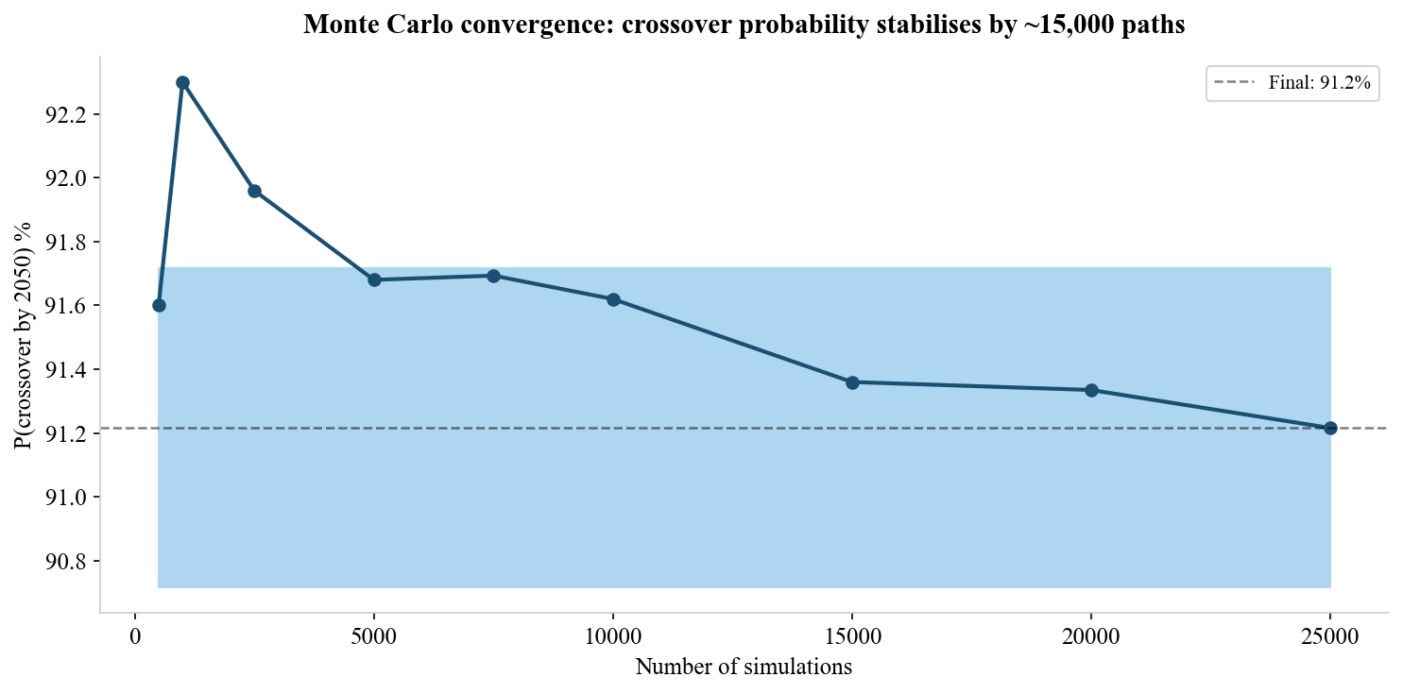

Figure A-2: Passive Share Cap Comparison (67% vs 80%)
