

Lecture with Computer Exercises:
Modelling and Simulating Social Systems with MATLAB

Project Report

Investigating the Influence of Fake News on the Opinion Formation

Yannick Bertschy, Mario Blatter, Guido Gandus, Aiping Yao

Zürich
27.11.2017
IMPORTANT

You MUST include the ETH declaration of originality here; it is available for download on the course website or at

http://www.ethz.ch/faculty/exams/plagiarism/index_EN;

It can be printed as pdf and should be filled out in handwriting.
Agreement for free-download

We hereby agree to make our source code of this project freely available for download from the web pages of the SOMS chair. Furthermore, we assure that all source code is written by ourselves and is not violating any copyright restrictions.

Yannick Bertschy | Mario Blatter | Guido Gandus | Aiping Yao

Table of Content

Inhalt
Table of Content 4
1. Abstract 5
2. Individual contributions 5
3. Introduction and Motivations 5
4. Description of the Model 5
5. Implementation 6
6. Simulation Results and Discussion 7
7. Summary and Outlook 7
8. References 7

1. Abstract

2. Individual contributions
The whole project was done in a cooperative manner among all the group members.

3. Introduction and Motivations
In view of recent discussions about the importance of so-called Fake News stories having made appearance on social networks such as Facebook or Twitter, questions about their influence have been brought up. The undoubtedly most popular example are the US elections in the last year where this problem was controversially discussed.

To understand better the influence of Fake-News on a society, we implement a model based on the one presented in the paper from P. Holme et. al and extend it. They described a model that combines opinion dynamics with assortative network formation. [1]
The main goal of our project is to expand this model in order to see how long it takes to flip the opinion of a society influenced by external Fake-News. In addition, we would like to find out the price that someone has to pay to change efficiently and significantly the opinions in a society.

This model is a so-called agent-based model since we simulate the interactions of autonomous agents and how they react on external influences we implement.

First, we describe the model by P. Holme et al. before we add the extended version. In the following, we analyse and discuss the behaviour of our model and answer the research questions we set up.

4. Description of the Model

4.1 Model by Petter Holme and M.E.J. Newman [1]

As just mentioned in the previous chapter, the model presented in this research bases largely on the one presented in the paper from P.Holme and M.E.J. Newman, but with the additional implementation of an external impact.
The model figures N individuals as vertices. Each of these vertices (i) can have an arbitrary number of pairwise connections M to another vertex representing friendship. Hence, each individual has M edges.

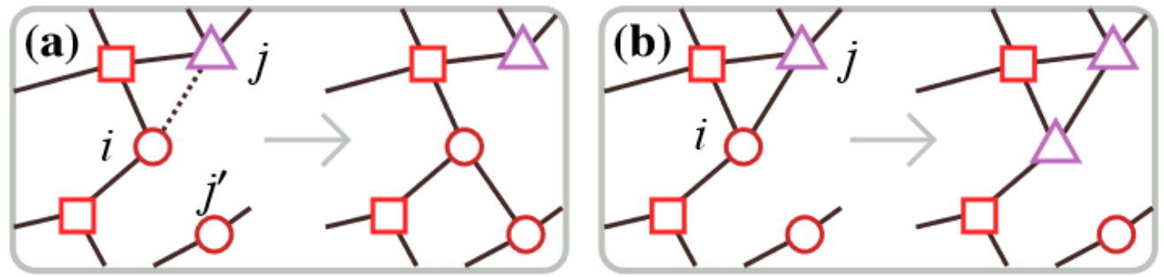
Figure 1. Representation of the model

Each individual holds one out of G possible opinions on a topic (g(i)). For our topic it makes sense to set G as the two main candidates from the 2016 US elections, thus G = {Hillary Clinton, Donald Trump}. As the starting conditions for the model, we distribute the total number of connections M at random and assign each vertex an opinion in G.
The dynamic of the system follows two rules:
- Pick a vertex (i) at random. With the probability φ a random connection to a vertex of a different opinion is changed to a random vertex of its same opinion g(i).
- With probability 1-φ the vertex (i) adopts the (different) opinion of one of its neighbouring vertices.
We assume the number of individuals N and their connections M, as well as the number of possible opinions G are fixed values. At each iteration we can change the opinion of L random vertices to a previously defined one with a certain probability ψ.
Therefore, the varying parameters in the model are L, ψ and φ. The latter is the same as in the original work of [1] to be able to compare our results with theirs.

4.2 Extension of the model

This report focuses on the effect of fake news on opinion formation. We want to investigate which business model is the most efficient to significantly shift the initial distribution of opinions in a society.
The implementation of fake news is superimposed to the dynamic described in the previous section. At each step of the computer simulation, the network can undergo a change because of the three possible events:
- An edge is moved to lie between two individuals whose opinion agree
- The opinion of an individual is changed to agree to one of his neighbour’s opinion
- One or more edges change their opinion due to the fake news
Events 1 and 2 are mutually exclusive events, i.e. cannot occur at the same time as the first occurs with probability φ and the second with 1-φ. Event 3 is subject to the probability variable ψ and can occur independently from the others. We implement the latter to investigate the most efficient business model to target a society with fake news.
Consider a network of individuals having two possible opinions on a specific topic, as it was the case for the USA elections, which we name A and B. We seek to favour opinion A via fake news. One possibility is to specifically target the most influent opponent having opinion B, which correspond to the vertex having the highest number of connections. Another possibility is to target at random a number of vertices from the set of all opponents having a total sum of connections equal to the most influent individual.
In this view, connections are the costs for the business model. Given an initial budget of connections, at each step the decision is either to invest in the vertex with most edges or in many vertices with an equivalent number of edges.

5. Implementation
The M edges are randomly distributed in the network and stored in a connection matrix. Opinions are assigned to each of the N individuals. Three different computer simulations are performed for the same initial configuration of the network. The first simulates the dynamic of the society in the absence of fake news, the second and the third implement the presence of fake news for the two business models described in the previous section. As a starting point, both models have the same budget of total connections to spend.

To be specific, on each step we pick one vertex i at random. If the degree of connections is zero we proceed to the next step, else we apply the same two rules used by P. Holme et al. explained in Section 4.1. In parallel, we search for the individual with the highest number of connections from the set of individuals having a different opinion than the target and store its number of connections as the current budget to spend. In simulation 2 the initial

6. Simulation Results and Discussion
Plots, results

7. Summary and Outlook

8. References

[1] Holme, P. and Newman M.E.J (2006). Nonequilibrium phase transition in the coevolution of networks and opinions. Physical review E74(5), 056108.

