**Lecture with Computer Exercises:**

**Modelling and Simulating Social Systems with MATLAB**

Project Report

|  |
| --- |
| Investigating the Influence of Fake News on the Opinion Formation |

Yannick Bertschy, Mario Blatter, Guido Gandus, Aiping Yao

Zurich

December, 2017

**IMPORTANT**

**You MUST include the ETH declaration of originality here; it is available for download on the course website or at**

**http://www.ethz.ch/faculty/exams/plagiarism/index_EN;**

**It can be printed as pdf and should be filled out in handwriting.**

**Agreement for free-download**

We hereby agree to make our source code of this project freely available for download from the web pages of the SOMS chair. Furthermore, we assure that all source code is written by ourselves and is not violating any copyright restrictions.

# 

|  |  |  |  |
| --- | --- | --- | --- |
| Yannick Bertschy | Mario Blatter | Guido Gandus | Aiping Yao |

# 

# 

# 

# 

# 

# 

# **Table of Content**

**Table of Content** **4**

**1. Abstract** **5**

**2. Individual contributions** **5**

**3. Introduction and Motivations** **5**

**4. Description of the Model** **5**

4.1 Model by Petter Holme and M.E.J. Newman [1] 5

4.2 Extension of the model 6

**5. Implementation** **7**

5.1 Replication of Holme’s Model 7

5.2 Extended model 7

**6. Simulation Results and Discussion** **8**

6.1 Replication of Holme’s Model 8

**7. Summary and Outlook** **8**

**8. References** **9**

# 

# 

# **1. Abstract**

# 

# **2. Individual contributions**

The whole project was done in a cooperative manner among all the group members.

# **3. Introduction and Motivations**

In view of recent discussions about the importance of so-called Fake News stories having made appearance on social networks such as Facebook or Twitter, questions about their influence have been brought up. The undoubtedly most popular example are the US elections in the last year where this problem was controversially discussed.

To understand better the influence of Fake-News on a society, we implement a model based on the one presented in the paper from P. Holme et. al and extend it. They described a model that combines opinion dynamics with assortative network formation. [1]

The main goal of our project is to reconstruct this model in order to see the dynamics of the model when varying some parameters. In addition, we extend it such that we see the influence of external Fake-News implemented by us. Further, we compare different strategies on implementing Fake-News and with the help of a cost function we find out which is the most efficient one.

The reconstructed model is a so-called agent-based model since we simulate the interactions of autonomous agents and how they react on external influences we implement.

First, we describe the model by P. Holme et al. before we add the extended version. In the following, we analyse and discuss the behaviour of our model and answer the research questions we set up.

# 

# 

# **4. Description of the Model**

## 4.1 Model by Petter Holme and M.E.J. Newman [1]

As just mentioned in the previous chapter, the model presented in this research bases largely on the one presented in the paper from P.Holme and M.E.J. Newman, but with the additional implementation of an external impact.

The model figures N individuals as vertices. Each of these vertices (i) can have an arbitrary number of pairwise connections M to another vertex representing friendship. Hence, each individual has M edges.

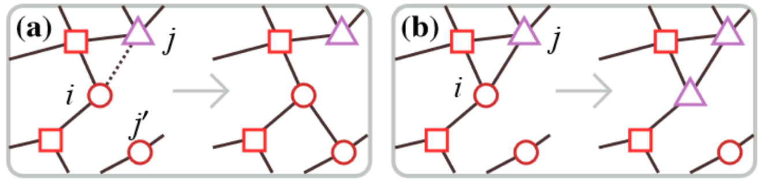

Figure 1. Representation of the two possible network modifications that can take place in the base model [1]

Each individual holds one out of G possible opinions on a topic (g(i)). For our topic it makes sense to set G as the two main candidates from the 2016 US elections, thus G = {Hillary Clinton, Donald Trump}. As the starting conditions for the model, we distribute the total number of connections M at random and assign each vertex an opinion in G.

The dynamic of the system follows two rules:

1. Pick a vertex (i) at random. With the probability φ a random connection to a vertex of a different opinion is changed to a random vertex of its same opinion g(i).
2. With probability 1-φ the vertex (i) adopts the (different) opinion of one of its neighbouring vertices.

We assume the number of individuals N and their connections M, as well as the number of possible opinions G are fixed values. At each iteration we can change the opinion of L random vertices to a previously defined one with a certain probability ψ.

Therefore, the varying parameters in the model are L, ψ and φ. The latter is the same as in the original work of [1] to be able to compare our results with theirs.

## 4.2 Extension of the model

For the sake of simplicity, we do not consider Fake News as individual information spreading across social networks following a power law, but rather as a constant news source (meaning that we assume the number of Fake News stories to be constant).

This implementation lets us introduce an external influence corresponding to Fake News impact, favouring one particular candidate. Hence, the variable L is meant to represent the influence of media outlets on top of ideas spreading among acquaintances, modelling more accurately the increased internet-based media reality, which is not accounted for in the existing paper.

In order to find out which strategy is the most efficient one, we first consider two different strategies. The first one describes the scenario where the most famous person in the society is influenced by our Fake-News. Since it has the most connections M, one would think that the Fake-News are spread out at the highest rate.

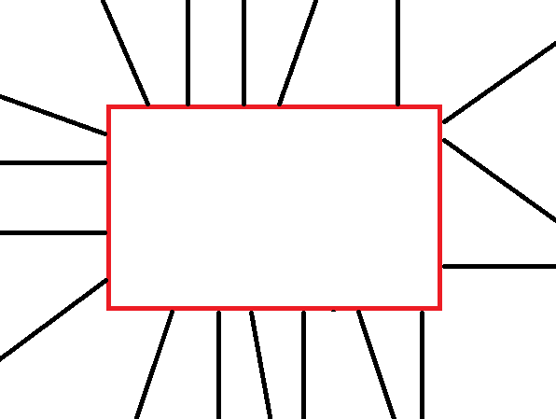 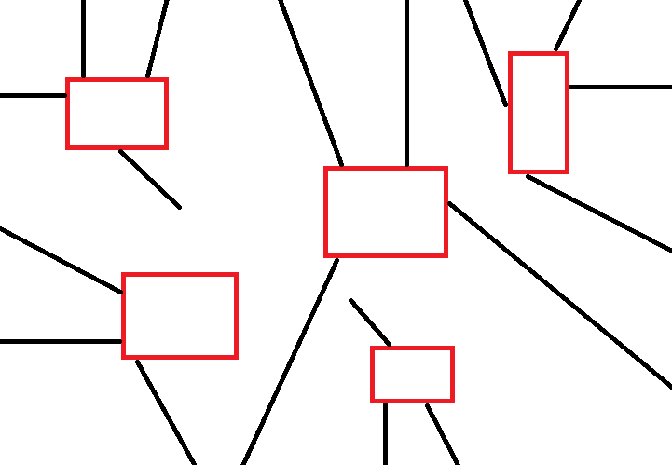

Figure 2. Scenario 1 [2] Figure 3. Scenario 2 [2]

On the other hand in the second scenario, we influence more people which are less prominent, so each individual has less connections M than the most famous person. However, both scenarios will have the same amount of connections in the beginning and we simulate them on Matlab in order to seek the rate of spreadness of the Fake-News.

This procedure will be repeated several times but with a different probability φ.

# **5. Implementation**

## 5.1 Replication of Holme’s Model

The realization of the model consists of a model initialization and an iteration for a predefined number of times. Both are executed when running the script “*Without_fake_news.m*”.

To initialize the framework an array representing the opinions held by each individual was created. Opinions were assigned at random. Then, a connectivity matrix was set up to represent the initial state of the network. This is implemented in the function file “*initialize.m*”.

Along the main model described in “*opinion_change_model.m*” these two instances were modified with each individual iteration according to the two criteria specified in section *4.1*. We use a random value in [0,1] and compare it against our defined probability φ. In a first attempt we ran 106 iterations in order to reach consensus state. In an improved version an abort criterion was introduced. It would stop the iteration of the model when there had not been any change in the population sizes for the last 1000 timesteps.

## 5.2 Extended model

On the basis of Holme’s Mode, we want to study the effect of fake news on the opinion change of people, by comparing the group sizes of different opinions.

The effect of fake news on people is added through an effect probability of Fake.Beta.

We take american election as an example, we form the group of opinions into two groups: De(democracy) and Re(republic), we want to find a better way to win the competition though the fake news affect. We start with randomly allocation of opinions to the whole population, which will end up with roughly 50%-50% distribution of Re and De. Then we add the fake news affect through “ extended_model_v2.m ” in which the cellar model based fake news effect is defined as “fake_news_affect.m” function.

Besides, we defined a fixed budget, and compared two strategies of adding fake news, strategy one is through affecting one of the most popular people, which means the person who has most connections; second is through affecting several ordinary people who has much less connections, but the sum of their connections should equals to the most popular person in strategy one. The implementation is also included in “ extended_model_v2” defined through variable Fake.strategy.

# **6. Simulation Results and Discussion**

## 6.1 Replication of Holme’s Model

6.2 Extended model

The results shown the groupsizes with different parameters,

here is a brief explain of the parameters I use:

Strategy 1: Affect one famous people;

Strategy 2: Affect several people;

N: Population number;

M: Connection number;

Budget = Fake.Budget: the total connections allowed to affect;

Beta = Fake.Beta: the probability of a person been affected by the fake news

G1 = opinion group 1;

G2: opinion group 2;

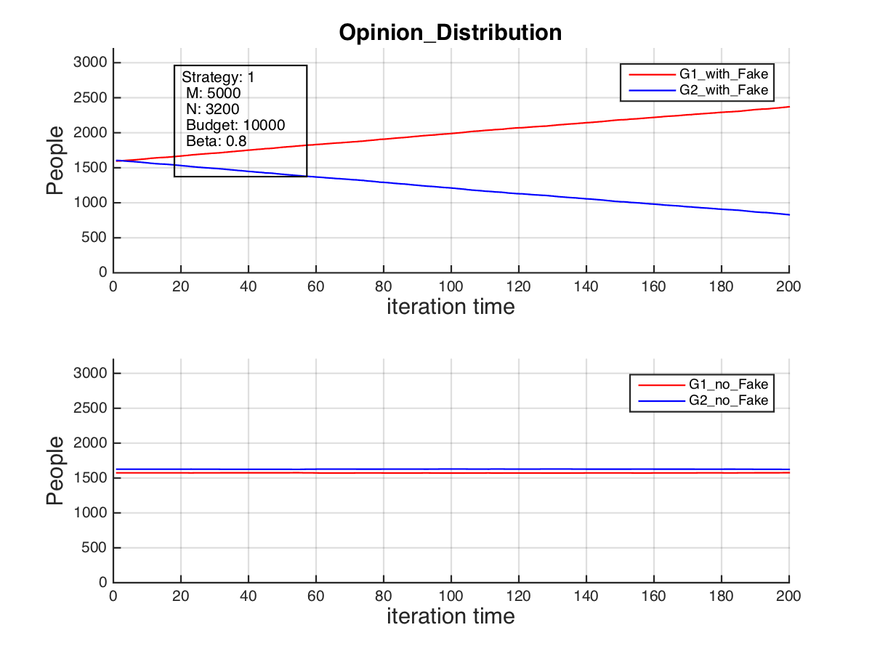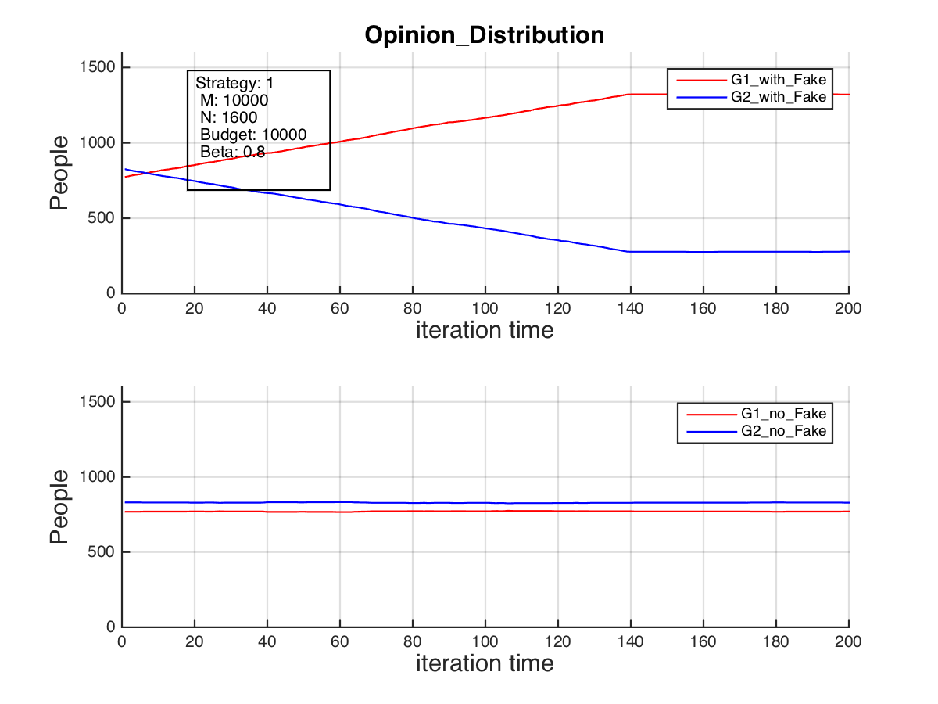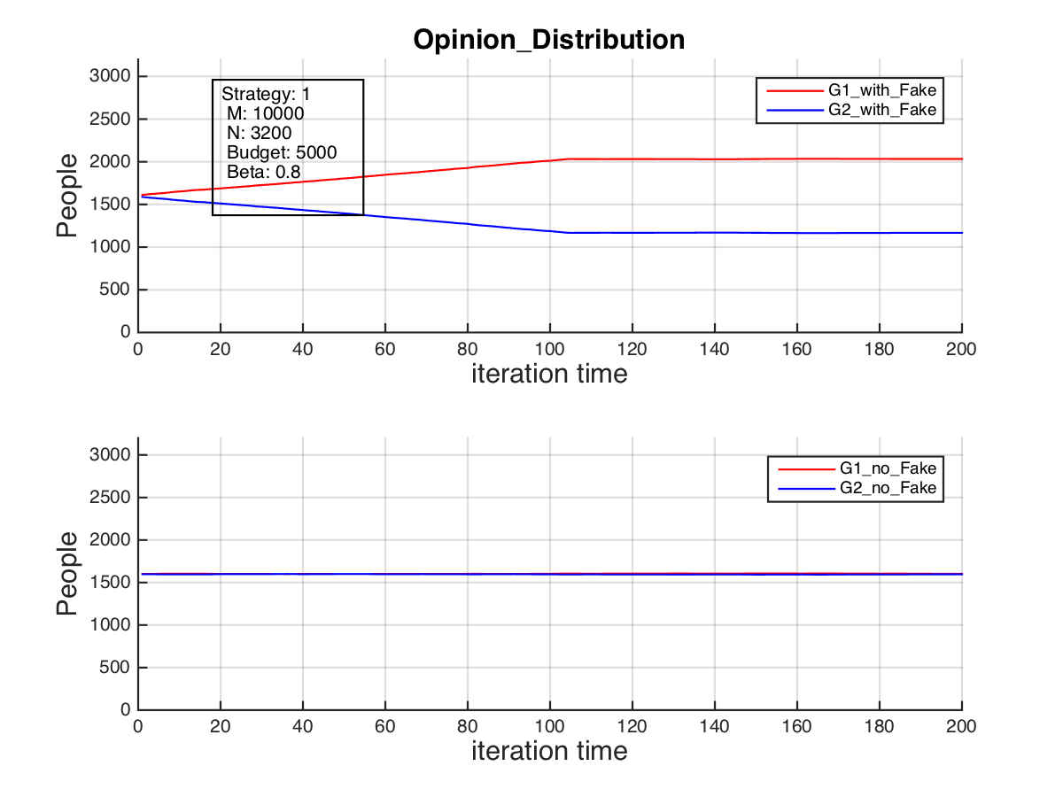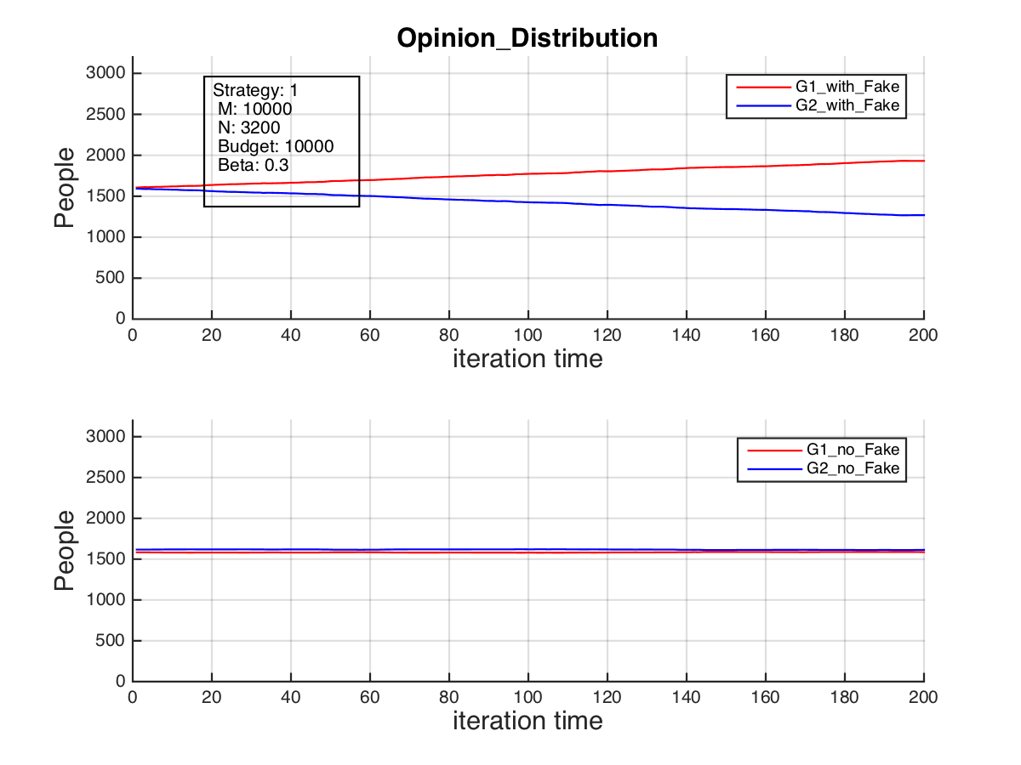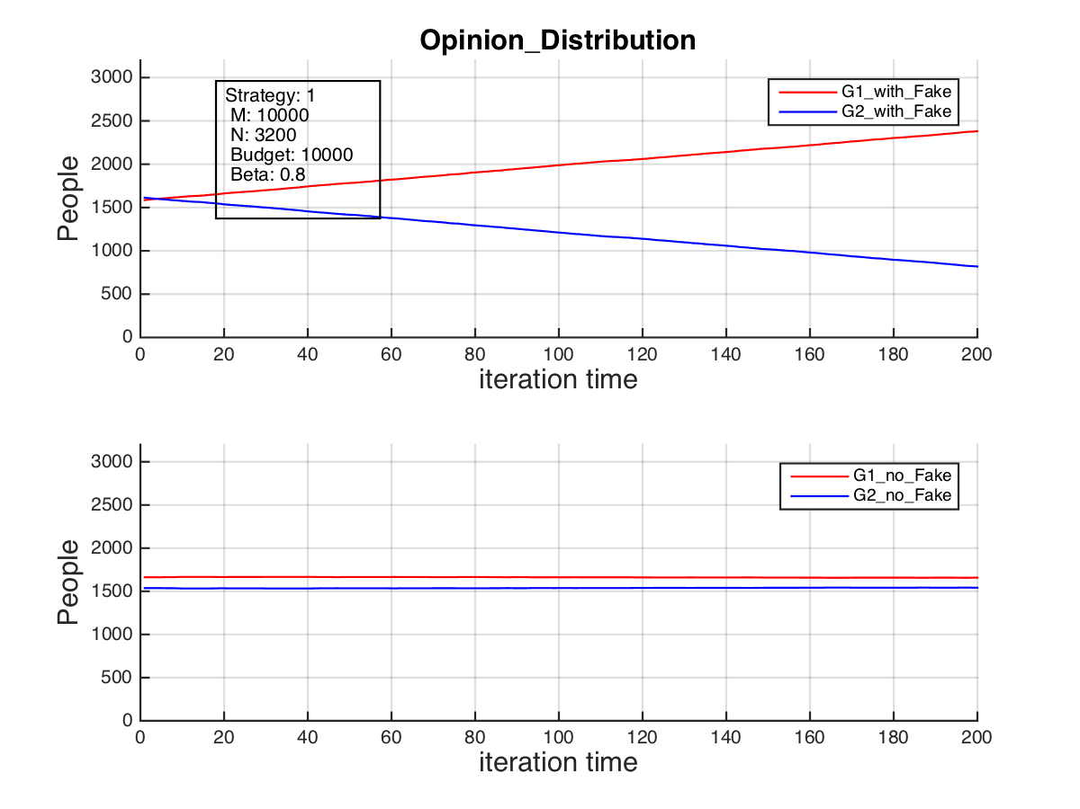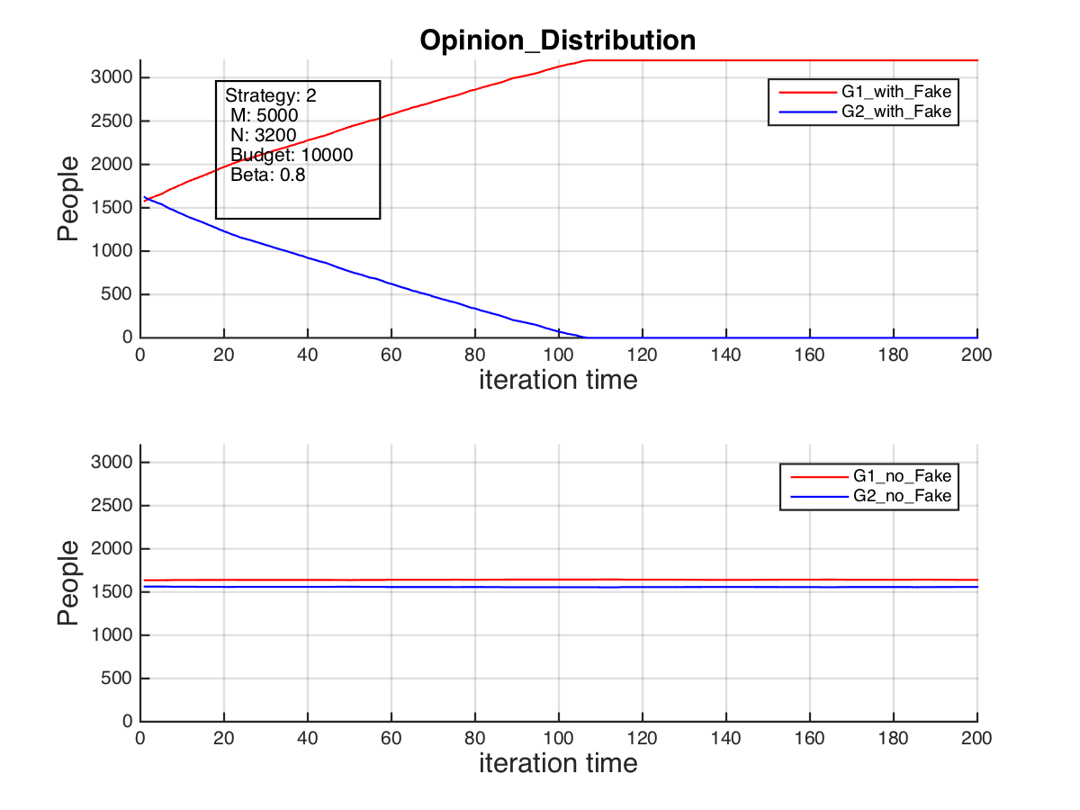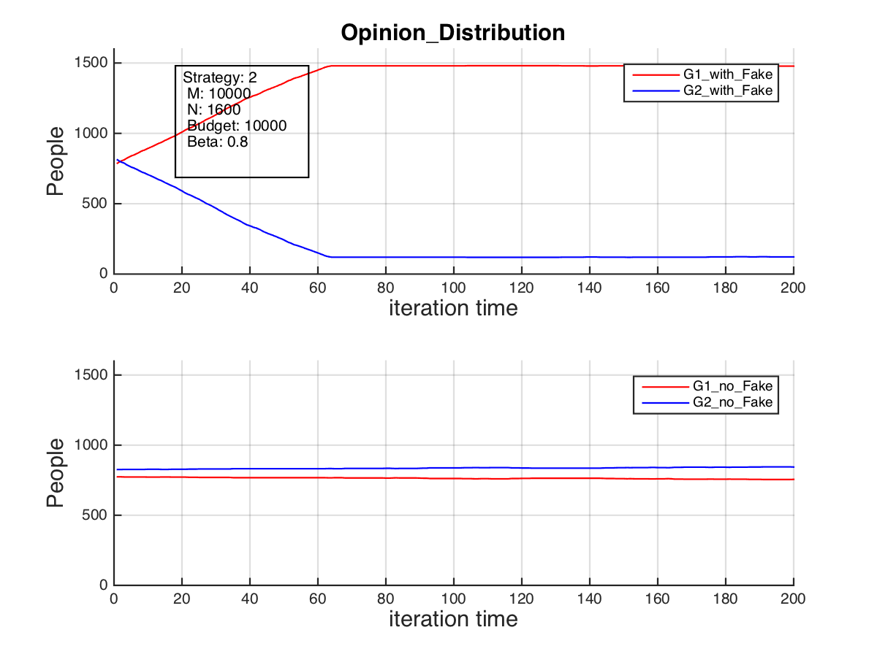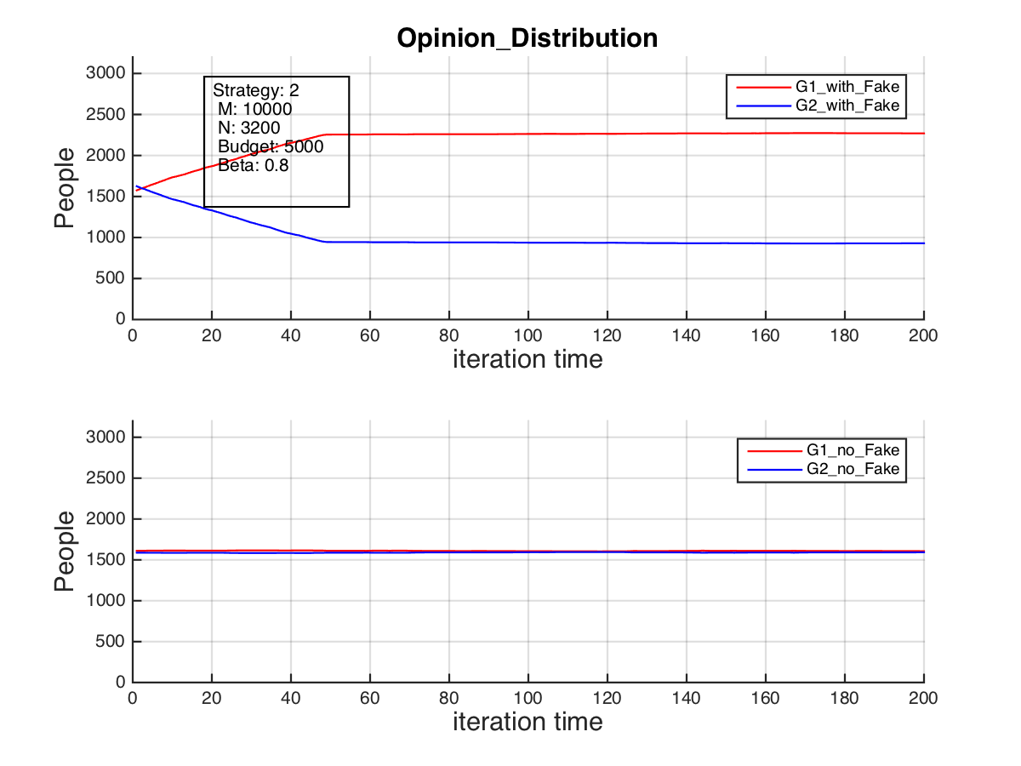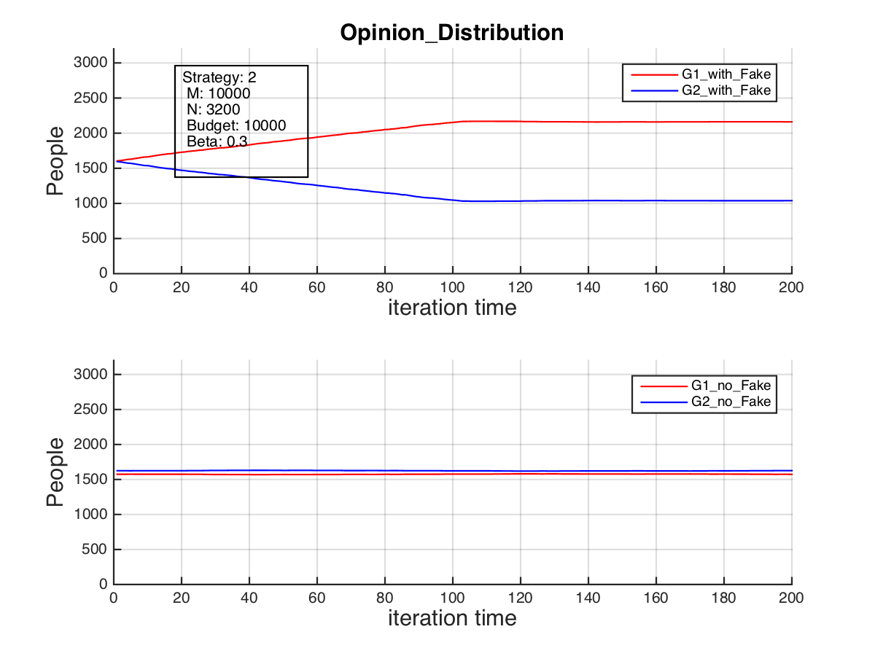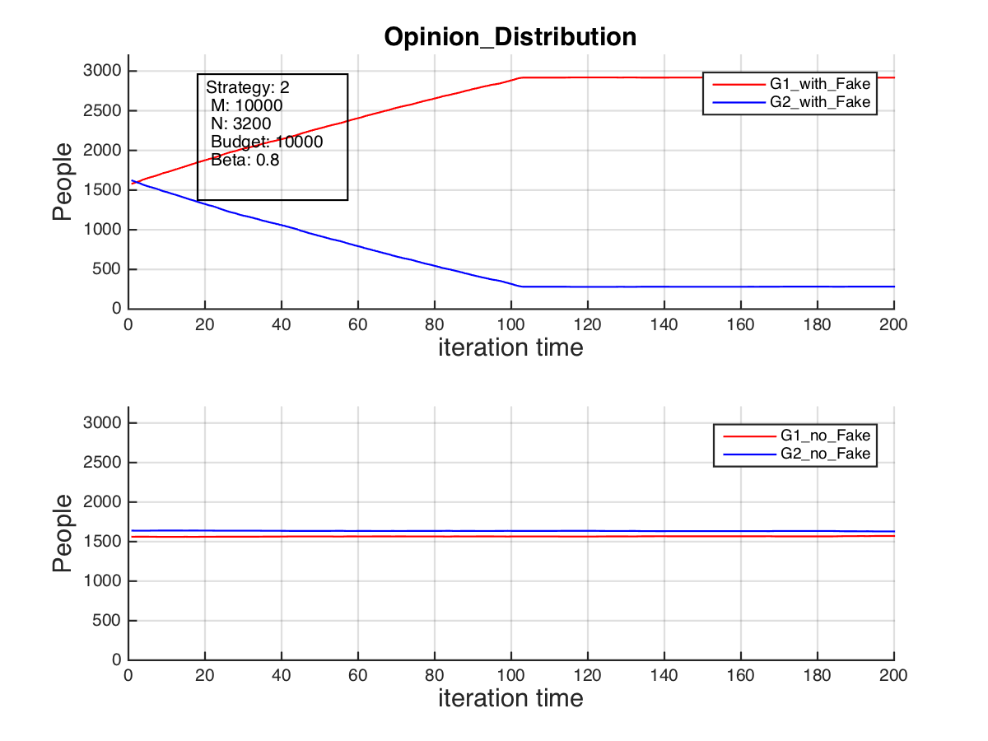



Groupsize after 200 no_of_runs, with different Budget



Groupsize after 200 no_of_runs, with different Connection Numbers



Groupsize after 200 no_of_runs, with different Population Sizes

# **7. Summary and Outlook**

# 

# 

# **8. References**

[1] Holme, P. and Newman M.E.J (2006). *Nonequilibrium phase transition in the coevolution of networks and opinions.* Physical review E74(5), 056108.

[2] Own illustration (2017).

# 