**Abstract**

In this paper, I aim to reproduce and extend work done by Dr. Michael New at the University of Alabama, "Analyzing the Effect of State Level Anti-Abortion Legislation in the Post-*Casey* Era." This paper, originally published in *State Politics & Policy Quarterly*, investigates the efficacy of various types of anti-abortion legislation on abortion rates through a series of regressions. He finds substantial and significant differences in abortion rates corresponding to parental involvement laws, informed consent laws, and Medicaid funding restrictions.

**Introduction**

Dr. New and other political scientist's empirical work investigating the efficacy of anti-abortion legislation is one of only a handful of abortion-related arenas where persons of opposing world-views stand to gain from scientific collaboration. Much abortion-related literature is so ideologically polarized that persons with opposite stances, at best, speak past one another but the empirical effects of these laws on abortion rates may be of interest whether a person is pro-life, pro-choice, or undecided.

In the paper, "Analyzing the Effect of State Level Anti-Abortion Legislation in the Post-*Casey* Era," Dr. New uses abortion data to investigate the effects of various types of anti-abortion legislation including parental involvement laws, Medicaid funding restrictions, and informed consent laws. Informed consent laws are particularly relevant since these first arose in the 1990s and their efficacy remains unclear. For a fuller account of current related literature the reader is directed to the original article.

In this paper, I aim to replicate and extend Dr. New's work. In Section I, I review the data sources. In Section II, I review his methodology including choices made in selecting an appropriate model. In Section III, I present my replication results. In Section IV, I extend Dr. New's work by exploring the robustness of his results under alternate modeling choices.

**Data**

One strength of Dr. New's study is that he uses both widely accepted data sources on state-level abortion rates: the Centers for Disease Control and Prevention (CDC) and the Alan Guttmacher Institute (AGI) over a wide time range, 1985-2005. Collecting accurate data on abortion is difficult in the United States since abortion reporting is loosely regulated. It is important to briefly mention some of the strengths and limitations of each of these datasets as well as some important omissions.

The CDC provides abortion rates tabulated from state health departments' data submissions. Reporting to the CDC is voluntary. There is no national requirement for reporting or data submission and state requirements vary widely. Increases and decreases in abortion rates may illustrate changes in reporting behavior rather than in the abortion rates themselves. For instance, in Kansas, the abortion rate increased by an astounding 69% in the 1990s, likely due to a strengthening of its abortion reporting requirements in 1995. The CDC estimates of abortion rates tend to be substantially lower than the corresponding AGI estimates.

The AGI provides data from periodic surveys of abortion facilities (between 1985 and 2000, the AGI reported data in 1985, 1987, 1988, 1991, 1992, 1995, 1996, 2000). It is important to note that not all abortions are performed at stand alone abortion facilities; abortions may also be legally performed at hospitals. However, even without hospital abortions, AGI estimates of abortion rates tend to be about 20% higher than corresponding CDC estimates of abortion rates. The AGI abortion rates are generally well regarded but it is important to note that the AGI is the former research branch of Planned Parenthood International and may, at times, have incentives to support their parent institution with their research.

Some data has been intentionally omitted for research purposes. Omitted cases are carefully documented in the paper by Dr. New. Several states failed to report abortion data to the CDC for portions of the relevant time frame (1985-2000): Alaska (1998-2002), California (1998-2005), Louisiana (2005), New Hampshire (1998-2005), Oklahoma (1998-1999), and West Virginia (2003-2004). Data from Kansas was omitted for two reasons: included in Kansas' abortion rates is an unusually large proportion of abortions performed on out-of-state residents (the CDC estimates over 40% throughout the 1990s), additionally, the abortion rate in Kansas increased by an astounding 69% in the 1990s, likely due to a strengthening of their abortion reporting requirements in 1995. Data from Alaska was also omitted due to unusual economic fluctuations so large that they may interfere with coefficient estimates of economic variables (verify).

**Methodology**

Dr. New's work is very thorough. In addition to using both widely accepted datasets, he analyzes both abortion rate (the number of abortions per 1,000 women of between ages 15 and 44) and abortion ratio (the number of abortions per 1,000 births) so that changes in population and fertility do not mask results. Additionally, he uses regression to control for an array of factors widely believed to effect abortion rates including: availability of public funding, economic measures (per capital personal income growth and unemployment rate, and annual change in the unemployment rate, and poverty rate), racial composition, age composition, fertility rates, marriage rates, availability of abortion (abortion providers per capita and percentage of residents in metropolitan areas). Predictor variables were obtained from the CDC, the AGI, the US Census Bureau, the Bureau of Labor Statistics, and the Bureau of Economic Analysis. He also takes a more detailed look the effects of parental consent laws on abortion rates and ratios for minors and a more detailed look at the differences in the effects of legislation in states where judges upheld and nullified relevant abortion restrictions.

Modeling, in general, is not one-size-fits-all. Many choices must be made along the way about which methods are appropriate for the data at hand. Sometimes these choices substantially impact the results. In this section, I aim to review some of the modeling choices made in Dr. New's work and a rationale for making these choices.

The basic form of the model used in Dr. New's work is Least Squares Linear Regression. Since both datasets are not comprised of independent observations but rather observations across time, Prais-Winston regression is applied. Prais-Winston regression is a type of Generalized Least Squares Regression where errors are assumed to be an AR(1) time series with an unknown parameter which is estimated and used to transform the data before applying Ordinary Least Squares. The need for some sort of time series correction is evident when one inspects the residuals under Ordinary Least Squares for autocorrelation (insert Durbin Watson Test results here). Inspecting the residuals after applying Praise-Winston we can see that the problem of autocorrelation in the residuals has been resolved (insert Durbin Watson Test results here).

The models used in Dr. New's work include a lot of variables relative to the number of observations. Regressions done on the CDC dataset include 89 coefficients estimated from 933 observations. If we consider the indicator variables as grouping variables, observations fall in groups of 6 to 21 observations. Regressions done on the AGI dataset include 77 coefficients estimated from 432 observations and observations fall in groups of 9. One concern related to estimating a lot of coefficients relative to the number of observations is overfitting. When models are overfit, since some combinations of variables apply to only a handful of observations, coefficient estimates may reflect the values of those specific observations rather than the underlying trends. Overfitting may cause variables with little relation to underlying trends to appear significant. With coefficient of determination values near 1 for most models and group sizes between 6 and 21 observations, overfitting is not obvious but it remains a concern. Unfortunately, here, the overwhelming majority of the estimated coefficients are tied to state-level indicators and year indicators. Since the paper aims to investigate the efficacy of state level laws, we cannot drop these indicator variables or group states to reduce their quantity. (Check dfbetas and other diagnostics that might show overfitting)

In addition to the time series correction and variable selection, since data is not comprised of similarly precise measurements, weighted regression is used. Ideally, the weight of an observation is set to the reciprocal of its variance. In practice, the variance at each observation is generally not known and weights must be estimated from available information. Dr. New chose to weight based on state population. This is an intuitively appealing choice for weights for since the variance of a proportion is linearly related to the sample size. To investigate the appropriateness of weighting by state population, plot of the residuals against the weights is shown below (CDC data on the left, AGI data on the right). There is a slight funnel shape indicating that the weights do indeed give information about the variance of the errors but the funnel is in the opposite direction one would expect - ideally large residual variances should correspond to small weights and small residual variances should correspond to large weights. We see this slight funnel shape in the residual plots using both data sets. This pattern indicates that weighting based on state population is not improving the efficiency of the model by correcting for heteroskedasticity. Weighting based on state populations may still be justified if, for instance, one considers it more important to accurately predict the abortion rates in large states despite the greater perceived imprecision in their estimates. It is important, however, that to note the potential decrease in efficiency that may result in using weights based on state populations. In the following section I will explore the effects of alternate weighting schemes on the results.

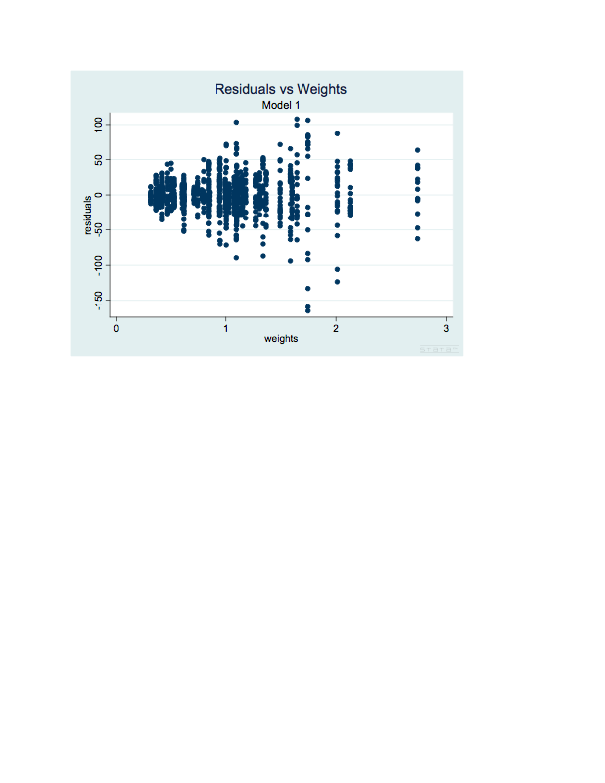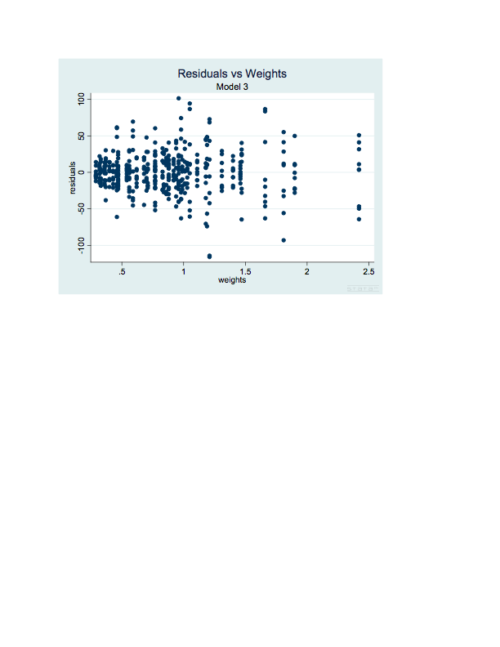

(additional model diagnostics go here)

**Results**

My results are similar to Dr. New's but not exactly the same. Although there are a few difference, it is important to note that none of the differences are significant and none of the differences affect the figures published in *State Politics & Policy Quarterly*. (More to come)

|  |  |  |  |  |  |  |  |  |
| --- | --- | --- | --- | --- | --- | --- | --- | --- |
|  | Model 1 | | Model 2 | | Model 3 | | Model 4 | |
| Variable | Manuscript | Reproduced | Manuscript | Reproduced | Manuscript | Reproduced | Manuscript | Reproduced |
| Income Growth | -1.45 | -1.45 | -0.1 | -0.1 | -0.01 | 0.01 | -0.04 | -0.04 |
| (se) | 0.57 | 0.57 | 0.04 | 0.04 | 0.97 | 0.97 | 0.07 | 0.07 |
| Change in Unemployment Rate | 0.09 | -0.09 | 0.01 | 0 | -1.18 | -1.39 | -0.01 | -0.02 |
| (se) | 1.15 | 1.15 | 0.08 | 0.08 | 1.94 | 2 | 0.14 | 0.14 |
| Unemployment Rate | -0.87 | -0.88 | -0.06 | -0.06 | 0.47 | 0.53 | 0.08 | 0.08 |
| (se) | 0.41 | 0.41 | 0.03 | 0.03 | 2.01 | 2 | 0.13 | 0.14 |
| Poverty Rate | -0.15 | -0.16 | 0 | 0 | -0.51 | -0.52 | -0.04 | -0.04 |
| (se) | 0.51 | 0.51 | 0.03 | 0.03 | 0.87 | 0.88 | 0.06 | 0.06 |
| Percent Black | 5.72 | 5.68 | 0.48 | 0.48 | 14.73 | 14.72 | 1.08 | 1.08 |
| (se) | 3.41 | 3.41 | 0.23 | 0.23 | 3.06 | 3.05 | 0.21 | 0.21 |
| Percent Native American | -1.99 | -1.99 | -0.02 | -0.02 | 5.52 | 5.51 | 0.47 | 0.47 |
| (se) | 2.7 | 2.7 | 0.17 | 0.17 | 5.69 | 5.7 | 0.42 | 0.42 |
| Percent Hispanic | 4.95 | 4.93 | 0.17 | 0.17 | -1.34 | -1.36 | -0.23 | -0.23 |
| (se) | 1.4 | 1.4 | 0.1 | 0.1 | 1.08 | 1.08 | 0.07 | 0.07 |
| Percent Asian | -14.1 | -14.13 | -0.86 | -0.86 | -7.91 | -7.9 | -0.53 | -0.53 |
| (se) | 3.04 | 3.02 | 0.24 | 0.24 | 4.33 | 4.33 | 0.31 | 0.31 |
| Percent 20-24 | 7.94 | 7.94 | 0.53 | 0.53 | 3.71 | 3.76 | 0.01 | 0.01 |
| (se) | 5.12 | 5.12 | 0.36 | 0.36 | 4.86 | 4.88 | 0.29 | 0.29 |
| Percent 25-29 | 6.43 | 6.43 | 0.41 | 0.41 | 1.66 | 1.64 | 0.1 | 0.1 |
| (se) | 4.1 | 4.1 | 0.28 | 0.28 | 3.72 | 3.72 | 0.27 | 0.27 |
| Percent 30-34 | 7.37 | 2.67 | 0 | 0.01 | 0.93 | 0.95 | -0.09 | -0.09 |
| (se) | 6.29 | 3.96 | 0.29 | 0.29 | 4.76 | 4.25 | 0.27 | 0.27 |
| Percent 35-49 | 7.25 | 7.35 | 0.57 | 0.57 | 12.68 | 12.65 | 0.52 | 0.52 |
| (se) | 6.29 | 6.28 | 0.44 | 0.44 | 7.06 | 7.07 | 0.47 | 0.47 |
| Percent 40-44 | 14.79 | 14.81 | 1.09 | 1.1 | 2.77 | 2.84 | 0.31 | 0.31 |
| (se) | 6.33 | 6.32 | 0.46 | 0.46 | 4.88 | 4.88 | 0.36 | 0.36 |
| Fertility Rate | -3.69 | -3.67 | 0.11 | 0.11 | -2.82 | -2.8 | 0.19 | 0.2 |
| (se) | 0.66 | 0.66 | 0.05 | 0.05 | 0.8 | 0.81 | 0.06 | 0.06 |
| Abortion Providers Per Capita | 1.57 | -1.58 | -0.09 | -0.09 | 1 | 0.99 | 0.02 | 0.02 |
| (se) | 1.64 | 1.64 | 0.11 | 0.11 | 1.98 | 1.97 | 0.13 | 0.13 |
| Abortion Providers Per Capita Squared | 0.1 | 0.1 | 0.01 | 0.01 | 0.15 | 0.15 | 0.01 | 0.01 |
| (se) | 0.03 | 0.03 | 0 | 0 | 0.05 | 0.05 | 0 | 0 |
| Percent Residents in Metro Area | -0.01 | -0.01 | 0 | 0 | 0.46 | 0.45 | 0.02 | 0.02 |
| (se) | 0.04 | 0.04 | 0 | 0 | 1.03 | 1.03 | 0.06 | 0.06 |
| Percent Married | -0.04 | -0.04 | -0.01 | -0.01 | -0.65 | -0.66 | -0.03 | -0.04 |
| (se) | 0.17 | 0.17 | 0.01 | 0.01 | 2.98 | 2.99 | 0.19 | 0.19 |
| **Parental Involvement** | **-6.47** | **-6.47** | **-0.46** | **-0.46** | **-5.72** | **-5.63** | **-0.54** | **-0.54** |
| **(se)** | **4.88** | **4.88** | **0.34** | **0.34** | **6.56** | **6.58** | **0.44** | **0.44** |
| **Informed Consent** | **-10.04** | **-10.07** | **-0.74** | **-0.74** | **-16.71** | **-16.71** | **-1.1** | **-1.11** |
| **(se)** | **4.55** | **4.55** | **0.33** | **0.33** | **6.76** | **6.75** | **0.46** | **0.46** |
| **Medicaid funding Restruction** | **-20.82** | **-20.85** | **-1.54** | **-1.54** | **-19.37** | **-19.42** | **-1.44** | **-1.45** |
| **(se)** | **10.09** | **10.08** | **0.7** | **0.7** | **10.33** | **10.33** | **0.65** | **0.65** |
|  |  |  |  |  |  |  |  |  |
| R Squared | 0.968 | 0.968 | 0.969 | 0.969 | 0.99 | 0.99 | 0.991 | 0.991 |

**Alternate Model Choices**

Many of Dr. New's modeling choices are incredibly straightforward. For instance, since we are working with time series data and this aspect of the data makes a substantial impact on the linear regression results, any reasonable model of this data should include time series corrections. Other choices, such as how to estimate appropriate weights, are less clear. I will investigate the sensitiveness of the results to an alternate weighting scheme. This is not intended as a critique of Dr. New's weighting choice, which I believe to be reasonable. It is an extension of his work providing additional information regarding the robustness of his results.

Recall from the previous section that since data is not comprised of similarly precise measurements, weighted regression is preferred. Ideally, the weight of an observation would be set to the reciprocal of its variance but since we do not have this information, as is generally the case in practice, weights must be estimated from available information. Dr. New chose to weight based on state population, an intuitively appealing choice for weights since variances is inversely related to sample size but, somewhat counter intuitively, state population seems to have a direct relationship with variance of the residuals. States with larger populations tend to have larger residual variances and states with smaller populations tend to have smaller residual variances.

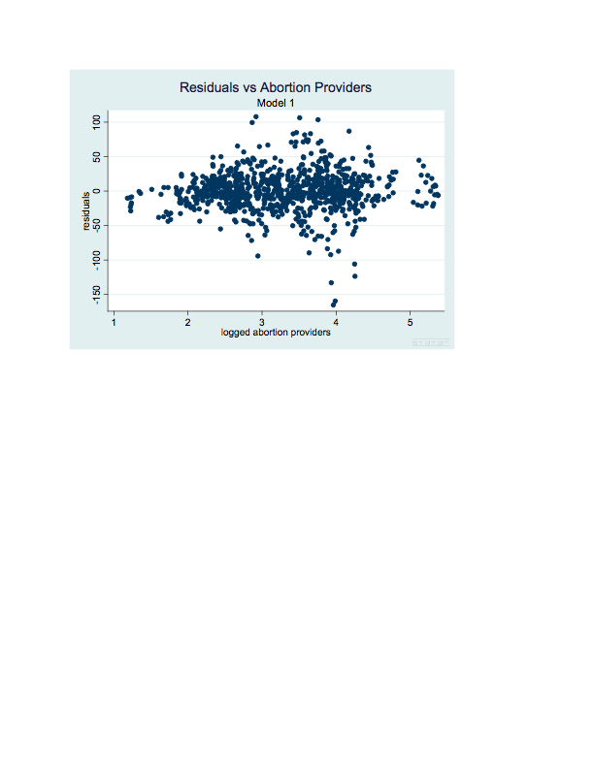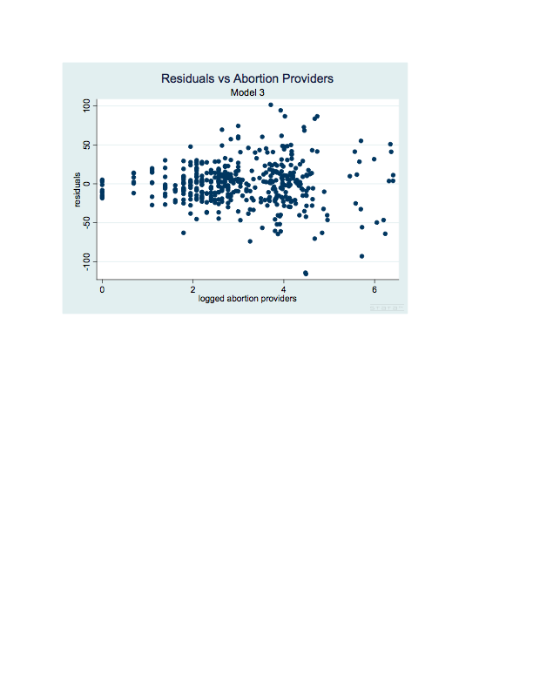

The number of licensed abortionists working in a state might also be a reasonable proxy for sample size. Due to the heavily skewed distribution of abortionist counts, a log transform of this variable is more appropriate. The plots above illustrate that variance of the residuals is indeed related to the number of practicing abortionists but we see the same unexpected pattern in the relationship that we saw with state population. States with few abortion providers tend to have smaller residual variances and states with many abortion providers tend to have larger residual variances. Although somewhat counterintuitive, this pattern is fairly clear in both datasets and I think it provides a reasonable base for devising weights.

To devise an appropriate weight based on logged abortion providers (logA), I divided the data into four equal parts according to logA. I then estimated the variance of each part

**References (in addition to those in the original study)**

Least Squares in the Presence of Autocorrelation in Economics: <http://irving.vassar.edu/faculty/wl/Econ210/autoF01.pdf>

CDC Abortion Rates by State 2000 (occurrence rates are occasionally lower than residence rates): <http://www.cdc.gov/mmwr/preview/mmwrhtml/ss5212a1.htm#tab1>

**Appendix: Code (STATA)**

To run the code, first load the appropriate dataset then use the line of code below to define the dataset as a multi-panel time series. After these two steps, the model-specific code below may be run.

tsset fips year, yearly

Appendix B

Model 1 (CDC Data)

xtpcse wratio wy05-wy85 wzal-wzwy wpcigrow wunemploych wunemploy_total wpoverty wblack windian whisp wasian wa20t24 wa25t29 wa30t34 wa35t39 wa40t44 wfertile wpc_abortprovide wabortprovidesq wmetropop wmarried wparcon winfcon wpubfundban, pairwise corr(ar1)

Model 2 (CDC Data)

xtpcse wrate wy05-wy85 wzal-wzwy wpcigrow wunemploych wunemploy_total wpoverty wblack windian whisp wasian wa20t24 wa25t29 wa30t34 wa35t39 wa40t44 wfertile wpc_abortprovide wabortprovidesq wmetropop wmarried wparcon winfcon wpubfundban, pairwise corr(ar1)

Model 3 (AGI Data)

xtpcse wratio wy05-wy85 wzal-wzwy w_pcigr w_uch w_u wrpoverty wblack windian whisp wasian wa20t24 wa25t29 wa30t34 wa35t39 wa40t44 wfertile w_pc_abortionprovide wabprovidesq wmetropop w_married wparcon winform wpubfundban, pairwise corr(ar1)

Model 4 (AGI Data)

xtpcse wrate wy05-wy85 wzal-wzwy w_pcigr w_uch w_u wrpoverty wblack windian whisp wasian wa20t24 wa25t29 wa30t34 wa35t39 wa40t44 wfertile w_pc_abortionprovide wabprovidesq wmetropop w_married wparcon winform wpubfundban, pairwise corr(ar1)

Appendix C

Model 1 (CDC Data)

xtpcse wtnrate wy05-wy85 wzal-wzwy wpcigrow wunemploych wunemploy_total wpoverty wblack_tn windian_tn wasian_tn whispanic_tn wfertile wpc_abortprovide wabortprovidesq wmetropop wmarried wparcon winfcon wpubfundban, pairwise corr(ar1)

Model 2 (CDC Data)

xtpcse wadultrate wy05-wy85 wzal-wzwy wpcigrow wunemploych wunemploy_total wpoverty wblack whisp windian wasian wa20t24 wa25t29 wa30t34 wa35t39 wa40t44 wfertile wpc_abortprovide wabortprovidesq wmetropop wmarried wparcon winfcon wpubfundban, pairwise corr(ar1)

Appendix D

Model 1 (CDC Data)

xtpcse wrate wy05-wy85 wzal-wzwy wpcigrow wunemploych wunemploy_total wpoverty wblack windian whisp wasian wa20t24 wa25t29 wa30t34 wa35t39 wa40t44 wfertile wpc_abortprovide wabortprovidesq wmetropop wmarried wparcon wicnull winfcon wpubfundban, pairwise corr(ar1)

Model 2 (CDC Data)

xtpcse wtnrate wy05-wy85 wzal-wzwy wpcigrow wunemploych wunemploy_total wpoverty wblack_tn windian_tn wasian_tn whispanic_tn wfertile wpc_abortprovide wabortprovidesq wmetropop wmarried wpcnull wparcon winfcon wpubfundban, pairwise corr(ar1)

Model Diagnostics and Supporting Figures

This code is intended for use after loading the relevant dataset, setting up the relevant variables as a time series as shown above, and defining the relevant model as shown above.

predict xb if e(sample)

gen resid = wratio - xb

twoway (scatter resid xb), ytitle(residuals) xtitle(fitted values) title(Residual Plot) subtitle(Model 1)

twoway (scatter resid wpcigrow), ytitle(residuals) xtitle(income growth) title(Residual Plot) subtitle(Model 1)

twoway (scatter resid wunemploych), ytitle(residuals) xtitle(change in unemployment) title(Residual Plot) subtitle(Model 1)

twoway (scatter resid wunemploy_total), ytitle(residuals) xtitle(total unemployment) title(Residual Plot – FUNNEL SHAPE) subtitle(Model 1)

twoway (scatter resid wpoverty), ytitle(residuals) xtitle(poverty) title(Residual Plot) subtitle(Model 1)

twoway (scatter resid wpc_abortprovide), ytitle(residuals) xtitle(abortion providers) title(Residual Plot) subtitle(Model 1)

twoway (scatter resid newt), ytitle(residuals) xtitle(weights) title(Residual Plot) subtitle(Model 1)

twoway (scatter resid abortprovide1544), ytitle(residuals) xtitle(Abortion Providers) title(Residual Plot) subtitle(Model 1)

gen logabpr = log(abortprovide1544)

twoway (scatter resid logabpr), ytitle(residuals) xtitle(Abortion Providers) title(Residual Plot) subtitle(Model 1)

R code for Weight estimates

library(foreign)

CDCdata=read.dta("SPPQ_March.dta")

attach(CDCdata)

pan1= order(logabpr)[1:186]

pan2= order(logabpr)[187:372]

pan3=order(logabpr)[373:

in progress

sortedmod1resid = mod1resid[order(logabpr)]

approxvarmod1 = c(var(sortedmod1resid[1:233]), var(sortedmod1resid[234:466]), var(sortedmod1resid[467:699]), var(sortedmod1resid[700:933]))

approxlogabpr = c(mean(sortedlogabpr[1:233]), mean(sortedlogabpr[234:466]), mean(sortedlogabpr[467:699]), mean(sortedlogabpr[700:933]))

plot(approxlogabpr, approxvarmod1, xlab="log abortionists", ylab="residual variance", main="Change in Variance by Logged Abortionists")

lm(approxvarmod1 ~ approxlogabpr)

#varihat=-432.6+364.8*logabpr <- too small for lowest values of logabpr