**Impacts of green space in the built environment: relationships between NO2, VOCs and noise in a major greenspace in Ottawa, Canada.**

Keith Van Ryswyk*1,2, Natasha Prince1, Mona Ahmad1, Erika Brisson1, J. David Miller1, Paul Villeneuve1

1 Department of Health Sciences, Carleton University, 1125 Colonel By Drive, Ottawa, Ontario, K1S 5B6, Canada

2 Air Health Sciences Division, Health Canada, 269 Laurier Avenue West, Ottawa, Ontario, K1A 0K9, Canada

# Abstract

Air pollution, traffic related noise and increased temperatures are all influenced by features of the urban built environment. These environmental factors are known to vary within cities, and these intra-city variations have been associated with differential risks of adverse health impacts. Because of the dense population in modern cities, mitigating strategies against these factors are of public policy importance nationally and internationally. Air pollution and noise from traffic have been ranked as the leading environmental threats to human health (Hanninen et al. 2014).

Green spaces in the built environment have been associated with several health benefits. There are many different pathways whereby greenness may impact human health, including a reduction in harmful levels of air pollution, noise, and extreme temperature.

Despite the possible health benefits of urban green spaces, to date, there have been relatively few attempts to jointly model, within Canadian urban areas, the interrelationships between noise, air pollution, temperature, and greenness at a highly resolved spatial scale. Moreover, these relationships are likely to differ substantially between Canadian cities due to many factors including: urban and roadway design, climate, meteorology, and topography. In Ottawa, the Central Experimental Farm (CEF) likely plays a prominent role in influencing these exposures, but to date there have been few efforts to evaluate these impacts. Presently, the CEF spans 427 hectares of open land, and nearly one quarter of Ottawa’s population lives within five kilometers from its boundaries.

Although there have been some environmental exposure surfaces generated for the city of Ottawa, these studies have focussed on within city contrasts in air pollution concentrations. Moreover, there have been no attempts to characterize variations in urban noise across the city.

The overall purpose of the current study was therefore to characterize air pollution, noise and ambient temperature on and around the CEF, and to determine if the farm has a mitigating impact on these exposures. Moreover, this exposure study was also undertaken to provide baseline data so that future changes in these exposures can be assessed.

**Keywords:** Traffic-related air pollution, noise, green space, urban built environment, population health, Ottawa

# Introduction

Over half of the world’s population live in urban environments (World Health Organization, 2016). With an increase in urbanization comes the increase in anthropogenic activities, such as industrial development and vehicular traffic. These activities are among some of the factors which favour the propagation of air and noise pollution, as well as increased heat (De Ridder et al., 2004). Not only can these activities have adverse effects on the environment, but they can have severe impacts on human health and well-being (Galea et al., 2005). Given that most of the world’s population resides in metropolitan areas, there has been considerable importance attributed to understanding how the different physical elements of the built environment affect human health.

## Air pollution and the built environment

Several causal links have been made between short and long-term exposure to air pollution and human health{{4499 Brunekreef,Bert 2002; 4507 Chen,H. 2013; 4655 Dockery,D.W. 2009}}. The Global Burden of Disease project estimated that air pollution was responsible for 5.5 million deaths worldwide in 2013, and was the 4th highest ranking risk factor for death globally{{4497 Brauer,M. 2016; 4532 Forouzanfar,Mohammad H. 2015}}. The Air Health Effects Division of Environment Canada estimated the number of excess deaths yearly due to air pollution levels in selected Canadian cities from 1998-2000. It was estimated that there were approximately 5900 excess deaths in Canada annually during this time period caused by anthropogenic sources of air pollution{{4571 Judek,Stan 2004}}.

Air pollution constitutes a mixture of many different compounds that are produced from both anthropogenic and natural sources. Some of the most important pollutants from a public health perspective are particulate matter (PM), nitrogen oxides (NOx), and volatile organic compounds (VOCs). Gaseous pollutants including various nitrogen oxides and ozone have substantial effects on human health and the environment{{4528 ECCC 2017; 4653 Zupancic,Tara 2013}}. NOx includes several compounds, of which NO2 is the most prevalent. The main sources of NOx are from fuel combustion for mobile use, electricity production and industry{{4565 Jerrett,M. 2007}}. Although the most harmful components of traffic related pollutants have not been determined, NO2 remains a central consideration in air pollution studies based on research associating the health effects of NO2 to short- and long-term exposures{{4498 Brook,Jeffrey R. 2007}}. Exposure to NO2 has been associated with all-cause and non-accidental mortality{{4624 Stieb,David M. 2003; 4500 Burnett,R.T. 2004; 4498 Brook,Jeffrey R. 2007; 4635 Villeneuve,Paul J. 2003}}, respiratory and cardiovascular specific mortality{{4624 Stieb,David M. 2003; 4635 Villeneuve,Paul J. 2003}}, airway inflammation and lung injury{{4480 Ayyagari,Vijayalakshmi N. 2007; 4589 Miller,Frederick J. 1978}}, and respiratory infections and asthma in children{{4506 Chauhan,A.J. 2003}}. NO2 gas can also contribute to reductions in crop yields{{4511 Colomb,AurÃ©lie 2008; 4590 Miller,Lindsay 2011; 4637 Vlasenko,A. 2009; 4649 Yuan,Bin 2012}}.

Sources of volatile organic compounds in the atmosphere range from household solvents, automobile exhaust, as well as industrial chemical production{{4637 Vlasenko,A. 2009}}. Plants (such as crops and forests) can also emit large quantities of VOCs{{4553 Hartig,Terry 2014; 4637 Vlasenko,A. 2009}}. VOCs can undergo reactions with NO2 in ambient air producing ground level ozone. Ozone is toxic because it is highly reactive. Ozone reacts with VOCs resulting in organic products that comprise the primary components of smog. Additionally, long-term effects of ambient ozone exposure and found that it was associated with respiratory mortality{{4479 Atkinson,R.W. 2016}}. In Canada specifically, ozone was associated with excess hospital admissions for respiratory diseases in 16 Canadian cities{{4502 Burnett,Richard T. 1997}}. Furthermore, researchers in Montreal noted associations between ground-level ozone and cause-specific mortality in warmer months (April to September){{4543 Goldberg,Mark S. 2001}}. More recently, studies on the VOCs benzene, toluene, and ethylbenzene are gaining importance due to their association with several health impacts including cancer{{4590 Miller,Lindsay 2011}}. Specifically, benzene is known to cause acute nonlymphocytic leukemia{{4477 Atari,Dominic O. 2008; 4560 IARC 1987}}.

Additionally, air pollutant concentrations tend to vary by season{{4598 Oiamo,Tor H. 2015; 4607 Ross,Zev 2007}}. Oiamo et al. (2015) reported observed higher levels of NO2 and VOCs in the winter than in the fall in Ottawa, Canada. Findings from a study conducted in New York City revealed seasonal variations in PM2.5, with higher concentrations in the summer over the winter{{4607 Ross,Zev 2007}}. Assessing the concentrations of air pollutants in different seasons is critical in understanding how these pollutants vary throughout the year and how this variation may affect human health{{4598 Oiamo,Tor H. 2015}}. As well, relationships between pollutants and predictors can vary seasonally{{4488 Bertazzon,Stefania 2015}}.

Long term air pollution exposure can potentially affect health to a much greater degree than short term exposures{{4602 Pope,Iii C. 2002}}. Central monitoring station data could result in an increase in exposure misclassification, as there is some evidence to suggest that within-city variability (at a finer spatial scale) may be greater than between-city variations in air pollution{{4568 Jerrett,Michael 2005; 4515 Crouse,Dan L. 2015}}. Studies conducted in Canada and elsewhere indicate that air pollutants can vary considerably within urban areas{{4556 Hoek,Gerard 2008; 4568 Jerrett,Michael 2005; 4598 Oiamo,Tor H. 2015; 4600 Parenteau,Marie-Pierre 2012; 4646 Wheeler,Amanda J. 2008}}. Researchers have used spatial variability to identify several health impacts in air pollutants{{4569 Jerrett,Michael 2009; 4579 KÃ¼nzli, Nino 2005}}. A spatial analysis of air pollution in Los Angeles taking in to consideration within city variation suggested that the relative risks of chronic health impacts studied were three fold higher than previous studies that assessed inter-city pollution levels{{4566 Jerrett,Michael 2005}}. In addition, intra-urban variations in VOCs (benzene, n-hexane and total hydrocarbons) were associated with mortality among Toronto residents. Benzene and total hydrocarbon had the strongest associations with cancer mortality{{4636 Villeneuve,Paul J. 2012}}. Results from a separate Toronto study also showed an association between increases in all-cause and circulatory mortality and within city variations of NO2{{4569 Jerrett,Michael 2009}}.

It is therefore important to assess the intra-urban variability of various exposures to identify areas where residents may be more susceptible to adverse health outcomes. Intra-urban variability was not often captured in earlier epidemiological studies, as those studies relied heavily on data collected from central monitoring stations to interpret pollutant variability{{4523 Dockery,Douglas W. 1993; 4602 Pope,Iii C. 2002}}.  Land use regression models (LURs) are an effective tool for characterizing spatial variation. From their systematic review on the use of LURs, Hoek et al. (2008) concluded that these models can be applied successfully to estimate concentrations of important pollutants such as NO2, PM2.5 and VOCs. For example, the European Study of Cohorts for Air Pollution Effects used LUR modelling to examine NO2 concentrations in 36 separate municipalities to assess the spatial variability within these areas{{4485 Beelen,Rob 2013}}. LUR models involve the prediction of environmental factors (such as noise, air pollution, and temperature) using metrics of the built environment and meteorology{{4556 Hoek,Gerard 2008}}. LURs combine exposure monitoring at a small number of locations and the development of stochastic models using predictor variables which are typically obtained through geographic information systems (GIS). Generally, studies measuring NOx, NO, NO2, and VOCs are measured with passive samplers, whereas studies measuring PM2.5 will use active sampling methods.

Because these pollutants proliferate through anthropogenic activities such as vehicular traffic and industrial processes, they vary at the local level. Although there have been previous studies investigating gradients of various pollutants within Canadian cities, further studies are needed to capture the intra-urban variation of pollutants to assess possible health impacts, as well as develop local mitigation strategies.

## Noise and the built environment

Noise is a common feature of the urban built environment. Noise (as opposed to sound) “…is unwanted or undesirable sound and is subjectively identified by the listener”{{4576 Knauert,M. 2016}}. Characteristics of sound include sound pressure or amplitude (loudness, measured in decibels [dB]), frequency (pitch, measured in Hertz), and time pattern. Decibel levels are measured on a logarithmic scale that assess the large range of sound intensity within the environment. The two most common weighted measurements for noise are A-weighted (unit dBA) and C-weighted (unit dBC) scales{{4576 Knauert,M. 2016}}. Weighted scales integrate levels of sound across varying frequencies (pitches) and give lower or higher weights to said frequencies. For example, the measurement of sound in dBA units provides more weight to the higher-frequency tones that are most readily heard by humans. Because C-weighted scales measure sound across all frequencies (low to high), A-weighted scales are more representative of the human ear’s frequency sensitivity. Much of the low-frequency noise is filtered out in A-weighted scales, which is similar to the response of human hearing, thus research on the health impacts of environmental noise will most commonly be measured in dBA.

Some of the key sources of noise in the urban environment include road traffic, rail and air transportation sources, and industries{{4623 Stansfeld,Stephen 2000}}. Elevated noise levels are of growing concern, as prolonged exposure to urban noise has been linked to poor health outcomes such as hypertension{{4490 Bluhm,GÃ¶ 2007; 4529 Eriksson,Charlotta 2007; 4492 Bodin,Theo 2009}}, cognitive and psychological decline{{4597 OhrstrÃ¶m, Evy 2004; 4647 Organization,World Health 1999}}, and cardiovascular disease{{4482 Babisch,Wolfgang 2005; 4518 Davies,Hugh 2012; 4614 Selander,Jenny 2009}}. An increase of 5 dBA in noise levels between 45 and 65 dBA has been associated with a 38 % increased odds for hypertension, even after control for several well-known risk factors{{4490 Bluhm,GÃ¶ 2007}}. A 2008 Canadian study indicated that 20-28% of the population in cities thought that road traffic to disruption during sleep, conversation, and communication tasks such as reading and writing{{4587 Michaud,David S. 2008}}. Given the adverse health impacts of noise, the U.S. EPA has recommended a 24-hour average exposure limit of 55 dBA in residential areas to mitigate against these health effects{{4557 Holzman,D.C. 2014}}. Similar noise limits (ranging from 45-55 dBA) have been established in the province of Ontario{{4591 MOECC 2013; 4509 Ottawa,City of 2017}}.

As with air pollution, noise levels can vary spatially within cities. Results from two studies conducted in Montreal using LUR modelling illustrated spatial variability of environmental noise levels{{4545 Goudreau,Sophie 2014; 4603 Ragettli,M.S. 2016}}. In addition, sampled noise levels in Halifax revealed noise levels had high spatial variability in relation to urban land use{{4575 King,Gavin 2012}}.

Several metrics for urban noise are used in this type of research such as daily means, weekday averages, weekend averages, and weighted daily averages{{4545 Goudreau,Sophie 2014; 4573 Kheirbek,Iyad 2014}}. However, there have been few attempts to determine how these various noise metrics relate to each other. Kheirbek et al. (2014) measured noise levels in New York City using several of these metrics, and found them to be highly correlated regardless of their averaging time. Understanding how various noise metrics relate to each other is important as it allows for comparison across studies.

It has been assumed that in areas of higher noise levels, individuals may also be exposed to higher traffic-related pollution, as road traffic is one of the main sources for both air pollution and noise in urban areas. Therefore, it can be challenging to determine whether health impacts are derived from elevated noise levels or pollutants individually, or whether various health impacts are the result of synergistic effects of air pollution and noise{{4481 Babisch,Wolfgang 2011; 4518 Davies,Hugh 2012}}. Although a focus on co-exposures of noise and traffic related air pollution is emerging, further research is needed to interpret associations with adverse health effects. The data in many of these studies were collected from large metropolitan cities such as New York City or Los Angeles{{4474 Allen,Ryan W. 2009; 4573 Kheirbek,Iyad 2014; 4617 Shu,S. 1007}}. Some studies have been conducted in Canada which have considered both traffic-related air pollution and noise jointly{{4535 Gan,Wen Qi 2012; 4520 De Roos, Anneclaire J. 2014; 4558 Hystad,Perry 2014; 4517 Davies,H.W. 2009; 4537 Gan,Wen Qi 2012}}. However, no studies have been conducted in Ottawa which examine both exposures concurrently. Evidence suggests that both air pollution and increased noise levels are linked to increased coronary heart disease{{4474 Allen,Ryan W. 2009; 4535 Gan,Wen Qi 2012}}. Therefore, assessing the correlation between traffic pollutants and noise is important in epidemiological studies, as one may act as a confounding variable, or they may jointly affect cardiovascular health.

## Green space and the built environment

Greenery has been recognized as a health-promoting feature of the built environment{{4495 Bowler,Diana E. 2010; 4513 Coutts,C. 2015; 4608 Ross,Zev 2011}}. Green spaces, such as parks, lawns, and forests, contribute to many tangible health benefits{{4493 Bolund,Per 1999; 4538 Gascon,Mireia 2016; 4636 Villeneuve,Paul J. 2012}}. There exists substantial evidence suggesting an association between exposure to green environments and improved mood and restoration from stress{{4632 Van,den Berg 2010}}. Other impacts of green space include, increased physical activity and socialization{{4563 James,Peter 2015}}.

Different strategies to curb the impacts of air pollution, noise and increased heat in the built environment have been extensively studied. Vegetation can remove air pollutants from ambient air{{4493 Bolund,Per 1999}}, reduce noise levels{{4562 Irvine,Katherine N. 2009; 4575 King,Gavin 2012}}, and mitigate high temperature in cities{{4495 Bowler,Diana E. 2010; 4599 Oliveira,Sandra 2011; 4629 Taylor,Lucy 2015}}, thereby having an indirect impact on the health of city residents. The following sections discuss how vegetation influences air pollution, noise and temperature in cities.

## Green space and air pollution

Green space implies the lack of urban features such as parking lots, roads, and buildings. One of the ways to measure the level of greenness is through the Normalized Difference Vegetation Index (NDVI) which varies on a scale of -1 to 1, with 1 being the highest level of greenness{{4514 Crippen,Robert E. 1990}}. The NDVI is a frequently used index which characterizes vegetation growth conditions through correlating with photosynthetically active radiation absorbed by plant canopies, the Leaf Area Index, photosynthesis and biomass amount{{4627 Tan,Zhiqiang 2015}}. Water, cloud, snow and other objects can be differentiated from various forms of vegetation by differences of near-infrared and red wave bands’ reflectivity{{4582 Liu,Yuanbo 2012}}. Vegetation has been associated with lowering air pollution levels by absorbing polluting gases by leaf pores or stomata{{4493 Bolund,Per 1999}}. Vegetation can also absorb and adsorb particulates, as well as influence wind direction, thereby dispersing pollutants{{4653 Zupancic,Tara 2013}}. Filtering air pollutants from the environment is dependent on the total surface area of the leaves. Therefore, the impact on air pollution differs depending on the type of greenery (for example, deciduous trees, versus coniferous needles or shrubs). Generally, the greater the leaf surface area, the more pollutants a plant can remove from the air{{4493 Bolund,Per 1999}}.

Given the impact of vegetation on air pollution, the relationship between urban greenness and health has been considered by many researchers. For example, researchers considered the effects of green space on mortality in 10 urban regions in Ontario. They determined that the strongest relationship was observed between increased residential green space and reductions in respiratory related mortalities{{4636 Villeneuve,Paul J. 2012}}.

## Green space and noise

Traditionally, cities have tackled urban noise by implementing at-source interventions, including developing road surfaces with low-noise characteristics, traffic management, speed regulations and protective installations that block sound waves{{4526 Dzhambov,A.M. 2015}}. Although these interventions can be effective, they only address some physical aspects of noise pollution and do not improve quality of life. In response to this, researchers suggest the incorporation of interaction with green space as a preventative factor against noise induced stress{{4526 Dzhambov,A.M. 2015}}.

Sound waves are influenced by the absorption and reflection from different surface areas, wind speed, wind direction and temperature. Green space can absorb sound waves thereby decreasing the propagation of noise. Pockets of dense shrubbery in cities can reduce noise levels by 2 dBA, whereas larger vegetation areas can lower noise levels by 3-6 dBA{{4493 Bolund,Per 1999}}. Evidence suggests the positive health impacts of green space on improving noise levels in neighbourhoods{{4540 GidlÃ¶f-Gunnarsson, Anita 2007}}. For example, residents of Plovdiv, Bulgaria who lived closer to urban green spaces reported decreased noise annoyance, in comparison to residents who did not live close to these green areas{{4526 Dzhambov,A.M. 2015}}.

## Urban parks and these environmental factors

Most studies have looked at the impact of trees in urban areas, as trees are known to offer the most beneficial effects such as lowering temperature, and removing air pollutants{{4577 Konijnendijk,Cecil Cornelis 2013; 4653 Zupancic,Tara 2013}}. However, the interest in determining the impacts associated specifically with urban parks has increased, as they are key components of urban green infrastructure. Konijnendijk et al. (2013) defined urban parks as “…delineated open space areas, mostly dominated by vegetation and water, and generally reserved for public use. Urban parks are mostly larger, but can also have the shape of smaller ‘pocket parks’.” From this general definition, this could include all city parks, farmland and wide open fields located in an urban sprawl; street trees, forests and urban woodlands, however, are excluded. Urban parks can be just as beneficial as trees for health purposes, as comparable benefits were found for residents living close to city parks, agricultural land and forests{{4521 De Vries, Sjerp 2003}}.

Over the past few years, there have been two useful systematic reviews in which researchers focused solely on urban parks{{4495 Bowler,Diana E. 2010; 4577 Konijnendijk,Cecil Cornelis 2013}}. In both reviews, the researchers categorized the various benefits (including reduction in air pollution, noise and temperature) of urban parks and assessed the strength of the correlations between the parks and these benefits. Konijnendijk et al. (2013) were interested in determining if the benefits from urban parks were greater in comparison to other urban land uses, including other green spaces. Unfortunately, the strength of these associations could not be determined with certainty, as most of the studies on urban parks were observational.

There is moderate evidence highlighting the association between urban parks and improved air quality{{4495 Bowler,Diana E. 2010; 4577 Konijnendijk,Cecil Cornelis 2013}}. Similarly, the evidence between urban noise and greenness has also been characterized as moderate. In one study{{4540 GidlÃ¶f-Gunnarsson, Anita 2007}}, researchers administered surveys to urban residents in Sweden, some living close to green environments and others who did not. Both groups highlighted that having better access to urban greenness would result in lower reported noise annoyances. Moreover, Gonzales-Oreja (2010) found in their research that urban parks were associated with noise reduction regardless of park location and tree species in these parks in Mexico cities. As well, park size was found to be positively correlated with decreased noise levels{{4544 GonzÃ¡lez-Oreja, JosÃ© Antonio 2010}}. Bowler et al. (2010) found that urban parks tend to be cooler than surrounding urban regions. Regardless of geographical location, researchers noted a reduction by one degree in daytime average temperature based on the findings from 16 studies. Urban parks have been found to be cooler than their surrounding areas by 5 degrees in Vancouver, BC, and between 5-7 degrees in In Sacramento, CA{{4621 Spronken-Smith, R 1998}}. In addition, compiled temperature data from 61 parks in the city of Taipei, indicated that urban parks over 3 hectares are cooler than the surrounding urban areas{{4505 Chang,Chi-Ru 2007}}. Based on this and other evidence, researchers have characterized the strength of this association as moderate to strong, particularly on a local scale{{4495 Bowler,Diana E. 2010}}.

## The Central Experimental Farm in Ottawa

Ottawa is the fourth largest city in Canada and features a large greenspace in its urban core. The Central Experimental Farm (CEF) is an agricultural research facility located in central Ottawa and was established in 1886. The CEF was one of five experimental farms across the country used for the promotion of agricultural development at a time where the farming industry was central for economic prosperity in Canada. Today, this farmland comprises over three square kilometers of green space. This is similar to the area of the Central Park in New York City. Approximately one quarter of Ottawa residents live within 5km of the border of the CEF, which stretches from the farm’s center. The CEF facilitates multiple uses for Ottawa residents. Not only does it serve as a landmark for agricultural research, it is also used by the public as a park space.

This research aims to characterize gaseous air pollution and noise in this urban area by conduction air pollution monitoring in and around this urban space and relating the spatial variation of these environmental factors to this unique greenspace. As these parameters have been linked to adverse health outcomes, evidence on this space’s potential to mitigate these exposures are valuable from a public health perspective.

# Methods

The environmental exposures that we measured in this study were air pollution, noise and ambient temperature. These were measured in a fixed site monitoring (FSM) and a mobile monitoring (MM) campaign. This manuscript focuses on the NO2, VOC, and noise measurements included in the FSM campaign.

The CEF is located in the central west end Ottawa, Ontario surrounded by a well-developed urban and residential environment. A 39km2 study area was chosen for the assessment of these environmental factors (Figure 1). This area was established as the space inside the 4.27km2 of the CEF and the area within 2km of its borders. A distance of 2km from the borders of the CEF was chosen to provide variability for the metric of the CEF space surrounding each measurement point. To determine the impact of the CEF on these exposures, metrics for CEF area surrounding each measurement point were calculated. As the effect of greenspace (the most similar land use type to the CEF) are typically tested within buffers of 1km{{4556 Hoek,Gerard 2008; 4598 Oiamo,Tor H. 2015; 4645 Wheeler,A.J. 2011}}, a study area within 2km of the CEF border would provide metrics of CEF space ranging from 0 to the total surface area of each buffer size.

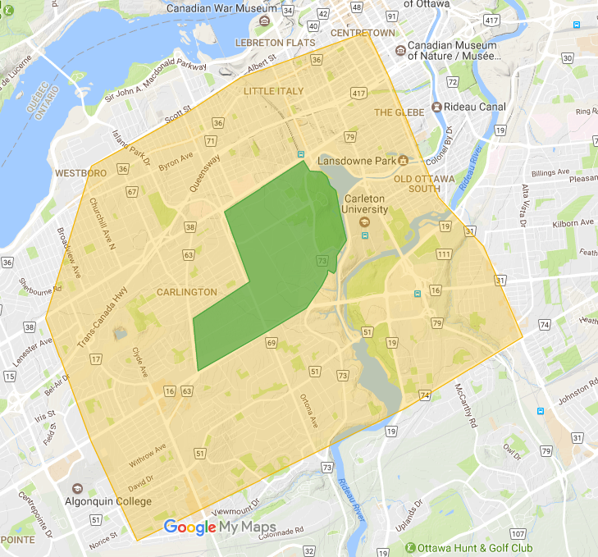

Figure : Map of the Ottawa urban area surrounding the central experiemental farm (CEF).

To capture seasonal differences in the environmental exposures, data were collected in in the fall of 2016 (September 22nd to October 7th) and winter 2017 (January 5th to January 19th). This yielded 14 consecutive days of data collection in each season. During each sampling period, 41 points located on and around the farm were chosen for this study (Figure). Similar research projects that have conducted passive sampling for entire cities used 50 points to ensure optimal spatial coverage and representativeness{{4488 Bertazzon,Stefania 2015}}. Locations for the 41 points were chosen in consideration of several factors. We chose points which represented both commercial and residential areas, locations inside and outside the CEF, and locations both in close proximity and far from highway 417 and arterial roadways. As well, we considered the general spatial coverage of the study area. Permission to connect our passive monitoring equipment to city lamp poles was obtained from the City of Ottawa. The monitoring equipment for NO2, VOC and noise were connected to rain shelters which were then strapped to lamp poles at each of the 41 points. Field blanks for NO2 and VOC samplers were deployed in each season to test for exposures due to sample handling and, if detected, correct for it.

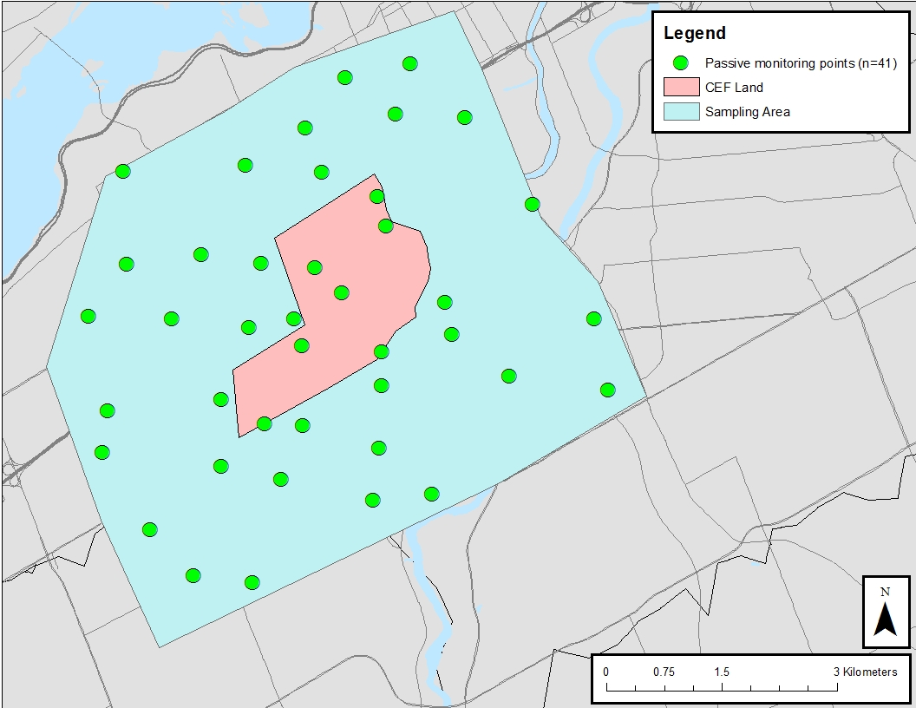

Figure .Locations of the 41 passive sampling points that collected measures for noise, NO2, and VOC in both fall and winter campaign. Note that no noise samplers were set up during the winter campaign.

A Sound Level logger noise sentry meter (Convergence Instruments, Quebec, CA) was used to record dBA values every two minutes for the period of 14 days during the fall session only. Previous work has demonstrated that these meters do not function well during cold temperatures{{4545 Goudreau,Sophie 2014}}. For this reason, they were only used during our fall sampling campaign. To prevent damage from rain, each noise meter was covered by a zip lock bag. A previous study noted this to be an effective strategy in minimizing its damage while not affecting data quality{{4545 Goudreau,Sophie 2014}}. Each noise meter ran on a battery life of 10 days. After 9 days, noise meters were taken down and replaced with new units with fresh batteries for the remainder of the 14-day period. For the battery change site visits, we arrived at the site with a new noise meter which was engaged on location as the old monitor was taken down. This was done to prevent gaps in data collection. At the end of the 14-day sampling period, each shelter was dismantled; the time of take down was also noted for the calculation of sample duration for each sample. NO2 and VOC samplers were stored in their respective containers, and NO2 samples were refrigerated as soon as possible. NO2 and VOC samplers were then mailed to a laboratory for analysis. Noise data were downloaded and stored on a laptop. Five field blanks were deployed for NO2 and VOCs. Passive sampling of VOCs was done using organic vapour samplers (3M 3500, St. Paul, MN), which provided exposure data for 26 VOCs. Laboratory analytical methods followed the established protocols. Five field blanks were deployed in each season to determine if any quantity of the measured exposures were due to the sampling handling process. Blank corrections were considered for each combination of VOC species and season. If the median blank value was greater than the lab detection limit, the median blank level was applied as a blank correction value for each sample in that season and VOC species group. Results for each VOC was provided by the laboratory in µg/m3. Each result represented a time weighted average for the 2-week sampling period for one site. NO2 data were collected using Ogawa passive samplers (Ogawa & Company USA, Inc., Pompano Beach, FL). Samples were kept below 5oC before and after deployment. Field blank correction protocol followed that of the VOC sampling approach.

## Data analysis

Noise monitors were calibrated to collect one dBA measurement every 2 minutes during the 14-day fall sampling period. Therefore, for every 24 hours, a total of 720 values would be collected for each of the 41 sites. The daily mean and standard deviation of all 2-min data collected for each site was calculated. Any 2-min dBA value that was 3 standard deviations from the daily mean was considered an outlier due to instrument error and removed from the data set. Metrics of noise were averaged over each day. All noise data were transformed logarithmically when calculating means and then exponentiated for interpretation. Days with less than 75% of valid noise data on account of equipment failure were invalidated. Sites with less than 10 days of data were excluded. For this study, these values were used to calculate daily average (LAeq24h), wighted daily average (Ldn24h), percent of day above the threshold of 65 dBa (>65 dBA), day time mean, night time mean, and coefficient of variation (COV). Continuous 2-min data were plotted by hour to examine the general diurnal variation of noise in the study area. Boxplots were also constructed to describe the distribution of daily values of noise. Combinations of seasons and gaseous pollutants (NO2 & VOCs) that were detected for at least 50% of the 41 passive sampling sites were further analyzed in descriptive statistics and considered for LUR model development.

## Creation of land-use regression models and surfaces

We used LUR models to predict the spatial variability of noise, NO2, and several VOCs in each season that they were measured. These models also provided a statistical test of significance, as well as a measure of the strength of the association between each environmental factor and the distance to the CEF. These models were further used to estimate these exposures for points which represented 100m × 100m points in a grid within the sampling area. This provided a visualization of each pollutant’s spatial variability. Models were developed which predicted our measured exposures using several factors of the built environment. Table 1 lists all potential model predictors which include traffic counts, bus routes, land type (commercial, residential, industrial, open space, CEF land), distance to the CEF, road network (local, major roads, and highway), and NDVI. Residential space was further characterized by 5 groups: single dwelling, duplex, triplex/townhomes, low-rise apartment, and high rise apartments.

LURs were developed as multivariate linear regression analyses (Equation 1) with the environmental factors as dependent variables and metrics of the built environment as their predictors. Dependent variables (environmental factors) were transformed using the natural logarithm for normality.

**(Equation 1)**

Here, Y is the natural logarithm of the environmental factor, β0 is the regression intercept, βi is the parameter estimate for the *i*th factor of the built environment (Xi). In this model, there are a total of n possible built environment factors. The random error is represented by ε. Metrics of each factor of the built environment were quantified for eight buffers (50m, 100m, 200 m, 300 m, 400 m, 500 m, 750 m, and 1000m). The association between the dependent variable and each potential predictor and dependent variable was quantified in a univariate regression analysis. Predictors with p-values less than 0.15 were retained for further consideration in model development. For each set of predictors belonging to a set of buffers, the predictor with the strongest relationship to the dependent (judged by R2 of the univariate regressions) was retained for further consideration in model development. The reason for this is because predictors belonging to a set of buffers are collinear due to their derivation. Remaining predictors were placed in a model to calculate the variance inflation factors (VIFs) of each predictor. Predictors with VIF values higher than 10 were judged as being too collinear with other predictors in the model and were dropped from further consideration. Backwards and forwards stepwise regression analyses were used to identify the best fitting model (judged by model R2). Effects of influential points for each final model were assessed by calculating Cook's distances (Hamilton, 2002). Residual plots were assessed for normality using the Shapiro-Wilk statistic (Srivastava & Hui, 1987). Data compilation, cleaning and statistical analyses were conducted in SAS 9.3.4. ArcGIS 10.4.1 was used for: assignment of mobile monitoring points to road segments, spatial averaging and relations, the creation of buffers, the quantification of built environment features in their areas, and LUR surfaces.

**Table 1 All potential model predictors along with their data source and description.**

|  |  |  |
| --- | --- | --- |
|  |  |  |
| Potential Predictor category* | Unit | Data Source |
| Commercial land | km2 | City of Ottawa (2016) Code ‘LC’ |
| Central Experimental Farm land | km2 | City of Ottawa (2016) Code ‘L3’ |
| Residential: single dwelling homes | km2 | City of Ottawa (2016) Code ‘R1’ |
| Residential: duplexes | km2 | City of Ottawa (2016) Code ‘R2’ |
| Residential: Triplexes and townhomes | km2 | City of Ottawa (2016) Code ‘R3’ |
| Residential: low rise apartments | km2 | City of Ottawa (2016) Code ‘R4’ |
| Residential: high rise apartments | km2 | City of Ottawa (2016) Code ‘R5’ |
| Open space | km2 | City of Ottawa (2016) Code ‘O1’ |
| Normalized difference vegetation index (NDVI) | Index unit |  |
| Length of highways | km | City of Ottawa |
| Length of major roads | km | City of Ottawa |
| Length of local roads | km | City of Ottawa |
| Length of trails | km | City of Ottawa |
| Distance to the centroid of the CEF | km | calculated in ArcGIS |
| Traffic | counts | City of Ottawa intersection  counts for 2015 and 2016 |
| Bus routes 2016 | km | City of Ottawa |
|  |  |  |

*Value of each surface type was quantified for 50, 100, 200, 300, 400, 500, 750, and 1000-meter buffers.

# Results

Of the 41 passive monitoring stations, complete data were obtained for 40 and 38 NO2 samples and 39 and 36 VOC samples, for fall and winter seasons, respectively. A total of 26 VOCs were measured in the passive campaign, however, only eight species were detected over 50% of the time in at least one season. The full list of VOC results is provided in supplemental (Table S1). The spatial variation as expressed by the descriptive statistics of NO2 and each VOCs is presented in Table 2. NO2 values across the 41 sites varied from 5 – 11 ppb with a mean of 7.1 ppb in the fall, whereas the mean value and range were 19.1 ppb and 1-27 ppb in the winter respectively. Among the measured VOCs, toluene, benzene and xylene had the highest concentrations. Additionally, these three VOCs were the most often detected. The concentrations of NO2, benzene and toluene in the fall were significantly (p<0.0001) different, with higher levels in the winter period. This phenomenon was not consistent with all VOCs.

Noise data were obtained from 34 of the 41 sites from the fall session. Three noise monitors were stolen.. An additional two noise monitors suffered power loss and or malfunctioned. After screening for outliers, 34 sites had at least 10 days of data, resulting in the ineligibility of two additional noise monitors. Although a 10-day sampling period does not have the 5:2 weighting of weekdays to weekend days, our data indicated that there was little difference between our week day noise data and that of our weekend data (Figure 3).

Table 2 A summary of the descriptive statistics obtained for NO2 and selected VOCs during the passive monitoring campaign in the fall (Sept. 22-Oct. 7) and winter (Jan. 5-Jan. 19) seasons.

|  |  |  |  |  |  |  |  |  |  |
| --- | --- | --- | --- | --- | --- | --- | --- | --- | --- |
|  |  |  |  |  |  |  |  |  |  |
| Pollutants | Season | N sites | % < LOD1 | Mean | SD2 | Min | p50 | Max | Seasonality  (p-value) |
| NO2  (ppb)* | Fall | 40 | 0% | 7.1 | 1.8 | 5 | 6 | 11 |  |
| Winter | 38 | 0% | 19.1 | 5.4 | 1 | 18.5 | 27 | <0.0001 |
| m,p-Xylene (µg/m3) | Fall | 39 | 0% | 0.56 | 0.24 | 0.26 | 0.47 | 1.27 |  |
| Winter | 36 | 0% | 0.54 | 0.21 | 0.23 | 0.49 | 1.14 | 0.7148 |
| Benzene  (µg/m3) | Fall | 39 | 8% | 0.37 | 0.16 | 0.1 | 0.36 | 0.9 |  |
| Winter | 36 | 0% | 0.71 | 0.29 | 0.25 | 0.67 | 1.58 | <0.0001 |
| Dichloromethane (µg/m3) | Fall | 39 | 11% | 0.04 | 0.1 | 0.1 | 0.1 | 0.92 |  |
| Winter | 36 | 11% | 0.35 | 0.12 | 0.1 | 0.35 | 0.62 | <0.0001 |
| Ethylbenzene (µg/m3) | Fall | 39 | 77% | 0.13 | 0.07 | 0.1 | 0.1 | 0.38 |  |
| Winter | 36 | 47% | 0.19 | 0.1 | 0.1 | 0.22 | 0.44 | 0.0022 |
| Hexane  (µg/m3) | Fall | 39 | 18% | 0.27 | 0.17 | 0.1 | 0.25 | 1.19 |  |
| Winter | 36 | 0% | 0.54 | 0.13 | 0.33 | 0.54 | 0.87 | <0.0001 |
| n-Decane  (µg/m3) | Fall | 39 | 79% | 0.21 | 0.23 | 0.1 | 0.1 | 1.07 |  |
| Winter | 36 | 39% | 0.23 | 0.14 | 0.1 | 0.22 | 0.61 | 0.6087 |
| o-Xylene  (µg/m3) | Fall | 39 | 67% | 0.16 | 0.09 | 0.1 | 0.1 | 0.41 |  |
| Winter | 36 | 36% | 0.21 | 0.1 | 0.1 | 0.22 | 0.47 | 0.0142 |
| Toluene  (µg/m3) | Fall | 39 | 0% | 0.97 | 0.26 | 0.59 | 0.94 | 1.89 |  |
| Winter | 36 | 0% | 1.5 | 0.54 | 0.68 | 1.47 | 2.93 |  |
|  |  |  |  |  |  |  |  |  |  |

Note: 1 < LOD, limit of detection (0.2 µg/m3), represents the percentage of time that these pollutants were below the limit of detection.

Descriptive statistics of the five noise metrics calculated for each of the 34 sites are presented in Table 3. LAeq24h varied from 49-73 dBA and the mean proportion of a day with noise levels exceeding the 65 dBA threshold varied from 1-91%. The average daily mean for all 34 sites was 57.4 dBA. The maximum daily mean was 72.7 dBA and the minimum daily mean was 48.6 dBA. On average, each site exceeded a 65 dBA threshold for 20% of the day. There was considerable range for this statistic with at least one site never exceeding this threshold (minimum = 0%) and a maximum of 90%. The time frames of the day and night averages were chosen based on an hourly analysis of the 2-min interval data. Noise data were plotted by hour (values 0-23) to investigate diurnal patterns of noise (Figure 4). This revealed the dBA values between 7AM-11PM were very similar, and was thus determined as the group of hours to be designated in the ‘day time’ noise metric. Consequently, the 11PM-7AM hours were designated as the ‘night time’ noise metric. Overall, night time dBA values were lower than daytime dBA values.

Table3 Descriptive statistics for noise metrics calculated for the 34 sites of the passive monitoring campaign in the fall (Sept. 22-Oct. 7).

|  |  |  |  |  |  |  |  |
| --- | --- | --- | --- | --- | --- | --- | --- |
| Table 3 Descriptive statistics for noise metrics calculated for the 34 sites of the passive monitoring campaign in the fall (Sept. 22-Oct. 7). | | | | | | | |
| Pollutant | Mean (dBA) | SD | Min | p25 | p50 | p75 | Max |
| LAeq24h | 60 | 7 | 49 | 53 | 57 | 67 | 73 |
| Ldn24h | 64 | 7 | 53 | 57 | 62 | 72 | 77 |
| % > 65 dBA | 35 | 35 | 1 | 2 | 21 | 75 | 91 |
| Night time average | 55 | 7 | 45 | 49 | 52 | 62 | 67 |
| Day time average | 62 | 7 | 51 | 55 | 61 | 70 | 75 |
| COV | 45 | 15 | 22 | 33 | 43 | 54 | 90 |
|  |  |  |  |  |  |  |  |

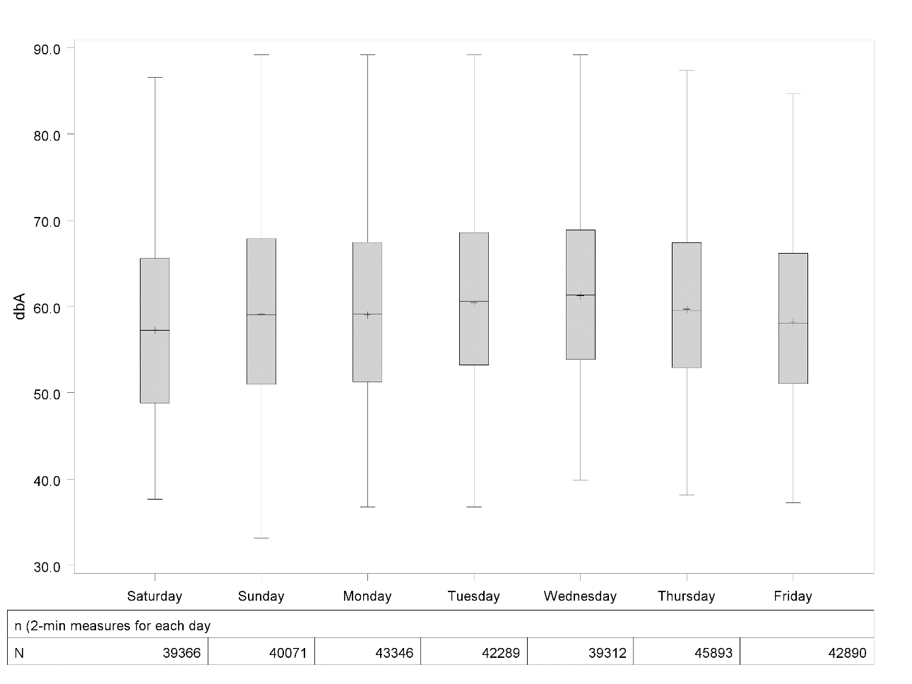

Figure . 2-min noise levels by weekday for 34 sites sampled in the fall of 2016.

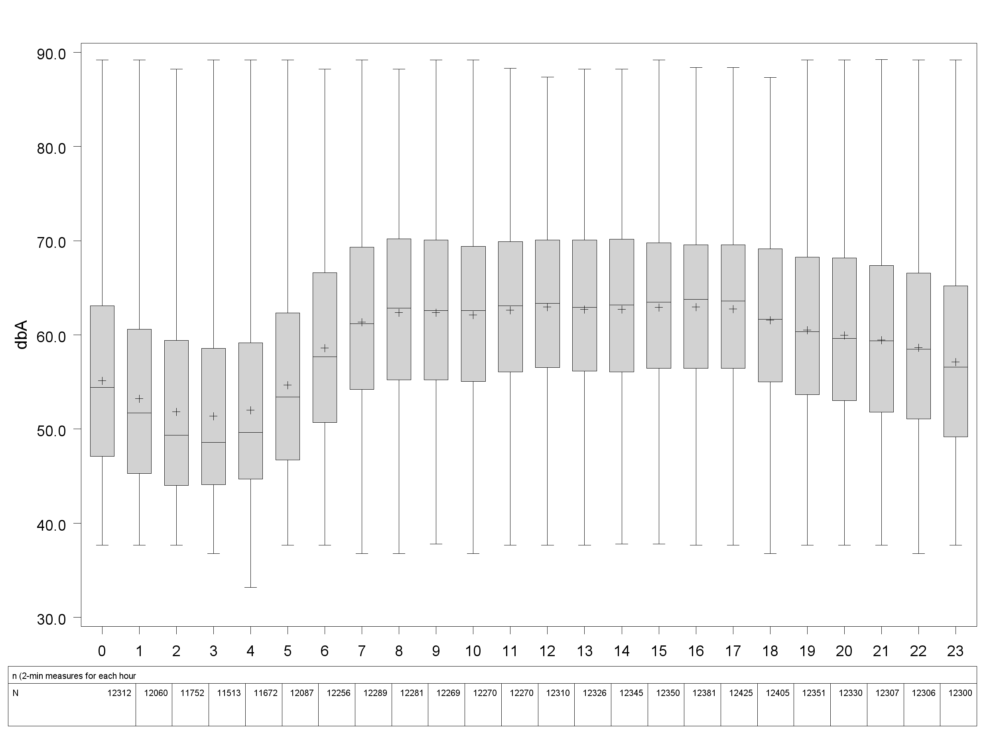

Figure 4. Diurnal variation of noise for 34 sites monitored in the fall of 2016.

Table 4 displays Pearson’s correlation values between each of the calculated noise metrics. Each noise metric shared strong positive relationships with one another (*r*>0.9) with the exception of the noise coefficient of variation (COV) which was the least related. We decided to conduct the LUR modelling of the daily mean metric as each noise metric was highly correlated, with the exception of the coefficient of variation. The daily mean noise levels was found to be correlated with NO2 only (Table 5).

Table 4. Pearson correlations coefficients for noise metrics calculated for the 34 sites in fall.

|  |  |  |  |  |  |  |  |  |  |
| --- | --- | --- | --- | --- | --- | --- | --- | --- | --- |
|  |  |  | |  | | | | | |
| Noise  metrics | Units |  | Pearson correlation coefficients* | | | | | | |
| LAeq24h | | Ldn24hr | %>65dBA | day time** | night time** | COV |
| LAeq24h | dBA |  | 1 | | 0.99 | 0.96 | 0.99 | 0.98 | 0.68 |
| Ldn24hr | dBA |  |  | | 1 | 0.96 | 0.99 | 0.98 | 0.67 |
| %>65dBA | % |  |  | |  | 1 | 0.96 | 0.95 | 0.66 |
| Day time average ** | dBA |  |  | |  |  | 1 | 0.95 | 0.59 |
| Night time average** | dBA |  |  | |  |  |  | 1 | 0.78 |
| COV | - |  |  | |  |  |  |  | 1 |
| *all Pearson correlations p-values < 0.001. | | | | | |  |  |  |  |
| **daytime = 7AM-11PM; night time = 11PM-7AM. | | | | | | |  |  |  |
|  | | | | | | |  |  |  |

Table 5. Pearson correlations coefficients between the daily average of noise (LAeq24h) and the air pollutants measured in the fall passive sampling campaign (NO2 and VOCs).

|  |  |  |  |
| --- | --- | --- | --- |
|  |  |  |  |
| Pollutant | *r* | n | p value |
| NO2 | 0.4728 | 33 | 0.005 |
| Benzene | 0.0262 | 32 | 0.887 |
| Toluene | 0.0547 | 32 | 0.7661 |
| Dichloromethane | -0.1329 | 32 | 0.4682 |
| Ethylbenzene | 0.1279 | 32 | 0.4853 |
| Hexane | 0.1607 | 32 | 0.3797 |
| n_Decane | -0.0394 | 32 | 0.8304 |
| o_Xylene | 0.1747 | 32 | 0.3389 |
| _m_p__Xylene | 0.213 | 32 | 0.2419 |

## Land Use Regression Models

The proportion of spatial variability accounted for in each LUR models is presented in Table 6. Generally, fall models performed better than the winter models.

Table 6. A summary of the R2 values of best fitting models for each pollutant, temperature and noise in both the fall and winter seasons.

|  |  |  |  |  |
| --- | --- | --- | --- | --- |
| Season | NO2 | Benzene | Toluene | Noise |
| Fall | 0.59 | 0.31 | 0.52 | 0.65 |
| Winter | 0.49 | 0.35 | 0.26 | - |

Table 7 and 8 display the NO2 LUR models for fall and winter, respectively. In both seasons, a moderate percentage of NO2 spatial variability was accounted for by land use factors with 1000m buffer sizes. In both seasons, NO2 was negatively associated with land use features associated with greenspace. While in the winter it was negatively associated with the mean NDVI factor within 1000m, the amount of CEF space within 1000kms was associated with lower NO2 in the winter. The spatial variation of NO2 was seen to be similar across seasons (Figure 5). The spatial variability of Toluene was contrasted across seasons. Where land use factors affecting Toluene levels were characteristic of large buffer sizes in the fall (100-1000m), very local circumstances accounted for the variability of Tolune in the winter (50-100m). This resulted in a significantly difference spatial patter between seasons (Figure 6). However, the model for the winter was weaker in predictive power (R2=26%) relative to winter (R2=52%). In winter, open park zone within 1000m was included in the final model, however, it waws not significantly associated with NO2 (p=0.091). A similar but low degree of spatial variability of benzene was accounted for by land uses in both seasons (Table 12 & 13). In both seasons, the measure of highways was found to be positively associated with benzene levels. In the fall, some evidence of the CEF lowering benzene levels as the amount of CEF land within 100m significantly lowered banezene levels (p=0.0375). Finally, 65% of the fall urban noise variability was characterized by the LUR model (Table 14). Predictors represented very local conditions (buffers 50,100, & 300 in size) and included factors of roads and bus routes. No factors of CEF space were included in the model.

**Table 7. Land use regression model for NO2 in the fall.**

|  |  |  |  |  |  |  |  |
| --- | --- | --- | --- | --- | --- | --- | --- |
|  |  |  |  |  |  |  |  |
| Dependent | Label | DF | Estimate | SE | Probability | RMSE | R2 |
| LOG(no2_ppb) | Intercept | 1 | 2.2018 | 0.49572 | <.0001 | 0.156 | 59% |
|  | mean NDVI within 1000m | 1 | -0.00007783 | 0.00006475 | 0.2375 |  |  |
|  | Length of local roads within 1000m | 1 | 0.00000778 | 0.0000047 | 0.1072 |  |  |
|  | Length of Highway within 1000m | 1 | 0.00001801 | 0.0000137 | 0.1971 |  |  |

**Table 8. Land use regression model for in NO2 the winter.**

|  |  |  |  |  |  |  |  |
| --- | --- | --- | --- | --- | --- | --- | --- |
|  |  |  |  |  |  |  |  |
| Dependent | Label | DF | Estimate | SE | Probability | RMSE | R2 |
| LOG(no2_ppb) | Intercept | 1 | 2.982 | 0.10155 | <.0001 | 0.388 | 49% |
|  | Duplex Residential Zone within 50m | 1 | -0.00017011 | 0.00003631 | <.0001 |  |  |
|  | Central Experimental Farm within 1000m | 1 | -2.29E-07 | 1.04E-07 | 0.0351 |  |  |
|  | Length of Highway within 1000m | 1 | 0.00003326 | 0.00002643 | 0.2169 |  |  |

**Table 9. Land use regression model for toluene in the fall.**

|  |  |  |  |  |  |  |  |
| --- | --- | --- | --- | --- | --- | --- | --- |
|  |  |  |  |  |  |  |  |
| Dependent | Label | DF | Estimate | SE | Probability | RMSE | R2 |
| LOG(Toluene) | Intercept | 1 | 0.08502 | 0.1719 | 0.6242 | 0.175 | 52% |
|  | Open park zone within 1000m | 1 | -2.41E-07 | 1.39E-07 | 0.091 |  |  |
|  | Single Dwelling Residential Zone within 750m | 1 | 2.21E-07 | 7.75E-08 | 0.0074 |  |  |
|  | Duplex Residential Zone within 400m | 1 | 1.8E-06 | 6.88E-07 | 0.0135 |  |  |
|  | Commercial zone within 300m | 1 | 0.000124 | 3.84E-05 | 0.0028 |  |  |
|  | mean NDVI within 100m | 1 | -4.1E-05 | 2.71E-05 | 0.1404 |  |  |

**Table 10. Land use regression model for toluene in the winter.**

|  |  |  |  |  |  |  |  |
| --- | --- | --- | --- | --- | --- | --- | --- |
|  |  |  |  |  |  |  |  |
| Dependent | Label | DF | Estimate | SE | Probability | RMSE | R2 |
| LOG(Toluene) | Intercept | 1 | 0.44977 | 0.05847 | <.0001 | 0.307 | 26% |
|  | Length of trails within 100m | 1 | -0.00104 | 0.000553 | 0.07 |  |  |
|  | Central Experimental Farm within 50m | 1 | -5.6E-05 | 3.98E-05 | 0.168 |  |  |
|  | Open park zone within 50m | 1 | -4.6E-05 | 2.56E-05 | 0.0824 |  |  |
|  |  |  |  |  |  |  |  |

**Table 11. Land use regression model for benzene in the fall.**

|  |  |  |  |  |  |  |  |
| --- | --- | --- | --- | --- | --- | --- | --- |
|  |  |  |  |  |  |  |  |
| Dependent | Label | DF | Estimate | SE | Probability | RMSE | R2 |
| LOG(Benzene) | Intercept | 1 | -1.24968 | 0.10597 | <.0001 | 0.406 | 31% |
|  | Central Experimental Farm within 100m | 1 | -1.8E-05 | 8.34E-06 | 0.0375 |  |  |
|  | Length of Highway within 1000m | 1 | 6.1E-05 | 2.69E-05 | 0.03 |  |  |
|  | Duplex Residential Zone within 400m | 1 | 3.35E-06 | 1.55E-06 | 0.0382 |  |  |
|  |  |  |  |  |  |  |  |

**Table 12. Land use regression model for benzene in the winter.**

|  |  |  |  |  |  |  |  |
| --- | --- | --- | --- | --- | --- | --- | --- |
|  |  |  |  |  |  |  |  |
| Dependent | Label | DF | Estimate | SE | Probability | RMSE | R2 |
| LOG(Benzene) | Intercept | 1 | -0.86788 | 0.12269 | <.0001 | 0.312 | 35% |
|  | Length of local roads within 300m | 1 | 0.000114 | 3.68E-05 | 0.0041 |  |  |
|  | Bus Route Length within 750m | 1 | 1.07E-05 | 5.03E-06 | 0.0422 |  |  |
|  | Length of Highway within 50m | 1 | 0.00388 | 0.00208 | 0.0712 |  |  |
|  |  |  |  |  |  |  |  |

**Table 13. Land use regression model for noise in the fall.**

|  |  |  |  |  |  |  |  |
| --- | --- | --- | --- | --- | --- | --- | --- |
|  |  |  |  |  |  |  |  |
| Dependent | Label | DF | Estimate | SE | Probability | RMSE | R2 |
| LOG(leq24h) | Intercept | 1 | 4.09182 | 0.03216 | <.0001 | 0.073 | 65% |
|  | Length of local roads within 100m | 1 | -0.00027 | 7.71E-05 | 0.0016 |  |  |
|  | Length of major roads within 50m | 1 | 0.000495 | 0.000204 | 0.0218 |  |  |
|  | Bus Route Length within 50m | 1 | 0.000722 | 0.000146 | <.0001 |  |  |
|  | Length of Highway within 300m | 1 | 3.54E-05 | 2.56E-05 | 0.1774 |  |  |
|  |  |  |  |  |  |  |  |

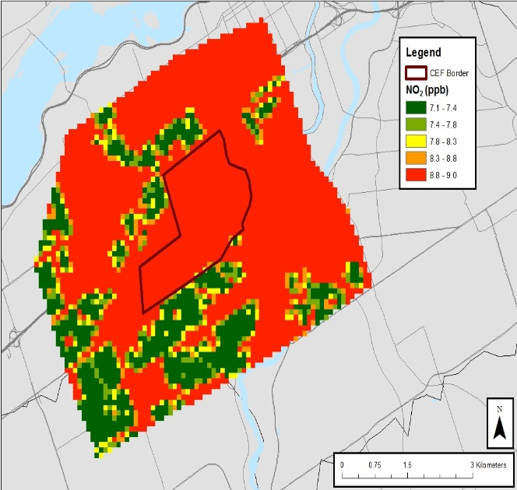 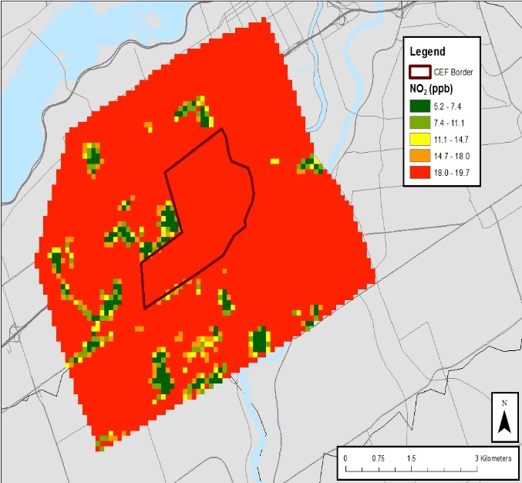

B

A

**Figure 5. NO2 LUR surfaces for fall (a) and winter (b).**

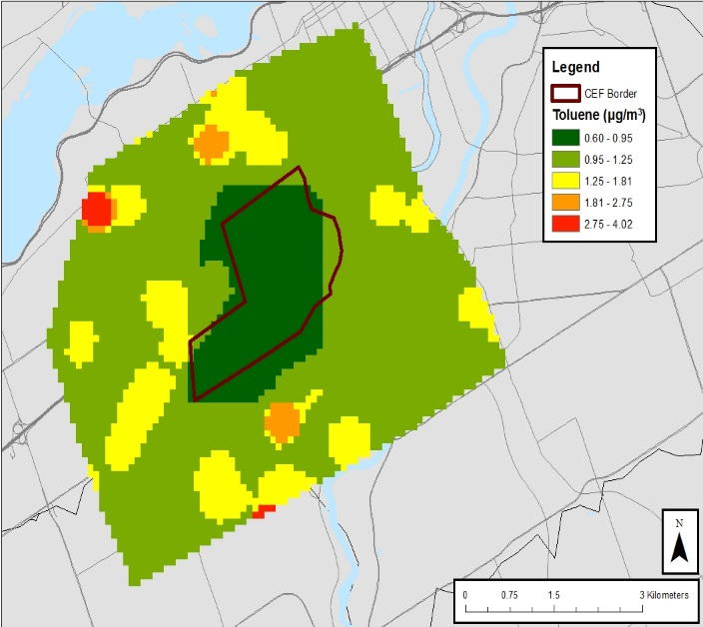 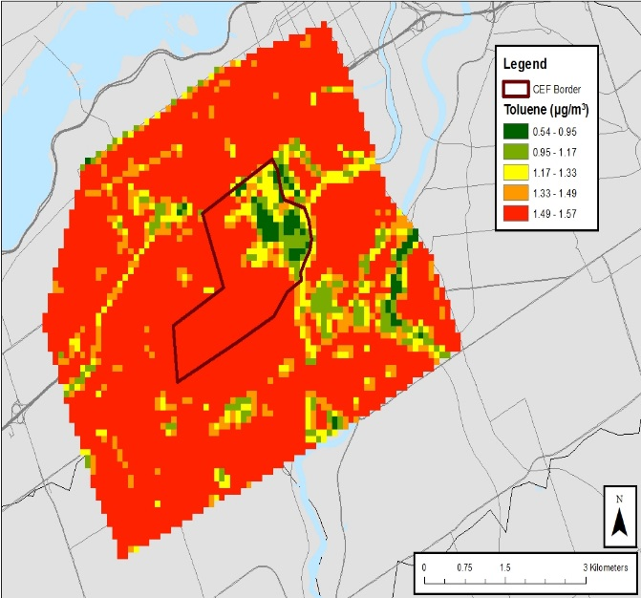

A

B

**Figure 6. Toluene LUR surfaces for fall (a) and winter (b).**

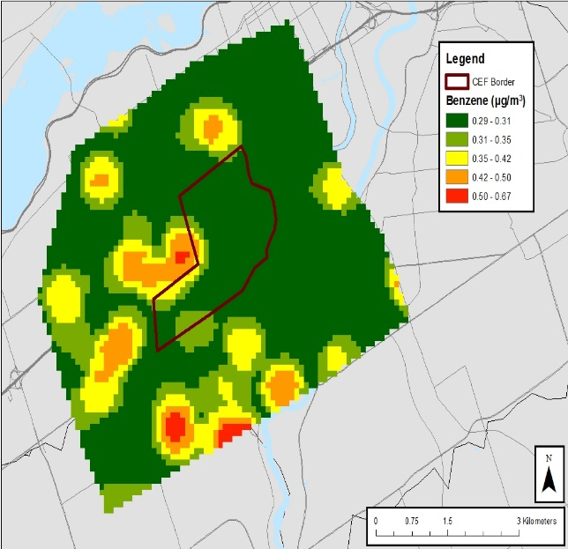 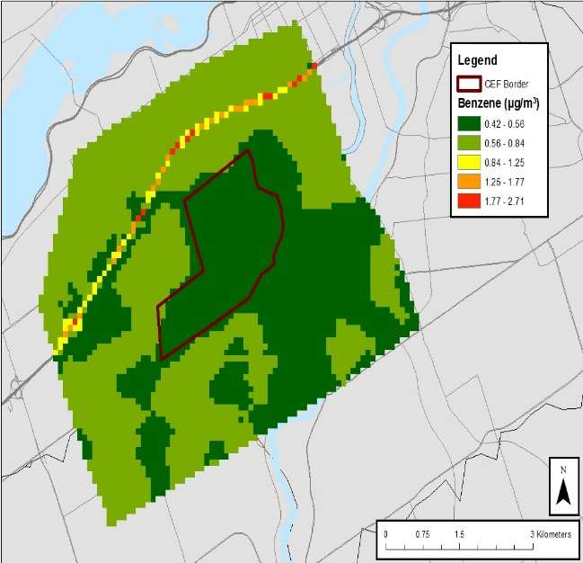

A

B

**Figure 7. Benzene LUR surfaces for fall (a) and winter (b).**

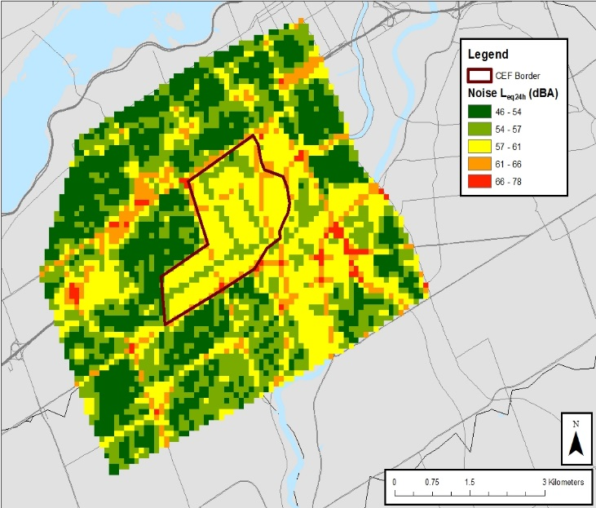

**Figure 8. Noise (Leq24h) surface for fall.**

# Discussion

This study’s use of the LUR method to characterize spatial variability of noise, heat and air pollution was unique in that it was applied to a small area of a city. Despite this, the generated models performed well for most environmental factors. The model performance was comparable with what was found in other studies, with R2 ranges of 0.31-0.76 and 0.21-0.57 for fall and winter models respectively. LURs developed for air pollutants in Canadian cities have generally performed well with R2 values from 0.50 to 0.96 (NO2), 0.73-0.78 (benzene), and 0.46-0.79 (toluene) (Atari et al., 2008; M. Jerrett et al., 2007; Oiamo et al., 2015; Parenteau & Sawada, 2012; Sahsuvaroglu et al., 2006; Wheeler et al., 2008). Researchers who conducted previous LUR studies in Canada presented pooled data for both seasons. Some may present the range of measurements for the specific air pollutants assessed. However, the final models and predictability power were determined using pooled data (Oiamo et al., 2015; Wheeler et al., 2008). To be considered in the model, sites must have a value in both seasons. This was not done here. The decision to characterize the spatial variability of these environmental factors in and around the CEF by season was an a priori decision. As the CEF space is agricultural in nature, its greenness and the activities conducted on it vary seasonally. Therefore assessing its relationship with the environmental factors by season was a reasonable approach to this study. In so doing, we may have lost some predicting power in our models. Nevertheless, we were able to assess the difference in model strength based on seasonality and develop surfaces based on seasons for different pollutants. This is the first time this has been done in a Canadian city. This finding further substantiates conclusions from Wheeler et al. (2008), as data collected in one season may not be sufficient to represent annual spatial variability in air pollutants. However, by comparing the fall and winter LUR models for NO2 of this study, support for combining data of both seasons to construct one LUR can be found. The LUR surfaces for NO2 in the fall (Figure A3.1(4)) and winter (Figure A3.2(4)) both demonstrate an even baseline through much of the study area with lower levels found in the same residential spaces. However, the effect of these spaces seems attenuated in the winter season. The winter NO2 model revealed a statistically significant inverse relationship between NO2 levels and the amount of CEF space within 1km, however, the examination of the LUR surface revealed the magnitude of this effect to be negligible in comparison with the other predictors. The representation of the LUR models as surfaces showed that lack of sources such as highways and bus routes on the CEF contribute to lower temperatures and air pollution. This was not the case for noise (see Figure 3.10), where the quietest areas of the city were areas with high concentrations of local roads and single dwelling homes. The surface for temperature in the fall also revealed a potential cooling effect in and around the CEF. However, this is potentially due to the lack of heat sources on the CEF. Several surfaces showed a similar effect for Vincent Massey Park, a large green space located south east of the study area. This is consistent with Parenteau and Sawada’s (2012) findings, as green space was a key predictor in several models developed in this study. This study thus provides added value to the existing information on the use of LUR models to represent noise, air pollution and temperature distribution in a Canadian context.

Oiamo et al. (2015) developed LUR surfaces for NO2 for the entire city of Ottawa in the fall (October 7-21, 2008) and spring (May 6-20, 2009). Researchers reported a range of 1.92-14.53 ppb for NO2 in the fall. This variation was greater than that observed in the fall season of the current study (range = 5-11 ppb). This lower spatial variability in is most likely due to our smaller sampling area relative to the city-wide sampling of the previous Ottawa study. To investigate the transferability of LUR NO2 models, Oiamo et al., provided estimates of NO2 exposure for our measurement sites based on their NO2 LUR model. Results suggest that the higher density of sampling sites characterized spatial variability which could not be captured by a city-wide model. The comparison in winter (Figure 9) showed only 29% of the variability in our measured NO2 was accounted for by the Oiamo model compared to the 49% of our best fit LUR model. The Oiamo model performed better for the fall explaining 44% of the variability (Figure 10). The better performance for the fall data could be due to the fact their own sampling took place in the fall.

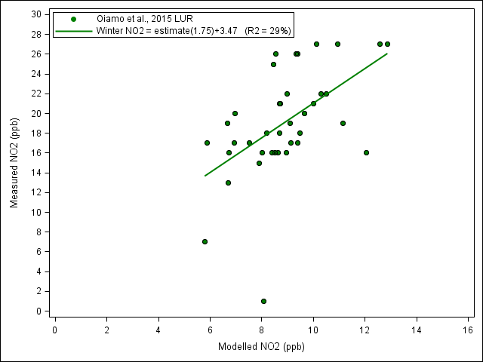

Figure 9. Performance of NO2 LUR models by Oiamo et al., 2015 for measured NO2 values in the winter (January 5-January 19).

In the present study, LUR models for VOCs were developed for benzene and toluene only, given that these have been extensively studied due to their health impacts. The concentrations of benzene and toluene determined in our fall study period varied from 0.10-0.90 µg/m3 and 0.59-1.89 µg/m3 respectively. While the concentrations in the previous study varied from 0.35-1.04 µg/m3 and 0.72-7.84 µg/m3 for benzene and toluene respectively (Oiamo et al., 2015). Comparable variations and levels were found in both studies for benzene. However, intra-urban variability of toluene was higher in the previous study. Again, these higher levels could be indicative of the greater area for which these pollutants were sampled.

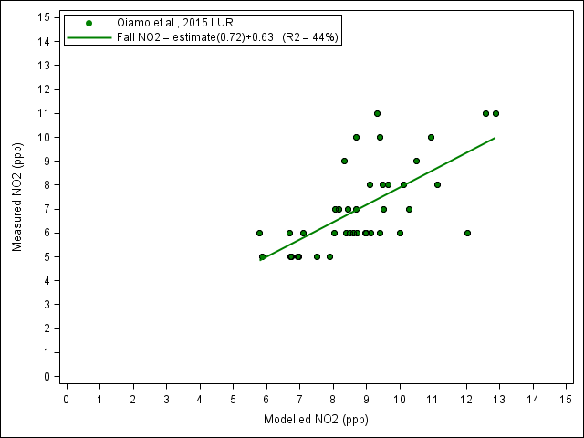

Figure 10. Performance of NO2 LUR models by Oiamo et al., 2015 for measured NO2 values in the fall (September 22 - October 7).

Average daily noise levels in the fall varied from 48.6 to 72.6 dBA, with a mean value of 59.5 dBA. Night and day time averages ranged from 44.7 to 67.4 dBA (mean 54.8 dBA) and from 50.9 to 75.5 dBA (mean 62.3 dBA) respectively. The scope of studies available in Canada in which researchers have considered the spatial variation of noise is very limited. However, in one such study conducted in Montreal during the summer (August 11-24, 2010), researchers found similar variations in daily averages (53.4 – 73.7 dBA) to those we found in the fall in Ottawa. This finding suggests that the values we captured were typical of a Canadian city.

The noise bylaw in Ottawa recommends values of 40-55 dBA in residential zones. As was mentioned in the introduction section above, there is some evidence suggesting that noise levels above 65 dBA may have adverse health impacts (Bluhm et al., 2007). In our study, most sites had sustained levels above this bylaw. Additionally, the threshold value of 65 dBA was exceeded across all points on average 20% of the time during the two-week study period. There is some evidence that supports the notion of sudden noises that differ from the consistent noise levels may have a greater impact on residents (Job, 1996). Therefore, although many of the sites had higher than recommended noise levels, these may or may not be regarded as noise annoyances by nearby residents.

Several metrics for urban noise are used to determine noise distribution in cities. For example, these include daily averages, and night and day time averages. In this study, we looked at the correlation between five different metrics of noise (see Table 3.11). Using a Pearson correlation matrix, we determined that four noise metrics used in this study were highly related to each other (*r* > 0.94). The final noise metric we chose, the coefficient of variation, was moderately associated to the other metrics (*r* = 0.59-0.78). This means, a station may have high noise levels with low variation, or low noise levels with high variation. Researchers in New York City (NYC) mapped noise levels for a one-week period (Kheirbek et al., 2014). Similar to this work, researchers also assessed the correlations among several noise metrics. Their findings were comparable to what was found here, as metrics of average noise (daily, day time, night time, weekday, and weekend averages) were highly correlated with each other (*r* > 0.83).

Although we found some correlation between noise and NO2 (*r* = 0.47), VOCs were not correlated (*r* < 0.1). Researchers assessing the association between traffic-pollutants, average noise and rheumatoid arthritis in Vancouver, BC reported that NO2 levels were only slightly related to noise (*r* = 0.33) (De Roos, Koehoorn, Tamburic, Davies & Brauer, 2014). However, results from the NYC study mentioned above indicated that daily average noise levels were correlated with 2-week average levels of NO2 (r = 0.59 to 0.64) (Kheirbek et al., 2014). Evidence from other studies have also supported a correlation between noise and the traffic related pollutant NO2 (Allen et al. 2009; Davies, Vlanderen, Henderson & Brauer, 2009). The evidence on this association remains inconclusive and may be city and pollutant level dependent.

One of the limitations related to our study is the exclusion of meteorological measurements such as wind speed and direction. Wind can have an impact on air pollution by dispersing pollutants throughout the city, and has been shown to impact intra-urban air pollutants distributions in previous studies (Arain et al., 2007; Oiamo et al., 2015). Our fall wind speed had a minimum speed of 32km/h and a maximum speed of 44 km/h. In the winter, our minimum wind speed was 31km/h and our maximum speed was 76 km/h (Environment and Climate Change Canada 2017). Our study does not analyze the extent of the impact of these wind speeds on the air pollutants measured. The inclusion of these meteorological factors is recommended for future research to further understand the contributions of wind direction and speed to the dispersion of air pollutants.

In this study, we successfully assessed the spatial variability of urban noise and air pollution in the city of Ottawa and conducted a spatial analysis to related these variations to CEF space. We found that the farm had an impact on NO2. The spatial variation in these environmental factors were also comparable to some previous research in Canadian cities. This study adds value to the previous LUR models that have been developed in Canada.

Understanding how air pollution and noise can vary within cities is the first step in assessing the impact that they may have on population health, as well as informing at-source mitigation strategies and urban design policies. By developing these models, we can assess the relationship between exposure and health. Epidemiological research looking at the potential impact of the variability we observed on the health of nearby residents would be beneficial. As was mentioned earlier, the farm is located in a densely populated area of the city. Consequently, should it have any impacts on health, this could have implications for many of Ottawa’s residents. As was mentioned in the introduction, different types of vegetation may impact these factors in different ways. We did not characterize the types of vegetation (deciduous trees, shrubbery, grass, etc.) on the farm. However, this would be worthwhile to determine how these factors are impacted by the different green spaces on the farm.

In their study of air pollution distribution in Windsor, Wheeler et al. (2008) observed that measurements taken in one season did not represent those of other seasons. This is important for health research. Consequently, it would be of value to develop surfaces for these exposures in all four seasons. This will allow for better temporal and spatial assessments of each environmental factor, thereby strengthening the LUR models (Arain et al., 2007).

Moreover, this study provides useful baseline data. Should there be any future developments on the farm, we will be able to reassess these exposures and determine if there are changes to the spatial variability we observed. Studies characterizing the intra-city variation of urban noise, temperature and air pollution, are invaluable as they provide results that could be used to assess exposure for specific populations. Furthermore, the sources of urban noise, heat, and air pollution are mainly anthropogenic in nature. This signifies that these environmental factors are modifiable, particularly at a local scale. The findings from the current study is therefore relevant for regulatory development, city planning, and the generation of health frameworks at a local interventional level.