

UCCD1203 DATABASE DEVELOPMENT AND APPLICATIONS

Assignment

June 2023

Group No: 68

|  |  |  |  |  |  |
| --- | --- | --- | --- | --- | --- |
| No | Student ID | Name | Program | Lecture Group | Signature |
| 1. | **2200685** | **Ang Chin Siang** | **CS** | **L2** |  |
| 2. | **2200836** | **Hi Kai Jie** | **CN** | **L2** | Inserting image... |
| 3. | **2200232** | **Lee Jia Jie** | **CS** | **L2** |  |
| 4. | **2300722** | **Leong Yee Chung** | **CS** | **L2** |  |

Marking Section:

|  |  |
| --- | --- |
| Section | Marks |
| Part A |  |
| Part B |  |
| TOTAL |  |

**MARKING SCHEME**

|  |  |
| --- | --- |
| **Scholarship Application Database Case Study** | |
| **Check list for Part A – Database Design (5%)** | |
| 1. **Introduction (5 marks)**  Describe the system overview, 3 main objectives of this project, and the list of database user. |  |
| 1. **ER model (15 marks)** You are required to design an ER diagram for the case study given, identify entities, identify relationships, identify associate attribute, and determine keys. Check the ERD with the requirements stated in the case. Resolve all the many-many relationships. |  |
| 1. **Business Rule** **Requirements (10 marks)**   Identify the business rule involve based on the ERD. Please include any assumptions that you make. |  |
| 1. **Report (5 marks)**   Submit your report with proper technical report writing skills (cover page, headers & footers, page numbering, headings, sections numbering, proper fonts, spell checked, proper alignments, spacing, marking scheme, table of contents etc). |  |
| **SUBTOTAL:** | **/35** |

|  |  |
| --- | --- |
| **Check list for Part B – The Implementation of Database using Microsoft Access (5%)** | |
| 1. **Tables and records (15 marks)**   Create all the relations in the ERD and insert the necessary records. (at least 10 records per table except for scholarship provider records) |  |
| 1. **Queries (15 marks)**   Create 3 useful queries based on the given case study and include the corresponding SQL command. Explain the purpose of each query. |  |
| 1. **Forms (15 marks)**   Create 3 useful forms based on the given case study. You may use subform(s). Explain the purpose of each form. Include colours/images to make your form look interesting. |  |
| 1. **Reports (15 marks)**   Create 3 useful reports based on the given case study. Explain the purpose of each report. Design your reports so that it will look proper and easy to understand. |  |
| 1. **Switchboard (5 marks)**   Create a switchboard that includes all the tables, forms, queries and reports. Make sure the switchboard can **start automatically** when the database is open and include the **exit button** to exclude the user from the database. |  |
| **SUBTOTAL:** | **/65** |

**TABLE OF CONTENTS**

|  |  |
| --- | --- |
| **FRONT PAGE** | **1** |
| **MARKING SCHEME** | **2-3** |
| **TABLE OF CONTENTS** | **4** |
| **LIST OF FIGURES** | **5** |
| **LIST OF TABLES** | **6** |
|  |  |
| **CHAPTER 1 PROJECT BACKGROUND** |  |
| 1.1 System Overview | 7 |
| 1.2 Project Objectives | 8 |
| 1.3 Target Database User | 8 |
|  |  |
| **CHAPTER 2 DATABASE DESIGN** |  |
| 2.1 List of entities and attributes | 9 |
| 2.2 Entity Relationship Diagram (ERD) | 10 |
| 2.3 Assumptions and Business Rules | 11-15 |
|  |  |
| **CHAPTER 3 DATABASE DEVELOPMENT** |  |
| 3.1 List of tables | 16 |
| 3.1.1 Data Dictionary and Table Records | 16-28 |
| 3.1 Switchboard | 28-29 |
|  |  |
| **CHAPTER 4 DATABASE OBJECTS** |  |
| 4.1 Queries | 30-32 |
| 4.2 Forms | 37-39 |
| 4.1 Reports | 33-36 |
|  |  |
| **CHAPTER 5 CONCLUSION** |  |
| 5.1 System Weaknesses | 40-41 |
| 5.2 Future Improvement | 41-42 |

**LIST OF FIGURES**

|  |  |  |
| --- | --- | --- |
| **Figure Number** | **Title** | **Page** |
| Figure 2.1 | Entity Relationship Diagram | 10 |
| Figure 3.1 | Switchboard | 28 |
| Figure 3.2 | Main Switchboard | 28 |
| Figure 4.1 | Query 1 | 30 |
| Figure 4.2 | Query 1 | 31 |
| Figure 4.3 | Query 2 | 31 |
| Figure 4.4 | Query 3 | 32 |
| Figure 4.5 | Query 3 | 32 |
| Figure 4.6 | Query 3 | 33 |
| Figure 4.7 | Query 3 | 33 |
| Figure 4.8 | Report 1 | 34 |
| Figure 4.9 | Report 2 | 34 |
| Figure 4.10 | Report 2 | 35 |
| Figure 4.11 | Report 2 | 35 |
| Figure 4.12 | Report 3 | 36 |
| Figure 4.13 | Form 1 | 37 |
| Figure 4.14 | Form 2 | 38 |
| Figure 4.15 | Form 3 | 39 |

**LIST OF TABLES**

|  |  |  |
| --- | --- | --- |
| **Table Number** | **Title** | **Page** |
| Table 3.1 | Student Dictionary | 16 |
| Table 3.2 | Student Table Records | 16 |
| Table 3.3 | Guardian Dictionary | 17 |
| Table 3.4 | GuardianTable Records | 17 |
| Table 3.5 | SPM Result Dictionary | 18 |
| Table 3.6 | SPM Result Table Records | 18 |
| Table 3.7 | Involvement Dictionary | 19 |
| Table 3.8 | Involvement Table Records | 20 |
| Table 3.9 | Subject Dictionary | 20 |
| Table 3.10 | Subject Table Records | 21 |
| Table 3.11 | Scholarship Providers Dictionary | 22 |
| Table 3.12 | Scholarship Providers Table Records | 22 |
| Table 3.13 | Scholarship Dictionary | 23 |
| Table 3.14 | Scholarship Table Records | 23 |
| Table 3.15 | Application Dictionary | 24 |
| Table 3.16 | Application Table Records | 24 |
| Table 3.17 | Application Recommendation Dictionary | 25 |
| Table 3.18 | Application Recommendation Table Records | 26 |
| Table 3.19 | Recommendation Dictionary | 26 |
| Table 3.20 | Recommendation Table Records | 27 |
| Table 3.21 | Recommender Dictionary | 27 |
| Table 3.22 | Recommender Table Records | 28 |

**Scholarship Application Database Case Study**

**CHAPTER 1 PROJECT BACKGROUND**

**(Q1) Introduction**

In this digital age, data has been one of an inseparables, crucial, and representative “items” that nearly indicating every affairs around our real life. However, such an important “item” deserved a space to contain as well as protect it from losing and leaking. It is a database.

In this project, our main mission is to design a system that provides comfortable using experience for SPM leavers in terms of making successful scholarship application from different providers while both accuracy and consistency of system are assured.

**(1.1) system overview**

The idea of this database system development mainly focuses on dealing with information of scholarship applications from students who are leavers of Sijil Pelajar Malaysia (SPM). In this system, several information of main entities such as student, scholarship providers, recommender are crucial in the database system. Besides, different kind of scholarship from providers are recorded in the system with distinct conditions and descriptions for applicants to make their option. This system will also store the application from every scholarship applicant and received by different providers. Also, each application required recommendations from recommenders, the recommendation details will also be stored to serve as a basis for identifying the impartiality. Besides recommendation, students’ SPM result plays an important role in an application, the system will also store it for later assessment. One of the function of system is, pulling out five important subjects for easing the qualification evaluation for each application. Lastly, the system has also the function of displaying the status of application to applicants.

**(1.2) Project Objectives**

The first objective of this project is to create a database system that includes all the useful information and details which is later helpful in dealing with relationship of all parties that involving in this database system. Just like entities which are mentioned above, each of them contributes information needed to ensure cycle of business event is running stably while fulfilling the business rules.

Second, the next objective of this project is to enable all relevant parties involved, to keep tracking desirable information. For example, student who is interested in applying scholarship can see all applicable scholarship provided by different providers as well as details of application. Besides, in the link of assessing qualification, necessary information of applicants can also be retrieved easily from connected entities. Finally, applicants can also track the status of applications of scholarship.

Lastly, a database provides a higher efficiency and effectiveness in data storing and retrieving which can save tons of time of users, especially when it involves great amounts of data. At the same time, it also ensures the accuracy, security and consistency of data item.

**(1.3) Target database users**

The targeted users for the system are students, scholarship providers and related staff who provide appropriate assessment to each scholarship application. This database system is mainly designed to serve as a platform for students to make scholarship applications as well as for scholarship providers to upload all available scholarship details. Student who is interested in applying scholarship can read all relevant information from the system by just giving an access to the system. Besides, application can be simply done by providing complete personal information and waiting for the status replying of each application. Staff as an evaluator can also easily retrieve information of each application and gives a judge of qualification based on the accuracy and authenticity of information provided. Lastly, scholarship providers can always update the latest available scholarship and details to the system. Since targeted users are from different levels of familiarity to use of system, the system is planned to be user friendly to provide good experience.

**CHAPTER 2 DATABASE DESIGN**

**(2.1) List of entities and attributes**

|  |  |
| --- | --- |
| **Entity** | **Attribute** |
| **Student** | **StuID (PK), StuName, IC_Number, Sch_Name, Home_Addr, Email, Gender, Tel_No** |
| **Guardian** | **StuID (FK), Guardian_Name, IC_Number, Relationship, Gender, Tel_No, Home_Addr** |
| **SPM_Result** | **SPMR_ID (PK), StuID (FK), Stu_Information** |
| **Involvement** | **Subj_ID (FK), SPMR_ID (FK), Grade, Number_Of_Subj** |
| **Subject** | **Subj_ID (PK), Subj_Name, Subj_Desc** |
| **Sch_Provider** | **Prov_ID (PK), Prov_Name, IC_Number, Gender, Email, Tel_No** |
| **Sch_Ship** | **Sch_S_Num (PK, FK), Prov_ID (FK), Sch_Ship_Name, Criteria, Sch_amount, Sch_Ship_Desc, Offer_Duration** |
| **Application** | **App_ID (PK), StuID (FK), Prov_ID (FK), Sch_S_Num (FK), App_Date, ExtraCurr_Details, Com_Activity_Details** |
| **Recommendation** | **RCMDER_ID (PK, FK), Recom_Code (PK, FK), Recom_Details** |
| **App_Recomm** | **App_ID (FK), Recom_Code (FK), Recom_Details** |
| **Recommender** | **RCMDER_ID (PK), Recom_Name, Gender, Tel_No, Identity, Email** |

**(2.2) Entity Relationship Diagram (ERD)**

Figure 2.1

**(2.3) Assumption and Business Rules**

1. **Entity: Student**

Assumption: Student is the main character in the system who engages scholarship application.

Business Rules:

* Each student will be provided unique ID
* Student must include their Name, IC_Number, School_Name, Telephone_No,

Home_Address, Gender, Email as their information.

* Student will only have one SPM_Result.
* Student can make **Zero** or **Many** scholarship applications.
* Each student may have more than one guardian information.

1. **Entity: Guardian**

Assumption: Guardian is a weak entity that having a strong relationship connected to student.

Business Rules:

* Each guardian information will be stored in another table as a existence dependence and only belonged to one student.
* Guardian information such as Guradian_Name, IC_Number, Telephone_No,

Home_Address, Gender, and Relationship with student is required.

1. **Entity: SPM_Result**

Assumption: SPM_Result contains multiple subjects and grade for each subject.

Business Rules:

* Each SPM_Result has unique ID.
* Stu_ID, student_information will be stored as attributes.
* Each SPM_Result is belonged to only **one** student.
* SPM_Result contains multiple subjects and its grade.
* Each SPM_Result may be included in **Zero or Many** scholarship applications.

1. **Entity: Involvement**

Assumption: Each **SPM_Result** will contain **Many** **Subject** and each **Subject** involves in **Many** different SPM result.

Business Rules:

* Every instance in Involvement includes SPMR_ID and Subj_ID.
* Attributes of Involvement include Number of subject, and Grade.

1. **Entity: Subject**

Assumption: Different subjects involved in different SPM result.

Business Rules:

* Every Subject has unique ID.
* Subject name and subject description will be stored in subject table.
* Each subject may involves in **Zero or Many** SPM result.

1. **Entity: Sch_Provider**

Assumption: Scholarship providers provide different kind of scholarship.

Business Rules:

* Every Scholarship providers is assigned an unique ID.
* Scholarship providers attributes including Name, IC_Number, Telephone_No,

Gender, Email.

* Each Scholarship providers may receive **Zero to many** Scholarship application**.**
* Each Scholarship provider can provide **Zero to many** scholarships to different applicants.

1. **Entity: Sch_Ship**

Assumption: Scholarship is an weak entity that follows different owned Scholarship provider. Scholarship application is only available once a year.

Business Rules:

* Scholarship has Scholarship number which is a composite key that include Prov_ID.
* Scholarship has Prov_ID as Foreign key.
* Different Scholarship has own name, details, and criteria.
* All type Scholarship can be received by **Zero to Many** different applications.
* Different Scholarships are provided by its Scholarship providers.

1. **Entity: Application**

Assumption: Scholarship application is applied by student who are interested in.

Business Rules:

* Each Application has unique ID.
* Each Application contains StuID, SPMR_ID, Prov_ID, and Sch_S_Num as foreign key, and applied date as single attribute.
* Every application is belonged to **One** applicant.
* Each application required SPM result, two or more recommendation.
* Each application can only be sent to **One** Scholarship provider.
* Each application will receive **Zero to One** status.

1. **Entity: App_Recomm**

Assumption: Each application requires **Many** recommendations and each Recommendation can be provided to **Many** different applications.

Business Rules:

* App_ID and Recom_Code are required in this table.
* Each combination of App_ID and Recom_Code has details.

1. **Entity: Recommendation**

Assumption: Recommendation is required by applicants for scholarship applications.

Business Rules:

* Recommendation has RCMDER_ID as foreign key and Recom_Code as composite key made partially of RCMDER_ID.
* Each recommendation contains its details.
* Each recommendation is provided by **One and only One** recommender.
* Each recommendation may involve in different applications.

1. **Entity: Recommender**

Assumption: Recommender provides recommendations to scholarship application.

Business Rules:

* Each Recommender has unique ID.
* Attributes such as Name, Gender, Telephone_No, Identity, Email will be stored in table.
* Each Recommender can provide **Zero to Many** Recommendations to different applications.

This section is going to discuss about the business rules involved in the development of this database system.

**Ensure the Uniqueness of Instances:**

First of all, the business rule is related to all strong entities is structural business rule. Every strong entities must be assigned unique attributes, which is primary key to ensure the uniqueness of each instances in the entities.

**Receipt of Application:**

Second, according to business rules, each scholarship provider is determined to be able to accept many applications at the same time, but each application from applicants can only be received by a scholarship provider.

**Requirement of Recommendations:**

Next, in order for every application from applicants to fulfill the application rules, it should be accompanied by at least two recommendations from authoritative parties which will be review for qualification justification.

**Submission of Application:**

Each applicant is allowed to make more than one different scholarship submission and will be recorded based on individual application. Besides, each application is required to include application date, extracurricular activities, and community activities if information is available.

**CHAPTER 3 DATABASE DEVELOPMENT**

**3.1 List of tables**

The tables involved in this database are student, guardian, SPM result, involvement, subject, scholarship providers, scholarship, application, application recommendation, recommendation, and recommender.

**3.1.1 Data Dictionary and Table Records**

**Student**

Data Dictionary:

Table 3.1

Table Records:

Table 3.2

**Guardian**

Data Dictionary:

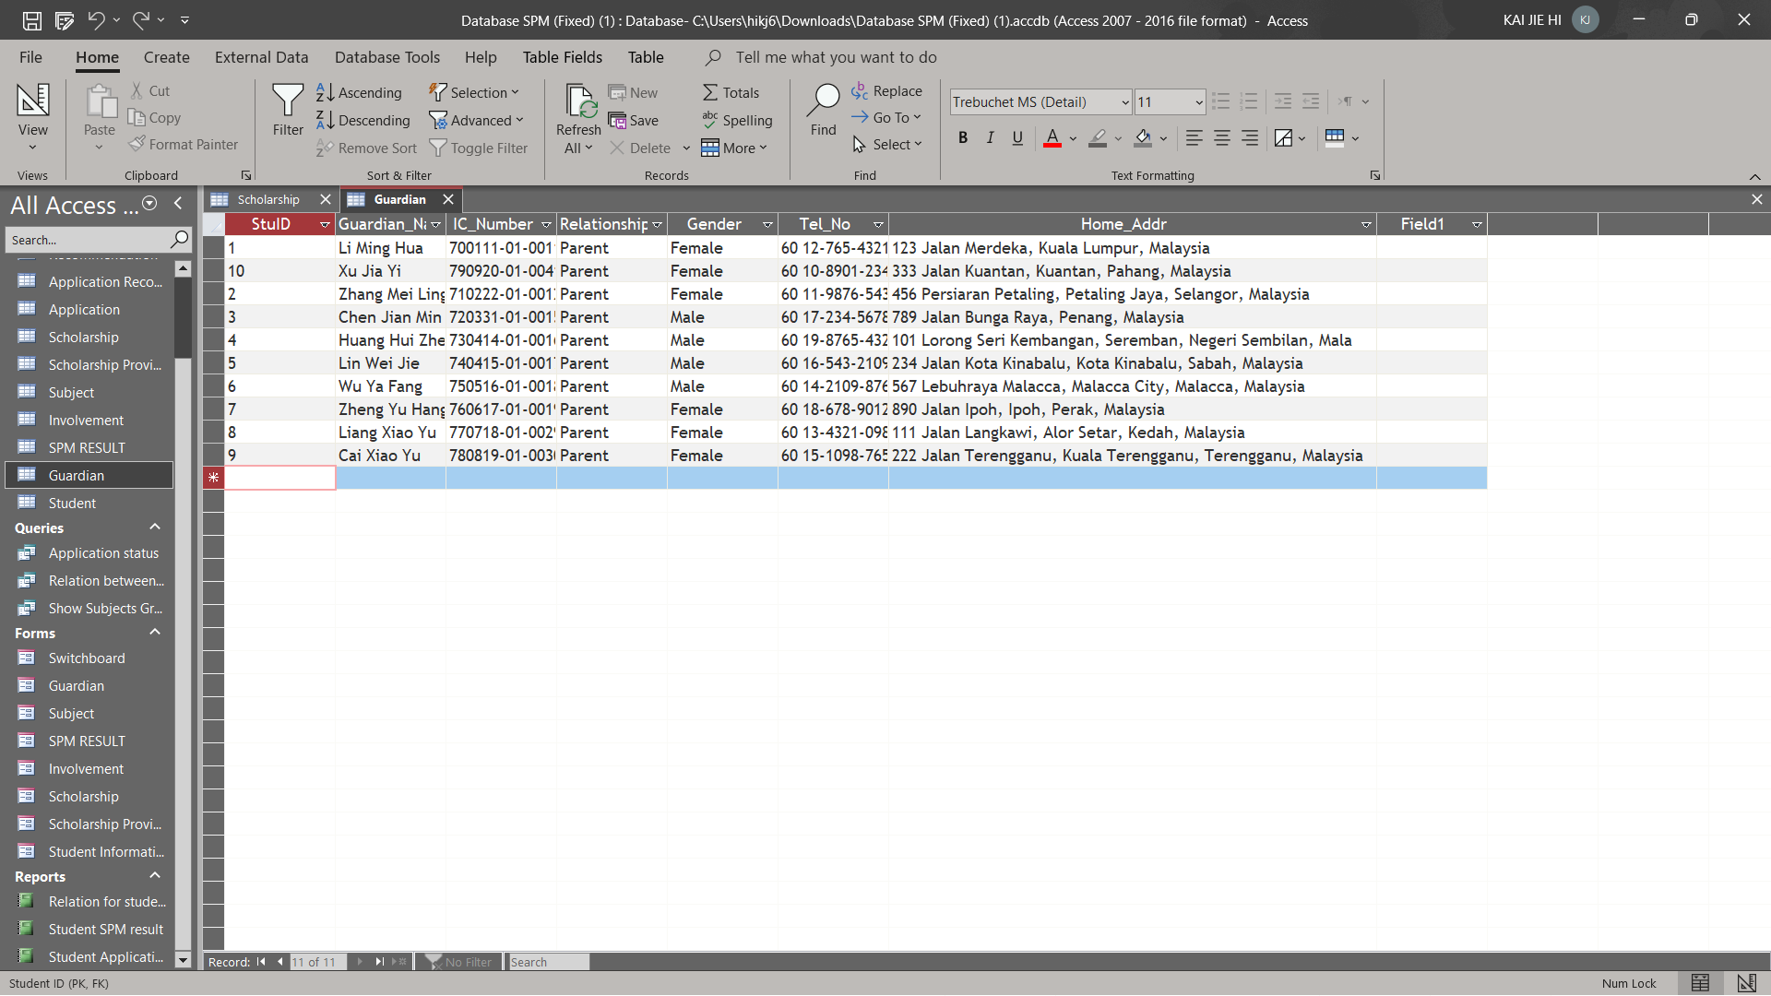Table 3.3

Table Records:

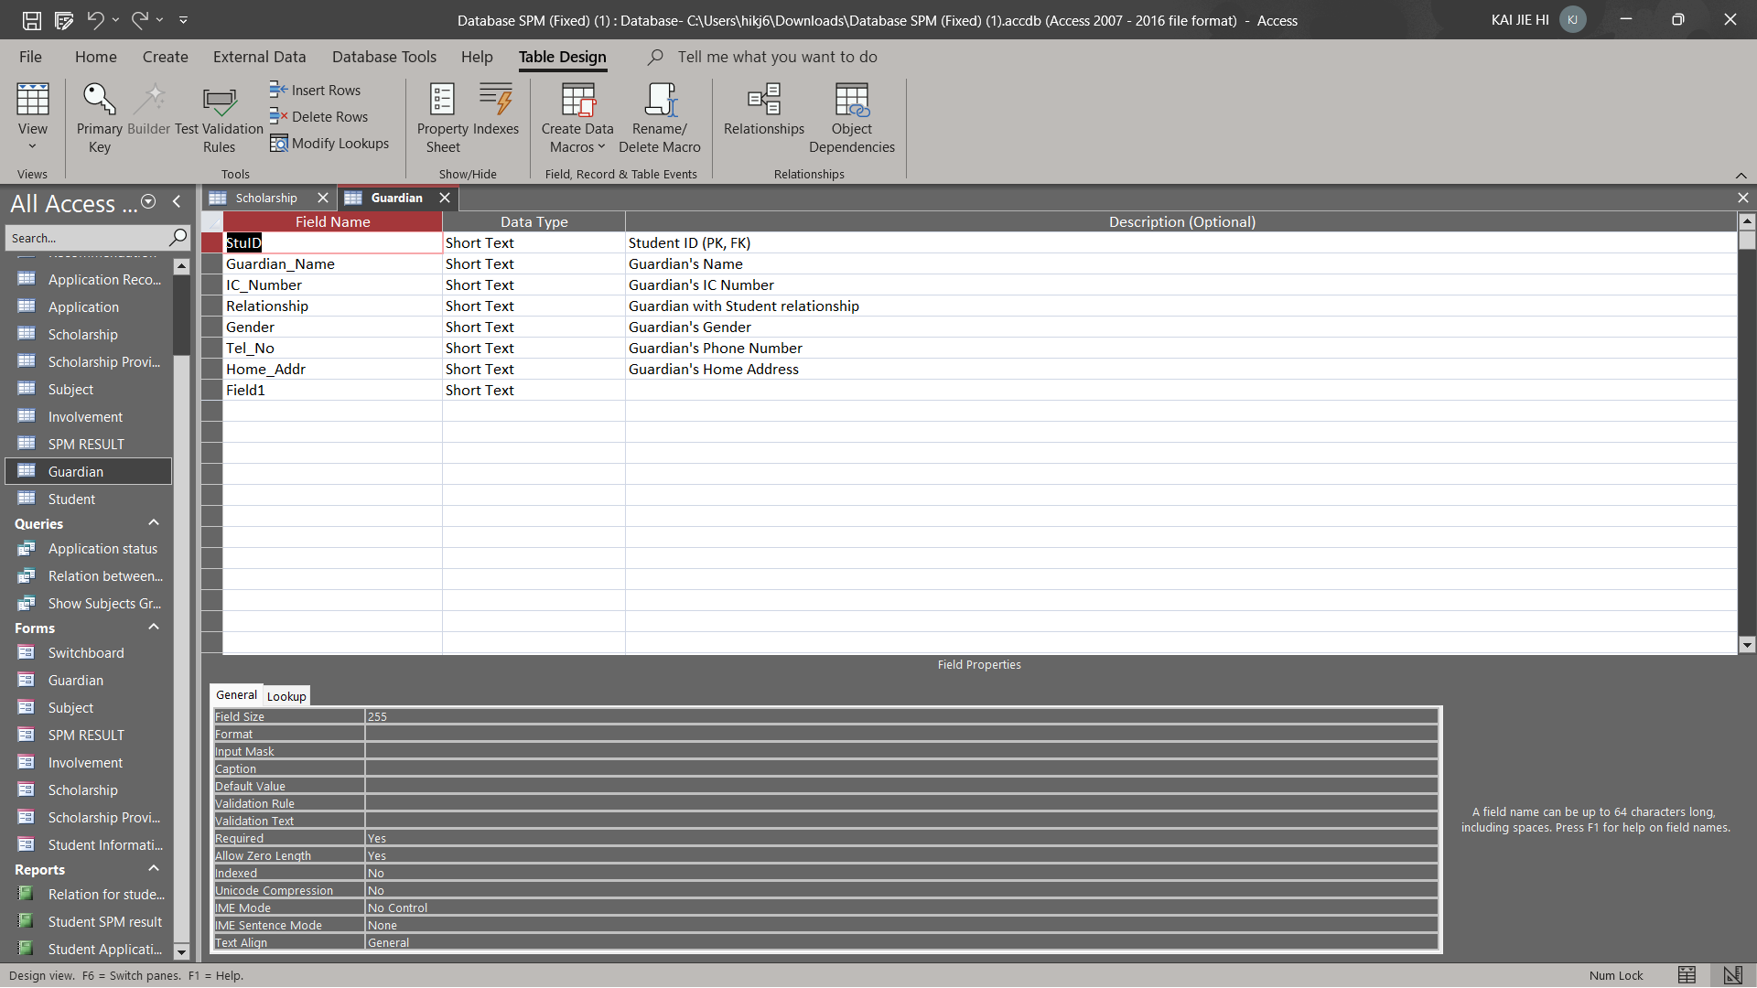

Table 3.4

**SPM Result**

Data Dictionary:

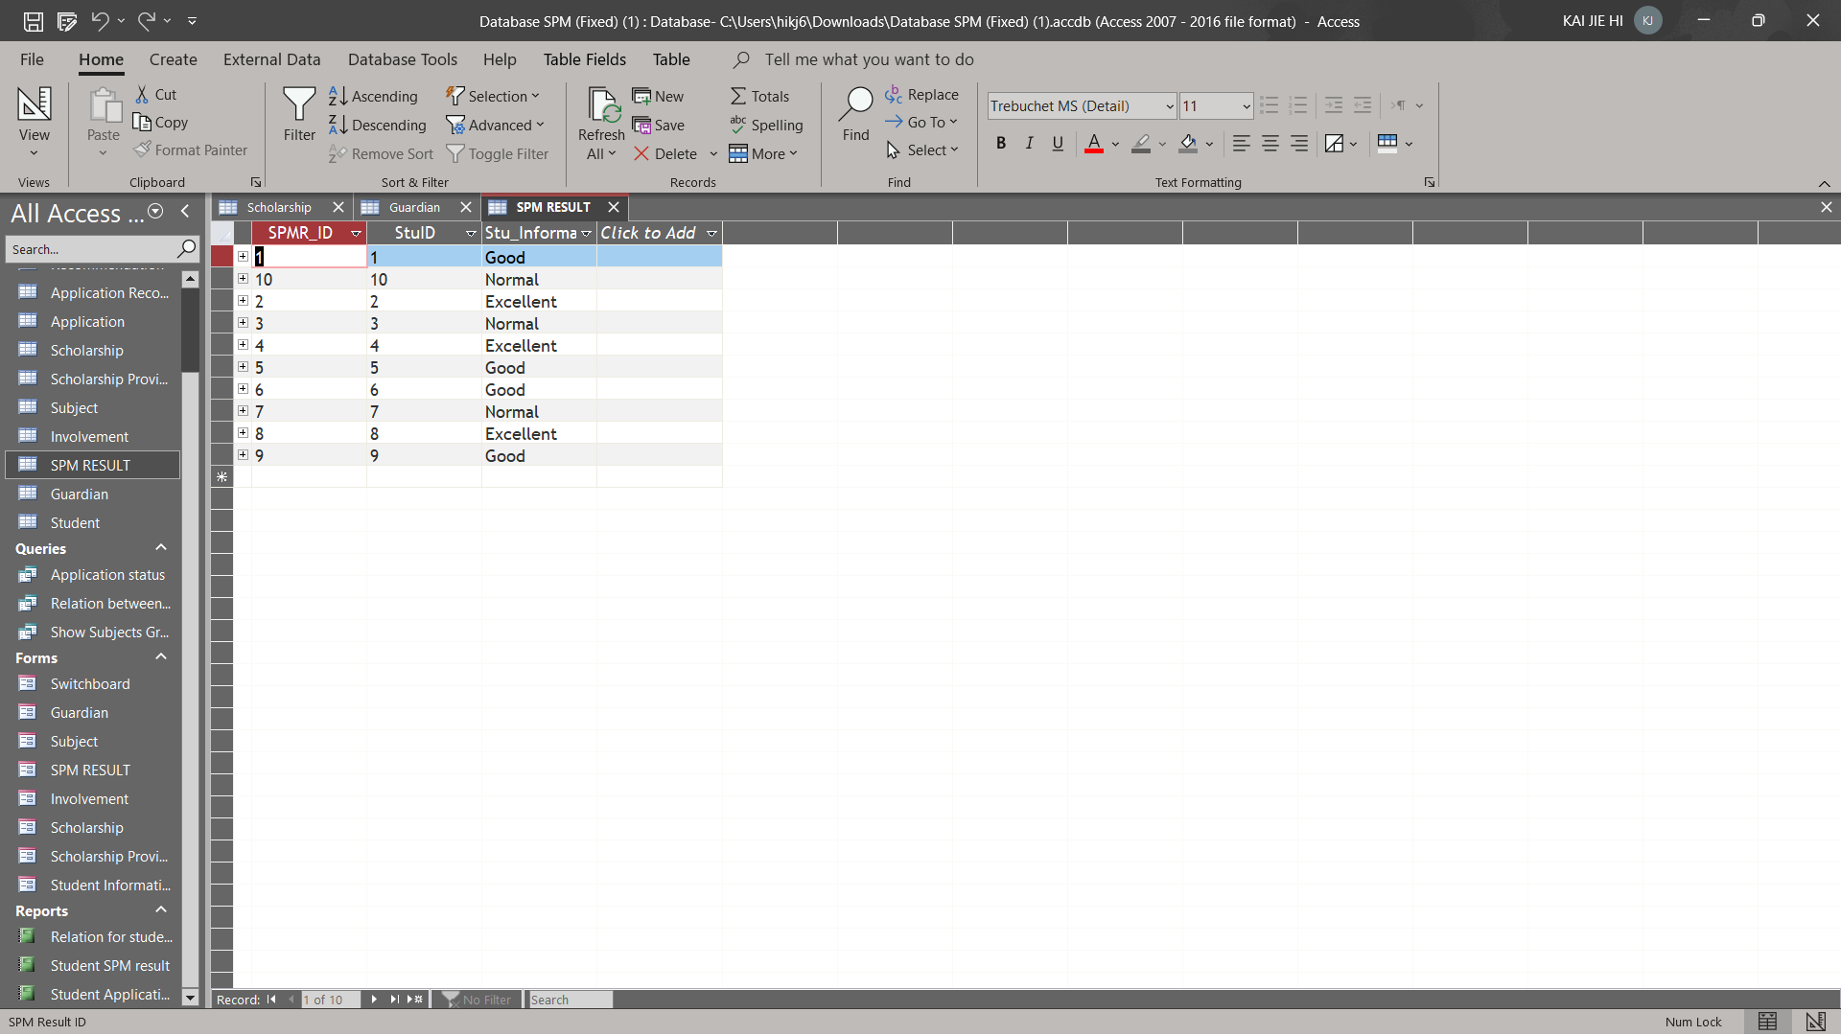

Table 3.5

Table Records:

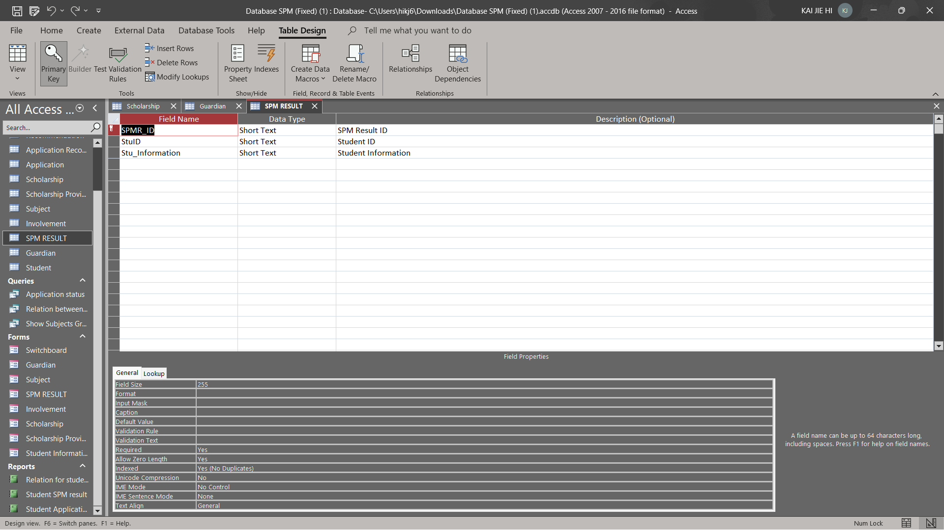

Table 3.6

**Involvement**

Data Dictionary:

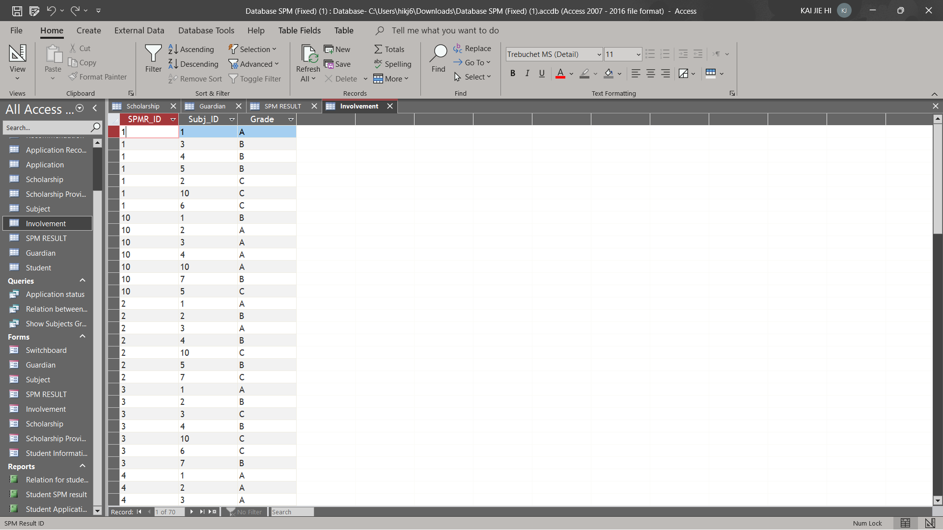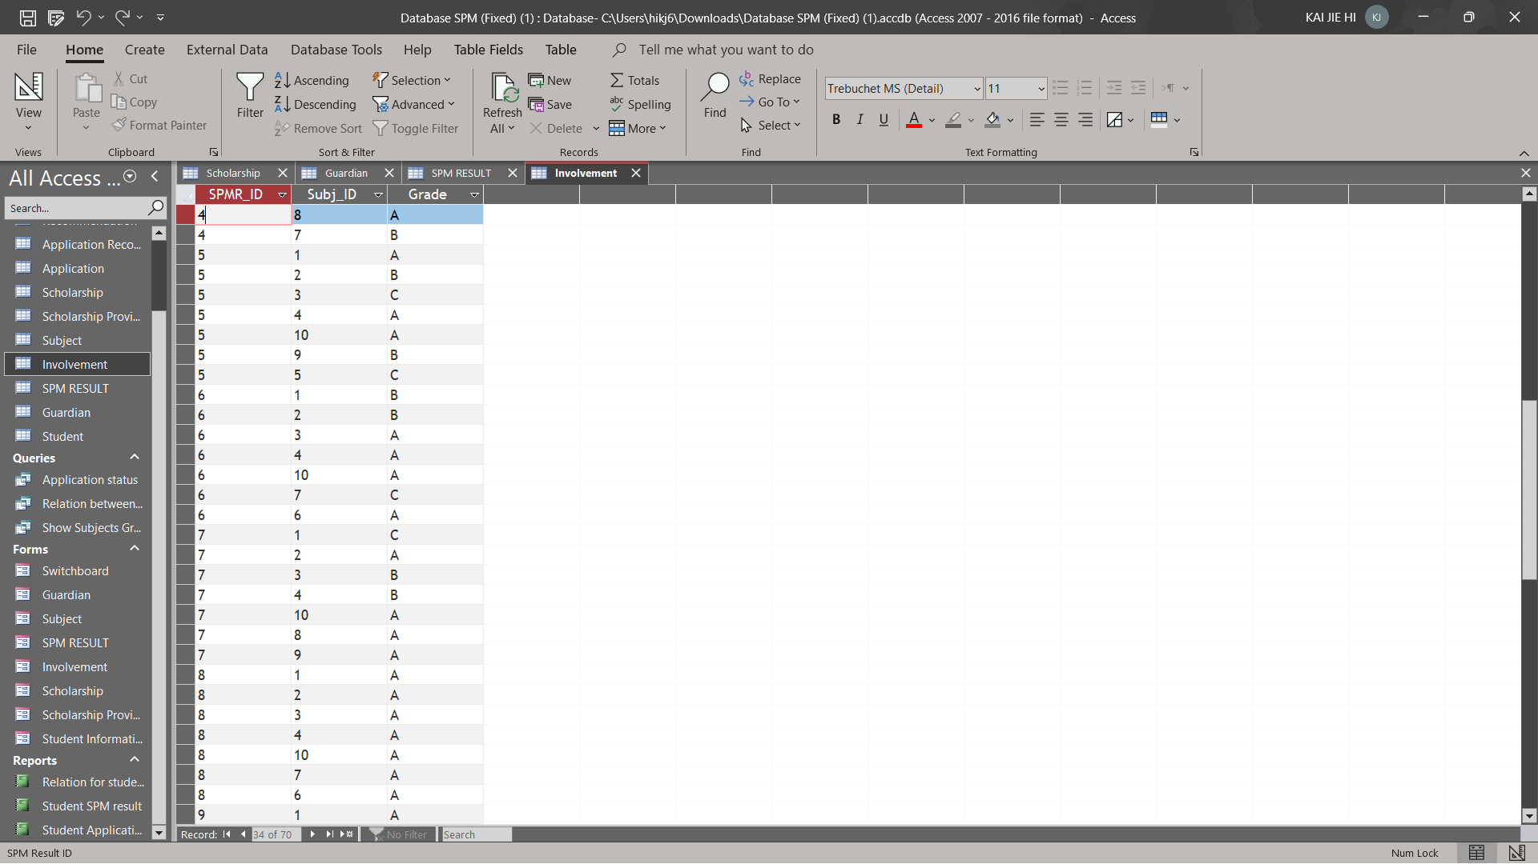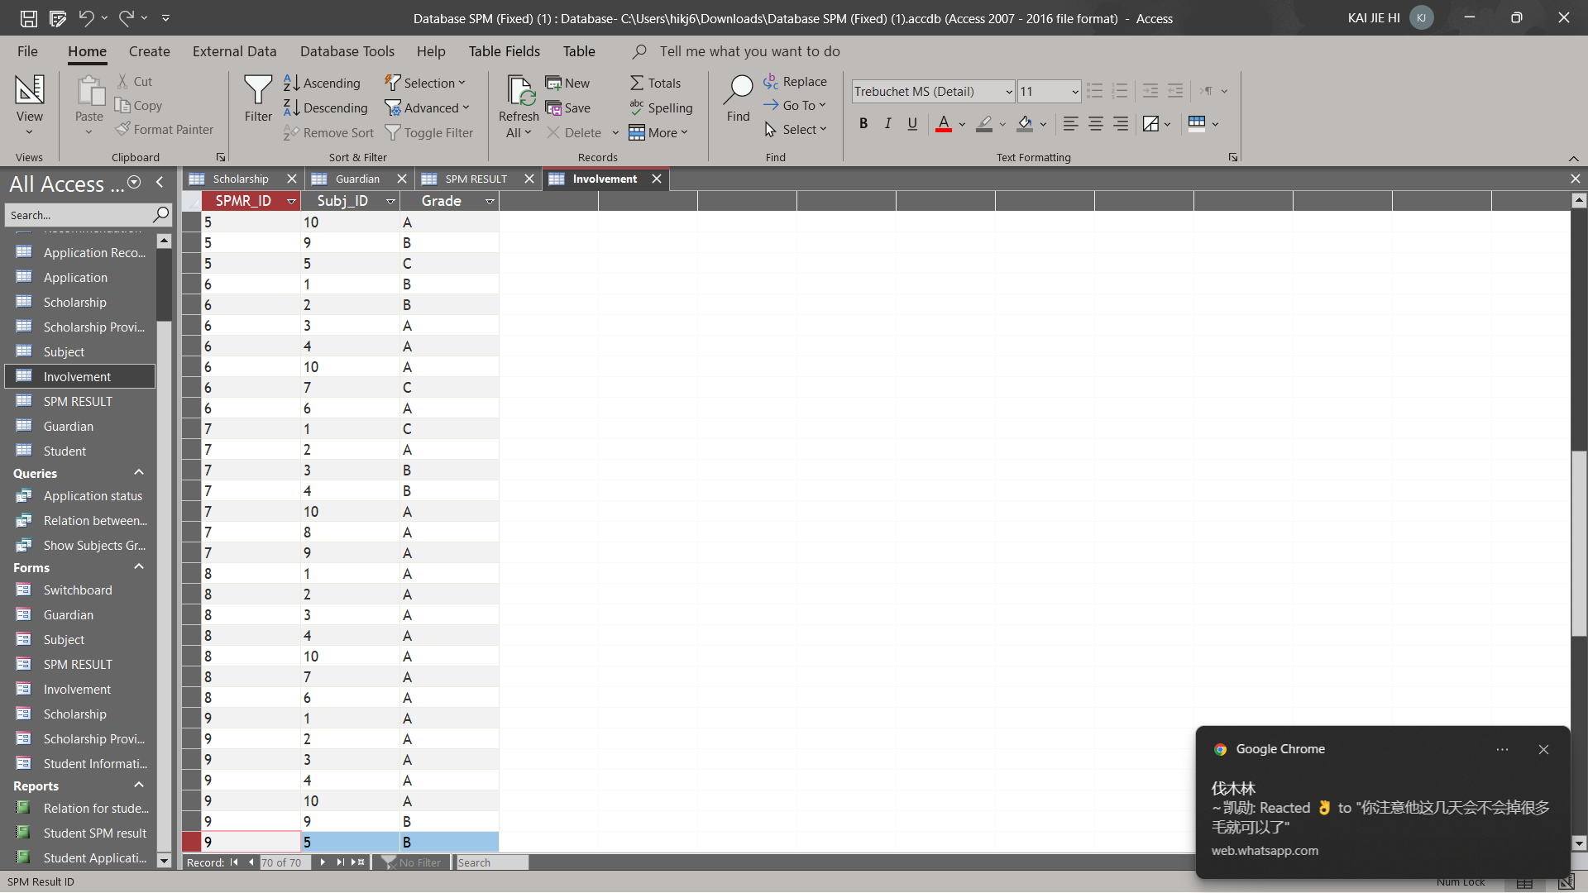

Table 3.7

Table Records:

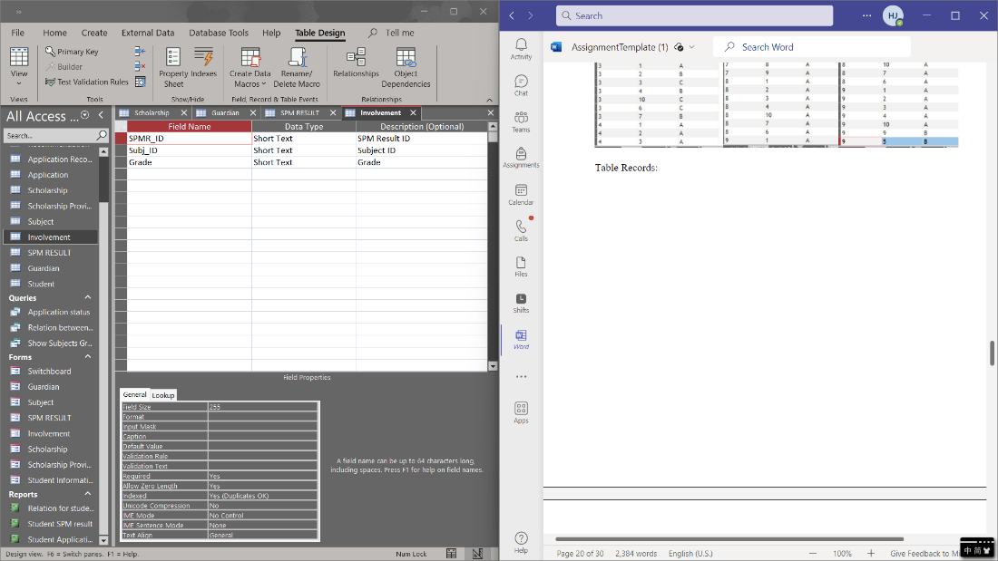

Table 3.8

**Subject**

Data Dictionary:

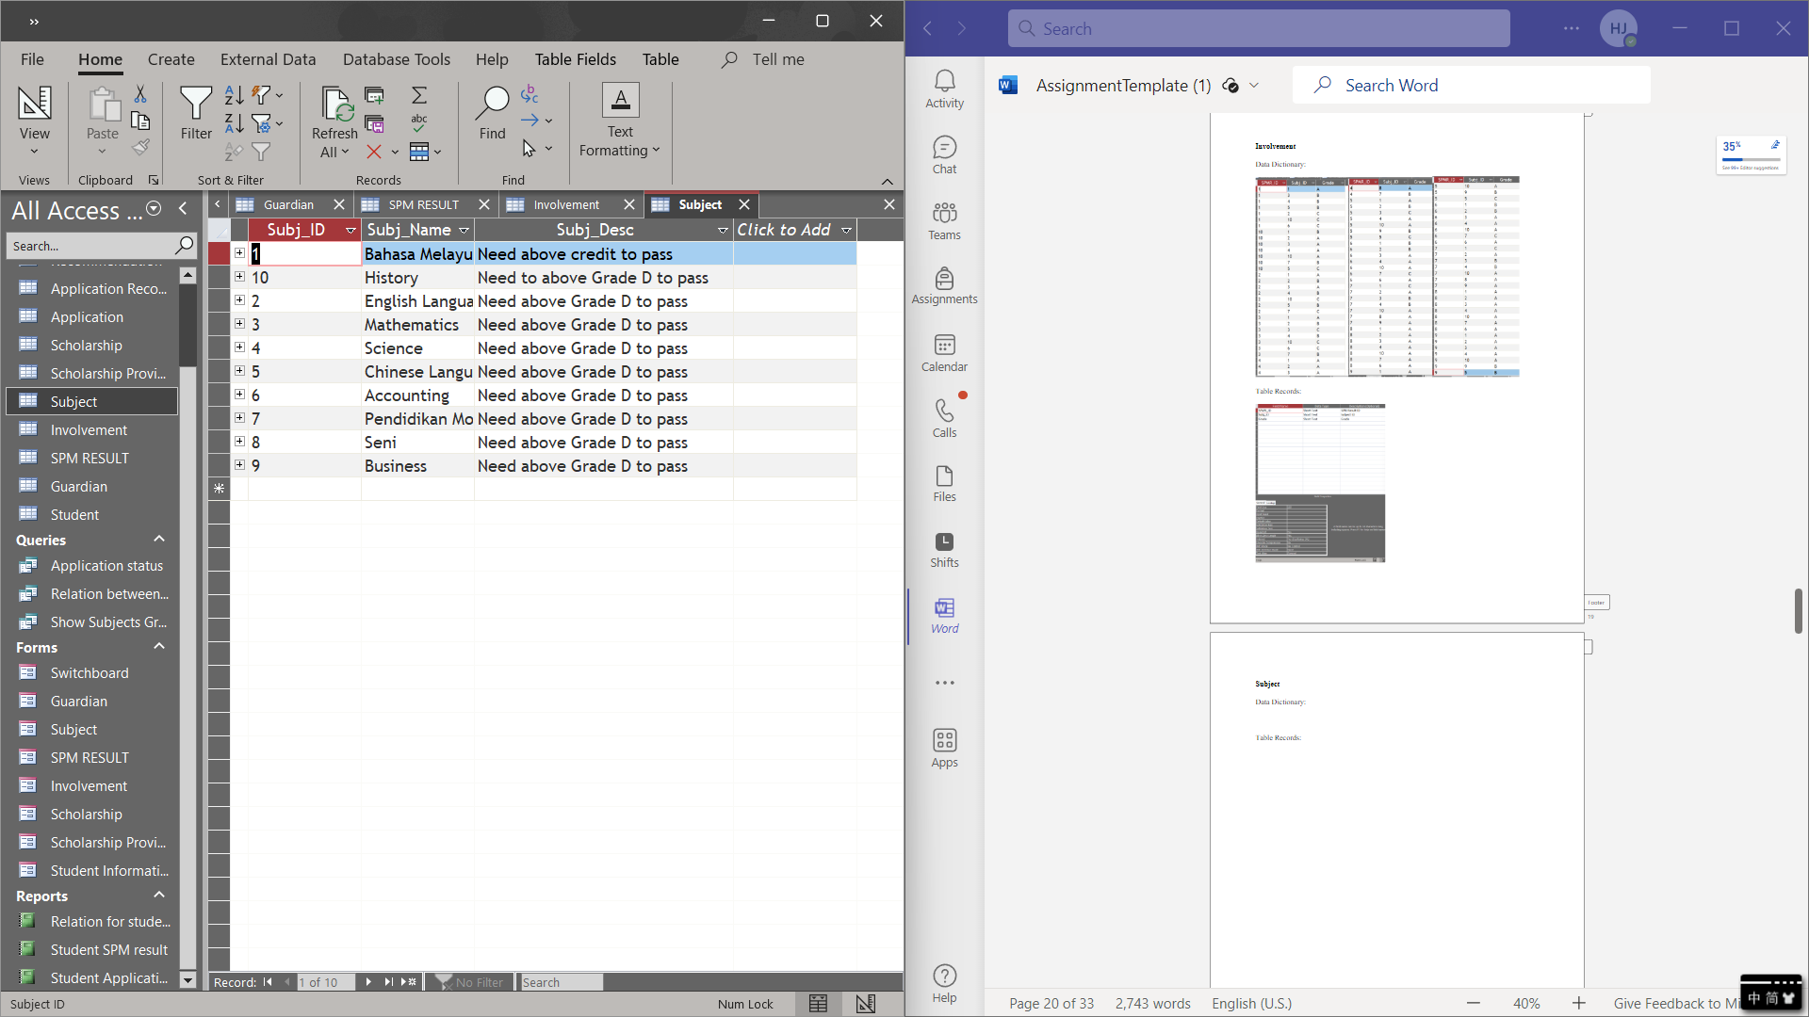

Table 3.9

Table Records:

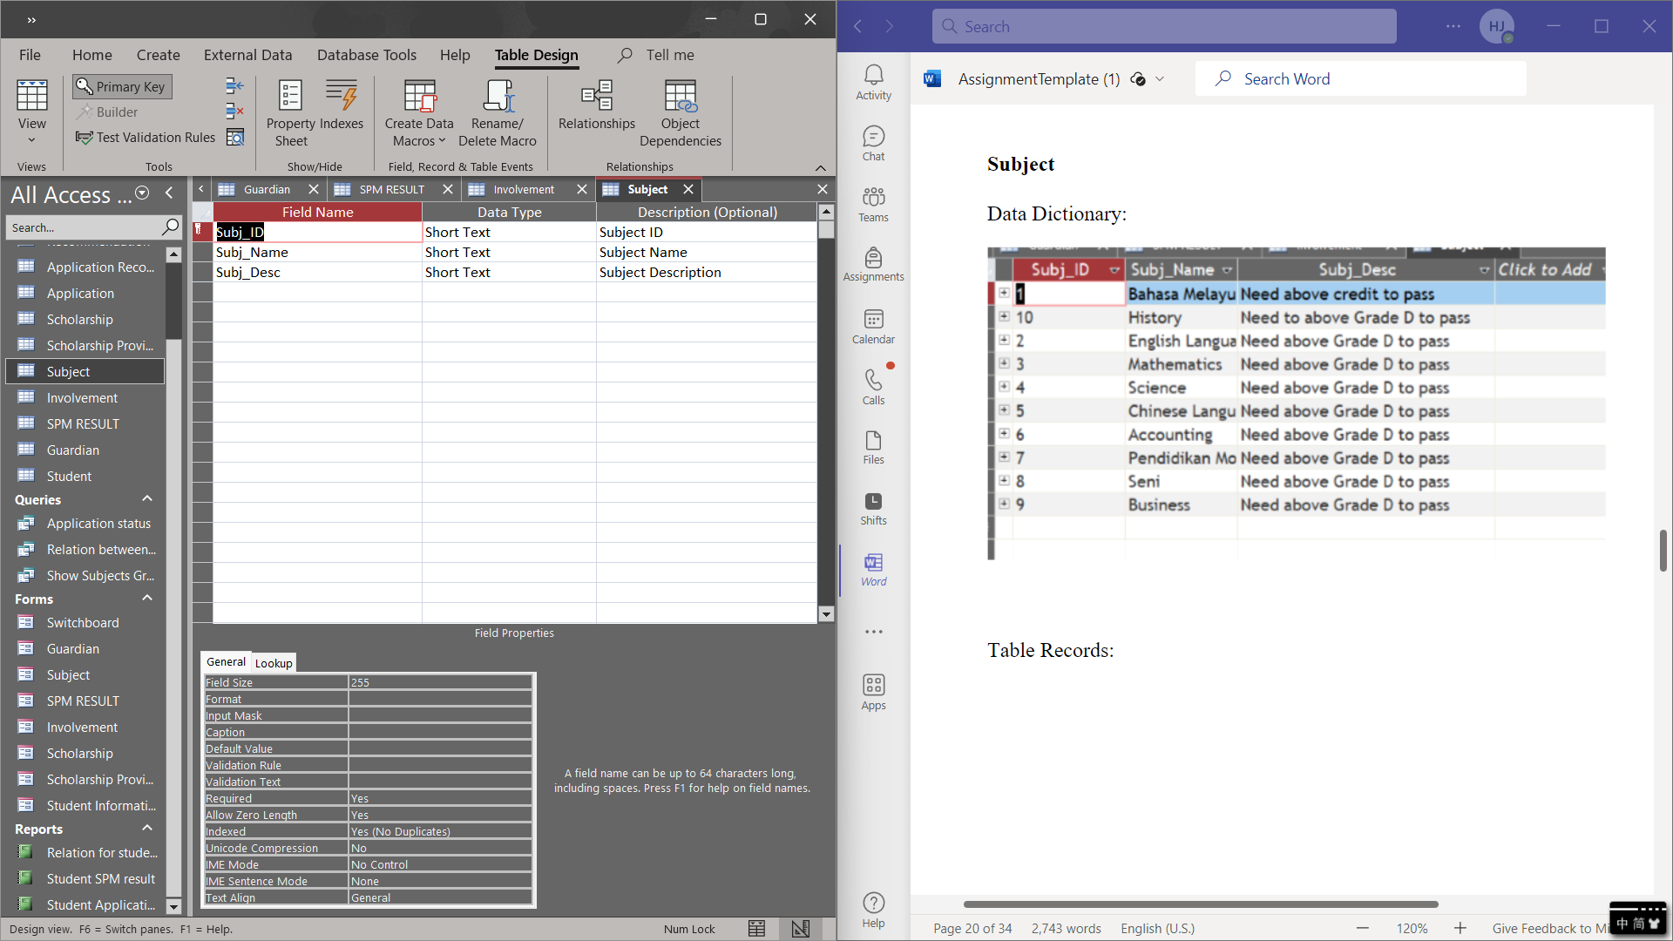

Table 3.10

**Scholarship Providers**

Data Dictionary:

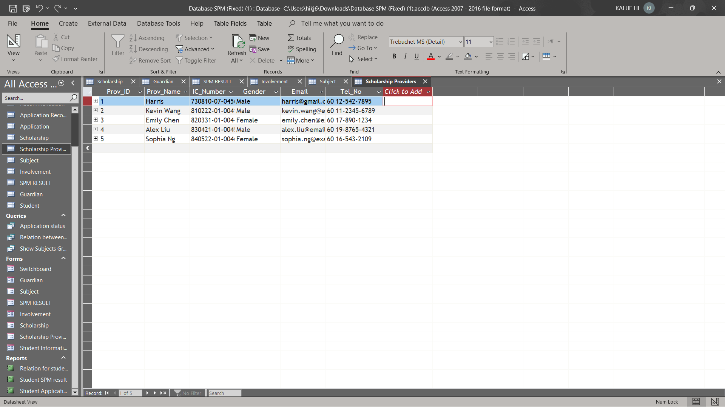

Table 3.11

Table Records:

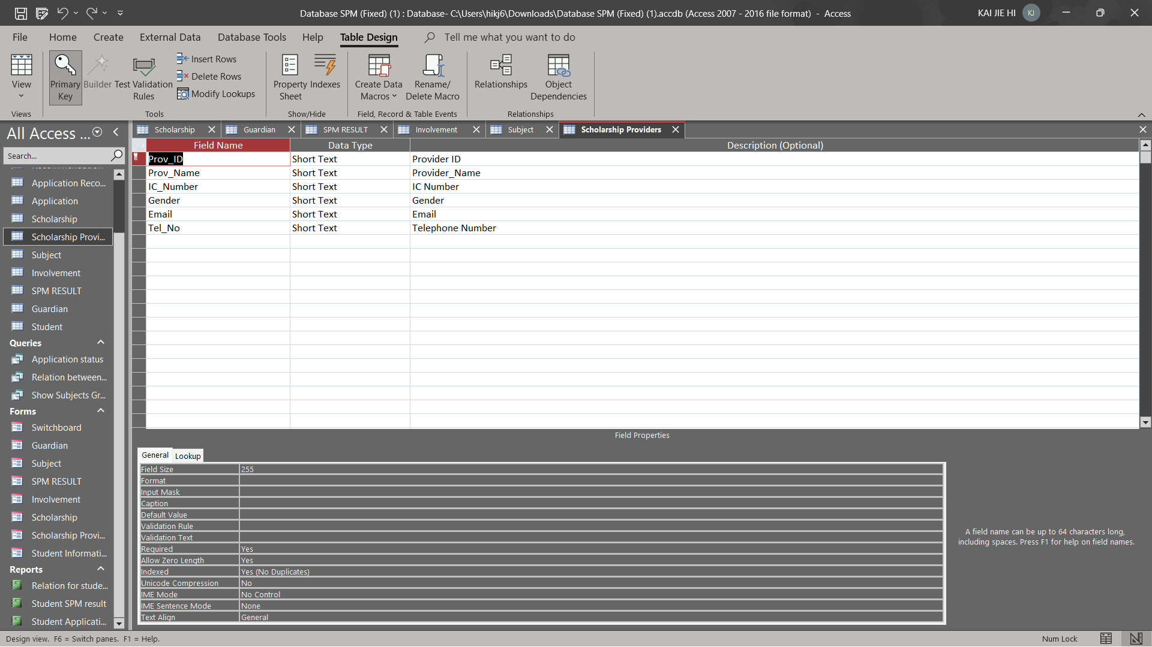

Table 3.12

**Scholarship**

Data Dictionary:

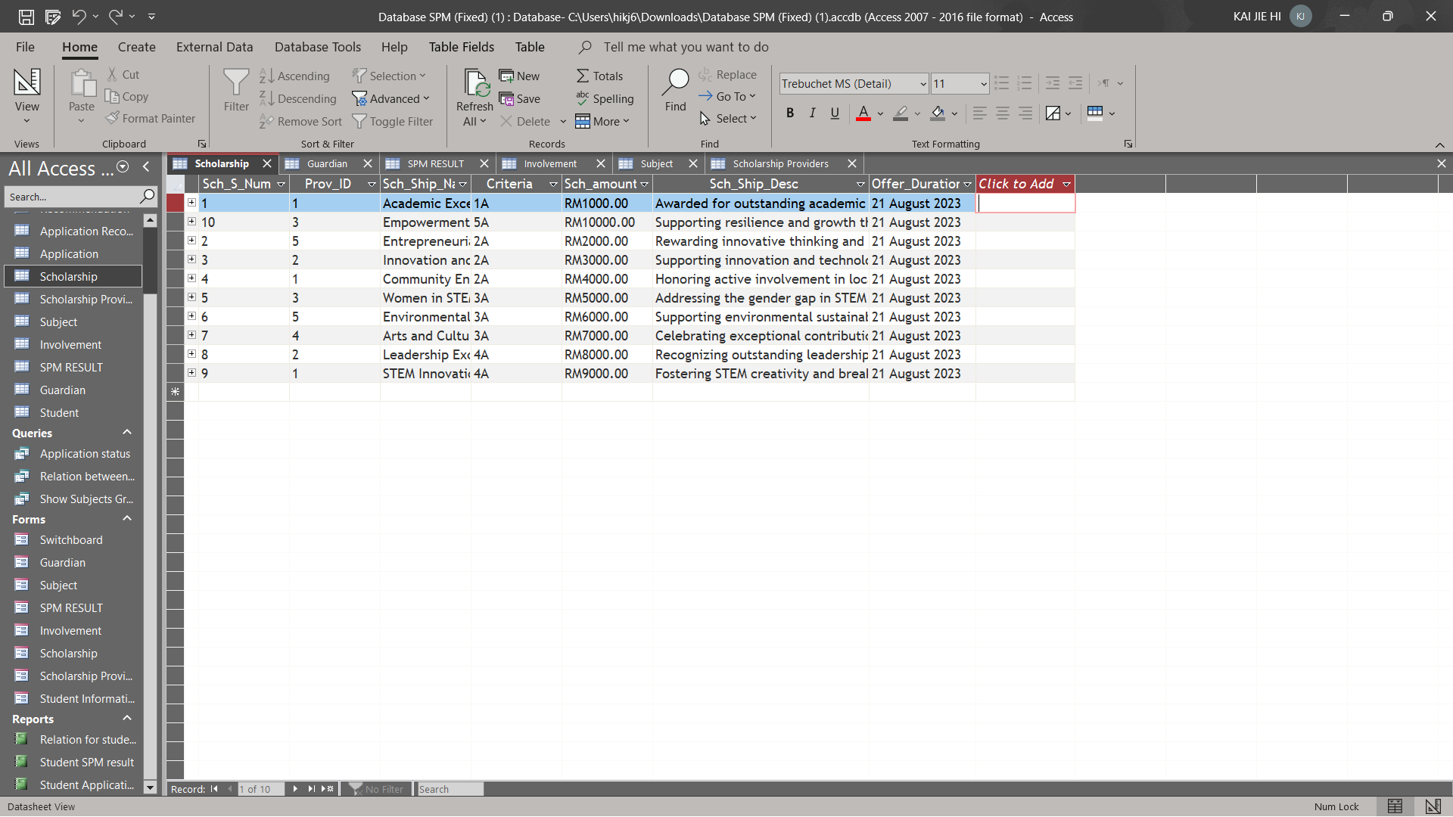

Table 3.13

Table Records:

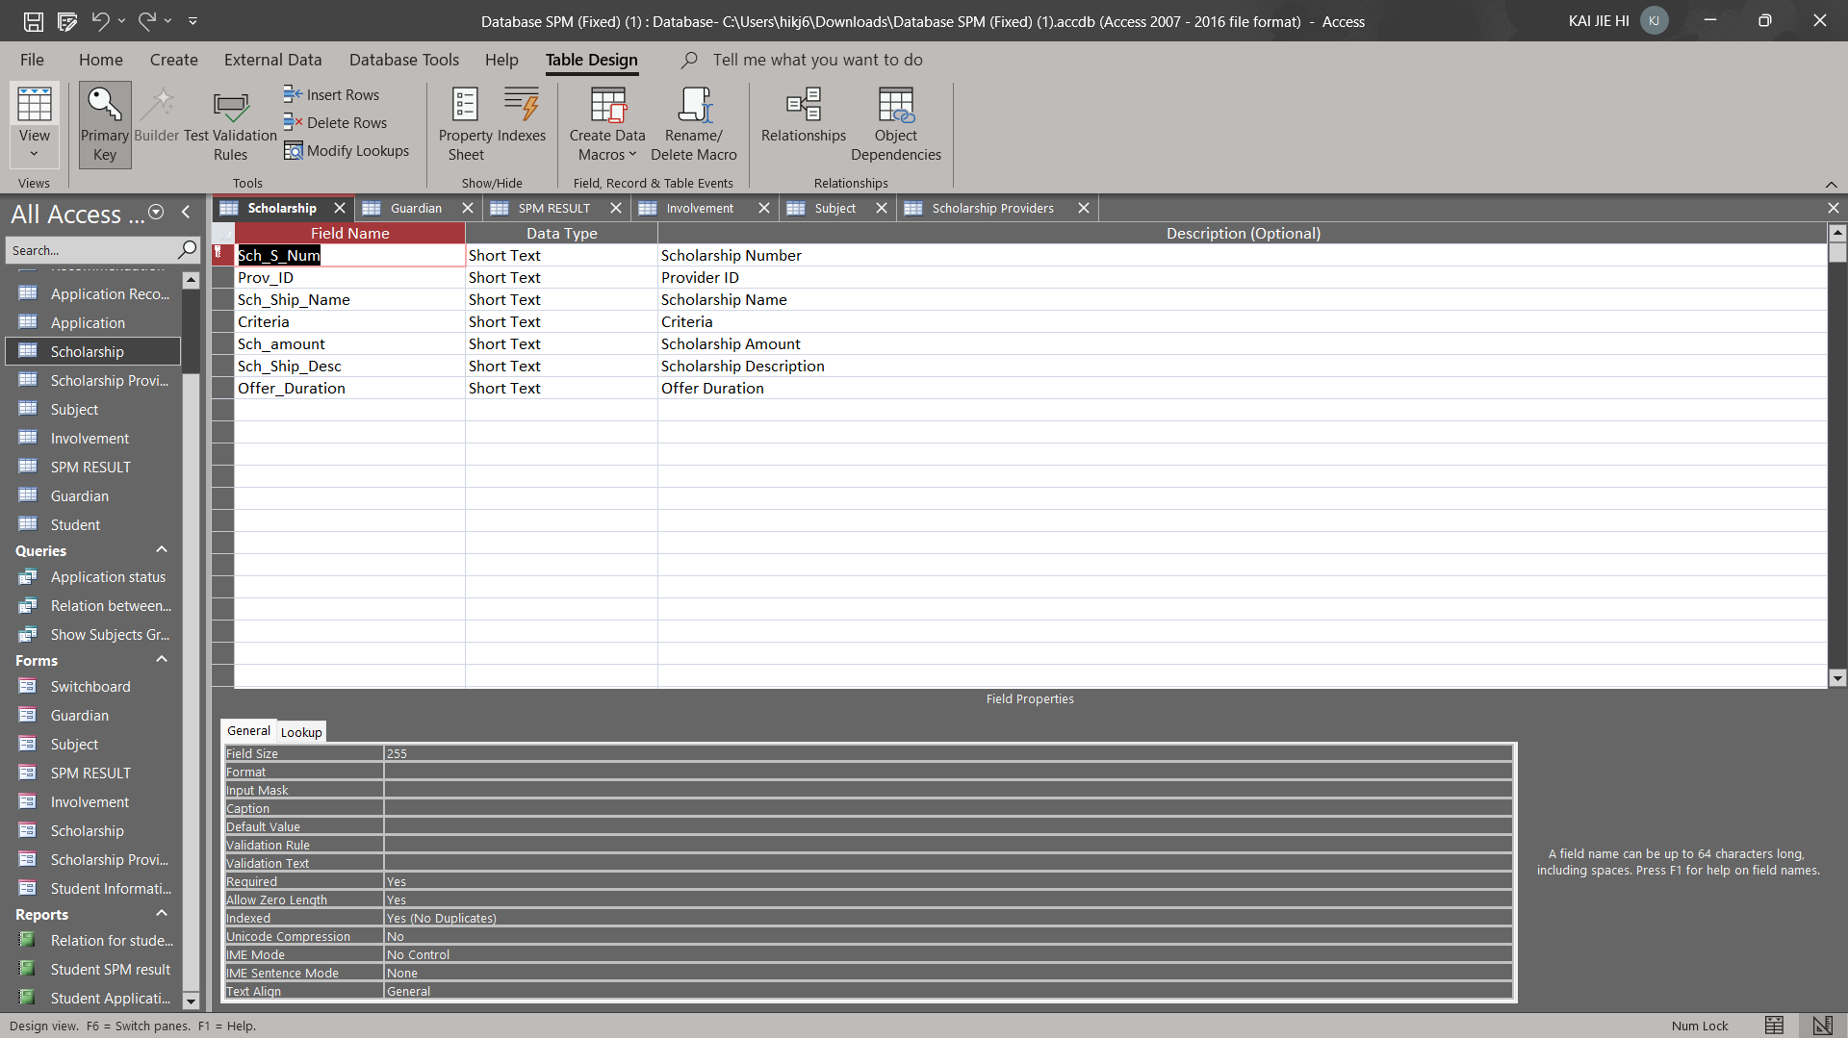

Table 3.14

**Application**

Data Dictionary:

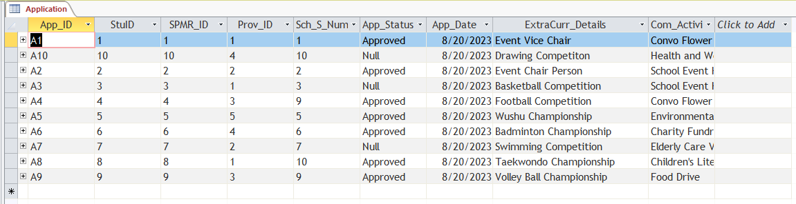

Table 3.15

Table Records:

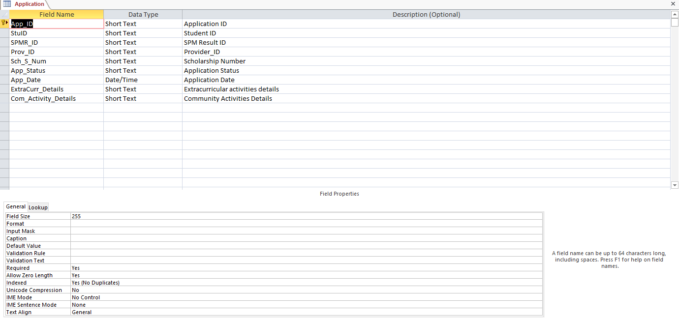

Table 3.16

**Application Recommendation**

Data Dictionary:

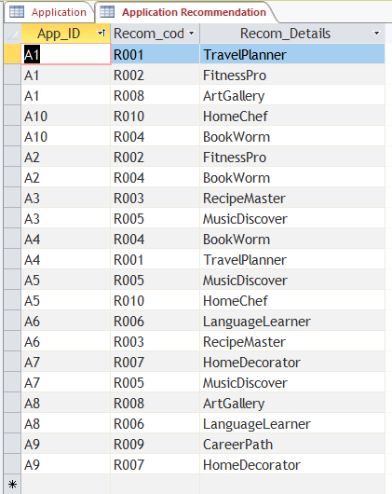

Table 3.17

Table Records:

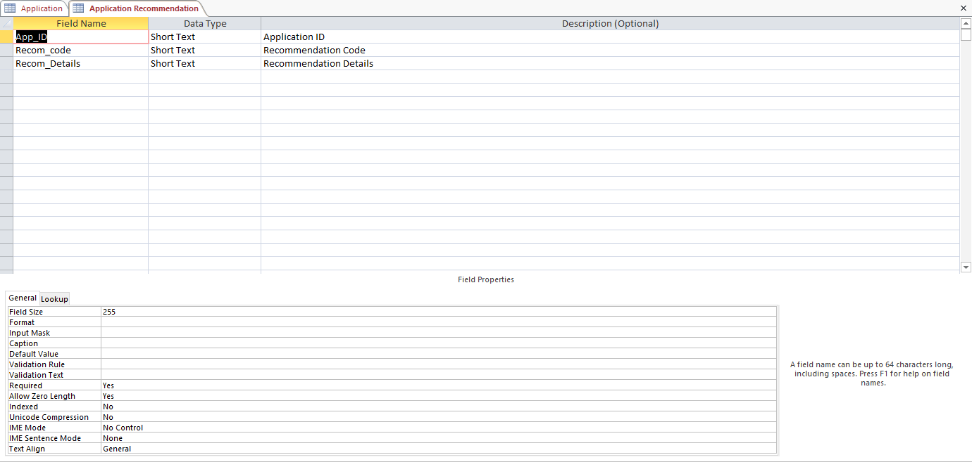

Table 3.18

**Recommendation**

Data Dictionary:

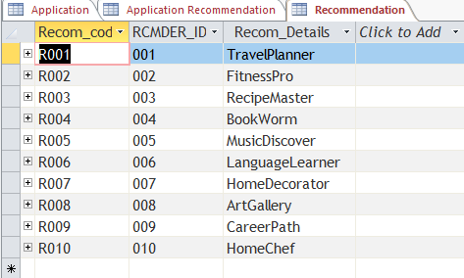

Table 3.19

Table Records:

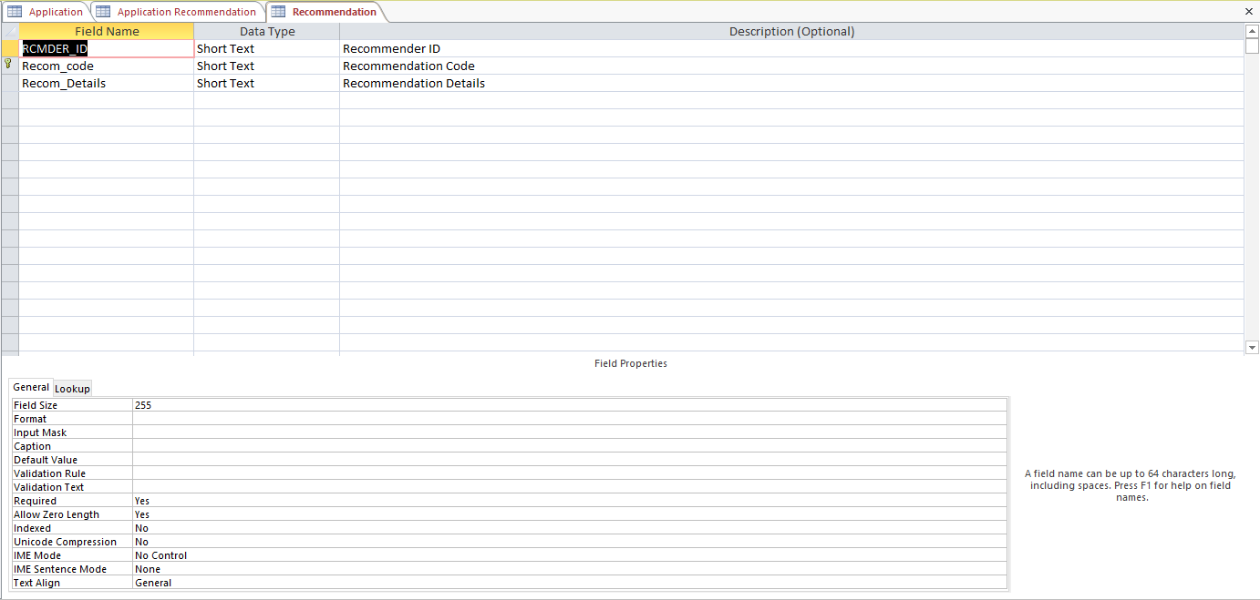

Table 3.20

**Recommender**

Data Dictionary:

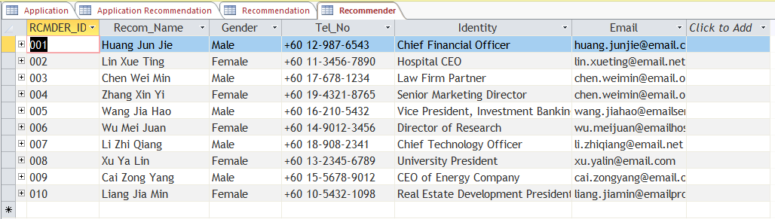

Table 3.21

Table Records:

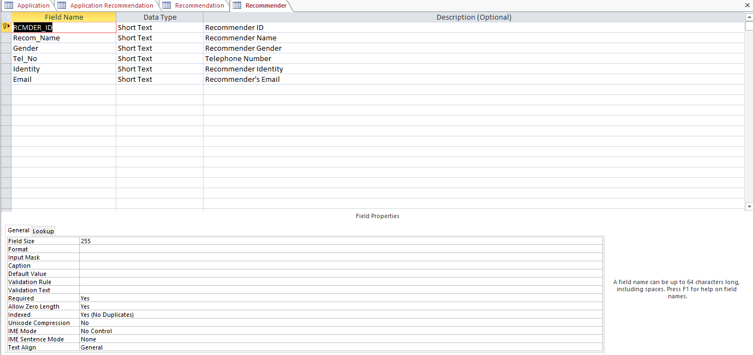

Table 3.22

3.2 Switchboard

Switchboard in Microsoft Access is a form that allows users to navigate in an access database.

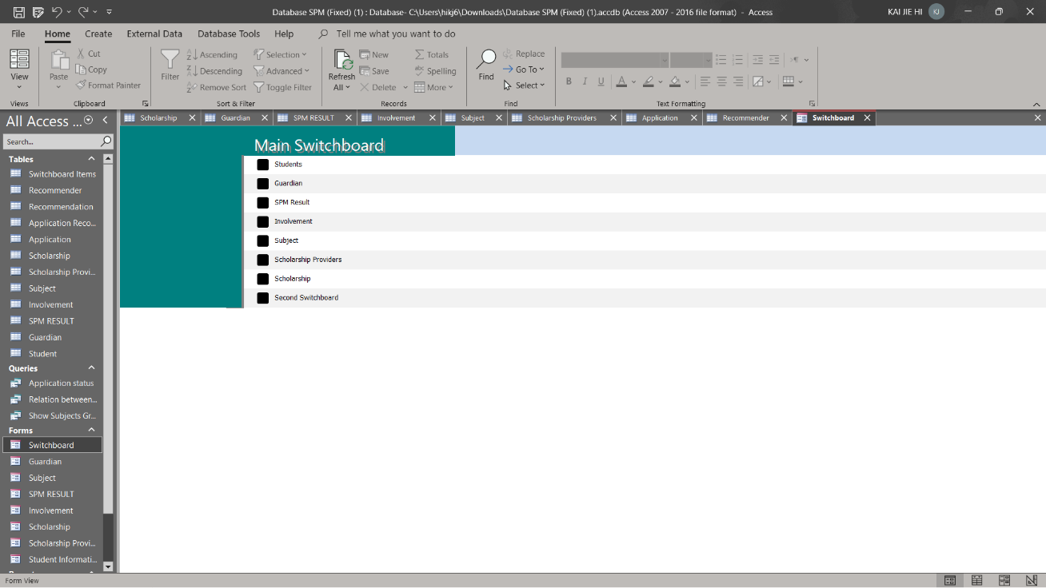

Figure 3.1

Main Switchboard

Upon opening the database, the switchboard will launch immediately. When you press the "Form" button, the "Form Switchboard" opens, while you push the "Report" button, the "Report Switchboard" opens, and you press the "Exit" button, the database is closed.

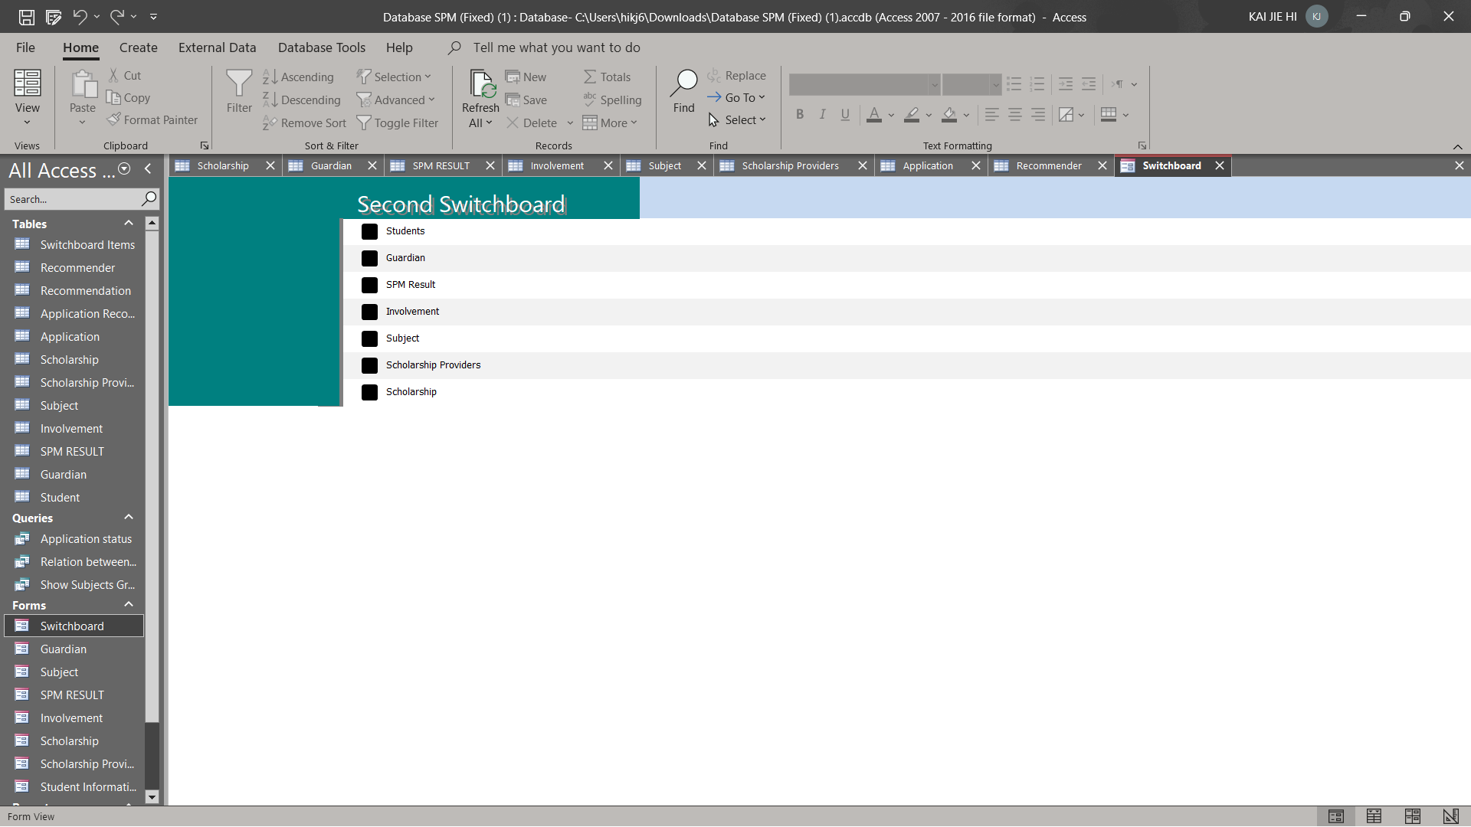

Figure 3.2

Form Switchboard

If you press "Add" on this switchboard, "Form Switchboard (Add)" will appear, while "Edit" will result in "Form Switchboard (Edit)". Backing up to "Main Switchboard" by hitting "Back".

**CHAPTER 4 DATABASE OBJECTS**

**Database Objects**

Database objects are components of a relational database management system (RDBMS) that allow users to store, manipulate, and manage data in a structured and organized manner

**4.1 Queries**

Queries are used to request for specific information or data from a database management system.

**4.1.1 Query 1**

**SQL Command**

SELECT Student.StuID, Student.StuName, Subject.Subj_Name, Involvement.Grade

FROM Subject INNER JOIN ((Student INNER JOIN [SPM RESULT] ON Student.StuID = [SPM RESULT].StuID) INNER JOIN Involvement ON [SPM RESULT].SPMR_ID = Involvement.SPMR_ID) ON Subject.Subj_ID = Involvement.Subj_ID

WHERE (((Student.StuID)=[Enter Student ID:]) AND ((Subject.Subj_Name)="Mathematics" Or (Subject.Subj_Name)="Bahasa Melayu" Or (Subject.Subj_Name)="History" Or (Subject.Subj_Name)="English Language" Or (Subject.Subj_Name)="Science"))

ORDER BY Student.StuID;

**Explanation**:

This query prompts the user to input a student ID in order to display the grades of the student's SPM results for five subjects.

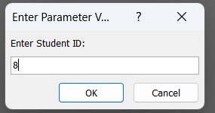

Figure 4.1

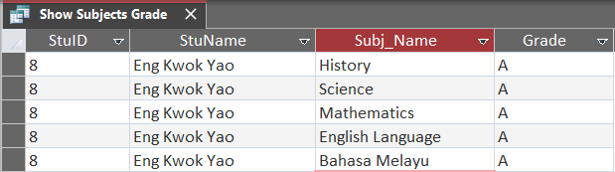

Figure 4.2

**4.1.2 Query 2**

**SQL Command**

SELECT Student.StuID, Student.StuName, Recommender.Recom_Name, Recommender.Identity, Recommendation.Recom_Details

FROM Student INNER JOIN (Recommender INNER JOIN (Recommendation INNER JOIN (Application INNER JOIN [Application Recommendation] ON Application.App_ID = [Application Recommendation].App_ID) ON Recommendation.Recom_code = [Application Recommendation].Recom_code) ON Recommender.RCMDER_ID = Recommendation.RCMDER_ID) ON Student.StuID = Application.StuID;

**Explanation**:

This query shows the relation between student and recommender. 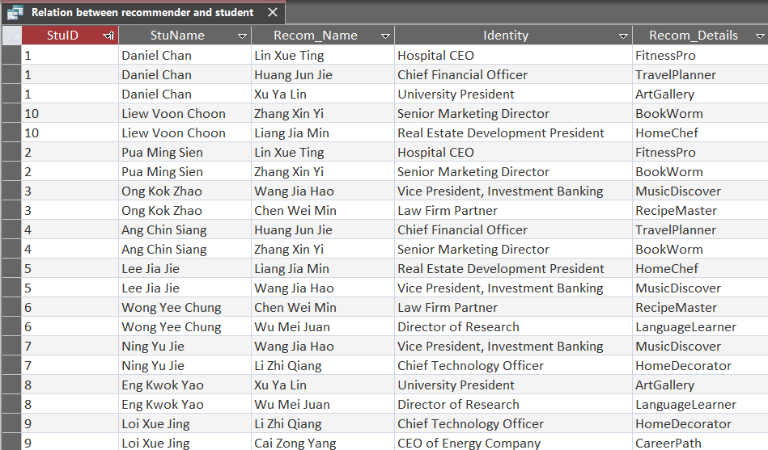

Figure 4.3

**4.1.3 Query 3**

**SQL Command**

SELECT Student.StuID, Student.StuName, Scholarship.Sch_Ship_Name, Scholarship.Criteria, Scholarship.Sch_amount, Scholarship.Sch_Ship_Desc, Scholarship.Offer_Duration

FROM Student INNER JOIN (Scholarship INNER JOIN Application ON Scholarship.Sch_S_Num = Application.Sch_S_Num) ON Student.StuID = Application.StuID

WHERE (((Student.StuID)=[Enter Student ID:]) AND ((Application.App_Status)="Approved"))

ORDER BY Student.StuName;

**Explanation**:

This query prompts the user to input a student ID to check the application status. If the application is approved, the student can access their application information; however, if the application status is not approved, the records will not be displayed.

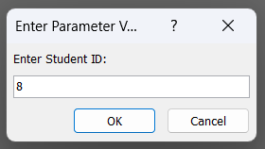

Figure 4.4

Figure 4.5

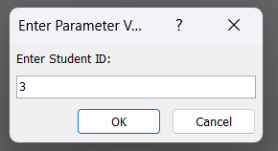

Figure 4.6

Figure 4.7

**4.3 Report**

Report is a structured display of information from a database that provides meaningful and structured information for analysis, presentation, or decision making.

**4.3.1 Report 1**

Explanation: The report shown which student has approved for the application of scholarship. We can still that what’s the criteria, how much scholarship the student awarded, and when is the offer duration.

Report 1:

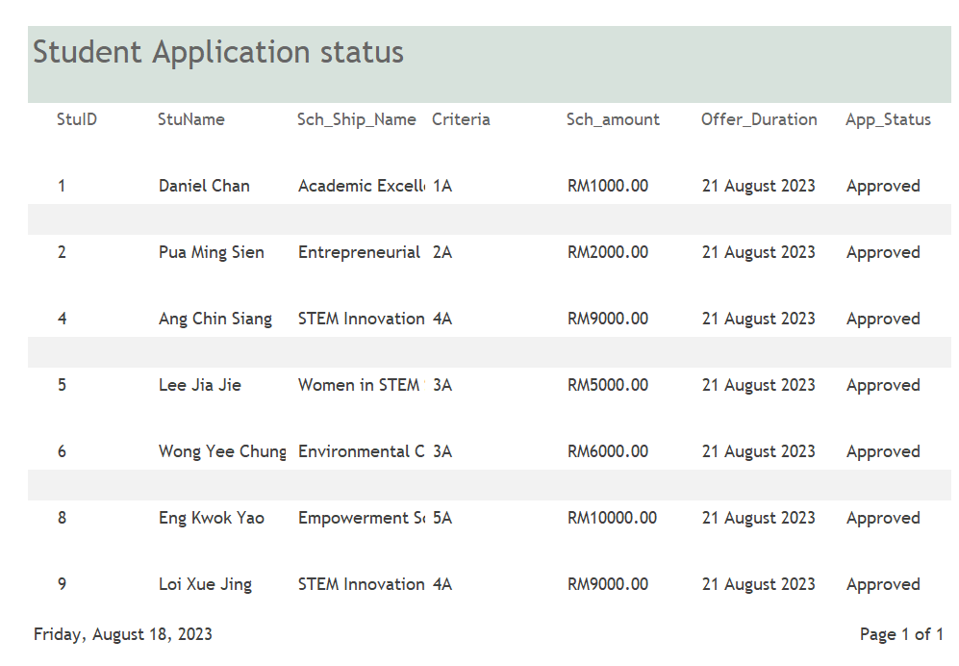

Figure 4.8

**4.3.2 Report 2**

Explanation: The report below shown student’s SPM result of all subjects.

Report 2:

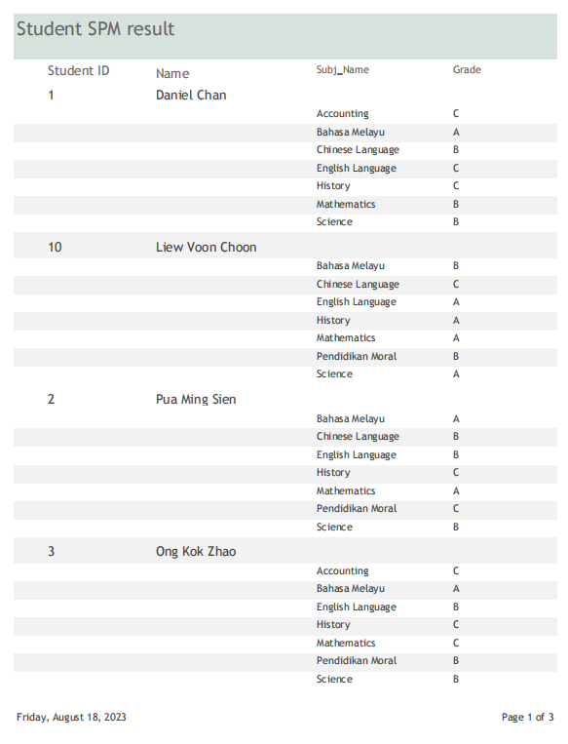

Figure 4.9

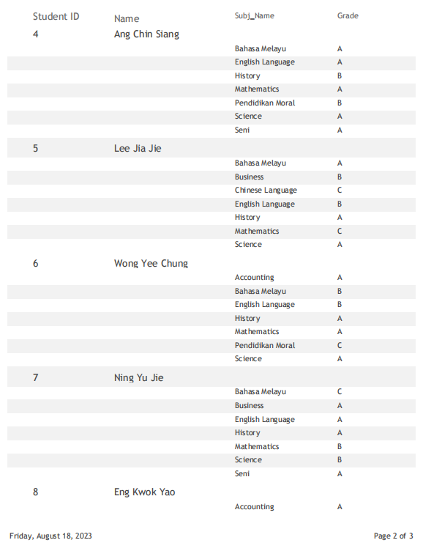

Figure 4.10

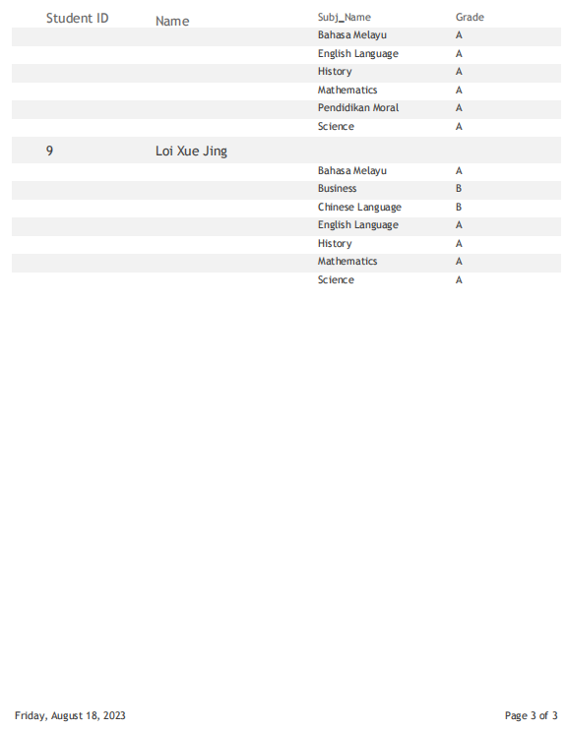

Figure 4.11

**4.3.3 Report 3**

Explanation: The report below shown which student is recommended by which recommender. We can see the relation between student and recommender.

Report 3:

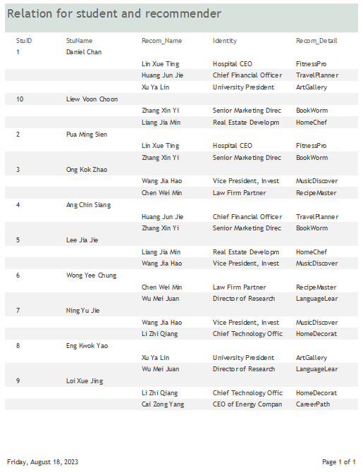

Figure 4.12

**4.2 Forms**

Form is used to create user interface to connect the user with the database application where forms allow users to add, edit and display data from the data source.

**4.2.1 Form 1**

**Student Information Form**

Explanation:

This form mainly deals with student personal information such as student name, student ID, student’s IC number, school name, home address, student’s email, gender, and telephone number. This form also links to another subform which is the Guardian form which use to store the details of the guardian of the respective student. This form allows user to create a new profile of newly registered student which will then be use by the scholarship application system and amendment can easily be made using this form by just retrieving the student information through the form and make appropriate edits.

Figure 4.13

**Form 2**

**Scholarship Provider Form**

Explanation:

This form allows those who are interested to becoming a scholarship provider to fill in their particulars. This form also consists of a subform to store the detail information of the scholarship that they offered to the student such as the criteria of the scholarship, amount offer and so on. This information is crucial for student to obtain relevant information about the scholarship before performing the application.

Figure 4.14

**Form 3**

**Involvement Form**

Explanation:

This form is mainly used to store all information regarding the student SPM results. This form allows user to create a SPM result ID to keep track of all the relevant records and allow user to fill in the grades for the corresponding subject where the subject is track by the subject ID. This form consists of two subforms which are data about the subject such as the subject name and description and data about the SPM result which is connect to the respective student using their student ID. This form which uses to store the result information of the students is important since the result will then be used to evaluate whether the student is eligible for the scholarship or not. This form allows user to enter all required information about the student’s result in one single place.

Figure 4.15

**Chapter 5**

**Conclusion**

In conclusion, the development of this scholarship application database system can offset those disadvantages of the old existing system which mainly involve manual paperwork for the whole process of scholarship application. This system can enhance and optimize the entire application process, this is because this system is able to reduce the time needed to process the application compared to manual paperwork. For example, with this system student can submit several applications easily and those application are also able to be retrieved by relevant parties such as the evaluation staff and scholarship provider at a very fast pace. If there are any error in the application, student can perform the amendment instantly online and the updated version will also directly receive by the relevant parties without need to send the physical application form among different parties involved. Therefore, this system can increase the productivity and efficiency of the entire scholarship application process without needing to waste a lot of time for processing various tedious paperwork and hence the scholarship can be awarded to eligible applicant as soon as possible to avoid any delay in pursing their education.

**5.1 System Weaknesses**

One of the weaknesses of this system is that the relevant information such as student result is solely provided by the student themselves. This may lead to potential human error during data entry and affect the accuracy of the information provided. This weakness might also cause the integrity and accuracy of the data being affected, this is because since the information is provided by the student therefore there is no any mechanism for data checking hence student are able to manipulate important data which might affect the decision making of scholarship award such as manipulating or providing fake SPM result to the system without being detected. Besides, another possible weakness of the system is that there might happen sensitive information of student being leak to unauthorized personnel. This is because the data stored in the system is not encrypted and furthermore there are also lack of safety measure that limit the access of the student information being taken. Furthermore, another weakness of the system is that although this system allow student to view the status of the applications, but it does not provide a channel that allow the evaluators to provide relevant feedback to applicants upon their application result. This can cause the process of evaluation lack of transparent and fairness of the awarding process might be affected since evaluation staff is not required to provide any valid reason whenever they approved or denied any applications. Lastly, the system which do not require student or applicant to create an account before performing the application is also one of the weaknesses of the system. This is because there might be some non-eligible or invalid applicants such as non-SPM leavers or those applicants that already submit their application for the same scholarship before still insists to perform the application through the system. This will cause there is some invalid record or redundant application exist in the system and this might waste the time for the evaluation staff to perform the filtering manually or wasting the time to evaluate the same repeated application since some evaluation staff might not aware of the repeated records. Therefore, appropriate improvement can be made on the system to ensure that these flaws can be addressed to ensure the effectiveness of the system and avoid the purpose of the system to be defeated.

**5.2 Future improvement**

One of the improvements to be made on the system to address the first weakness of this system is that this system can directly synchronized with the official site to obtain the relevant information directly. For example, this system can link to the Ministry of Education Malaysia (MOE) to obtain the official SPM result directly from there instead of obtaining the result from student. This can ensure that the information obtained for the application is valid and authentic and prevent any human error during data entry. Besides, another improvement that can be made on the system is that the data should be encrypted before storing in the database. This could prevent attackers to hack into the system to obtain sensitive and valuable information of students. The system should also restrict the access limit such as restrict the data sharing activities where only relevant data can be access based on different level of authority of the users. This system can also be enhanced by adding the auto deletion features to remove all those data after the entire scholarship application process is ended to minimize the risk of sensitive applicants’ information being obtain by attackers as the storing time of those data is reduced. Furthermore, this system can also be improved by enabling applicants to obtain the feedback upon their application result from the evaluators so that applicants are acknowledge on the reason behind the application decision being made by the evaluation staff and ensure the fairness of the final decision. Lastly, another improvement that can be made on this system is that this system should allow and required all applicants to register for an account first before performing any application through this system. During the registration of account, the system should ask the applicant to provide relevant information such as uploading their official identity card photo and other necessary information. This is to ensure that the student applications can be tracked to avoid redundant applications to happen and automatically filter out those students that are not eligible for the application at the beginning. With this improvement, evaluators can ensure that all those applicants for the following process are eligible and there are no redundant record as well and hence saving the time in checking the validity of each application manually. By implementing these improvements on the system, existing flaws in the system can be addressed to maintain the effectiveness and efficiency of the system.