**HEADER**

Header (Design from https://www.titangrowth.com/ with logo, phone number and contact us link like the photo below  
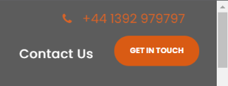

**MENU ITEMS:**

* Home
* Who We Are
* Why Us
* Services (Drop Down)
  + Lead Generation
* Contact Us

**HOME PAGE   
  
HOME PAGE BANNER TEXT (You select the image):**   
NEED A CONSISTENT FLOW OF HIGH QUALITY LEADS FOR YOUR BUSINESS?   
We Are Digital Marketing Company Focused On The Success Of Your Business

(section 1)

**Vonexx Media Services**We are a digital marketing agency that specializes in using proprietary techniques and software to deliver highly targeted, pre-qualified leads at scale. If you need a consistent flow of the very best quality, ready to buy leads, then we are the agency for you.

(section 2)

**Are ready to grow your business with a steady flow of high quality leads with an agency you can trust?**

Our team of experts have put together thousands of successful digital marketing campaigns for small and medium sized businesses looking to increase leads, phone calls, and ultimately, customers. They’ll do the same for you.   
  
(section 3 – place the pic on the left and text on the right)

**Our tech-enabled marketing services help your business grow through leads and exponentially grow your business.**

Combining our propriety software and our expert marketing team gives you an unfair advantage over your competition in your market. We at Vonexx Media pride ourselves on driving QUALIFIED traffic using cutting-edge technology while consistently measuring the effectiveness of our campaigns to deliver real results for our clients.

(section 4)

THREE PILLARS OF SUCCESS

(Add a similar section below)  
PLAN

We learn your business and develop a robust, hyper-targeted customer acquisition strategy for our clients so they can dominate their market.

EXECUTE

We execute that strategy and through constant monitoring, continuously optimize and improve to deliver they best quality leads and ROI.

DATA

Data is more than just raw, measurable information. As digital marketing professionals, it is our lifeblood. Data guides our decisions, proves our value, and validates your investment.

(section 5)

Our lead generation experts have crafted countless successful campaigns for businesses to produce a consistent, reliable and scalable flow of the highest quality leads – on demand.   
  
We understand and have developed systems so that we can take the entire lead generation process off your hands and deliver vetted, quality leads to your sales team (direct into your CRM and in real time) at an agreed fixed price per lead.

(add the section below)

**Guaranteed Results**

We give you the strongest guarantee possible so that you can focus on growing your business. We will generate the promised number of targeted enquiries at the price agreed. Every week without fail.

**Scalable Leads**

Wouldn’t it be great to have a machine that produces high quality inquiries on demand, whenever you need them? Scale up or scale back your lead flow for any reason, at any time. Just let us know!

 **Hyper-Targeting**

We tap into demographic and psychographic big data across a variety of social media and other platforms to place ads in front of the right prospects for your business and are able to predict those most likely to convert.

**Education First**

Your prospects are fed up with the same old marketing they get from every supplier. That’s why we use a different approach that gives them information that solves their problems and builds desire for your service.

**Real Time Leads**

When our campaigns generate pre-qualified leads, we pass the contact details to you in real time. You’ll be able to follow up with them immediately and convert them in to paying customers.

### Lead Nurturing

We send custom multichannel marketing communications to interested leads at planned intervals to gradually align them for successful sales

Add a similar banner below. The button text should say “Connect With Us” and send the user to the contact page

**WHO WE ARE PAGE**

**About Us**

Our culture, system analytics, and custom software empowers our team to quickly solve problems and drive results for our clients. We work with small and medium sized to help them grow their business exponentially.

We use our industry experience, proven methods and test and experiment with our clients to find a formula that produces the highest quality leads for our clients and provides them the best return on their investment.

We believe in, and strive to, develop long-term relationships so we are thoroughly invested in, and love to see our clients win!

**About You**

Enough about us — let’s talk about you!

Whether you’re an established business or just getting started, you need a proven agency that takes care of the monotonous, complicated, rejection-filled stuff so you can focus on providing the best quality service.

You're interested in growing your business, first and foremost.

(Learn More Link to Contact Page)

**WHY US PAGE** (https://valveandmeter.com/why-us/?)

MATH BEFORE MARKETING

At Vonexx Media, we hold a core belief that your financial growth and goals should determine your marketing investment. That’s why we lead with a philosophy of “Math Before Marketing.” When you can determine your threshold on a per-customer acquisition cost, you can invest your dollars wisely to deliver leads at a cost that keeps you profitable. This philosophy transcends channels and creates leads at a cost that makes good financial sense for your business.

Traditionally, businesses view marketing spend as a percentage of revenue. Some marketing firms will perform transactional services, such as creating a website or delivering a direct mail program, then walk away. Our approach is rather different. We view marketing as a profit center. We believe any marketing channel has the ability to perform for you; however, we do not believe any channel will deliver results at your targeted acquisition cost.

USING LEADS AS AN INDICATOR OF MARKETING PERFORMANCE

A lead is a direct result of your marketing efforts and occurs every time your phone rings or a customer engages with you via another channel, such as chat, email or social media. Our job is to deliver as many highly qualified leads to your business as possible. Some measure this as Cost Per Lead (CPL). We believe this is important but not a primary driver, as it doesn’t consider your ability to convert leads to customers, which is essentially what you are trying to achieve.

DELIVERING CONVERSION: OUR METHODOLOGY, YOUR OPERATIONAL EXCELLENCE

We view conversion rate as the rate at which you convert a lead to a customer. This defines our Return on Marketing Spend (ROMS) strategy. This metric is measured by the number of leads delivered to you and your ability to convert those leads to a paying customer. It considers your total dollar spend, by channel, to deliver that result.

If your reps are inadequately trained to close deals you are more likely to miss every promising lead in plain sight or lose them to competition. B2C markets are populated with leads with a variety of requirements, but without an effective B2C lead generation strategy you will be left with a high churn rate and low conversion. You can revive consumer interest by partnering with an experienced B2C lead generation service provider like us.

**Why Choose Us?**

VX Lead Pro Software  
 Connect with your leads before your competitors by using our VX Lead Pro Software. We have an arsenal of lead generation strategies to speed up sales pipeline. By choosing our service you can bid goodbye to legwork because we selectively qualify leads that are most likely to become your customers.  
(use this image somewhere)  
  
High Accuracy and Quality Service   
We deliver prospects who match your businesses criteria and are ready to use your services. After beginning the lead assessment, we [verify the quality](https://www.flatworldsolutions.com/call-center/callcenter-quality.php) of those leads and enact additional campaigns to ensure they become your customer.   
  
Short Turnaround  
Our B2C lead generation solution will make way for 30% faster conversion. By understanding your precise needs, we architect a custom lead generation strategy that will effortlessly educate, entice, and nurture the interest of your leads to help them recognize merits of becoming your customer.   
  
Scalability  
To keep an unwavering momentum in lead generation, we provide maximum efficiency by strengthening your marketing messages to counter attenuation as they are broadcast across a larger marketing space. To this end, we ensure that our systems are scalable to varying marketing conditions and consumer needs

Single-point Contact  
It's easy to work with us because we keep communications easy with our clients. You can too by choosing Vonexx as your lead generation provider. Our subject matter experts can be contacted through our channels to get your concerns addressed in the quickest way

### Experienced Team of B2C Data Scientists Marketers, and Researchers

Our team is backed by years of experience in building sales relationships and driving conversations. We have skilled market researchers and multichannel campaign specialist who can efficiently guide lost customers back to a profitable buying experience

Modern Infrastructure  
We operate enterprise-level software that comes with a range of lead generation tools and automation software to enhance the precision of our lead targeting. Our robust infrastructure can also facilitate quick assessment of your lead quality by tracking and measuring real-time data from our campaigns

**LEAD GENERATION PAGE**

Wouldn’t it be great if your B2B company was able to get consistent, qualified leads easily? It can be. We generate qualified leads to small and medium sized businesses.

We power marketing programs that generate qualified leads and nurture warm leads to help your business close those opportunities. Our clients need to improve the outcomes from their investment in marketing and we use software to build state of the art, qualified lead acquisition programs that use objective reporting and transparent analytics.  
  
Many B2B sales leaders think purchasing lead lists is their silver bullet. In reality, you’re risking your brand reputation with a list of unqualified names. We do the heavy lifting when it comes to lead generation by prospecting on behalf of clients and finding targeted accounts. Our services create the sales opportunity for your team and hand it off to your closers. As with any of our lead-generation campaigns, we iterate, optimize and improve all of the tactics to yield better results over time that measures back to the revenue it creates.

VX We Have Proven Sales Funnels and Marketing Campaigns For The Following Industry Niches:

• Stock and Options Traders • Chiropractors

• Dentists • Orthodontists offering 'Invisalign'

• Plastic Surgeons • Cool Sculpting

• Massage Therapists • Real Estate Agents

• Mortgage Brokers

VX Lead Pro Software  
  
Our state of the art software delivers hyper-targeted ads across relevant platforms allows you to connect with your leads in real-time before your competitors. We have an arsenal of lead generation strategies to speed up sales pipeline. By choosing our service you can bid goodbye to legwork because we selectively qualify leads that are most likely to become your customers. Check out our pipeline below!

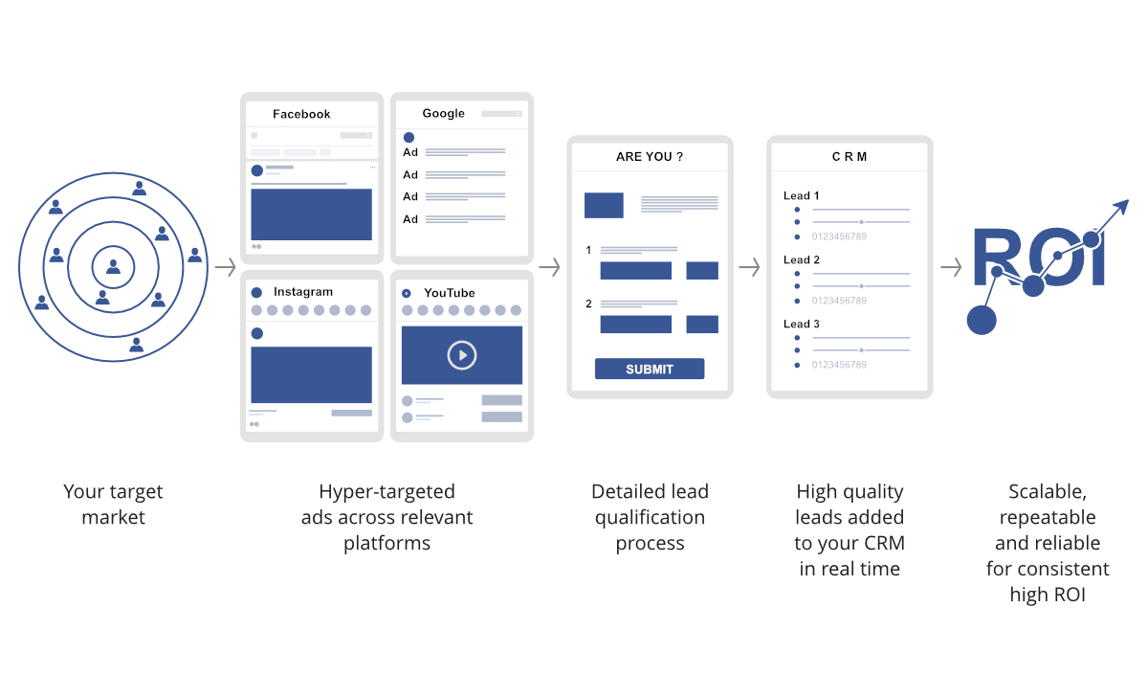

Add a similar banner below. The button text should say “Let’s Talk Leads” and send the user to the contact page  


**CONTACT US PAGE**

Create a form that submits to [geron@vonexx.com](mailto:geron@vonexx.com) Capture the following information:  
Name, Email, website, Phone, Company, Comments/Questions