GEO Analytics
User Guide
How to use GEO — Onclusive

1. Introduction — What is GEO?
GEO (Generative Engine Optimization) is Onclusive's brand analytics platform. It measures how AI engines (ChatGPT, Gemini, Claude, Grok, Perplexity) perceive and cite your brand when users ask them questions. Where SEO optimizes your visibility on classic search engines, GEO reveals and optimizes your presence inside AI-generated answers.
In practice, GEO automatically queries several AI engines with targeted questions about your brand, products and competitors, then aggregates the answers into metrics, rankings and actionable recommendations.
What GEO lets you do:
- Measure your visibility and Share of Voice in AI answers.
- Benchmark your brand against competitors (win rate, positioning).
- Understand how AI engines perceive your brand (sentiment, themes, reputation).
- Identify the sources (domains) AI engines cite, and their favorability.
- Detect concrete improvement areas (visibility, competitive, reputation).

User roles:
- Editor — read/write access: create and edit analyses.
- Reader — read-only access: view dashboards and exports.
- Super administrator — read/write access: creation and modification of analyses, and also administrative access for managing organizations and users
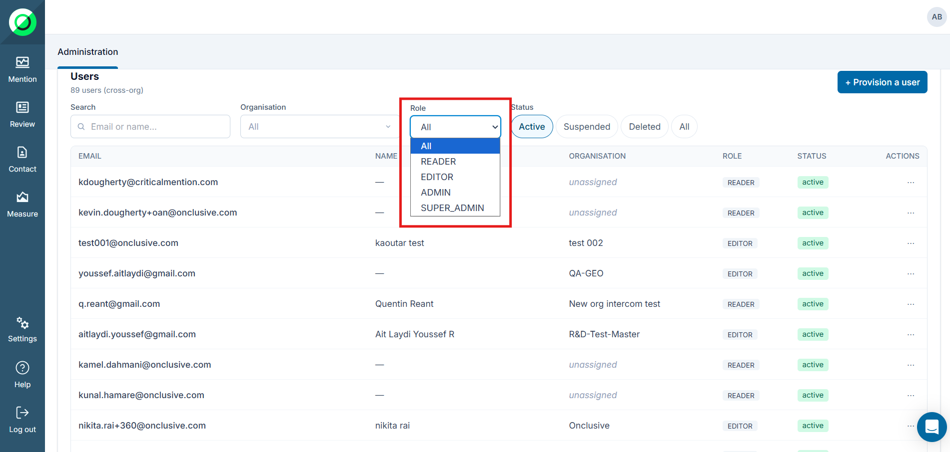
Each user is linked to their own organization
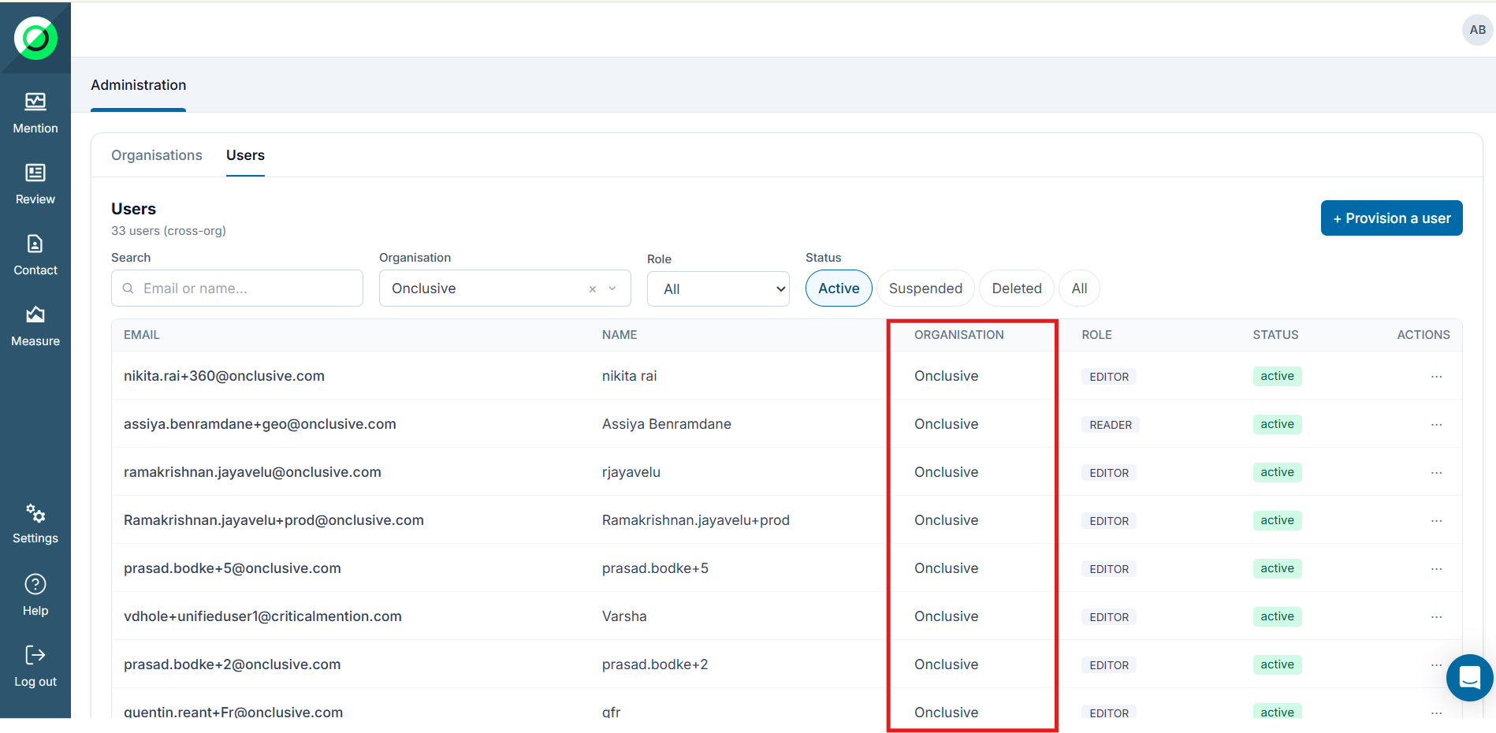

Organisation:
The organization is created by name, quotas, collection frequency(Daily or One time), and authorized AI engine providers.
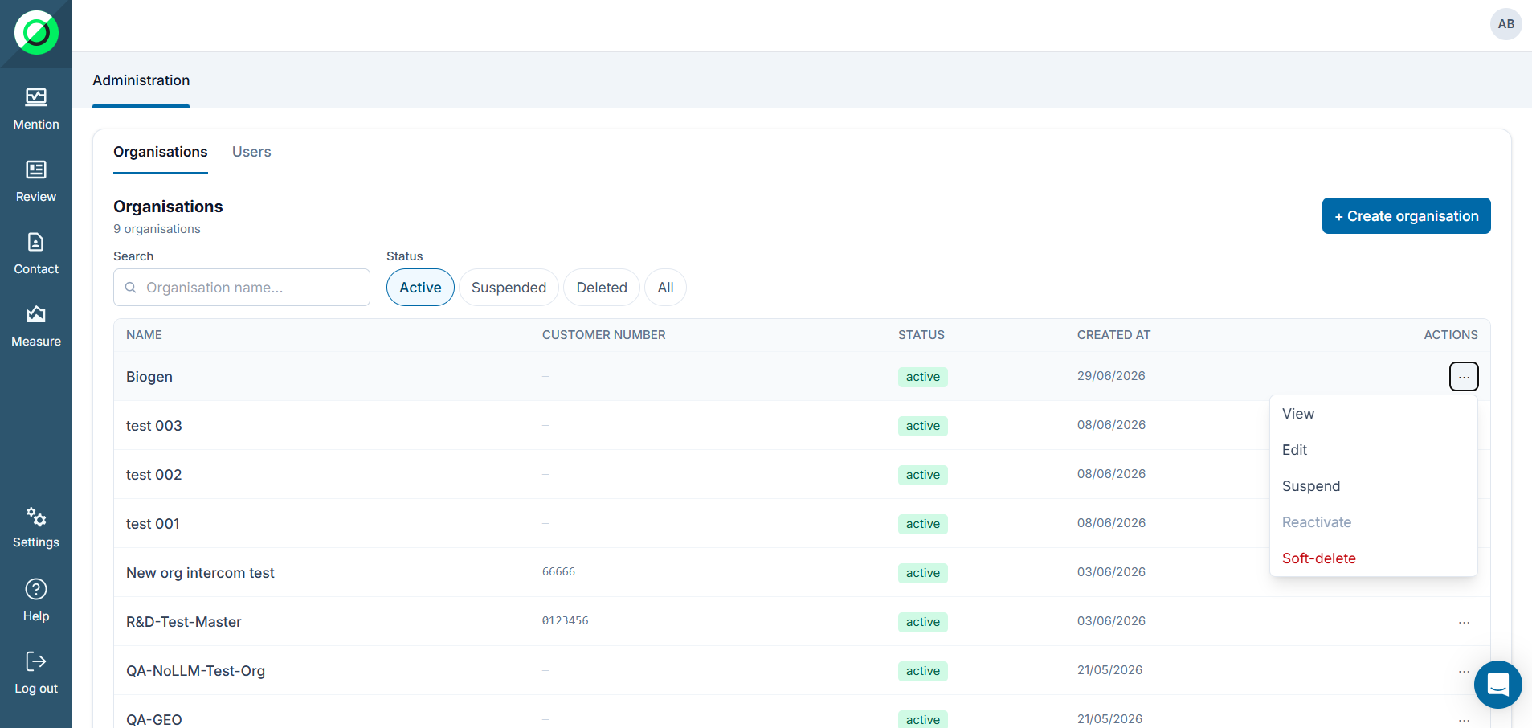

2. Access and sign-in
Access to GEO is provided through Onclusive's single sign-on (SSO) via Auth0.

2.1 Signing in
- Open the platform and let it redirect you to the Auth0 login page.
- Enter your Onclusive credentials. Your organization is resolved automatically.
- Once signed in, your session is kept (no need to log in again on each visit).

2.2 Access to the “Measure” (GEO) module
On sign-in, GEO checks whether the module is activated for your user account:
- Module activated → you go straight to the GEO dashboard.
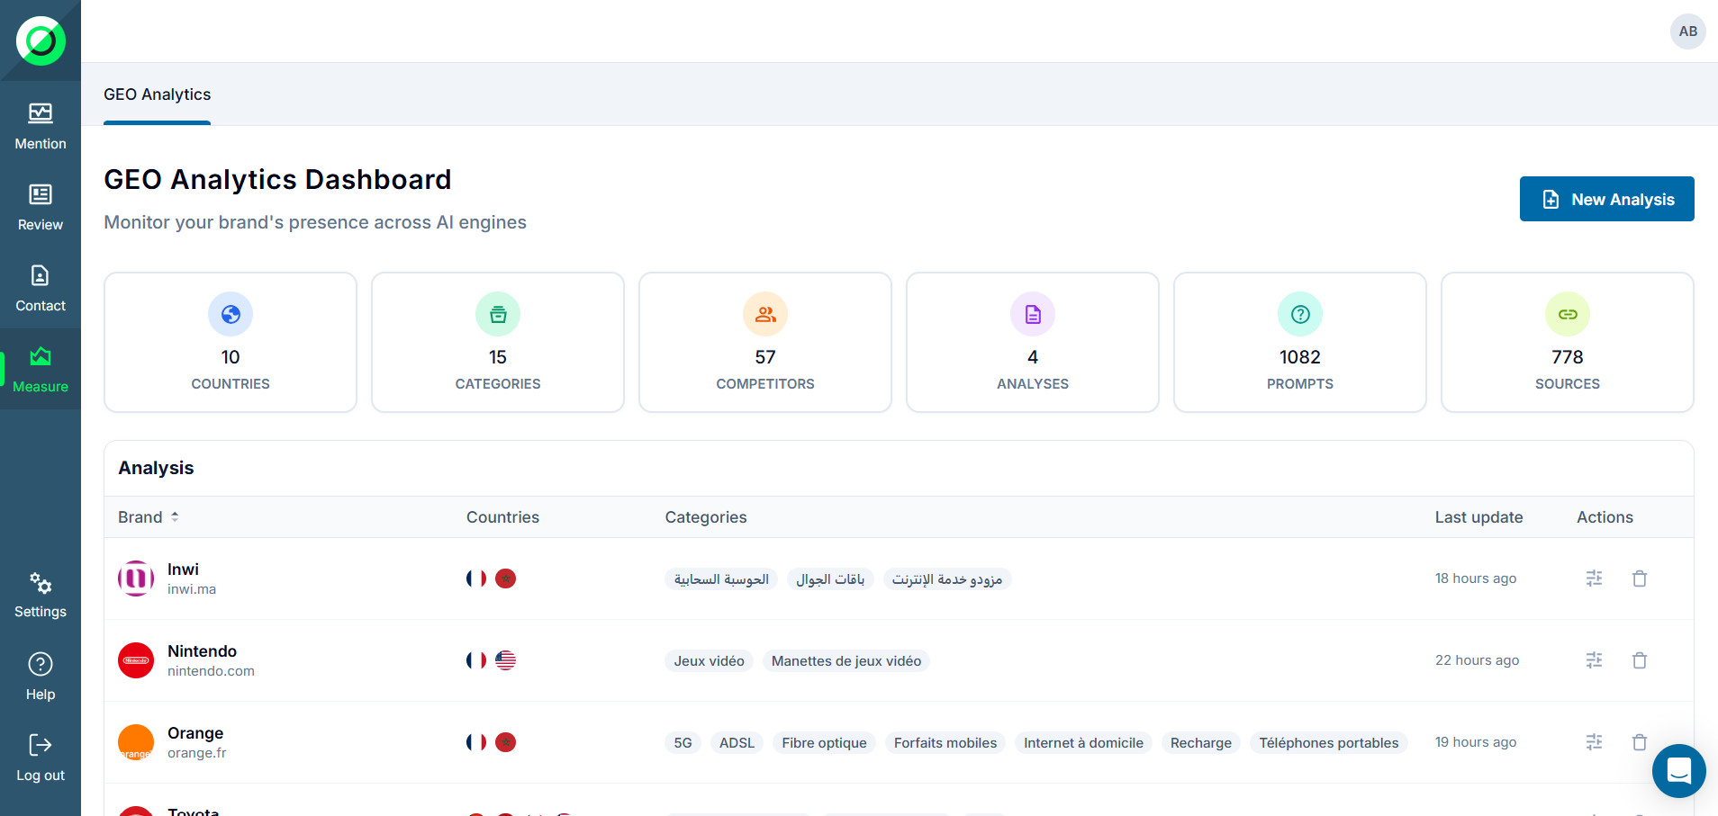
- Module not activated → you are redirected to a sales (upsell) page to discover GEO.
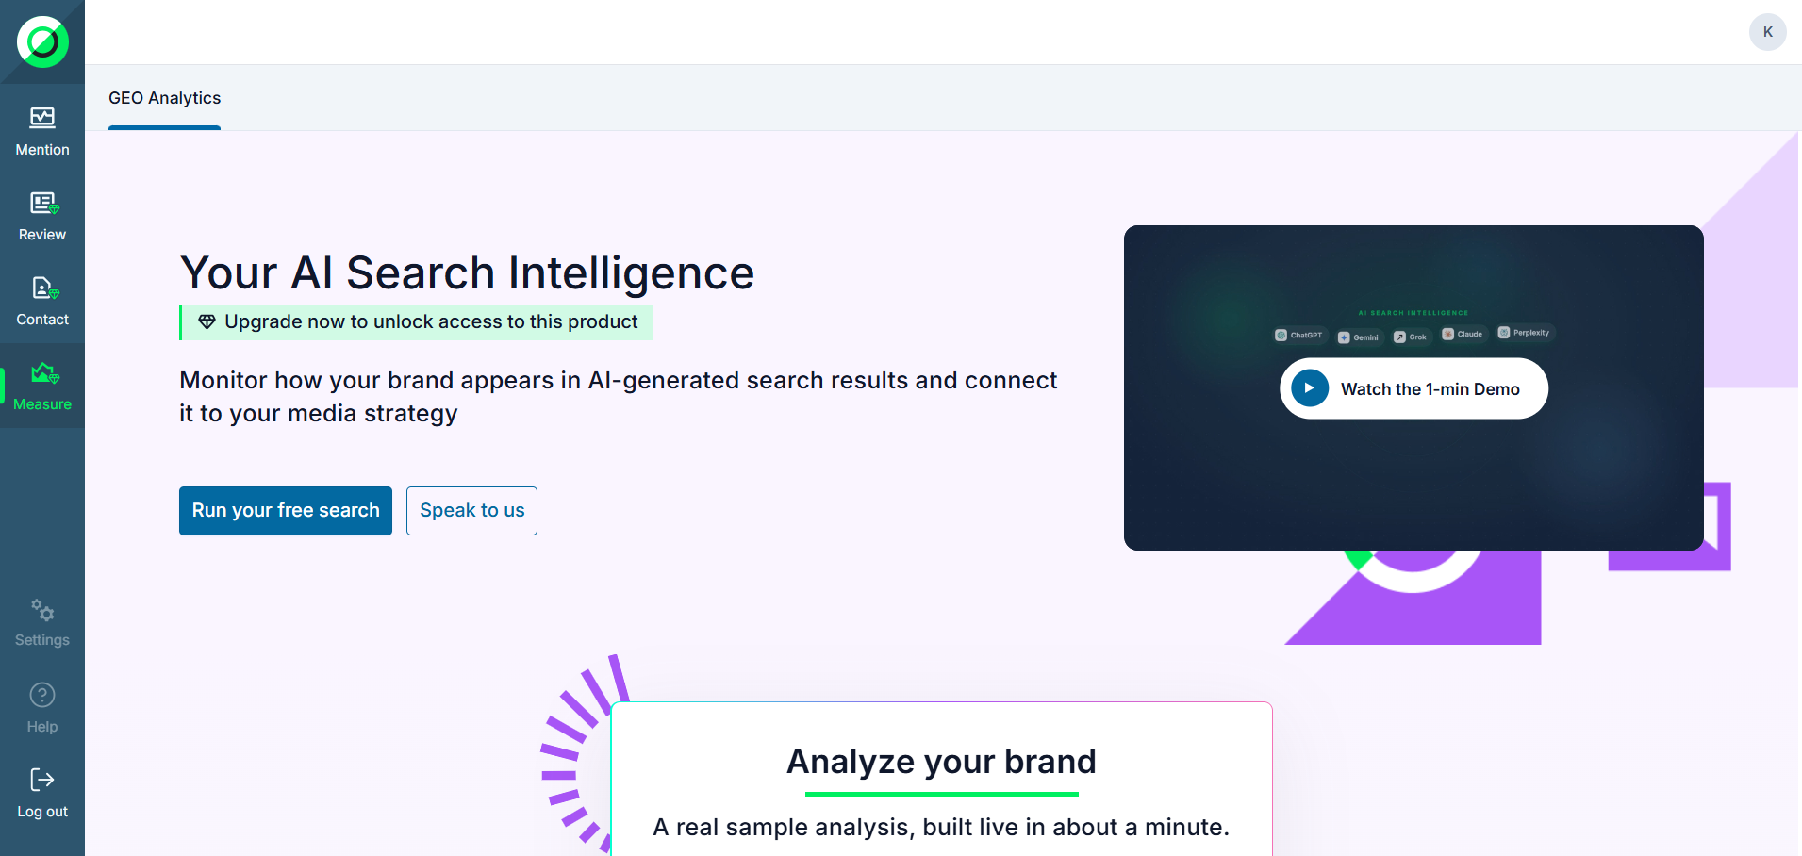

2.3 The report list
The home page lists all of your organization's reports (analyses):
- Report name, status (In progress / Completed), creation date and last-analysis date.
- Click a report to open its dashboard.
- Editors can create a new report; Readers can only view.
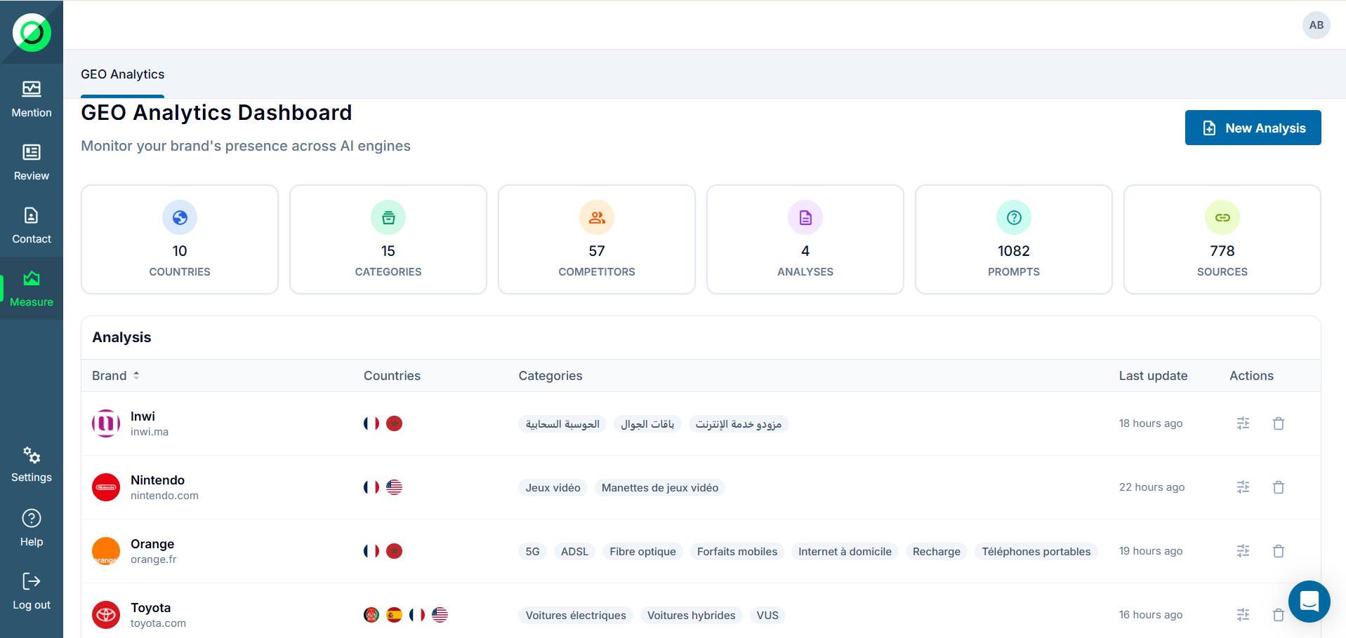

3. Creating an analysis — the Wizard
Creating an analysis is done through a 4-step wizard, with a progress bar and sticky header/footer. At any point, leaving the wizard with unsaved changes opens a confirmation (Discard) dialog.

3.1 Step 1 — Brand and country
- Select your brand: an auto-complete search field (powered by Brandfetch) that returns the brand name, logo and metadata.
- Markets: add one or more countries (at least 1 required). The default language is auto-detected per country and remains editable.
- One market is flagged “Primary”; it sets the language of AI insights (see also GEO-656, which replaces this concept with an explicit AI-insights language choice).
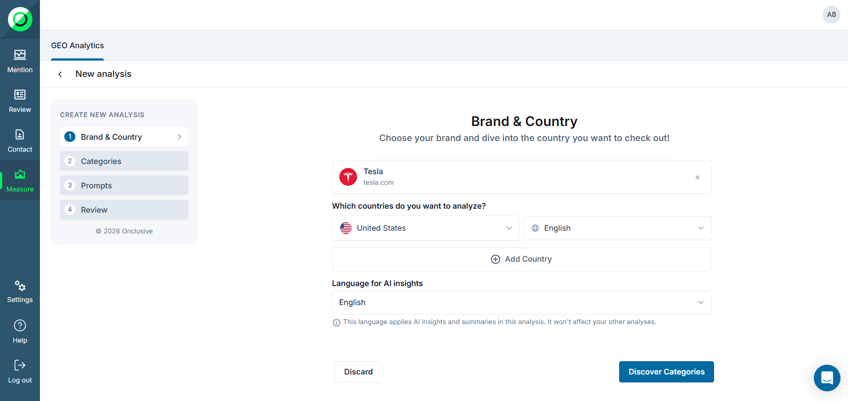

3.2 Step 2 — AI category discovery
GEO analyzes your brand across the selected markets and automatically generates the relevant categories b .
- Detected categories carry an “AI GENERATED” badge.
- “+ Add Category” button: add a manual category (“CUSTOM” badge, translated for all markets).
- × icon: delete a category. Last-one rule: you cannot delete the only remaining category.
- Empty state: if nothing is detected, an illustration and an “Add Custom Category” appear.
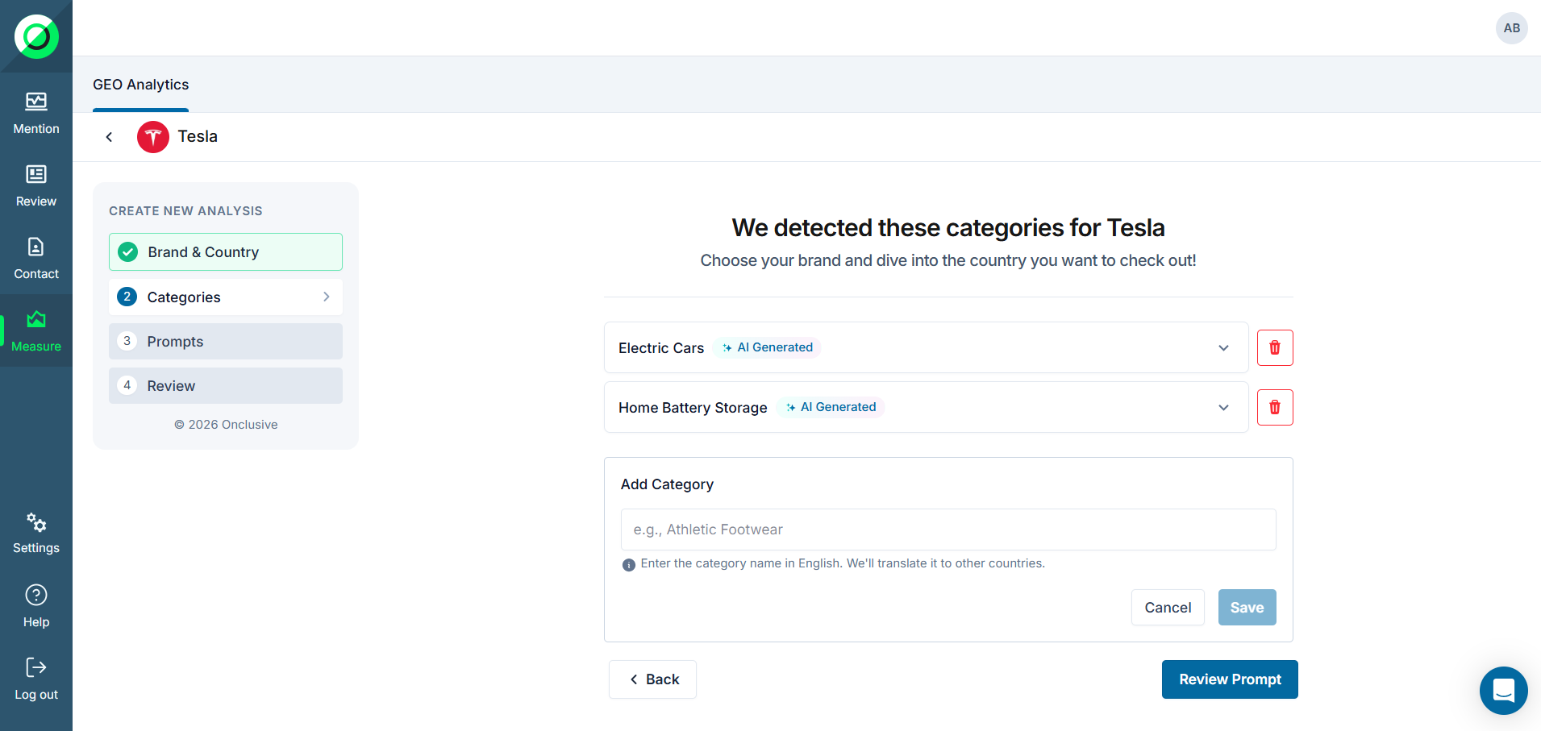

3.3 Step 3 — Prompts review (questions)
The questions asked to the AI engines are organized by market (tabs with flag + language) then by type:
- Sentiment (Perception): reputation and brand image.
- Visibility Analysis: how often the brand is cited / how visible it is.
- Competitive Analysis: comparison against competitors (auto-detected).
Inline editing: hover a question to reveal the pencil (edit) and trash (delete) icons. Enter to save, Escape to cancel; a “?” is appended if missing. An empty or invalid question (invalid characters, single letter) triggers the message “Please enter a valid question.” A deletion can be undone within 5 seconds (Undo toast).
Per-type quotas: per-category limits apply (perception / visibility / competitive); a toast blocks the addition once the quota is reached.
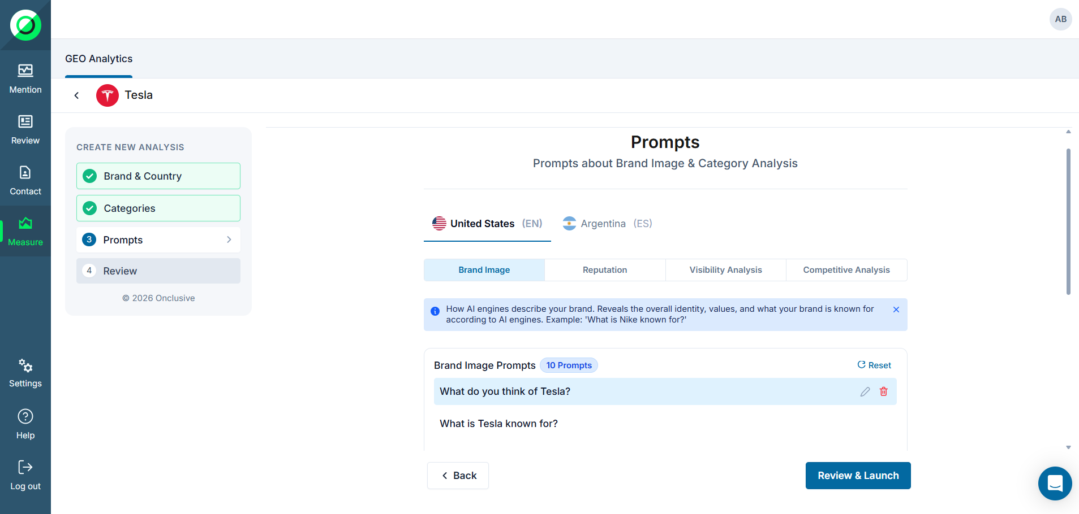

3.4 Step 4 — Review and launch
A “Ready to analyze {Brand}” summary shows the number of countries, categories and questions.
AI engine selection (5 available):
- Gemini, ChatGPT, Claude, Grok, Perplexity — each card shows logo, name, description, a “web search” checkbox and an ON/OFF toggle.
- Defaults: Gemini ON and ChatGPT ON, the others OFF.
- At least 1 engine must stay active; if you try to disable them all, the system reactivates all (never 0).
Click “Review & Launch”. On first creation you are redirected to the report and the analysis starts automatically. For an existing analysis, changes apply on the next scheduled execution.
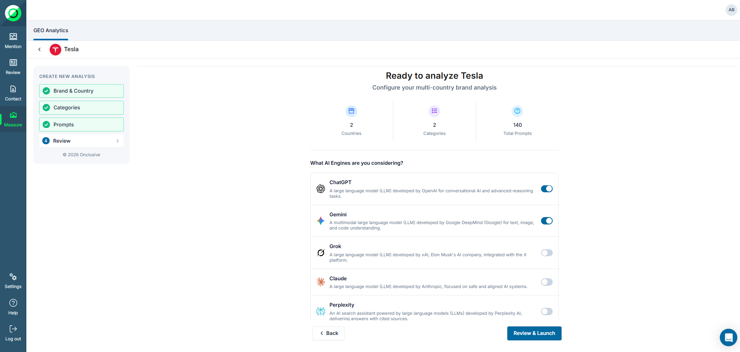

4. Following the analysis execution
Once launched, the analysis runs through a resilient pipeline that queries every enabled engine in parallel. You follow the progress in real time.

4.1 Progress view
- Live status messages (e.g. “Your analysis is launched ”).
- The pipeline is never blocked
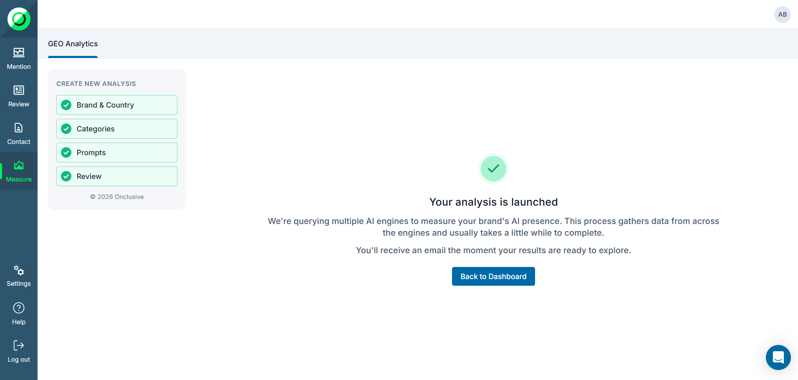
At the end, the status changes to COMPLETE “A few second later”, a snapshot is created and the results are immediately available in the Overview.
5. The dashboard — Overview
The Overview is the summary view of your analysis: key metrics, rankings, concepts, sources and AI summaries.
5.1 Layout and navigation
- Header: “Back to Analysis” arrow, brand name + logo, generation date, active engine badges.
- Sidebar: Overview section, Categories accordion (clickable list), Manage Scope access. The current view is highlighted; navigation is instant and filters persist.
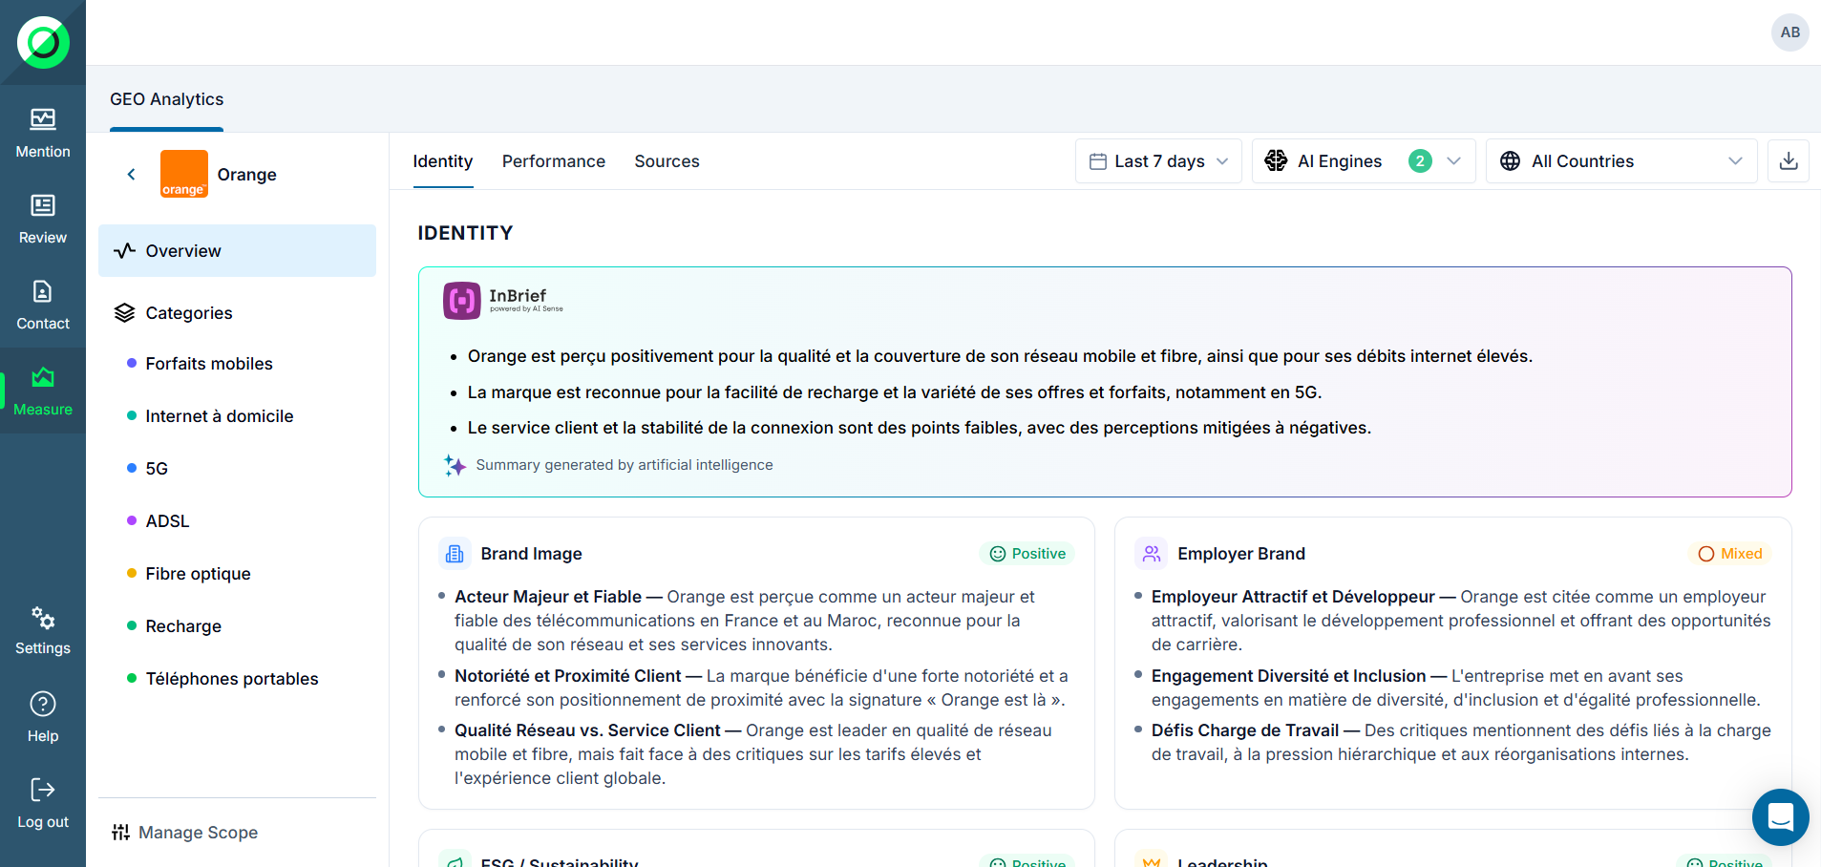

5.2 Filters: country and LLM engines
- Country filter: “Master (All countries)” by default, or a specific country. It rescopes all metrics, tables and charts.
- LLM engine filter: all 5 engines active by default; deselect some to exclude their data. At least 1 engine must remain selected. Perception summaries are regenerated if the engine set changes.
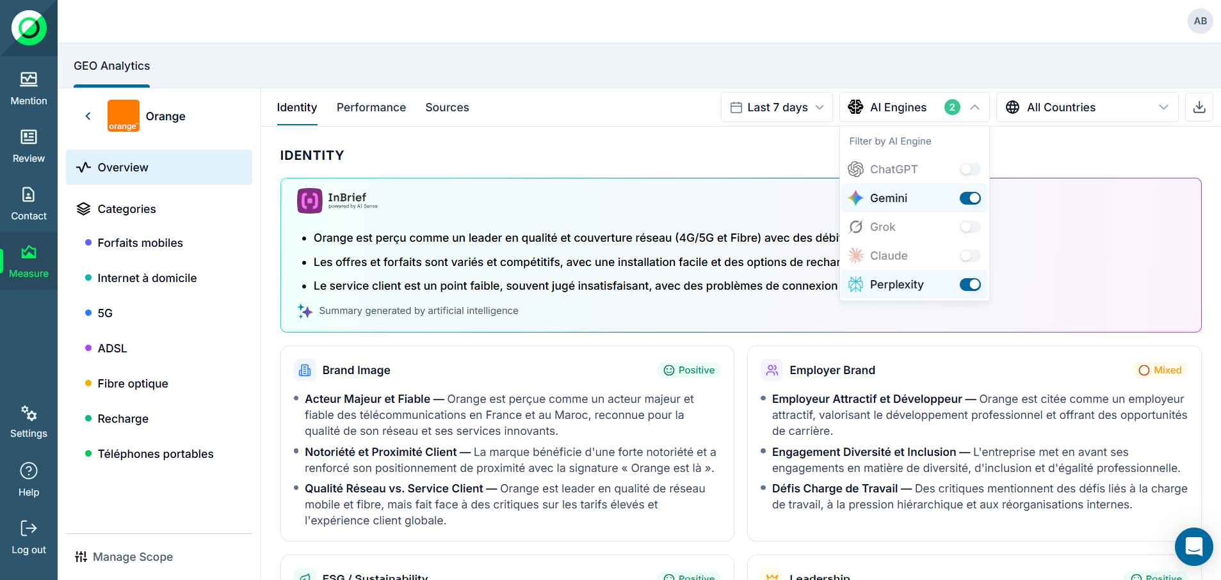
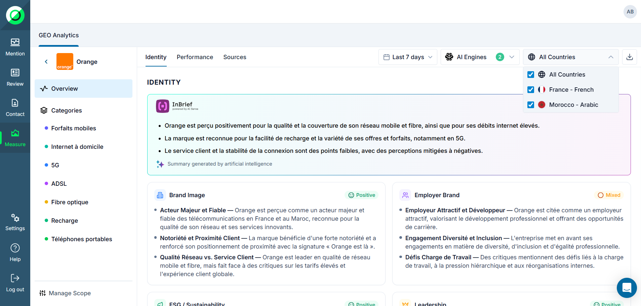

5.3 The 4 KPI cards
The same 4 metrics appear on the Overview and on every Category view. Each card shows the value, an optional quality label, and an (i) icon that describes the metric on hover.
Metric | What it measures | Quality labels
Visibility | % of AI responses that name your brand | —
Avg Position | Average rank when the brand appears | Good #1–2 · Fair #3–4 · Poor #5+
LLM Choice (Win Rate) | % of head-to-head comparisons won | —
Sentiment | Average tone of mentions (−100 to +100) | —
FAILED responses are excluded from calculations; an unranked brand is penalized (rank 11) for the average-position computation.
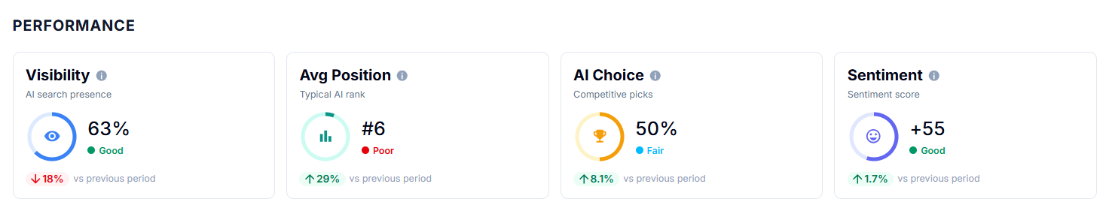

5.4 Category prioritization matrix
Scatter chart: X-axis = Visibility %, Y-axis = Win Rate %. Each bubble is a category. Read by quadrant:
- Top-right (high visibility + high win rate): strength to double down on.
- Top-left (low visibility + high win rate): opportunity to invest in.
- Bottom-right (high visibility + low win rate): competitive challenge to improve.
- Bottom-left: monitor, low priority.
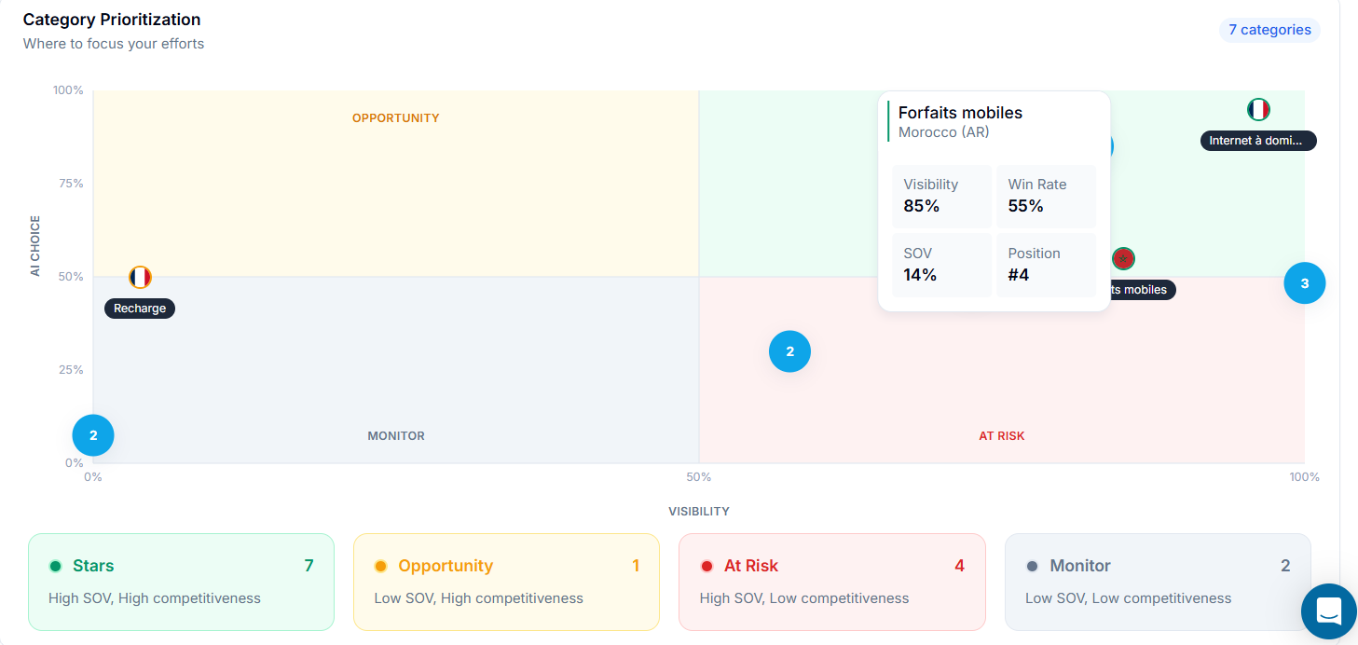

5.5 Brand Rankings
Table listing every brand that appears in the AI responses, with columns: brand, Visibility %, Avg Position, Win Rate %, Sentiment and source count. Sorted by descending visibility by default; each row expands to a per-engine breakdown.
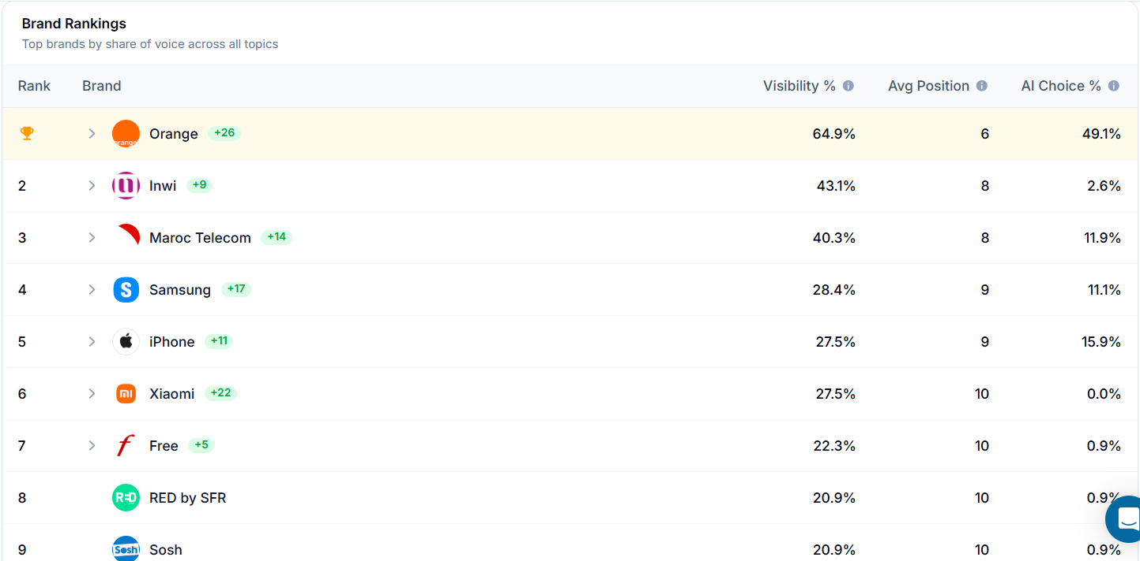

5.6 Top Concepts
Cards for the concepts / themes spontaneously associated with the brand: concept name, sentiment split (positive / mixed / negative), frequency, badges of the engines that mentioned it, and clickable sources. The content recomputes according to the active engine filter.
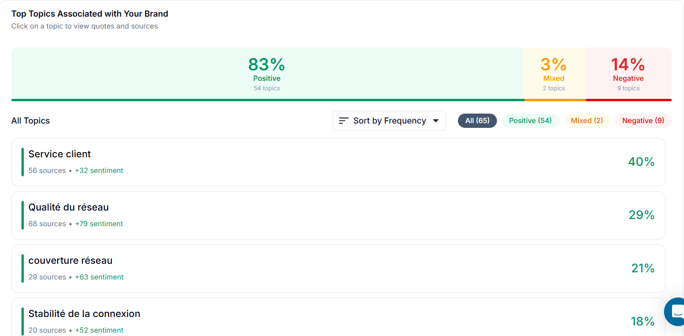

5.7 AI Citation Sources
Two components: a stacked bar chart of the distribution by source type (news, blogs, academic, government, social media, video, forums, e-commerce, press releases, official sites, other) and a table of domains with type,Frequency and favorability (Favorable / Neutral / Unfavorable) . Everything respects the country and engine filters.
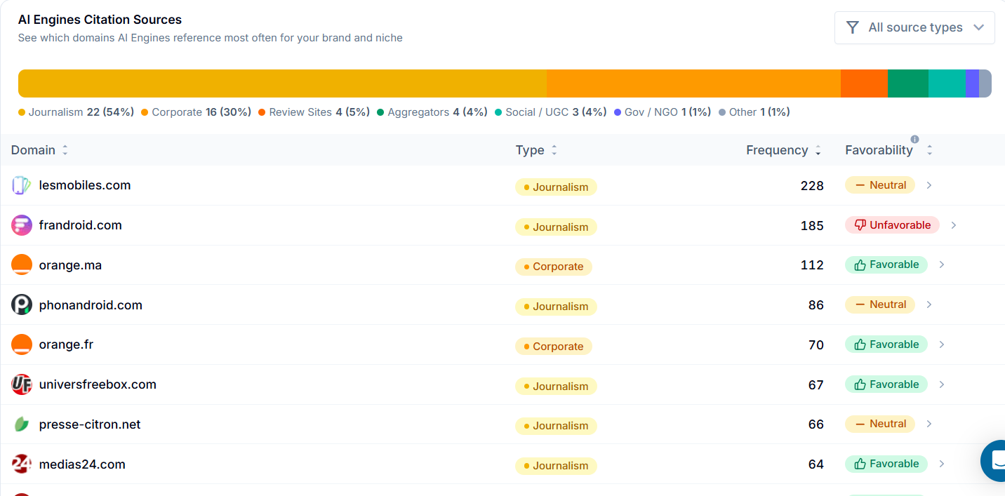

5.8 AI summaries: Perception Summary and Executive Summary
AI Perception Summary: a 3 bullet summary, generated with an AI insights language chosen by the user
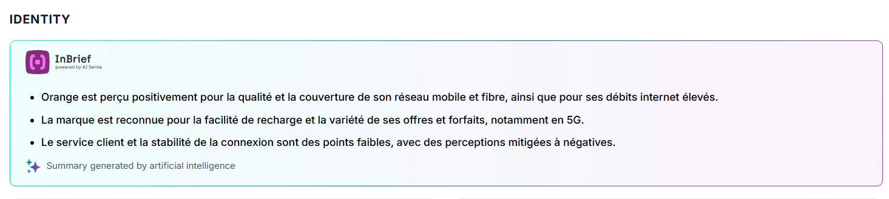
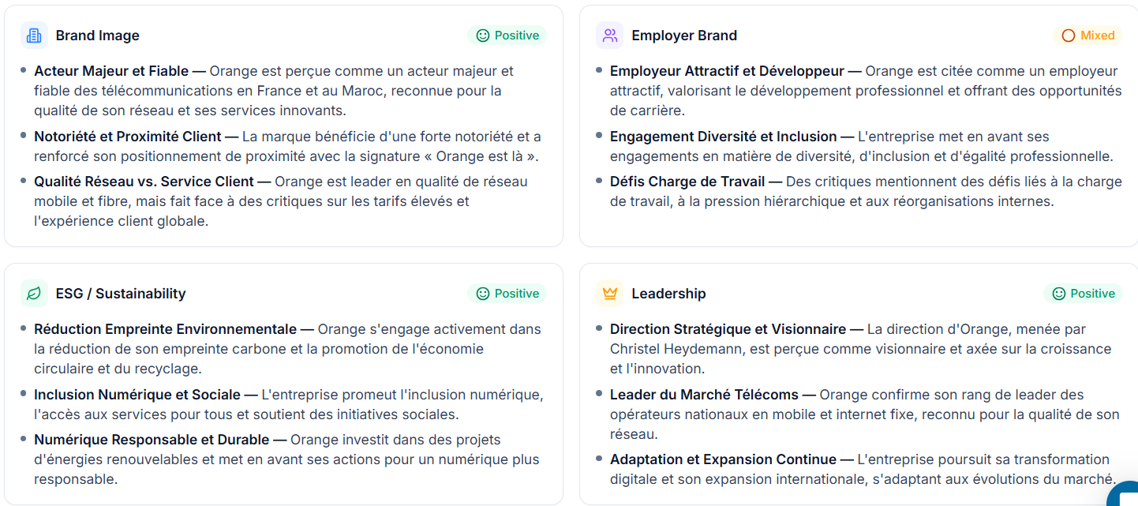

5.9 Report actions
- Export: Excel / PowerPoint / PDF .
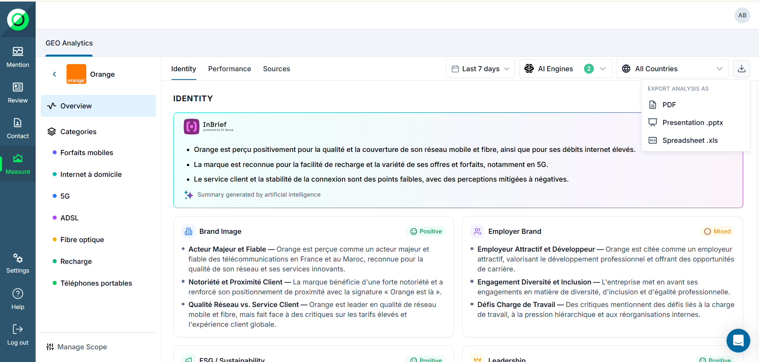
- Delete: delete the report (with confirmation).
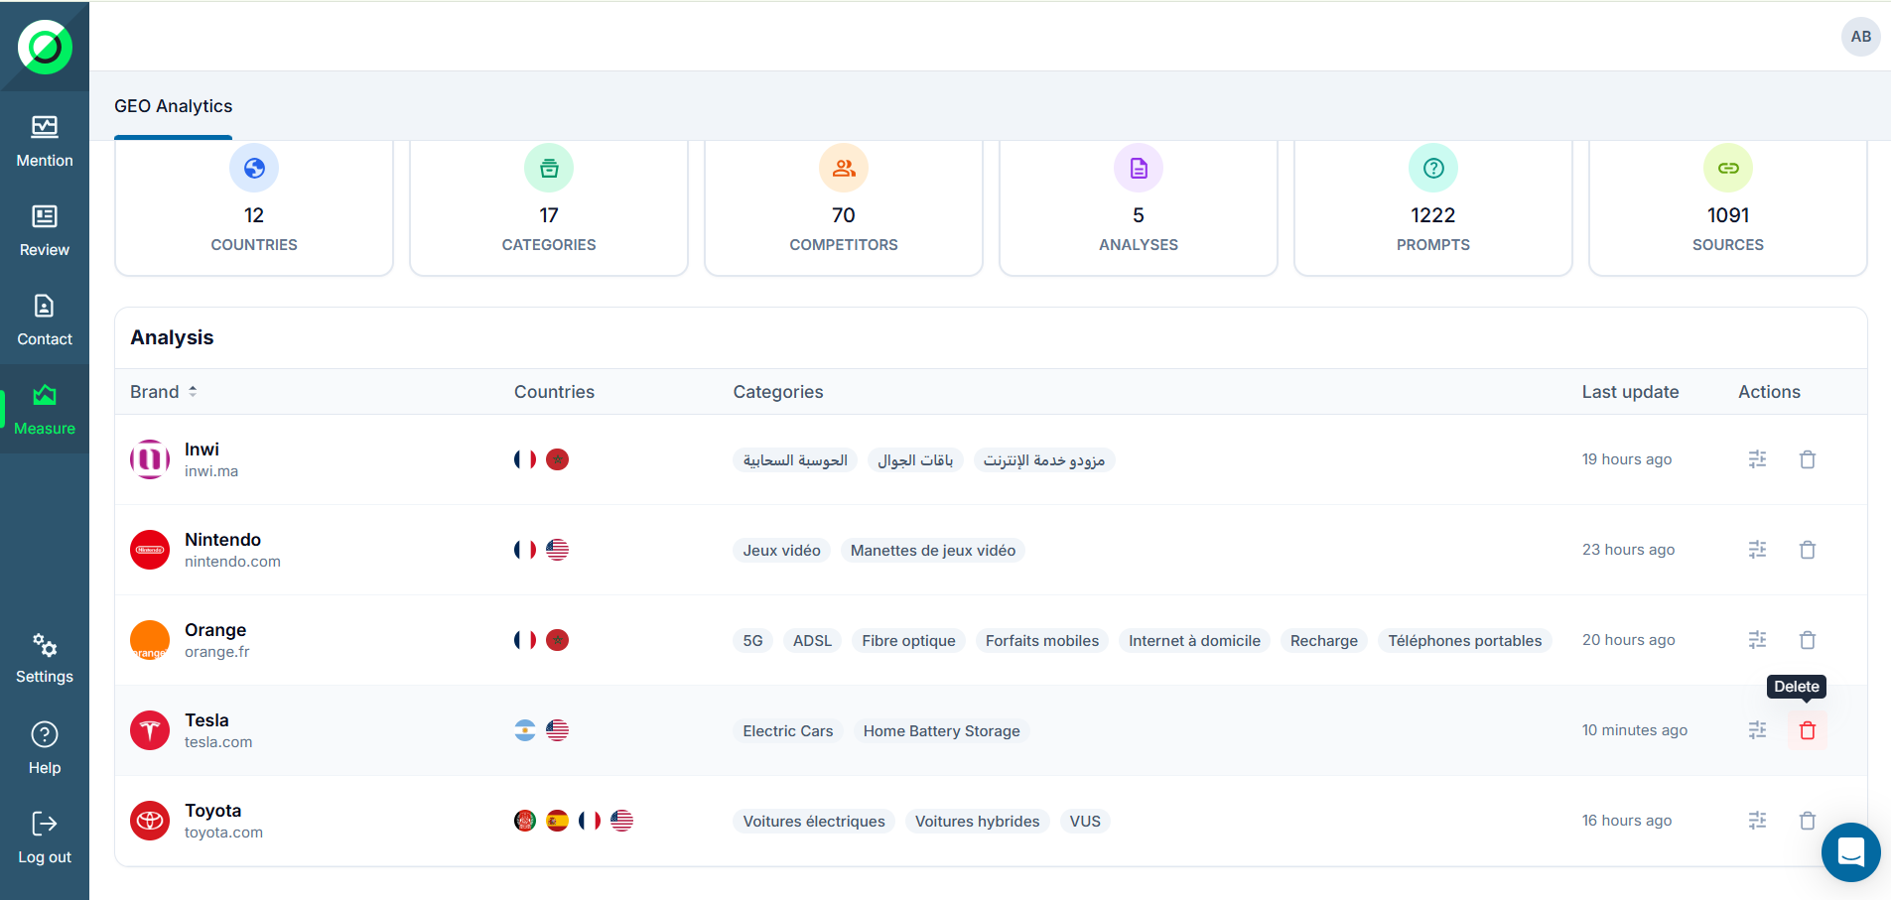
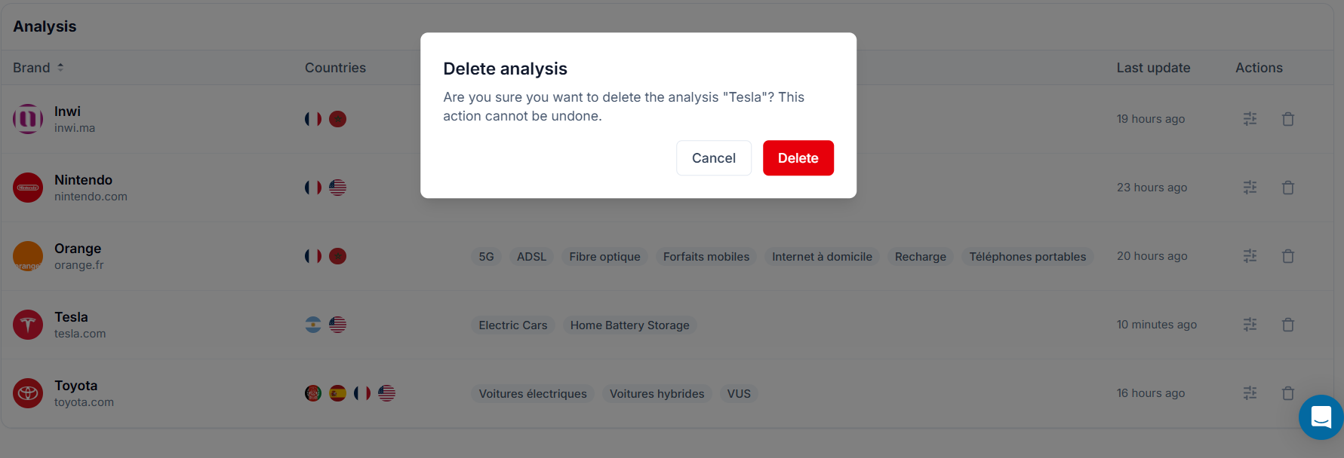

6. Category views
Clicking a category in the sidebar opens its detailed page, organized into Identity | Performance | Sources tabs.

6.1 Category KPIs and summary
The same 5 KPI cards, but scoped to the selected category, together with a category-specific perception summary. Market + engine filters apply.

6.2 Category matrix and rankings
- Prioritization matrix (Visibility % × Win Rate %) focused on the category's competitor brands.
- Category brand ranking, with per-engine detail on expand.

6.3 Questions Table
A unified table of every question asked in the category and the responses, with Visibility | Perception | Competitive tabs. Columns: question, type, engine, answer/rank/outcome, favorability.
Status labels :
- Visibility (per engine): rank 1–3 → Favorable (green); rank 4–10 → Unfavorable (amber); unranked → Unranked (red, brand missing).
- Competitive (per engine): engine picks the brand → “Won”; otherwise → “Lost”.
- Cross-engine aggregate: “Split” when engines disagree.
Voir plus de details sur : https://docs.google.com/spreadsheets/d/198hfK9gVzNmgmDKp5PclJqJx5-EI2MfAKhI1ds6cJ-c/edit?gid=0#gid=0
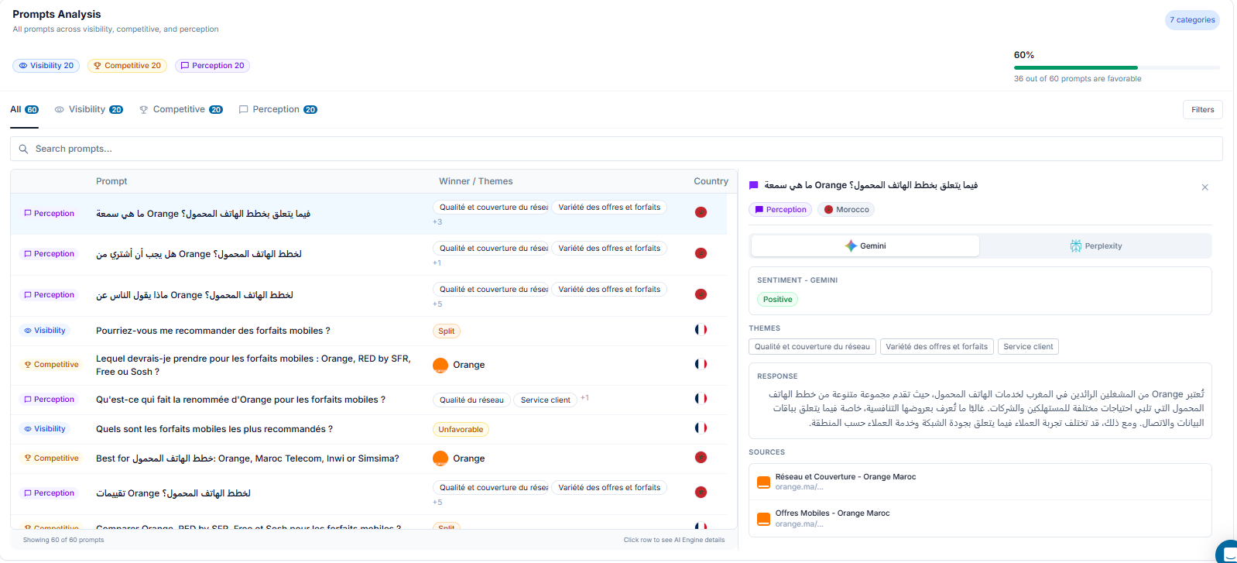

7. Manage Scope
The Manage Scope page lets you evolve an existing analysis without recreating it: markets, categories ,engines and prompts. Editors get the controls; Readers see a read-only version.

7.1 Page content
- Countries / Markets: list of markets (one “Primary” badge), “+ Add Country” button, removal via trash icon (last-one rule).
- Categories: list of categories, “+ Add Topic” button, removal via trash (last-one rule).
- AI Engines: 5 ON/OFF cards with a “web search” checkbox; at least 1 active engine required.
- Prompts : list of prompts.
- Report metadata: creation / last-analysis dates.
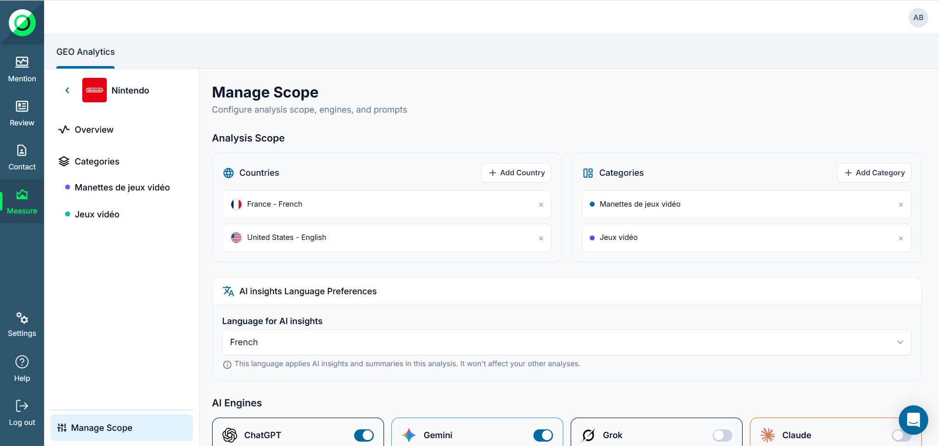

7.2 Adding / removing a country or category
Adding a country consumes a market quota; adding a category does not. Any change comes with the message “Changes will take effect on next scheduled execution”: changes apply on the next scheduled run and do not alter existing results.
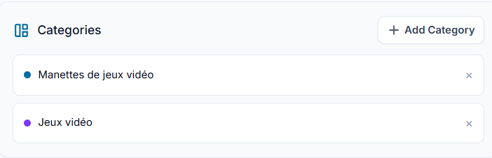
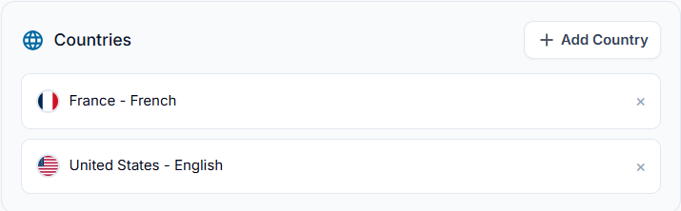

7.3 LLM engine configuration
- Each engine's ON/OFF toggle is saved immediately (no Save button).
- The “web search” checkbox is active only if the engine is enabled (otherwise greyed out).
- You cannot disable the last engine: its toggle is locked with an explanatory tooltip.
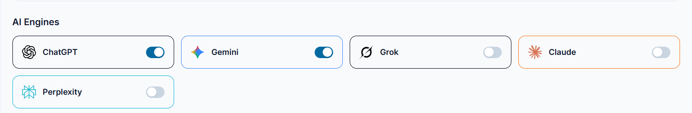

7.4 Prompts
You can add, remove and update a prompts , and also you can see the history of each action
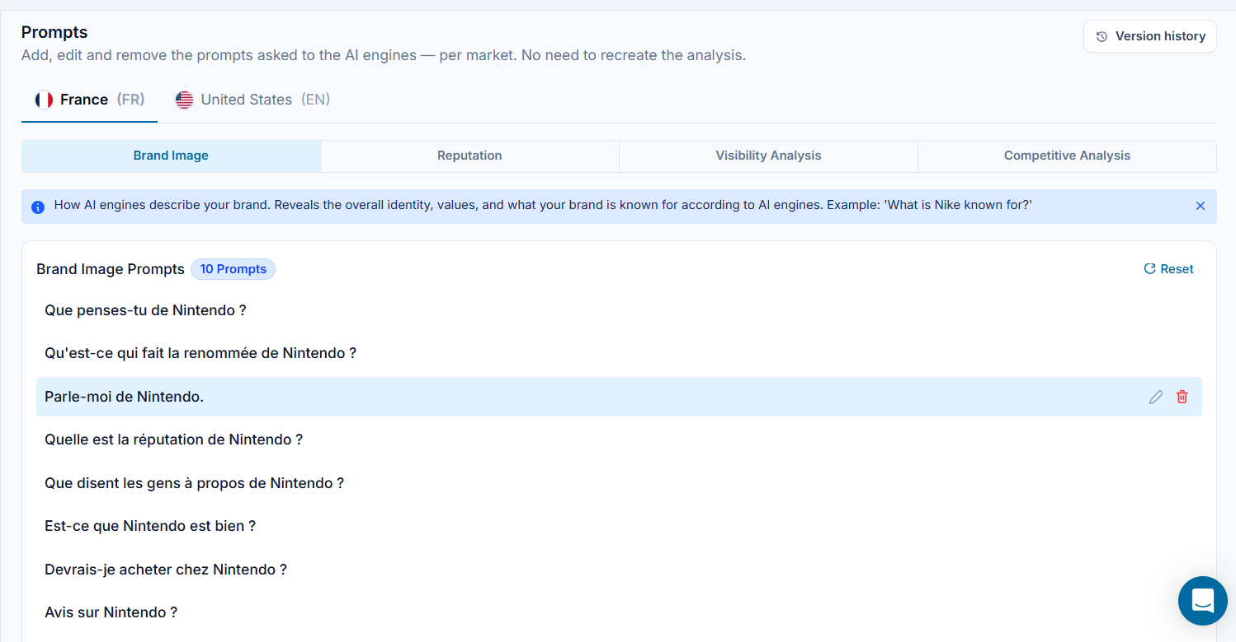
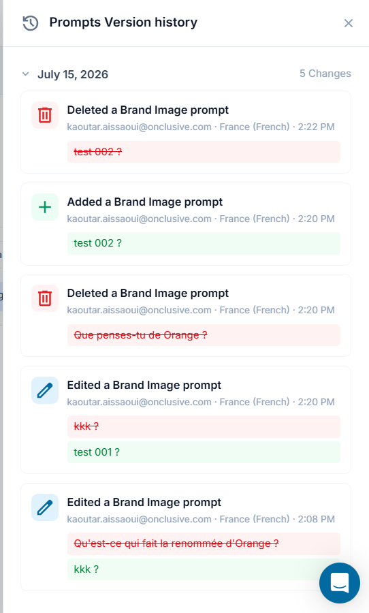

8. Snapshots, navigation and guided tour

8.1 Snapshots
On each completed execution, GEO creates an immutable snapshot. Snapshots are never modified and enable historical comparison (12+ months retention).

8.2 Snapshot navigator
Move from one snapshot to another (date selection). The whole dashboard reflects the selected snapshot (frozen data, not live); country+ engine filters apply.
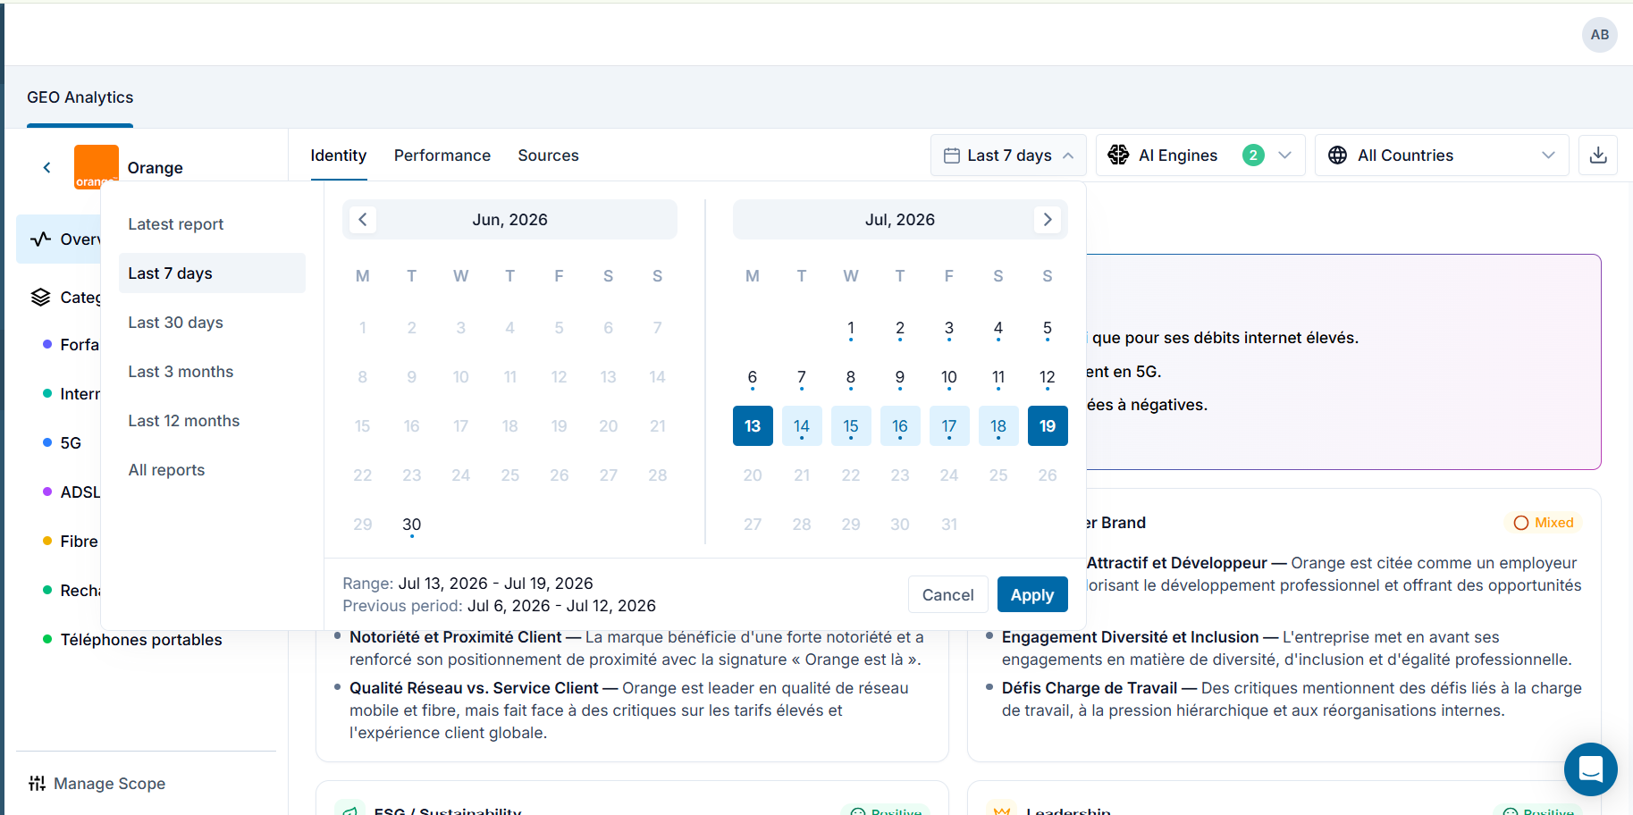²

9. Brand Identity and corporate reputation
The Identity tab analyzes the brand's image and reputation, beyond the raw performance figures.

9.1 In-Brief
3 AI-written bullets summarizing the brand's overall perception (personality, position, reputation), regenerated when the engine filter changes.

9.2 Corporate reputation cards (4 dimensions)
Card | Dimension
Brand Image | Perception of products, quality, innovation
Employer Brand | Employer reputation, talent attraction
ESG / Sustainability | Environmental and social responsibility
Leadership | Perception of executives and company direction
Each card shows a sentiment badge (Positive / Mixed / Negative / Neutral) and 3 bullets. A click opens a side detail panel.

9.3 Drill-in panel
6 tabs: “All” (consolidated) + one tab per engine (ChatGPT, Gemini, Grok, Claude, Perplexity). The All tab merges the bullets and sources; each engine tab shows the raw response and its own sources.
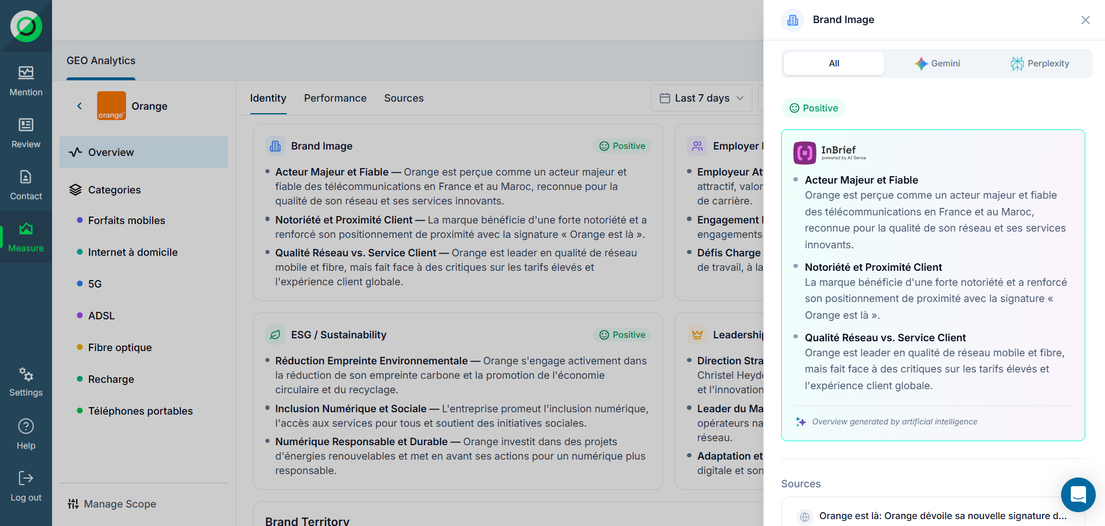

9.4 Brand Territory Chart
A bubble chart of the categories/themes spontaneously associated with the brand: size = frequency. Hover for detail, click to open the theme(AI contexte and AI Engine Contributions).
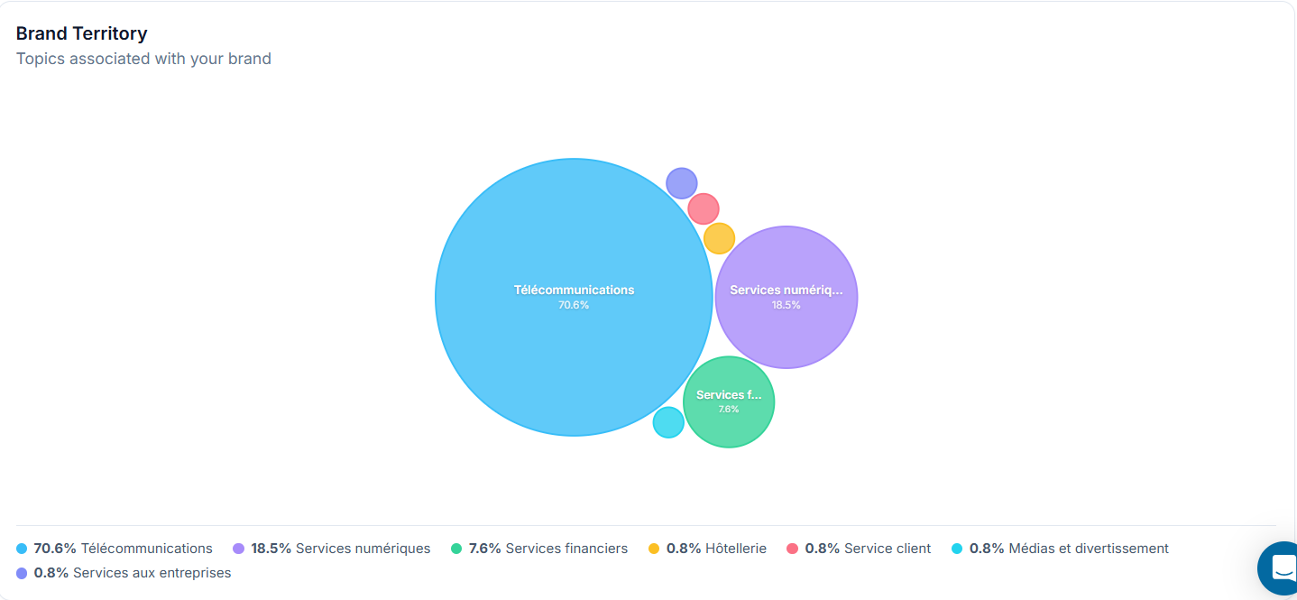

10. Exporting and sharing reports
Export is available to all roles via the “Export” button in the header. Processing runs in the background and a (time-limited) download link is emailed. The export reflects the selected snapshot.
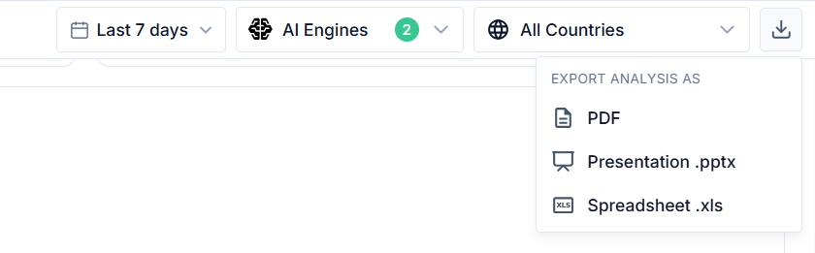

10.1 Excel
- Overview tab (summary metrics), one tab per category, a raw-data tab (one row per question × engine) and chart backing tables.
- Deeper content than on-screen: top 10+ brands, complete source list, competitor drill-in, per-engine win rates. Data only (no chart images).

10.2 PowerPoint
A deck in Onclusive branding: title, executive summary, Overview metrics and charts, one slide per category, recommendations (Actions Center) and a methodology appendix.

10.3 PDF
A fixed, printable document reproducing the current filtered view with rendered charts.

11. Freemium — Lite Analysis
The freemium mode targets logged-in Onclusive platform users who do not yet have the full GEO module. It offers a generic demo and a near-instant lite analysis.

11.1 Generic demo
Entry point “Try for Yourself”: product video, sample dashboard and guided tour.
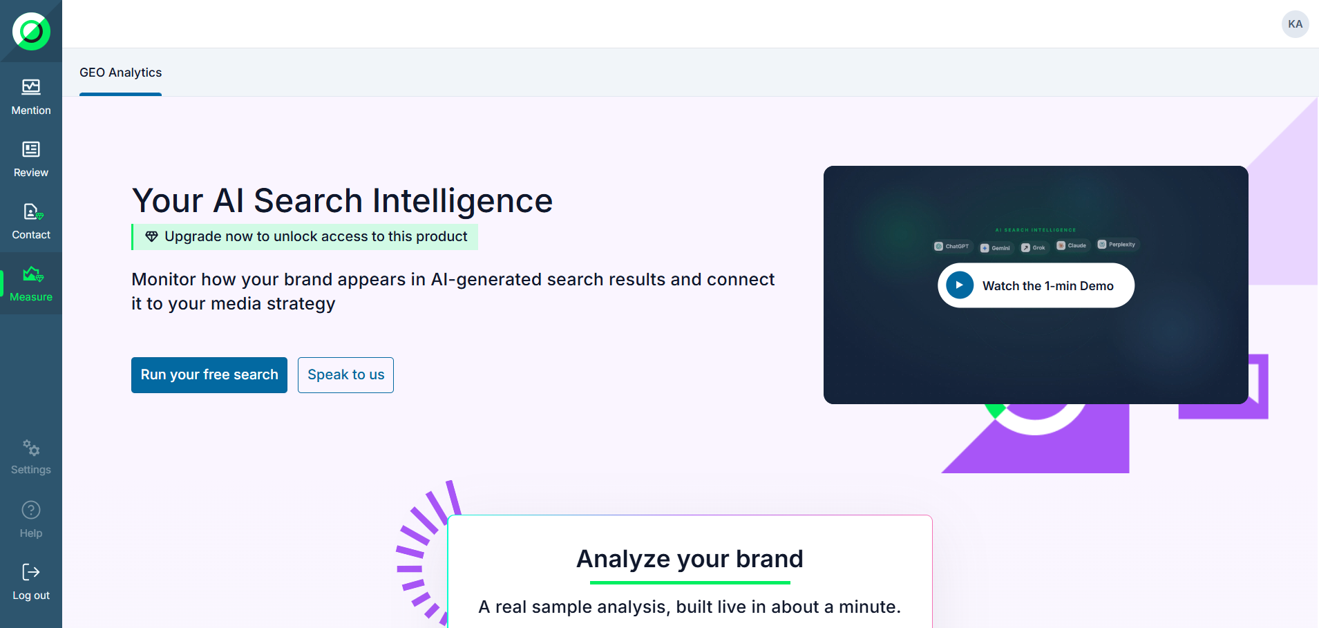

11.2 Lite analysis form
- Brand name (required).
- Products or services: 1 to 3 (the form prevents adding a 4th).
- A single market (Country); the language is pre-filled from the market and remains editable.

The brand is required to launch; a staged loading card shows the progress (target ~30 s).

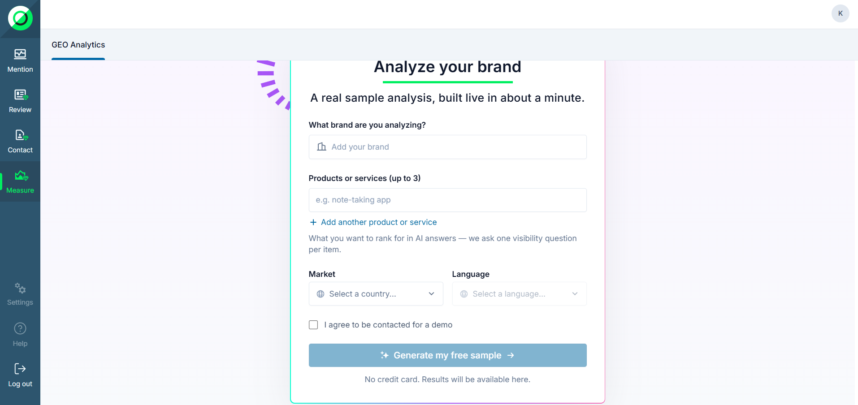

11.3 Result (Reduced Overview)
- In-Brief: 3 AI bullets on the brand's perception.
- “your brand did not appear” banner if the brand is absent from all rankings.
- 5 gauges: Share of Voice, Visibility, Avg Position as real values; Sentiment and AI Choice locked (upgrade).
- Brand Ranking Table: first rows real, the rest blurred behind a lock.
- Prompts Analysis: Visibility and Perception tabs (first rows real), Competitive fully locked.
- Citation Sources: domains and frequency real; type distribution and favorability locked.
- Every locked element carries a “Speak to us”.
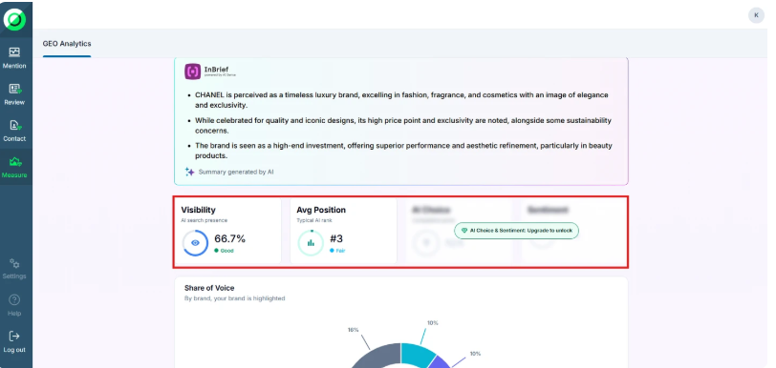
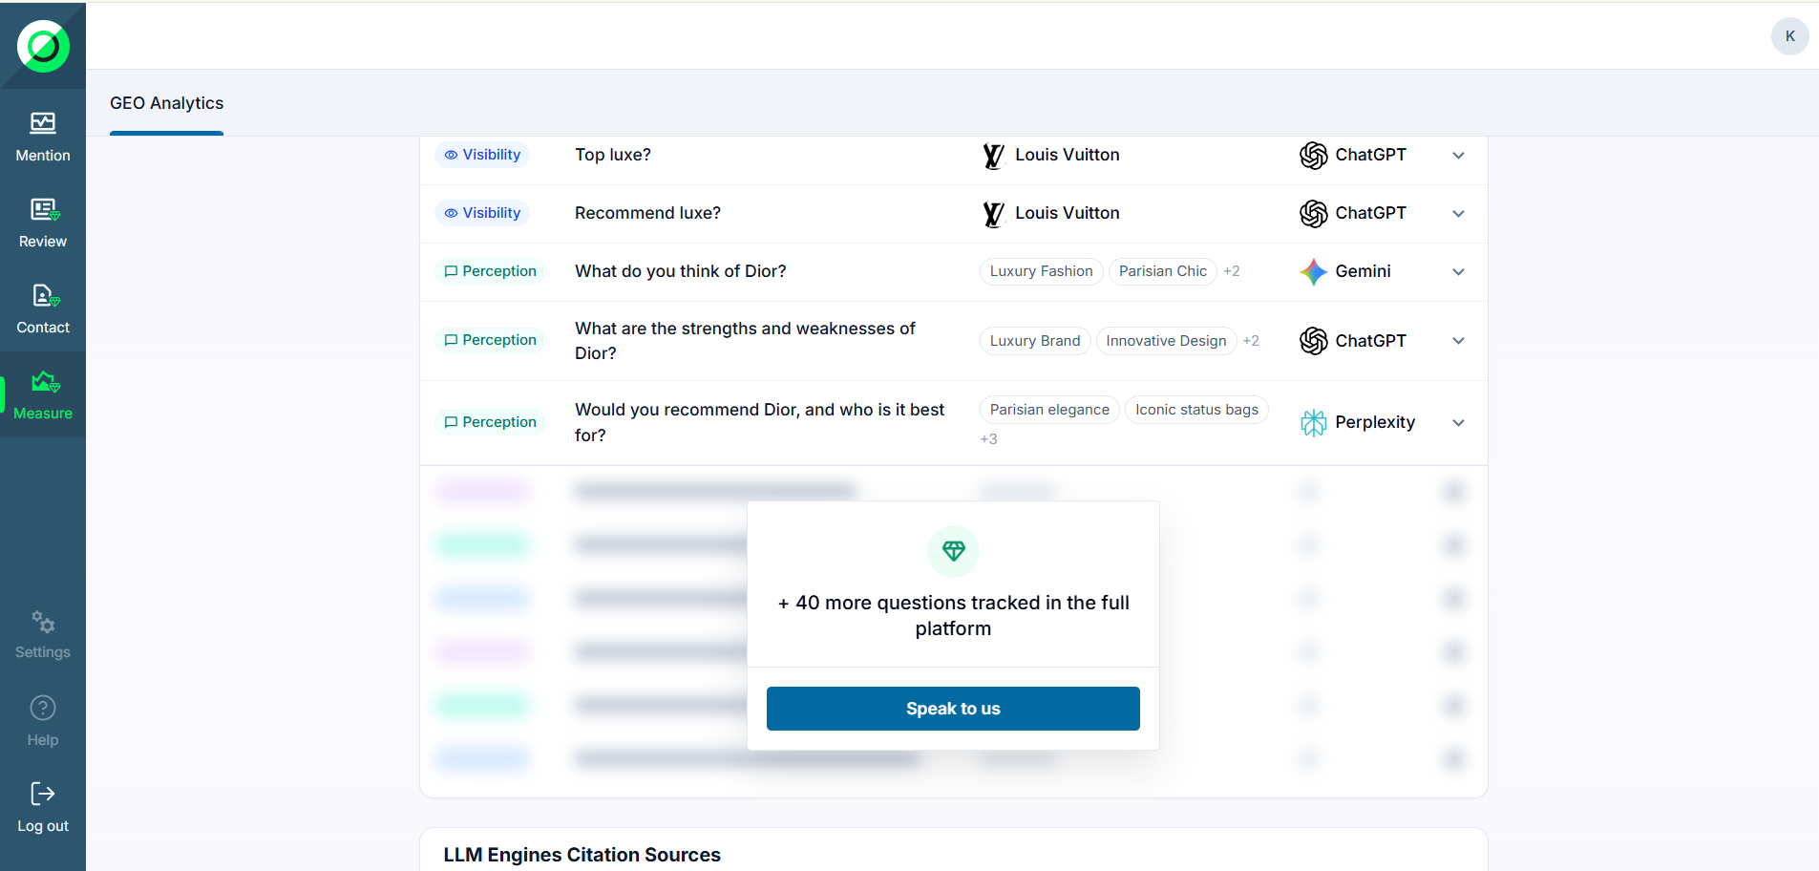
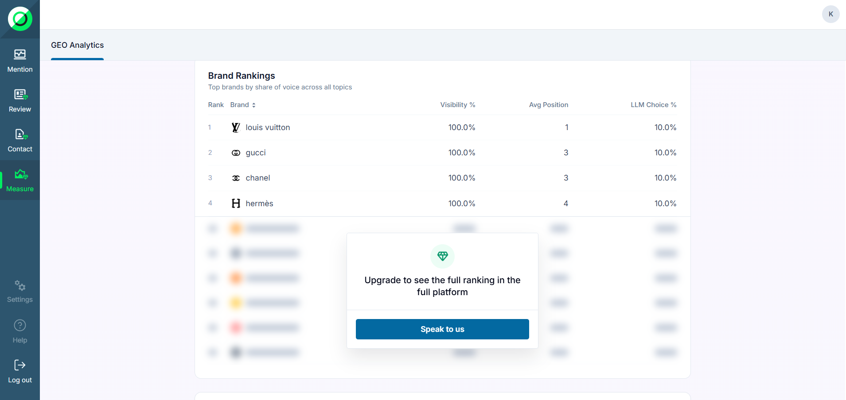

11.4 Lead capture and quota
- A “contact me” consent checkbox; with consent + launch, the lead is sent to HubSpot (identity, analyzed brand, market, consent). Without consent, no lead is sent.
- Quota: 3 lite analyses per user; the 4th is blocked and guides to a demo / talk to sales.
- Cookies: lite analysis is unavailable if Support / Functional (HubSpot) cookies are rejected (explanatory hover tooltip).
- 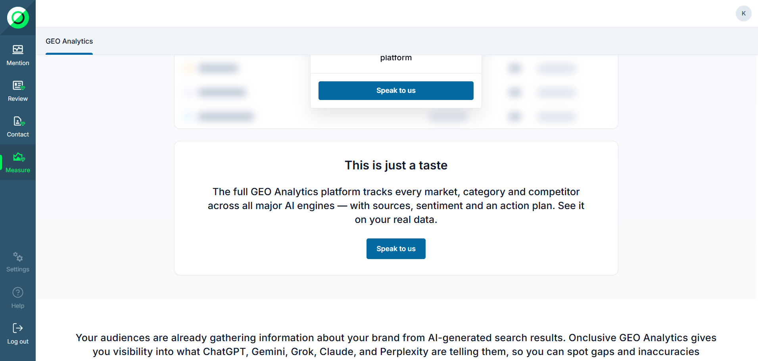

12.1 Multi-language support
GEO is available in several interface languages. The chosen language applies to menus, labels, buttons and static screens across the whole platform.
- Supported languages: English (US), English (UK), French and Spanish.
- Default and fallback: any string not yet translated falls back to English, so the interface is never left blank.
- Changing the language: pick your language from the language selector; the choice is kept for your next visits.
- Interface language vs. markets: a market is a country + language pair (e.g. "US-English", "FR-French"). The interface language is independent of the markets you analyse — changing the UI language does not change your markets or their results.
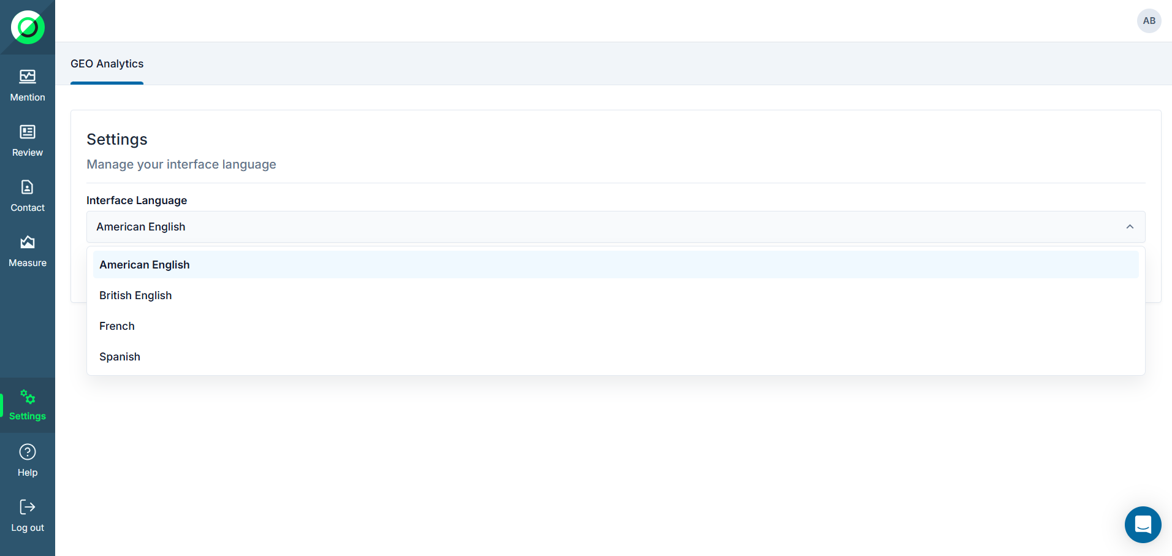
12.2 AI insights language
AI insights are the natural-language contents GEO generates from your analysis. Their language is chosen explicitly on the Brand & Country step of the setup wizard, through the "AI insights language" field. This replaces the former "primary market" concept: there is no primary market anymore, and the language is no longer inferred from a country.
Where the selected language applies
- In-brief summaries across the app, including the In-brief summary shown on the corporate reputation graph.
- Key concepts graphs labels: the brand territory graph and the themes sentiment graph.


