Taylor K-2006 Pool Water Testing Guide
34,400-gallon inground vinyl-liner pool • Steps follow the kit insert (#5165 / Guidebook #2004B) • Chlorine standardized to the 25 mL fill

Know Your Two Tubes
This kit uses two different tubes. Getting the right one is the most common mistake, so check this first:
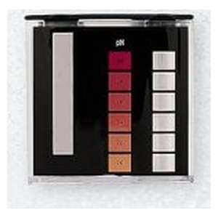
- Small tube (in the comparator block): the short tube that seats in the black comparator viewer shown above. Used for color-matched reads — pH (red scale) and the CYA black-dot read. It has a 9 mL mark.
- Large tube: the tall graduated tube with 10 mL, 25 mL, and 44 mL marks. Used for all drop-count titrations — Free/Combined Chlorine, Total Alkalinity, and Calcium Hardness.
Note: The comparator is one molded piece: small-tube slot on the left, pH color scale in the middle, chlorine scale on the right. You are not missing a part — the "large cylinder" is simply the large tube packed in the case.

Before You Start
- Collect a fresh sample about 18 inches (45 cm) deep, away from return jets, in a clean container. Rinse tubes with pool water first.
- Work in shade. For color matching, hold the comparator facing north, away from direct sun.
- Shake each reagent bottle, hold it vertical (tip straight down), and squeeze slowly so every drop is the same size.
- Rinse tubes between tests. Run the tests in the order below. Record each result as you go.

At a Glance
Test | Tube | Fill to | Reagents (in order) | Device
1. pH | Large tube | 44 mL | R-0004 — 5 drops, then match RED scale | 
2. Free Chlorine (FC) | Large tube | 25 mL | R-0870 (2 dippers), then R-0871 dropwise. FC = drops × 0.2
3. Combined Chlorine (CC) | Large tube | (same sample) | R-0003 — 5 drops, then R-0871 dropwise
4. Total Alkalinity (TA) | Large tube | 25 mL | R-0007 (2 drops), R-0008 (5 drops), then R-0009 dropwise
5. Calcium Hardness (CH) | Large tube | 25 mL | R-0010 (20 drops), R-0011L (5 drops), then R-0012 dropwise
6. Cyanuric Acid (CYA) | CYA bottle + small tube | 7 mL → 14 mL | R-0013, then read black dot in small tube | 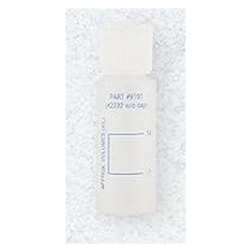

Note: "Dippers" are the small measure built into the R-0870 cap. Reagent codes are printed on each bottle.

Step-by-Step

1. pH
Tube: large tube, 44 mL. Reagent: R-0004 (phenol red). Read on the comparator's RED pH scale.
 | 1. Fill the large tube to the 44 mL mark with pool water.
 | 2. Add 5 drops of R-0004. Cap and invert to mix.
 | 3. Match the color against the RED pH scale. If the color is between two values, record the average. Record the value.
Note: Run pH first — it sets context for everything else. If pH is far off, the insert points to the Acid Demand / Base Demand tests (red panel) to size the adjustment; tell me your pH and I'll handle that math for your volume.

2. Free Chlorine (FC) — FAS-DPD
Tube: large tube. Reagents: R-0870 powder, then R-0871 titrant.
- Fill the large tube to the 25 mL mark. (Always use 25 mL — 1 drop = 0.2 ppm.)
- Add 2 dippers of R-0870 powder. Swirl until dissolved. Sample turns pink if free chlorine is present.
- Add R-0871 one drop at a time, swirling and counting, until the pink turns colorless. Record the drop count.
- FC = drops × 0.2 (e.g. 17 drops = 3.4 ppm).
Note: If no pink appears in step 2, free chlorine is zero — record 0 and still run CC below.

3. Combined Chlorine (CC) — continue in the same tube
Tube: same large-tube sample from FC. Reagent: R-0003, then more R-0871.
- To the now-colorless sample, add 5 drops of R-0003. Swirl. If pink returns, combined chlorine (chloramines) is present.
- Add R-0871 drop by drop until colorless again. Count only these new drops.
- CC = new drops × 0.2. Target is 0.

4. Total Alkalinity (TA)
Tube: large tube, 25 mL. Reagents: R-0007, R-0008, then R-0009.
- Fill the large tube to 25 mL.
- Add 2 drops R-0007. Swirl to mix.
- Add 5 drops R-0008. Swirl — sample turns green.
- Add R-0009 one drop at a time, swirling and counting, until green turns red. Record drops.
- TA = drops × 10 ppm (as calcium carbonate, CaCO₃).
Note: Standard 25 mL fill — each drop of R-0009 = 10 ppm.

5. Calcium Hardness (CH)
Tube: large tube, 25 mL. Reagents: R-0010, R-0011L, then R-0012.
- Fill the large tube to 25 mL.
- Add 20 drops R-0010. Swirl to mix.
- Add 5 drops R-0011L. Swirl — sample turns red if calcium hardness is present.
- Add R-0012 one drop at a time, swirling and counting, until red turns blue with no red or purple tinge left. Record drops.
- CH = drops × 10 ppm (as calcium carbonate, CaCO₃).
Note: On a vinyl liner there's no plaster to protect, so calcium hardness matters far less. Don't be alarmed by a low reading — we'll decide whether it needs touching once we see the numbers.

6. Cyanuric Acid (CYA) — turbidity / black-dot test
Containers: CYA bottle (#9191), then the small tube in the comparator. Reagent: R-0013.
 | 1. Fill the CYA bottle (#9191) to the 7 mL mark with pool water. Add R-0013 up to the 14 mL mark.
 | 2. Cap and mix for 30 seconds. The solution turns cloudy.
 | 3. Transfer the cloudy solution to the small tube until the black dot on the bottom just disappears when viewed from the top.
 | 4. Read the liquid level against the CYA scale on the back of the comparator block. Record as ppm.
Note: Do this in indirect daylight, not shade or direct sun, for an accurate read. CYA sets your target chlorine range, so it's an important number to get right.

After Testing: Balancing with the Watergram
The Taylor Watergram (Part #6026) is a dial calculator, not a test step. Once you have your numbers, it estimates the water's saturation index — whether the water is corrosive, balanced, or scale-forming — from four inputs.
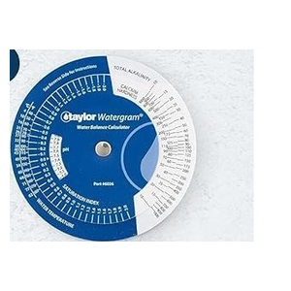 | 1. Set the four scales: pH, Total Alkalinity, Calcium Hardness, and Water Temperature.
 | 2. Read the Saturation Index in the window. A value near 0 (roughly -0.3 to +0.3) is balanced; negative means corrosive, positive means scaling.
Note: On a vinyl-liner pool there's no plaster to protect, so the saturation index matters less than on plaster or gunite. We'll lean on it mainly to keep the water from going aggressively corrosive. Send me your numbers and I'll run the balance for you either way — no dial spinning required.

Test Log
Record each test session here. Keep the FC test on the 25 mL fill (drops × 0.2) every time so readings are comparable. Note the time so daily loss can be calculated.
Date | Time | pH | FC | CC | TA | CH / CYA | Notes (chlorine added, weather, swimmers)

Note: FC reminder: count R-0871 drops to clear, then × 0.2. CC: after FC, add 5 drops R-0003, titrate again, new drops × 0.2. TA/CH/CYA change slowly — you can leave those cells blank on daily checks and fill them weekly.

Chlorine Added Log
Track every dose so you can match it against FC changes. (12.5% liquid: ~36 oz raises FC ~1 ppm; 1 gallon ≈ +3.5 ppm in this pool.)
Date | Time | Amount (gal / oz) | FC before | Notes

What to Send Me
Post all six numbers, plus the time you tested:
- pH — from the red scale
- FC — 25 mL fill, drops × 0.2
- CC
- TA
- CH
- CYA — drives your whole chlorine target range
Once I have these, I'll work out the adjustments and the order to make them (pH and alkalinity usually come before everything else) for your 34,400 gallons.

