About BRAVO-VICTOR-VICTOR
Welcome. VH-BVV (Bravo-Victor-Victor) is an AESL (Victa) Airtourer T6/24 two-seat aerobatic training aeroplane. Airtourers are popular planes with aerobatic pilots and are regarded with a “cult’ status.

Originally designed and built in Australia as a high-performance training and aerobatic plane, Airtourers were later popular with several air forces around the world.

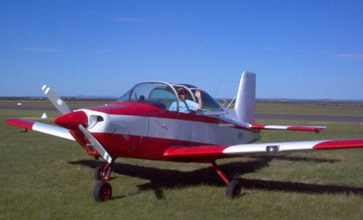 | Originally registered as ZK-DDU, VH-BVV was used by the Republic of Singapore Air Force until 1988.  The cockpit layout, high wing-load factor and precise control systems of the Airtourer make it an ideal training aircraft for transition to high-performance military jets.  The original khaki-color interior derives from the military heritage of VH-BVV.  Photo: VH-BVV on a sunny day at Tooradin airfield (Westernport Bay)

When not flying in aerobatic competitions, VH-BVV is available for aerobatic joy flights. Airtourers have an extremely strong, aerobatic-rated, airframe and are rated to +9 and –4 Gs. A typical aerobatic joy flight may involve manoeuvres upto +4 and -1 G. Combined with a powerful Lycoming 320-E1A 150 HP engine and constant speed propeller, VH-BVV gives a safe but exciting ride.
There are two types of planes – those with cabins and those with cockpits.  Fun aeroplanes have cockpits.  Tips for entering and exiting planes with cockpits:  In one motion, place a foot on the step protruding from the fuselage.  Push up on that foot and grab the handle next to the cockpit.  Rest the other foot on the black walk-way.  Please, never step on the control surfaces outside the walk-way, this will damage the aeroplane. | 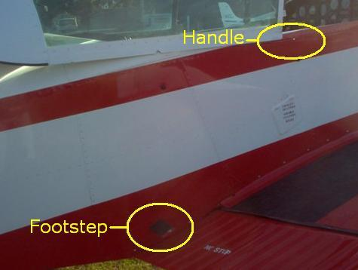

Airtourer cockpits are a snug fit for occupants. This may not be comfortable for long cross-country flights, but provides good bracing during aerobatics. Pressing your knees outward against the fuselage and console will give extra bracing. Never put you feet on the foot pedals unless instructed to do so.

The physical stresses of aerobatics may cause nausea to those unaccustomed to radical motions. Tell the pilot in command if you feel nauseas or want a break from aerobatic flight.

Airtourer T6 - PASSENGER BRIEFING CARD

TERMINAL / APRON PROCEDURES
- Maintain a good look-out.
- Beware propellers.
- Stay with and follow directions from your pilot.
- While waiting to board, stay between the wing and tail of your aeroplane.
- No smoking.
BOARDING
- Note the FOOTSTEPS and walk ONLY ON THE BLACK WALK-WAY.
- Do not support your weight on the sliding canopy.
- Pay attention to the boarding demonstration by your pilot.
HATCHES
- The aeroplane emergency exit is the sliding canopy.
- To OPEN: rotate latch 90° and slide the canopy rearward.
- Pay attention to the canopy opening demonstration by your pilot.
- The canopy must be secure at all stages in the flight.
PERSONAL SAFETY
- Remove any sharp objects from your pockets, Eg. pocket knives, keys, pens etc.
SMOKING
- No smoking at any time on company aeroplanes or airside.
SEATING AND SEAT BELTS
- Pay attention to seat belt demonstration by your pilot.
- You must occupy your seat at all times.
- You must wear a seat belt during take-off, landing and as advised by your pilot. It is strongly recommended that you wear your seal belt securely at all times.
- During aerobatic manoeuvres make sure your seat belt is firmly adjusted.
- Make note of the seat belt locking mechanism. Make sure it remains in the "FASTEN" position throughout the flight.
- To release: rotate the latch to either "UNLOCK" position.
STOWAGE OF HAND LUGGAGE
- Small carry on items Eg. Camera bag or hand bag are stowed in the aircraft glove compartment.
- Please present all items to your pilot for safe storage.
FLIGHT CONTROLS
- Caution; note the position of the cockpit controls. This includes the foot pedals. Keep hands and feet well clear unless you are flying the aeroplane.
- Be prepared for abrupt and full movement of the controls.
MOBILE TELEPHONES
- Mobile telephones must be turned off.
TURBULENCE
- A bumpy ride is considered a normal part of light aircraft flying. Please do't be alarmed but keep your seat belt securely fastened.
AIR SICKNESS
- Sick bags are located in the side pocket. Use ventilation. Use aerodrome amenities before departure, there are no in-flight facilities.
EMERGENCY AND SURVIVAL EQUIPMENT
- Your pilot will demonstrate the location and use of any emergency or survival equipment required to be carried on-board the aeroplane.
IN THE EVENT OF AN EMERGENCY
- In an emergency your pilot may ask you to "BRACE". This means remove sun glasses, debentures and tighten seat belts very securely. Cover your head with your arms.
- Evacuate only after the aeroplane has come to a complete stop. Release your seat belt, open the canopy, disembark and walk clear of the aeroplane. Stay with the aeroplane until help arrives.

