APPROVED
FLIGHT MANUAL
FOR THE
AESL AIRTOURER T6

This Flight Manual is approved as the Manual referred to in the relevant Certificate of Airworthiness.

It is the responsibility of the pilot operating this aircraft to be familiar with the contents of this Flight Manual including all amendments thereto, and for ensuring that it is carrried on all flights as required by Regulation 26 of the Civil Aviation Regulations 1953.

The Modification Appendix which forms part of this Flight Manual consists of operating information different from that contained in the remainder of the Flight Manual and is only applicable when the modifications as detailed are incorporated.

The pilot should therefore ascertain the applicability of the operating information contained in the Modification Appendix prior to flight in order to ensure the appropriate limitations can be complied with for the flight to be undertaken as required by Regulation 60 of the Civil Aviation Regulations 1953.

Amendments to this Flight Manual may only be incorporated by Aircraft Surveyors of the Civil Aviation Division of the Ministry of Transport unless delegation of this responsibility has been, granted, in writing, to other persons.

If this Flight Manual is lost the Director of Civil Aviation should be informed at once.

Any person finding this Flight Manual should forward it immediately to the Director of Civil Aviation, Ministry of Transport, Wellington, New Zealand.
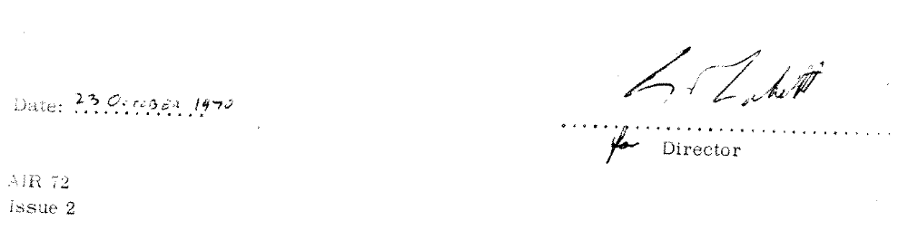

CONTENTS

Compliance with the contents, of this Flight Manual must be considered as being mandatory and overriding similar information contained in other documents such as the Owner's Manual or Pilot's Handbook.

However, as a considerable amount of valuable information is contained in such documents operators are advised to maintain them in a fully amended condition and use them, as appropriate, in conjunction with this Flight Manual.

SECTION 1 GENERAL.

SECTION 2 LMITATIONS

SECTION 3 EMERGENCY PROCEDURES,

SECTION 4 NORMAL PROCEDURES.

SECTION 6 PERFORMANCE.

APPENDIX 1 : WEIGHT AND LOADING DATA,

APPENDIX 2 : MODIFICATIONS.

