Dump 1090 is a Mode S decoder specifically designed for RTL-SDR devices.

The main features are:

* Robust decoding of weak messages, with mode1090 many users observed improved range compared to other popular decoders.
* Network support: TCP30003 stream (MSG5...), Raw packets, HTTP.
* Embedded HTTP server that displays the currently detected aircrafts on Google Map.
* Single bit errors correction using the 24 bit CRC.
* Decode raw IQ samples from file (using --ifile command line switch).
* Interactive command-line-interfae mode where aircrafts currently detected are shown as a list refreshing as more data arrives.
* TCP server streaming and receiving raw data to/from connected clients.

The commands used extract the data:

* **./dump1090**

This command is used to capture traffic directly from the RTL device and show the captured traffic.

* **./dump1090 --raw**

This command is used to output hexadecimal messages.

* **./dump1090 --ifile /path/to/binfile**

This command is used to decode data from a file

**Sample code:**

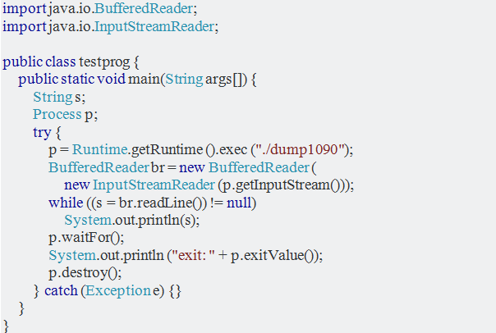

**The previous code will return the following:**

{    
   **"now"**:1536641434.9,  
   **"messages"**:683,  
   **"aircraft"**:[    
      {    
         **"hex"**:"a3c68c",  
         **"version"**:2,  
         **"sil_type"**:"perhour",  
         **"mlat"**:[    
  
         ],  
         **"tisb"**:[    
  
         ],  
         **"messages"**:34,  
         **"seen"**:91.7,  
         **"rssi"**:-25.0  
      },  
      {    
         **"hex"**:"abd30f",  
         **"flight"**:"FDX160  ",  
         **"alt_baro"**:37000,  
         **"alt_geom"**:38550,  
         **"gs"**:489.6,  
         **"track"**:137.0,  
         **"baro_rate"**:0,  
         **"squawk"**:"7416",  
         **"emergency"**:"none",  
         **"category"**:"A5",  
         **"nav_qnh"**:1012.8,  
         **"nav_altitude"**:36992,  
         **"nav_heading"**:135.7,  
         **"lat"**:38.719208,  
         **"lon"**:-94.498364,  
         **"nic"**:8,  
         **"rc"**:186,  
         **"seen_pos"**:0.2,  
         **"version"**:2,  
         **"nic_baro"**:1,  
         **"nac_p"**:9,  
         **"nac_v"**:1,  
         **"sil"**:3,  
         **"sil_type"**:"perhour",  
         **"gva"**:2,  
         **"sda"**:2,  
         **"mlat"**:[    
  
         ],  
         **"tisb"**:[    
  
         ],  
         **"messages"**:159,  
         **"seen"**:0.1,  
         **"rssi"**:-20.1  
      },  
      {    
         **"hex"**:"a3f1c2",  
         **"category"**:"A5",  
         **"version"**:2,  
         **"sil_type"**:"perhour",  
         **"mlat"**:[    
  
         ],  
         **"tisb"**:[    
  
         ],  
         **"messages"**:467,  
         **"seen"**:101.1,  
         **"rssi"**:-19.0  
      }  
   ]  
}

**The ground station:**

* + 1. The RaspberryPi Computer

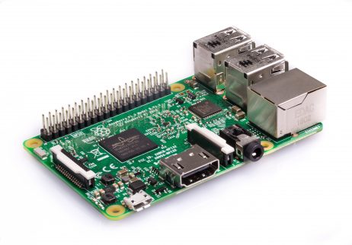

* + 1. The RTL-SDR decoder

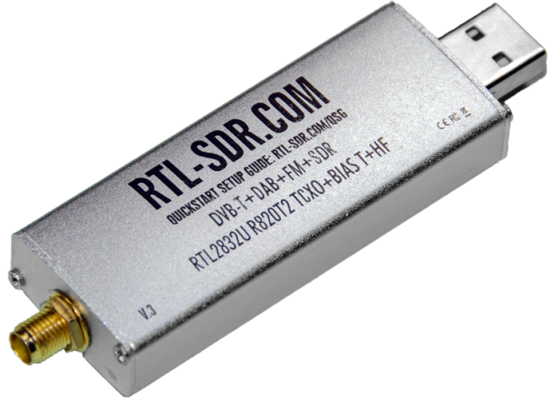

* + 1. The portable antenna

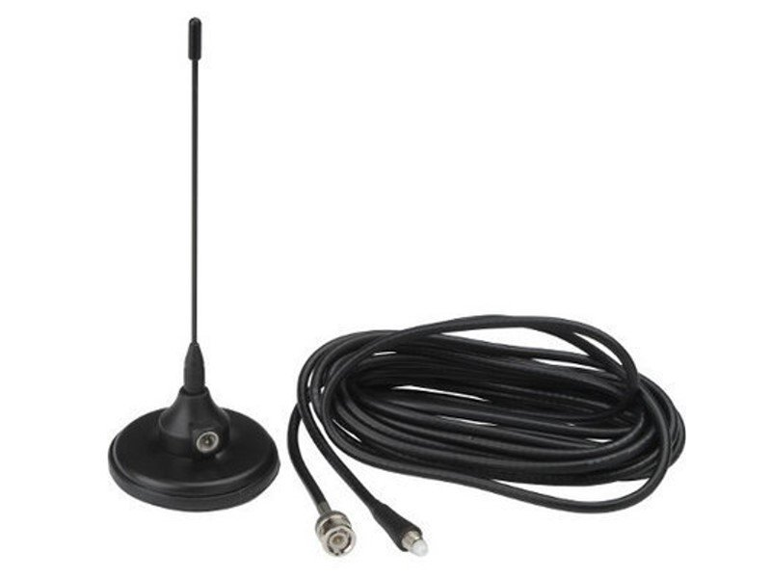

**Definitions**:

**Mode S:**

Mode S is a [Secondary Surveillance Radar](https://www.skybrary.aero/index.php/Transponder) process that allows selective interrogation of aircraft according to the unique 24-bit address assigned to each aircraft. Recent developments have enhanced the value of Mode S by introducing Mode S EHS (Enhanced Surveillance).

**RTL** refers to register-transfer level. It is a design abstraction which models a [synchronous](https://en.wikipedia.org/wiki/Synchronous_circuit) [digital circuit](https://en.wikipedia.org/wiki/Digital_circuit) in terms of the flow of digital signals (data) between [hardware registers](https://en.wikipedia.org/wiki/Hardware_register), and the [logical operations](https://en.wikipedia.org/wiki/Boolean_logic) performed on those signals.

**SDR** refers to is a [radio](https://en.wikipedia.org/wiki/Radio) [communication](https://en.wikipedia.org/wiki/Telecommunications) system where components that have been traditionally implemented in hardware (e.g. [mixers](https://en.wikipedia.org/wiki/Frequency_mixer), [filters](https://en.wikipedia.org/wiki/Filter_(signal_processing)), [amplifiers](https://en.wikipedia.org/wiki/Amplifier), [modulators](https://en.wikipedia.org/wiki/Modulator)/[demodulators](https://en.wikipedia.org/wiki/Demodulator), [detectors](https://en.wikipedia.org/wiki/Detector_(radio)), etc.) are instead implemented by means of software on a personal computer or [embedded system](https://en.wikipedia.org/wiki/Embedded_system).

**RTL-SDR** is a device that receives different kinds of radio signals from aircraft through and antenna, and decodes the analog signals into a digital format.

References:

* + <https://mode-s.org/decode/>
  + <https://en.wikipedia.org/wiki/Register-transfer_level>
  + Software Defined Radio: Architectures, Systems and Functions (Markus Dillinger, Kambiz Madani, Nancy Alonistioti) Page xxxiii (Wiley & Sons, 2003, [ISBN](https://en.wikipedia.org/wiki/International_Standard_Book_Number) [0-470-85164-3](https://en.wikipedia.org/wiki/Special:BookSources/0-470-85164-3))
  + Annex 10 to the Convention on International Civil Aviation, Aeronautical Telecommunications. International Civil Aviation Organization, 2002.