Capstone Project

Multilingual Automatic Narration System
Focused Use Cases

Version 1.0
Revision History
Date | Version | Description | Author
9-20-2026 | 1.0 | Focused Use Cases: UC1–UC5 (Geofence, QR Code, POI management, Tour management, Analytics) | Development Team
Table of Contents
UC1 4
UC2 6
UC3 8
UC4 10
UC5 12
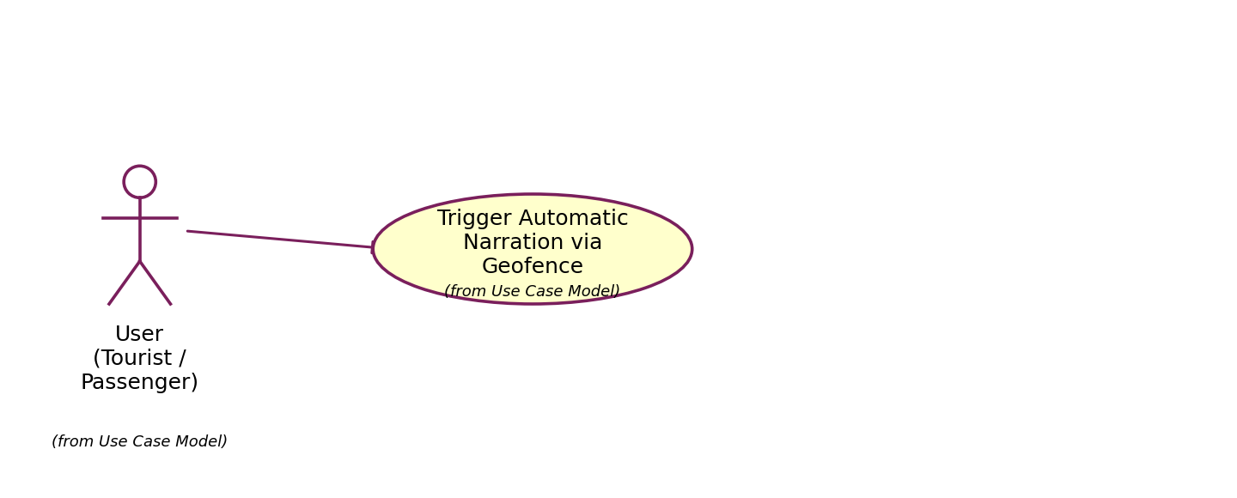
Use Case Number: | UC1
Use Case Name: | Trigger Automatic Narration via Geofence
Actor(s): | User (Tourist / Passenger)
Maturity: | Focused
Summary: | The system automatically plays narration content when the user moves into the activation radius of a pre-configured Point of Interest (POI), based on the user's current GPS location.
Basic Course of Events:
  Actor Action | System Response
  1. Actor opens the app and grants location (GPS) access permission.
   | 2. The app downloads the list of POIs (lat/lng coordinates, activation radius, priority level, narration content) to the device.
  3. Actor moves around (walking, riding, etc.) within an area containing POIs.
   | 4. A background service continuously updates the actor's current location.
   | 5. The Geofence Engine compares the current location against the radius of each POI, determines the nearest/highest-priority POI the actor has just entered or approached, and sends a trigger event.
   | 6. The Narration Engine checks the playback state (is something else currently playing? has this POI already been played within the last X minutes?). {Debounce/Cooldown Control} A1
   | 7. The system plays the corresponding narration content (TTS or a pre-recorded audio file) for the actor to hear.
   | 8. The system logs the playback (POI, timestamp) to prevent repetition and to feed the analytics data. Use case ends.
Alternative Paths: | A1. If the Narration Engine determines that this POI's content was already played within the cooldown window, or the device is currently playing other content, the system discards the trigger event (does not replay it) and returns to step 4.
Exception Paths: | E1. If the actor does not grant location access, the system informs the actor that location must be enabled to use automatic narration; use case ends.  E2. If the app has no POI data (never synced and no network connection), the system informs the actor that automatic narration cannot be triggered and suggests connecting to the network to sync data.
Extension Points: | Debounce/Cooldown Control: ensures the same POI is not replayed repeatedly in a short time when the actor stays still or moves back and forth within the activation zone.
Triggers: | The actor moves into the activation radius of (or close enough to) a configured POI.
Assumptions: | The list of POIs (coordinates, radius, priority level, narration content) has already been created by an administrator and synced to the system (see UC3).
Preconditions: | The actor has installed the app and granted location (GPS) access.
Post Conditions: | The corresponding narration content is played for the actor; the playback event is logged to support anonymous analytics (see UC5).
Reference: Business Rules | Duplicate trigger spam is prevented via a debounce & cooldown mechanism.
Author(s): | Development Team

Activity Diagram: UC1
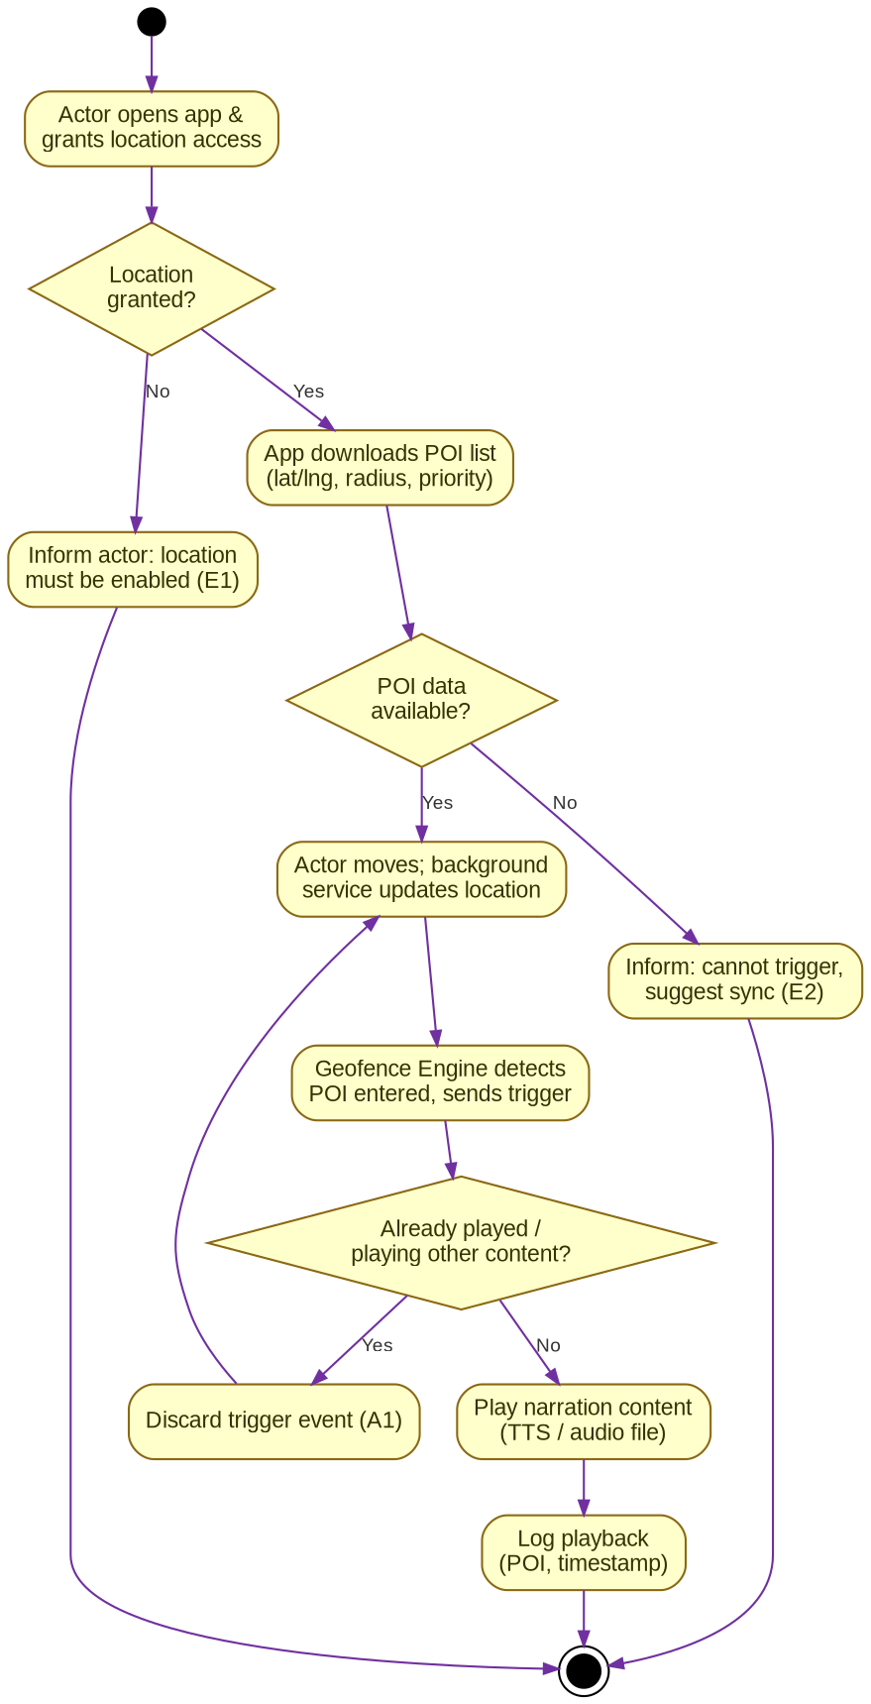

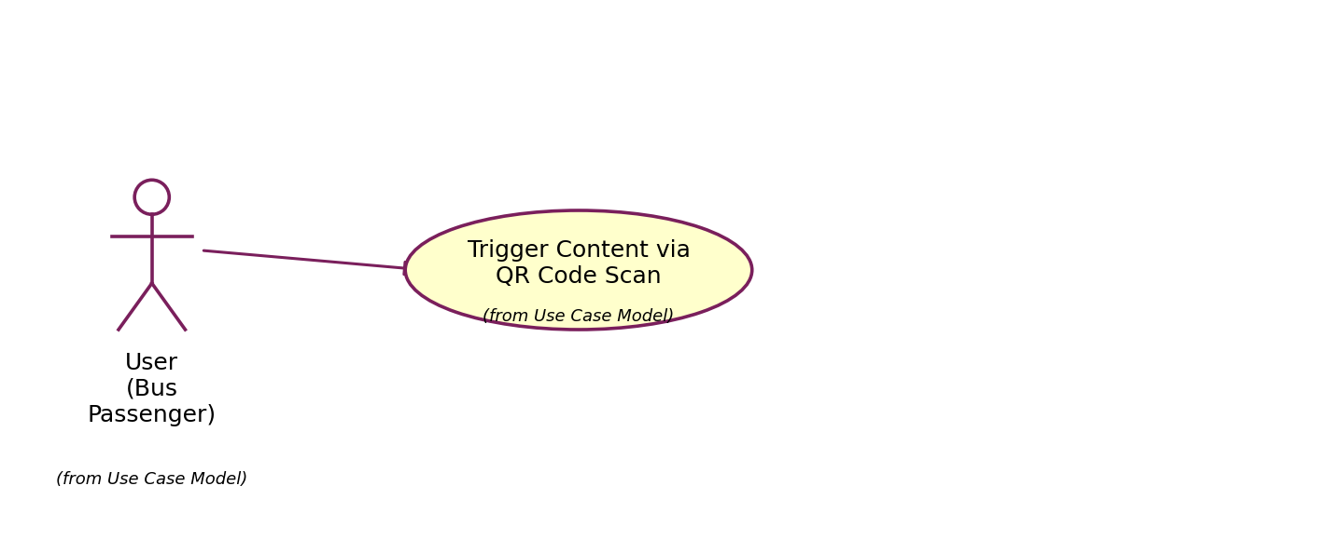
Use Case Number: | UC2
Use Case Name: | Trigger Content via QR Code Scan
Actor(s): | User (Bus passenger)
Maturity: | Focused
Summary: | The actor scans a QR code installed at bus stops (Khanh Hoi, Vinh Hoi, and Xom Chieu wards) to immediately hear the related narration content without needing GPS location.
Basic Course of Events:
  Actor Action | System Response
  1. Actor opens the QR scanning feature in the app (or uses the camera).
  2. Actor scans the QR code posted at a bus stop.
   | 3. The system decodes the QR code to obtain the corresponding POI identifier. E1
   | 4. The system looks up the narration content (audio/translation) linked to that POI. A1
   | 5. The system immediately plays the narration content for the actor to hear, with no need to wait for location detection.
   | 6. The system logs the usage event (POI, timestamp, method = QR). Use case ends.
Alternative Paths: | A1. If the actor has selected a narration language other than the default in the settings, the system plays the translation corresponding to the selected language.
Exception Paths: | E1. If the QR code is invalid or is not linked to any POI in the system, the app displays "Invalid QR code"; use case ends.  E2. If there is no network connection and the POI's audio content has not been stored offline on the device, the system informs the actor that the content cannot be played right now and suggests trying again once connected.
Extension Points: | None
Triggers: | The actor scans a QR code posted at a bus stop.
Assumptions: | The QR codes at bus stops have been generated, printed, and installed by an administrator, and correctly linked to the corresponding POI in the CMS (see UC3).
Preconditions: | The app has been granted camera access permission.
Post Conditions: | Narration content is played for the actor independent of GPS signal; the usage event is logged.
Reference: Business Rules | None
Author(s): | Development Team

Activity Diagram: UC2
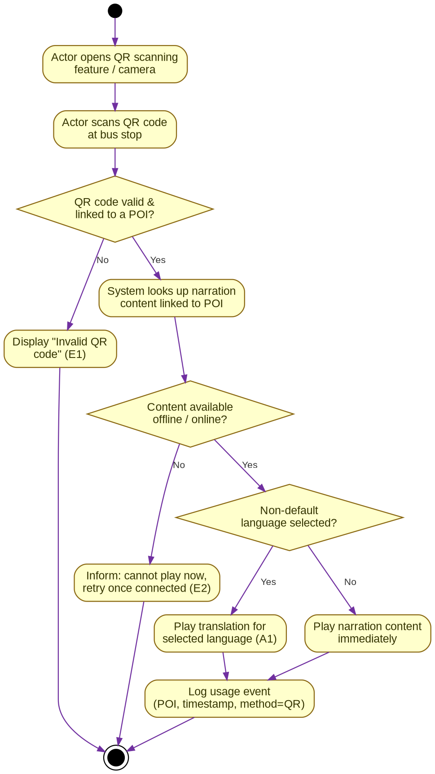

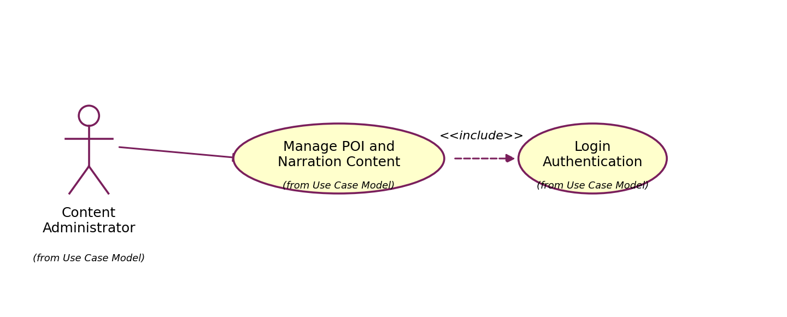
Use Case Number: | UC3
Use Case Name: | Manage Points of Interest (POI) and Narration Content
Actor(s): | Content Administrator
Maturity: | Focused
Summary: | The administrator uses the content management system (CMS) to create, edit, and delete Points of Interest (POIs) along with their associated audio files and multi-language translations, serving as the data source for UC1 and UC2.
Basic Course of Events:
  Actor Action | System Response
  1. Perform {Login Authentication}.
   | 2. The system displays the admin dashboard with the main features (POI, Audio, Translations, Usage History, Tour Management).
  3. Actor selects the POI management feature. A1
   | 4. The system displays the list of existing POIs.
  5. Actor creates a new POI or edits an existing one: enters coordinates (lat/lng), activation radius, and priority level.
  6. Actor uploads a narration audio file and/or enters translated content for each supported language. A2
  7. Actor saves the POI information.
   | 8. The system validates the input data (valid coordinates, radius > 0, at least one language of content). E1
   | 9. The system saves the POI to the database and queues it for sync to the mobile app once a connection is available. Use case ends.
Alternative Paths: | A1. The actor may choose to delete an existing POI; the system requires confirmation before permanently deleting it.  A2. The actor may generate/link a QR code to the POI being edited, to support UC2.
Exception Paths: | E1. If the entered data is invalid (missing coordinates, radius negative or zero, no language content provided), the system displays the corresponding error and asks the actor to re-enter the data. Returns to step 5.
Extension Points: | None
Triggers: | The actor needs to add, update, or remove a narration point and its related multi-language content.
Assumptions: | None
Preconditions: | The actor holds a valid administrator account with access to the CMS.
Post Conditions: | The POI along with its related audio/translation content is saved and ready to sync to the mobile app, supporting UC1 and UC2.
Reference: Business Rules | Every POI must have valid coordinates, an activation radius greater than 0, and at least one default language of content.
Author(s): | Development Team

Activity Diagram: UC3
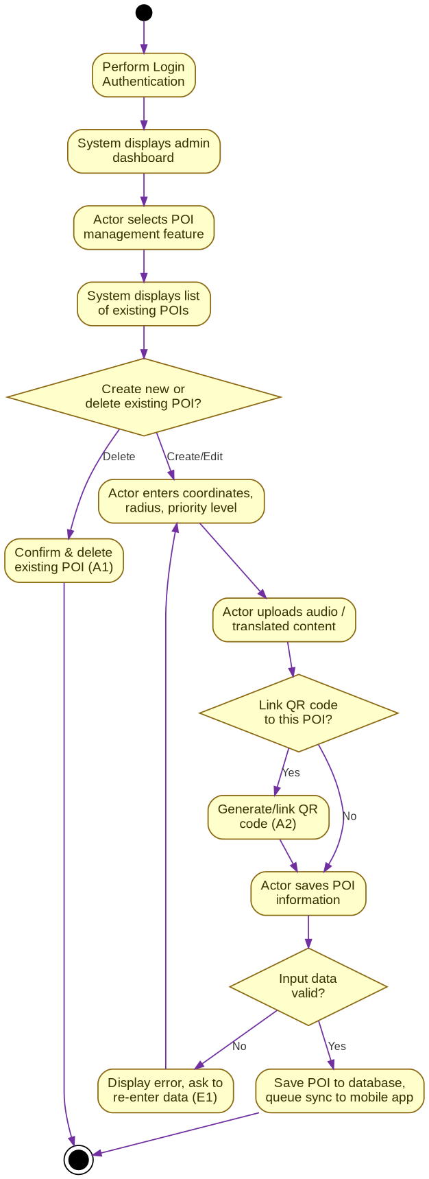

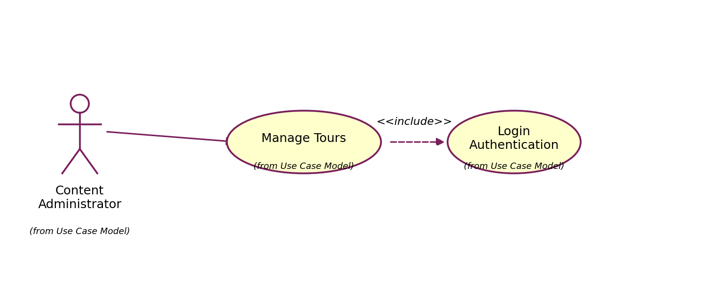
Use Case Number: | UC4
Use Case Name: | Manage Tours
Actor(s): | Content Administrator
Maturity: | Focused
Summary: | The administrator creates and manages "tours" (a set of POIs grouped by route/theme) in order to organize narration content along a specific sightseeing route or bus line.
Basic Course of Events:
  Actor Action | System Response
  1. Perform {Login Authentication}.
  2. Actor selects the "Manage Tour" feature.
   | 3. The system displays the list of existing tours.
  4. Actor creates a new tour, entering a name and description. A1
  5. Actor selects and orders the POIs (already existing per UC3) into the tour in the desired visiting sequence.
  6. Actor saves the tour.
   | 7. The system validates the tour (must contain at least one POI). E1
   | 8. The system saves the tour structure and syncs it to the mobile app. Use case ends.
Alternative Paths: | A1. The actor may edit or delete an existing tour; the system requires confirmation before deletion.
Exception Paths: | E1. If the tour contains no POIs when saved, the system warns the actor and does not allow saving an empty tour; returns to step 5.
Extension Points: | None
Triggers: | The actor needs to organize narration points into a specific sightseeing route or bus line.
Assumptions: | The related POIs have already been created in the system (see UC3).
Preconditions: | The actor holds a valid administrator account with access to the CMS.
Post Conditions: | The tour is saved and can be displayed/used by users in the mobile app.
Reference: Business Rules | None
Author(s): | Development Team

Activity Diagram: UC4
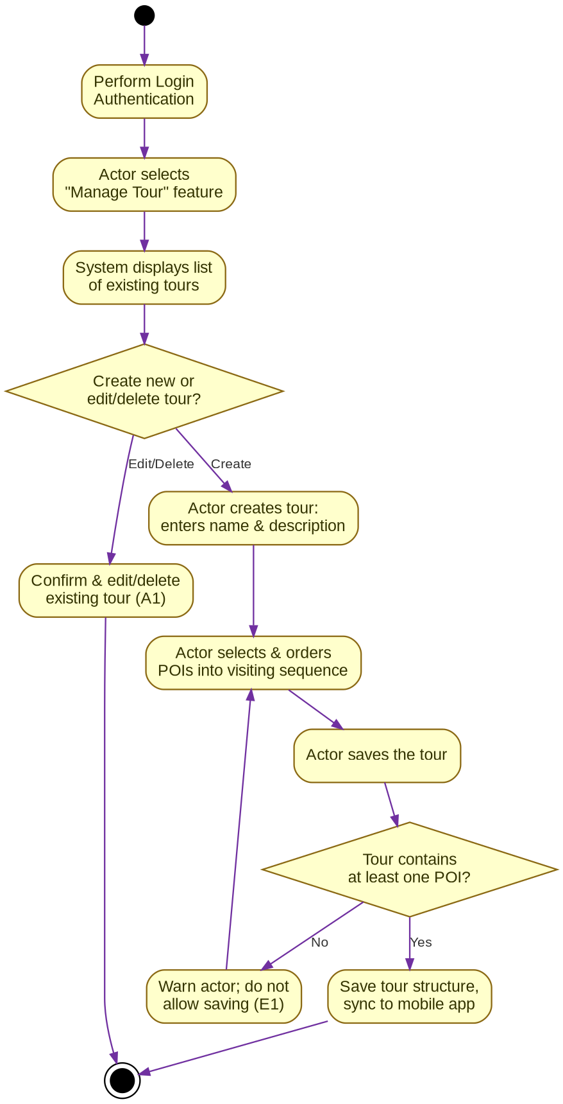

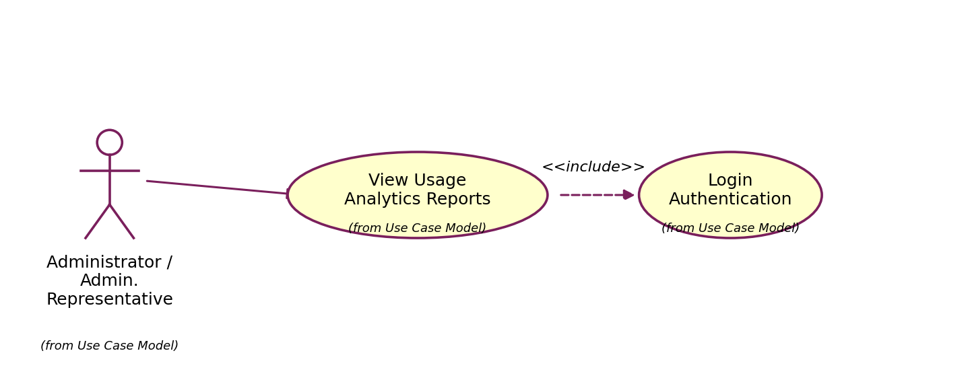
Use Case Number: | UC5
Use Case Name: | View Usage Analytics Reports
Actor(s): | Administrator / Administration Representative
Maturity: | Focused
Summary: | The actor views statistical reports on app usage behavior (anonymous movement routes, most-listened-to locations, average listening time, user location heatmap) to evaluate effectiveness and optimize narration content.
Basic Course of Events:
  Actor Action | System Response
  1. Perform {Login Authentication}.
  2. Actor selects the "Analytics" feature.
   | 3. The system displays report filters: date range, area/tour.
  4. Actor selects filter parameters and requests the report.
   | 5. The system queries the stored anonymous usage data (movement routes, playback events from UC1 and UC2) and computes: top most-listened-to locations, average listening time per POI, and a user location heatmap. E1
   | 6. The system displays the report as charts and a heatmap for the actor. A1. Use case ends.
Alternative Paths: | A1. The actor may export the report to a file (PDF/Excel) for storage or sharing.
Exception Paths: | E1. If there is no usage data for the selected date range/area, the system displays "No data available"; use case ends.
Extension Points: | None
Triggers: | The actor needs to evaluate the effectiveness of narration content usage for optimization or reporting purposes.
Assumptions: | Movement route and playback data have already been recorded anonymously while users used the app (see UC1, UC2).
Preconditions: | The actor holds an account with access to the analytics feature.
Post Conditions: | The report is displayed and/or exported to a file; the underlying raw data is not modified.
Reference: Business Rules | User location and movement route data must be stored and processed anonymously, without personal identification.
Author(s): | Development Team

Activity Diagram: UC5
