Usability Study
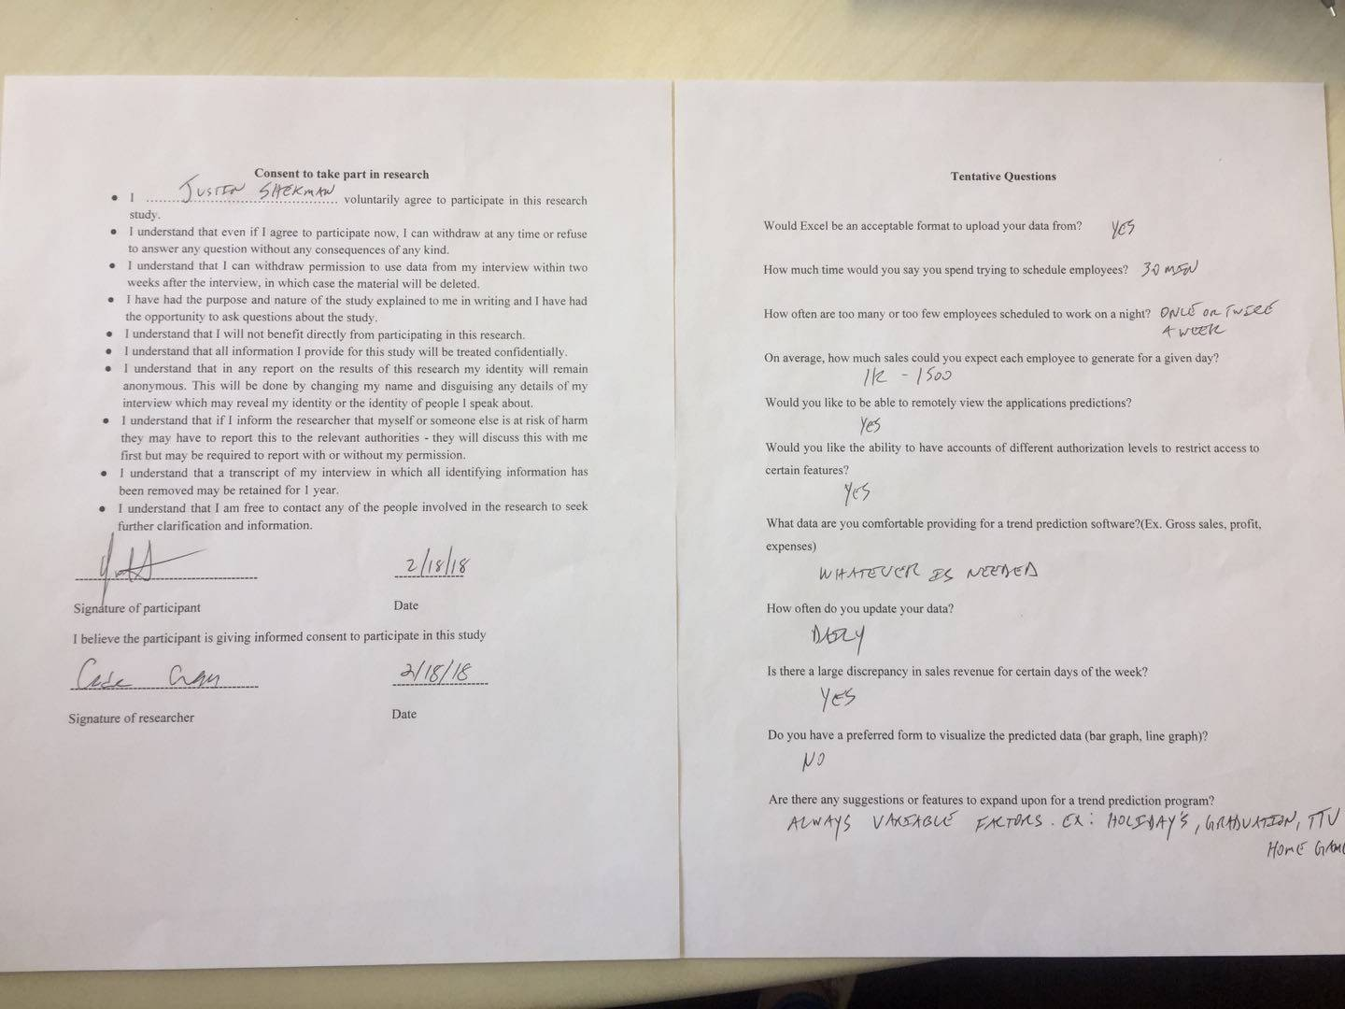
- Justin Shekman

User Story | :Checkmark if satisfied:  :X if not satisfied:
As a small business owner, I want to be able to predict the amount of sales on a certain day so that I can schedule employees accordingly. | X
As a small business owner, I want to be able to predict the amount of income on a certain day so that I can account for potential sales. | X
As a small business owner, I want to be able to input the total revenue made for the day into the database upon closing so that I can use that data to update the accuracy of the software. | Check
As a small business owner, I want to use my sales report from past years so that I can get an estimate prediction of future sales. | X
As a small business owner, I want to use sales reports from past years so that I can see requirements needed to hit specific sales margins. | X
As a small business owner, I want to input any date into the software so that I can review data over my company for that specific date. | Check
As a small business owner, I want to be able to create sub accounts, so that I can keep access to certain data restricted. | Check
As a small business owner, I want to be able to log in into my account, so that I can easily access my data. | Check
As a small business owner, I want to be able to set certain parameters so that I can easily view specific data. | Check
As a small business owner, I want to be able to input sales reports from past years, so they can be used in the application. | Check
As a small business owner, I want to be able to have an unrestricted admin account to access all data. | Check

Was the app straightforward to use?
Yes
Was the app fast?
Yes
Would you use this app in your current business or for a future business for gross sales predictions?
Yes, when completed
What suggestions do you have for the app?
- Hide the account passwords in Account Settings.
- I’d like the sales data to also be encrypted in the database, just like y’all did with the passwords.
- Have a separate button for graphing and generate prediction. I want to be able to get a set number for a given date based on the past data. The graph display looks great and is useful, but I want to see the predicted sales for a specific date.
- I would also like to see the total predicted sales over the course of a month instead of the average sales. I know weekdays will be less busy than weekends, so the average gross sales don’t really matter too much. The gross sales prediction is more important.
- I’ll get you guys the rest of the sales data so you have more of a baseline on the average sales.
Overall, I think you guys are on the right track to building something I’ll be using consistently.

- Kody Parkhurst-Johnson (Turner’s roommate)
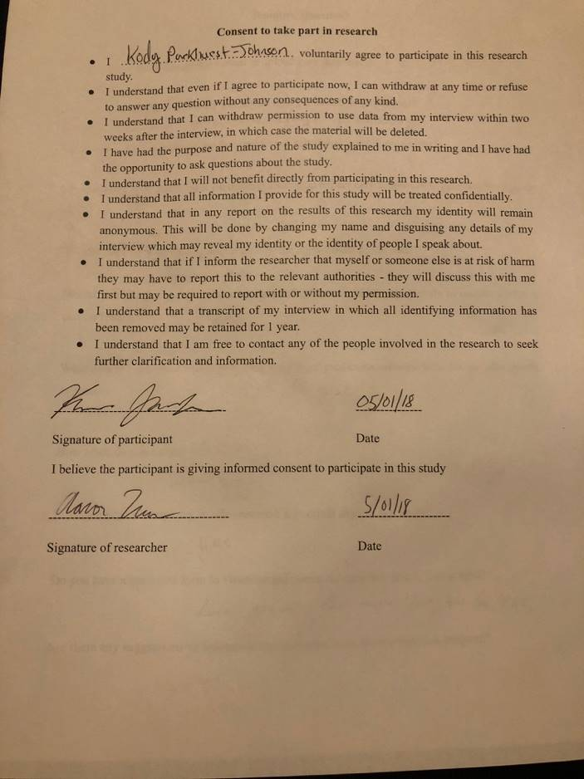
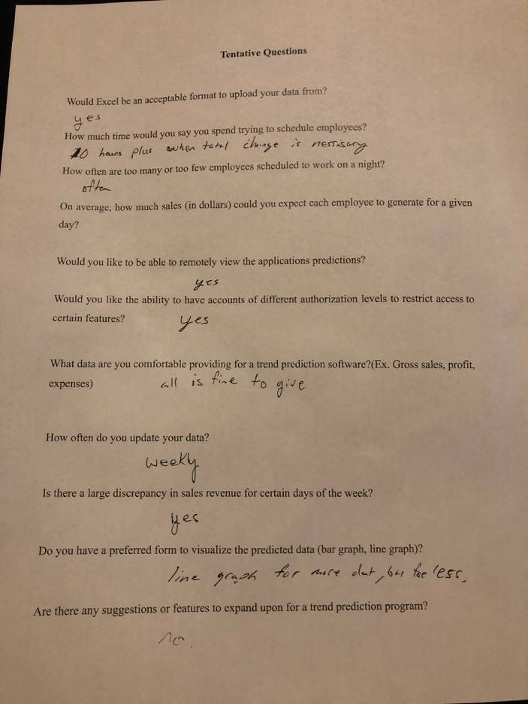

User Story | :Checkmark if satisfied:  :X if not satisfied:
As a small business owner, I want to be able to predict the amount of sales on a certain day so that I can schedule employees accordingly. | X
As a small business owner, I want to be able to predict the amount of income on a certain day so that I can account for potential sales. | ✓
As a small business owner, I want to be able to input the total revenue made for the day into the database upon closing so that I can use that data to update the accuracy of the software. | ✓
As a small business owner, I want to use my sales report from past years so that I can get an estimate prediction of future sales. | ✓
As a small business owner, I want to use sales reports from past years so that I can see requirements needed to hit specific sales margins. | ✓
As a small business owner, I want to input any date into the software so that I can review data over my company for that specific date. | ✓
As a small business owner, I want to be able to create sub accounts, so that I can keep access to certain data restricted. | ✓
As a small business owner, I want to be able to log in into my account, so that I can easily access my data. | ✓
As a small business owner, I want to be able to set certain parameters so that I can easily view specific data. | ✓
As a small business owner, I want to be able to input sales reports from past years, so they can be used in the application. | X
As a small business owner, I want to be able to have an unrestricted admin account to access all data. | ✓

Was the app straightforward to use?
Yes it was
Was the app fast?
Yes
Would you use this app in your current business or for a future business for gross sales predictions?
Yes once program is complete with all features.
What suggestions do you have for the app?
Change white font on orange background for better contrast

- Lexi Urbanovsky
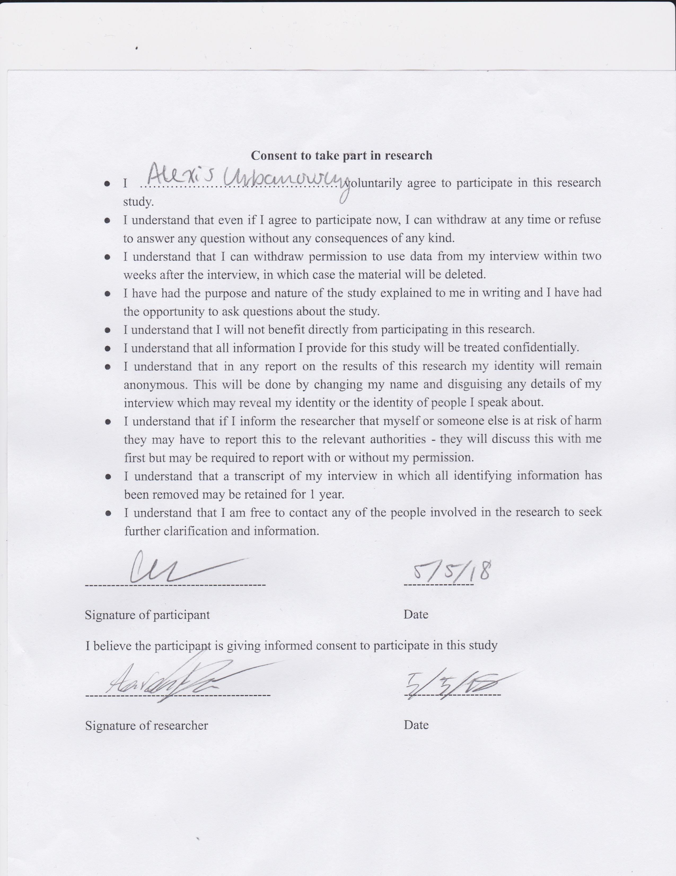
User Story | :Checkmark if satisfied:  :X if not satisfied:
As a small business owner, I want to be able to predict the amount of sales on a certain day so that I can schedule employees accordingly. | X
As a small business owner, I want to be able to predict the amount of income on a certain day so that I can account for potential sales. | Check
As a small business owner, I want to be able to input the total revenue made for the day into the database upon closing so that I can use that data to update the accuracy of the software. | Check
As a small business owner, I want to use my sales report from past years so that I can get an estimate prediction of future sales. | X
As a small business owner, I want to use sales reports from past years so that I can see requirements needed to hit specific sales margins. | Check
As a small business owner, I want to input any date into the software so that I can review data over my company for that specific date. | Check
As a small business owner, I want to be able to create sub accounts, so that I can keep access to certain data restricted. | Check
As a small business owner, I want to be able to log in into my account, so that I can easily access my data. | Check
As a small business owner, I want to be able to set certain parameters so that I can easily view specific data. | Check
As a small business owner, I want to be able to input sales reports from past years, so they can be used in the application. | Check
As a small business owner, I want to be able to have an unrestricted admin account to access all data. | Check

Was the app straightforward to use?
Yes
Was the app fast?
Yes
Would you use this app in your current business or for a future business for gross sales predictions?
Yes, when completed
What suggestions do you have for the app?
- Have the backgrounds be less distracting from the true use of the app.

4.
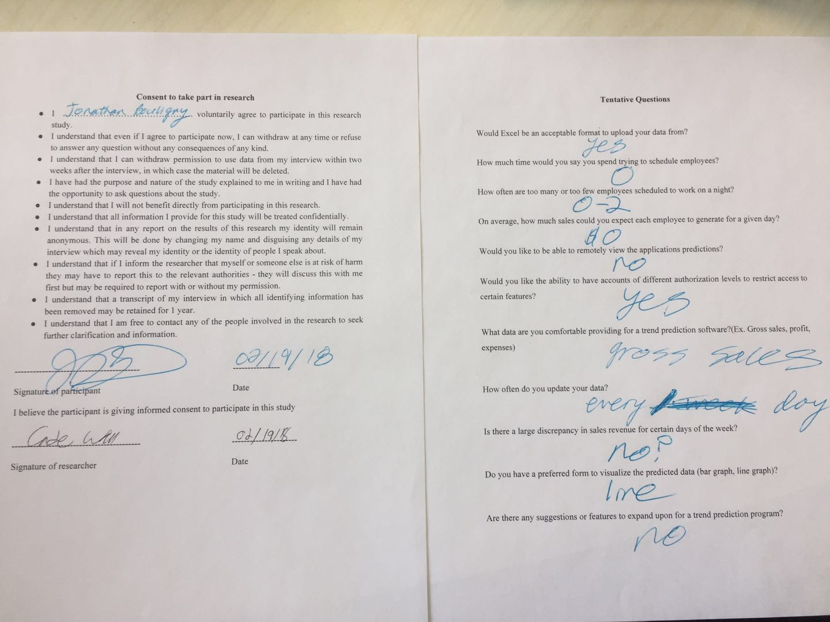

User Story | :Checkmark if satisfied:  :X if not satisfied:
As a small business owner, I want to be able to predict the amount of sales on a certain day so that I can schedule employees accordingly. | check
As a small business owner, I want to be able to predict the amount of income on a certain day so that I can account for potential sales. | check
As a small business owner, I want to be able to input the total revenue made for the day into the database upon closing so that I can use that data to update the accuracy of the software. | check
As a small business owner, I want to use my sales report from past years so that I can get an estimate prediction of future sales. | check
As a small business owner, I want to use sales reports from past years so that I can see requirements needed to hit specific sales margins. | check
As a small business owner, I want to input any date into the software so that I can review data over my company for that specific date. | check
As a small business owner, I want to be able to create sub accounts, so that I can keep access to certain data restricted. | check
As a small business owner, I want to be able to log in into my account, so that I can easily access my data. | check
As a small business owner, I want to be able to set certain parameters so that I can easily view specific data. | check
As a small business owner, I want to be able to input sales reports from past years, so they can be used in the application. | x
As a small business owner, I want to be able to have an unrestricted admin account to access all data. | check

Was the app straightforward to use?
yes

Was the app fast?
yes
Would you use this app in your current business or for a future business for gross sales predictions?
yes
What suggestions do you have for the app?
none

5.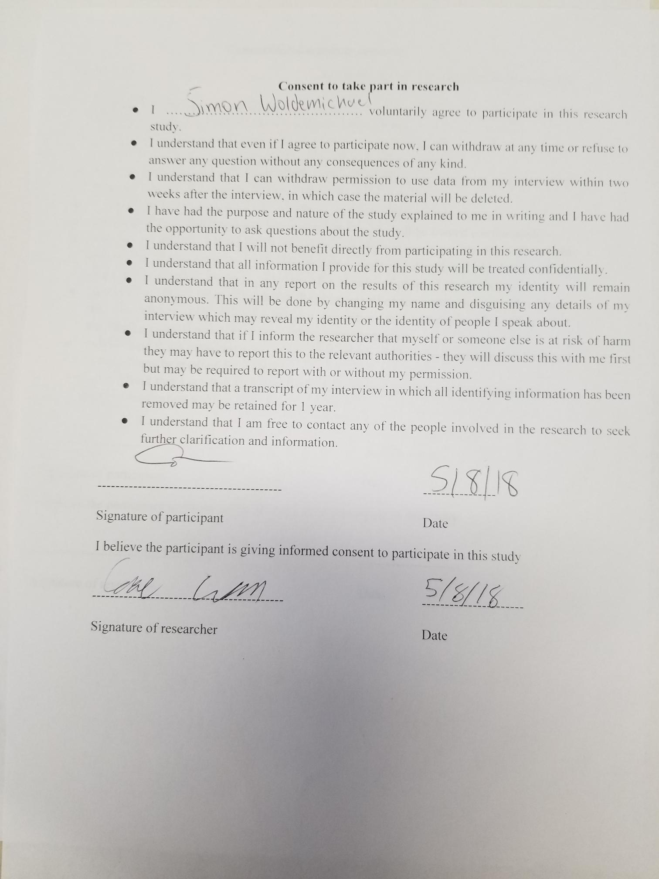

User Story | :Checkmark if satisfied:  :X if not satisfied:
As a small business owner, I want to be able to predict the amount of sales on a certain day so that I can schedule employees accordingly. | ✓
As a small business owner, I want to be able to predict the amount of income on a certain day so that I can account for potential sales. | ✓
As a small business owner, I want to be able to input the total revenue made for the day into the database upon closing so that I can use that data to update the accuracy of the software. | ✓
As a small business owner, I want to use my sales report from past years so that I can get an estimate prediction of future sales. | ✓
As a small business owner, I want to use sales reports from past years so that I can see requirements needed to hit specific sales margins. | ✓
As a small business owner, I want to input any date into the software so that I can review data over my company for that specific date. | ✓
As a small business owner, I want to be able to create sub accounts, so that I can keep access to certain data restricted. | ✓
As a small business owner, I want to be able to log in into my account, so that I can easily access my data. | ✓
As a small business owner, I want to be able to set certain parameters so that I can easily view specific data. | ✓
As a small business owner, I want to be able to input sales reports from past years, so they can be used in the application. | X
As a small business owner, I want to be able to have an unrestricted admin account to access all data. | ✓

Was the app straightforward to use?
Yes
Was the app fast?
Yes, very responsive
Would you use this app in your current business or for a future business for gross sales predictions?
Yes, the predictions seem accurate
What suggestions do you have for the app?
Nothing

