**Domain Model and UML Class Diagram Design**

1. **Domain Model**

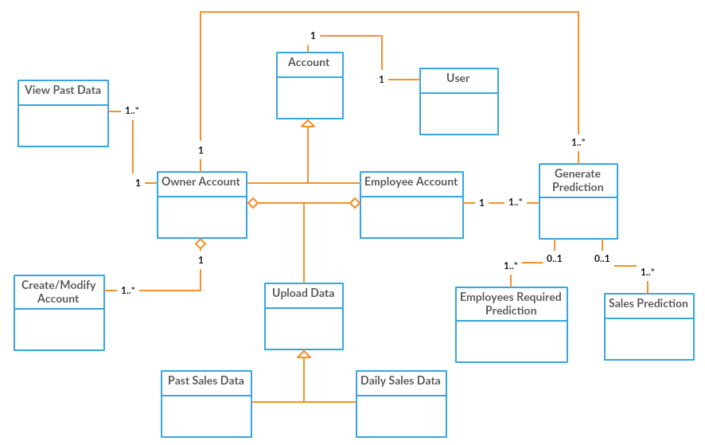

Large scale visualization of the concepts of the problem domain and their relationship.

1. 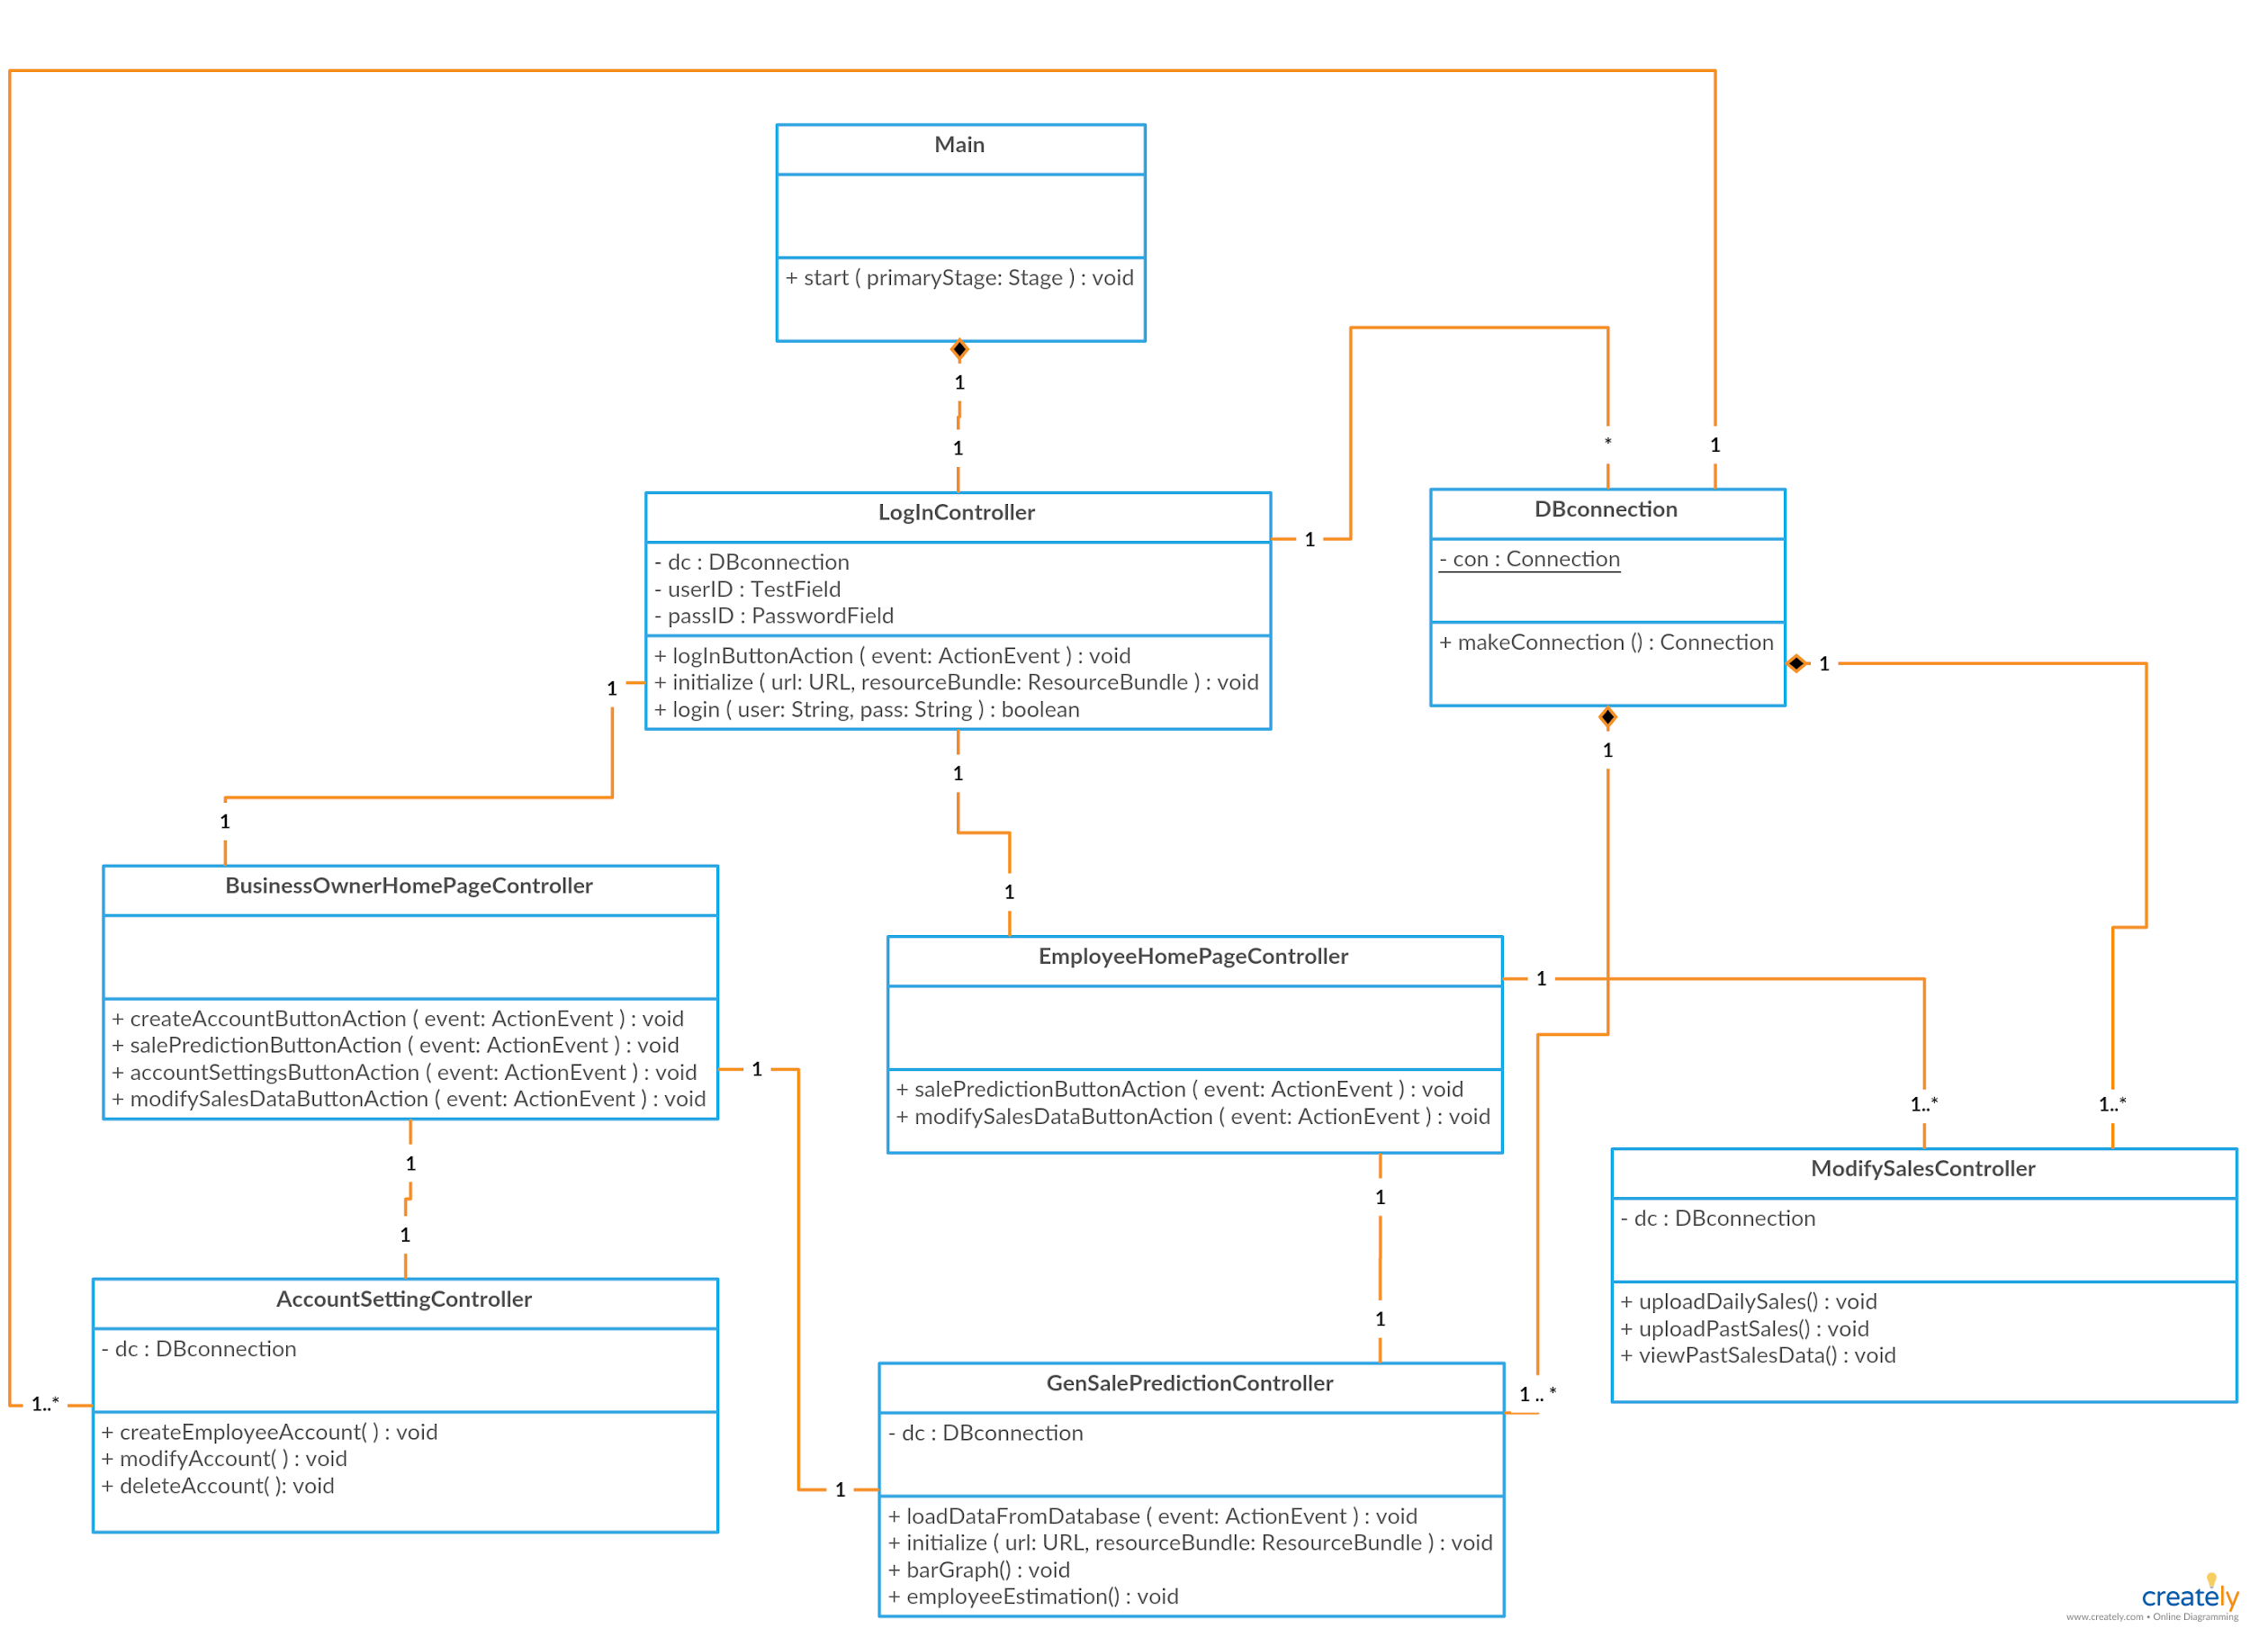**Front End UML Class Diagram**

UML class diagrams the describes how each class in the front end are associated with each other, also it contains controller classes in which each controller will handle events for each screen in the application.

1. **Encryption UML Class Diagram**

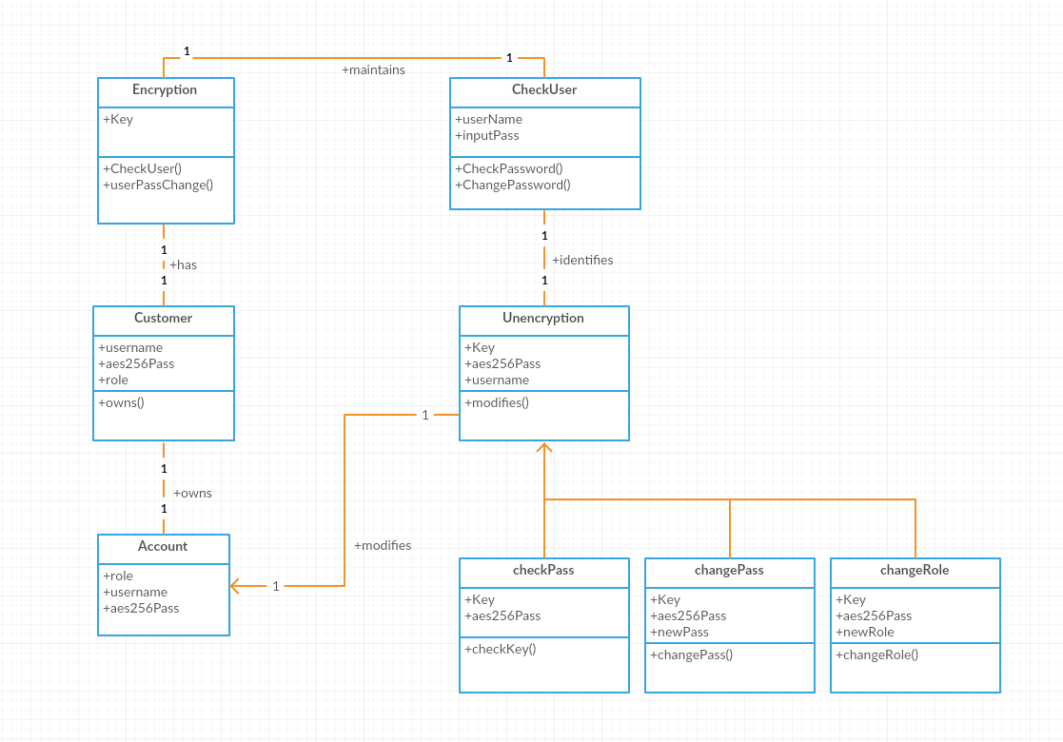

UML class diagram the describes the process of encrypting and decrypting passwords.

1. **Business Logic UML Class Diagram**

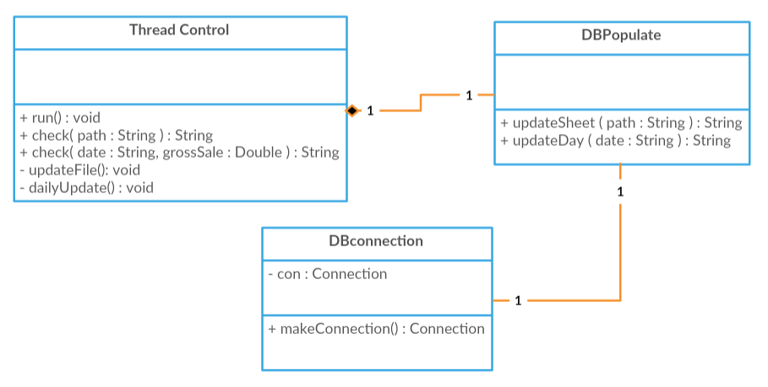

UML class diagrams for the business logic side of the application, containing statistical calculations on sales data that will be used to provide an accurate forecast on sales to user.