**GRL and UCM Models**

1. **GRL models in jUCMNav for each of the actors**

For developers:

Softgoal: pass the class with A.

Softgoal: protect privacy

Goal: minimize development cost.

Goal: satisfy the business owners’ need

Goal: protect privacy

Task: data analysis

Task: output the predicate gross sale

Resource: the input data

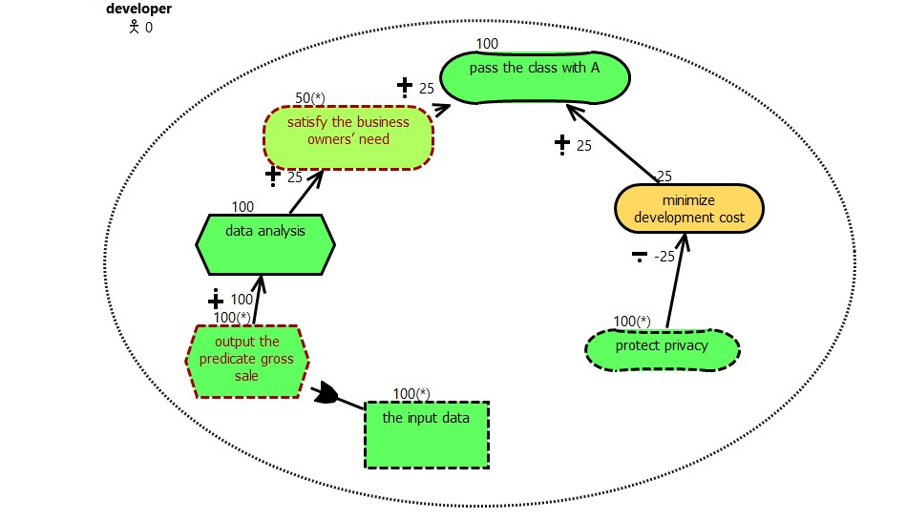

For employees:

Softgoal: get higher salary

Goal: let the business owner get more profit

Task: input the daily gross sales Resource: the input gross sales

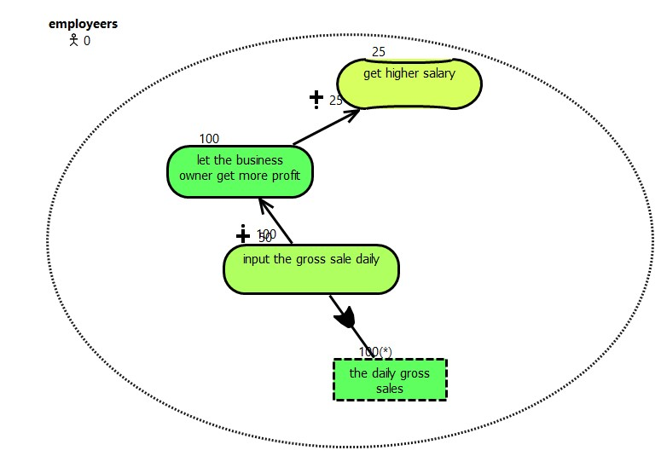

For TrendAssist – privacy:

Softgoal: protect privacy of PI.

Softgoal: be secure

Task: AES-256 Encryption

Task: use Username/ password

Task: log in

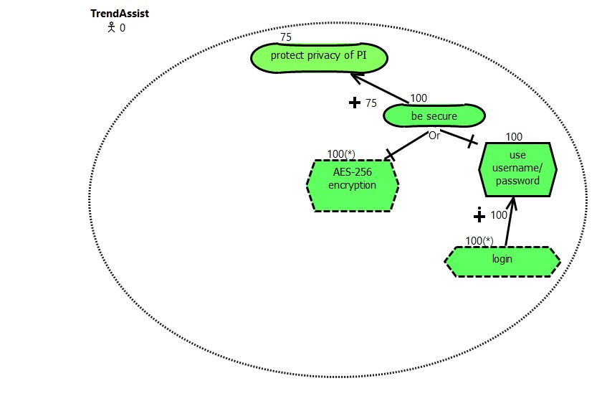

For TrendAssist– Functionalities Softgoal: predict the gross sales for specific day

Softgoal: predicate the gross sales for period.

Task: create graph from data

Task: data analysis

Resource: the daily gross sale

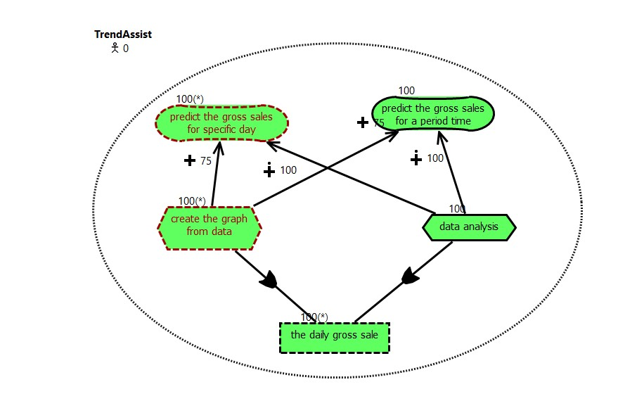

For business owner:

Softgoal: increase profit

Goal: lead to more customer coming

Goal: predicate the gross sales today

Goal: less food wastage

Task: make food on demand

Task: select employees to use the TrendAssist.

Task: create account Task: delete account

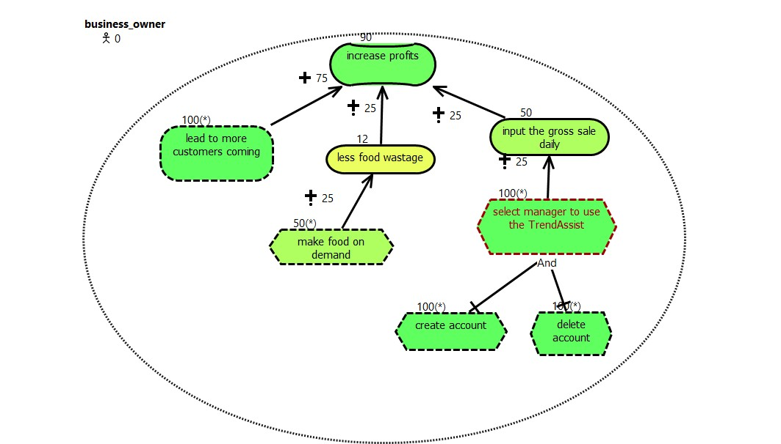

Business owner - trendAssist

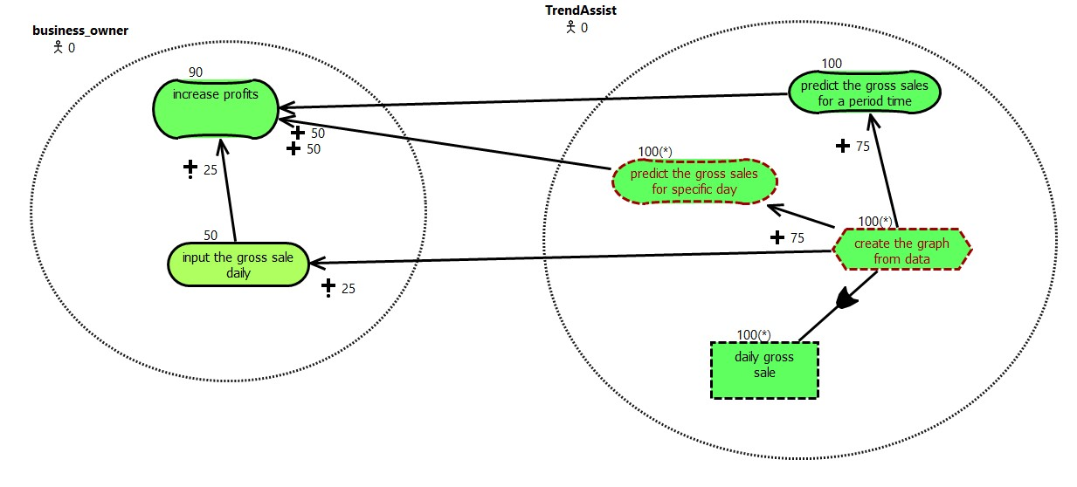

Developer – trendAssist

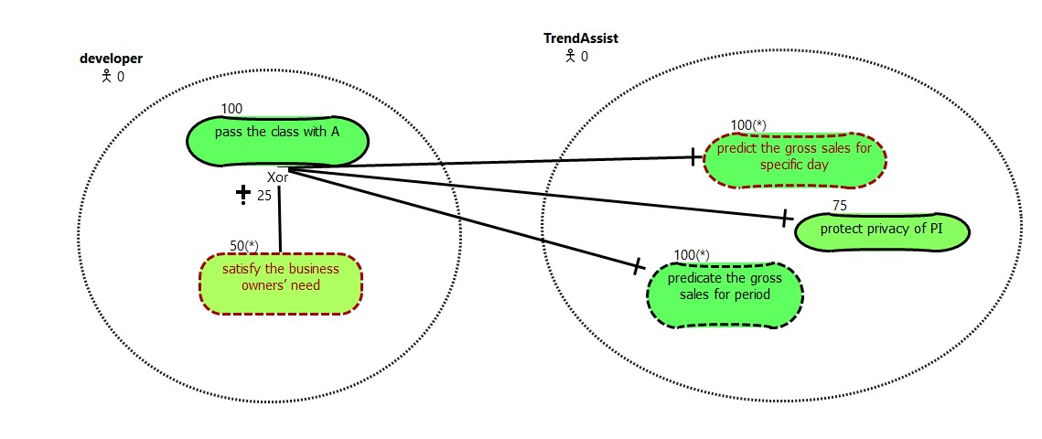

Employee – trendAssist

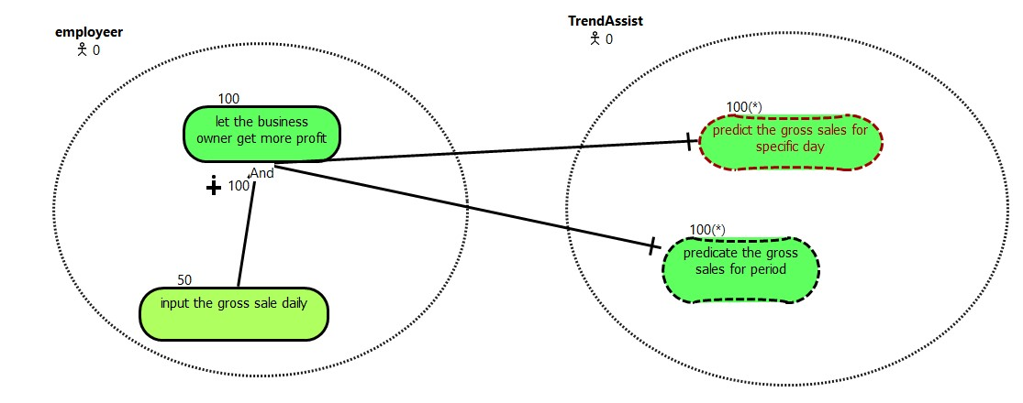

1. **Use Case Maps models in jUCMNav for each of the actors**

First case:

Business owner ==true after business owner logging, he can do both general sale predication and modify sales data

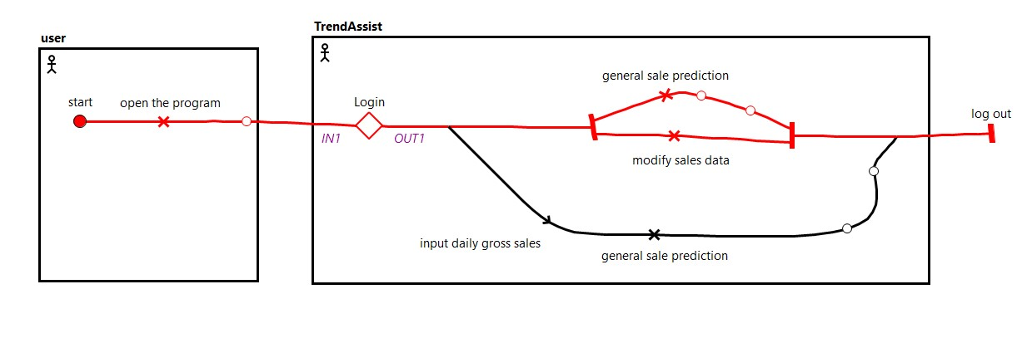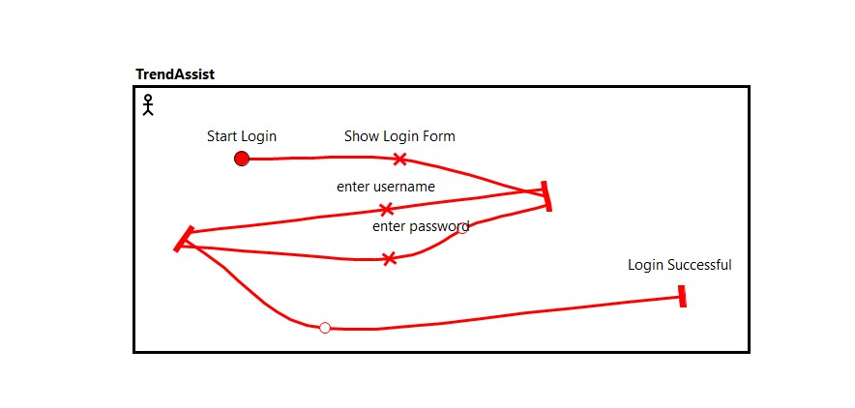

Second case:

Manager run the program

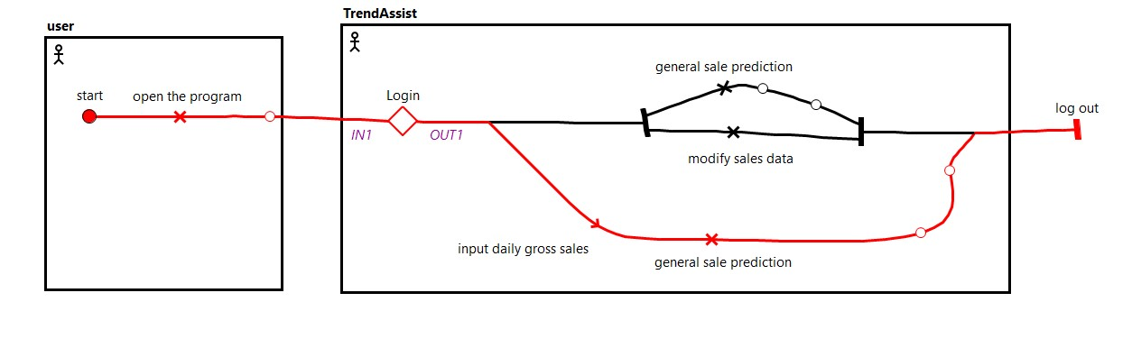



1. **Identifying a set of high-level goals and show their trade-offs between different alternative solutions. Create a set of strategies for the alternative solutions and reason about why certain solutions have been picked.**

Business Owner A:

Business Owner B:

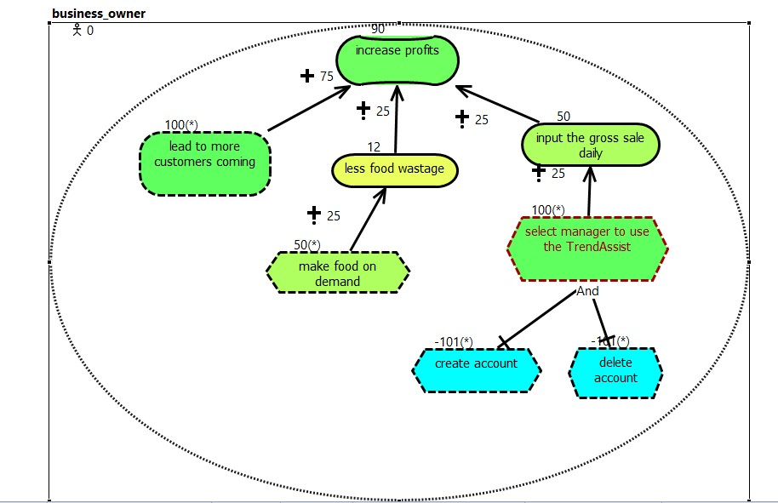

As shown in figure A and B, A is the best option for satisfying the soft goal of increasing profit, because without creating account or create accounts, the owner needs to charge the restaurant by himself, but if there is one manager can help him, it will be more effective.

Developer A:



Developer B:

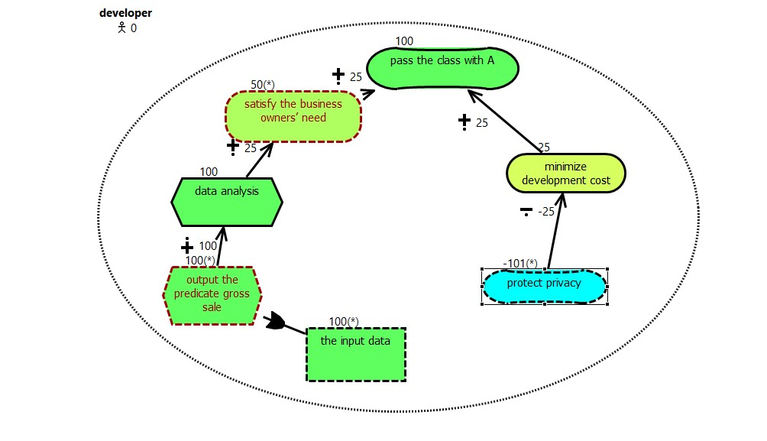

As shown in figure A and B, A is the best option for satisfying the soft goal of passing class with A, because without protecting privacy, the application loses the meaning to build it, privacy is the most important to implement.

Employee A:



Employee B:

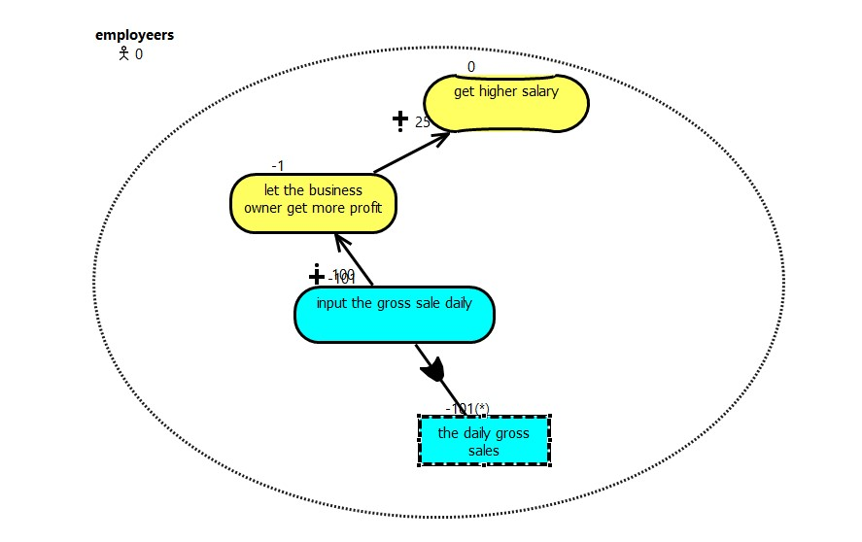

As shown in figure A and B, A is the best option for satisfying the soft goal of getting higher salary, because without the daily gross sales, the application cannot retrieve any statistics, and then the application cannot work.

trendAssist-privacy A:



trendAssist-privacy B:

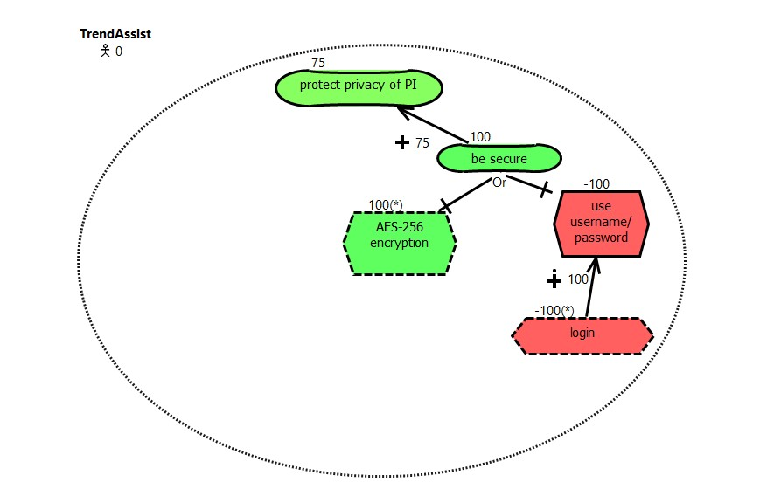

As shown in figure A and B, A is the best option for satisfying the soft goal of protecting privacy of PI, because without logging in, the user cannot use that application.

trendAssist-Functionalities A:



trendAssist-Functionalities B:

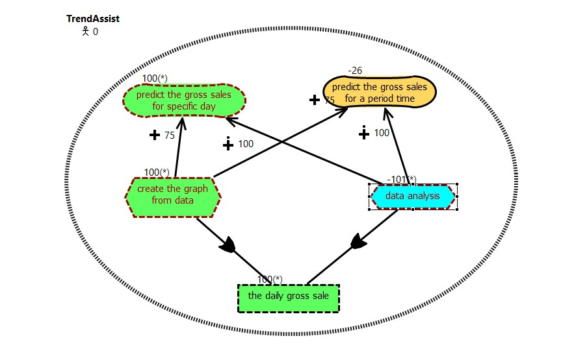

As shown in figure A and B, A is the best option for satisfying the soft goal of protecting the gross for a period time, because without data analysis, the application cannot predicate any gross sales and then application is useless.