**Usability Study**

1. Justin Shekman

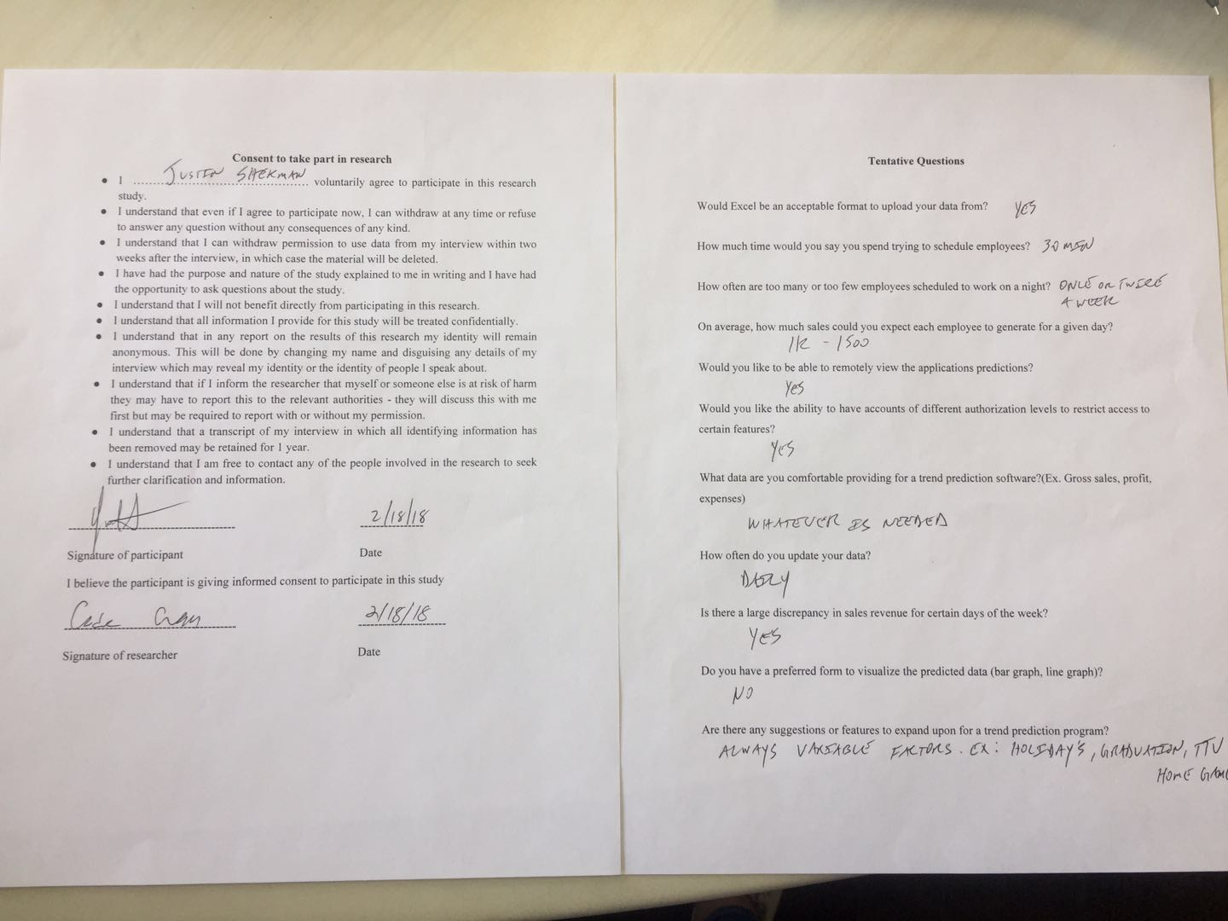

|  |  |
| --- | --- |
| User Story | :Checkmark if satisfied: :X if not satisfied: |
| As a small business owner, I want to be able to predict the amount of sales on a certain day so that I can schedule employees accordingly. | X |
| As a small business owner, I want to be able to predict the amount of income on a certain day so that I can account for potential sales. | X |
| As a small business owner, I want to be able to input the total revenue made for the day into the database upon closing so that I can use that data to update the accuracy of the software. | Check |
| As a small business owner, I want to use my sales report from past years so that I can get an estimate prediction of future sales. | X |
| As a small business owner, I want to use sales reports from past years so that I can see requirements needed to hit specific sales margins. | X |
| As a small business owner, I want to input any date into the software so that I can review data over my company for that specific date. | Check |
| As a small business owner, I want to be able to create sub accounts, so that I can keep access to certain data restricted. | Check |
| As a small business owner, I want to be able to log in into my account, so that I can easily access my data. | Check |
| As a small business owner, I want to be able to set certain parameters so that I can easily view specific data. | Check |
| As a small business owner, I want to be able to input sales reports from past years, so they can be used in the application. | Check |
| As a small business owner, I want to be able to have an unrestricted admin account to access all data. | Check |

**Was the app straightforward to use?**

Yes

**Was the app fast?**

Yes

**Would you use this app in your current business or for a future business for gross sales predictions?**

Yes, when completed

**What suggestions do you have for the app?**

* Hide the account passwords in Account Settings.
* I’d like the sales data to also be encrypted in the database, just like y’all did with the passwords.
* Have a separate button for graphing and generate prediction. I want to be able to get a set number for a given date based on the past data. The graph display looks great and is useful, but I want to see the predicted sales for a specific date.
* I would also like to see the total predicted sales over the course of a month instead of the average sales. I know weekdays will be less busy than weekends, so the average gross sales don’t really matter too much. The gross sales prediction is more important.
* I’ll get you guys the rest of the sales data so you have more of a baseline on the average sales.

Overall, I think you guys are on the right track to building something I’ll be using consistently.

1. Mayur Bhakta

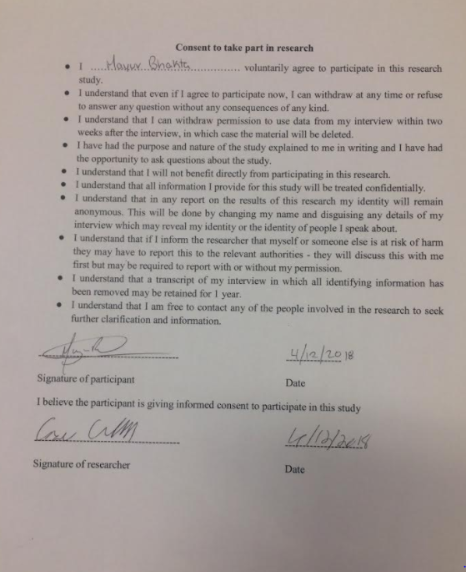

|  |  |
| --- | --- |
| User Story | :Checkmark if satisfied: :X if not satisfied: |
| As a small business owner, I want to be able to predict the amount of sales on a certain day so that I can schedule employees accordingly. | X |
| As a small business owner, I want to be able to predict the amount of income on a certain day so that I can account for potential sales. | Check |
| As a small business owner, I want to be able to input the total revenue made for the day into the database upon closing so that I can use that data to update the accuracy of the software. | Check |
| As a small business owner, I want to use my sales report from past years so that I can get an estimate prediction of future sales. | Check |
| As a small business owner, I want to use sales reports from past years so that I can see requirements needed to hit specific sales margins. | X |
| As a small business owner, I want to input any date into the software so that I can review data over my company for that specific date. | Check |
| As a small business owner, I want to be able to create sub accounts, so that I can keep access to certain data restricted. | Check |
| As a small business owner, I want to be able to log in into my account, so that I can easily access my data. | Check |
| As a small business owner, I want to be able to set certain parameters so that I can easily view specific data. | Check |
| As a small business owner, I want to be able to input sales reports from past years, so they can be used in the application. | Check |
| As a small business owner, I want to be able to have an unrestricted admin account to access all data. | Check |

**Was the app straightforward to use?**

Yes

**Was the app fast?**

Yes

**Would you use this app in your current business or for a future business for gross sales predictions?**

Yes, after some changes are done.

**What suggestions do you have for the app?**

* Get the number of employees required prediction implemented.
* Be able to upload data for several days instead of one at a time.
* Modify the account settings page so it doesn’t show all the accounts password in the database.

1. Aaron Turner

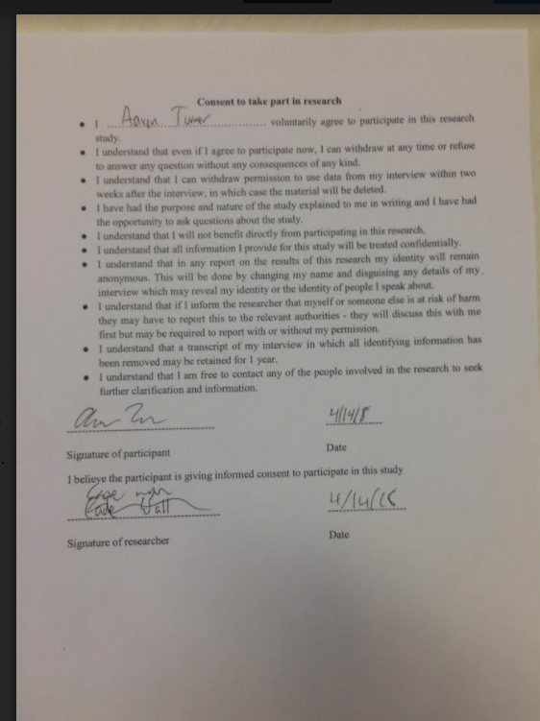

|  |  |
| --- | --- |
| User Story | :Checkmark if satisfied: :X if not satisfied: |
| As a small business owner, I want to be able to predict the amount of sales on a certain day so that I can schedule employees accordingly. | X |
| As a small business owner, I want to be able to predict the amount of income on a certain day so that I can account for potential sales. | Check |
| As a small business owner, I want to be able to input the total revenue made for the day into the database upon closing so that I can use that data to update the accuracy of the software. | Check |
| As a small business owner, I want to use my sales report from past years so that I can get an estimate prediction of future sales. | Check |
| As a small business owner, I want to use sales reports from past years so that I can see requirements needed to hit specific sales margins. | X |
| As a small business owner, I want to input any date into the software so that I can review data over my company for that specific date. | Check |
| As a small business owner, I want to be able to create sub accounts, so that I can keep access to certain data restricted. | Check |
| As a small business owner, I want to be able to log in into my account, so that I can easily access my data. | Check |
| As a small business owner, I want to be able to set certain parameters so that I can easily view specific data. | Check |
| As a small business owner, I want to be able to input sales reports from past years, so they can be used in the application. | Check |
| As a small business owner, I want to be able to have an unrestricted admin account to access all data. | Check |

**Was the app straightforward to use?**

Yes

**Was the app fast?**

Yes

**Would you use this app in your current business or for a future business for gross sales predictions?**

Yes, after some changes are done.

**What suggestions do you have for the app?**

None

1. Aaron Riggs

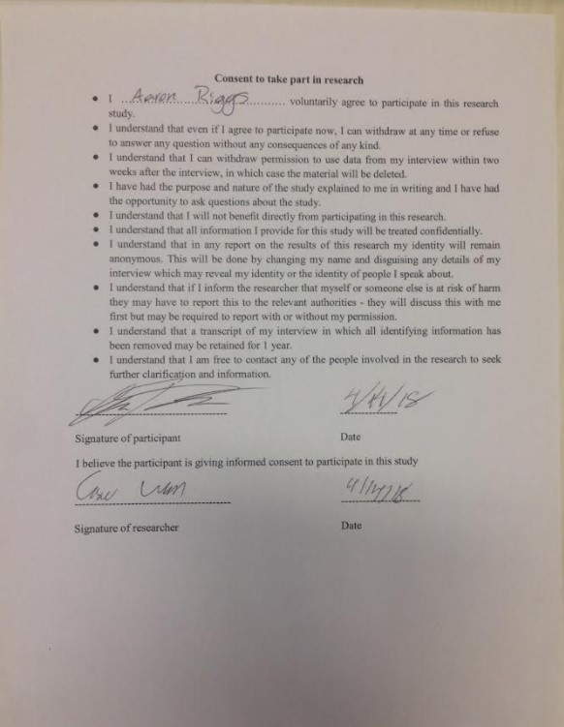

|  |  |
| --- | --- |
| User Story | :Checkmark if satisfied: :X if not satisfied: |
| As a small business owner, I want to be able to predict the amount of sales on a certain day so that I can schedule employees accordingly. | check |
| As a small business owner, I want to be able to predict the amount of income on a certain day so that I can account for potential sales. | X |
| As a small business owner, I want to be able to input the total revenue made for the day into the database upon closing so that I can use that data to update the accuracy of the software. | Check |
| As a small business owner, I want to use my sales report from past years so that I can get an estimate prediction of future sales. | check |
| As a small business owner, I want to use sales reports from past years so that I can see requirements needed to hit specific sales margins. | check |
| As a small business owner, I want to input any date into the software so that I can review data over my company for that specific date. | Check |
| As a small business owner, I want to be able to create sub accounts, so that I can keep access to certain data restricted. | Check |
| As a small business owner, I want to be able to log in into my account, so that I can easily access my data. | Check |
| As a small business owner, I want to be able to set certain parameters so that I can easily view specific data. | Check |
| As a small business owner, I want to be able to input sales reports from past years, so they can be used in the application. | Check |
| As a small business owner, I want to be able to have an unrestricted admin account to access all data. | Check |

**Was the app straightforward to use?**

Yes

**Was the app fast?**

Yes

**Would you use this app in your current business or for a future business for gross sales predictions?**

No

**What suggestions do you have for the app?**

* Hide the account passwords in Account Settings.
* I would like to see the app have a more professional feeling, the falling code background looks childish.