**Domain Model and UML Class Diagram Design**

1. **Domain Model**

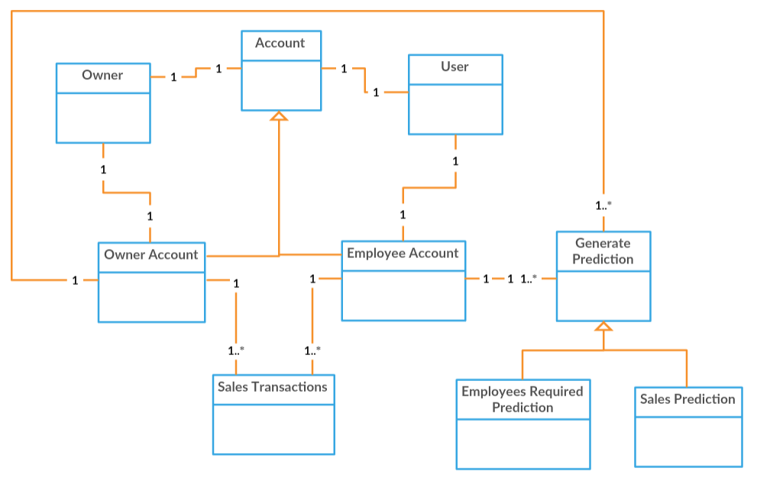

Large scale visualization of the concepts of the problem domain and their relationship.

There are two types of users: employees and an owner. Both type of users can have exactly one account. An account can be of two different types: owner or employee, both employee account and owner account are extensions of account. Both type of accounts can navigate and view one or many sales transactions and they can also generate one or many predictions. A prediction consists of employees required for a day predication or sales prediction for a given day. But only a user with an owner account can generate both sales and employees required prediction, while the employee can only generate sales prediction.

1. **Front End UML Class Diagram**

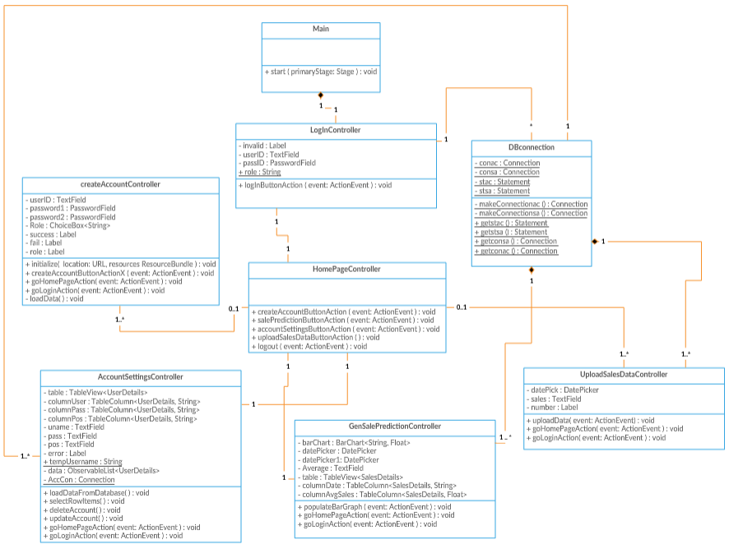

UML class diagrams the describes how each class in the front end are associated with each other, also it contains controller classes in which each controller will handle events for each screen in the application.

1. **Encryption UML Class Diagram**

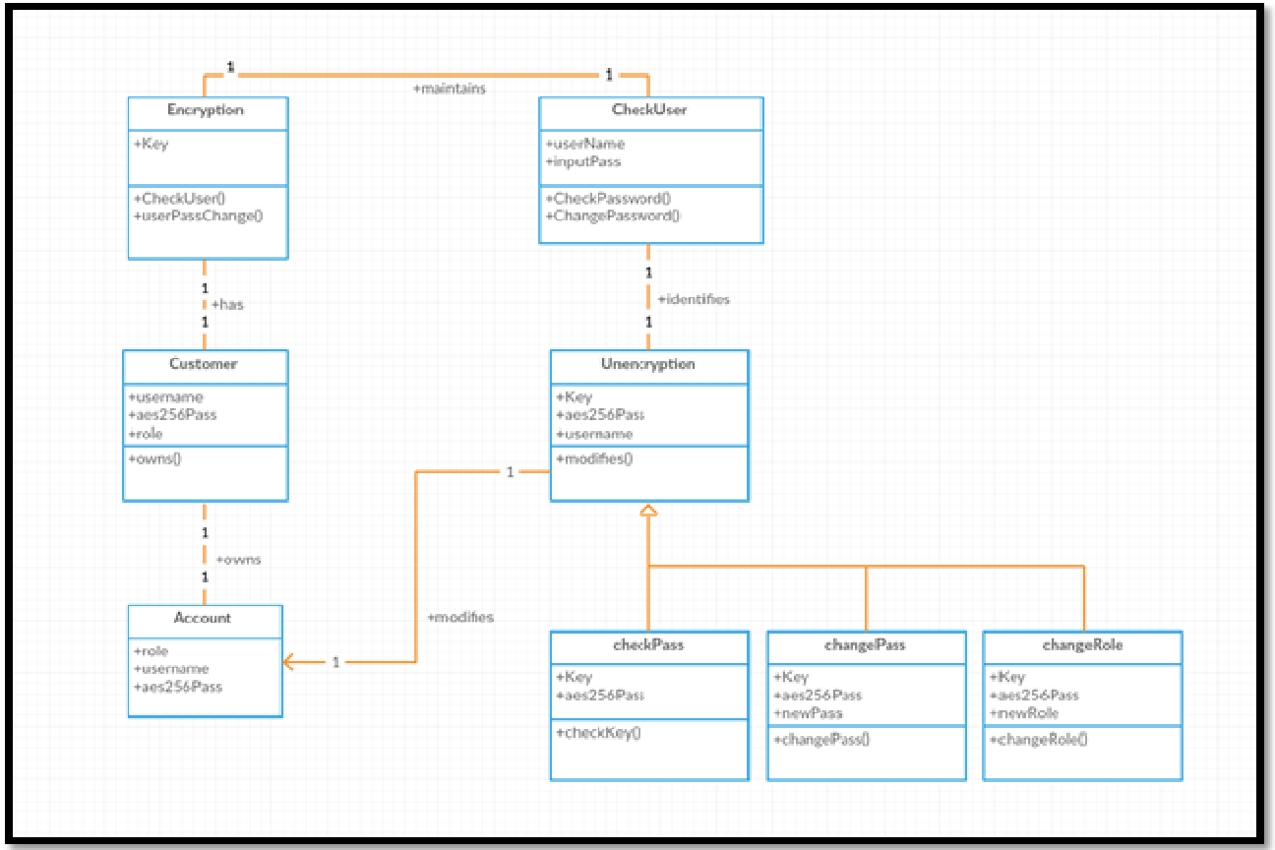

UML class diagram the describes the process of encrypting and decrypting passwords.

1. **Business Logic UML Class Diagram**

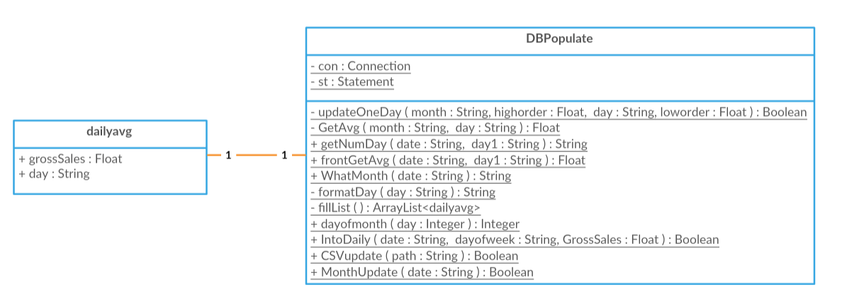

UML class diagrams for the business logic side of the application, containing statistical calculations on sales data that will be used to provide an accurate forecast on sales to user.