**Usability Study**

1. Justin Shekman

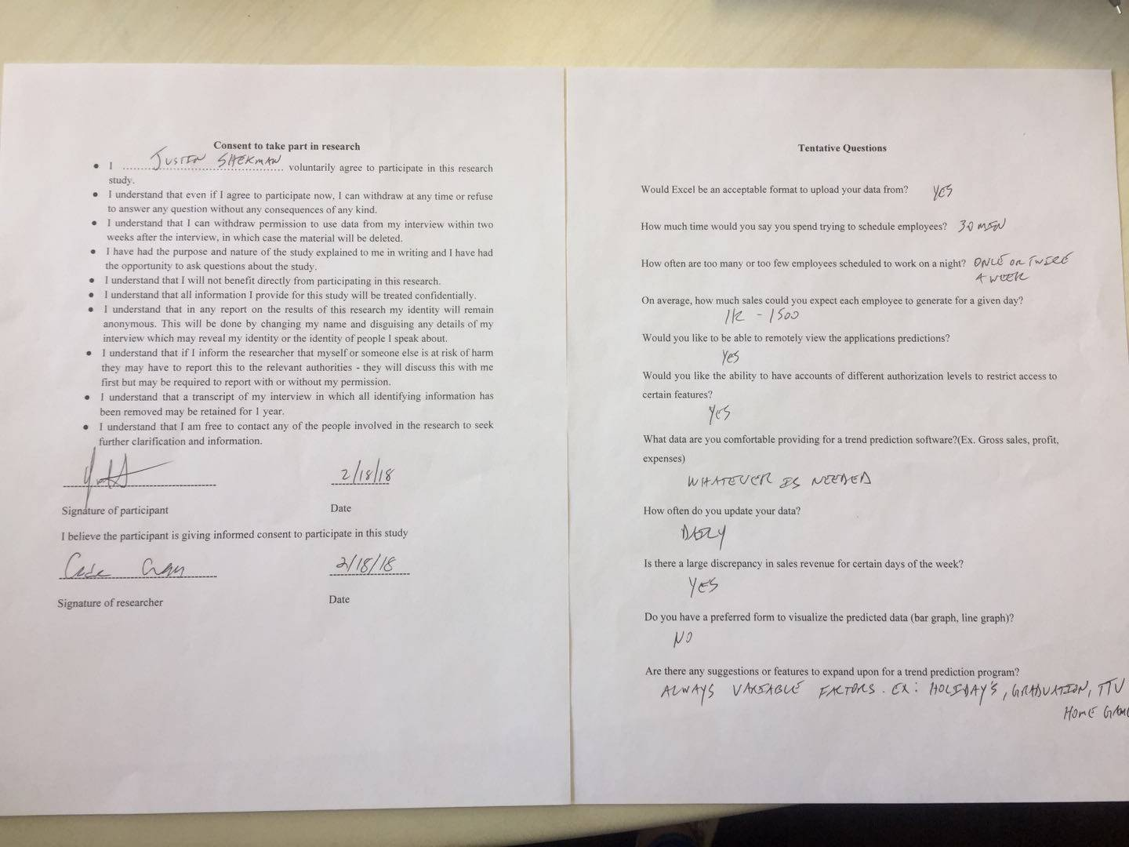

|  |  |
| --- | --- |
| User Story | :Checkmark if satisfied: :X if not satisfied: |
| As a small business owner, I want to be able to predict the amount of sales on a certain day so that I can schedule employees accordingly. | X |
| As a small business owner, I want to be able to predict the amount of income on a certain day so that I can account for potential sales. | X |
| As a small business owner, I want to be able to input the total revenue made for the day into the database upon closing so that I can use that data to update the accuracy of the software. | Check |
| As a small business owner, I want to use my sales report from past years so that I can get an estimate prediction of future sales. | X |
| As a small business owner, I want to use sales reports from past years so that I can see requirements needed to hit specific sales margins. | X |
| As a small business owner, I want to input any date into the software so that I can review data over my company for that specific date. | Check |
| As a small business owner, I want to be able to create sub accounts, so that I can keep access to certain data restricted. | Check |
| As a small business owner, I want to be able to log in into my account, so that I can easily access my data. | Check |
| As a small business owner, I want to be able to set certain parameters so that I can easily view specific data. | Check |
| As a small business owner, I want to be able to input sales reports from past years, so they can be used in the application. | Check |
| As a small business owner, I want to be able to have an unrestricted admin account to access all data. | Check |

**Was the app straightforward to use?**

Yes

**Was the app fast?**

Yes

**Would you use this app in your current business or for a future business for gross sales predictions?**

Yes, when completed

**What suggestions do you have for the app?**

* Hide the account passwords in Account Settings.
* I’d like the sales data to also be encrypted in the database, just like y’all did with the passwords.
* Have a separate button for graphing and generate prediction. I want to be able to get a set number for a given date based on the past data. The graph display looks great and is useful, but I want to see the predicted sales for a specific date.
* I would also like to see the total predicted sales over the course of a month instead of the average sales. I know weekdays will be less busy than weekends, so the average gross sales don’t really matter too much. The gross sales prediction is more important.
* I’ll get you guys the rest of the sales data so you have more of a baseline on the average sales.

Overall, I think you guys are on the right track to building something I’ll be using consistently.

1. Kody Parkhurst-Johnson (Turner’s roommate)

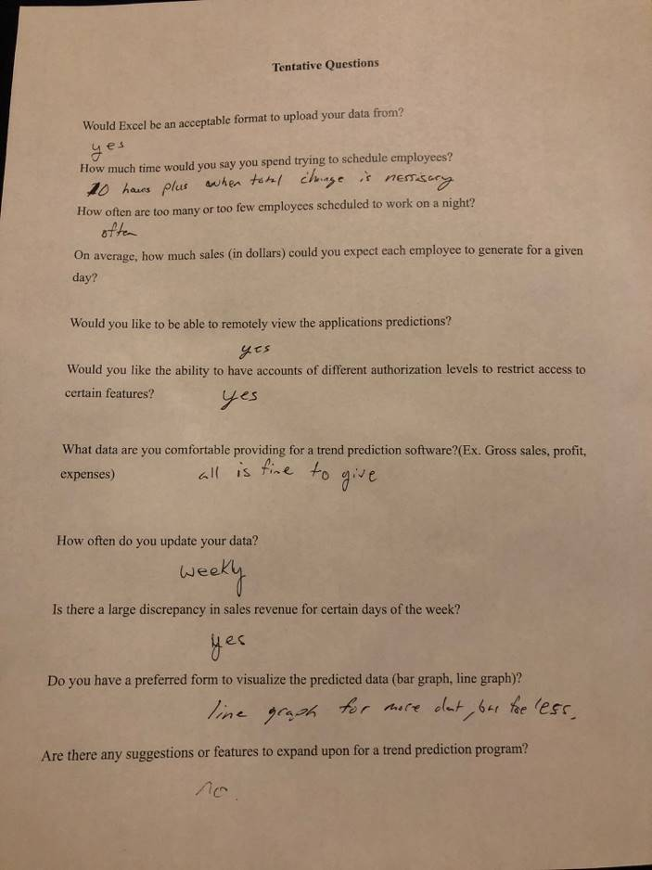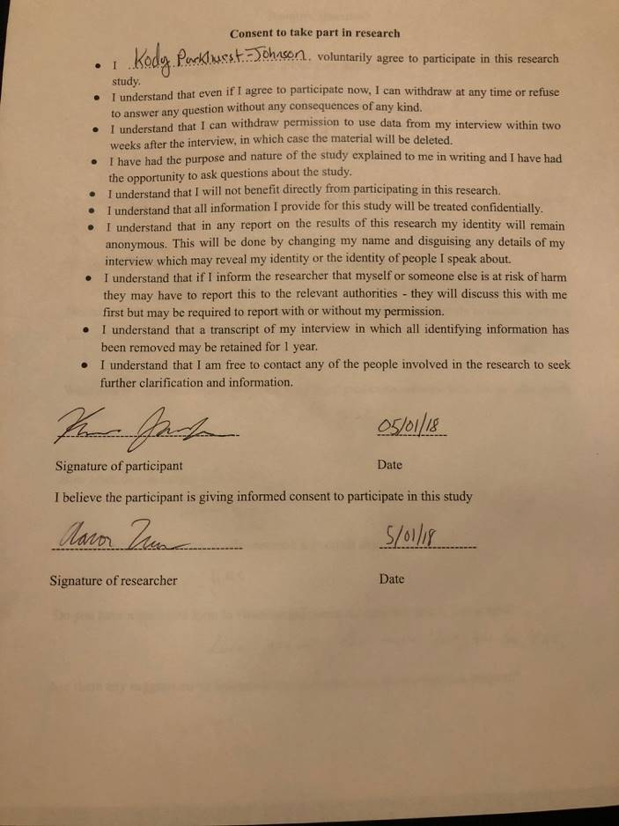

|  |  |
| --- | --- |
| User Story | :Checkmark if satisfied: :X if not satisfied: |
| As a small business owner, I want to be able to predict the amount of sales on a certain day so that I can schedule employees accordingly. | X |
| As a small business owner, I want to be able to predict the amount of income on a certain day so that I can account for potential sales. | ✓ |
| As a small business owner, I want to be able to input the total revenue made for the day into the database upon closing so that I can use that data to update the accuracy of the software. | ✓ |
| As a small business owner, I want to use my sales report from past years so that I can get an estimate prediction of future sales. | ✓ |
| As a small business owner, I want to use sales reports from past years so that I can see requirements needed to hit specific sales margins. | ✓ |
| As a small business owner, I want to input any date into the software so that I can review data over my company for that specific date. | ✓ |
| As a small business owner, I want to be able to create sub accounts, so that I can keep access to certain data restricted. | ✓ |
| As a small business owner, I want to be able to log in into my account, so that I can easily access my data. | ✓ |
| As a small business owner, I want to be able to set certain parameters so that I can easily view specific data. | ✓ |
| As a small business owner, I want to be able to input sales reports from past years, so they can be used in the application. | X |
| As a small business owner, I want to be able to have an unrestricted admin account to access all data. | ✓ |

**Was the app straightforward to use?**

Yes it was

**Was the app fast?**

Yes

**Would you use this app in your current business or for a future business for gross sales predictions?**

Yes, once program is complete with all features.

**What suggestions do you have for the app?**

Change white font on orange background for better contrast

1. Lexi Urbanovsky

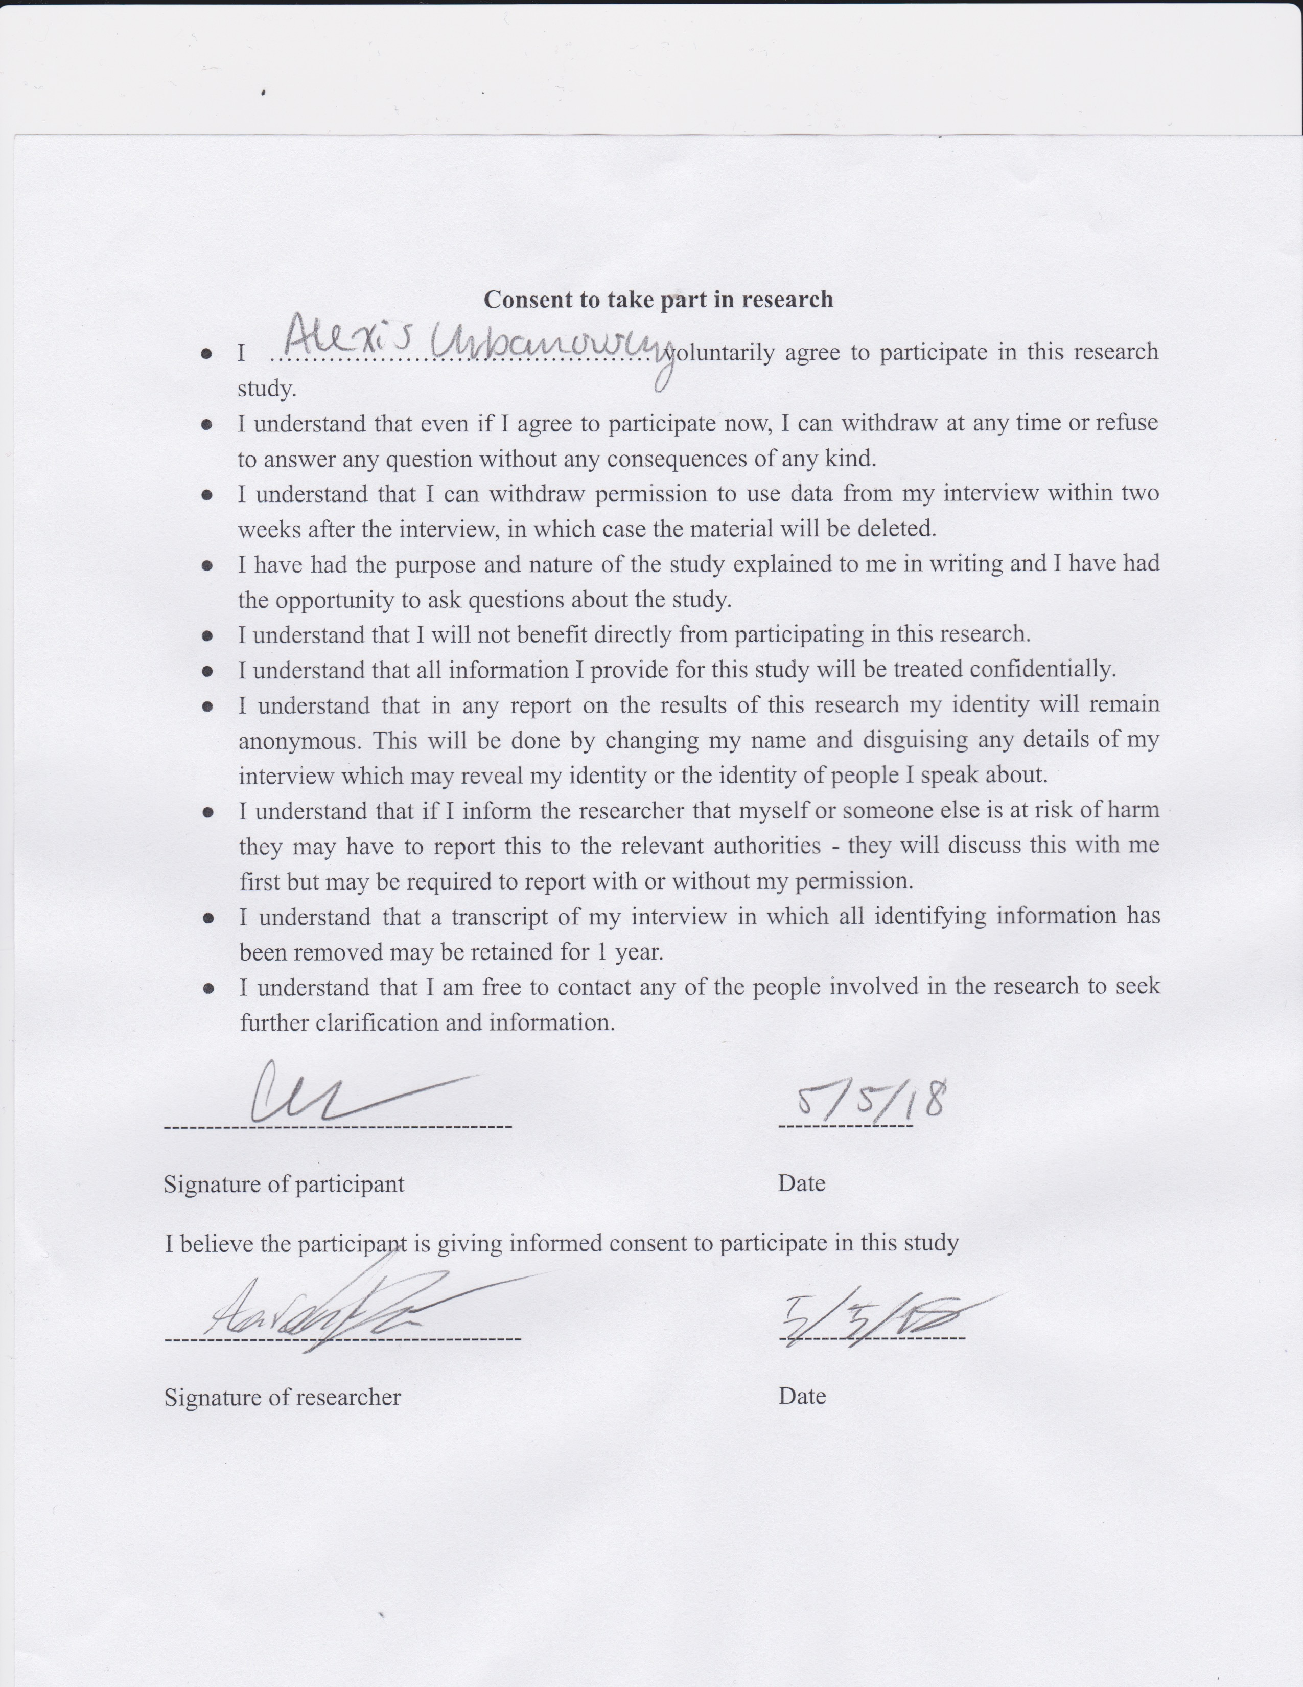

|  |  |
| --- | --- |
| User Story | :Checkmark if satisfied: :X if not satisfied: |
| As a small business owner, I want to be able to predict the amount of sales on a certain day so that I can schedule employees accordingly. | X |
| As a small business owner, I want to be able to predict the amount of income on a certain day so that I can account for potential sales. | Check |
| As a small business owner, I want to be able to input the total revenue made for the day into the database upon closing so that I can use that data to update the accuracy of the software. | Check |
| As a small business owner, I want to use my sales report from past years so that I can get an estimate prediction of future sales. | X |
| As a small business owner, I want to use sales reports from past years so that I can see requirements needed to hit specific sales margins. | Check |
| As a small business owner, I want to input any date into the software so that I can review data over my company for that specific date. | Check |
| As a small business owner, I want to be able to create sub accounts, so that I can keep access to certain data restricted. | Check |
| As a small business owner, I want to be able to log in into my account, so that I can easily access my data. | Check |
| As a small business owner, I want to be able to set certain parameters so that I can easily view specific data. | Check |
| As a small business owner, I want to be able to input sales reports from past years, so they can be used in the application. | Check |
| As a small business owner, I want to be able to have an unrestricted admin account to access all data. | Check |

**Was the app straightforward to use?**

Yes

**Was the app fast?**

Yes

**Would you use this app in your current business or for a future business for gross sales predictions?**

Yes, when completed

**What suggestions do you have for the app?**

* Have the backgrounds be less distracting from the true use of the app.

1. Jonathan Bouligny

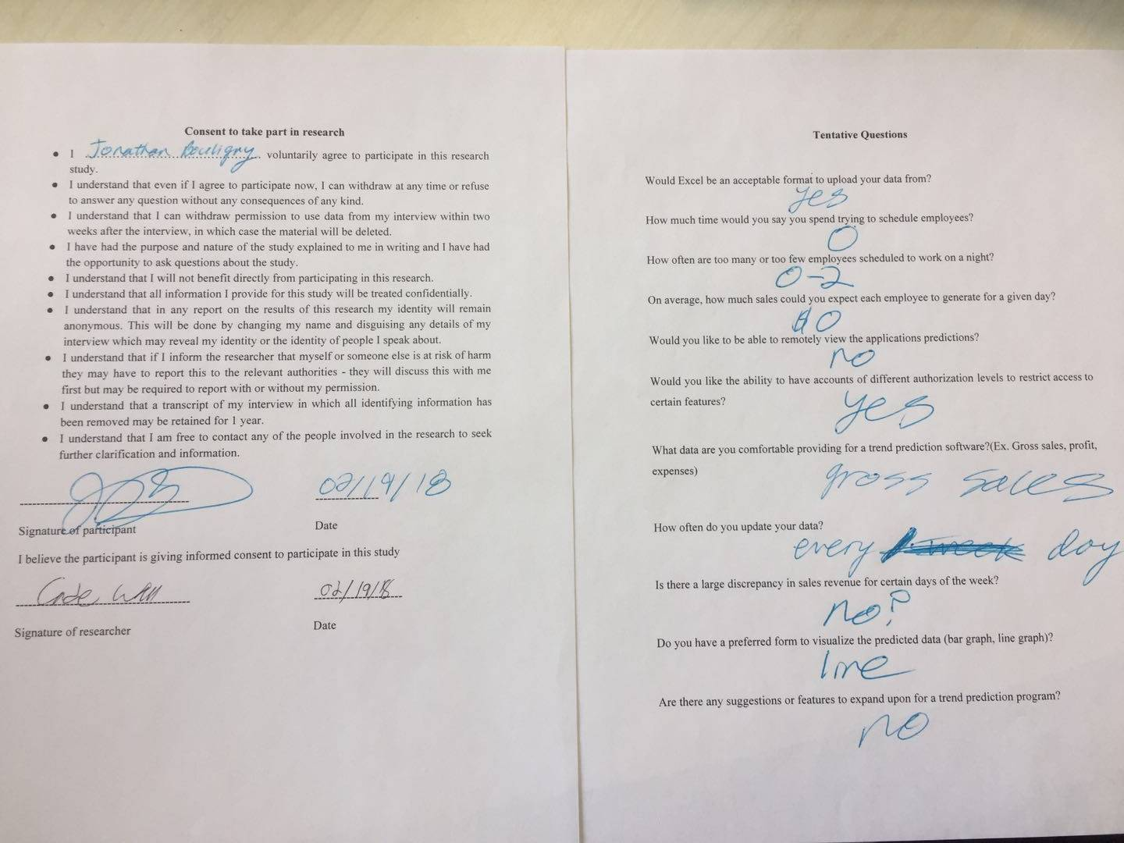

|  |  |
| --- | --- |
| User Story | :Checkmark if satisfied: :X if not satisfied: |
| As a small business owner, I want to be able to predict the amount of sales on a certain day so that I can schedule employees accordingly. | check |
| As a small business owner, I want to be able to predict the amount of income on a certain day so that I can account for potential sales. | check |
| As a small business owner, I want to be able to input the total revenue made for the day into the database upon closing so that I can use that data to update the accuracy of the software. | check |
| As a small business owner, I want to use my sales report from past years so that I can get an estimate prediction of future sales. | check |
| As a small business owner, I want to use sales reports from past years so that I can see requirements needed to hit specific sales margins. | check |
| As a small business owner, I want to input any date into the software so that I can review data over my company for that specific date. | check |
| As a small business owner, I want to be able to create sub accounts, so that I can keep access to certain data restricted. | check |
| As a small business owner, I want to be able to log in into my account, so that I can easily access my data. | check |
| As a small business owner, I want to be able to set certain parameters so that I can easily view specific data. | check |
| As a small business owner, I want to be able to input sales reports from past years, so they can be used in the application. | x |
| As a small business owner, I want to be able to have an unrestricted admin account to access all data. | check |

**Was the app straightforward to use?**

Yes

**Was the app fast?**

Yes

**Would you use this app in your current business or for a future business for gross sales predictions?**

Yes

**What suggestions do you have for the app?**

None

1. Simon Woldemichael

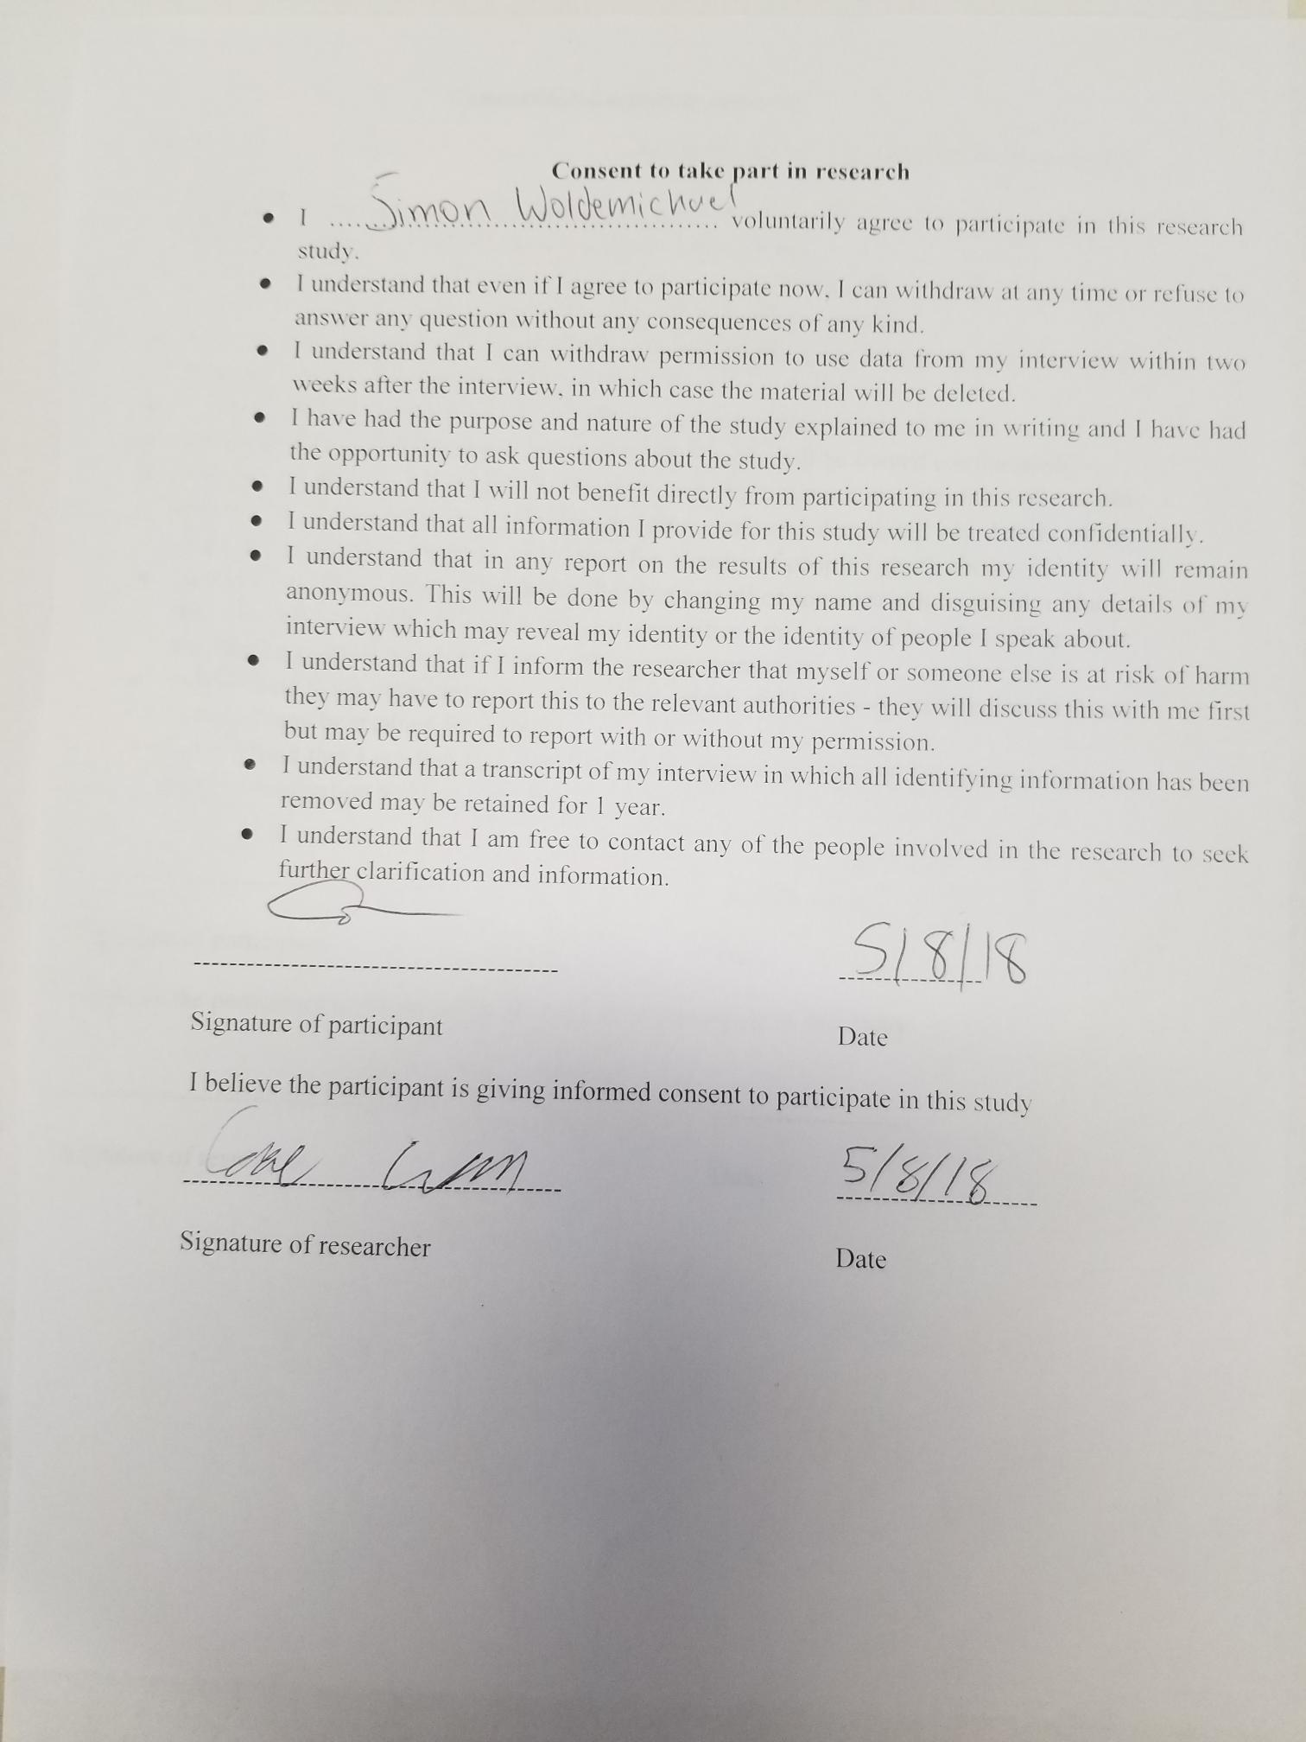

|  |  |
| --- | --- |
| User Story | :Checkmark if satisfied: :X if not satisfied: |
| As a small business owner, I want to be able to predict the amount of sales on a certain day so that I can schedule employees accordingly. | ✓ |
| As a small business owner, I want to be able to predict the amount of income on a certain day so that I can account for potential sales. | ✓ |
| As a small business owner, I want to be able to input the total revenue made for the day into the database upon closing so that I can use that data to update the accuracy of the software. | ✓ |
| As a small business owner, I want to use my sales report from past years so that I can get an estimate prediction of future sales. | ✓ |
| As a small business owner, I want to use sales reports from past years so that I can see requirements needed to hit specific sales margins. | ✓ |
| As a small business owner, I want to input any date into the software so that I can review data over my company for that specific date. | ✓ |
| As a small business owner, I want to be able to create sub accounts, so that I can keep access to certain data restricted. | ✓ |
| As a small business owner, I want to be able to log in into my account, so that I can easily access my data. | ✓ |
| As a small business owner, I want to be able to set certain parameters so that I can easily view specific data. | ✓ |
| As a small business owner, I want to be able to input sales reports from past years, so they can be used in the application. | X |
| As a small business owner, I want to be able to have an unrestricted admin account to access all data. | ✓ |

**Was the app straightforward to use?**

Yes

**Was the app fast?**

Yes, very responsive

**Would you use this app in your current business or for a future business for gross sales predictions?**

Yes, the predictions seem accurate

**What suggestions do you have for the app?**

Nothing

**Summary of Results**

General feedback we got from conducting the usability studies above was generally positive. The various testers we had test our program were very helpful and gave good feedback. They all believed that the app was straightforward enough to use based on the self-explanatorily labeled buttons. Because of the lightweight aspect of our program, the app was very responsive to any input. Most testers besides the bar manager didn’t have much application for this program since they aren’t currently involved in a small business and dealing financial data. There were a few small suggestions such as changing the color scheme of the program and the bar manager advised that we go ahead and encrypt the sales data in the database just like the account passwords. These changes wouldn’t be too hard to implement, and we could possibly develop some kind of color scheme toggle to appease people who don’t care for the current color scheme.