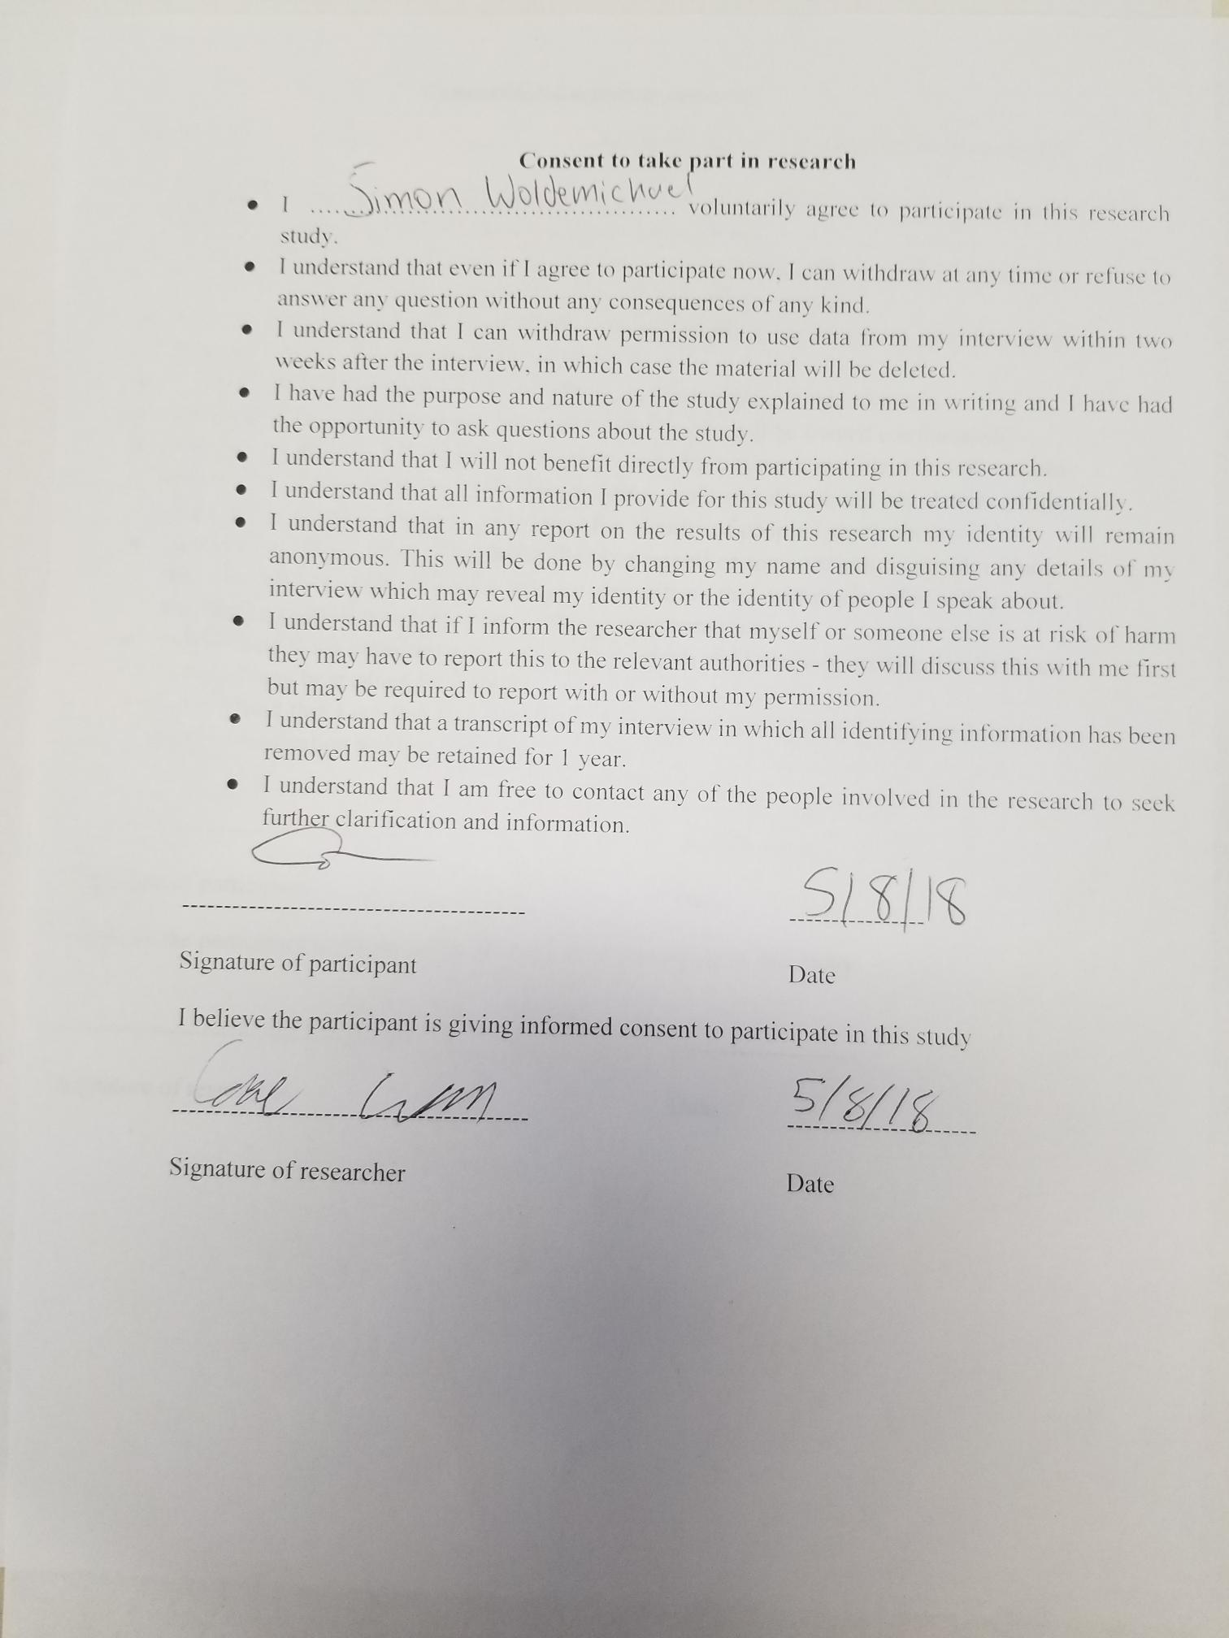

|  |  |
| --- | --- |
| User Story | :Checkmark if satisfied: :X if not satisfied: |
| As a small business owner, I want to be able to predict the amount of sales on a certain day so that I can schedule employees accordingly. | ✓ |
| As a small business owner, I want to be able to predict the amount of income on a certain day so that I can account for potential sales. | ✓ |
| As a small business owner, I want to be able to input the total revenue made for the day into the database upon closing so that I can use that data to update the accuracy of the software. | ✓ |
| As a small business owner, I want to use my sales report from past years so that I can get an estimate prediction of future sales. | ✓ |
| As a small business owner, I want to use sales reports from past years so that I can see requirements needed to hit specific sales margins. | ✓ |
| As a small business owner, I want to input any date into the software so that I can review data over my company for that specific date. | ✓ |
| As a small business owner, I want to be able to create sub accounts, so that I can keep access to certain data restricted. | ✓ |
| As a small business owner, I want to be able to log in into my account, so that I can easily access my data. | ✓ |
| As a small business owner, I want to be able to set certain parameters so that I can easily view specific data. | ✓ |
| As a small business owner, I want to be able to input sales reports from past years, so they can be used in the application. | X |
| As a small business owner, I want to be able to have an unrestricted admin account to access all data. | ✓ |

**Was the app straightforward to use?**

Yes

**Was the app fast?**

Yes, very responsive

**Would you use this app in your current business or for a future business for gross sales predictions?**

Yes, the predictions seem accurate

**What suggestions do you have for the app?**

Nothing